BR_LMS_08- User Registration
Activity diagram
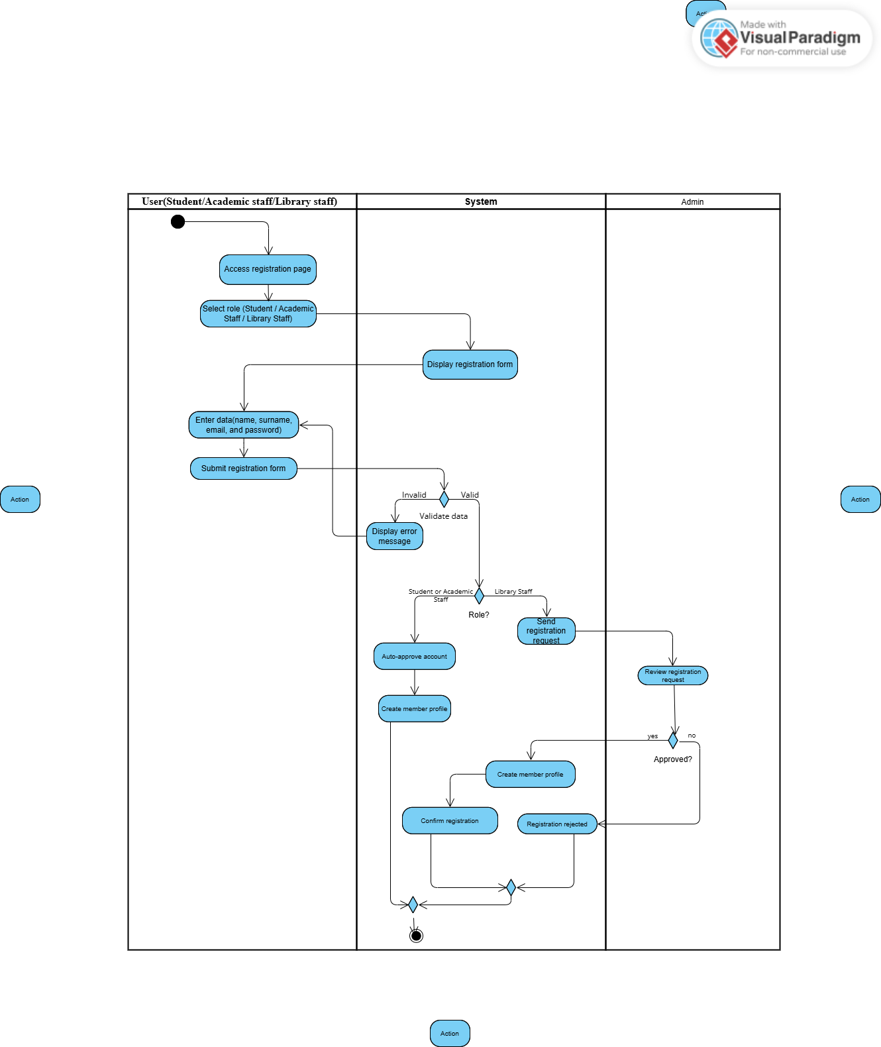

BR_LMS_09 – Administrator Account Management
Activity diagram
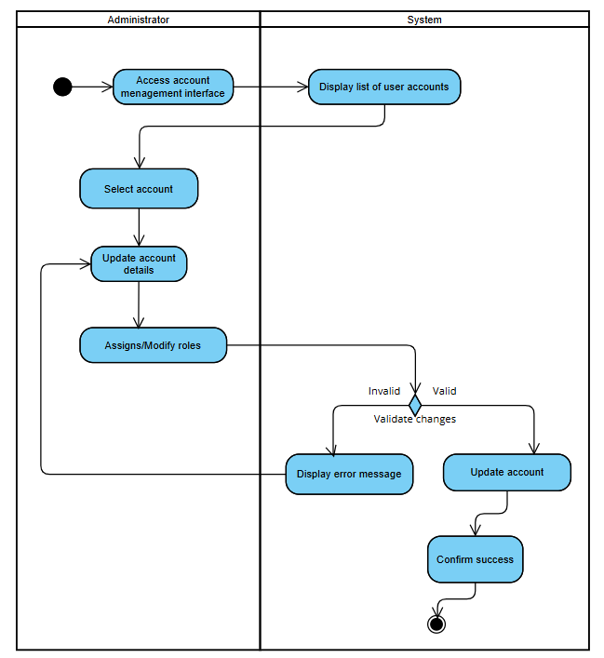

BR_LMS_10- Manage User Profile
Activity diagram
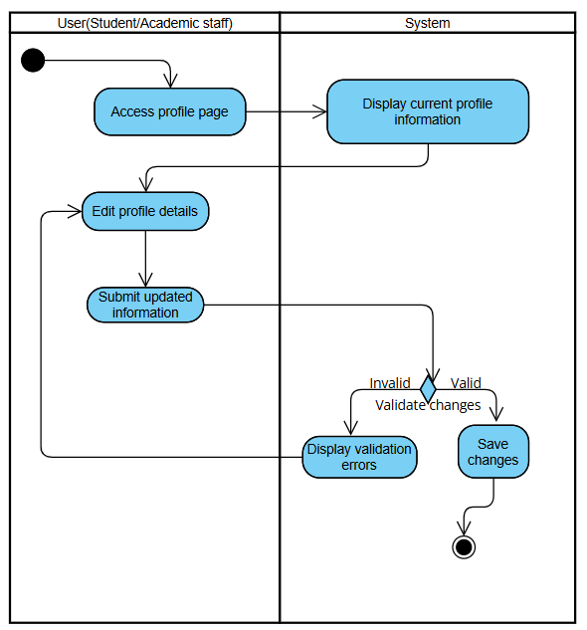

BR_LMS_11- Track System Activity
Activity diagram
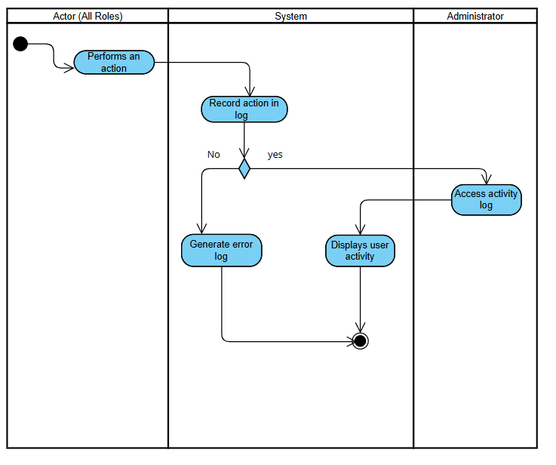

BR_LMS_12 – Library Event Management
Activity diagram
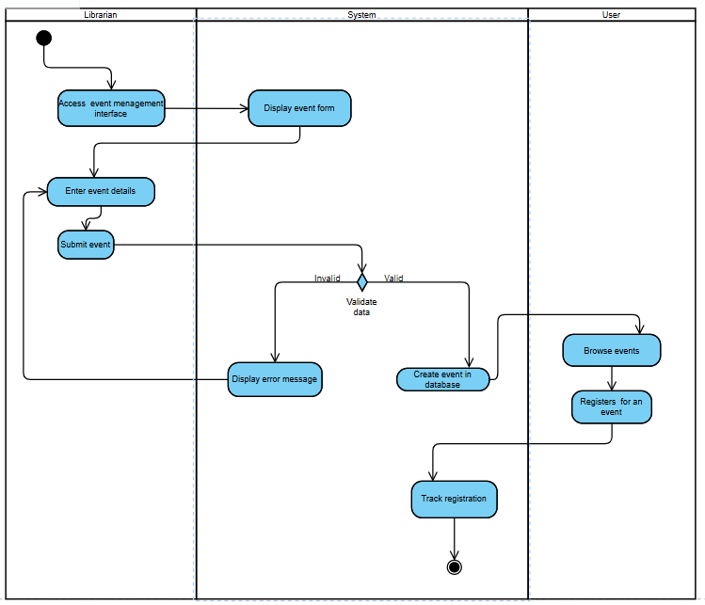

BR_LMS_13 — Manage Lost and Found Items
Activity diagram
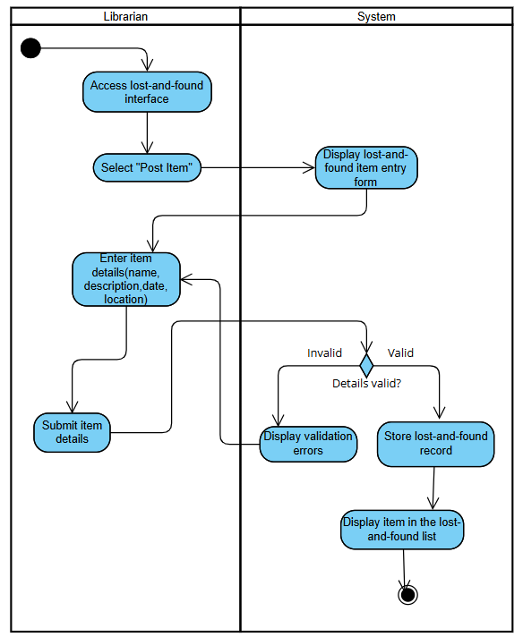

State diagram-Administrator
