CC_LMS_08 — User Registration
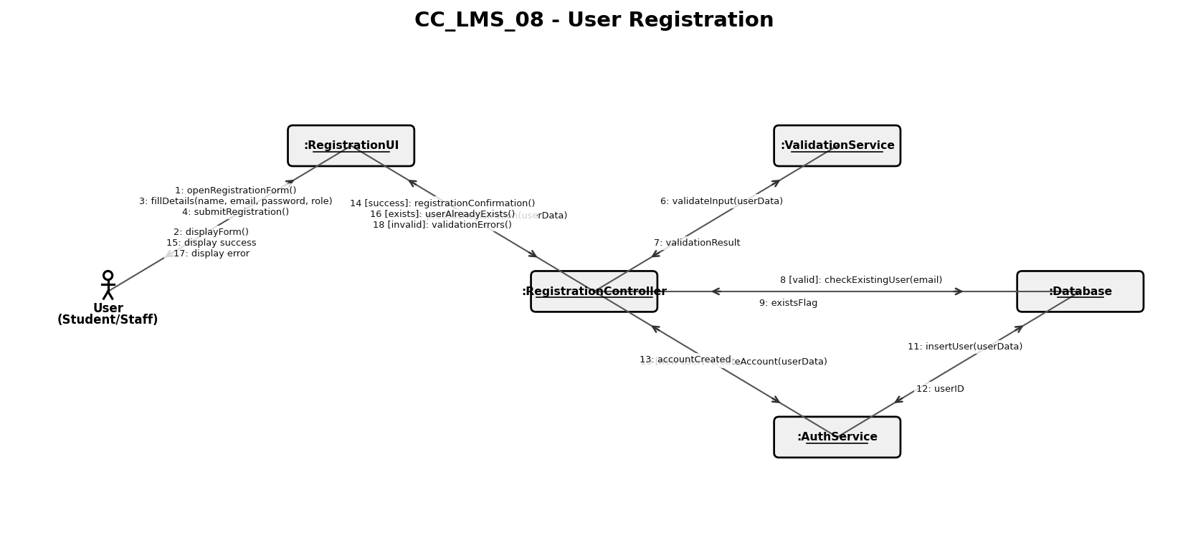

CC_LMS_09 — Administrator Account Management
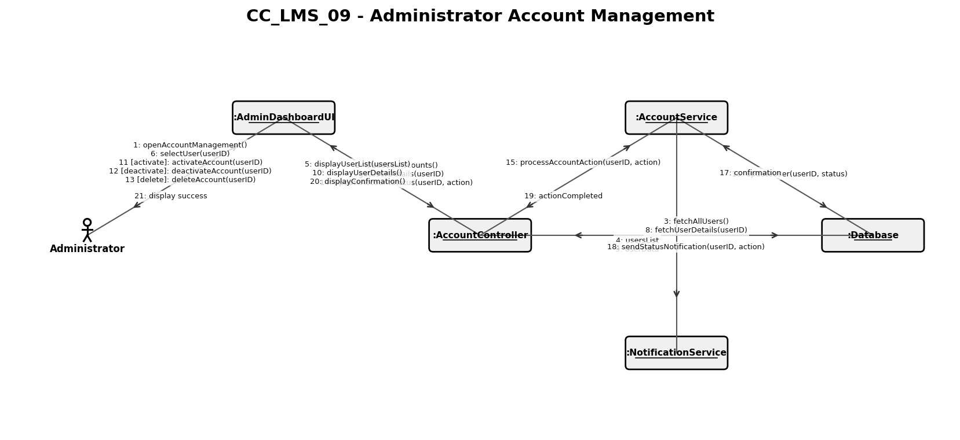

CC_LMS_10 — Manage User Profile
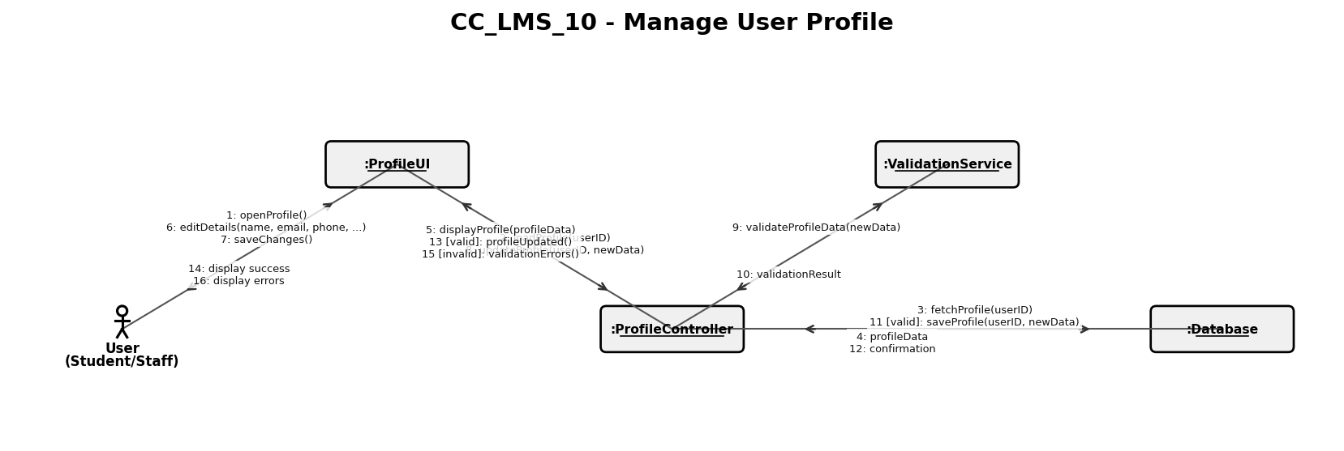

CC_LMS_11 — Track System Activity
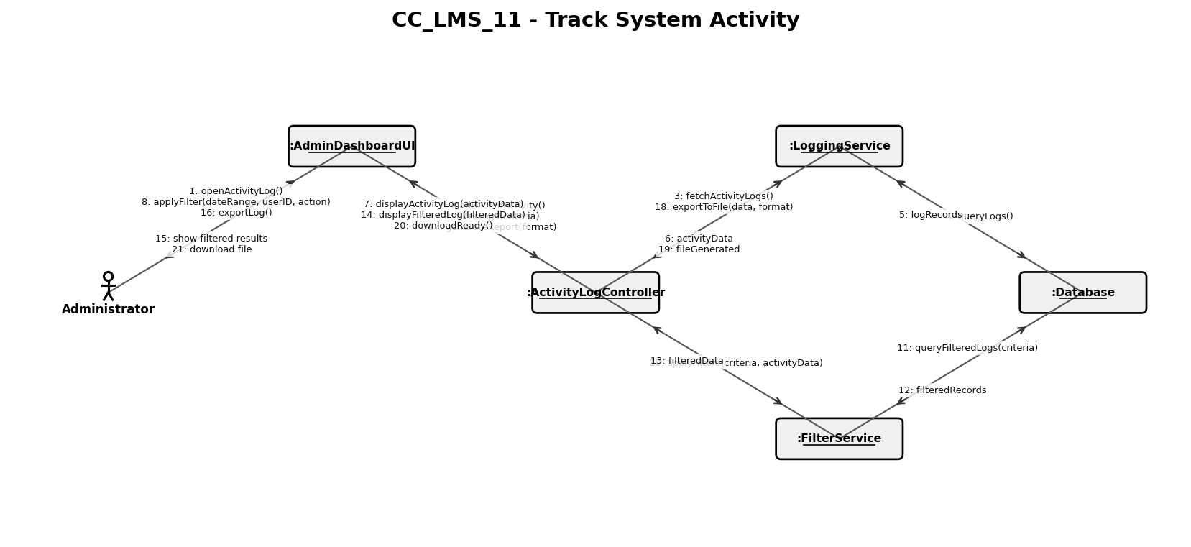

CC_LMS_12 — Library Event Management
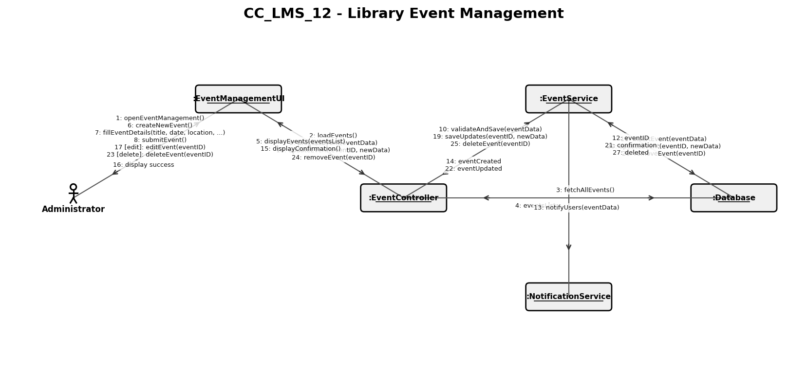

CC_LMS_13 — Manage Lost and Found Items
