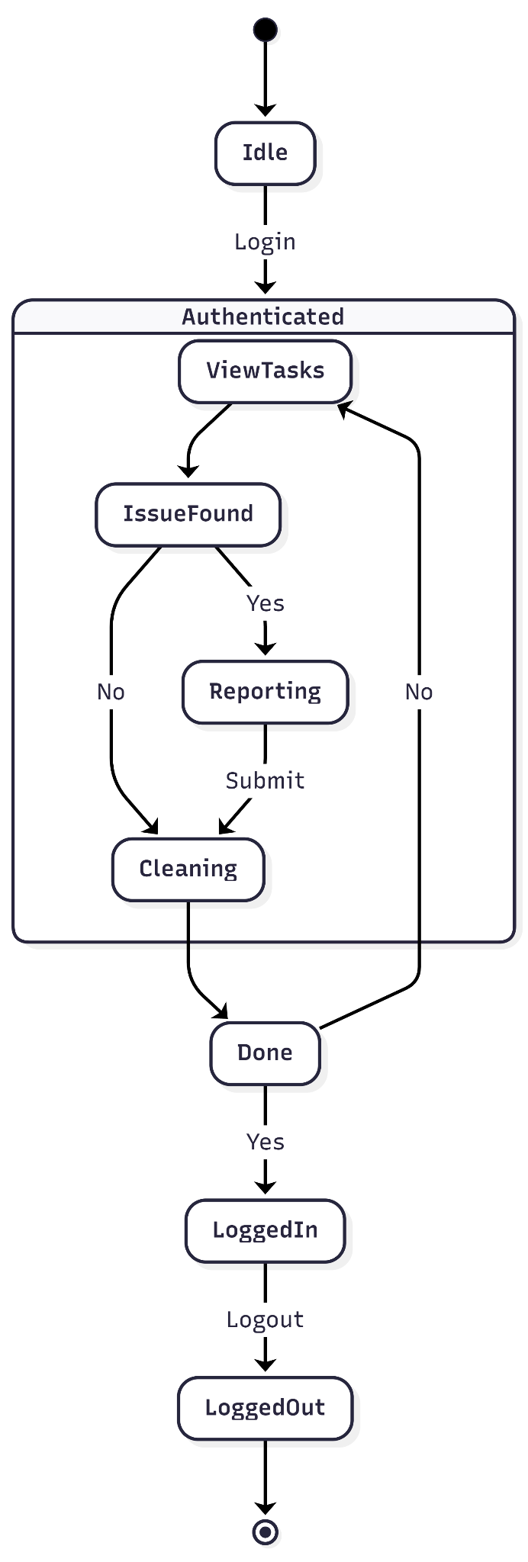
User State Diagram
Maintenance Staff

