BR_LMS_08- User Registration
Activity diagram
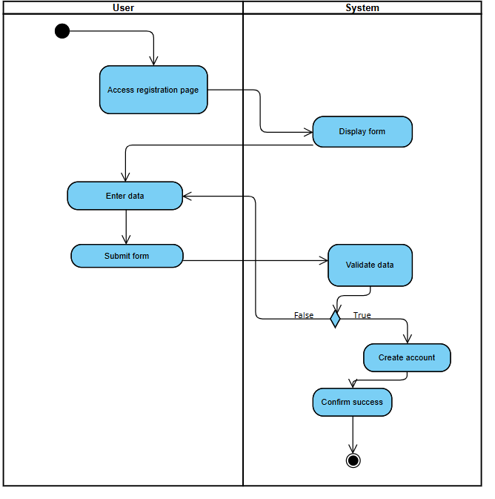

State diagram- BR_LMS_08- User Registration

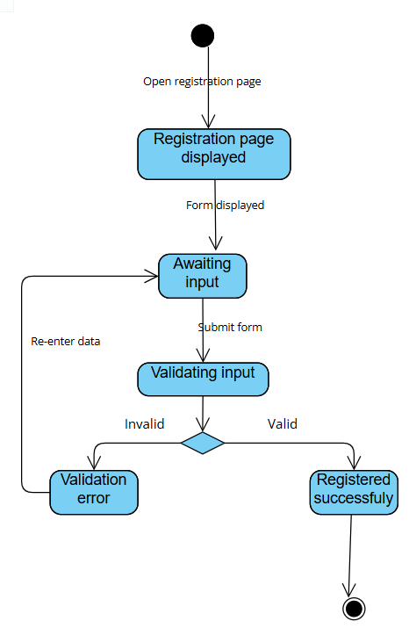

BR_LMS_09 – Administrator Account Management
Activity diagram
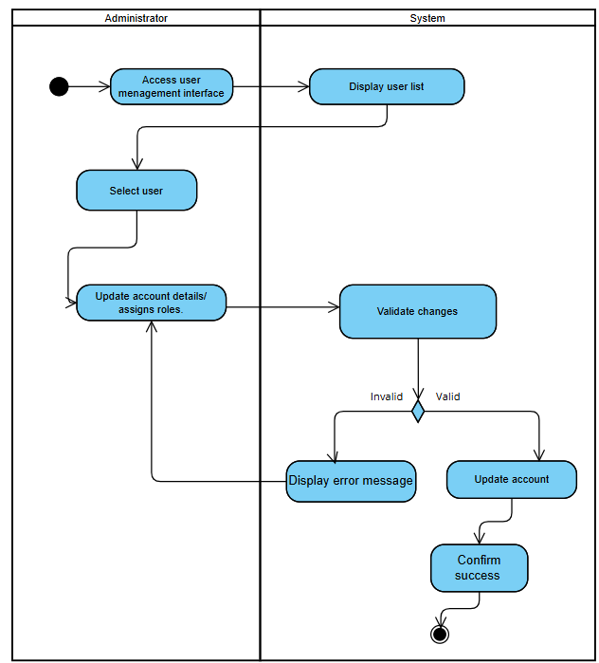

State diagram- BR_LMS_09 – Administrator Account Management

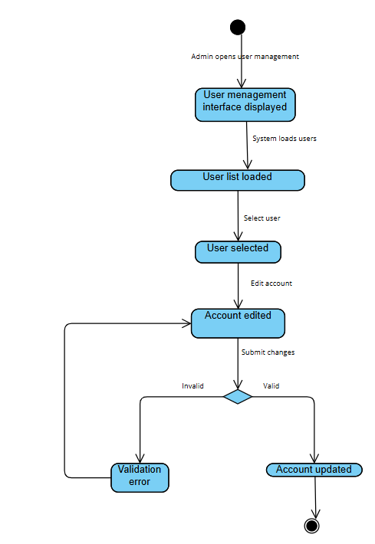

BR_LMS_10- Manage User Profile
Activity diagram
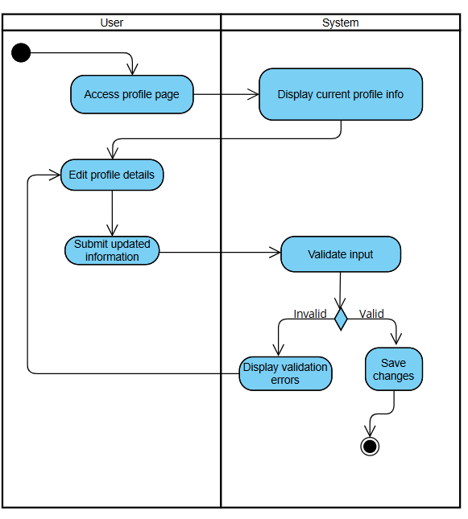

State diagram- BR_LMS_10- Manage User Profile

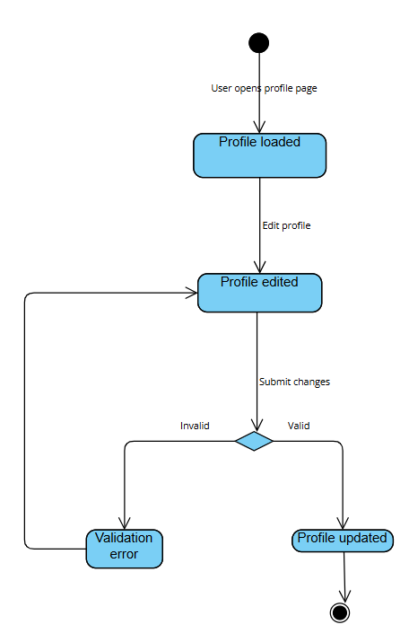

BR_LMS_11- Track User Activity
Activity diagram
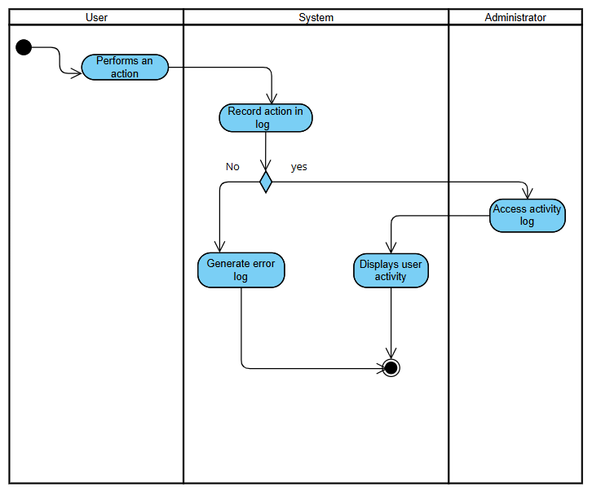

State diagram- BR_LMS_11- Track User Activity

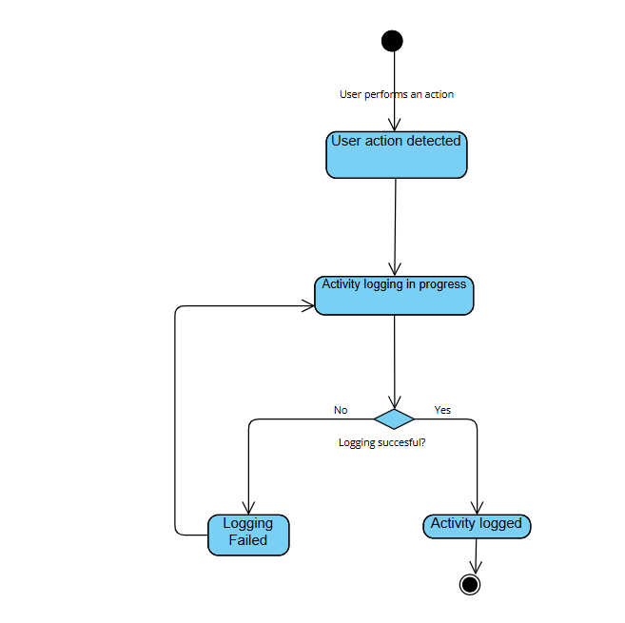

BR_LMS_12 – Library Event Management
Activity diagram
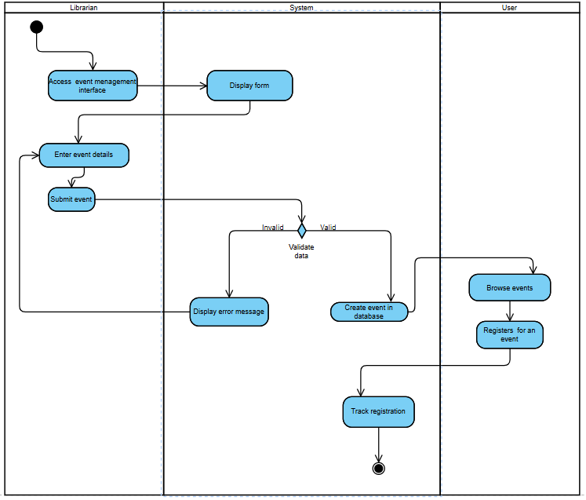

State diagram- BR_LMS_12 – Library Event Management

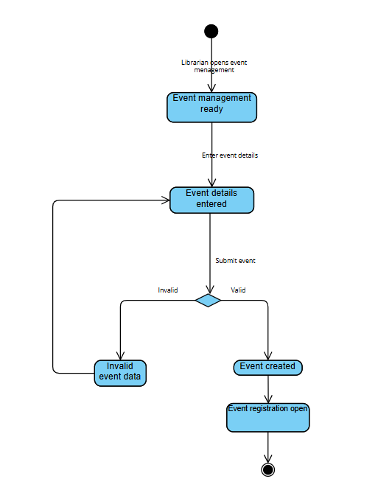

BR_LMS_13 – Overdue Fine Management
Activity diagram
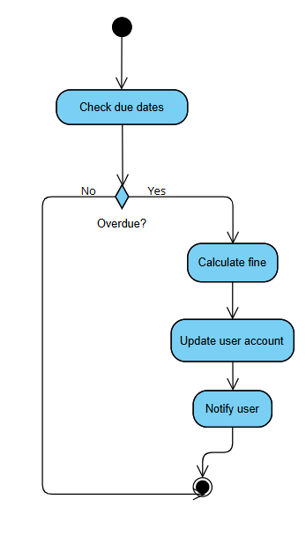

State diagram- BR_LMS_13 – Overdue Fine Management

