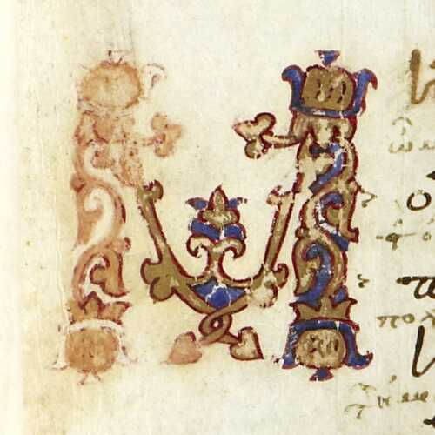

The first letter of the *Iliad*

# Same & Different

“identical” & “different”

“identity” & “difference”

**Identity** and **difference** depend on context.

## ¼ + ½

## ½ + ¼

## ¾

You have an intuitive understanding of “Scholarly Identity”.

## ½ + ¼ = ¾

And you know that it is *functionally determined*, and that this depends on *technology*…

## 1/2 + 1/4

## 2/4 + 1/4

## 0.25 + 0.5

## 0.01 + 0.10

Let’s level up. We are not only computerers but Humanists…

“a quarter and a half”

“a half and a quarter”

˘ ￣ ˘ ￣ ˘ ￣  
a quarter and a half  
  
(iambic trimeter)

˘ ￣ ˘ ˘ ￣ ￣  
a half and a quarter  
  
( an iamb, a phyrric, and a spondee?   
  
or an amphibrach and a baccius?)

## The Same or Different?

* “the son of Atreus, spear-loving Menelaos”
* “Menelaos, son of Atreus”

## The Same or Different?

“In 1815, M. Charles-François-Bienvenu Myriel was Bishop of D—— He was an old man of about seventy-five years of age; he had occupied the see of D—— since 806.”

“En 1815, M. Charles-François-Bienvenu Myriel était évêque de Digne. C’était un vieillard d’environ soixante-quinze ans; il occupait le siège de Digne depuis 1806.”

## The Same or Different?

* “…what role will you play? Will you coordinate?”
* “…what rôle will you play? Will you coördinate?”

## Use this template!

Build a presentation with:

pandoc -t revealjs markdown.md -s -o identity.html --metadata pagetitle=identity

The result will be identity.html.