

Blue Base

CLMS User manual

**Features:**

* Manage all contractor and employee salary details.
* Software works if network is connected otherwise data entry and reports generation won’t work.
* Easily generate payroll for current month with one click.
* And see all form b wage, form d, and wage slip reports in a single click.
* Efficiently calculate payroll deduction for contractors based on attendance.
* Contractors and employees data are securely saved and retrieved.
* Without admin login credential no one have rights to access this software.
* We can use this software anywhere any time with public URL.

**Comments:**

**Run Project:**

* npm start

**Terminate Project:**

* Ctrl+c

**Restart project:**

* ctrl+c (terminate project)
* npm start (Restart project)

**Run project forever:**

* npm I forever
* forever index.js

**Stop forever run**

* forever stop( Stop forever run)

**Login Activity:**



* This activity allows the user to login to the application with only a specific username fixed permanently.
* Before login please check your system is connected to network.

**Dashboard:**

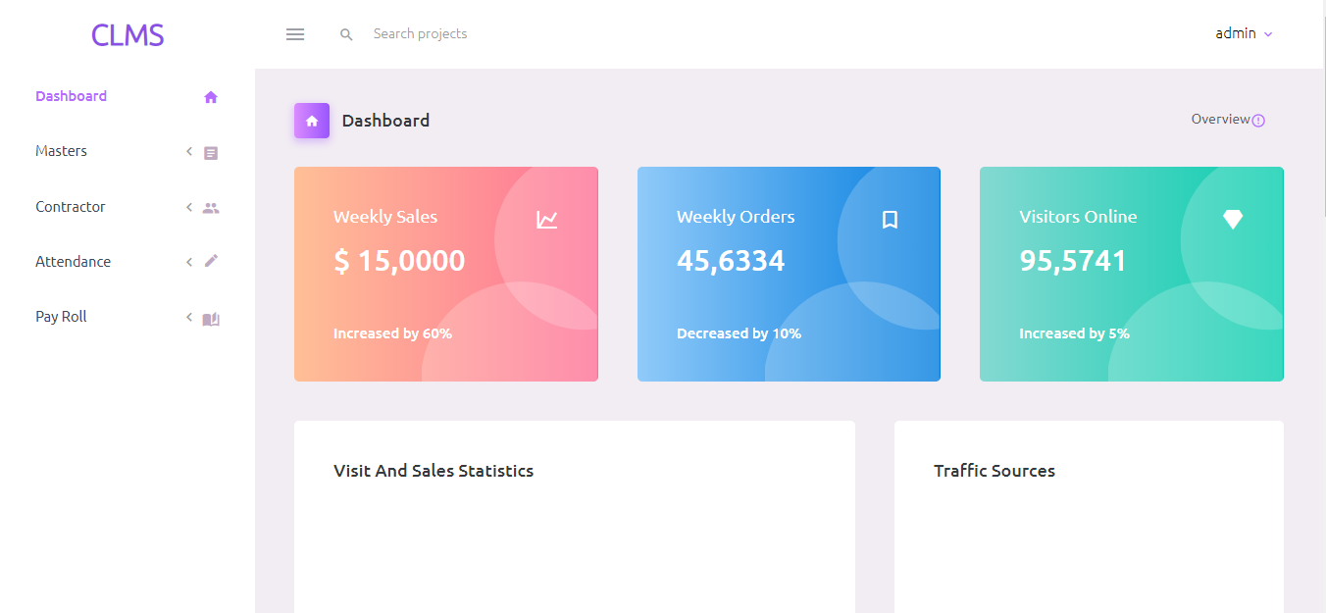

* The dashboard can show overall contractors and employee’s details statistically.

**Header:**



**Footer:**



**Menus:**

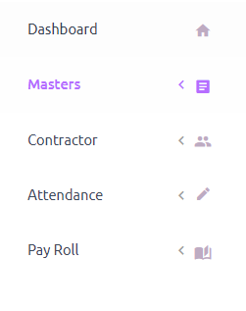

* The Menus are used to navigate across the software.
* You can easily navigate to particular master using this menu bar.

**1. Masters:**

**1.1 Engineer:**

**1.1 .1 Add Engineer:**

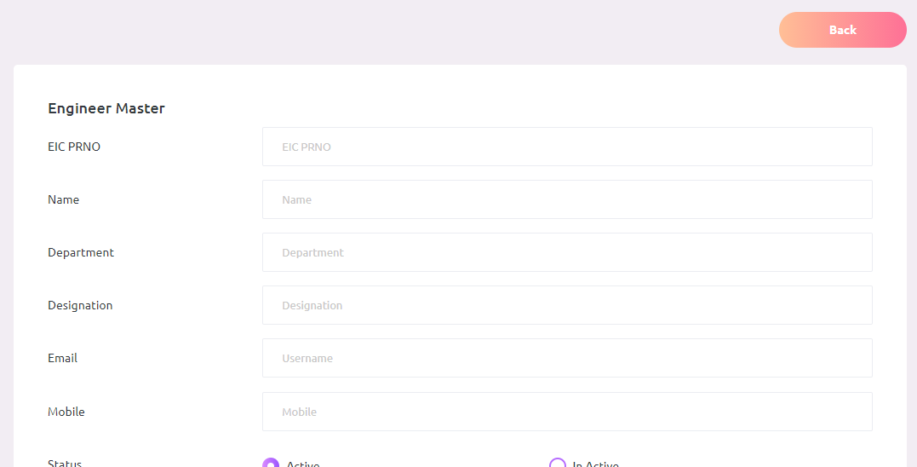

* This form is used to add new engineers.
* Using this form we can add engineer details like name, department, designation, email and mobile etc.
* And also we can change the status of particular engineer (Active and Inactive).

**1.1.2 Engineer View & Edit**

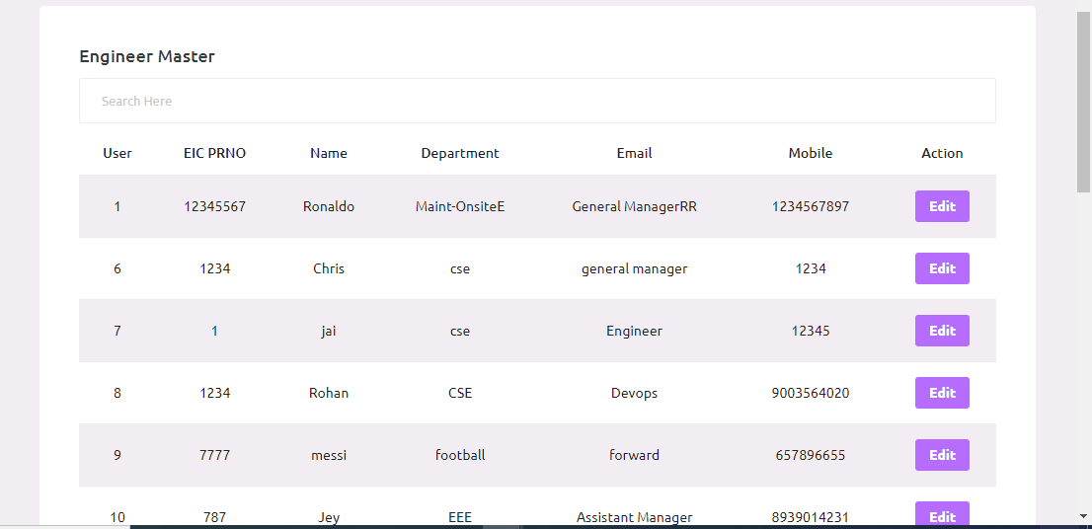

* Here we can see how many engineers are there.
* Search filter is used to search particular engineers. And using the edit button we can edit engineer details.

**1.1.3 Engineer Bulk Upload**

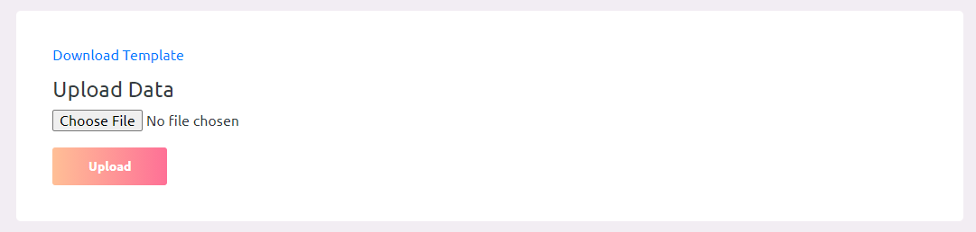

* The Bulk Upload is used to insert multiple data’s.
* We can upload min 15000 to max 20000 in a time.

**1.2 Shift:**

**1.2.1 Shift Add:**

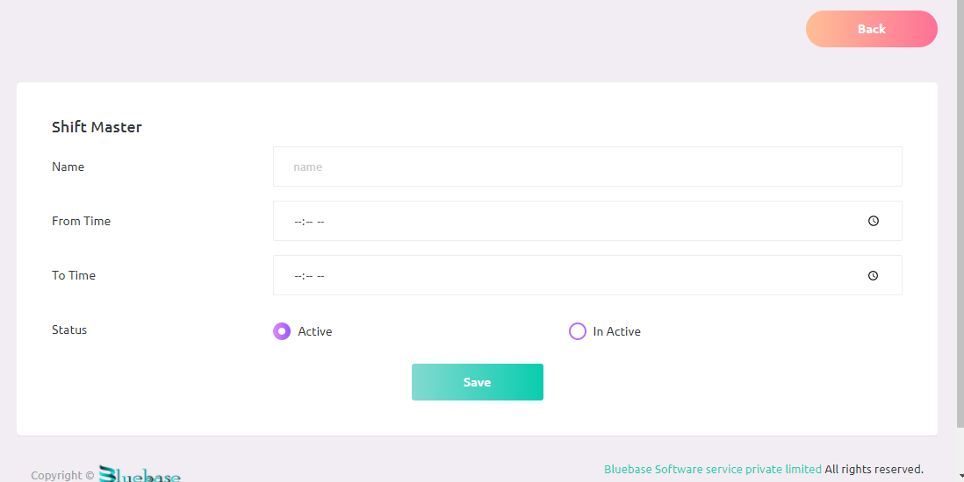

* This form is used to add new Shift time.
* Using this form we can add shift details like name, from time and to time etc.
* And also we can change the status of particular shift (Active and Inactive).

**1.2.2 Shift View & Edit:**

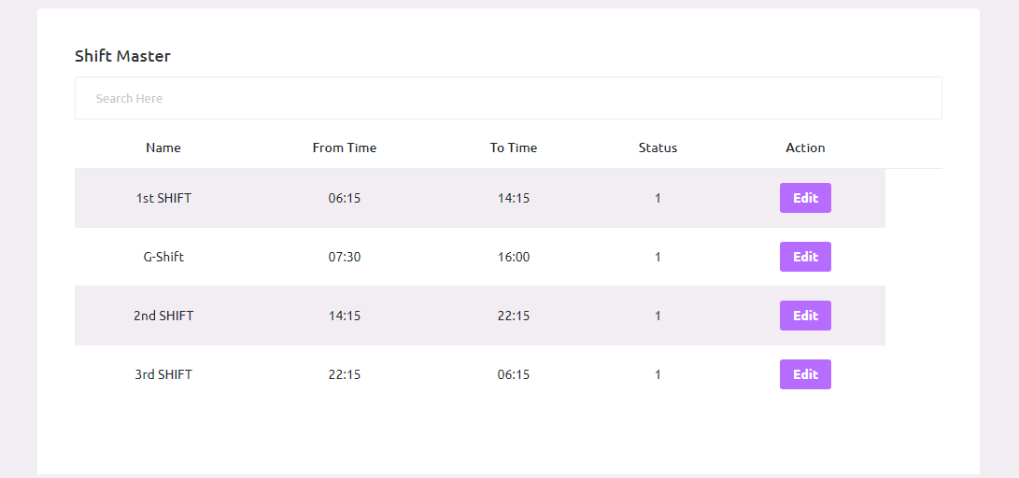

* Here we can see how many Shifts are there.
* Search filter is used to search particular Sift. And using the edit button we can edit shift details.

**1.2.3 Shift Bulk Upload:**



* The Bulk Upload is used to insert multiple data’s.
* We can upload min 15000 to max 20000 in a time.

**1.3 Gate:**

**1.3.1 Gate Add:**

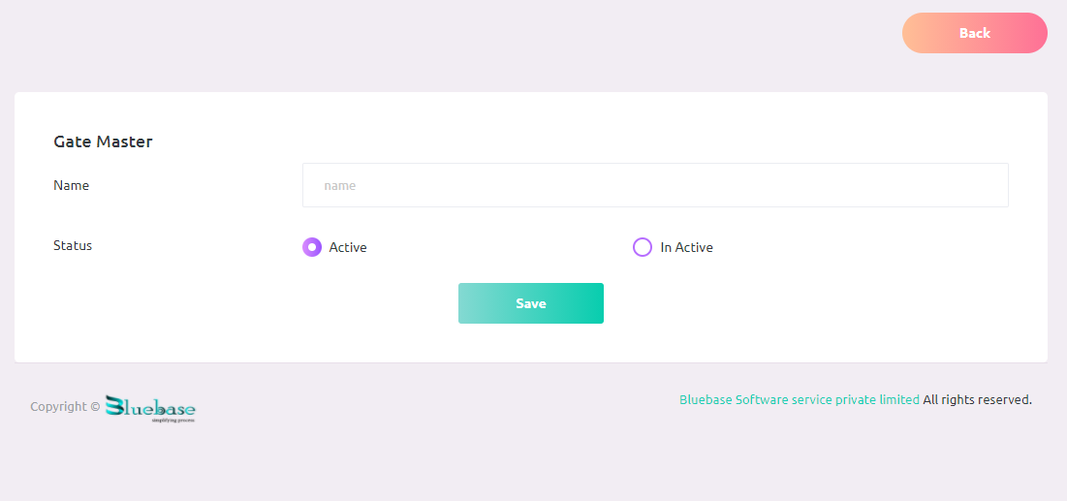

* This form is used to add new gate.
* Using this form we can add gate name and status.
* And also we can change the status of particular shift (Active and Inactive).

**1.3.2 Gate View & Edit:**

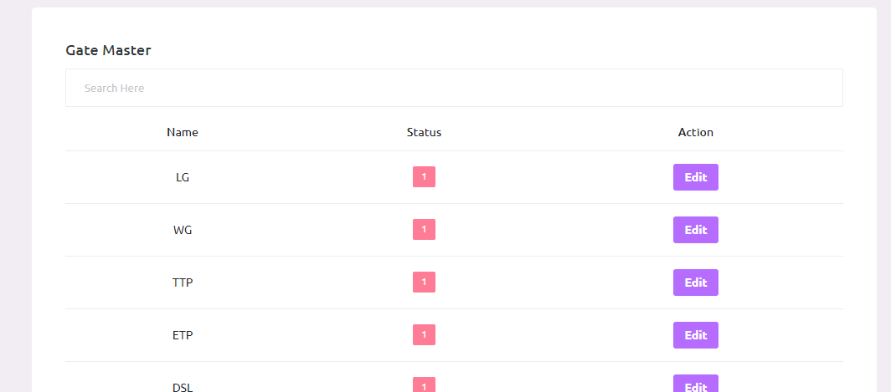

* Here we can see how many Gates are there.
* Search filter is used to search particular gate details. And using the edit button we can edit gate details.

**1.3.3** **Shift Bulk Upload:**

* The Bulk Upload is used to insert multiple data’s.
* We can upload min 15000 to max 20000 in a time.

**2. Contractor Master:**

**2.1 Contractor:**

**2.1.1 Contractor Add:**

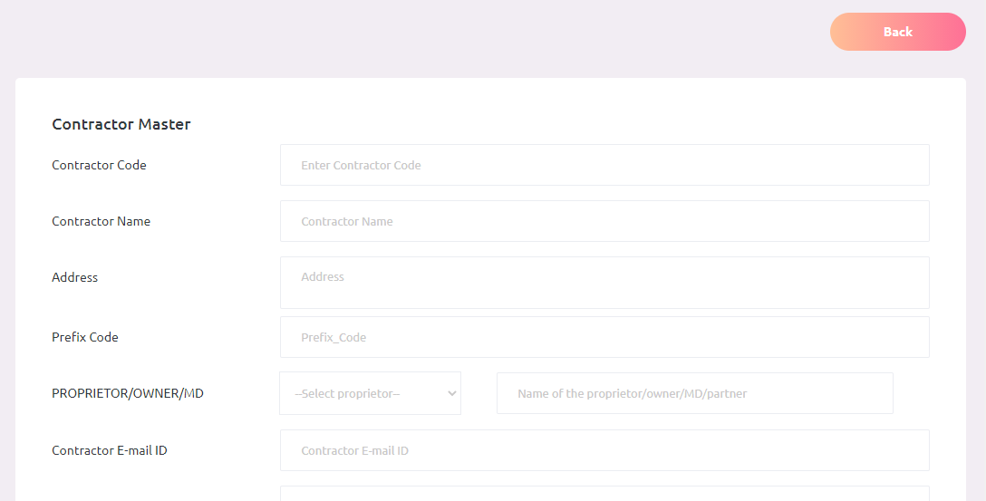

* This form is used to add new Contractor.
* Using this form we can add Contractor details like code, name, address, prefix code and status.
* And also we can change the status of particular shift (Active and Inactive).

**2.1.2 Contractor view & edit:**

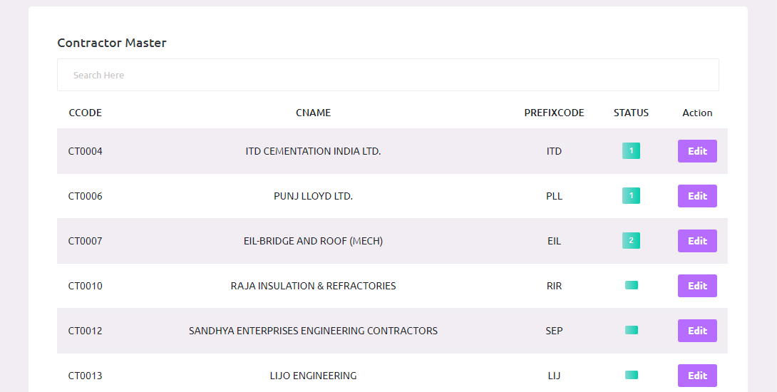

* Here we can see how many contractors are there.
* Search filter is used to search particular contractor details. And using the edit button we can edit contractor details.

**2.1.3 Contractor Bulk Upload:**



* The Bulk Upload is used to insert multiple data’s.
* We can upload min 15000 to max 20000 in a time.

**2.2 Work order:**

**2.2.1 Work order Add:**

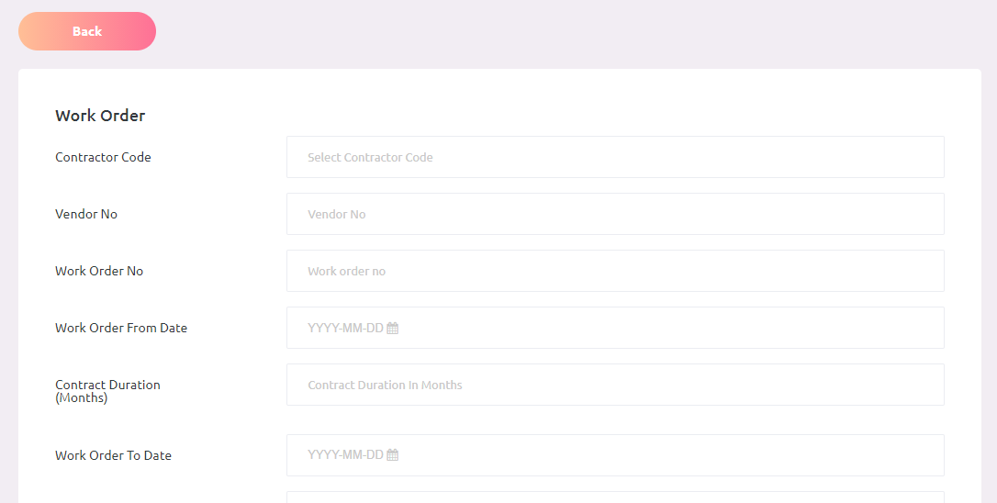

* This form is used to add new Work Order.
* Using this form we can add work order details like code, name, date and status etc.
* And also we can change the status of particular shift (Active and Inactive).

**2.2.2 Work order View & Edit:**

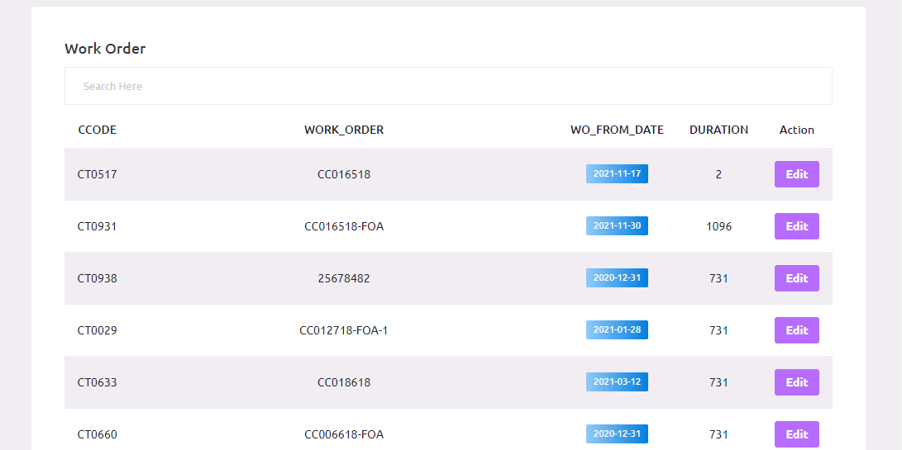

* Here we can see how many work orders are there.
* Search filter is used to search particular work order details. And using the edit button we can edit work order details.

**2.2.3** **Work order bulk upload:**



* The Bulk Upload is used to insert multiple data’s.
* We can upload min 15000 to max 20000 in a time.

**2.3 Employee:**

**3.3.1 Employee Add:**

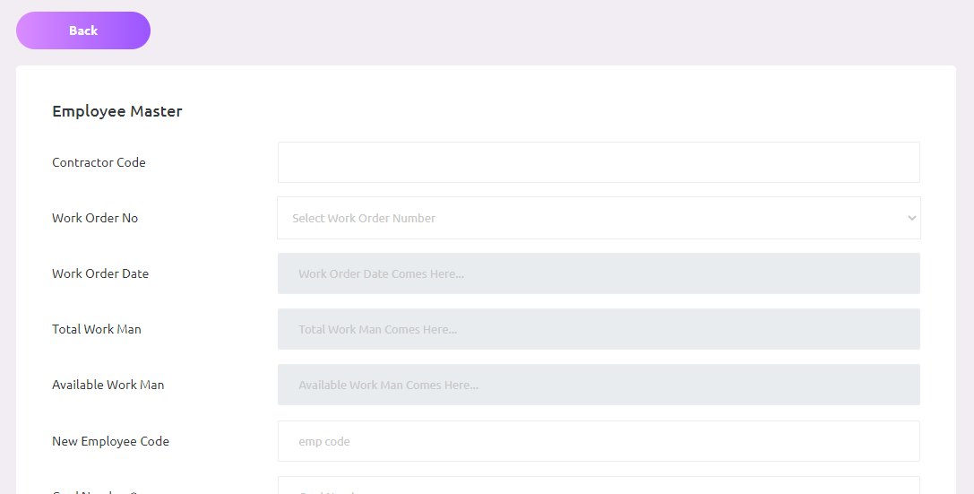

* This form is used to add new Employee.
* Using this form we can add employee details like code, name, address and status etc.
* And also we can change the status of particular employee (Active and Inactive).

**2.3.2 Employee View & Edit:**

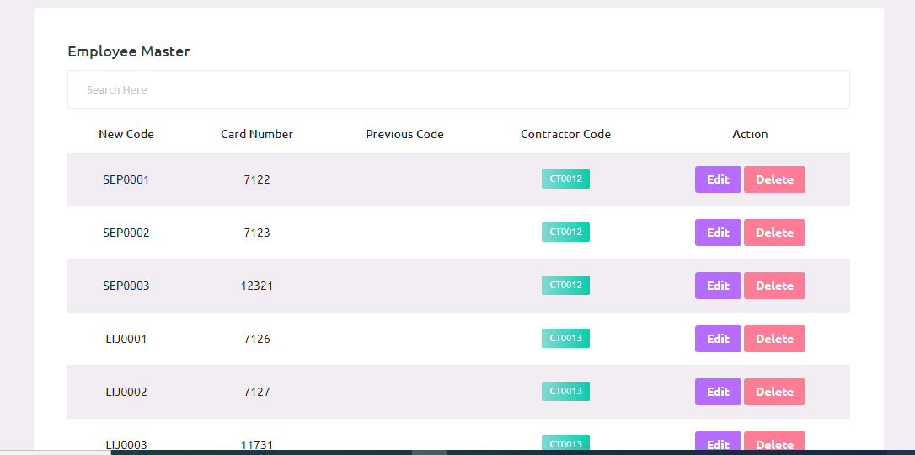

* Here we can see how many Employees are there.
* Search filter is used to search particular employee details. And using the edit button we can edit employee details.

**2.3.3 Employee Bulk Upload:**



* The Bulk Upload is used to insert multiple data’s.
* We can upload min 15000 to max 20000 in a time.

**2.4 Transfer:**

**2.4.1 New transfer:**

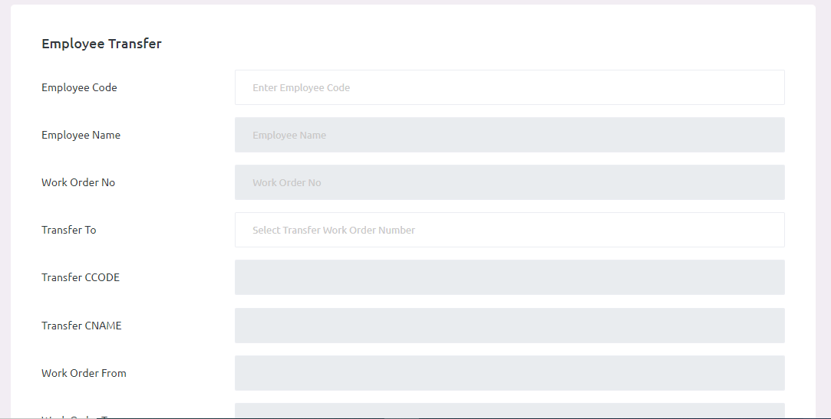

* This form is used to transfer new Employee.
* Using this form we can transfer employee to another contractor.

**2.4.2 Transfer View:**

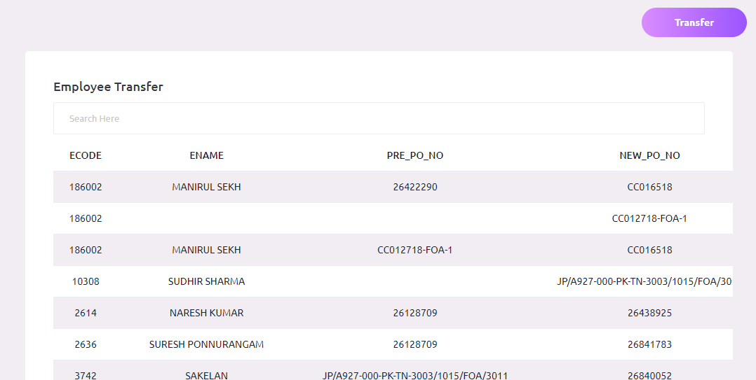

* Here we can see all transfer details.
* Search filter is used to search particular transfer details.

**3. Attendance:**

**3.1 Attendance Summary Report:**

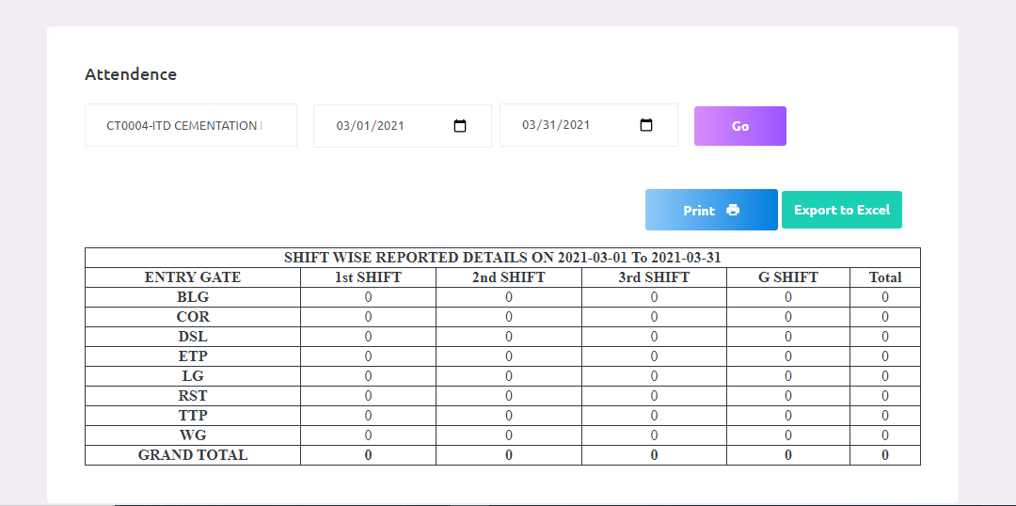

* The summary report used to see all shift wise attendance report.
* Here we can see particular contractor attendance and all contractor attendance Reports.
* Also we can download this report as excel format and pdf format using print and excel button.

**3.2 Attendance In-Out Report:**

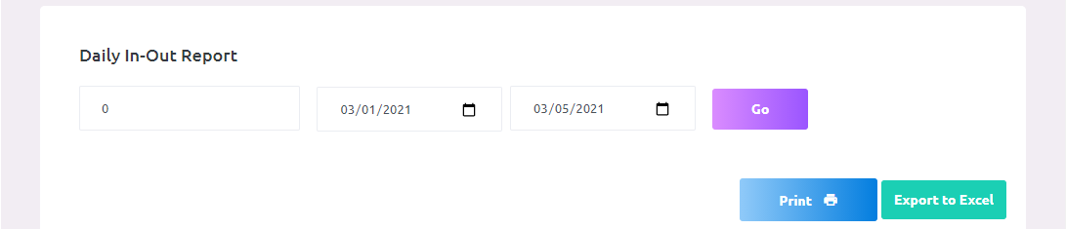

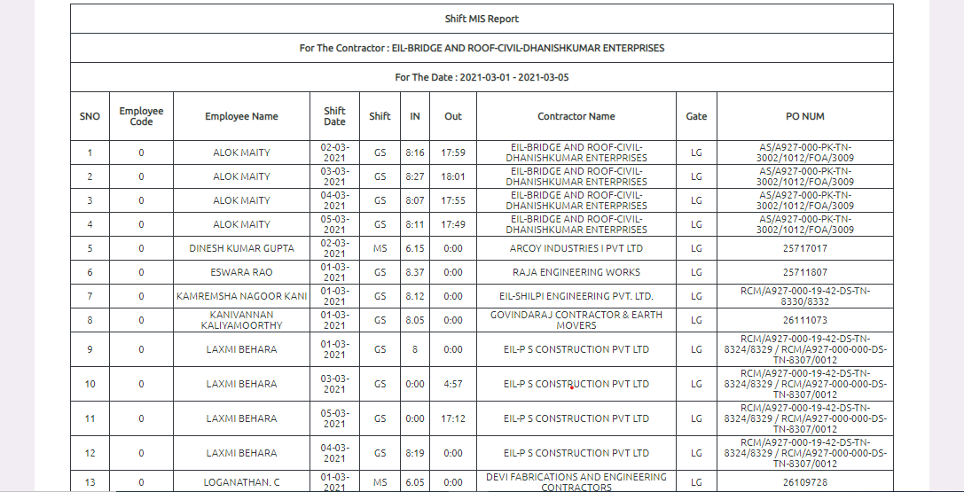

* The attendance in out report used to see all employee attendance details.
* Here we can see contractor wise employee attendance and all employee attendance report.
* Also we can download this report as excel format and pdf format using print and excel button.

**3.3 attendance MIS Report:**

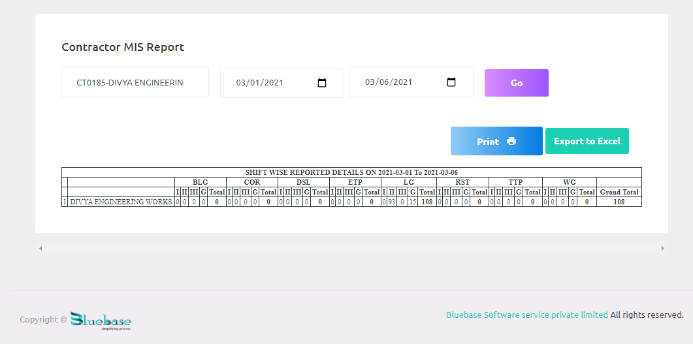

* The MIS report used to see all Contractor attendance details both shift and gate wise.
* Here we can see contractor wise attendance and all contractor attendance report.
* Also we can download this report as excel format and pdf format using print and excel button.

**4. Payroll:**

**4.1 Payroll Generation:**



* The payroll generation is used to generate current month payroll.
* Based on this details we can generate remaining reports.
* If you do any mistake in payroll generation using payroll delete we can delete generated payroll details and insert new payroll details.

**4.2 Wage Slip 1:**

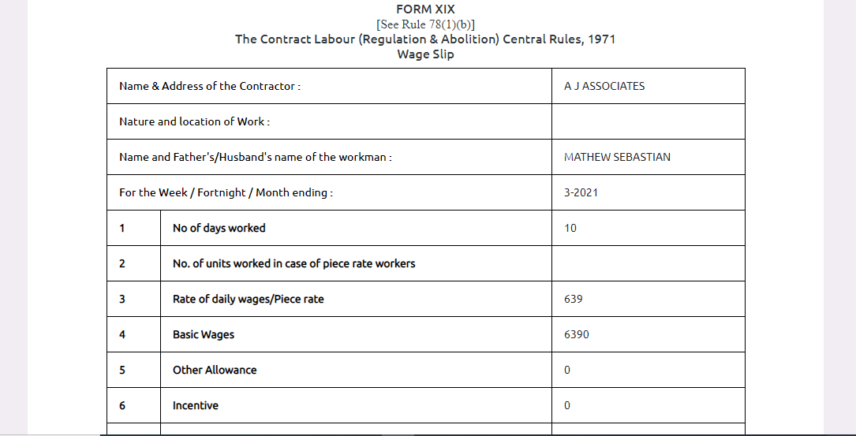

* The wage slip one is used to see particular contractor wage report based on attendance.
* Here we can easily find out number of working days, esi, pf and other wage details.
* Also we can download this report as excel format and pdf format using print and excel button.

**4.3 Wage Slip 2:**

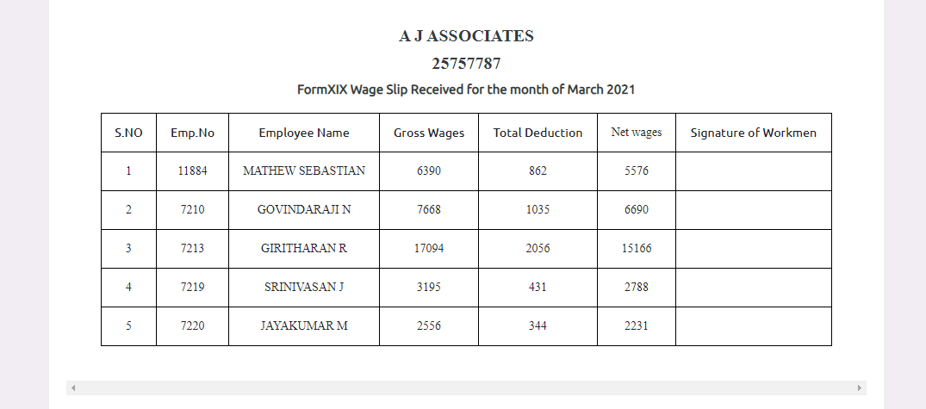

* The wage slip two is used to see employee’s gross wages, total deduction and net wages.
* Here we can see contractor wise employee’s salary reports.
* Also we can download this report as excel format and pdf format using print and excel button.

**4.4 From B Wage Report:**

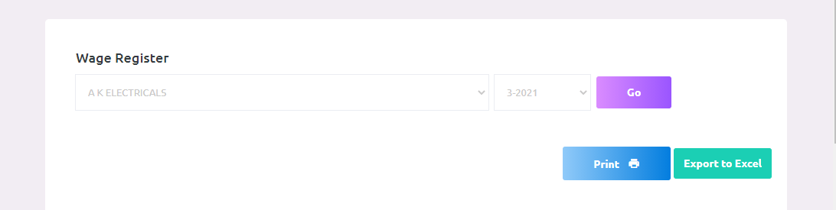

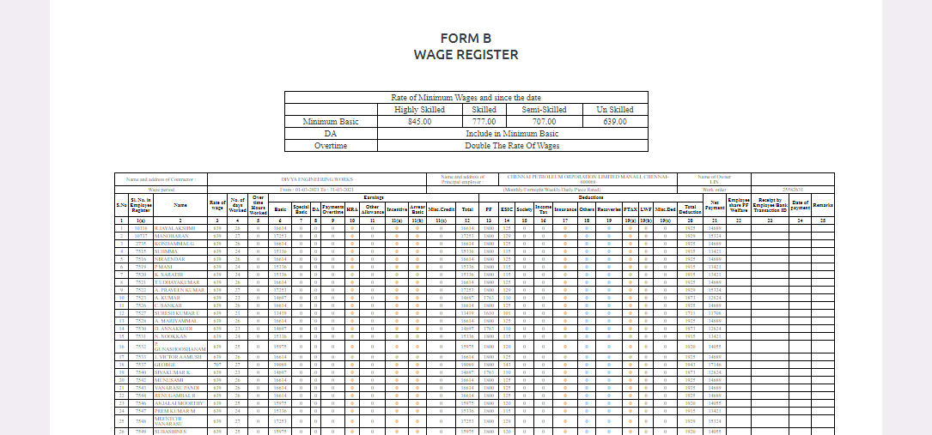

* Here we can see contractor form b wage report. This report includes all deduction like pf, esi, leave and based on this deduction the net payment automatically generate.
* So we can easily identify if any miss calculation happened.
* It reduce extra payment for contractor and all salary calculations are done by system itself, So there is no chance for any miss calculation and extra pay happened.
* Also we can download this report as excel format and pdf format using print and excel button.

**4.5 Form D Attendance Report:**



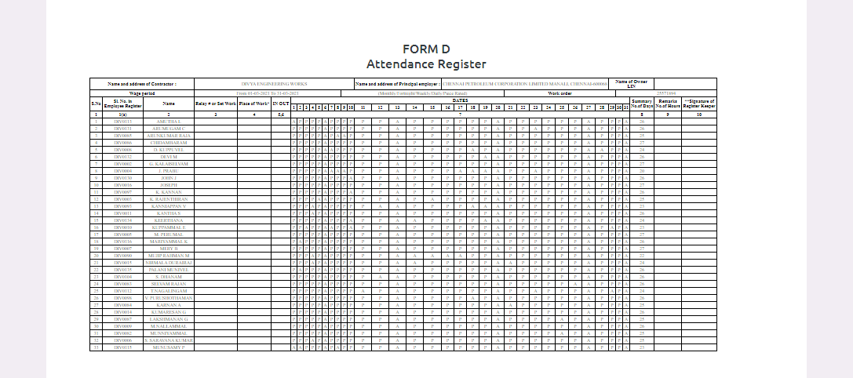

* Here we can see contractor form D Attendance report. This report includes contractor wise employee’s attendance details.
* So we can easily identify all employee’s attendance details that is number of working days.
* It is also used for salary deduction. Based on the attendance the pay slip will be generate.
* Also we can download this report as excel format and pdf format using print and excel button.

**4.6 Deduction:**



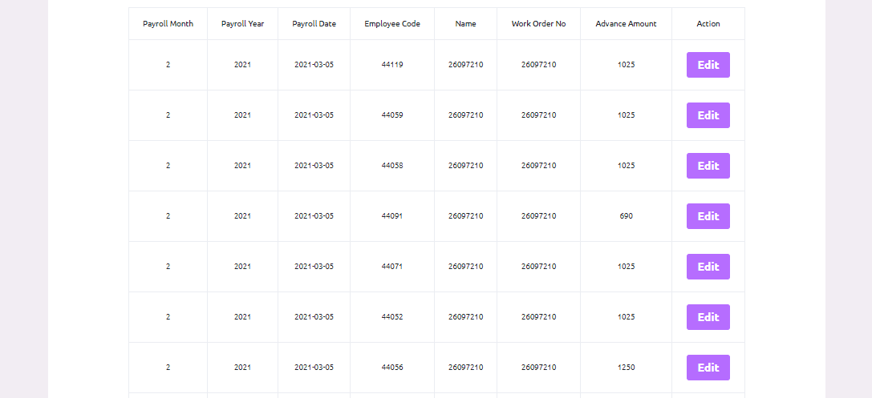

* The payroll deduction table shows the all deduction amount for employees.
* We can see how much advance amount particular employee get and how much amount need to deduct from his salary these details are show in this table.
* The edit option is used If any mistake happened in this salary deduction. Only the admin have the rights to do it.
* Also we can download this report as excel format and pdf format using print and excel button.

**4.7 Payroll Close:**



* Here we can close the generated payroll for current month.
* After payroll close the table will be freeze and here after we can’t generate payroll for that month.