**Implementation Details on Word Embeddings :**

**WordEmbeddings.py** contains the simpler code that learns word embeddings from the imdb dataset contained within keras.

**WordEmbeddingsPretrained.py** is code that reads in raw imdb data vectorizes/tokenizes words before embedding. This program can be run with both pretrained embedding and learning task specific embeddings mode.

Screen- shot below is from when it is run using pretrained glove embeddings – note the non-trainable params value

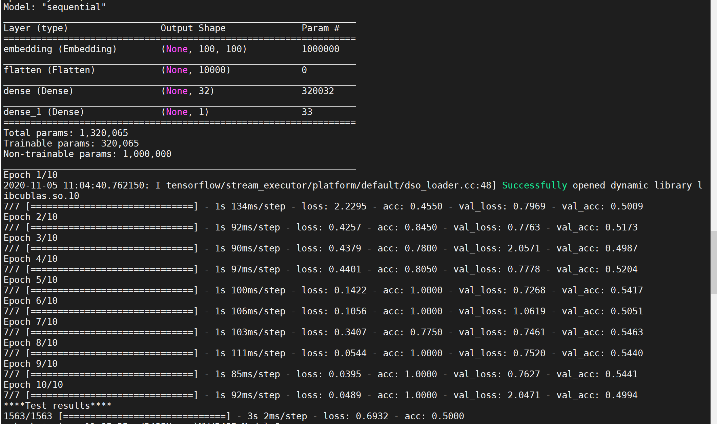

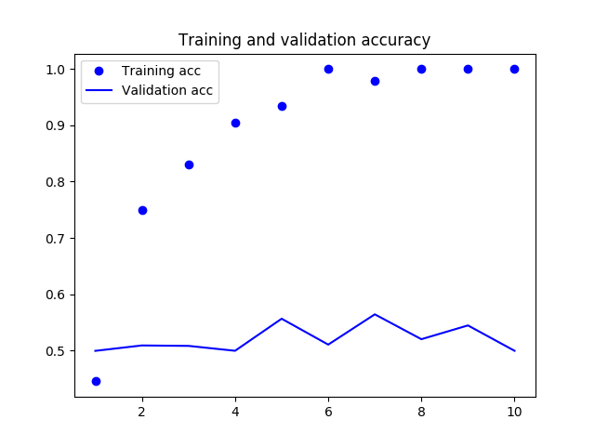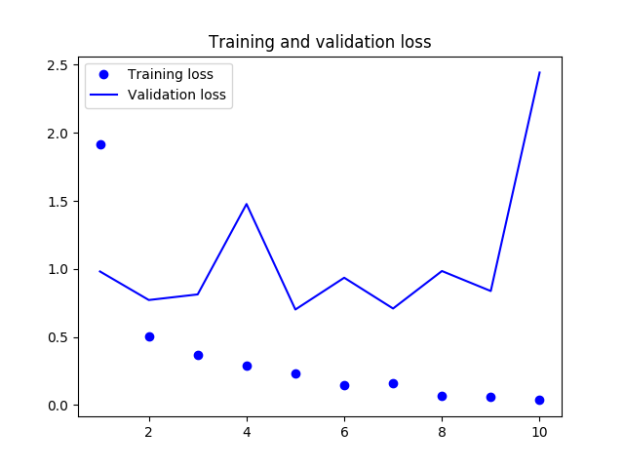

Graphs for train vs validation loss and accuracy on pretrained embeddings

Screen-shot below is from when same program is run without the pretrained portion – note non-trainable params is 0

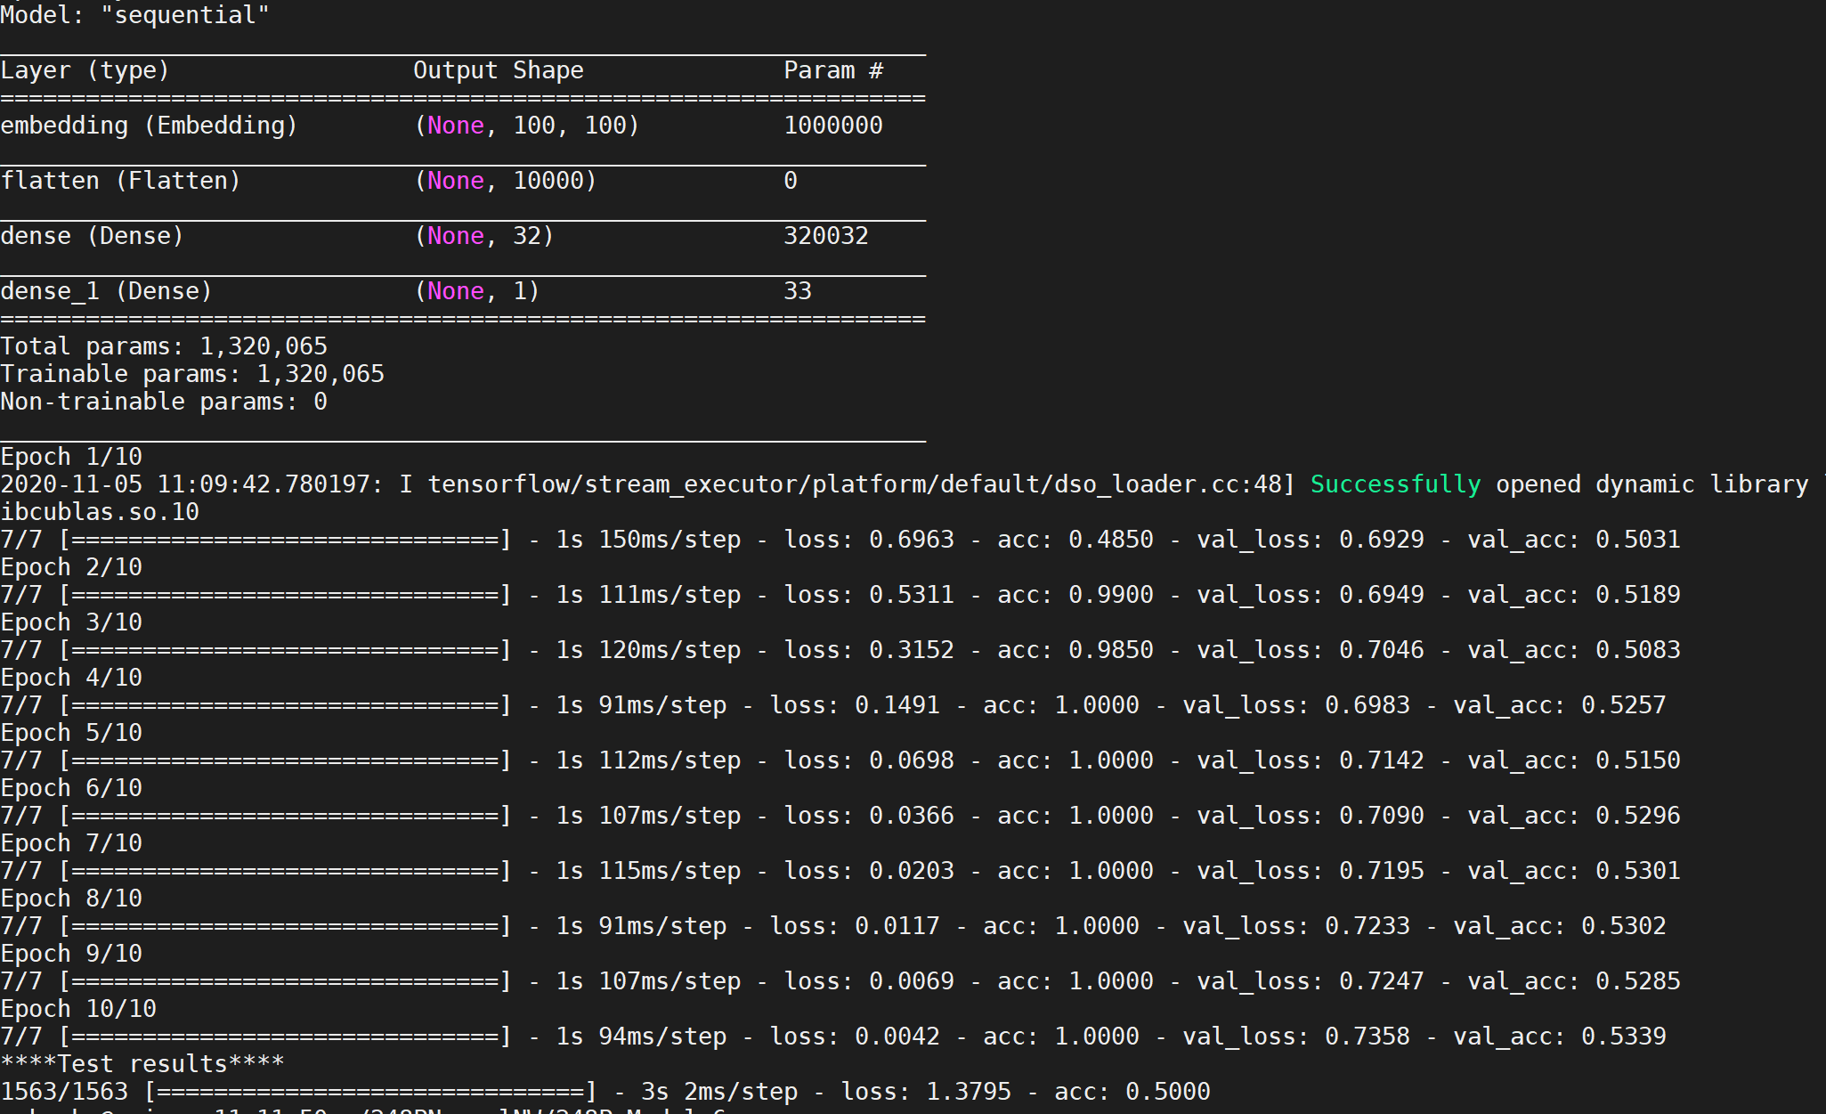

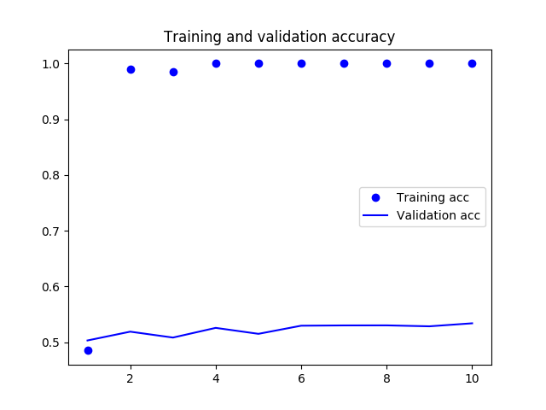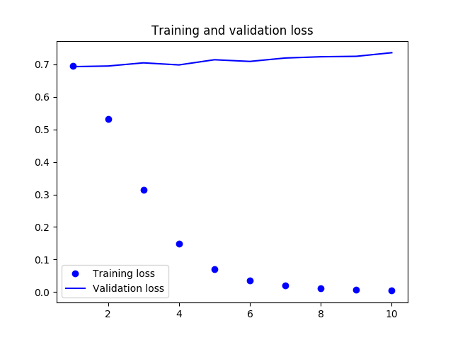

Graphs for train vs validation loss and accuracy on run without pre-trained embeddings