**Project Code:**

########################################

#perform hold-out cross validation

########################################

###getwd() will give current working directory###

###read csv file###

filename = paste("~/vyshya/IUPUI/mybooks/fall2015/intelligent_systems/prject/data/training/","training.csv",sep="")

print(filename)

complete_data <- read.csv(filename, stringsAsFactors=F)

str(complete_data)

#install foreach.zip and iterators.zip.Install these and execute:

library(foreach)

library(entropy)

images <- foreach(i = complete_data$Image, .combine=rbind) %dopar% {

as.integer(unlist(strsplit(i, " ")))

}

head(images)

#####get 80% of the data using permutation#####

set.seed(0)

perm <- sample(nrow(complete_data), nrow(complete_data)*0.8)

#####split into 80% training data and 20% test data#####

training_data <- complete_data[perm,]

test_data <- complete_data[-perm,]

training_images <- images[perm,]

test_images <- images[-perm,]

head(training_images)

head(test_images)

###########################################################

#perform histogram stretching for training images

###########################################################

l = 0

u = 255

stretched_training_images = matrix(0,5639,9216)

#row index

i=1

while(i<=5639){

a = 255

b = 0

j=1

while(j<=9216){

p = training_images[i,j]

if(isTRUE(p<a)){a=p}

if(isTRUE(p>b)){b=p}

j = j+1

}

a = a * 0.05

b = b * 0.95

firstPart = (u-l)/(b-a)

j = 1

while(j<=9216){

secondPart = training_images[i,j] - a

stretched_training_images[i,j] = floor((firstPart*secondPart) + l)

j = j + 1

}

i = i+1

}

head(stretched_training_images)

dim(stretched_training_images)

###########################################################

#perform histogram stretching for test images

###########################################################

l = 0

u = 255

stretched_test_images = matrix(0,1410,9216)

#row index

i=1

while(i<=1410){

a = 255

b = 0

j=1

while(j<=9216){

p = test_images[i,j]

if(isTRUE(p<a)){a=p}

if(isTRUE(p>b)){b=p}

j = j+1

}

a = a * 0.05

b = b * 0.95

firstPart = (u-l)/(b-a)

j = 1

while(j<=9216){

secondPart = test_images[i,j] - a

stretched_test_images[i,j] = floor((firstPart*secondPart) + l)

j = j + 1

}

i = i+1

}

head(stretched_test_images)

dim(stretched_test_images)

#####################################################

#display normal and stretched training image

#####################################################

#normal

im <- matrix(data=rev(training_images[1,]), nrow=96, ncol=96)

image(1:96, 1:96, im, col=gray((0:255)/255))

#stretched

im <- matrix(data=rev(stretched_training_images[1,]), nrow=96, ncol=96)

image(1:96, 1:96, im, col=gray((0:255)/255))

#####################################################

#PCA

#####################################################

pca_train<-prcomp(stretched_training_images, center = TRUE,scale. = TRUE)

restored_matrix_train <- pca_train$x[,1:125] %*% t(pca_train$rotation[,1:125])

#Display PCA Image

rst <- matrix(data=rev(restored_matrix_train[1,]), nrow=96, ncol=96)

image(1:96, 1:96, rst, col=gray((0:255)/255))

#######################################################

#Mean Patch Search

#######################################################

################################Left Eye Center###############################################

################################################################

#Determination of patch_size and mean_patch for left eye center

################################################################

coord_left_eye <- "left_eye_center"

patch_size <- 10

coord_lefteyecenter_x <- paste(coord_left_eye, "x", sep="_")

coord_lefteyecenter_y <- paste(coord_left_eye, "y", sep="_")

patches <- foreach (i = 1:nrow(training_data), .combine=rbind) %dopar% {

if(i<=125){

temp_matrix <- matrix(data = restored_matrix_train[i,], nrow=96, ncol=96)

x <- training_data[i, coord_lefteyecenter_x]

y <- training_data[i, coord_lefteyecenter_y]

pix_left <- (x-patch_size)

pix_right <- (x+patch_size)

pix_bottom <- (y-patch_size)

pix_top <- (y+patch_size)

if ( (!is.na(x)) && (!is.na(y)) && (pix_left>=1) && (pix_right<=96) && (pix_bottom>=1) && (pix_top<=96) )

{

as.vector(temp_matrix[pix_left:pix_right, pix_bottom:pix_top])

}

else

{

NULL

}

}

}

mean.patch.lefteyecenter <- matrix(data = colMeans(patches), nrow=2*patch_size+1, ncol=2*patch_size+1)

###########################################################

#Plot and display the mean patch image of left eye

###########################################################

image(1:21, 1:21, mean.patch.lefteyecenter[21:1,21:1], col=gray((0:255)/255))

###########################################################

#Search_size determination for left eye center

###########################################################

mean.patchInput.data = training_data[1:125,]

dim(mean.patchInput.data)

output <- foreach(k =1:5, .combine=rbind) %do%{

search_size <- k

mean_lefteyecenter_x <- mean(mean.patchInput.data[, coord_lefteyecenter_x], na.rm=T)

mean_lefteyecenter_y <- mean(mean.patchInput.data[, coord_lefteyecenter_y], na.rm=T)

test.pix.left <- as.integer(mean_lefteyecenter_x)-search_size

test.pix.right <- as.integer(mean_lefteyecenter_x)+search_size

test.pix.bottom <- as.integer(mean_lefteyecenter_y)-search_size

test.pix.top <- as.integer(mean_lefteyecenter_y)+search_size

candidate_pixels_lefteyecenter <- expand.grid(x = test.pix.left:test.pix.right, y = test.pix.bottom:test.pix.top)

#################################################

#Correlation check with a given test image

#################################################

test_image_1 <- matrix(data = test_images[1,], nrow=96, ncol=96)

correlation_values_lefteyecenter <- foreach(j = 1:nrow(candidate_pixels_lefteyecenter), .combine=rbind) %dopar% {

x <- candidate_pixels_lefteyecenter$x[j]

y <- candidate_pixels_lefteyecenter$y[j]

candidate_patch <- test_image_1[(x-patch_size):(x+patch_size), (y-patch_size):(y+patch_size)]

score <- cor(as.vector(candidate_patch), as.vector(mean.patch.lefteyecenter))

score <- ifelse(is.na(score), 0, score)

data.frame(x, y, score)

}

correlation_values_lefteyecenter

candidate_pixel_and_score_lefteyecenter<- correlation_values_lefteyecenter[which.max(correlation_values_lefteyecenter$score), c("x", "y")]

candidate_pixel_and_score_lefteyecenter

################################################################################

#Calculate training error(MSE) for left eye center using MSE formula

################################################################################

left_eye_center_x_trainingvalues = data.frame(training_data[,coord_lefteyecenter_x])

left_eye_center_y_trainingvalues = data.frame(training_data[,coord_lefteyecenter_y])

# calculate training error for left_eye_center_x

left_eye_center_x_trainingerror_MSE = 0

count = 0

foreach(i = 1:nrow(left_eye_center_x_trainingvalues)) %do% {

if(!is.na(left_eye_center_x_trainingvalues[i,1])){

left_eye_center_x_trainingerror_MSE = as.numeric(left_eye_center_x_trainingerror_MSE) + (as.numeric(candidate_pixel_and_score_lefteyecenter$x) - as.numeric(left_eye_center_x_trainingvalues[i,1]))*(as.numeric(candidate_pixel_and_score_lefteyecenter$x) - as.numeric(left_eye_center_x_trainingvalues[i,1]))

count = count + 1

}

}

left_eye_center_x_trainingerror = as.numeric(left_eye_center_x_trainingerror_MSE/count)

left_eye_center_x_trainingerror = sqrt(left_eye_center_x_trainingerror)

left_eye_center_x_trainingerror

# calculate training error for left_eye_center_y

count =0

left_eye_center_y_trainingerror_MSE = 0

foreach(i = 1:nrow(left_eye_center_y_trainingvalues)) %do% {

if(!is.na(left_eye_center_y_trainingvalues[i,1])){

left_eye_center_y_trainingerror_MSE = as.numeric(left_eye_center_y_trainingerror_MSE) + (as.numeric(candidate_pixel_and_score_lefteyecenter$y) - as.numeric(left_eye_center_y_trainingvalues[i,1]))*(as.numeric(candidate_pixel_and_score_lefteyecenter$y) - as.numeric(left_eye_center_y_trainingvalues[i,1]))

count = count+1

}

}

left_eye_center_y_trainingerror = as.numeric(left_eye_center_y_trainingerror_MSE/count)

left_eye_center_y_trainingerror = sqrt(left_eye_center_y_trainingerror)

left_eye_center_y_trainingerror

#calculate total training error for left_eye_center

left_eye_center_trainingerror = as.numeric(((left_eye_center_x_trainingerror^2)+ (left_eye_center_y_trainingerror^2))/2)

left_eye_center_trainingerror = sqrt(left_eye_center_trainingerror)

left_eye_center_trainingerror

################################################################################

#Calculate test error(MSE) for left eye center using MSE formula

################################################################################

left_eye_center_x_testvalues = data.frame(test_data[,coord_lefteyecenter_x])

left_eye_center_y_testvalues = data.frame(test_data[,coord_lefteyecenter_y])

# calculate test error for left_eye_center_x

left_eye_center_x_testerror_MSE = 0

count = 0

foreach(i = 1:nrow(left_eye_center_x_testvalues)) %do% {

if(!is.na(left_eye_center_x_testvalues[i,1])){

left_eye_center_x_testerror_MSE = as.numeric(left_eye_center_x_testerror_MSE) + (as.numeric(candidate_pixel_and_score_lefteyecenter$x) - as.numeric(left_eye_center_x_testvalues[i,1]))*(as.numeric(candidate_pixel_and_score_lefteyecenter$x) - as.numeric(left_eye_center_x_testvalues[i,1]))

count = count + 1

}

}

left_eye_center_x_testerror = as.numeric(left_eye_center_x_testerror_MSE/count)

left_eye_center_x_testerror = sqrt(left_eye_center_x_testerror)

left_eye_center_x_testerror

# calculate test error for left_eye_center_y

left_eye_center_y_testerror_MSE = 0

count = 0

foreach(i = 1:nrow(left_eye_center_y_testvalues)) %do% {

if(!is.na(left_eye_center_y_testvalues[i,1])){

left_eye_center_y_testerror_MSE = as.numeric(left_eye_center_y_testerror_MSE) + (as.numeric(candidate_pixel_and_score_lefteyecenter$y) - as.numeric(left_eye_center_y_testvalues[i,1]))*(as.numeric(candidate_pixel_and_score_lefteyecenter$y) - as.numeric(left_eye_center_y_testvalues[i,1]))

count = count + 1

}

}

left_eye_center_y_testerror = as.numeric(left_eye_center_y_testerror_MSE/count)

left_eye_center_y_testerror = sqrt(left_eye_center_y_testerror)

left_eye_center_y_testerror

#calculate total test error for left_eye_center

left_eye_center_testerror = as.numeric(((left_eye_center_x_testerror^2)+(left_eye_center_y_testerror^2))/2)

left_eye_center_testerror = sqrt(left_eye_center_testerror)

left_eye_center_testerror

lec_x <- candidate_pixel_and_score_lefteyecenter$x

lec_y <- candidate_pixel_and_score_lefteyecenter$y

lec_trainingerror <- left_eye_center_trainingerror

lec_testerror <- left_eye_center_testerror

data.frame(search_size,lec_x, lec_y, lec_trainingerror, lec_testerror)

}

#print the training and test errors for left eye center to an output file

write.csv(output,"~/vyshya/IUPUI/mybooks/fall2015/intelligent_systems/prject/data/outputErrors_lefteyecenter.csv")

########################################Left Eye Center##########################################

################################Right Eye Center###############################################

################################################################

#Determination of patch_size and mean_patch for right eye center

################################################################

coord_right_eye <- "right_eye_center"

patch_size <- 10

coord_righteyecenter_x <- paste(coord_right_eye, "x", sep="_")

coord_righteyecenter_y <- paste(coord_right_eye, "y", sep="_")

patches <- foreach (i = 1:nrow(training_data), .combine=rbind) %dopar% {

if(i<=125){

temp_matrix <- matrix(data = restored_matrix_train[i,], nrow=96, ncol=96)

x <- training_data[i, coord_righteyecenter_x]

y <- training_data[i, coord_righteyecenter_y]

pix_left <- (x-patch_size)

pix_right <- (x+patch_size)

pix_bottom <- (y-patch_size)

pix_top <- (y+patch_size)

if ( (!is.na(x)) && (!is.na(y)) && (pix_left>=1) && (pix_right<=96) && (pix_bottom>=1) && (pix_top<=96) )

{

as.vector(temp_matrix[pix_left:pix_right, pix_bottom:pix_top])

}

else

{

NULL

}

}

}

mean.patch.righteyecenter <- matrix(data = colMeans(patches), nrow=2*patch_size+1, ncol=2*patch_size+1)

###########################################################

#Plot and display the mean patch image of right eye

###########################################################

image(1:21, 1:21, mean.patch.righteyecenter[21:1,21:1], col=gray((0:255)/255))

###########################################################

#Search_size determination for right eye center

###########################################################

mean.patchInput.data = training_data[1:125,]

dim(mean.patchInput.data)

output <- foreach(k =1:5, .combine=rbind) %do%{

search_size <- k

mean_righteyecenter_x <- mean(mean.patchInput.data[, coord_righteyecenter_x], na.rm=T)

mean_righteyecenter_y <- mean(mean.patchInput.data[, coord_righteyecenter_y], na.rm=T)

test.pix.left <- as.integer(mean_righteyecenter_x)-search_size

test.pix.right <- as.integer(mean_righteyecenter_x)+search_size

test.pix.bottom <- as.integer(mean_righteyecenter_y)-search_size

test.pix.top <- as.integer(mean_righteyecenter_y)+search_size

candidate_pixels_righteyecenter <- expand.grid(x = test.pix.left:test.pix.right, y = test.pix.bottom:test.pix.top)

#################################################

#Correlation check with a given test image

#################################################

test_image_1 <- matrix(data = test_images[1,], nrow=96, ncol=96)

correlation_values_righteyecenter <- foreach(j = 1:nrow(candidate_pixels_righteyecenter), .combine=rbind) %dopar% {

x <- candidate_pixels_righteyecenter$x[j]

y <- candidate_pixels_righteyecenter$y[j]

candidate_patch <- test_image_1[(x-patch_size):(x+patch_size), (y-patch_size):(y+patch_size)]

score <- cor(as.vector(candidate_patch), as.vector(mean.patch.righteyecenter))

score <- ifelse(is.na(score), 0, score)

data.frame(x, y, score)

}

correlation_values_righteyecenter

candidate_pixel_and_score_righteyecenter<- correlation_values_righteyecenter[which.max(correlation_values_righteyecenter$score), c("x", "y")]

candidate_pixel_and_score_righteyecenter

################################################################################

#Calculate training error(MSE) for right eye center using MSE formula

################################################################################

right_eye_center_x_trainingvalues = data.frame(training_data[,coord_righteyecenter_x])

right_eye_center_y_trainingvalues = data.frame(training_data[,coord_righteyecenter_y])

# calculate training error for right_eye_center_x

right_eye_center_x_trainingerror_MSE = 0

count = 0

foreach(i = 1:nrow(right_eye_center_x_trainingvalues)) %do% {

if(!is.na(right_eye_center_x_trainingvalues[i,1])){

right_eye_center_x_trainingerror_MSE = as.numeric(right_eye_center_x_trainingerror_MSE) + (as.numeric(candidate_pixel_and_score_righteyecenter$x) - as.numeric(right_eye_center_x_trainingvalues[i,1]))*(as.numeric(candidate_pixel_and_score_righteyecenter$x) - as.numeric(right_eye_center_x_trainingvalues[i,1]))

count = count + 1

}

}

right_eye_center_x_trainingerror = as.numeric(right_eye_center_x_trainingerror_MSE/count)

right_eye_center_x_trainingerror = sqrt(right_eye_center_x_trainingerror)

right_eye_center_x_trainingerror

# calculate training error for right_eye_center_y

count =0

right_eye_center_y_trainingerror_MSE = 0

foreach(i = 1:nrow(right_eye_center_y_trainingvalues)) %do% {

if(!is.na(right_eye_center_y_trainingvalues[i,1])){

right_eye_center_y_trainingerror_MSE = as.numeric(right_eye_center_y_trainingerror_MSE) + (as.numeric(candidate_pixel_and_score_righteyecenter$y) - as.numeric(right_eye_center_y_trainingvalues[i,1]))*(as.numeric(candidate_pixel_and_score_righteyecenter$y) - as.numeric(right_eye_center_y_trainingvalues[i,1]))

count = count+1

}

}

right_eye_center_y_trainingerror = as.numeric(right_eye_center_y_trainingerror_MSE/count)

right_eye_center_y_trainingerror = sqrt(right_eye_center_y_trainingerror)

right_eye_center_y_trainingerror

#calculate total training error for right_eye_center

right_eye_center_trainingerror = as.numeric(((right_eye_center_x_trainingerror^2)+ (right_eye_center_y_trainingerror^2))/2)

right_eye_center_trainingerror = sqrt(right_eye_center_trainingerror)

right_eye_center_trainingerror

################################################################################

#Calculate test error(MSE) for right eye center using MSE formula

################################################################################

right_eye_center_x_testvalues = data.frame(test_data[,coord_righteyecenter_x])

right_eye_center_y_testvalues = data.frame(test_data[,coord_righteyecenter_y])

# calculate test error for right_eye_center_x

right_eye_center_x_testerror_MSE = 0

count = 0

foreach(i = 1:nrow(right_eye_center_x_testvalues)) %do% {

if(!is.na(right_eye_center_x_testvalues[i,1])){

right_eye_center_x_testerror_MSE = as.numeric(right_eye_center_x_testerror_MSE) + (as.numeric(candidate_pixel_and_score_righteyecenter$x) - as.numeric(right_eye_center_x_testvalues[i,1]))*(as.numeric(candidate_pixel_and_score_righteyecenter$x) - as.numeric(right_eye_center_x_testvalues[i,1]))

count = count + 1

}

}

right_eye_center_x_testerror = as.numeric(right_eye_center_x_testerror_MSE/count)

right_eye_center_x_testerror = sqrt(right_eye_center_x_testerror)

right_eye_center_x_testerror

# calculate test error for right_eye_center_y

right_eye_center_y_testerror_MSE = 0

count = 0

foreach(i = 1:nrow(right_eye_center_y_testvalues)) %do% {

if(!is.na(right_eye_center_y_testvalues[i,1])){

right_eye_center_y_testerror_MSE = as.numeric(right_eye_center_y_testerror_MSE) + (as.numeric(candidate_pixel_and_score_righteyecenter$y) - as.numeric(right_eye_center_y_testvalues[i,1]))*(as.numeric(candidate_pixel_and_score_righteyecenter$y) - as.numeric(right_eye_center_y_testvalues[i,1]))

count = count + 1

}

}

right_eye_center_y_testerror = as.numeric(right_eye_center_y_testerror_MSE/count)

right_eye_center_y_testerror = sqrt(right_eye_center_y_testerror)

right_eye_center_y_testerror

#calculate total test error for right_eye_center

right_eye_center_testerror = as.numeric(((right_eye_center_x_testerror^2)+(right_eye_center_y_testerror^2))/2)

right_eye_center_testerror = sqrt(right_eye_center_testerror)

right_eye_center_testerror

rec_x <- candidate_pixel_and_score_righteyecenter$x

rec_y <- candidate_pixel_and_score_righteyecenter$y

rec_trainingerror <- right_eye_center_trainingerror

rec_testerror <- right_eye_center_testerror

data.frame(search_size,rec_x, rec_y, rec_trainingerror, rec_testerror)

}

#print the training and test errors for right eye center to an output file

write.csv(output,"~/vyshya/IUPUI/mybooks/fall2015/intelligent_systems/prject/data/outputErrors_righteyecenter.csv")

################################Right Eye Center##################################################

RMSE_lefteyecenter <- 3.2175

RMSE_righteyecenter <- 2.9434

RMSE = sqrt(((RMSE_lefteyecenter^2)+(RMSE_righteyecenter^2))/2)

RMSE

**Output:**

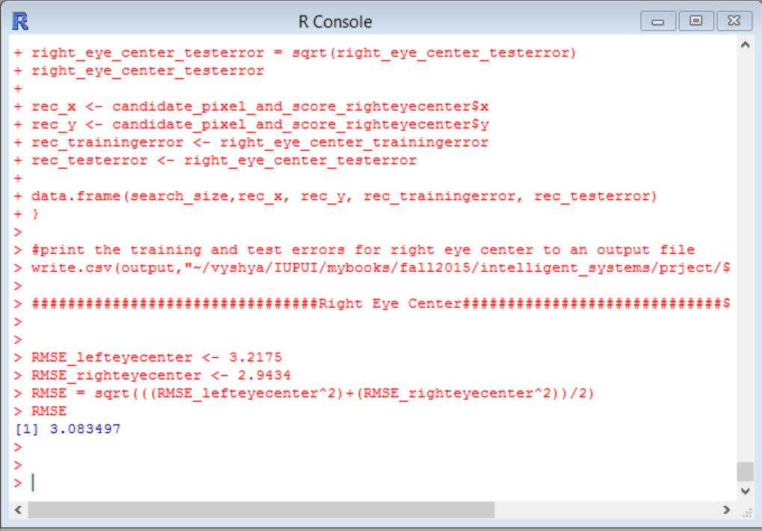

**Generated Output Files:**

**outputErrors_lefteyecenter.csv:**

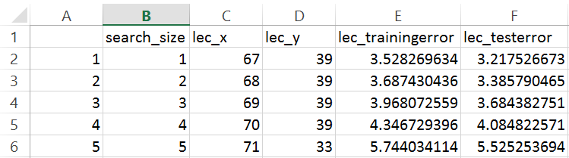

**outputErrors_righteyecenter.csv:**

