**Title : Online Address book**

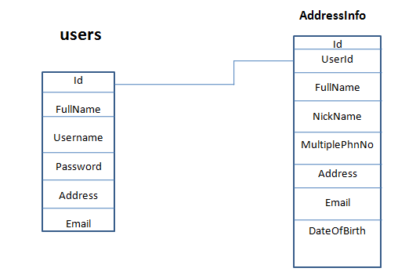

**Title : A simple Blog**

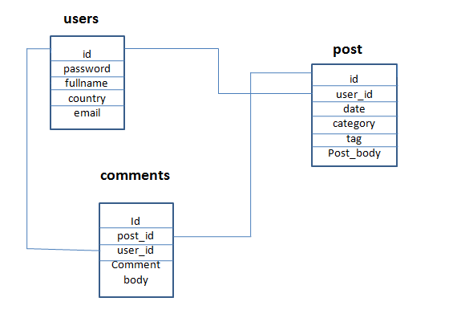

**Title : File uploading and Server side file management**

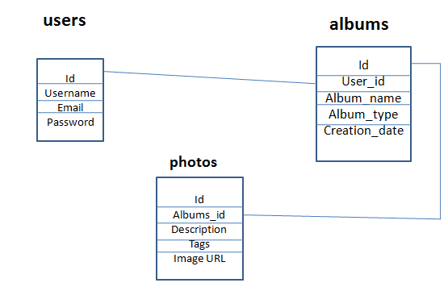

**Title : A simple Shopping Cart**

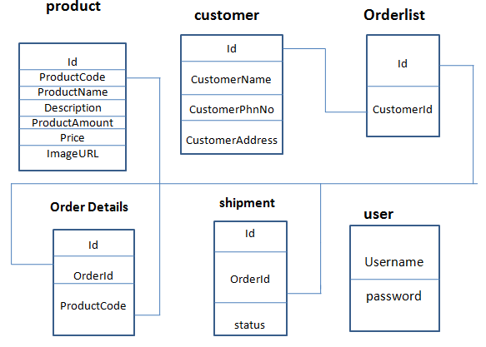

**Title : Supplier Oriented B2B – eAuction**

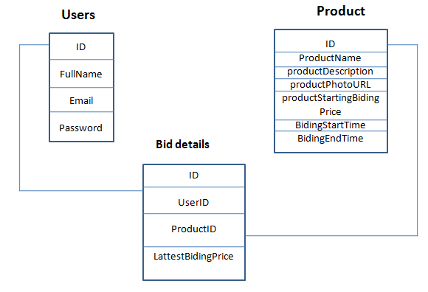

**Data Validation:**

