Sean Levorse

Being Successful at RIT



Table of Contents

Scope 2

Introduction 2

Body 3

Basic Skills 3

Your RIT Gmail 3

Googling and Using Search Engines 4

Academics and Courses 4

RIT Graduation requirements 4

Planning Courses 5

Immersions and Minors 7

Double and Custom majors 7

Changing Majors 8

MyCourses 8

Succeeding at RIT 9

How to Pass a Class 9

How to Drop a Class 11

Getting the Most Out of Your Professors 11

Academic Resources on Campus 12

Exams 13

Group Projects 13

Time Management 14

Email 15

Campus Life 15

Making Friends 15

Living with a Roommate 16

Dealing with Homesickness, Loneliness, Depression, and Mental Health 17

Laundry 18

Conclusion 19

Definitions 19

# Scope

This manual will cover all of the aspects of acquiring a degree at RIT. Starting with Academics, it will cover determining program requirements as well as planning for the next few semesters which courses you should take. It will show the general requirements all students at RIT must take and how to work them into your schedule. It will also give a brief introduction to SIS [1]and the new TigerCenter [2]applications for students to plan and enroll in classes. Next, the manual will cover the less formal requirements for graduating. This includes tips on doing well in classes, finding and using resources, how to approach exams and projects, and how to balance your time. Lastly, this manual will go into campus life at RIT. This will address the personal needs of a student who may be living on their own for the first time. This guide is intended for the incoming freshmen or transfer students at RIT and will most likely not be as helpful for Graduate students as their programs are much more varied. Additionally, it will not get into the nitty gritty details of each major as there are 116 different undergraduate majors.

# Introduction

Each year about 4000 freshmen are accepted into RIT for the fall. Of these, about 2500 of them graduate with their bachelor’s degree. Making it completely through a program at RIT is not easy and takes careful planning. Many people think that they just have to go to class and get good grades to graduate. However, there are plenty of underlying factors that play a role into a particular student graduating. Besides doing well in class, students need to take care of their bodies and their minds. Additionally, a lot of students don’t know where to find the help that they need. RIT offers a lot of resources that not many people know exist. All of the faculty are more than willing to help out students in need, but the students need to find that help for themselves. This manual is intended to help students find their path through college at RIT and make it to graduation.

# Body

## Basic Skills

Congratulations, you made it to college! For many, college can be an exciting time of enormous personal growth. Now that you’ve made it, there are some things that you will need to be able to do. These skills are not difficult but will go a long way in helping you help yourself. This will save you time as you move through your college career.

### Your RIT Gmail

Upon accepting RIT’s offer, you should have been granted an RIT Email. It is usually in the form of [abc1234@rit.edu](mailto:abc1234@rit.edu). There are actually 3 forms of the same email:

* [abc1234@rit.edu](mailto:abc1234@rit.edu)
* [abc1234@g.rit.edu](mailto:abc1234@g.rit.edu)
* [abc1234@mail.rit.edu](mailto:abc1234@mail.rit.edu)

All of these get forwarded to the same inbox, so you can use any of them when sharing your email with others.

You can access your email by going to <http://google.rit.edu> and clicking on RIT Gmail. Get familiar with this as you should use this email a lot throughout the next few years. Most professors will not respond to any emails that aren’t sent from an rit.edu account and having one account specifically for school related things can be very helpful for keeping things organized. Check this email frequently because it is where RIT and your professors will send messages that you don’t want to miss; class is cancelled, there’s a quiz tomorrow, free Ben and Jerry’s on Friday, etc.

TIP:

An easy way to check your email quickly is to connect it to a smartphone. However, when you do this, you will need to use the @g.rit.edu account or else the authentication may fail.

Additionally, this email account comes with everything a Google account comes with:

* Google Docs: a free office suite that allows for easy collaboration with teammates
* Google Calendar: lets you keep track of appointments and events by category
* Google Drive: cloud storage. RIT students get unlimited storage on your RIT Google Drive
* Google Hangouts: a chat client that lets you chat with anyone in RIT’s Google network

Take the time to learn what resources your RIT Google account has to offer you.

### Googling and Using Search Engines

Beyond your Google account, another skill that will help you immensely throughout your time at RIT, and in the professional world, is knowing how to make the most out of search engines. RIT is a big school and has a lot of resources to offer. There are thousands of web pages across RIT’s website. It is almost impossible to navigate all of these pages to find exactly what you need if you don’t know how to search for it. This is where search engines come in. Before you ask anyone for help, you can do a simple search on Google, Bing, Yahoo, etc. and have a good chance of finding what you are looking for. All you have to do is add “ RIT” to whatever you need and there is a good chance it will come up.

TIP:

Use Google to find the hours and menu of your favorite dining service locations. For example:

“RIT Crossroads”

brings up Crossroads’ hours and today’s menu!

For example, let’s say that you are doing a group project and want to reserve a room to meet in. However, you don’t know where or how to make a room reservation. Simply search “Room reservations +RIT” 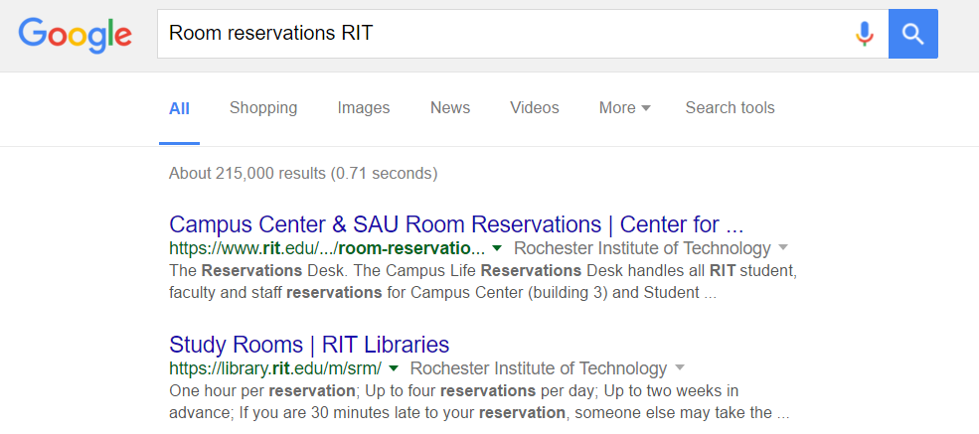

Within the first two results, you will find that you can make reservations in the SAU or in the Library. Since this is for a class, you probably want to use the library, so you click on that link, log in and it automatically brings you to the form for reserving a room.

Because of RIT’s size and status as a technical school, there are also plenty of student made website that can be useful. For example, searching “RIT meal plan tracker” offers up mymealplan.info, a website made by a student to track your meal plan throughout the semester. Using a search engine is how most of this manual was made. Becoming familiar with what can be searched will save you a lot of time and frustration.

## Academics and Courses

### RIT Graduation requirements

Every student at RIT has to complete some general education requirements in addition to the requirements that their program puts on them. In order to graduate, you must complete the following:

* Minimum 2.0 GPA (2.8 for Physician Assistant program)
* At least 120 credits, (but your major will probably require more)
* A first year writing course
* At least 2 writing intensive courses, one of which must be part of your program
* 8 perspective[3] courses – These are liberal arts courses that fulfil specific requirements
  + Ethical
  + Artistic
  + Global
  + Social
  + Natural Science Inquiry
  + Scientific
  + Mathematical x 2
* An immersion[4] (See “Immersions and Minors”)
* Two wellness classes (Some exemptions for certain students)

All of these courses need to be completed before you graduate. Fortunately, most programs have a website where you can find a recommended path to graduation. You should have been shown this site at orientation, but if you forgot, you can usually Google “RIT {{department name}} website” and click “curriculum” to find the recommended curriculum for your program. These will usually cover all of the general education requirements with your program requirements. If at any point you need help figuring out how classes fit into your schedule, you can make an appointment with your academic advisor and they will help you figure it out.

### Planning Courses

There are several tools out there for helping to plan your courses. The first resource is your academic advisor. They should know the requirements inside and out and can help you figure out what prerequisites a course has and what order you need to take certain courses. The next is SIS. This is an application that lets you access your schedule, transcripts, academic requirements, course enrollment, and transfer credit. Additionally, there is TigerCenter, a wrapper for SIS that makes certain functions easier. There’s also the CSH[5] Schedule Maker, created by students on Computer Science House. This can be found at <http://schedule.csh.rit.edu>.

TIP:

Plan out your classes for the next few semesters. Start with your department’s recommended plan. Cross out courses you already have credit for and fill in any blanks with courses you are interested in taking

#### SIS and Tiger Center

SIS can be found at <http://sis.rit.edu>. Click on “Student Info System” and sign in to access the app. To search for classes, click Search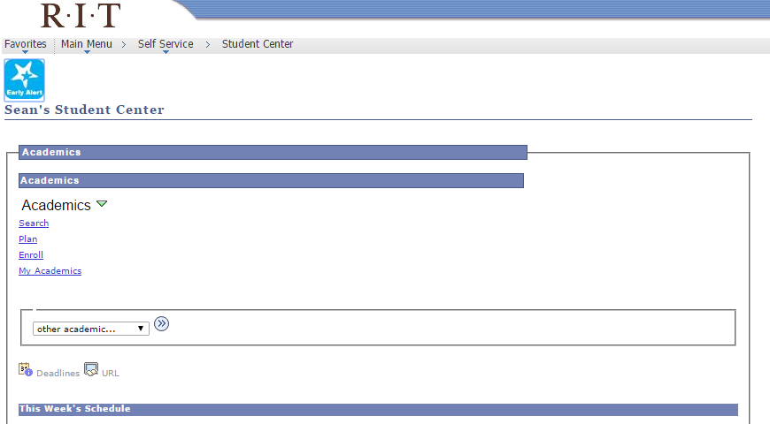



From there, a form will come up. Make sure to set the semester to the one you want to search in. The subject is the 4 character department code (i.e. FNRT for Fine Art). You can search for specific course numbers or look for beginner courses (is less than 200) or more advanced courses (is greater than 300). Course career is undergraduate or graduate courses. In the additional search criteria is how you search for courses to fill certain requirements. Click on the left magnifying glass to view attributes.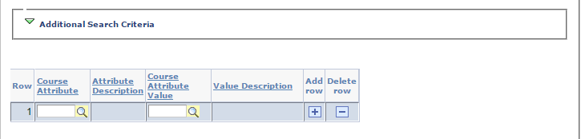

GE is for perspectives; the rest are all self-explanatory. Click on one of the attributes to fill it in and click on the right magnifying glass. This is where you can choose which perspective you want to look for.

When you are done, click search and it will show you the list of classes that fit that search. Alternatively, you can use <http://tigercenter.rit.edu>. Log in and click on the 3 white lines for the menu.

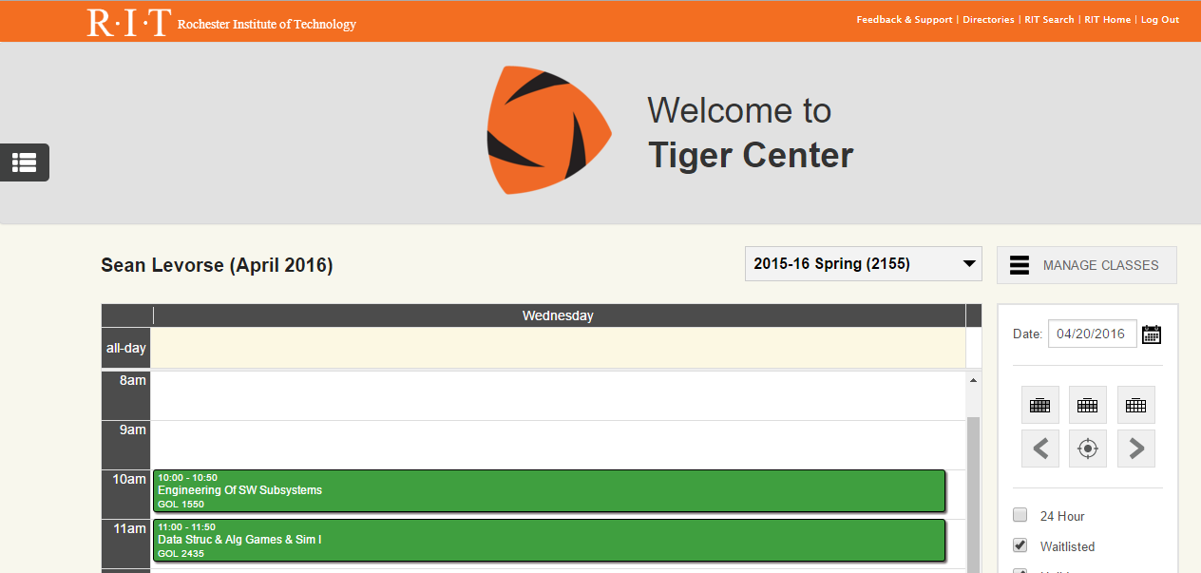



Click “Class Search” and you will get a search bar. Enter any terms you like, or use the “Advanced search” to use specific attributes. This is much faster and looks more visually readable.

### Immersions and Minors

Every student must complete an immersion. Many students complete a minor by adding a few more courses onto their immersion. You can find the list of minors and immersions here: <https://www.rit.edu/programs/immersions>

Take a look through the list and see what interests you. Then look at the minors in related fields. Often times they will overlap. For example, the Journalism minor is the Journalism immersion with two additional courses. Some immersions will have prereqs, such as the Math immersion. When you are ready to declare an immersion, find the Immersion Declaration form (using a search engine is the easiest) and bring it filled out to the registrar’s office.

### Double and Custom majors

If you would like to double major, you have to speak with your academic advisor as well as the advisor of the major you would like to double major in. They will help you form a plan for completing both degrees and give you the necessary paperwork to fill out to declare the double major. It helps to have a lot of AP or transfer credit coming into RIT, or to have majors with a lot of overlapping courses (i.e. Computer Science and Software Engineering).

If you are interested in picking out courses for your own education rather than sticking to requirements set by a department, check out the School of Individualized Study. This lets you decide how you want your education to be run. The tradeoff is that you lose out on the reputation of an established program at RIT, but you have control over the courses you take to graduate. This is also useful for graduating if you have a lot of credits but still haven’t completed all of the requirements for a major. For example, one student switched majors 4 times. After spending 7 years at RIT, he felt it was time to graduate with what he had rather than try and finish a set program. The School of Individualized Study helped him graduate.

### Changing Majors

There may come a point where you are not satisfied with your classes. Maybe you aren’t understanding the material. Maybe they just don’t interest you. Maybe you’ve found something that you like more and want to know more about. If this is the case, you may want to consider changing majors. This is a lot more common than you think it is. The first thing you should do is talk to your academic advisor. They will help you decide if switching majors is what is best for you. You may need to spend an extra semester or two catching up, depending on what you are switching from and to. If your new major and old major are related, it is likely that some courses can count from your old major. Also the general education classes you take will still count towards those requirements. It also helps to have AP credit or Transfer credit to help open up spaces in your schedule.

### MyCourses[6]

Lastly, many courses at RIT will use an application called MyCourses. This can be found at <http://mycourses.rit.edu>. Each semester, all of your courses will get a class page here. Professors and TAs can post assignments, grades, articles, and quizzes. Many courses, especially online courses, will have discussion boards where you can interact with your professor or classmates. Courses will also have a classlist where you can see who is in your class and what their email is. This is helpful in case you miss class and need to get the notes from someone. You will most likely be required to submit some assignments through MyCourses before you graduate. To do this, you navigate to the course page that you are submitting an assignment for and select Dropbox



Find the assignment you want to submit and click on it

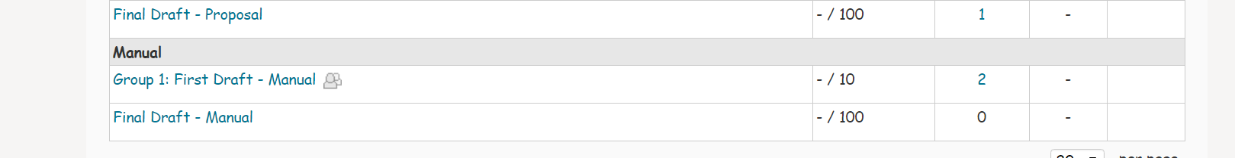

Select “Add a file”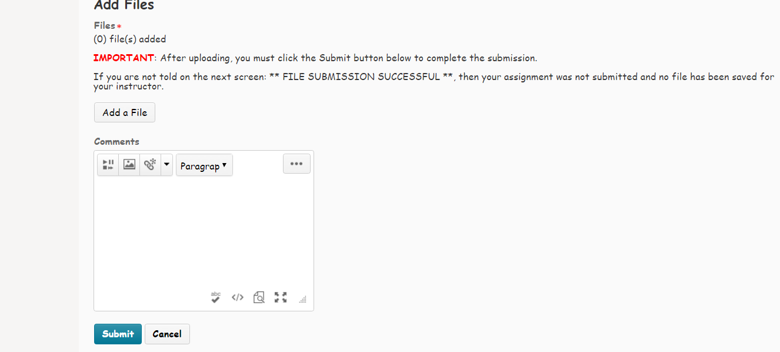



Upload a file and click “Add” and finally MAKE SURE TO CLICK SUBMIT. It is all too easy to forget to click “Submit” because you already clicked “Add.”

After you have submitted a file, you will receive and email in your RIT email. If you do not get this email within a few minutes, submit the file again. If it still doesn’t work, email your professor.

## Succeeding at RIT

### How to Pass a Class

An easy way to not graduate is to fail too many classes. If your GPA drops below a 2.00, you can be put on academic probation or even academic suspension. In order to get credit for a class, you must get a grade of at least a D. However, if a course is a prerequisite for another course, the minimum grade is a C. The grading system generally works like this:

|  |  |  |
| --- | --- | --- |
| Numeric Grade | Letter Grade | Grade Points |
| >93 | A | 4.000 |
| >90 | A- | 3.667 |
| >87 | B+ | 3.333 |
| >83 | B | 3.000 |
| >80 | B- | 2.667 |
| >77 | C+ | 2.333 |
| >73 | C | 2.000 |
| >70 | C- | 1.667 |
| >60 | D | 1.000 |
| <60 | F | 0 |

What this means is that you only need to get 73% to pass prerequisite courses and only 60% to pass everything else. Granted, you should be trying to do your best to get as high of a grade that you can get, but sometimes it is important to focus on passing before focusing on doing exemplary work. Acknowledging this can greatly reduce the stress of getting a 60 on an exam.

Next, you should figure out what type of learner you are. There are generally four types:

1. Auditory – learn through listening
2. Visual – learn through seeing
3. Kinesthetic – learn through action
4. Graphic – learn through writing

Knowing what type of learner you are can help you approach a class from the perspective that will help you learn more. If you are an auditory or visual learner, it may be more distracting to take notes and you may benefit from just simply writing down the concepts so you can look up a video later and pay attention to what the professor is doing and saying. If you are a kinesthetic learner or graphic learner, study by coming up with activities and practice problems.

At the start of the semester, dissect the syllabus. Keep track of all of your classes syllabi and make sure to understand how each class will work. Some things to keep track of:

* Which classes count attendance

Always go to class if you can, you are paying for it. But sometimes, you already know that today’s class is going to be a work day and you have a 20 page essay for another class due. So skipping one class won’t be as detrimental and will help you do well in another class.

* How much of the grade is homework

If you find yourself stressing out about homework in a class where homework is only 10% of the grade, it may make more sense to not submit the homework on time. Then you can go to the professor’s office hours and ask for help. This will make sure that you understand the content and will help you for exams more than getting 100% on a homework assignment that is one out of fifteen other homework assignments that are 10% of your grade.

* When and where are the professor’s office hours

Keep track of which professors have office hours during times you cannot make it so you know if you have to reach out for help, you can contact them.

* Major projects and exams

A lot of professors will list major projects and exams on the syllabus. Write these down and set reminders so that you aren’t caught off guard when the professor tells you there’s a midterm next week.

Once you understand all of these, you can make a personal plan for yourself that will help you do the best you can in that class with the minimum amount of stress. Remember to keep the big picture in mind to avoid stress whenever you don’t do as well as you think you can do.

### How to Drop a Class

It happens. Sometimes you get caught by surprise by the transition from highschool to college. Sometimes you realize taking 18 credits and 3 labs was a mistake. Sometimes you just don’t get the material. Dropping a class is nothing to be ashamed of and sometimes is the right decision for you. Before dropping a class, *always* talk to your academic advisor. They will know more about what is the best option for you. Here are some things to take into consideration before dropping a class:

* Can you still pass the class?

Sometimes it may be mathematically impossible to get at least a 73% or even a 60%. If you only have one more exam that is worth 25% of the grade, but your average is less than a 50%, you may not be able to pass the class. If this is the case, withdraw. There is no point in you spending any more time distracted from your other classes.

* If you can pass the class, will you be able to?

If you have been averaging 65 on every exam, assignment, and homework, and you need to get an 85 on the next exam to get the minimum passing grade, will you be able to get that 85%? Unless you started understanding the class a lot more, or the professor explains the material better for you, you may want to consider dropping the course.

* If you are not required to take the course and are doing poorly

If you are getting a 50% in an elective class that doesn’t fill any requirements, drop it. It will hurt your GPA much more having that 0 averaged in. Even though it will show up as a W on your transcript, no employer will hold it against you. It is also not worth your time to try and bring your grade up when you could be focusing on your other courses.

TIP:

Some of the most commonly dropped classes are the ones that are introductory:

* Computer Science I and II
* Project Based Calculus I and II
* University Physics I and II

Dropping a class is serious. You paid a lot of money for that course and now it’s down the drain, so never drop a class unless you have to. Always consult your professor and academic advisor before dropping. Also keep in mind you *must* withdraw from a course be the Friday of week 12. After that point you cannot withdraw and you get whatever grade you get.

### Getting the Most Out of Your Professors

Professors are an important resource for your college career. Most of them have experience in the industry and pull from those experiences while teaching. They want to see you succeed and will do as much as they can to help you on your path to graduation. Get close with the professors in your department, because they’re the ones that will probably be writing letters of recommendations for you or passing your resume on to their old colleagues who are looking to hire.

One way to get on your professor’s radar is to participate in class. If you ask questions, answer their questions, put your solution up on the board, participate in discussions, etc., the professor will start to remember your face and maybe even your name. This is a great in and will make it easier for you to interact with them outside of class since they will already know who you are.

Additionally, almost all professors have office hours. If you’re stuck on something, even if it’s not an assignment but it’s still related to their course, go to that professor’s office hours and ask for help. This will give you one on one time with that professor where they will get to know you more outside of the class setting. You can also ask professors about their experiences. What classes do they teach? What research have they done? Where have they worked in the past? If they have the time, some professors will love to answer questions about working in the industry and you will learn a lot about their experiences for when you eventually graduate. Getting to know your professor will make it easy for you to ask for help and can expand your network to include theirs.

### Academic Resources on Campus

Beyond professors and advisors, there are a lot of offices and organizations geared toward helping you.

### Exams

One of the most valuable skills for doing well in a class is being able to take exams. There are many reasons people stress over exams. Usually, they are the most valuable part of your grade and can have a big impact on if you do well or fail a class. If you find yourself getting test anxiety, take a deep breath and consider the impact this exam will have on your education over. Chances are, it will at most be 30% of the grade. Also if you payed attention in class, you should be able to manage, at the worst, a 50%. Okay, that means that if you get 90% on everything else, and a 50% on this exam, you will get a 75% for the class. Congratulations! You aren’t going to fail the course! Chances are, once you get over this test anxiety, you will actually do better than a 50% anyway. Every time you find yourself feeling anxiety over an exam, remind yourself that this exam does not define you, it does not define your results in the class, and it does not define your education as a whole.

Another helpful strategy is to understand the exam format. Most professors will tell you ahead of time what the format is. Don’t worry too much about multiple choice/short essay format. Instead worry about the content format. Instead find out what will be tested on the exam.

Some exams will be total recall. For these, the key is spending as much time memorizing the information.

Another common format is application of knowledge. These are more common in math and science classes. These kinds of questions will give you a problem to solve using what you have learned in class. To study for these, come up with practice problems. Look online, in you textbook, ask your professor, redo old quizzes, etc. The more practice you do, the more the knowledge will be ingrained in your head and you should have no problem figuring out another problem on the exam.

Lastly, there are some classes that have practical exams. Usually these are lab classes or programming classes. This comes down to a combination of knowing your stuff and having the practice. For programming classes, spend time outside of class to work on personal projects in the language you are learning in that class. For science labs look over your old lab reports to understand why you did the calculations that you did. Each lab you did in class was intended to teach you something. Ask yourself what each lab was intended to teach you.

Once you master exams, the rest of your college career is putting all of this into practice.

### Group Projects

There will come a time when you have to work on a project with a group. This can be frustrating as it means that a portion of your grade relies on the work of other people. However, there are things that you can do to ensure that your teammates stay on track and everyone can work on the project together. There are also ways to hold your teammates accountable for their work.

The first thing you should do in any group is set up some sort of shared access to whatever it is you need to work on. For most projects, Google Drive works wonders for collaborating and communicating. You can create a shared folder, and since everyone at RIT has a Google account, you will be able to grant access to all of your teammates. The best part of this if someone messes everything up, you can walk through older revisions of a file to revert back to before the mess up. This can also be used to track how much work one teammate has done on a particular project.

How to deal with a teammate who isn’t doing their fair share of the work:

1. Talk to them

A lot of the time, just talking to the teammate to express your concerns will be enough for them to start pitching in. Start with non-confrontational statements: “Hey, can you do tasks x, y, and z by this Friday please?” and evolve to more direct approaches if this fails.

1. Talk to your professor

If one of your teammates refuses to do their fair share, bring your professor into it. Only do this after confronting the teammate though, or else you’ll just get “Did you talk to them about it?” Most professors will then try and resolve the issue.

Lastly, for group projects, meeting face to face is generally more effective than only working electronically. However, it can be difficult to set up a meeting time when everyone can make it. To solve this, use a tool like When2Meet or Doodle. These allow groups to find the time in everyone’s schedule when they are free. In larger groups, it’s possible to have no time when all members can meet. The solution to this is to have two meetings where a couple people volunteer to go to both meetings and act as liaison for each group. Then use the 5 minutes before and after class to have extremely brief meetings with everyone.

### Time Management

Throughout the semester, things can start to add up. Courses tend to start picking up around week 9 which means that if you’re used to having free time before then, you will have to adjust to the sudden time commitment of final projects and exams. You may have joined several clubs and have to cut back as assignments start to stack up. Time management can help you find the free time to get all of your work done and have personal time as well.

Balancing your workload comes down to prioritizing. Keep track of all assignments and tasks that have to get done. This includes things like filling out FAFSA forms, applying for scholarships, calling your parents, etc. Assign everything a priority and a due date. Some things can have no due date too. These tasks are what you can do when you’re feeling productive but are caught up on your work. When coming up with priorities, scale how important it is that a task gets done on time. Consider how much an assignment is worth to your grade, the consequences of not doing a task, and how much effort the task will take. You can scale priorities on a numeric scale or a qualitative scale, as long as you can rank these tasks. After assigning priorities, arrange the tasks by due date. Start working on the ones that are due sooner.

TIP:

Keep post-it notes on the wall in front of your desk for each task you need to complete. When you complete a task, take down the post-it note. This note only will provide you a visual representation of how much work you actually have to do, but it can be satisfying to rip that one post-it off the wall after it’s been there for weeks.

It is also important to take breaks. If you just work nonstop until you’re done, the work you produce will not be your best. For each task, estimate how long you think it will take you to complete each task. When you want to take a break, add up the amount of time tasks that are due today will take and multiply by 1.5. That is how long you should leave for working on those tasks. If you add that time to the current hour, and there is extra time during the day, then you can take a break. As you complete tasks early, you’ll find more time to take brakes during and will be able to take more breaks. To keep your momentum going, never break for more than 5 minutes.

Keep in mind that classes count as a task. While you should prioritize classes high, there may come a time when it makes sense to skip one class to get work done for another. Do this carefully, but if this is the case, then you need to manage your time better.

### Email

Email is one of the most universally accessible forms of communication across the RIT community and in the professional world. However, not everyone knows how to effectively use email. Here are some tips and tricks for using your RIT Gmail effectively:

* Make your subjects relevant

When you send an email, make sure the subject tells your recipient exactly what the email is in relation to. If you are sending an email to a professor, be sure to include the course number in the subject. This will provide them context to questions in your email.

* Avoid childish gimmicks

College is meant to be professional. Using more than one emoji or sending animated GIFs is unprofessional. Depending on your relationship with the recipient, you may want to avoid unprofessional conduct.

* If an attachment is too large to send, share a link to it on Google Drive

You can only send files up to 25Mb through email. But, you can send a lot more text. If you are trying to send a large file, you can upload it to Google Drive and get a share link. Then paste the link into the email to let the recipient download the file. This is especially helpful for Photoshop files and Unity projects.

* Keep emails on topic, brief, and pleasant

The larger the wall of text, the less likely every word will be read. By limiting paragraphs in emails to 3 to 5 lines, your recipient will most likely read the entire thing. Avoid going off topic which can bloat the email. Also, be aware that not everyone reads your email in the same tone. What you may have meant sincerely can come across as sarcasm. Be as polite and accurate as possible with your wording to avoid confusion.

* Beware “Reply All”

You don’t want to be that person that accidentally sends a reply as a reply all. It puts others in an awkward position and can be embarrassing.

## Campus Life

### Making Friends

Having friends in college will go a long way towards helping you graduate. Good friends will help you stave off homesickness and loneliness by keeping you distracted. Be sure to balance your social life with your academic life. When you get to college, use the first few months to start making friends. Try and meet as many people as possible. You will probably find as time goes on, you don’t stay friends with the people you met during orientation week. As a freshman, there are plenty of easy ways to make friends:

* Get a head start with the freshman class Facebook page: Every year, admissions makes a Facebook group specifically for incoming students. This can be a great place to meet people with similar interests as you. Be sure to check the group often to see what people are posting and comment when someone says something that interests you.
* Your orientation group and YearOne class: In the first week, when no one knows anyone, some of the first people you meet will be the people in your orientation group. While you may not hit it off with everyone in your group, chances are at least one person will have similar interests with you.
* Clubs: Join clubs that interest you and you will find friends. Inherently, everyone at that specific club has one thing in common. You may start hanging out with those club members outside of the club itself.
* Classes: Participating in class will make it easier to start conversations with your classmates outside of class. This works especially well with the classes for you major. Chances are, they’re freshmen too and are in the same boat looking for friends. Offer to get lunch with your classmates and you’ll find friends quickly.

### Living with a Roommate

Part of the transition to college involves living with a roommate. For many people, it will be their first time sharing a living space with someone who they probably never knew. Living with a roommate can be difficult. Try and get to know your roommate before you move in. If you happen to live near each other, maybe you can meet up. If not, then the internet is a great tool for friendly discussion. When you first move in, take the time to get to know each other. At the beginning of the year, your RA will encourage everyone to fill out a roommate agreement. It may seem corny or restricting, but it really is the best option for dealing with conflicts. Make sure to be yielding and understanding but also don’t let them take advantage of you. Nobody’s perfect, and chances are there will be something about your roommate that bothers you. Your only options are to discuss it with them face to face or learn to live with it.

If you do have a problem with your roommate, be sure to talk to them first. If you try to go to your RA, they will just ask if you talked to your roommate about it. A lot of the time, people are willing to change if something is making you uncomfortable, so don’t be afraid of confrontation. If your roommate refuses to work with you to find middle ground, then talk to your RA so they can figure out what would be a fair solution. Don’t expect your RA to side with you right away, but the RA should be able to help. If they can’t you should go to the RC for your area.

If your roommate confronts you about something, be sure to listen to everything they say. Try not to take it as an attack against you. Everyone comes from different backgrounds and is used to a different standard of living. If what they are asking is within reason, then it shouldn’t be hard to make things work. If you think they are asking too much, try and find some middle ground. You need to be able to live with your roommate for the rest of the year. If there is any awkward tension between you, things will just get worse and worse. Avoid being passive aggressive and don’t sneak around behind your roommate’s back. If both of you are understanding of each other’s needs and are willing to work with each other, having a roommate can be not that bad. It can even be a lot of fun, and they could be one of your closest friends.

COLLEGE PARABLE:

You either have a good roommate, or you have good stories to tell about your roommate.

### Dealing with Homesickness, Loneliness, Depression, and Mental Health

College is tough. Classes are generally harder than high school, you don’t get to see your family, you have to start over with finding friends, and the environment is generally much more stressful. Therefore, you need to take care of your body and your mental health, especially at RIT. Since the winter comes early and never leaves, RIT students are particularly susceptible to SAD or Seasonal Affective Disorder. This is seasonal depression that comes and goes depending on the season. Additionally, if you are in any engineering, art, or computer science program, these classes tend to require a lot of projects that eat away at your free time and can increase stress. It is important to keep tabs on your mental health during your time at RIT.

Look for the following signs to see if something might be wrong with you or any of your friends:

* Irregular sleep patterns (sleeping much more than usual, sleeping less than usual)
* Change in diet (Binge eating, eating significantly less, or nothing at all)
* Loss of motivation/Apathy
* Stops attending social events/class
* Lack of concentration

TIP:

Don’t be afraid to reach out to the Counseling Center. They are here to help and will make sure that you get the help that you need.

https://www.rit.edu/studentaffairs/counseling/

If you notice these within a friend, be sure to check up on them. Make sure they’re doing okay, and invite them to do something with you. Try not to let them dodge your offer. Sometimes just one forced social interaction is enough to snap someone out of a depressed funk. If you’re really concerned about someone, including yourself, you can speak to their RA, your RA, or someone at the Counseling Center.

The Counseling Center has plenty of resources for understanding common mental illnesses. They span from depression, to alcohol abuse, and mental disabilities. For more information, check out the links here:

<https://www.rit.edu/studentaffairs/counseling/get-support/self-help-resources>

“An ounce of prevention is worth a pound of cure.” Here are some tips for avoiding becoming depressed:

* Take care of your body

Eating well and exercising does wonders for your mental health. When you go to Gracie’s, eat a salad with every meal. Avoid eating the same foods over and over again, and moderate your fats and sweets.

The Hale Andres wellness center is free for all RIT students. The gym can be intimidating at first, but keep in mind that no one really cares. If you don’t know how to use the equipment, just ask and people will be more than happy to help. It’s great to pick a friend or two that you can make each other go to the gym regularly.

* Balance your workload

When you think you have too much work to do, you feel stressed. This can lead to depression. Balancing your workload helps to manage stress.

* Leave your dorm room

Social interaction helps stimulate your mind. If your friends are all busy, check out some of the events that are going on. <http://thelink.rit.edu> and <http://cab.rit.edu> are both great resources for finding on campus events. There’s always something going on

* Don’t eat meals alone

Sometimes you can’t, but if possible, try and eat out with friends. Make a post on Facebook or text your friends asking who wants to get dinner. It is a small thing, but it will go a long way in helping you and your friends feel like a family.

* Call your family regularly

Your parents miss you. And you may not want to admit it, but you probably miss them a little too. At least once a week/month, pick up the phone and call home to catch up on how things are going. Not only will this help with homesickness, but it will let your parents know you think about them, which will help you in the long run.

* Clean up your living space and work space

It’s hard to work when the room around you is a mess. Cleaning and organizing your room not only gives you a productive way to procrastinate, but also helps you get your work done.

### Laundry

For many freshman, this is their first time having to live on their own. Nobody wants to be that kid that has to bring their laundry home every weekend, or worse, have their parents come up to do their laundry for them. Laundry is not that difficult when you get the hang of it, and can be done while you do your homework. However, there are things you need to be careful to *not* do. Don’t be the person who floods the laundry room.

Start by sorting your clothes. The dorm washing machines can only handle so much weight. If you overload the washing machine, it will not clean your clothes and it might flood the laundry room. Generally, you sort by color, and pulling out socks, underwear, and bras into their own pile. You can sort by light and dark colors, cool and warm colors, etc. Just don’t mix colors that are very different. You may also want to have a pile for delicate clothing. Iron on decals, weird materials, wool, etc. should be in this. Over time, you will get a hang for what clothes can be washed together.

Put your clothes in the washing machine. If you are using pods, the pods go in with the clothes. If you are using liquid detergent, measure out half of the lid of your detergent bottle, and pour that into the shelf. If you use more than half of a lid in the dorm washers, your washer will overflow with suds and get all over the floor. If this happens to you, run another cycle of the washing machine without any detergent.

Picking which cycle to run depends on the type of clothes. Socks and underwear should always be run on hot to kill bacteria. Everything else depends on the markings on the tag. Use this reference to understand the symbols on your clothing: <http://www.textileaffairs.com/lguide.htm>

When transitioning clothing to the dryers, you can condense two washers into one dryer. This will save space in the laundry room since there are usually less than half the number of dryers than there are washers.

RIT Laundry Room Etiquette:

* If you leave the laundry room, set an alarm for at least two minutes before your clothing will be ready
* If the only washers/dryers that are available have clothes in them, wait at least 5 minutes from the time you got there before removing the clothes and placing them on top of the dryer that you found them in
* Never use more than 4 machines at a time if the laundry room is busy. 2 machines in the apartment complexes.
* It helps to do your laundry at off hours. Late at night or early in the morning on week days are often the least busy times.
* Don’t steal people’s clothes.

# Conclusion

Graduating from RIT is more than just a question of academics. It involves balancing a tiring workload with a healthy social life, and adult responsibilities. While you should always try your hardest in each and every class, sometimes it will require taking a look at what is really important to pass a class and focusing on the bigger picture. College can be a lot of fun and RIT has a great track record for setting its graduates up for success. If you find yourself struggling, **ask for help!** No one will judge you for needing assistance. If anything, they’ll admire that you know when you can’t do things alone. Yes, many students end up dropping out of RIT, but thousands of students manage to make it to graduation. You can be one of them if you’re up to the challenge.

# Definitions

1. SIS – Student Information System found at <http://sis.rit.edu>. This tool will let you access your academic record, enroll in classes, plan for your requirements, and track your progress toward your degree. Become familiar with all of the functionality that SIS offers.
2. TigerCenter – A wrapper for SIS made by RIT’s Student Government. This tool provides an easier interface for enrolling in classes and browsing the course catalogue.
3. Perspective courses – RIT doesn’t have a core curriculum. Instead, you are required to take classes that fulfil certain perspectives.
4. Immersion – RIT also requires students to complete three courses in a related field called an immersion
5. CSH – Computer Science House, one of the special interest houses located on the 3rd floor of Nathaniel Rochester Hall
6. MyCourses – An online application that allows students and professors to upload and submit assignments, communicate with classmates, and other functionality.