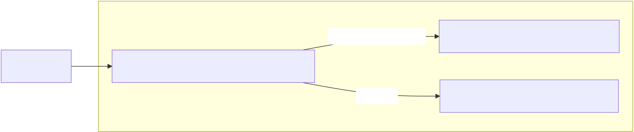
Frontend_Vite_Dev_Server
User_UI | Frontend_UI_frontend/src/App.tsx | toggle_Prefetch_ON | frontend/src/api/fhirClient.ts
 |  | callHook | frontend/src/api/cdsClient.ts

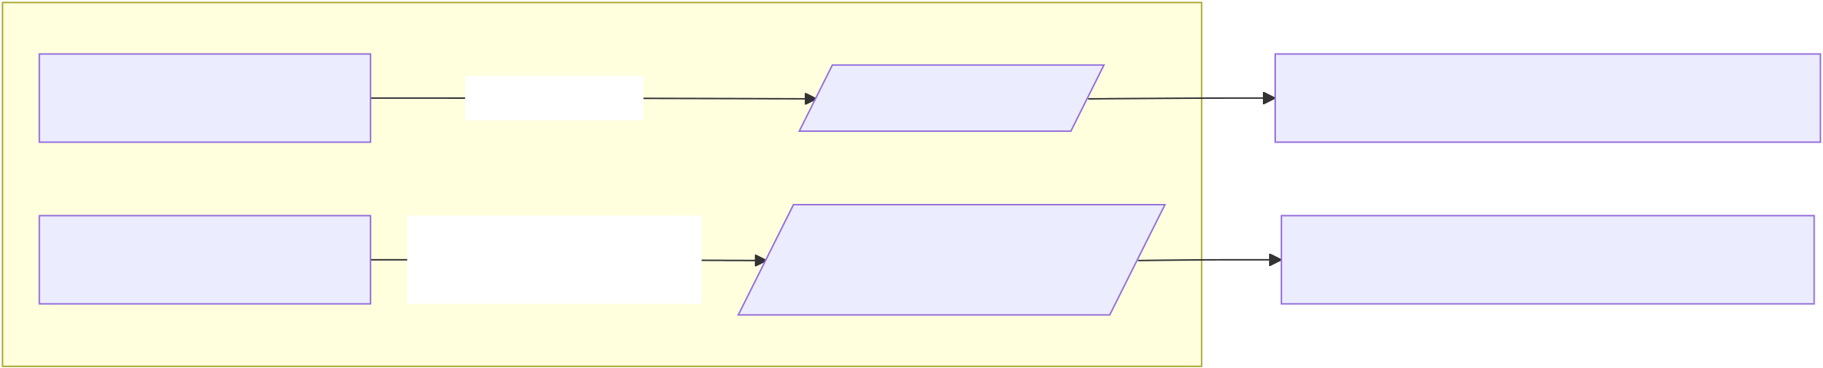
Vite_Proxy
frontend_prefetch | GET_/fhir/... | vite_proxy_/fhir | HAPI_FHIR_Server_FHIR_BASE_URL
frontend_callHook | POST_/cds- | vite_proxy_/cds- | CDS_Service_Fastify_src/server.ts
 | services/{serviceId} | services

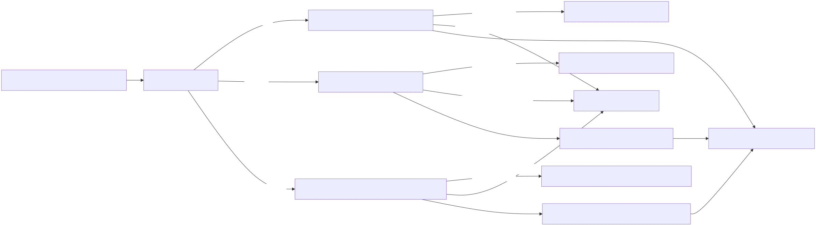
egfr-check | src/cds/egfrCheckHookHandler.ts | USE_ELM=true | src/cql/egfrElmExecutor.ts
Prefetch_OFF_or_missing
CDS_Service_Fastify_src/server.ts | src/cds/routes.ts | ckd-risk | src/cds/ckdHookHandler.ts | USE_ELM=true | src/cql/ckdRiskElmExecutor.ts | CDS_Hooks_Response_cards
 |  | ckd-comprehensive | src/cds/ckdComprehensiveHookHandler.ts | Prefetch_OFF_or_missing | src/fhir/fhirClient.ts
 |  |  |  | src/cds/ckdRiskCardBuilder.ts
Prefetch_OFF_or_missing
USE_ELM=true src/cql/ckdComprehensiveElmExecutor.ts
src/cds/ckdComprehensiveCardBuilder.ts

