# Functional Connectivity ect

**Sean Maguire**Ecology, Evolution and Behavior[smmaguire@utexas.edu](mailto:smmaguire@utexas.edu)

## Project Summary

Animals are bombarded with visual, acoustic, chemical, tactile and social information as they navigate their environment. The central nervous system integrates these stimuli with internal information and past experience in order to guide adaptive behavioral decisions (i.e. approach or avoidance of a salient stimulus). Even controlled laboratory presentations of stimuli are not processed in the brain with static stimulus-response chains, but rather processing depends on the state of local and distributed brain networks. The network state is the emergent structure of ongoing activity in the brain: the response properties of one neural element (e.g. a single neuron, assembly of neurons or a brain region) is affected by the modulatory activity of the network it is embedded in (Bressler and McIntosh 2007). Neural context (i.e. network state) is a determinative factor in sensory processing, influencing not only the perception of stimuli but also behavioral decision-making. Across vertebrates, social behavior is linked to a core network of brain regions called the social decision making network (SDMN). The SDMN is comprised of 11 brain regions, many of which are bidirectionally connected to one another and are sensitive to sex steroid hormones (SSH). They have been linked to a large variety of social and sexual behaviors across vertebrates (O’Connell and Hofmann 2011; Newman 1999; Crews 2003; Goodson 2005). My overarching hypothesis is that neural context in the SDM network represents an animals internal computing framework for interpreting external social information and that SSHs preconfigure the neural context of the network. Consistent with this hypothesis, I expect that ongoing neural activity will be influenced by SSHs and that this neuromodulatory patterning will be correlated to the neural responses evoked by social interaction. As a general approach I will exploit the different time courses of two neural activity measures, cytochrome oxidase and egr-1, within the same animals to measure ongoing neural activity and also activity evoked by social interactions.

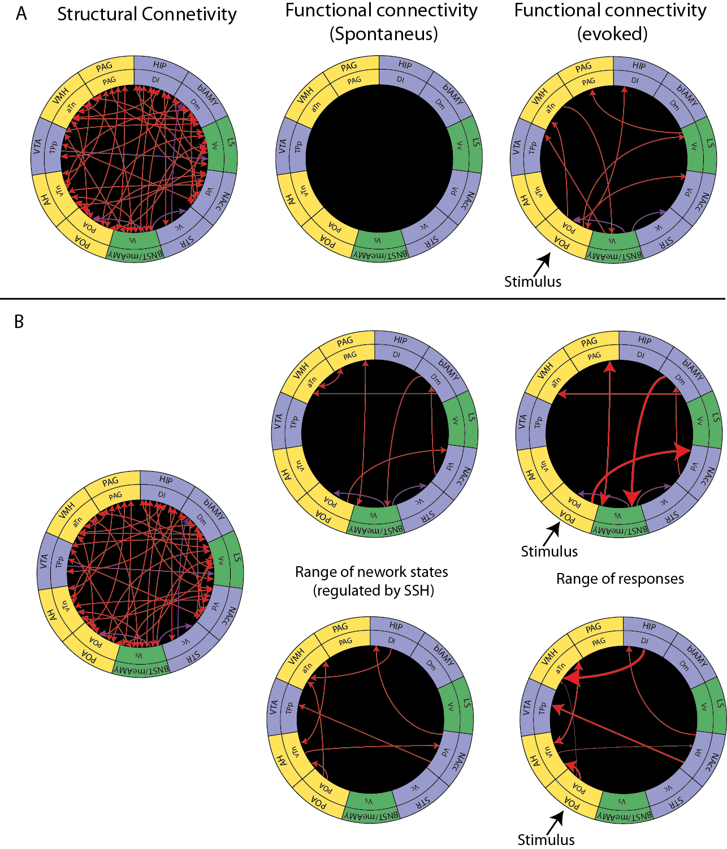

Hypothesis concept map. Brain areas in the SDMN are shown in a circle, the inner ring is the teleost brain areas, the outer ring is the proposed mammalian homolog. SBN nodes are colored in yellow, nodes of the mesolimbic reward center are shown in blue and overlapping nodes are shown in green based on (O’Connell and Hofmann 2011) A) Static response model, stimuli are processed in the brain independent of on-going neural activity. B) SSH regulate a repertoire of different network states that may direct and constrain the neural responses to social stimuli. Figure redrawn and based on a figure from (Fontanini and Katz 2008) Abbreviations: PAG = periaqueductal gray, HIP= hippocampus, blAMY = basolateral amygdala, LS= lateral septum, NAcc = Nucleus accumbens, STR= striatum, BNST/meAMY= bed nucleus of the stria terminalis and the medial amygdala, POA= preoptic area, AH= anterior hypothalamus, VTA = venteral tegmental area, VMH = ventromedial hypothalamus.

Animals are bombarded with visual, acoustic, chemical, tactile and social information as they navigate their environment. The central nervous system integrates these stimuli with internal information and past experience in order to guide adaptive behavioral decisions (i.e. approach or avoidance of a salient stimulus). Even controlled laboratory presentations of stimuli are not processed in the brain with static stimulus-response chains, but rather processing depends on the state of local and distributed brain networks. The network state is the emergent structure of ongoing activity in the brain: the response properties of one neural element (e.g. a single neuron, assembly of neurons or a brain region) is affected by the modulatory activity of the network it is embedded in (Bressler and McIntosh 2007). Neural context (i.e. network state) is a determinative factor in sensory processing, influencing not only the perception of stimuli but also behavioral decision-making.

Bressler, S., and A. McIntosh. 2007. “The Role of Neural Context in Large-scale Neurocognitive Network Operations.” *Handbook of Brain Connectivity*: 403–419.

Crews, David. 2003. “The Development of Phenotypic Plasticity: Where Biology and Psychology Meet.” *Developmental Psychobiology* 43 (1) (may): 1–10.

Fontanini, Alfredo, and Donald B. Katz. 2008. “Behavioral States, Network States, and Sensory Response Variability.” *Journal of Neurophysiology* 100 (3) (sep): 1160–1168.

Goodson, James L. 2005. “The Vertebrate Social Behavior Network: Evolutionary Themes and Variations.” *Hormones and Behavior* 48 (1) (jun): 11–22.

Newman, S. W. 1999. “The Medial Extended Amygdala in Male Reproductive Behavior. A Node in the Mammalian Social Behavior Network.” *Annals of the New York Academy of Sciences* 877 (jun): 242–257.

O’Connell, Lauren A., and Hans A. Hofmann. 2011. “The Vertebrate Mesolimbic Reward System and Social Behavior Network: A Comparative Synthesis.” *The Journal of Comparative Neurology* 519 (18) (oct): 3599–3639.