Social Media Sentiment Analysis Using NLP and Machine Learning
GitHub repository: github.com/smmehedidm/Social_Media_Sentiment_Analysis_-using_NLP_and_Machine_Learning

1. Introduction and Pipeline Summary
This project is going to be targeted at the development of the pipeline of raw text from Social Media and categorize the text into Positive, Negative and Neutral. The data consists of 732 Facebook, Instagram and Twitter posts, engagement, hashtags, date and platform. There was no emotion that was marked by the posts, at first, there was the original column of Sentiments and a total of 191 emotion names (such as Joy, Anger, Nostalgia, Confusion) were marked. This set was then classified according to general polarity of words (Positive words, Negative words and Neutral words) and this set was utilized in the prediction. The final classes are imbalanced: 489 Positive (66.8%), 188 Negative (25.7%) and 55 Neutral (7.5%).
Table 1. Sentiment distribution after mapping to three classes
Sentiment | Count | Percentage
Positive | 489 | 66.80%
Negative | 188 | 25.68%
Neutral | 55 | 7.51%

The following operations were performed for each post: Only lowercasing it, eliminating URLs, @mentions, punctuation, numbers and emojis, splitting into words and removing the English stop words. Unigrams and bigrams (max 5,000 features in total) were extracted from the cleaned text and then converted to TF-IDF features. Since the cap is active (that is, the training matrix itself is exactly 5,000 columns), then the values in the rarest terms are eliminated, which diminishes the noise, if there are only 585 posts available when training the model. Instead of words, such as "new recipe", only short phrases will be used for training the model, due to the bigrams. The 80:20 split was made up of the same proportion between training posts (585) and test posts (147) as is found in the split for the training and test sets.
This information was also leveraged for training three classifiers: a baseline (Logistic Regression), a fast and common for word-count-style features (Multinomial Naive Bayes), and suitable for the high dimensional sparse text (Linear SVM). So, in the training, the minority classes were not neglected but the weights were given to the minority classes in the Logistic Regression and SVM.

2. Model Comparison
Table 2. Model performance on the 147-post test set
Model | Accuracy | Precision | Recall | F1 (weighted)
Logistic Regression | 85.03% | 83.92% | 85.03% | 83.32%
Multinomial Naive Bayes | 75.51% | 74.61% | 75.51% | 69.50%
Linear SVM | 86.39% | 88.19% | 86.39% | 84.34%

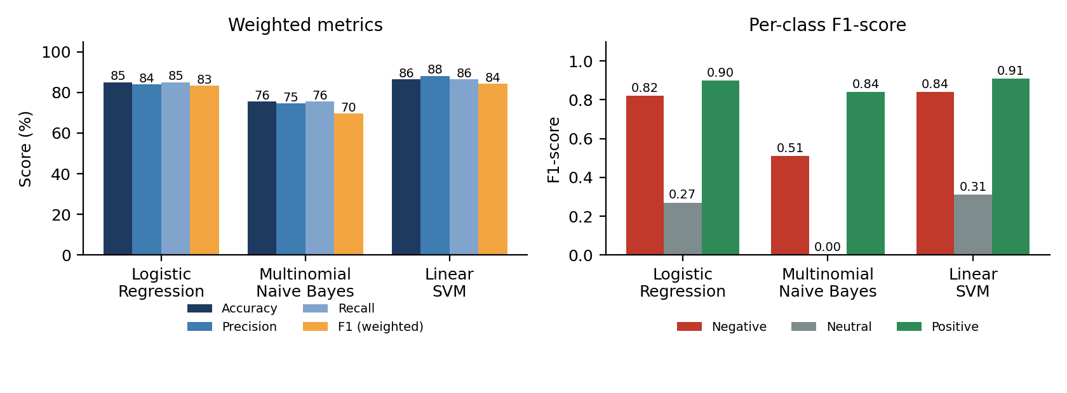
Figure 1. Weighted metrics (left) and per class F1 score (right) - 147 post test set.
Linear SVM scored highest on all four weighted metrics, so I recommend it as the final model. Looking beyond accuracy supports that choice: its macro-average F1 is 0.68, against 0.66 for Logistic Regression and 0.45 for Naive Bayes, and its precision on the Negative class (0.97) and Neutral class (1.00) means that when it does assign these labels it is almost always right. Naive Bayes is clearly the weakest. It never predicted Neutral (F1 of 0.00) and caught only 34% of Negative posts, because with a dominant Positive class it falls back on the most common label whenever the evidence is weak.
One caution: the gap between the SVM and Logistic Regression is small. 86.39% versus 85.03% corresponds to 127 versus 125 correctly classified posts, a difference of only two. With a single split and 147 test posts, I would treat these two models as close, and cross-validation would be needed to separate them with confidence.

3. Sentiment Trends
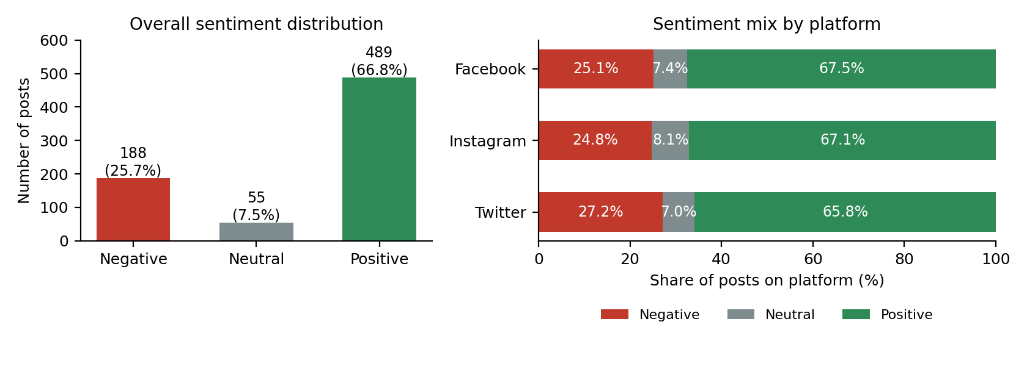
Figure 2. Sentiment Distribution (left), and Sentiment Mix per Platform (right).
Overall. Positive posts make up two thirds of the data, with Negative posts about a quarter and Neutral posts under one in ten. Any model trained on this mix will be pulled toward predicting Positive, which matters for the error analysis in Section 4.
By platform. Positive is the largest class on every platform. Instagram has the most posts of each type in raw counts (173 Positive, 21 Neutral) and Twitter the most Negative (66), but Instagram is also the largest platform, so counts alone are misleading. Measured as a share of each platform's posts, the picture is very similar: Positive is 67.5% on Facebook, 67.1% on Instagram and 65.8% on Twitter, and Negative is 25.1%, 24.8% and 27.2%. Twitter is slightly more negative, but the differences are only a few percentage points, so I would not claim that any platform has a distinctly different mood.
Table 3. Sentiment counts by platform
Platform | Negative | Neutral | Positive
Facebook | 58 | 17 | 156
Instagram | 64 | 21 | 173
Twitter | 66 | 17 | 160

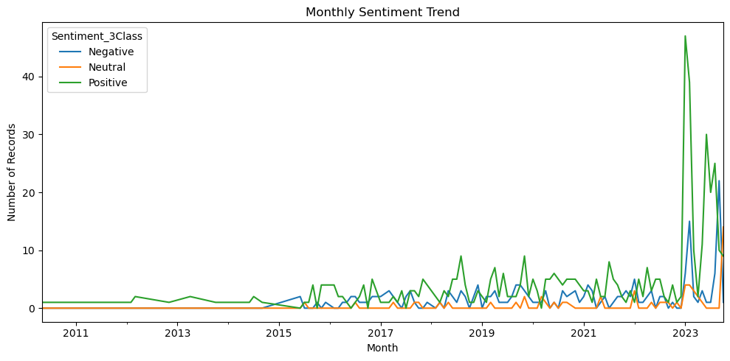
Figure 3. Number of sentiment posts per month (sentiment trend per month).
Over time. Activity is sparse before 2015 (typically one post a month) and heavily concentrated in 2023, so the time series is uneven and the early months should not be interpreted. Within 2023, January was strongly Positive (47 Positive, 6 Negative, 4 Neutral), and Positive posts also led in February, June, July and August. September 2023 is the clear break: Negative posts (22) outnumbered Positive posts (10), the only month in the highlighted period where this happens. October 2023 then shows an unusually high Neutral count (14, against 9 Positive and 1 Negative). The data show that something changed in these two months, but not why; linking it to a particular event would need additional evidence, such as topics or hashtags from those posts.

4. Confusion Matrix Interpretation
Table 4. Confusion matrix of Linear SVM (rows = actual, columns = predicted)
Actual / Predicted | Negative | Neutral | Positive
Negative | 28 | 0 | 10
Neutral | 0 | 2 | 9
Positive | 1 | 0 | 97

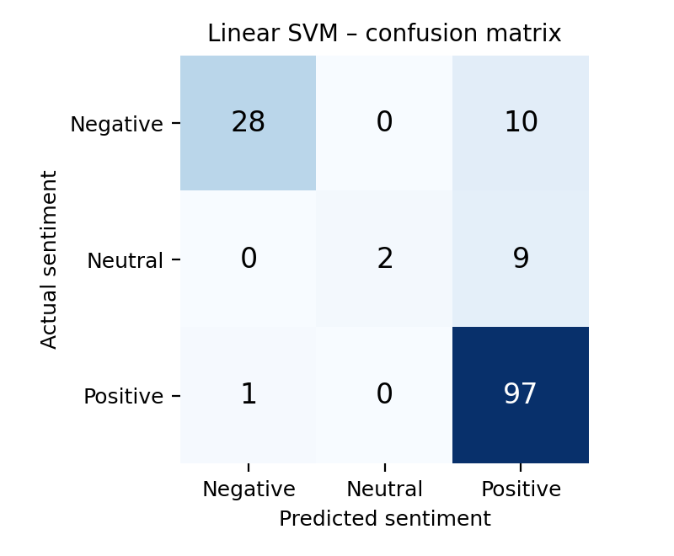
Figure 4. Confusion Matrix of Linear SVM.
The SVM classified 127 of 147 test posts correctly. Almost every Positive post was found (97 of 98), and 28 of 38 Negative posts were correct. The hard class is Neutral: only 2 of 11 were identified, and 9 of the 11 were labelled Positive (recall 0.18). Every error in the matrix points in one direction, toward Positive: 10 Negative and 9 Neutral posts were pushed into it, while almost nothing moved the other way.
Neutral is confused most often in proportion (82% of Neutral posts went to Positive), while Negative posts sent to Positive are the largest number in absolute terms (10). I see three plausible explanations, although I did not test them directly. First, there are only about 44 Neutral posts in the training set, so the model sees very little evidence for that class and the Positive class dominates the decision. Second, Neutral posts are often plain descriptions of activity (for example, "trying a new recipe for dinner tonight") that contain no emotional vocabulary to separate them from mildly Positive posts. Third, the Neutral class is built from unrelated emotion labels such as Confusion, Challenge, Journey and Ambivalence, so its members share little common wording. Using balanced class weights did not solve the problem, which suggests the limitation lies in the amount and consistency of data rather than only in the algorithm.

5. Limitations and Improvement
- Derived labels. The three-class target comes from my own mapping of 191 emotion names, not from human sentiment annotation. Some choices are debatable (Surprise, Nostalgia or Yearning could reasonably go either way), so part of the model's error may reflect label noise.
- Class imbalance and small test size. Neutral has 55 posts in total and only 11 in the test set, so one extra correct prediction changes its recall by about 9 points. The Neutral results are therefore unstable and should be read as a direction, not a precise figure.
- Uneven time coverage. Most posts fall in 2023 and many earlier months have a single record, so month-to-month comparisons outside 2023 are unreliable.
- Bag-of-words features. It is insensitive to the order of words in a sentence, doesn't pay attention to the context of the words, and doesn't capture many of the implications of sarcasm, negation or subtle emotion.
Improvement idea. The next step would be to correct/re-label the Neutral examples, collect more of such examples and then use Stratified k fold cross validation and hyper parameter optimization (for an SVM, the C value). A pre-trained transformer, such as BERT, which is able to learn the context, may be more appropriate for dealing with negation and phrasing than TF-IDF.

6. Business Implication and Conclusion
This is a good way to begin screening; however, as a decision maker, this is not suitable for a company. It's the power of monitoring at scale – it will continuously find positive posts and when it finds there's a negative post it is correct 97% of the time, which means that a review staff will not follow false alarms. Sadly it can't seem to capture about ¼ of the really 'Negative' posts (10 of 38) and most of the 'Neutral' posts. My recommendations are:
- Keep humans in the loop. Use the model to prioritise which posts to read, and do not assume that posts it labels Positive or Neutral are safe to ignore.
- Monitor trends rather than single posts. Watching the Negative share over time would have highlighted September 2023 as a month to investigate, and an alert on a sudden rise in Negative or Neutral posts is a practical use of this system.
- Do not tailor strategy by platform on this evidence. Sentiment mix is similar on Facebook, Instagram and Twitter, with Twitter only slightly more negative.
- Invest in better data before scaling. More and more consistently labelled Neutral and Negative examples would improve reliability more than changing the algorithm.
In conclusion, a TF-IDF and Linear SVM pipeline reached 86.39% accuracy and 84.34% weighted F1 on three-class social media sentiment, clearly ahead of Naive Bayes and slightly ahead of Logistic Regression. Positive sentiment dominates the data and all platforms, September 2023 stands out as a negative period, and the Neutral class remains the main weakness. The approach is a sound and practical baseline, and its limits are best addressed with better labels, more data and context-aware models.

