Software Requirements and Design Document

For

BRIGHT WHEELS CAR WASH

**Prepared by**

**Murtaza Kazmi 21i-0685**

**Muhammad Waleed 21i-0438**

**<OREZENTTE>**

**20th November 2023**

**Table of Contents**

**Table of Contents ii**

**1.** **Introduction 1**

1.1 Purpose 1

1.2 Product Scope 1

1.3 Title 1

1.4 Objectives 1

1.5 Problem Statement 1

**2.** **Overall Description 2**

2.1 Product Perspective 2

2.2 Product Functions 2

2.3 List of Use Cases 3

2.4 Extended Use Cases 3

2.5 Use Case Diagram 10

**3.** **Other Nonfunctional Requirements 11**

3.1 Performance Requirements 11

3.2 Safety Requirements 11

3.3 Security Requirements 11

3.4 Software Quality Attributes 12

3.5 Business Rules 12

3.6 Operating Environment 12

3.7 User Interfaces 13

**4.** **Domain Model 18**

**5.** **System Sequence Diagram 19**

**6.** **Sequence Diagram 30**

**7.** **Class Diagram 41**

**8.** **Package Diagram 41**

**9.** **Deployment Diagram 42**

# Introduction

## Purpose

## The purpose of the Software Requirements Specification (SRS) document is to outline the functionalities and features of the Bright Wheel Car Wash app. This SRS covers the entire scope of the app's functionality related to car wash management. It encompasses various modules aimed at simplifying car wash scheduling, station management, staff administration, login security, and user registration. This document details the specific software requirements necessary to develop and implement these modules within the app framework.

## The scope of this Software Requirements Specification includes all the essential components and functionalities required for the successful operation of the Bright Wheel Car Wash app. It encompasses the user-facing aspects (such as appointment scheduling and registration) as well as the backend functionalities (like station schedule management and staff administration). This SRS focuses solely on defining the software requirements for the car wash management system and does not extend to other parts of the broader car wash infrastructure or unrelated systems

## Product Scope

Bright Wheels Car Wash, your car cleaning companion in Pakistan, offers hassle-free access to premium car wash services. Schedule your car wash and enjoy a sparkling clean vehicle, all from the palm of your hand

## Title

“BRIGHT WHEELS CAR WASH”

“Experience the Ultimate Car Wash Convenience with Our Car Wash App”

## Objectives

## The application is equipped with various modules to simplify car wash management. First, the Appointment Management Module enables users to effortlessly schedule and manage their car wash appointments, ensuring a seamless experience. The Car Wash Station Schedule Management Module assists car wash station operators in efficiently organizing their schedules, guaranteeing timely service. Furthermore, the Staff Management Module simplifies the administration of car wash employees' details. The Login Module ensures secure access for both customers and car wash staff, emphasizing data security. Lastly, the Registration Module offers a user-friendly sign-up process for newcomers, expanding the app's accessibility. These modules together create a robust car wash management system, enhancing accessibility, efficiency, and security in the car cleaning industry.

## Problem Statement

The decision to undertake the Bright Wheel Car Wash app project stemmed from a critical need within Pakistan's car cleaning industry. The existing methods of scheduling car wash appointments were often cumbersome, leading to inconvenience and inefficiencies for both customers and car wash station operators. Traditional systems lacked a streamlined approach, resulting in missed appointments, long wait times, and operational challenges for car wash businesses. This project aimed to address these pain points by introducing a comprehensive, user-friendly app that streamlines car wash management.

The problem at hand revolved around the lack of a modernized system for scheduling and managing car wash appointments. Customers faced difficulties in finding available slots and managing their wash schedules, leading to frustration and inconvenience. On the other side, car wash station operators struggled with inefficient scheduling methods, resulting in underutilization of resources and difficulties in providing timely services. The Bright Wheel Car Wash app aimed to bridge this gap by introducing a digital platform that allows users to easily book appointments, aids operators in managing schedules effectively, and ensures a seamless experience for both parties.

Regarding feasibility, initial assessments highlighted the viability of the project. Market research indicated a high demand for a more convenient car wash scheduling solution, indicating a substantial user base. Technological advancements and the availability of mobile app development tools suggested that creating such an application was within reach. Additionally, the potential for revenue generation through subscription models or service fees further supported the project's feasibility. Overall, the project was deemed feasible based on market demand, technological capabilities, and potential financial viability.

# Overall Description

## Product Perspective

The Bright Wheel Car Wash app is a new, self-contained product developed to revolutionize car wash management in Pakistan. It doesn't serve as a replacement for existing systems but stands as an independent platform designed to address the inefficiencies in traditional car wash scheduling methods. The app operates as a standalone system, enabling seamless interaction between car wash station operators, administrators, and customers. The system doesn't integrate with other external systems but provides a comprehensive solution within its own framework.

## Product Functions

1-User Management:

Registration of new users.

Customer verification process.

2-Appointment Management:

Booking car wash services.

Selecting desired services.

Making payments for services.

3-Feedback and Reviews:

Allowing users to submit feedback and reviews.

4-Staff Administration:

Managing employees.

Administering employee profiles.

5-System Administration:

Managing user profiles.

Maintaining inventory supplies.

Adding or dropping services.

Activity Records:

Recording and managing activity logs

## List of Use Cases

Use Case 1: Register User

Use Case 2: Verify Customer

Use Case 3: Booking Service

Use Case 4: Select Service

Use Case 5: Make Payment

Use Case 6: Submit Feedback/Reviews

Use Case 7: Manage Employees

Use Case 8: Manage Profile

Use Case 9: Inventory Supplies

Use Case 10: Add/Drop Services

Use Case 11: Activity Records

## Extended Use Cases

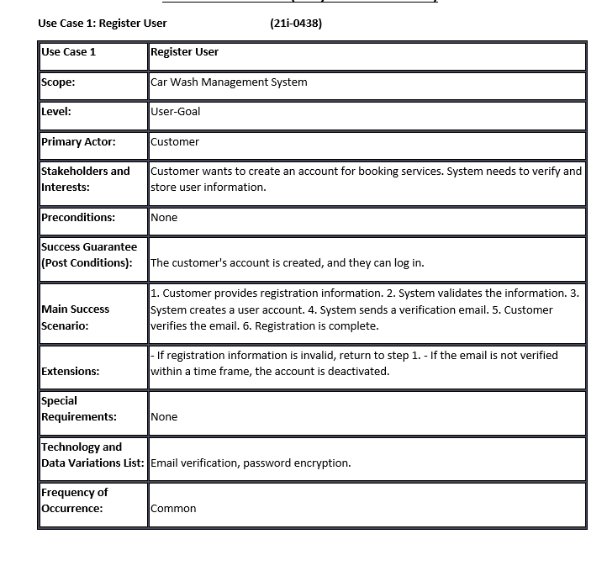z

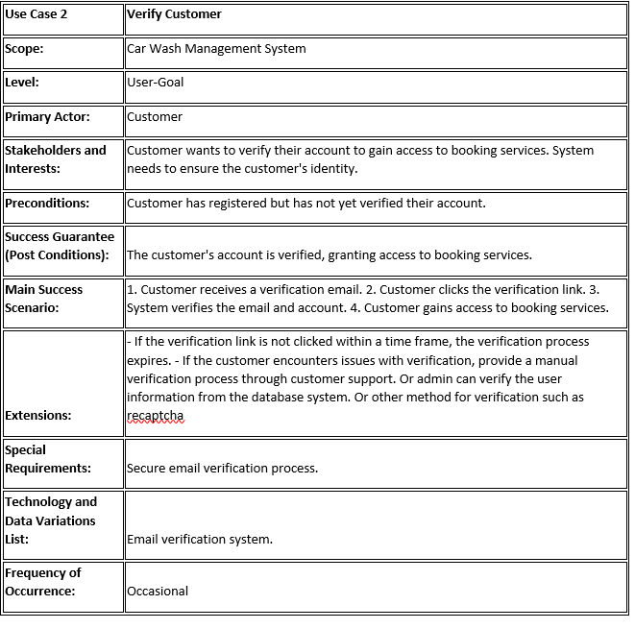

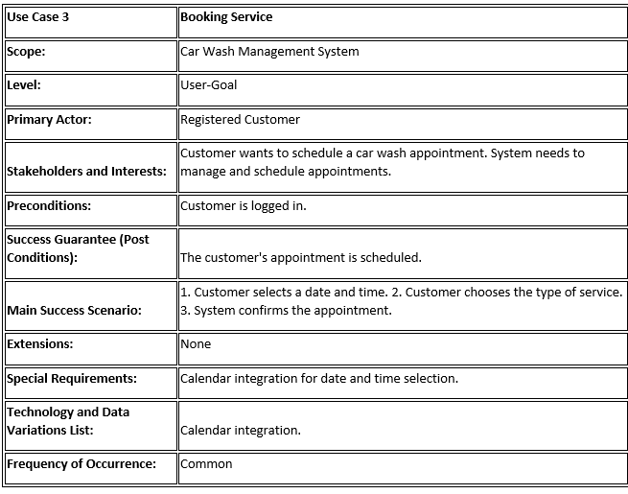

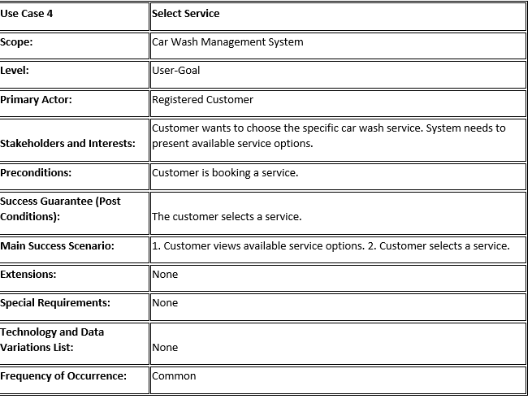

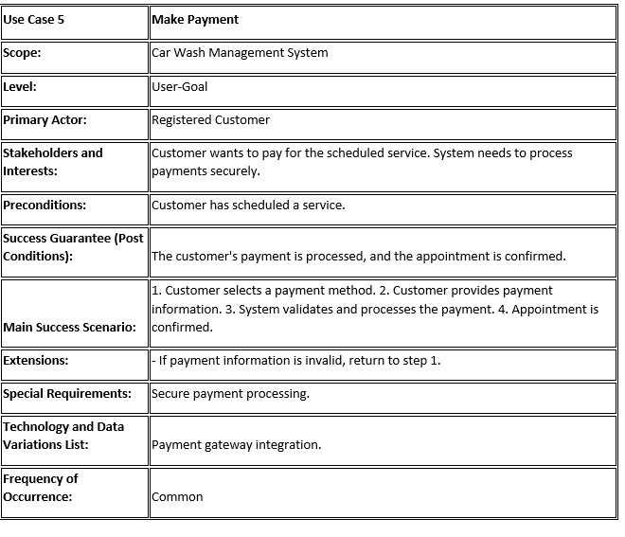

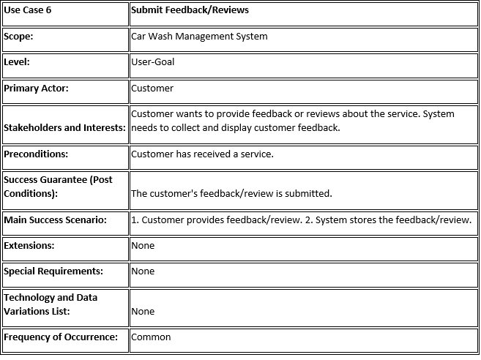

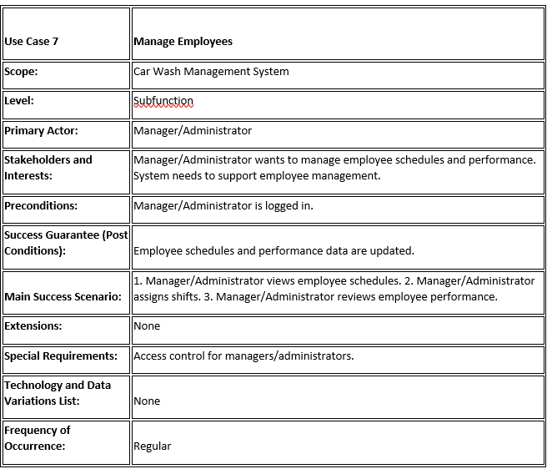

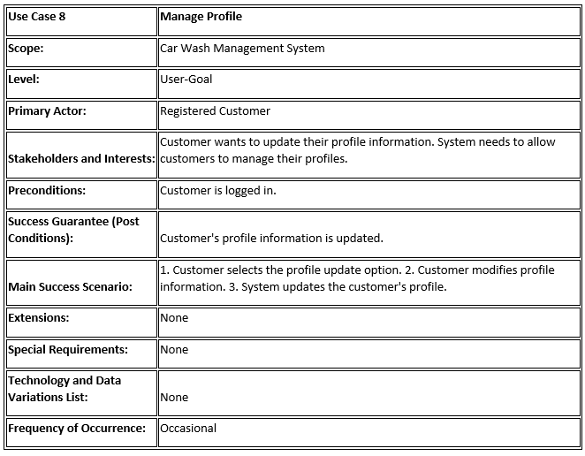

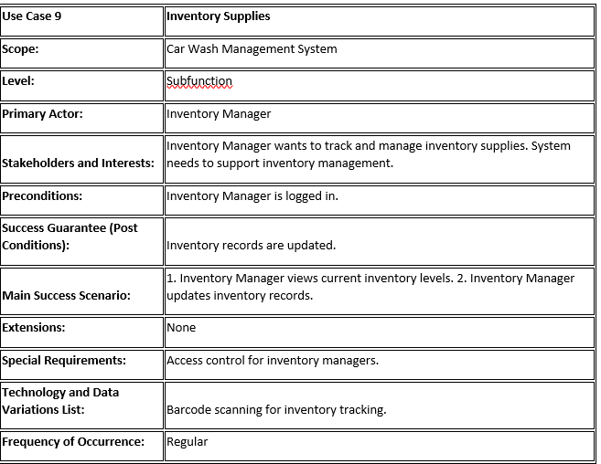

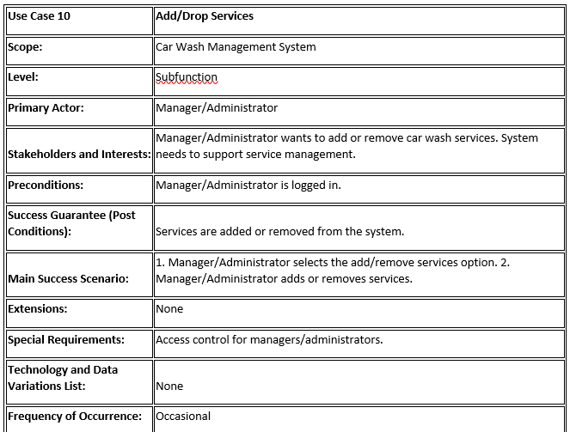

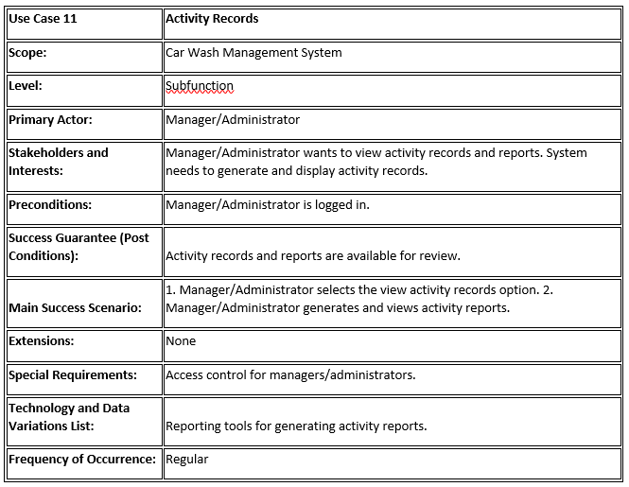

## Use Case Diagram

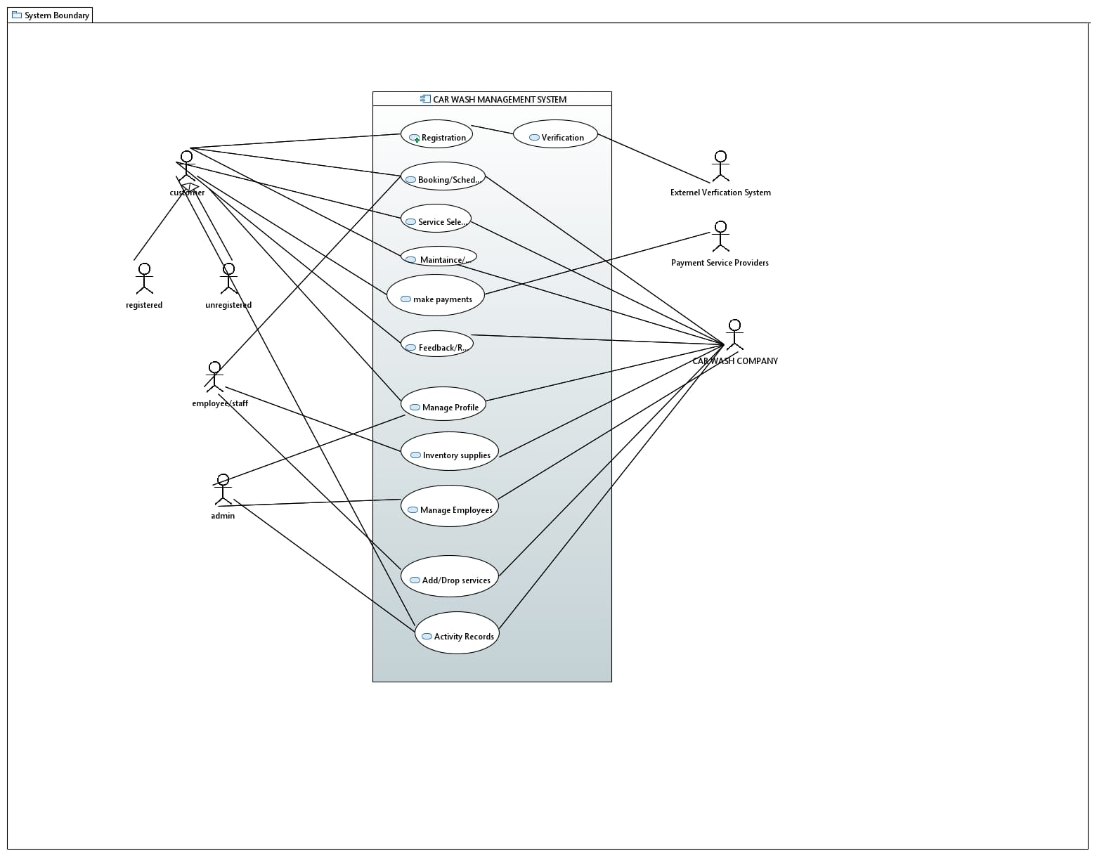

# Other Nonfunctional Requirements

## Performance Requirements

## Response Time:

## Rationale: The app should respond swiftly to user actions to ensure a seamless experience. Requirement: 95% of user interactions (booking, service selection, payment) must have a response time of less than 3 seconds.

## Scalability:

## Rationale: As user base and data grow, the app should remain responsive and efficient. Requirement: The system should support a 20% increase in user base and data load without a significant degradation in performance.

## Reliability:

## Rationale: The app must be available during operational hours. Requirement: 99.9% uptime during standard operational hours.

## Security Response:

## Rationale: To prevent data breaches and ensure secure transactions. Requirement: Encryption/decryption operations for user data must be completed within 0.5 seconds.

## Safety Requirements

## Data Security:

## Rationale: Protect user information and financial transaction. Requirement: Comply with industry-standard encryption protocols (such as SSL/TLS) for all data transmissions.

## User Authentication:

## Rationale: Ensure only authorized access to user accounts. Requirement: Implement multi-factor authentication for staff members accessing sensitive information.

## Compliance:

## Rationale: Adherence to legal and industry standards. Requirement: The app must comply with data protection laws like GDPR or any local data privacy regulations in Pakistan

## Security Requirements

## User Authentication:

## Requirement: Implement strong user authentication mechanisms such as password encryption and multi-factor authentication for staff members accessing sensitive data.

## Data Encryption:

## Requirement: Utilize industry-standard encryption protocols (e.g., SSL/TLS) for securing data transmissions between the app and servers to protect user information and transactions.

## Compliance:

## Requirement: Ensure compliance with data protection laws

## Software Quality Attributes

## Reliability:

## Requirement: The app should maintain 99.9% uptime during standard operational hours to ensure reliability.

## Maintainability:

## Requirement: Codebase and system architecture should be designed for easy maintenance and future updates without disrupting core functionalities.

## Usability:

## Requirement: The app should provide a user-friendly interface for both customers and staff to ensure ease of use.

## Business Rules

## User Roles:

## Rule 1: Customers can book services, submit feedback, and view their own appointment history.

## Rule 2: Staff members have access to managing schedules, employee profiles, and inventory supplies.

## Operating Environment

Platform: The app should be compatible with both iOS and Android operating systems.

Hardware: Compatible with standard smartphones and tablets commonly used in Pakistan.

Integration: Should operate independently without direct integration with other car wash infrastructure systems.

## User Interfaces

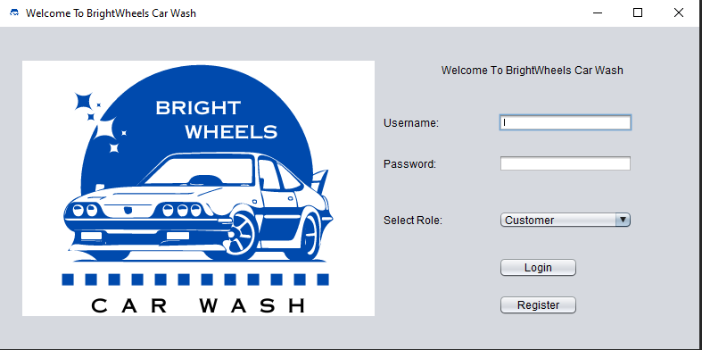

1: Customer Interface:

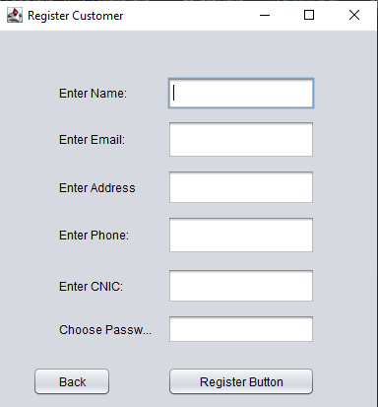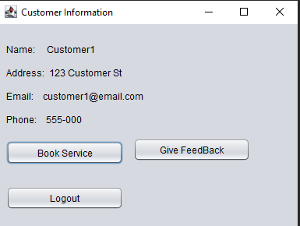

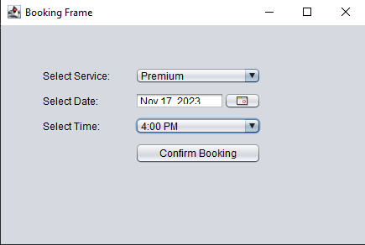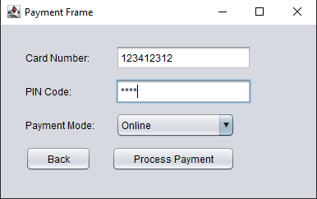

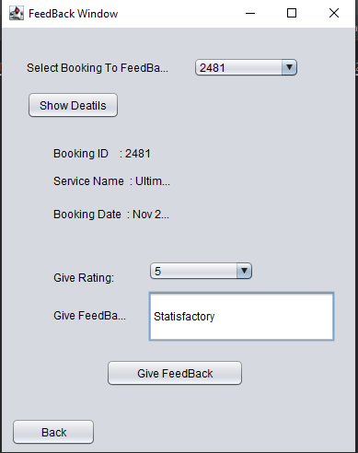

2: Employee Interface

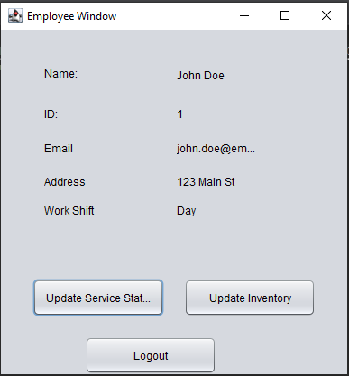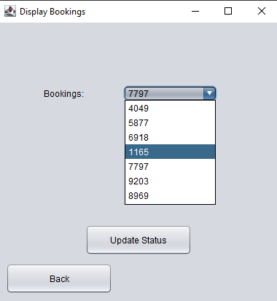

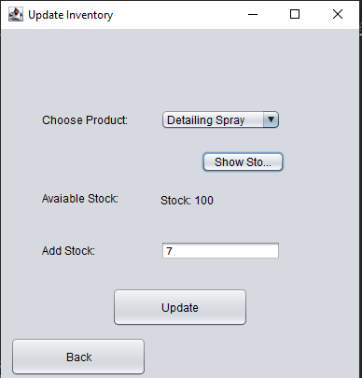

3: Admin interface

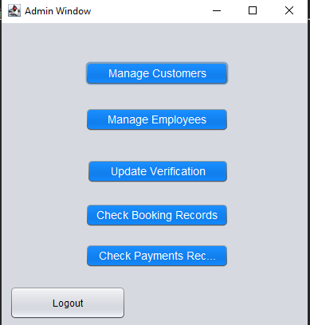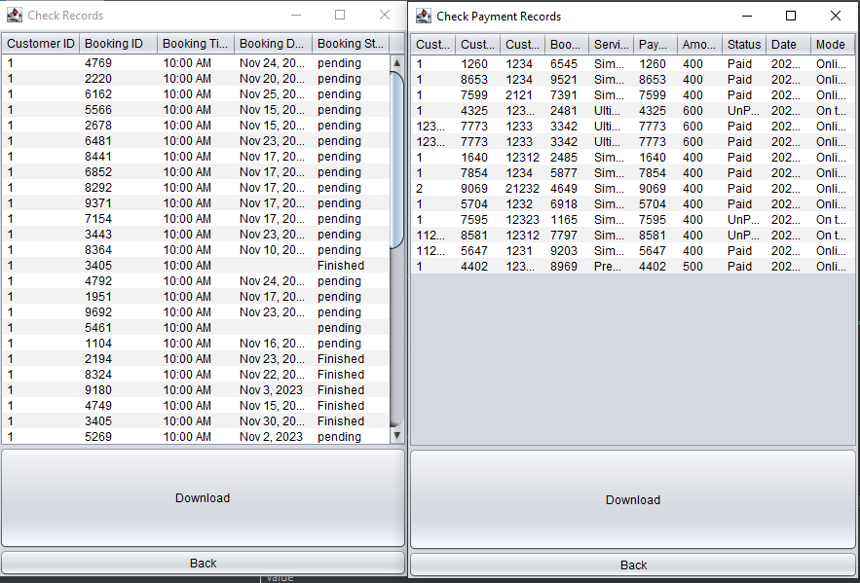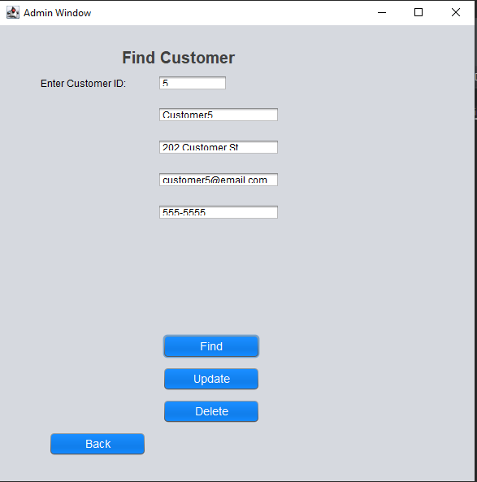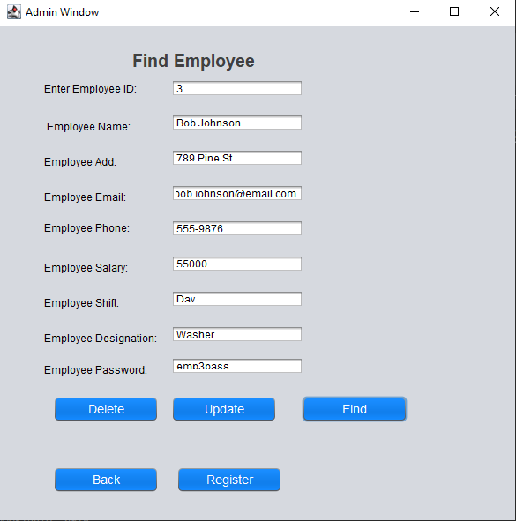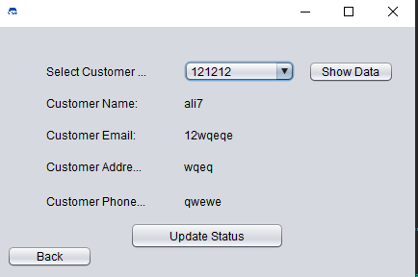

# Domain Model

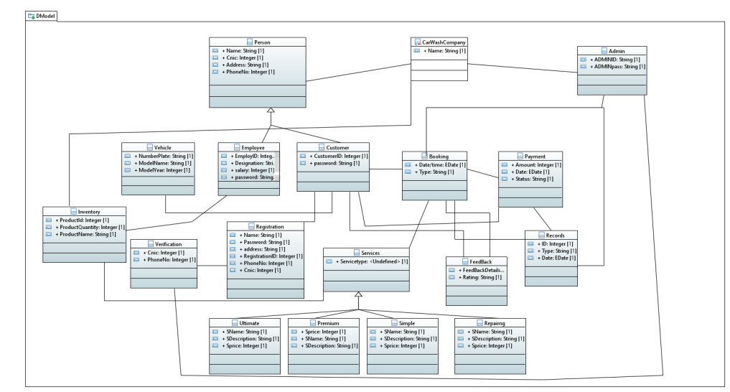

# System Sequence Diagram

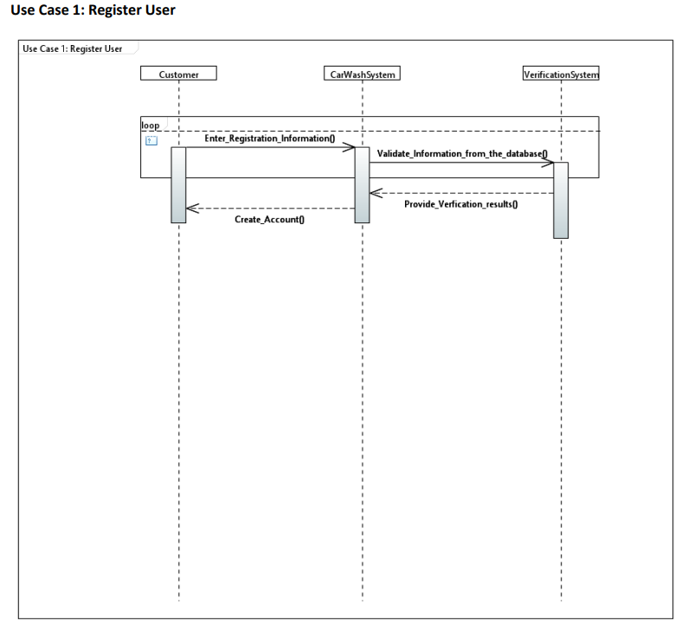

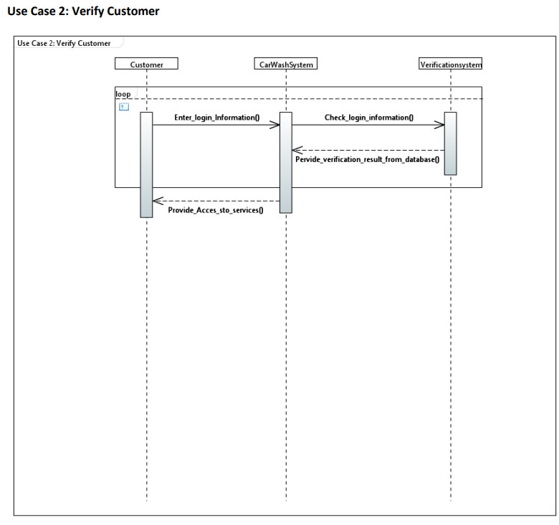

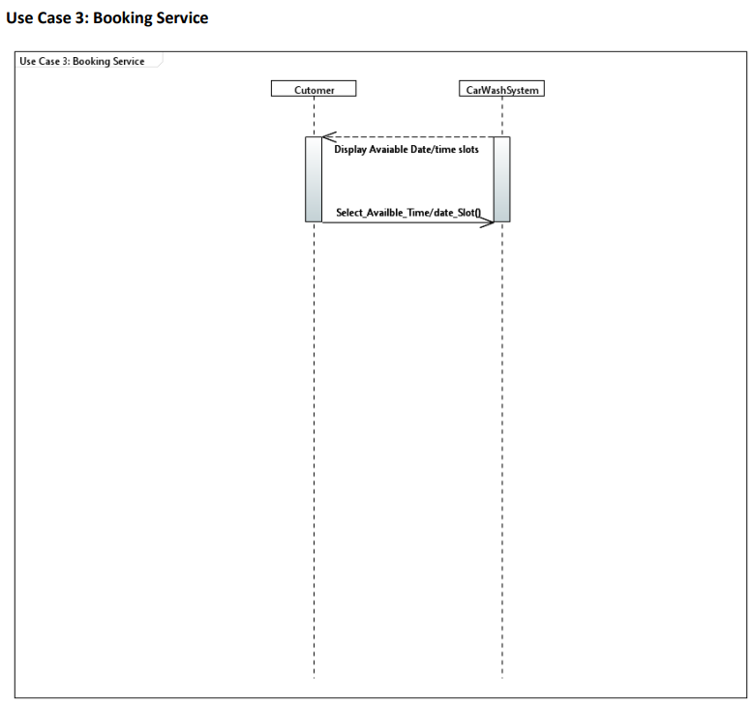

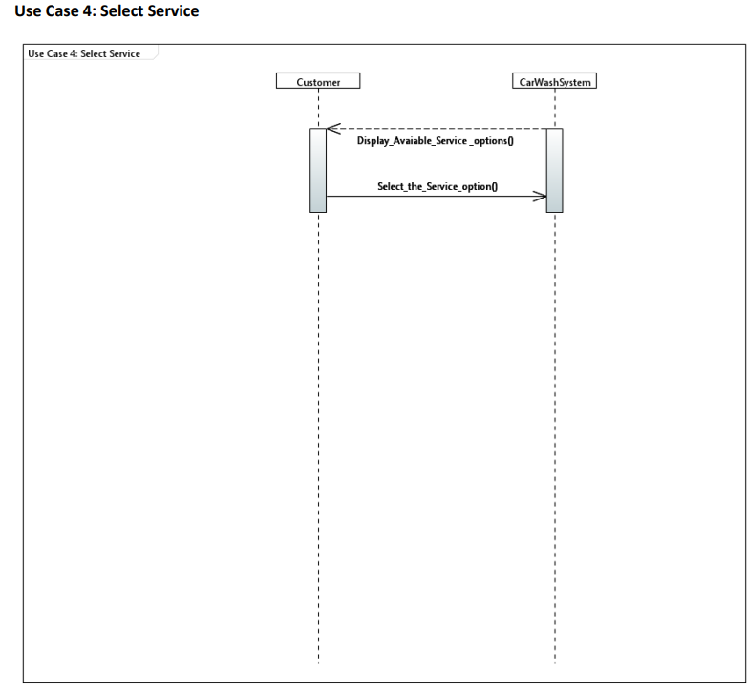

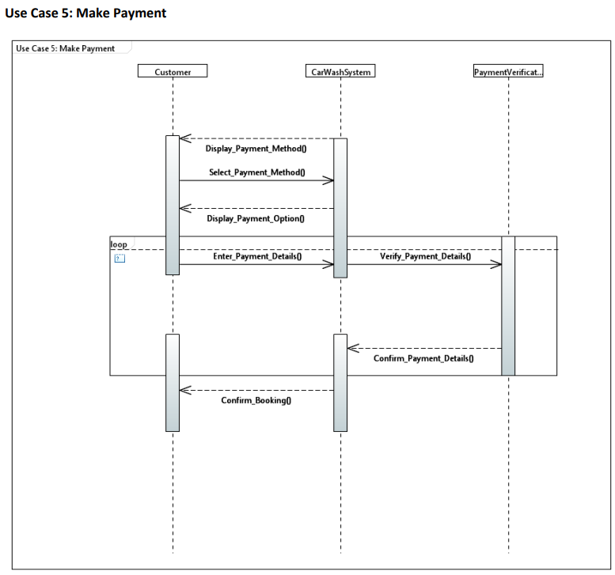

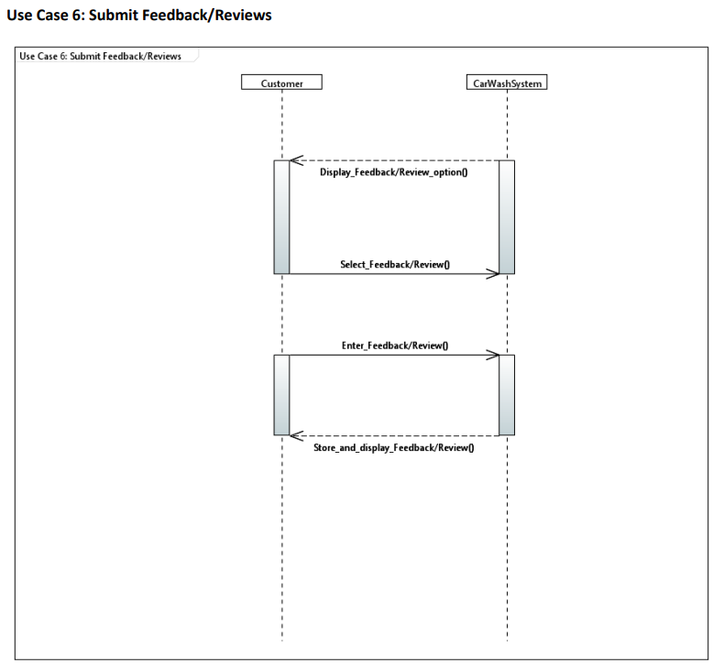

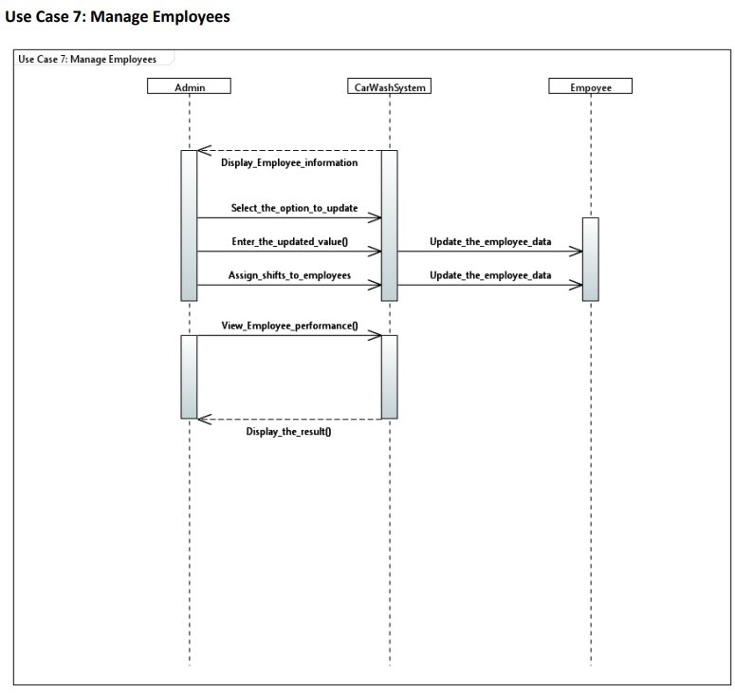

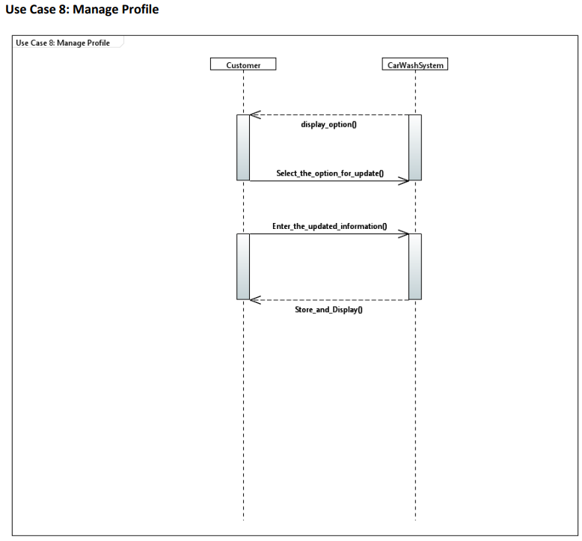

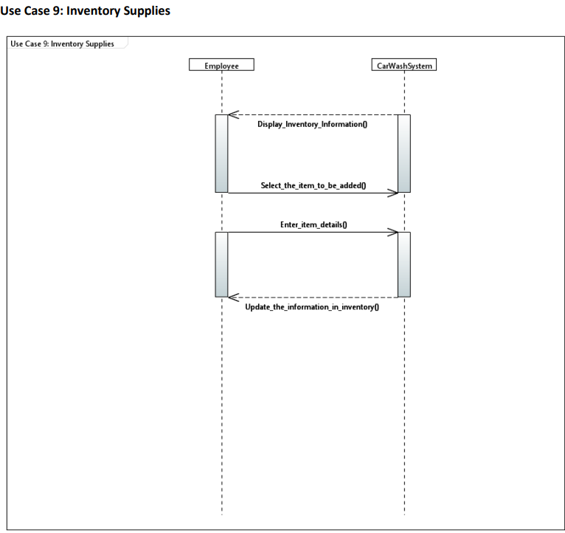

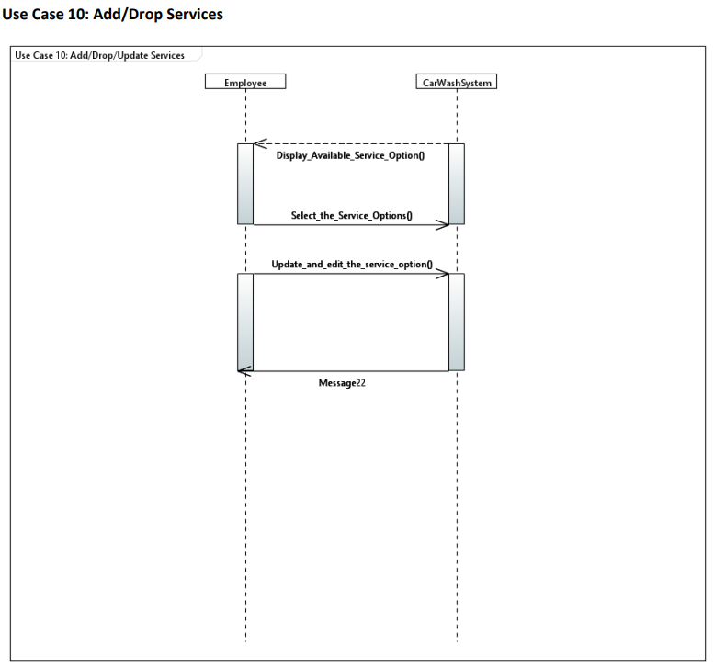

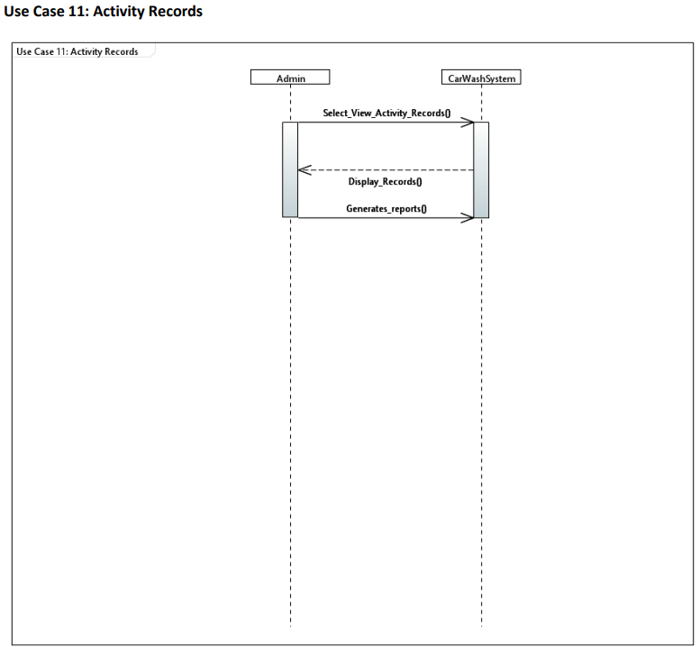

# Sequence Diagram

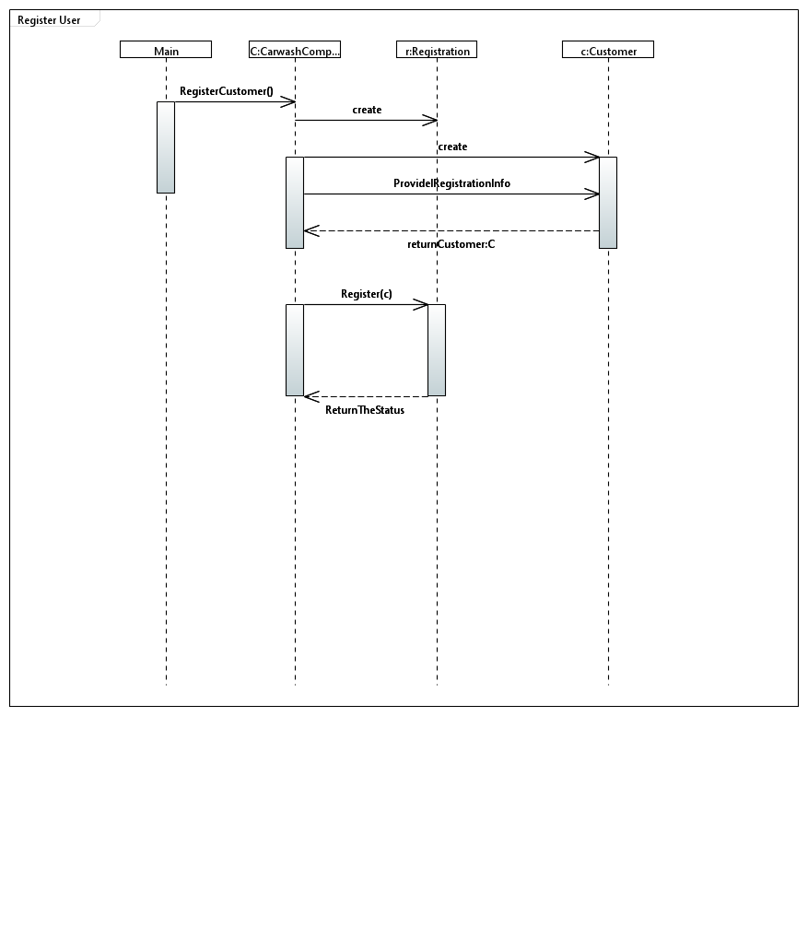

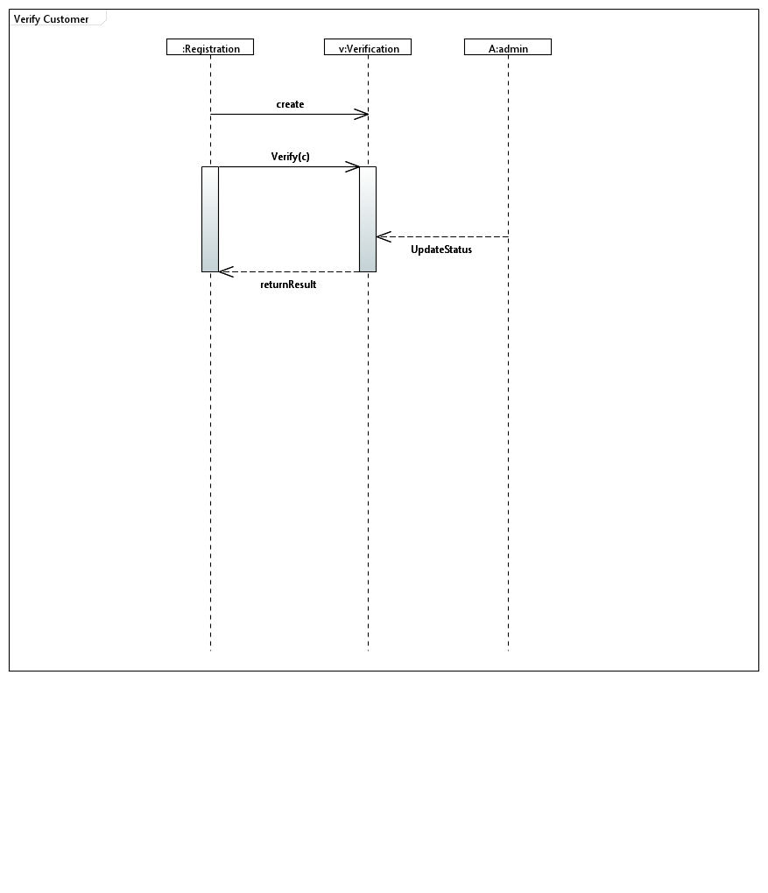

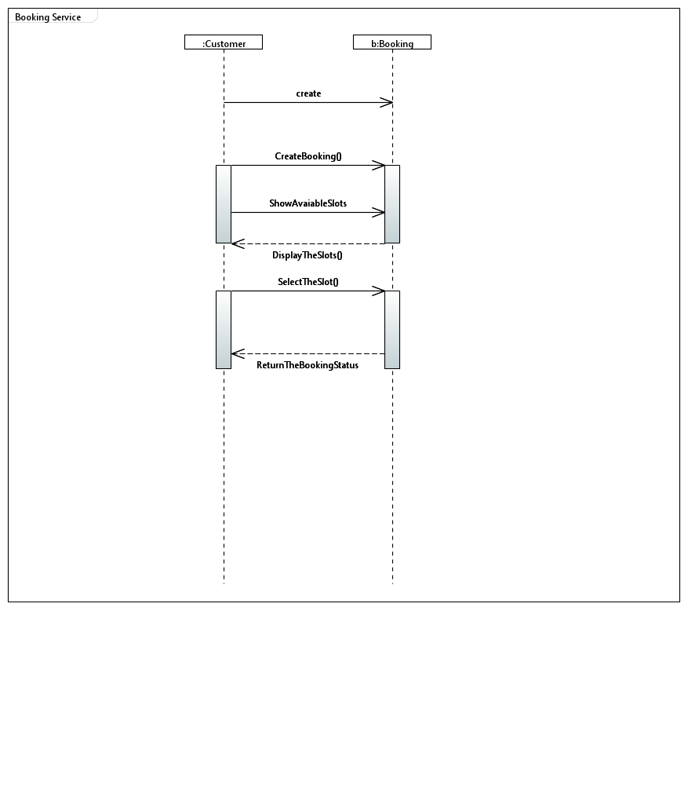

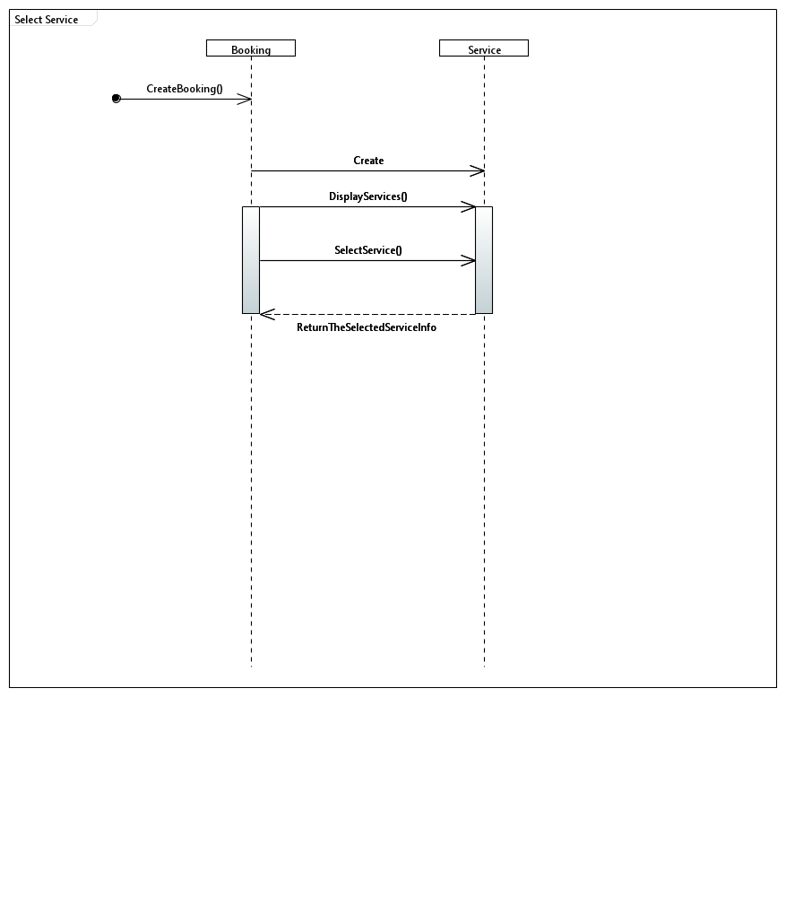

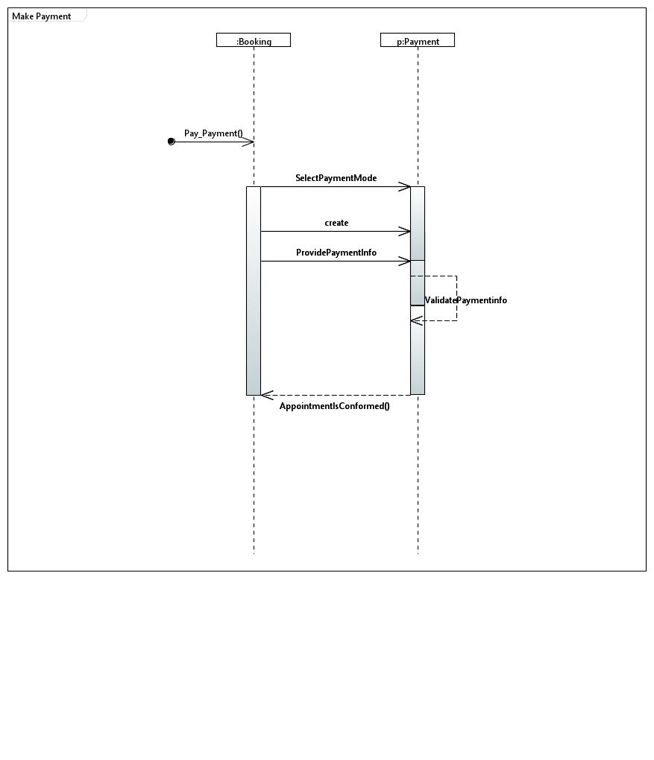

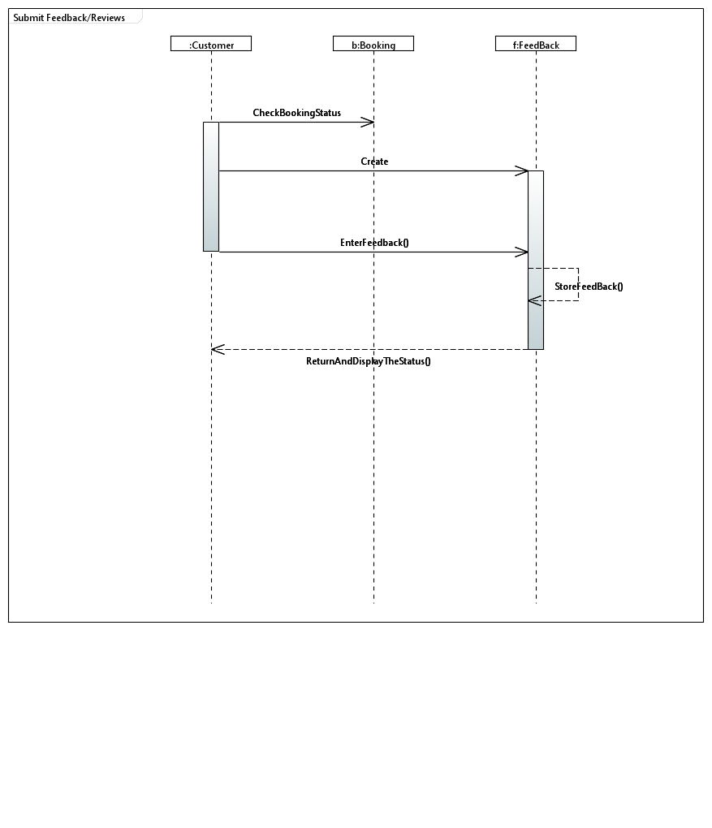

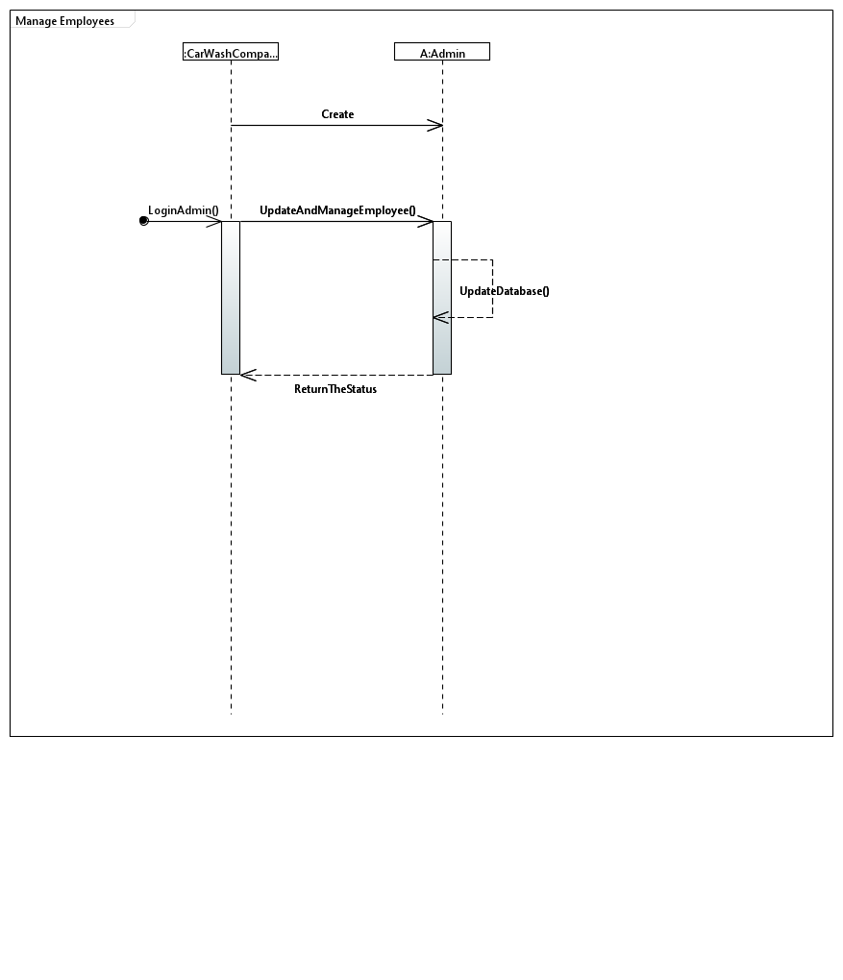

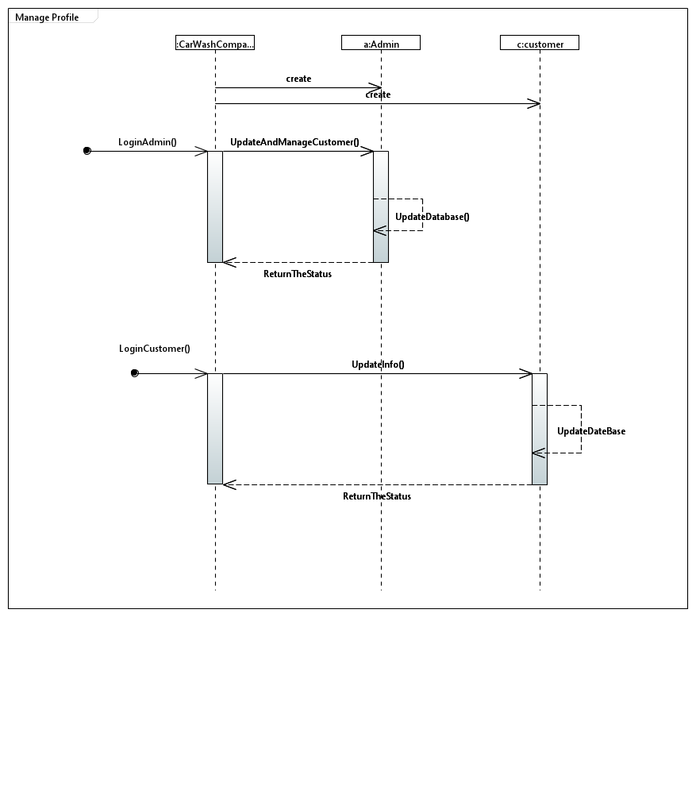

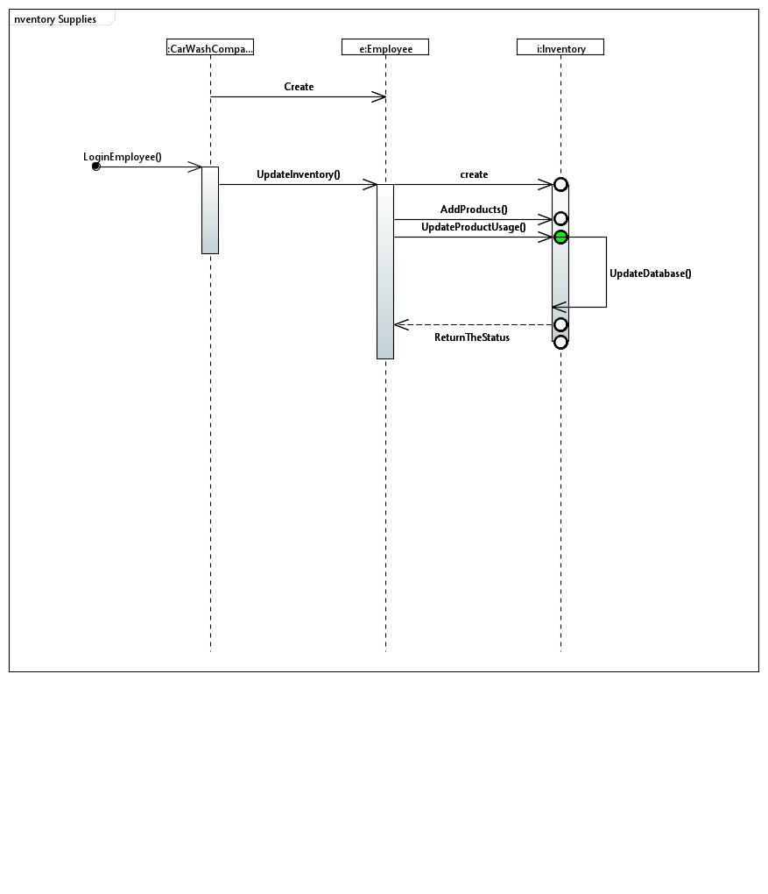

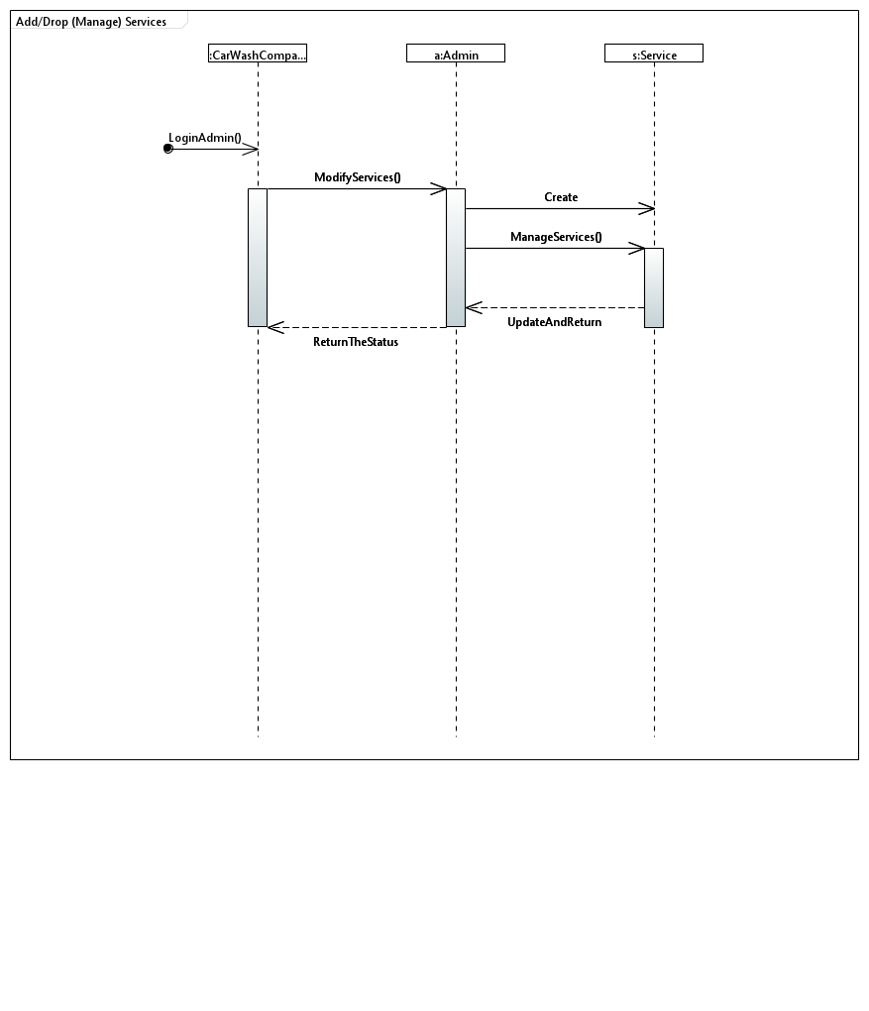

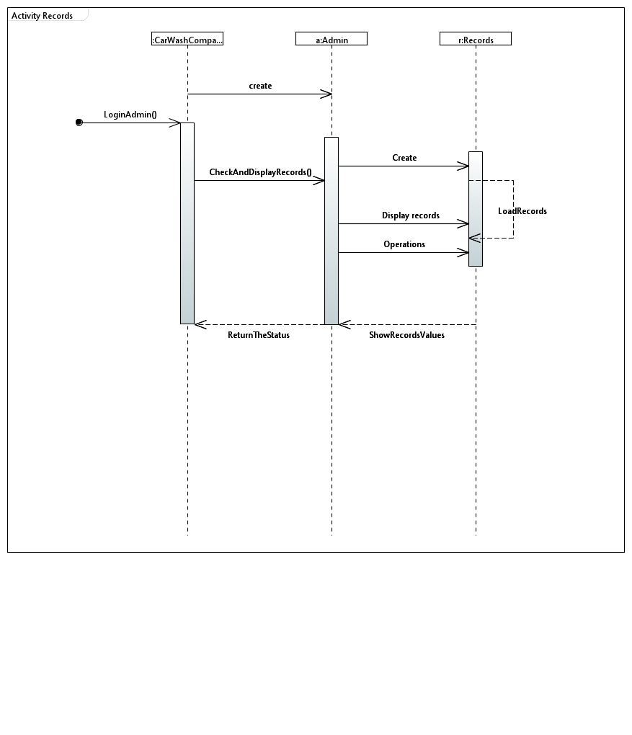

# Class Diagram

# 

# Package Diagram

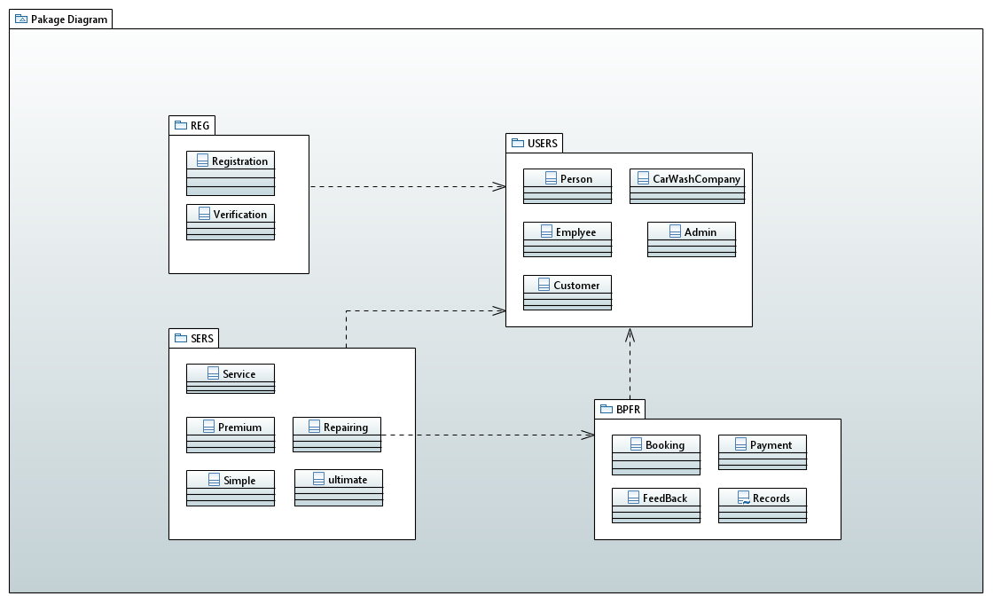

# Deployment Diagram

