University of Duisburg-Essen

Praxisprojekt Real-Time Mobile NLP Analysis WS20/21
Natural Language Processing

Authors:
Abdulsatar Sayed : abdulsatarsayed@stud.uni-due.de
Ahmad Hussien :ahmadhussien@stud.uni-due.de
Ashraf Hashash :ashrafhashash@stud.uni-due.de

Table of Content

Introduction 3
Natural Language Processing 3
Project Goals 4
Related Works 4
Layout 4
Frontend 5
Backend 7
Experiments 7
Conclusions 7

Introduction
Text Analytics is the process of converting unstructured text data into meaningful data for analysis, to measure customer opinions, product reviews...etc.
Text Analytics involves information retrieval from unstructured data and the process of structuring the input text to derive patters and trends and evaluating and interpreting the output data. It also involves lexical analysis, categorization, clustering, pattern recognition, tagging, annotation, information extraction, link and association analysis, visualization, and predictive analytics. Text Analytics determines key words, topics, category, semantics, tags from the millions of text data available in an organization in different files and formats. The term Text Analytics is roughly synonymous with text mining. Text analytics software solutions provide tools, servers, analytic algorithm-based applications, data mining and extraction tools for converting unstructured data into meaningful data for analysis. The outputs, which are extracted entities, facts, relationships are generally stored in a relational, XML, and other data warehousing applications for analysis by other tools such as business intelligence tools or big data analytics or predictive analytics tools.

Natural Language Processing
(NLP): Text analytics software uses natural language processing algorithms to detect language, process text, classify topics, and perform readability assessments. It also provides services like parsing, tokenization, sentence segmentation, named entity extraction, and part-of-speech tagging.

Project Goals

The aim of the project is to develop a mobile application for the android operating system.
The mobile application, the so-called "Partyholic" describes those who cannot stop going to the party, that's why it is called „Partyholic”.
The mobile application should read out a clear text and find out the relevant information in this text. In our case we are interested in the address and the date or time, which come from a clear text.
“Partyholic” mobile application then searches for the given address with the help of “Google Maps API” and determines the destination and the associated route starting from the current location to the destination, and the remaining time should also be shown on the screen.

Related Works
At the beginning we thought about what our application should do. That cost us a couple of online sessions, then we had the idea to create an application for those who want to party a lot, so you could save time instead of writing the location on google maps, it is enough to take a photo.

Design
First of all, we started with the layout, we selected a suitable colored design that fits our application.
There were several possibilities to design the layout, with the help of InVision Studio we determined and designed the number of activities.
If you click on the icon of the application, you go to the home screen and the functionality of the application is shown in a small text.
In this case you have two options either by click the camera button or the gallery button, in both cases an access message will be shown to the user and the user has to select a photo to find out the information that he is looking for.

Frontend
Based on our previous experiments we decided to use the framework "android Studio" for the Frontend design.
Our decision is based on the advantages of the "Android Studio" framework such as:
1-Apply Changes
Android Studio's Apply Changes feature lets you push code and resource changes to your running app without restarting your app—and, in some cases, without restarting the current activity. This flexibility helps you control how much of your app is restarted when you want to deploy and test small, incremental changes while preserving your device's current state.
2-Intelligent code editor
The code editor helps you write better code, work faster, and be more productive by offering advanced code completion, refactoring, and code analysis. As you type, Android Studio provides suggestions in a dropdown list. Simply press Tab to insert the code.
3-Fast and feature-rich emulator
The Android Emulator installs and starts your apps faster than a real device and allows you to prototype and test your app on various Android device configurations: phones, tablets, Android Wear, and Android TV devices. You can also simulate a variety of hardware features such as GPS location, network latency, motion sensors, and multi-touch input.
We used XML to create the front-end design, such as the design of buttons and activities.
XML stands for Extensible Markup Language. It is a text-based markup language derived from Standard Generalized Markup Language (SGML).
XML tags identify the data and are used to store and organize the data, rather than specifying how to display it like HTML tags, which are used to display the data. XML is not going to replace HTML in the near future, but it introduces new possibilities by adopting many successful features of HTML.
There are three important characteristics of XML that make it useful in a variety of systems and solutions.
- XML is extensible − XML allows you to create your own self-descriptive tags, or language, that suits your application.
- the data irrespective of how it will be presented.
- XML is a public standard − XML was developed by an organization called the World Wide Web Consortium (W3C) and is available as an open standard.
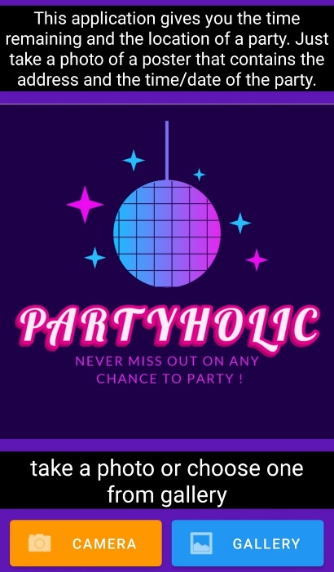
In total we have 3 activities with different functions:
Home activity: the application is defined here, and the functionality of this application is shown to the user.
Camera or Gallery Activity: after the user has clicked on one of the two buttons "Camera" or "Gallery" on the home screen, he comes to this activity and an access message is shown before the camera or the gallery is reached.
Result activity: this activity shows the result that comes from the backend. Detailed information is spoken in the section Backend.
Functionality:
We used Java for the functionality of the front end because we already had experience with Java.
the following is some important information that we have used in the course of the project.
At the beginning we imported a couple of libraries such as:
android.Manifest, android.content.Intent, androidx.annotation.RequiresApi,
androidx.core.app.ActivityCompat, com.google.android.gms.maps.GoogleMap, java.io.DataOutputStream ... etc
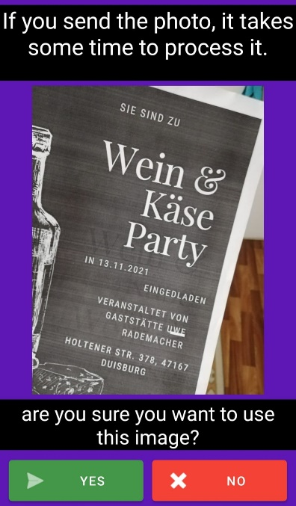
Then we carried out variable declarations that we need in our project, for example: private static Location currentLocation, Date, Time, Address ... etc

In the following we explain some functions that we have used for the frontend.
When the icon is clicked, the "onCreate" method is called and the "home activity" is shown.
On the home activity the button Camera is clicked so the method "onclickCamera" is called and the following is executed:
an object "takePictureIntent" of the type "Intent" is declared and initialized and then the camera is opened.
If the button Gallery is clicked, the method onClickGallery is called and the following is executed:
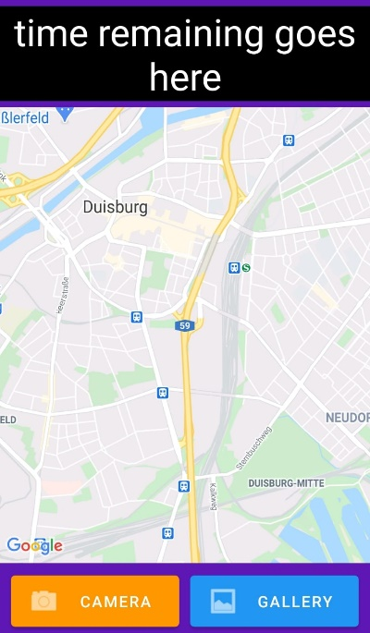
a "photoPickerIntent" object of the "Intent" type is declared and initialized. The object "photoPickerIntent" is required to fetch a picture from the gallery.
Another method such as onClick is called when you click the No button on the gallery activity and thus the user is redirected to the home activity.
And another function is “OnClickShowLocation”:
basically trying to run the method "onMapReady" again, which in turn checks for permission, and if the permission is given, then it runs and shows current location on map, and if not, then it keeps the map hidden in delegates to the user, to click this button in order to try again.a

Backend

As mentioned in the section “Project Goals” the user is capable to explore or capture an Brochure of a party with his/her mobile phone and get the direction to the party (shown on google maps) and the remaining time.
Since our app involve image processing and optical character recognition (OCR) it will be more efficient to estimate our goals with server-client architecture because the mobile processor is not much powerful as Computer processor
Because of that we separate our Project in two independent parts:

- the front-end is the part which is installed on the android mobile and the back-end part which is running on the cloud

- the back-end server is dedicated to get an image from front-end and analyze It to extract the desired information.

We choice the python based framework (Flask) to build our server since it is simple and easy to be deployed on Heroku In order to achieve our goals we need some steps to take:

Receiving the image from the mobile app

after capturing an image with the app or exploring an old one , the image will be sent to the server as a stream of bytes whereas the server will receive these stream of bytes and write it in the home directory and give this image a unique name to distinguish it from other requests since the server can receive more than one request in the same time from different users .

When the image is no more needed after sending the response to the app it get deleted so that the home directory is not filled with unnecessary files and the storage will not run out of capacity.

Applying the OCR on the received image

The Process of extracting the text of an image called optical character recognition (OCR)
and it is a complex process which involve neural network and machine learning.

There is an open-source engine to apply OCR on an image called tesseract and we try to use it first
but it appears that this engine is developed to be applied on a scanned book documents and it gives in that case very accurate and reliable results.

But in our project the data we need to process are colorful images and after applying the tesseract on some test cases we did not get an accurate result even after many experiments with reprocessing as filtering, Re-scaling, Blurring, and image Thresholding.

Because of that we choice to do this step by a third-party API which is OCR. space and
they offer a free API-KEY but some limitation.

One of this limitations is the file size, which should be less than 1 MB and therefore we compress the image so that it will be always under this limitation .

Detecting the related information from the text

We did this step with regular expression (Regex), which is the manual way or (rolled based way) in Natural language processing (NLP) to detect a specific pattern in a given text.
As we are aiming the German user, we specify our app just for the German language.
We define some patterns to detect the time of the party, which could be as followed:
(um 20:00 Uhr ) or (um 18 Uhr) As well as for the date For example:
(am 12.04.2021) or (am 12-januar-2021)

And also for detecting the addresses, which were not doable just with regular expression
because it is not possible to detects all possible addresses without trained data and machine learning
So, we just tried to catch the most address patterns and it seems that the word “Straße” appeared on the most street name’s in Germany depending on this website:

http://interactive.zeit.de/german-streetnames/
and it also help us to find other common patterns.

Resolving the coordinate of the address

In order to show the location of the party on user’s google maps we need a geocoder, which is an API to resolve the coordinate of an address

We try first to use the google-API-geocoder but google does not let us to use this service before adding an Credit card and therefore we switch to an open geocoder it called “Nominatim” and it does not required an API-key to use it.

Sending the response to Front-End
The last step is adding all extracted information which is the address, date ,time ,coordinate to a JSON file and send it to the front-end

In case of the image does not have one of the mentioned information or the server could not extract it this part will filled in the JSON file with “Unknown”.

Implementation

Conclusions
After the completion of the project, our knowledge of the importance and impact of Natural Language Processing „NLP “on the technical revolution increased, especially in the field of applications, in addition to increasing our experience of how it works and how to make the best use of it and put it into practice.
And we have a clear vision of how to build an application in all its stages, starting from discussing the idea of ​​the project and the problems that may face us within a working group and how to find solutions for searching in various sites and passing through how to design the Graphic user interface, build the server and link the user interface to the appropriate API.
In addition to testing the program to find out and troubleshoot problems, and to end with developing the program in accordance with the needs of users.

