**ST. THOMAS’ COLLEGE OF ENGINEERING**

**AND TECHNOLOGY**

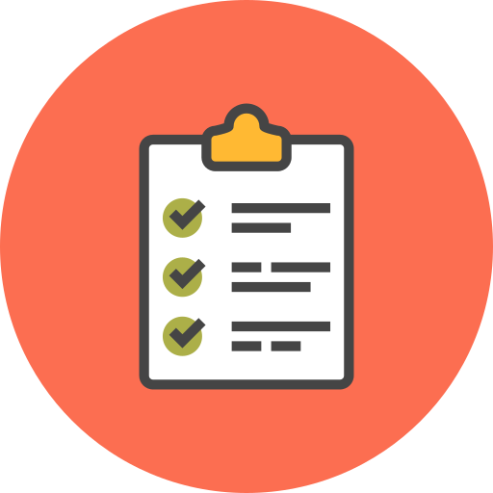

**REPORT**

**ON**

**TODO APP**

***BY GROUP* NO. -13**

**MEMBERS:**

* **Argha Mukherjee (ROLL 49)**
* **Sumon Nath (ROLL 50)**
* **Abhishek Kumar Pandey (ROLL 51)**
* **Utkarsh Pandey (ROLL 52)**

**INDEX**

1. INTRODUCTION
2. TECHNOLOGIES INVOLVED
3. METHODOLOGY INVOLVED
4. SYSTEM DESIGN
5. DATABASE SCHEMA
6. SNAPSHOTS OF APPLICATION
7. FUTURE SCOPE
8. CONCLUSION

**INTRODUCTION:**

This project is about developing an android app ‘To Do List App’. Nowadays, this gadget are rolling the world. Many people cannot imagine even one day without their favourite mobile device. We use the for everything find information, stay connected with our friends and family members, find the way around, decide what to do, and many other things.

To do app basically help users to list up the tasks that we want to perform. After completion of the task, he marks that has done or deletes the task. The user specifies a date within which he needs to complete his work.

**TECHNOLOGIES INVOLVED:**

Android SDK(Android 9 API 29):

The android is a powerful operating system and it supports large number of applications in Smartphones. These applications are more comfortable and advanced for the users. It is an open source operating system means that it’s free and anyone can use it.

Realm Database:

Realm is an open source object database management system. In our application, we have used the realm database for storing the news details which will be saved by the user for future reading.

Java Programming language:

Java is a general-purpose programming language that is class-based, object-oriented (although not a pure OO language, as it contains primitive types), and designed to have as few implementation dependencies as possible. It is intended to let application developers write once, run anywhere, meaning that compiled Java code can run on all platforms that support Java without the need for recompilation. Java applications are typically compiled to bytecode that can run on any Java virtual machine (JVM) regardless of the underlying computer architecture. The syntax of Java is similar to C and C++, but it has fewer low-level facilities than either of them. As of 2018, Java was one of the most popular programming languages in use according to GitHub, particularly for client-server web applications, with a reported 9 million developers.

**METHODOLOGY:**

* The first page of the app is the login page. User can access the page by logging in through this page.
* If the user is new to the app, then the app creates an account of the user. Tf an account is already created, then the user can log in and it will show welcome toast and proceed.
* The next activity is a floating-point button to add new task. In this activity user gives the description of his task, it includes the name of the task, description about the task within task details, date within the task is to be completed and a colour selection part. On clicking submit button, all the details of the user are stored in the database.
* Realm database is used to store data.
* The concept of Nav-Drawer is used introduced in the app the app where, if the drawer is drawn, then the user finds an option through which he can directly exit from the app.
* On this activity, we can see the records or the pending tasks of the user.
* After completion of the task, user can delete the task by swapping the desired task. Thus, the task gets cleared.
* Another option is kept for clearing all tasks at once, when required with this feature.

**SYSTEM DESIGN:**

Our To-Do Application design is following a sequence of steps through moving between different activities.

It starts with the main activity. In this main activity the users are provided with login and sign up options. New users have to move to the sign-up activity where they are entering details like the user name, an email-Id, a phone number and a password. This information is stored in the user database and simultaneously a system generated user Id is provided to the user for login purpose. Pre-existing users can however move to the login page and enter their username and password which is being searched and matched for in the database and if authentication details are matched user is logged in or appropriate message is shown for failure. After logged in User can enter their tasks which will store in the database.

User enters the dashboard which will be containing the list of tasks pending ranging from zero to as many as desired. The tasks are displayed as a recycler view list. We have a navigation menu attached to the sidebar connecting to edit profile and logout options. User profile information is sent from the login page to the dashboard. Edit Profile will help to modify user’s data and logout exits the user from the app. We can move to the create task activity through the click of a button.

Task details like the name of the task, due date, task details and a holder colour for the recycler view item holder can be chosen by the user and is thus saved as Task information on clicking save button and we move back to the dashboard viewing the newly created task is being added to the list. We can also discard the task midway of filling the details and it will take us back to the dashboard.

Each task item also has a clickable image button to record which tasks have been completed and they will be removed from the list on beginning our next login session can also mark all existing tasks as checked with clicking one button. Pressing back from dashboard will also log us out from the system.

**DATABASE SCHEMA:**

A single Realm database was sufficient for our application and it consisted of two Tables as follows:

1.User:

|  |  |
| --- | --- |
| **attribute** | **data type** |
| surname | string (primary key) |

2.Task:

|  |  |
| --- | --- |
| **attribute** | **data type** |
| Task id | int (primary key) |
| Todo item | string |
| Details | string |
| Colour | string |
| Date | string |
| Username | (refers to User (user Id)) |

**Snapshots of the application:**

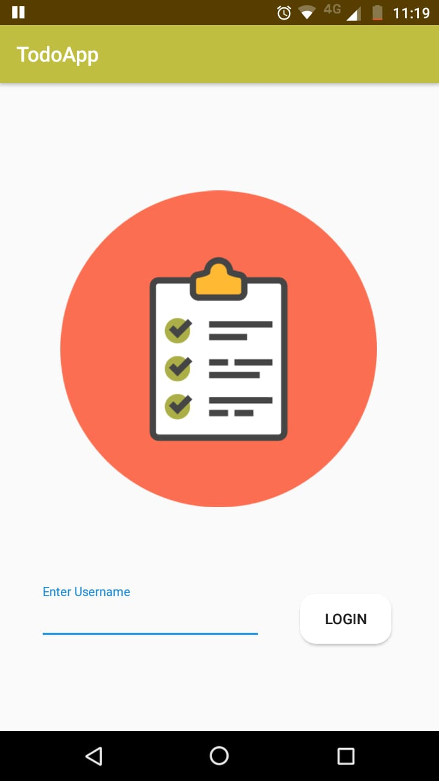 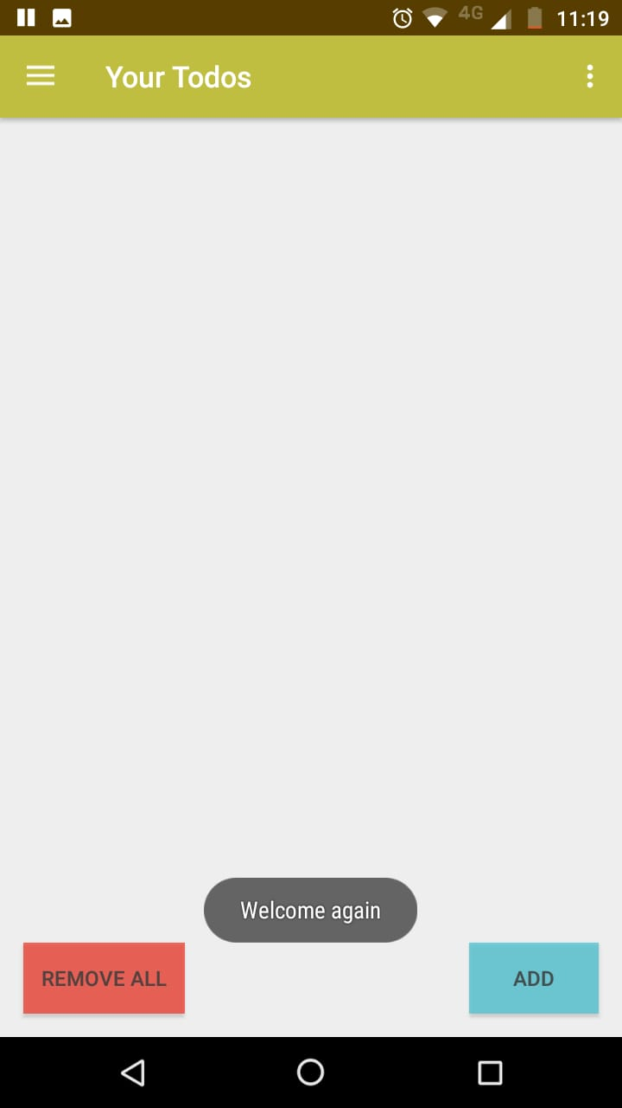 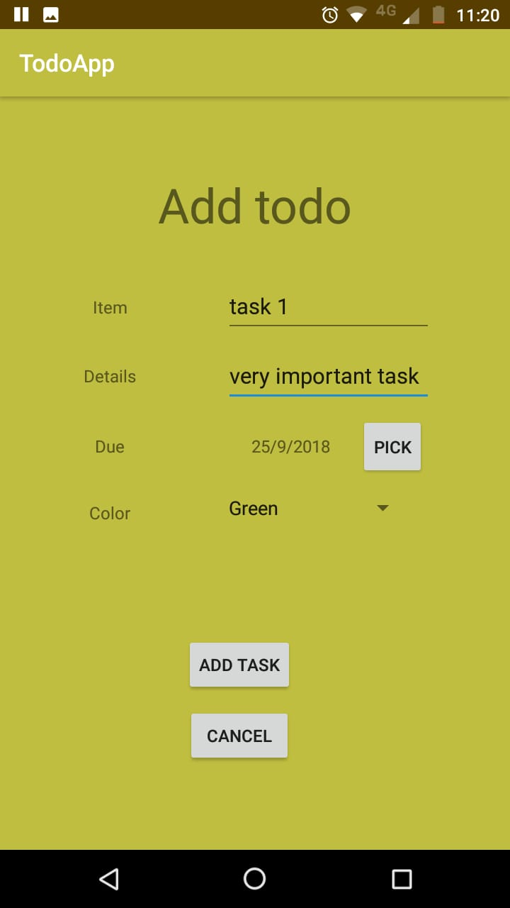

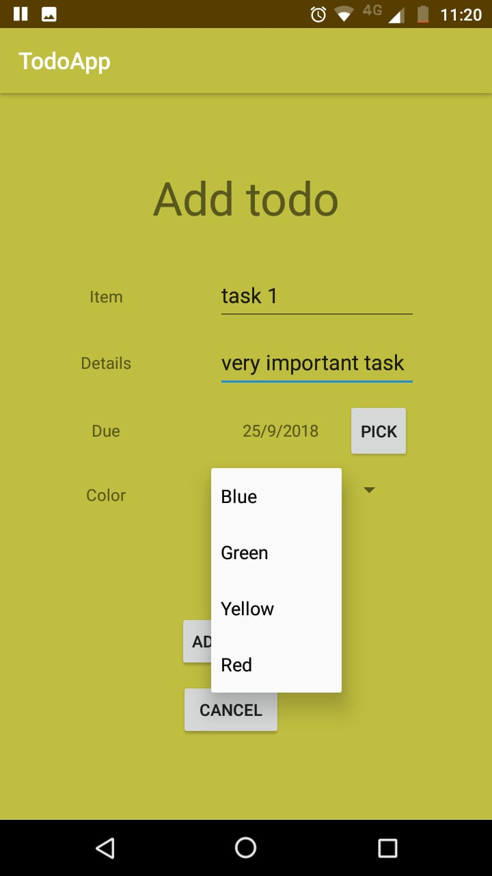 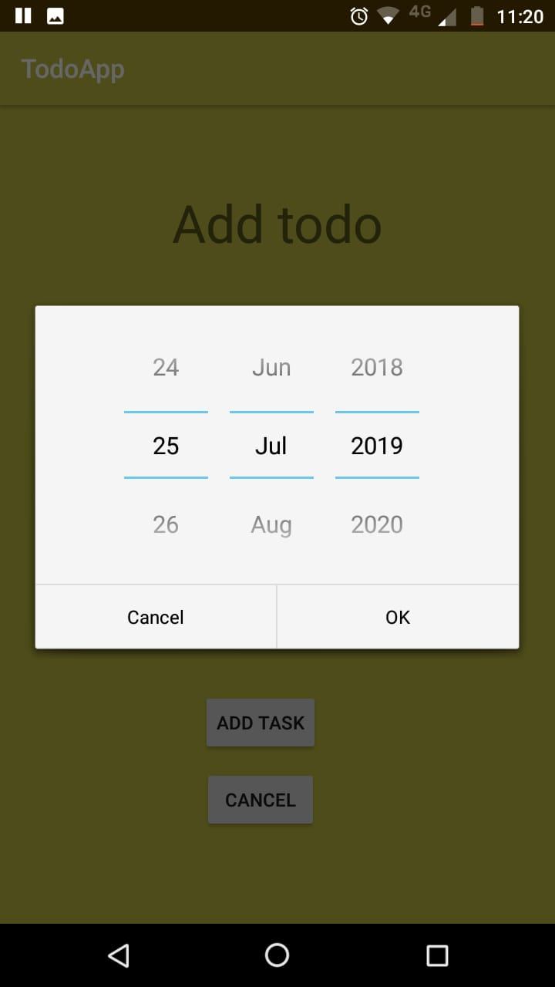 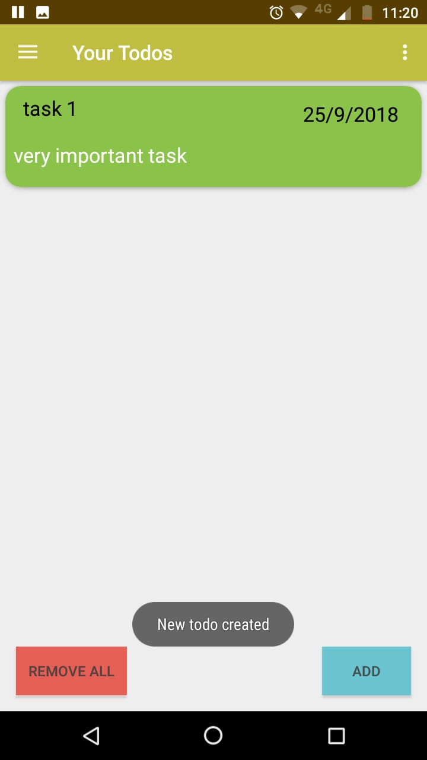

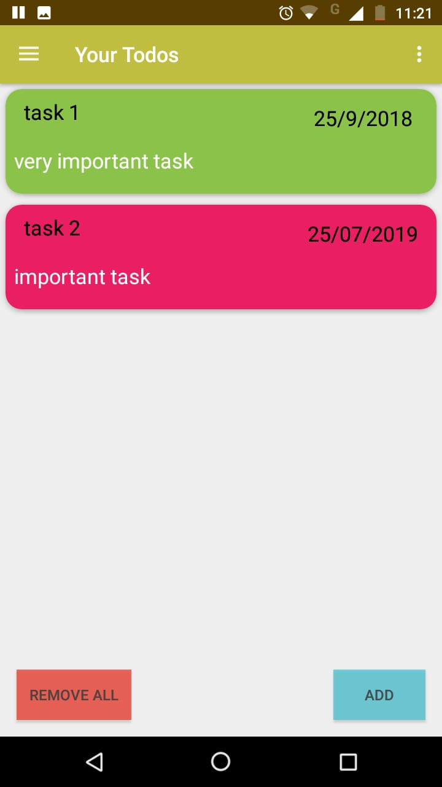 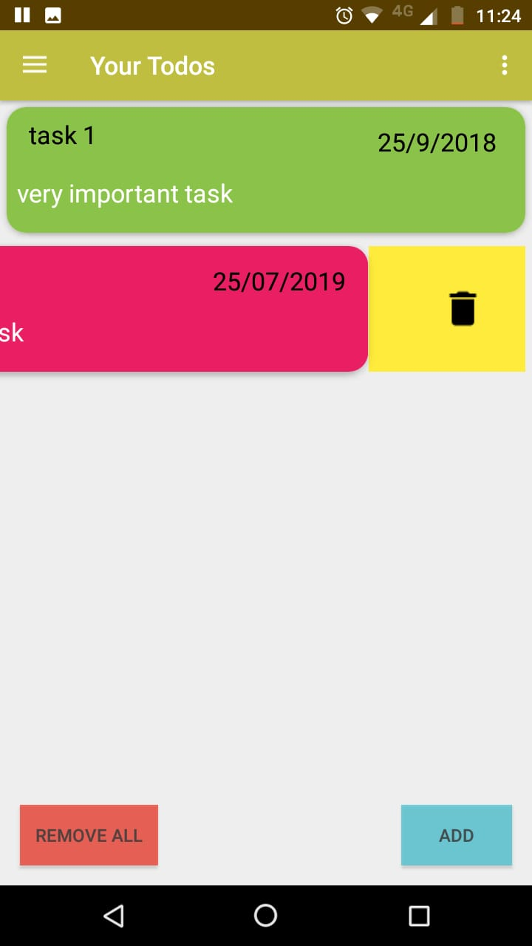 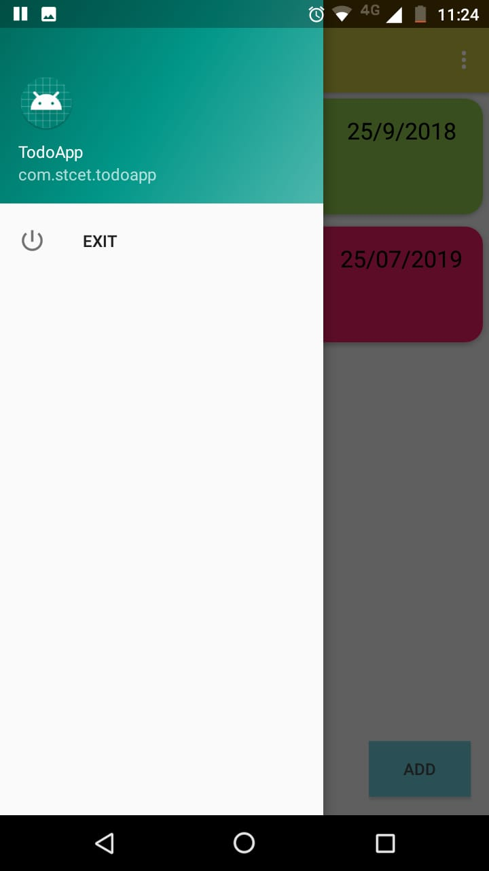

**Future Scope:**

Though due to time constraints we had to limit the scope of this project, but in the future, we can add extra functionality to improve the app. For e.g., we can introduce a feature called reminder that can remind the user about his pending task before due time. We can also keep a feature that will allocate a specific amount of time to complete his job and the countdown of the app will take care of the time the user is taking to complete his work. The app, in this way can also support time management.

**Conclusion:**

To conclude, this app, by listing down the tasks of the user will help user to get an image of

the tasks that he needs to complete within a specific date. He will be able to manage his tasks in a better way with the help of this app. After completing his work, he will mark his work as done and can also remove the already done task from the app. The app, by supporting the use of multiple users, assures a multiple number of people to manage their tasks with the help of a single app.