Title of the Thesis

Association of Occupational Exposure to Silica Dust and COPD

Investigator
Dr. Md. Sadequr Rahman
Resident (phase-B), Internal Medicine
Sylhet MAG Osmani Medical College, Sylhet.

Guide
Prof. Dr. A. F. M. Nazmul Islam
Professor and Head
Department of Medicine
Sylhet MAG Osmani Medical College, Sylhet.

Co-Guide
Dr. Md. Enayet Hossain
Associate Professor
Department of Medicine
Sylhet MAG Osmani Medical College, Sylhet.

Dr. Md. Delwar Hossain
Assistant Professor
Department of Respiratory Medicine
Sylhet MAG Osmani Medical College, Sylhet.

TABLE AND CONTENTS
Chapter No | Title | Page No.
List of tables
List of figures
Abbreviations
Abstract
Chapter-1 | Introduction
1.1 | Background
1.2 | Rationale of the study
1.3 | Research Question
1.4 | Hypothesis
1.5 | Objectives
Chapter-2 | Literature Review
2.1 | An overview of COPD
2.2 | Incidence and Prevalence of COPD
2.3 | Pathogenesis of COPD
2.4 | Diagnosis of COPD
2.5 | Risk Factors of COPD
2.6 | Exposure to Tobacco Smoke and Second-hand Smoke
2.7 | Exposure to Biomass Smoke and COPD
2.8 | Association of COPD and Socio-Demographic Profile
2.9 | Occupational Exposure to Silica Dusts and COPD
2.10 | Mechanism by which Silica dust can induce Emphysema and chronic bronchitis
2.11 | Combined effect of silica dust and smoking with COPD
Chapter-3 | Methodology
3.1 | Study Type
3.2 | Place & Period of Study
3.3 | Target Population & Study Population
3.4 | Eligibility criteria
3.5 | Addressing Ethical Issues
3.6 | Determinations of Sample
3.7 | Sampling Method
3.8 | Variables Studied
3.9 | Operational Definitions
3.10 | Procedure of Data Collection
3.11 | Laboratory Procedure
3.12 | Data Collection
3.13 | Statistical analysis
3.14 | Flow chart for the steps of study
Chapter-4 | Results
Chapter-5 | Discussion
5.1 | Discussion
5.2 | Strengths and limitations of the study
Chapter-6 | Conclusion and recommendation
6.1 | Conclusion
6.2 | Recommendations
Chapter-7 | References
Appendices

LIST OF TABLES
Table | Title | Page
Table I | Distribution respondents based on sex (n=200)
Table II | Distribution of respondents based on educational level (n=200)
Table III | Distribution respondents based on Smoking status of (n=200)
Table IV | Distribution of pattern of lung function among the respondents (n=200)
Table V | Distribution of COPD among the Smokers and non-smokers (n=200)
Table VI | Distribution of respondents according to length of service of (n=200)
Table VII | Distribution of the respondents based on body mass index (BMI) category (n=200)
Table VIII | Frequency of respiratory symptoms among the respondents (n=200)
Table IX | Distribution of COPD patient based on gender (n=78)
Table X | Distribution of gender and smoking status of the respondents (n=78)
Table XI | Distribution of smoker respondents based on pack year smoked (n=50)
Table XII | Distribution of GOLD severity grading among the COPD patients (n=78)
Table XIII | Distribution of pattern of lung function in case and control respondent
Table XIV | Association between Exposure to smoking plus Silica (vs Smoking) and COPD (Logistic regression analysis)

LIST OF FIGURES
Table | Title | Page
Figure I | Distribution of the respondents based on age group (n=200)
Figure II | Distribution of Protective equipment using among the respondents (n=200)
Figure III | Distribution of COPD patients based on age group (n=78)
Figure IV | Distribution of service length of the COPD patients (n=78)
Figure V | Distribution of protective equipment using among the COPD patients (n=78)
Figure VI | Distribution of service length and Gold Severity of COPD patients (n=78)
Figure VII | Distribution of case and control among the different age group
Figure VIII | Distribution of case and control among the different GOLD severity grade

ABBREVIATIONS
ATS | American Thoracic Society
BMI | Body Mass Index
BOLD | Burden of Obstructive Lung Disease
COPD | Chronic Obstructive Pulmonary Disease
CS | Cigarette Smoke
CI | Confidence Interval
EC | Endothelial Cell
ERS | European Respiratory Society
FEV1 | Force Expiratory Volume in 1st Second
FVC | Forced Vital Capacity
GLI | Global Lung Function Initiative
GOLD | Global initiative for Chronic Obstructive Lung Disease
HIC | High Income Countries
LMICs | Low- and Middle-Income Countries
LLN | Lower Limit of Normal
QOL | Quality of Life
ROS | Reactive Oxygen Species
RNS | Reactive Nitrogen Species
SES | Socioeconomic Status
WHO | World Health Organization

ABSTRACT
Introduction: COPD is a global health concern and a major cause of chronic morbidity and mortality throughout the world. The main risk factor for COPD is cigarette smoking. Other risk factors have also been implicated including exposure to industrial dust and fumes, outdoor air pollution, second-hand smoke & biomass smoke. Increased COPD risk has been associated with some specific occupational exposure agents, including: Silica, coal dust, asbestos, Cement dust, diesel exhausts etc.
Objective: Therefore, the purpose of this study is to ascertain the association between prolonged exposure to silica dust and COPD among the stone quarry workers in Sylhet.
Methodology: We used a cross-sectional observational study. The study was carried out in the stone quarries of Companiganj and Gowainghat Upazila, Sylhet and the control subjects were collected from Sylhet MAG Osmani medical college. Total 300 respondents in the age range of 25 years to 60 years were included, among 300 respondents, 200 workers who have been working for at least five years were included in this study.
Results: In case group, 39% (n=78) were diagnosed as non-reversible obstruction (NR) that is COPD and 5.5% (n=11) have reversible obstruction. Restrictive pattern was found in 18% (n=36) and 37.5% (n=75) has normal lung function. Among them, 64.1% (n=50) were smoker and 35.9% (n=28) were non-smoker. In case group, 52% have cough, 28.5% have associated sputum production and 47.5% have breathlessness. Among the male COPD patients, 78.3% (n=47) were smoker and 21.7% (n=13) were non-smoker. Among the female COPD patients, 16.7% (n=3) were smoker and 83.3% (n=15) were non-smoker. Among the COPD patients, 10.3% (n=8) were in mild and 59% (n=46) were moderate grade. 28.2% (n=22) and 2.6% (n=2) has severe and very severe diseases, respectively, by GOLD severity grading. By pattern of lung function between case and control. The case subjects 47.2% developed COPD and among the control group only 23% developed COPD. Association between Exposure to smoking plus Silica (vs Smoking) and COPD shows that workers who were smoker and exposed to silica dust were significantly (p<0.001) more likely to developed COPD (OR 2.99; 95% CI 1.64–5.46) compared to the only smoking exposure group.
Conclusion: The study revealed that silica dust associated with COPD irrespective of smoking and the severity of the disease increased along with the increasing the length of service in stone quarry workers of sylhet. Furthermore, the severity of disease is more prone to cases subjects who is exposed to silica dust than that of control group. Finally, it was shown that, the workers who were exposed to both silica dust and smoking are more likely (two-fold increase risk) to develop the COPD as compared to the control group (only smokers) which was statistically significant.

INTRODUCTION

INTRODUCTION
1.1 Background
The Global Initiative for Chronic Obstructive Lung Disease (GOLD) has defined Chronic obstructive pulmonary disease (COPD) as a common, preventable and treatable disease that is characterized by persistent respiratory symptoms and airflow limitation that is due to airway and/or alveolar abnormalities usually caused by significant exposure to noxious particles or gases. Chronic airflow limitation is a characteristic of the COPD, which is caused by a mixture of small airways disease and parenchymal destruction the relative contributions of which vary from person to person (GOLD 2019). COPD includes emphysema and chronic bronchitis (John J. Reilly 2012).
COPD is a global health concern and a major cause of chronic morbidity and mortality throughout the world. The Global Burden of Disease Study has projected that COPD, which ranked sixth as the cause of death in 1990, will become the third leading cause of death (Dhadke, Dhadke & Raut 2015) and 5th common cause of morbidity all over the world by the year of 2020 (Helvaci, Aydin & Aydin 2012).
The main risk factor for COPD is cigarette smoking. Other risk factors have also been implicated including exposure to industrial dust and fumes, outdoor air pollution (Blanc et al. 2009b), second-hand smoke & biomass smoke (Blum et al. 2011). An estimated 15-30% of COPD cases are attributable to occupational exposures (Torén & Järvholm 2014a).
Increased COPD risk has been associated with some specific occupational exposure agents, including: Silica (Dement et al. 2010; Tse et al. 2007), coal dust (Coggon and Newman Taylor, 1998), asbestos (Dement et al. 2010), Cement dust (Fell et al. 2010), diesel exhausts (Hart et al. 2009) etc.
Although tobacco smoking is the major risk factor for COPD, only 15–20% of smokers develop COPD (Barr et al. 2002; Mannino et al. 2002). A significant fraction of all COPD cases and COPD-related mortality occurs among nonsmokers (Eisner et al. 2010a).
Crystalline silica is found in stone, rock, sand, gravel and clay, as well as products such as bricks, tiles, concrete, artificial stone benchtops and some plastic materials. When these materials are worked on, the silica is released as a fine dust. This dust is respirable crystalline silica commonly called silica dust (Carey et al. 2014).
It has been found that crystalline silica is more dangerous because of its needle like structure which is cytotoxic and produce highly reactive surface radicals after grinding which favours the adsorption of surface materials. The severity of diseases depends upon the size, shape, concentration of particles and duration of exposure (Iftikhar et al. 2009a).
The air of quarry area is composed of abundant particulate substance of silica dust. The workers of stone quarry are exposed to silica dust of different concentration and particulate size. Average dust levels vary from about 0.04mg/m3 to over 5mg/m3. A study suggested that loss of lung function occurs with exposures to silica dust at concentration of between 0.1 and 0.2mg/m3 (Rushton 2007). Moreover, inhalation of silica dust for long periods can causes focal and interstitial fibrosis, centrilobular emphysema and progressive massive fibrosis of lungs (Ralston et al. 2018). It is also found that workers exposed to silica have an increased risk of chronic bronchitis because of non-specific effects of dust (Seaton, Seaton & Leitch 2008).
People with COPD suffering from chronic respiratory symptoms such as cough, sputum production and shortness of breath. They may also experience more systemic symptoms such as fatigue, weight loss, muscle weakness and anorexia. Depression and anxiety are also common factors that contribute to comorbidity (Ralston et al. 2018).
The most widely recommended diagnostic criteria for COPD used in clinical practice requires the presence of relevant symptoms and a compatible clinical history (history of smoking or other noxious exposures) together with objective measures of airflow obstruction as defined by a post-bronchodilator forced expiratory volume in one second (FEV1) to forced vital capacity (FVC) ratio of less than 0.7 (Benfield, Lange & Vestbo 2008).
A study was conducted in Peshawar, Pakistan on 160 workers of dust generating industries having exposure to silica dust for 5 years or more. The result showed, 56 (35%) people were suffering from COPD among them 48 were smoker and 8 were non-smoker exposure (Iftikhar et al. 2009a). Another study was conducted in Wales, UK. In that study, 1255 men participated and among them 726 were slate miners expose to respirable crystalline silica and 529 were unexposed non miners. The study also showed COPD was more common in miners, n=213 (33%), than non-miners, n=120, (26%). After adjustment for smoking status, slate miners were associated with reduction of FEV1 and FVC and increase risk of COPD which is independent of the smoking status (Reynolds et al. 2017).
Stone quarry is one of the industries in Bangladesh that make the workers more prone to silica exposure. There are more than eight hundred stone quarries in Sylhet region, mainly distributed in Bholaganj of Companiganj upazilla and Jaflong of Gowainghat upazilla which roughly employ more than one lac workers. But even with such large number of employees, stone quarrying remains an unorganized sector of industry.
Because quarry industry has become one of the major employers of labour in Bholaganj and Jaflong, this study aims to determine the association of occupational exposure to silica dust with COPD among stone quarry workers in that areas. This study will also document the availability of health care facilities and safety measures at the site as ways of minimizing occupational health hazards associated with stone quarrying.
1.2 Rationale of the study
Rapid industrialization, requiring heavy supplies of construction material like stones, bricks, cement producing silica dust in health endangering amounts. Cigarette smoking, lack of protective measures against silica dust inhalation and long hours of daily exposure are all adding significantly to the problem.
The workplace health hazards are an important public health issue and are avoidable through preventable intervention in the workplace. Although the developed nations have taken few steps forward to ensure safe and healthful working conditions by setting and enforcing standards, Bangladesh is still lagging behind.
Even though stone quarry industry has been the main way of earning livelihood for thousands of people in Sylhet. This occupation quite understandably posing and has health risks for the employees who is working there. Silica dust, being the most abundant particulate substance in the air of quarry areas, is likely to causing the COPD.
Therefore, the purpose of this study is to ascertain the association between prolonged exposure to silica dust and COPD among the stone quarry workers in Sylhet. The findings of this study will be beneficial in policy making and enforcing proper legislative measures, so that the health hazards of the quarry workers can be minimized in the future.
1.3 Research Question
Is silica dust associated with COPD irrespective of smoking?
1.4 Hypothesis
COPD can be caused by silica dust only irrespective of smoking.
Silica dust act synergistically with smoking causing the chronic obstructive pulmonary diseases (COPD).
1.5 Objectives
General Objective:
To see the association between silica dust exposure and COPD among the stone quarry workers in Sylhet.
Specific Objectives:
To establish the diagnosis of COPD by compatible history and spirometry.
To see the prevalence of COPD among the non-smokers exposed to silica dust.
To see the prevalence of COPD among the smokers exposed to silica dust.
To assess the severity of COPD by GOLD severity scale 2008.
To see the association between silica dust exposure and COPD.

Literature Review
2.1 An overview of COPD
Chronic Obstructive Pulmonary Disease (COPD) is a global health concern and a major cause of chronic morbidity and mortality worldwide. Chronic obstructive pulmonary disease (COPD) is characterized by persistent airflow limitation that is usually progressive and associated with a chronic inflammatory response in the airways and lungs to noxious particles or gases. The persistent airflow limitation results from a combination of diffuse small airway disease and destruction of the lung parenchyma (emphysema). Chronic bronchitis (defined as cough and phlegm for at least 3 months per year in 2 consecutive years) may precede or coincide with airway narrowing but may also be seen in patients without COPD (Soriano & Rodríguez-Roisin 2011).
The ATS/ERS defined COPD as "Chronic obstructive pulmonary disease (COPD) is a preventable and treatable disease characterized by airflow limitation that is not fully reversible. The airflow limitation is usually progressive and is associated with an abnormal inflammatory response of the lungs to noxious particles or gases, primarily caused by cigarette smoking. Although COPD affects the lungs, it also produces significant systemic consequences (Celli et al. 2004).
COPD is a large, growing public health problem. According to the World Health Organization, its expected burden will increase in the coming decades, mostly due to continued exposure to risk factors, population growth and aging, to become the third leading cause of death by 2030 (Blanco et al. 2018).
The Global Burden of Disease Study reports a prevalence of 251 million cases of COPD globally in 2016. Globally, it is estimated that 3.17 million deaths were caused by the disease in 2015 (that is, 5% of all deaths globally in that year). More than 90% of COPD deaths occur in low and middle income countries (Mathers & Loncar 2006).
Cigarette smoking (CS) is by far the most common cause of COPD (Kirkham & Barnes 2013). The World Health Organization estimates that up to 73% of COPD deaths in high-income countries and over 90% in developing countries are related to tobacco smoking. Other factors such as environmental pollution, exposure to biomass smoke and genetic factors have been reported to be involved in the development of the disease (Kirkham & Barnes 2013).
Chronic Obstructive Pulmonary Disease (COPD) is one of the leading causes of morbidity and mortality in the industrialized and the developing countries. It is currently the sixth leading cause of death in the world, and further increases in the prevalence and mortality of the disease is predicted for the coming decades (Aït-Khaled, Enarson & Bousquet 2001). These increases are mainly linked to the epidemic of tobacco exposure and indoor and outdoor air pollution. The burden of COPD in Asia is currently greater than that in the developed western countries, both in terms of total number of deaths and the burden of disease, as measured in years of life lost and years spent living with disability (Tan & Ng 2008).
2.2 Incidence and Prevalence of COPD
Existing COPD prevalence data vary widely due to differences in survey methods, diagnostic criteria, and analytical approaches. Importantly, all the studies defined COPD by spirometry alone and not by the combination of symptoms and spirometry. The lowest estimates of prevalence are those based on self-reporting of a doctor’s diagnosis of COPD, or equivalent condition. For example, most national data show that <6% of the adult population have been told that they have COPD. This is likely to be a reflection of the widespread under-recognition and under-diagnosis of COPD (GOLD 2019).
World Scenario:
COPD is an increasing disease in both developed and developing countries (Govender, Lalloo & Naidoo 2011). According to estimated data from the Global Burden of Disease Study, more than 300 million people in 2013 were suffering from the COPD (Vos et al. 2015).
The overall COPD prevalence among US adults aged 40–79 years varied from 0.2% to 20.9% based on whether pre- or post-bronchodilator values were used and which diagnostic criterion was applied (Tilert et al. 2013).
In European adult populations, over 40 years, the prevalence of COPD ranges between 15–20% and is higher in men than in women (Atsou, Chouaid & Hejblum 2011). For example, the overall prevalence of COPD in the Netherlands is 3.0% (Afonso et al. 2011), in Denmark, it is 17.4% (Fabricius et al. 2011). In addition, in Spain, the COPD prevalence is 7.3% as found by Cabrera López et al., (2014) and 10% as found by Gómez Sáenz et al., (2014). A study was conducted based on national medical data in Italy, reported that, COPD prevalence was 2.8% (Cazzola et al., 2011).
Prevalence of COPD in the Middle East and North Africa is 3.6% (Tageldin et al. 2012). The pooled COPD prevalence defined by GOLD criteria at Latin America and the Caribbean is 13.4% (Ciapponi et al. 2014). A Meta-analysis of five spirometry-based studies from Africa reported a mean prevalence of COPD is 13.4%, ranging from 9.4 to 22.1% (Adeloye et al. 2015). Another Meta-analysis of nine studies from Sub-Saharan Africa reported a prevalence ranging from 4 to 25% (Finney et al. 2013). In 2012, a study was done in rural Uganda reported a COPD prevalence of 16.2% in people older than age 30 years. Higher prevalence among people aged 30–39 years was reported in this study (Van Gemert et al.,2015). Furthermore, COPD prevalence among adults aged 40–80 years in Abu Dhabi was reported 3.7% (Al Zaabi et al. 2011).
The reported prevalence of COPD ranged from 0.2% in Japan to 37% in the USA, but this varies widely across countries and populations both by the diagnosis method and by the age group analysed (Rycroft et al. 2012).
Bangladesh Scenario:
Chronic obstructive pulmonary disease (COPD) is a leading cause of mortality and morbidity in low- and middle-income countries (LMICs). More than 90% of COPD deaths occur in LMICs (Peter J. Barnes, 2012). In Bangladesh, limited data are available on COPD. Since 2000, several studies have been conducted in Bangladesh to identify the burden and risk factors of COPD. A study was conducted in Bangladesh in terms of methodology (hospital-based and population-based study), sample size, and area of the study (urban/rural). Furthermore, different criteria were used to measure the COPD status in this study. However, no systematic review has been carried out in Bangladesh to provide a clear scenario of COPD burden and risk factors. Therefore, they carried out this systematic review with the aim to find out the prevalence of COPD and its associated risk factors among the Bangladeshi population. They found the pooled COPD prevalence among Bangladeshi adult was 12.5% (95% CI, 10.9-14.1) using the Global Initiative for Chronic Obstructive Lung Disease (GOLD) criteria and 11.9% (95% CI, 11.4-13.6) using the lower limit of the normality (LLN) criteria (Sutradhar et al. 2019).
A large cluster study, [Burden of Obstructive Lung Disease (BOLD)] found that the population prevalence of COPD among people greater than 40 years and older is 21.6% and overall prevalence in general population is 4.32%. The disease hits hardest those who are still in the productive phase of life (42% of COPD between 40 and 50 years) (Biswas & Chowdhury 2017). According to a study that used the GOLD criteria, the pooled COPD prevalence among Bangladeshi adults was 12.5% (95% CI, 10.9-14.1) ranging between 11.4% (95% CI, 9.3-13.5), which was found among participants aged 35 years or more, and 13.5% (95% CI, 12.4–14.6), which was reported among participants aged 40 years or above (Alam et al. 2015).
Moreover, two other studies were carried out on two specific groups of population: (a) R. S. R. Biswas et al., (2016) conducted a study on women of rural Chittagong exposed to fuel smoke and (b) helpers of human haulers of Dhaka city (Mahfuz et al. 2014). Remarkably, the prevalence of COPD was found much higher in these two groups of people (women exposed to fuel smoke: 20.4%; helpers of human haulers: 41.7%).
Furthermore, the prevalence of COPD was greater among males and ranged from 11.7% to 22.0% compared to females (range: 6.4% to 10.6%). The studies also reported that COPD was more prevalent among the low socio-economic groups (13.6% to 16.3%) than the high socio-economic groups (9.8% to 11.1%) (Sutradhar et al. 2019). Interestingly, Alam et al., (2015) found that the mean age of COPD patients was higher than that of the non-COPD patients (COPD: 57 years; non-COPD: 44 years). A study conducted in 2013, reported that COPD was more prevalent among rural people (17.0%) than their urban counterparts (9.9%) (Islam et al., 2013).
The pooled prevalence of COPD among people in the 40-49 years age group was 7.5% (range: 5.2% to 9.8%). On the other hand, this prevalence was 21.5% (range: 13.6% to 29.4%) among 50-59 years age group and 39.3% (27.5% to 51.0%) among people of 60-69 years age group (Alam et al. 2015; Biswas et al. 2016). A study reported that the prevalence of COPD was also higher among biomass fuel users and ranged from 16.4% to 17.3% compared to clean fuel (e.g. LP gas or natural gas) users (range: 4.4% to 10.0%) (Islam et al., 2013). Based on peak expiratory flow rate (PEFR)%, severe bronchial obstruction was also found higher among biomass fuel users (55.4 %) than gas users (29.1%) (Alim et al. 2014).
Prevalence of COPD among male and female are variable. A study was conducted in this regard where it was seen that most of the COPD patient are male. The Ratio of COPD patient Male: Female almost 4:1. The prevalence of COPD according to patient’s age are higher in older age group and it’s about to 35%. They also found that most of the COPD patients are smoker and most of them having smoking experience at least 10 pack year or above. (Saroar Hosan et al., 2017).
According to a study known as BOLD-BD (Burden of obstructed lung disease in Bangladesh), on COPD conducted by Bangladesh lung foundation, Burden of COPD in Bangladeshis are as follows:
Prevalence in >40 years of age is 21.24%
Prevalence in general population is 4.3%
Total burden of COPD patients is about 6 million (James P 2016).

2.3 Pathogenesis of COPD
Chronic obstructive pulmonary disease (COPD) is a heterogeneous disease characterized by persistent respiratory symptoms and irreversible airflow limitation. It has become the fourth leading cause of death (Lozano et al. 2012) and in the coming decades, further increases in COPD morbidity and mortality are expected (C. Wang et al. 2018) Epidemiological data has proved that cigarette smoking is the most common risk factor for COPD development and progression throughout the world. The airway epithelium is the first line of defence against noxious particles or gases entering the lungs. Increasing evidence has demonstrated that airway epithelial cell dysfunction plays a critical role in COPD pathogenesis (Hiemstra, McCray & Bals 2015).
The pathology of this disease is characterized by abnormal inflammatory responses, mucus hypersecretion, airway obstruction and remodelling, as well as alveolar destruction (Mirza et al. 2018). Cigarette smoke (CS) is a major risk factor for the development of COPD, which accounts for at least 75% of COPD deaths. CS contains thousands of chemicals, which contact with lung epithelial cells and damage them directly. This leads to cascade responses, including oxidative stress, protease/antiprotease imbalance, inflammation, apoptosis, and senescence, thereby causing lung injury (Yue & Yao 2016). In addition to the epithelial cells, endothelial cells (ECs) are also effector cells during CS-induced emphysema, as the volatile components in CS, such as aldehyde and acrolein, can directly enter into the blood vessels, causing EC injury (Lerner, Sundar & Rahman 2016). In fact, EC apoptosis is one of the contributing factors to the development of pulmonary emphysema. However, the mechanisms of underlying CS-induced EC apoptosis are not fully understood (García-Lucio et al. 2018).
Disease onset occurs most often in people over 40 years of age and elderly populations that have a personal history of smoking. However, although about 90% of COPD are smokers, only 15–20% of chronic smokers (rising to 50% in heavy smokers) will develop clinically relevant COPD. In addition, current therapies for COPD are largely ineffective and the development of new treatments for the disease have been hindered because the basic mechanisms that lead to COPD initiation and progression are poorly understood (McGuinness & Sapey 2017).
The pathophysiology of COPD is associated with obstruction of the smaller airways and tissue remodelling that occurs because of chronic inflammation and destruction of the lung parenchyma in response to various environmental (CS among others) and genetic stimuli. Despite public information campaigns by governments and medical societies to prevent and quit smoking, one-fifth of the population continues to smoke, and in each puff, 1015 oxidants and more than 4000 chemical compounds are inhaled (Van Eeden & Sin 2013). Numerous evidences over the years have shown that oxidative stress, a condition in which the amount of oxidizing molecules overwhelms cellular antioxidant defences, and the associated oxidative damage to biomolecules located in the cells of the airways play an important role in the pathogenesis of COPD (Van Eeden & Sin 2013). Importantly, oxidative stress and oxidative damage persist in the airways of COPD patients after smoking cessation (Louhelainen et al. 2009). The sources of oxidizing substances responsible for the development of oxidative stress are numerous and varied and include oxidants derived from environmental pollution (nanoparticles from industries, car exhaust fumes, etc.) and cigarette smoke and endogenous substances released by leukocytes and macrophages involved in the chronic inflammation process observed in the lungs of COPD patients (Kirkham & Barnes 2013). These endogenous substances include reactive oxygen species (ROS) and reactive nitrogen species (RNS) which are capable on the one hand of causing oxidative damage to biomolecules hindering normal cell function and on the other hand of activating the expression of redox-sensitive pro-inflammatory transcription factors to maintain a chronic pro-inflammatory state that increases the production of cell-derived ROS such as NADPH oxidase, the xanthine oxidase system and the heme-peroxidases which have been found to be elevated in COPD patients (Van Eeden & Sin 2013). Similarly, oxidative stress is involved in the pathogenesis of alpha-1 antitrypsin deficiency (“the genetic COPD”), a hereditary condition characterised by low plasma levels of alpha-1 antitrypsin, that also increases the risk of COPD (Torres-Durán et al. 2018).
2.4 Diagnosis of COPD
The three cardinal symptoms of COPD are dyspnea, chronic cough, and sputum production and the most common early symptom is exertional dyspnea (Rennard et al. 2002).
Cough and sputum production is present in up to 30% of patient. These symptoms may vary from day to day and may precede the development of airflow limitation by many years. Significant airflow limitation may also be present without chronic dyspnoea and or cough and sputum production and vice versa (GOLD 2019).
Less common symptoms include wheezing and chest tightness . However, any of these symptoms may develop independently and with variable intensity (Rennard et al. 2002).
Chronic obstructive pulmonary disease (COPD) is a debilitating multicomponent respiratory condition. The pathogenesis and clinical manifestations of COPD are not confined solely to pulmonary inflammation and structural remodelling but extend to and encompass a variety of systemic alterations. These extra pulmonary effects include systemic inflammation, nutritional abnormalities and weight loss, skeletal muscle dysfunction and additional organ effects. The high burden of COPD resulting from respiratory symptoms, such as breathlessness and exacerbations, is further contributed to by systemic effects, leading to a pronounced deterioration in health status and a diminished quality of life (QOL). Recently, there has been a much greater appreciation of the clinical importance of the systemic manifestations of COPD (Agustí et al. 2003).
Globally, the spirometric criterion established by the GOLD is simple, independent of reference values, and has been used in numerous clinical trials (Agustí et al. 2003).
COPD should be considered in any patient who has dyspnea, chronic cough or sputum production, and/or a history of exposure to risk factors for the disease.
Spirometry is required to make the diagnosis; the presence of a post-bronchodilator FEV1/FVC < 0.70 confirms the presence of persistent airflow limitation (GOLD 2019).

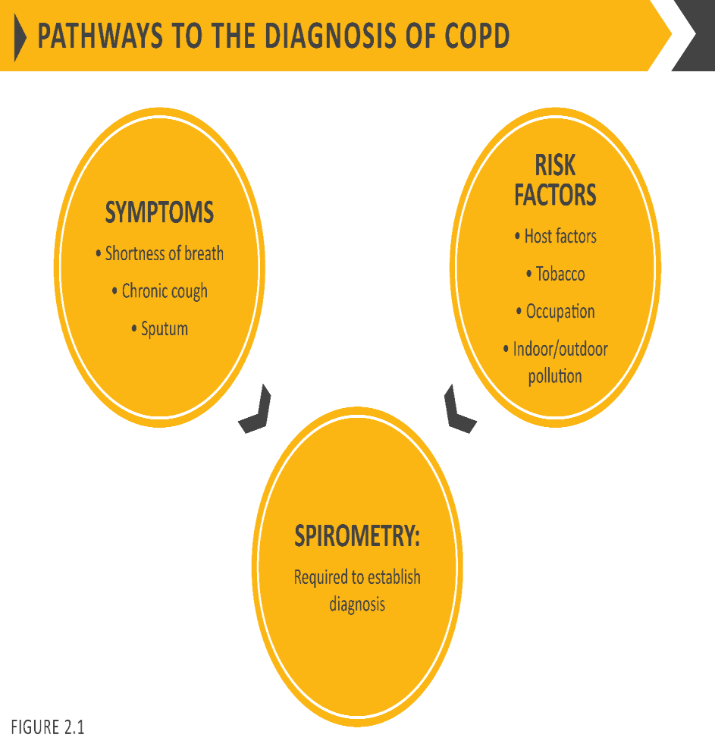

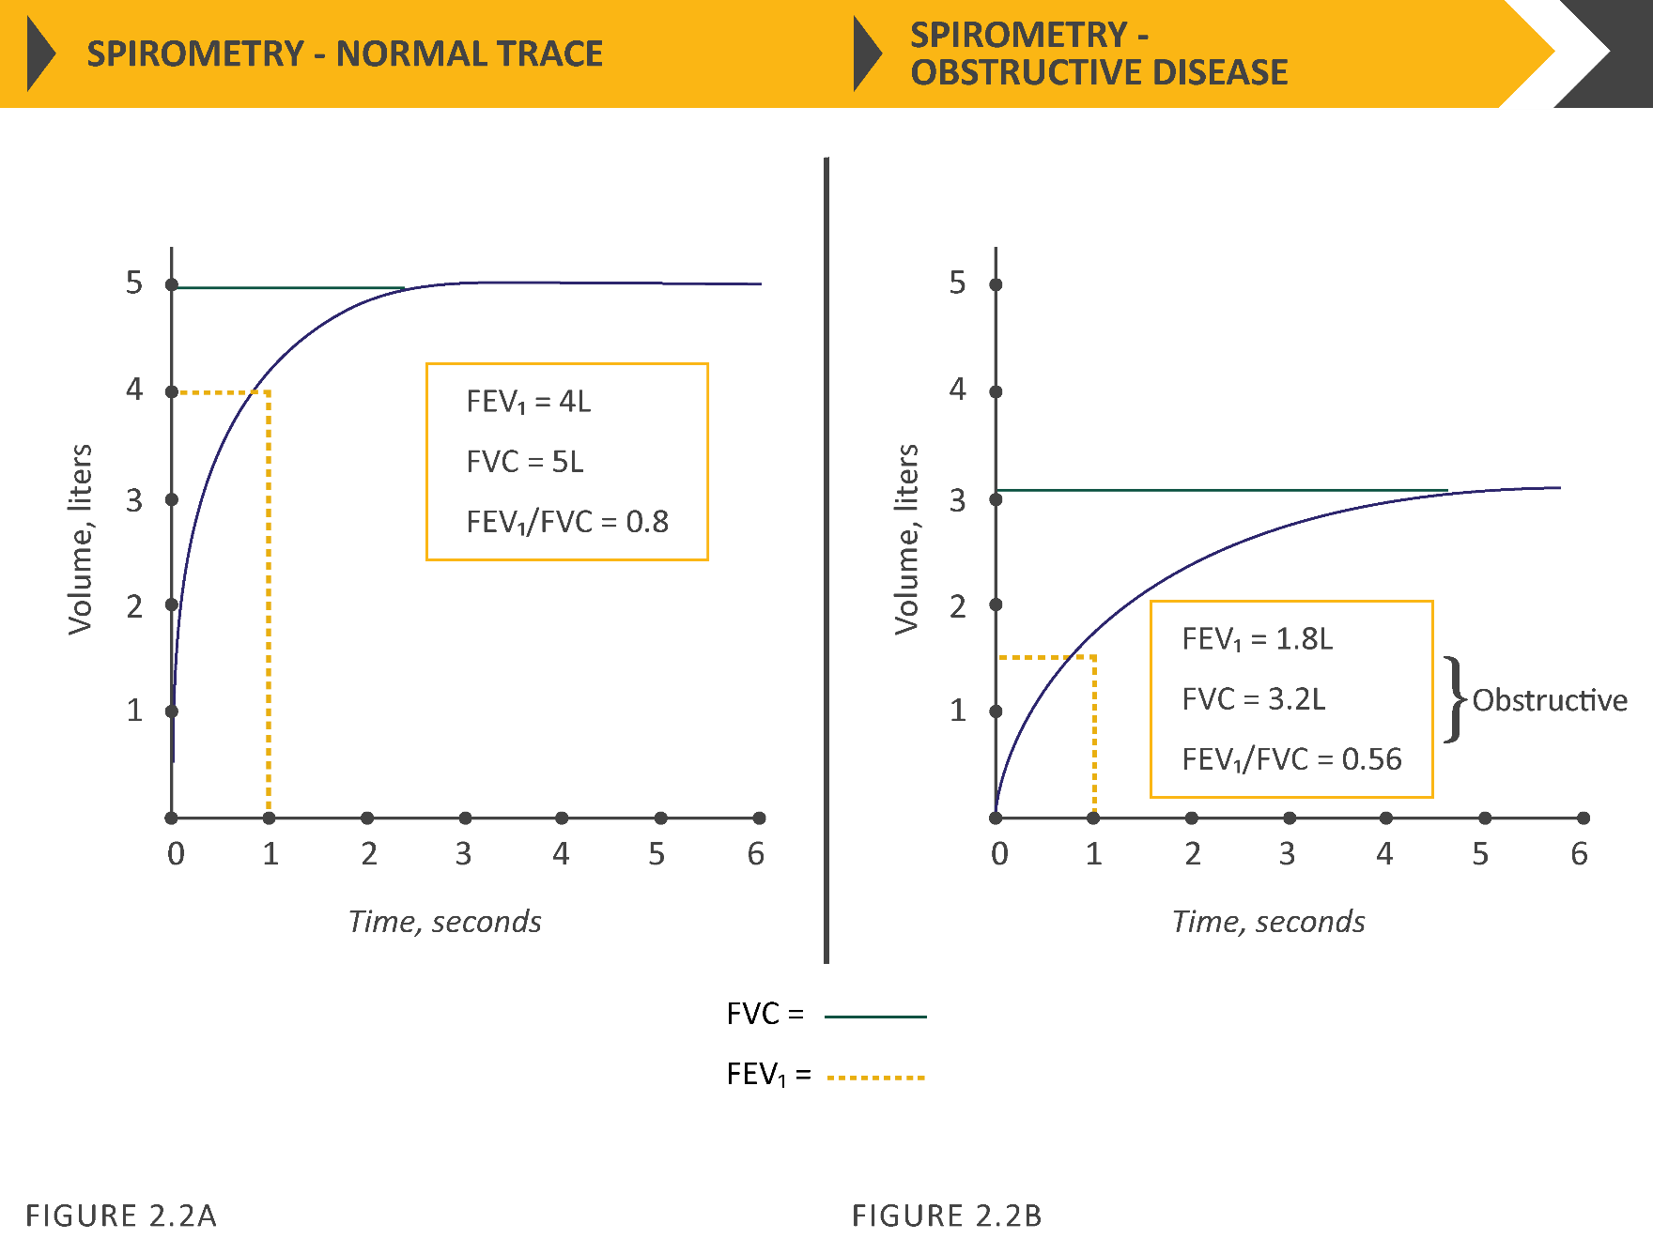

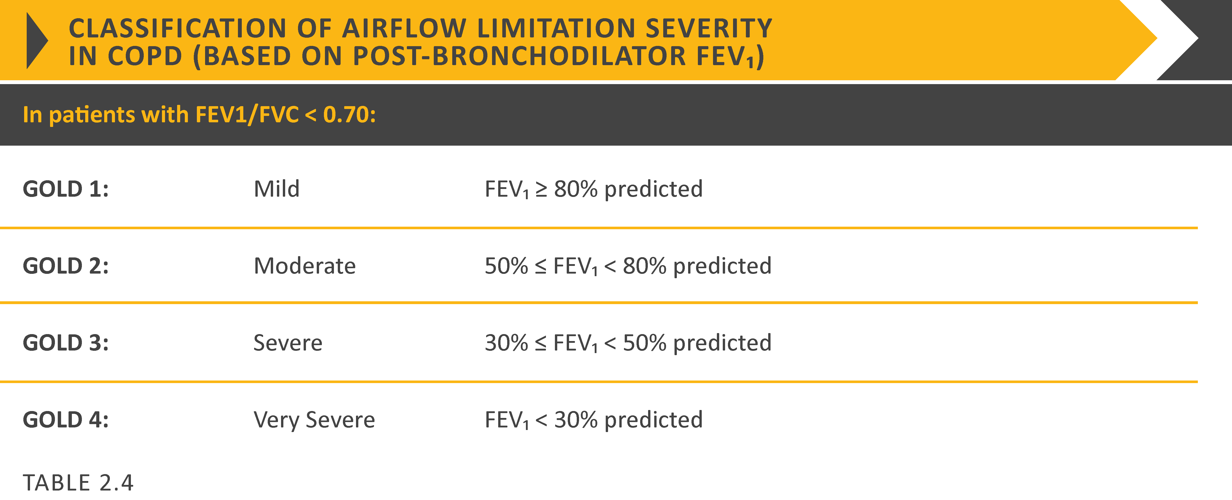

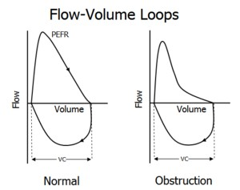
2.5 Risk Factors of COPD
Tobacco smoking is the main cause of COPD and it is also the main determinant of a poor outcome in those who have the disease. Other factors may also influence the risk of developing COPD (De Marco et al., 2011). The host factors that seem to play a major role are age, genes, and early respiratory infections. Among environmental determinants, occupational exposures and exposure to biomass smoke are primary risk factors. The role of sex, socioeconomic status, and body mass index (BMI) on the risk of developing COPD is still open to debate. According to these authors, cigarette smoke is the most important risk factor for COPD also among young adults, and that smoking prevention could reduce the incidence of COPD in the young population by 29 to 39% (De Marco et al. 2011). The longitudinal study points out that subjects with BMI less than 18.5 kg/m2 had a threefold risk of developing the disease compared with subjects with a normal weight. While tobacco smoking is a major risk factor for COPD, only approximately 20% of smokers develop the disease. Previously, most of the studies on COPD mainly focused on smoking as a risk factor but recent studies showed that non-smokers also contribute a significant proportion of COPD. About 50% cases of COPD worldwide are related to smoking, and an estimated 10%-12% of individuals with COPD have never smoked (Lamprecht et al. 2011). More evidence is rising to suggest that other risk factors such as air pollution, respiratory infections, poor nutritional status, impaired lung growth, poor socio-economic status and genetic factors are also important for disease development (Salvi & Barnes 2009).
Occupational exposures to particulates, and possibly to ambient particulates, are associated with COPD (Andersen et al. 2011; Eisner et al. 2010b; Omland et al. 2014). Increased COPD risk, and increased COPD mortality, has been observed among workers exposed to “vapours, gases, dusts, and fumes” (VGDF) (Torén & Järvholm 2014b). Both large and small airway effects of VGDF exposures are suggested in the literature (Churg & Wright 2002; De Jong et al. 2014).
Increased COPD risk has been associated with some speciﬁc occupational exposure agents, including: coal dust, asbestos, silica, welding and cutting gases and fumes, cement dust, diesel exhausts and organic solvents (Dement et al. 2015).
Occupational exposure is an important risk factor for chronic obstructive pulmonary disease (COPD), and silica dust is one of the most important occupational respiratory toxins. Epidemiological and pathological studies suggest that silica dust exposure can lead to COPD, even in the absence of radiological signs of silicosis, and that the association between cumulative silica dust exposure and airflow obstruction is independent of silicosis (Tilert et al. 2013).
2.6 Exposure to Tobacco Smoke and Second-hand Smoke
Although tobacco smoking is the major risk factor for COPD, exposure to second-hand smoke is also an important risk factor. Increasing passive smoke exposure was independently associated with increased risk of COPD, with adjusted OR 1.05 (95% CI 0.93 to 1.18) for 1–19 h and OR 1.18 (95% CI 1.01 to 1.39) for 20 or more hours of exposure per week. Similar patterns (although attenuated and non-significant) were observed among never smokers. More marked dose–response relationships were observed between passive smoking exposure and respiratory symptoms, but the most marked effects were on the development of clinically significant COPD (airflow obstruction plus symptoms), where the risk among never smokers was doubled (OR 1.98 (95% CI 1.03 to 3.79)) if exposure exceeded 20 h/week (Jordan et al. 2011).
Exposures to second hand smoking at work and at home during adulthood were associated with increased COPD risk: odds ratio (OR) = 1.12 (95% confidence interval [CI]: 1.02–1.23; p = 0.01) and OR = 1.09 (95% CI: 1.00–1.18; p = 0.04) per 10 years of exposure adjusted for smoking and other covariates, respectively (Koeverden et al. 2015).
A study was conducted on US workers and found that >10 000 adults concluded that COPD attributable to work was 19% in the total population, and 31.1% among never smokers. They also added the sex-specific analyses and showed that for females, the adjusted odds ratios for COPD (number of cases/number of subjects exposed) were increased for rubber, plastics, and leather manufacturing overall (8/46; OR = 4.7, 95 percent confidence interval (CI): 2.7, 8.3) and for never smokers in that industry (2/31; OR = 3.8, 95 percent CI: 1.2, 12.3); for the textile mill products manufacturing industry overall (10/99; OR = 2.4, 95 percent CI: 1.2, 4.8) and for never smokers in that industry (3/53; OR = 6.0, 95 percent CI: 0.6, 62); for the agriculture industry overall (13/196; OR = 2.0, 95 percent CI: 0.9, 4.5) and for never smokers in that industry (6/134; OR = 2.3, 95 percent CI: 0.5, 10.4); for sales overall (40/512; OR = 1.6, 95 percent CI: 0.9, 2.9) and for never smokers in that industry (8/279; OR = 3.0, 95 percent CI: 0.7, 13); for food products manufacturing overall (9/123; OR = 1.5, 95 percent CI: 0.6, 4.0) and for never smokers in that industry (2/77; OR = 3.4, 95 percent CI: 0.3, 44); and for personal services overall (34/470; OR = 1.5, 95 percent CI: 0.7, 3.2) (Eva Hnizdo et al., 2002).
Chronic tobacco smoking is the major risk factor for the development of COPD, but only a relatively small proportion of smokers develop airway obstruction. Although there is a dose-response relationship between FEV₁ and the extent of cigarette smoking, smoking history accounts for only approximately 15% of the variation in lung function. That is why the genetic predisposition of COPD may exist in smokers. Although cigarette smoking is the most important risk factor for the development of COPD, allergic airway inflammation, air pollutants, and diesel exhaust particles may also cause irreversible airflow limitation such as COPD. Environmental pollution, age, and airway hyperreactivity are also the risk factors (Hooper et al. 2012).
There was a consistent pattern of higher prevalence in men, in older people, and in those with less education, lower body-mass index, and greater exposure to smoking . Among risk factors, tobacco smoking either active or passive, current or ex-smoking-all have a higher respiratory symptoms and lung function abnormalities, a greater annual rate of decline in FEV₁ and a greater COPD mortality rate than non-smokers (Menezes et al., 2005).
Although prevalence varies across countries, in Bangladesh, it appreciably higher in smokers and ex-smokers compared with non-smokers, in those older than 40 years compared with those younger than 40 years and in men compared with women. Tobacco consumption, in the form of smoking or chewing, was found associated with an increased prevalence of COPD in four studies (Alam et al. 2015; Biswas et al. 2016; Islam et al. 2013; Mahfuz et al. 2014).
A higher risk to experience COPD after adjusting potential confounders in both current smokers (OR: 5.5; 95% CI, 4.2-7.2; p < 0.001) and former smokers (OR: 4.5; 95% CI, 3.3-6.0; p < 0.001) was observed by Alam et al., (2015). He also made conclusion that, prevalence was three times higher in males compared to females (22% VS 6.4% by GOLD criteria and 16.2% VS 5.3% by LLN criteria) and about 60% higher in rural than urban populations (17% VS 9.9% by GOLD criteria and 12.5% VS 8% by LLN criteria). COPD was higher among individuals from households using biomass fuel compared to clean fuel (natural gas) users (17.3% VS 9.9% by GOLD criteria and 12.7% VS 7.9% by LLN criteria). The prevalence of stage I (mild), stage II (moderate), stage III (severe), and stage IV (very severe) COPD was 2.7, 8, 2.3, and 0.6%, and by the GOLD severity criteria and 1.2, 6.4, 2.2 and 0.5% by the LLN criteria. Increase in GOLD-defined COPD relative to the LLN largely occurred in those aged 60–69 year (Alam et al., 2015).
Women greater than 40 years old living in rural area having tobacco chewing habit were 13 times more likely to suffer from COPD (OR: 12.9; 95% CI, 3.4-49.4; p < 0.001). In this study among the 250 females, 150 (60%) were biomass fuel users and Natural gas/LPG users were 100 (40%). COPD was found in 41 (16.4%) biomass users and 10 (4%) in later. The frequency of COPD was 20.4% with a higher number in women who were using biomass then who were using natural gas/LPG (p<0.001). Regarding risk analysis, biomass fuel was found significantly associated with COPD (OR= 3.385, CI=1.606-7.135, p<0.05). ) (Biswas et al., 2016).
2.7 Exposure to Biomass Smoke and COPD
Biomass smoke is one of the major air pollutants and contributors of household air pollution worldwide. It is considered one of the leading environmental risk factors of several diseases, including COPD and acute lower respiratory disease, and is thought to cause 4 million deaths annually across the globe (Capistrano et al., 2017). Wood smoke and other biomass exposure have been shown to be independent risk factors for obstructive airways disease, and earlier and longer time of exposure has been shown to increase the risk for development of COPD (Salvi & Barnes 2010). The combustion of biomass fuels has now been recognized as a relevant risk factor for respiratory disorders, such as chronic bronchitis and COPD, asthma, lung cancer, lung fibrosis, and tuberculosis (Ocakli et al., 2018).
Biomass smoke exposure is a prominent risk factor for developing several airway diseases. For example, relative to non-exposed people, those exposure to biomass smoke have an odds ratio of 2.44 (95% CI, 1.9–3.33) for developing COPD (Hu et al. 2010). While among women over 30 who were predominantly undertaking domestic duties in rural areas the relative risk for COPD was estimated as either 3.2 (95% CI 2.3–4.8) (Ezzati et al. 2004) or 2.14 (95% CI 1.78–2.58) (Balmes 2010).
A systematic review and meta-analysis identified 23 studies, 10 reporting COPD based on both physician diagnosis and spirometry definitions, 11 reporting chronic bronchitis based on respiratory questionnaire data, and two reporting both COPD and chronic bronchitis. The pooled effect estimates for lung function diagnosed COPD (OR 2.96, 95% CI 2.01–4.37) was greater than those diagnosed by a doctor in hospital (OR 2.29, 95% CI 0.70–7.52), with a combined pooled effect estimate of 2.80 (95% CI 1.85–4.23) for COPD. Similarly, the pooled effect estimates for chronic bronchitis was 2.32 (95% CI 1.92–2.80) of chronic obstructive pulmonary disease (COPD) in populations exposed to solid fuel smoke (Kurmi et al., 2010).
The odds of having biomass fuel smoke exposure among males were 4.25 while in the female it was 4.37. Overall OR is 3.16. The odds of having other types of indoor pollution such as wood exposure, coal and stove exposure in COPD patients are 2.70, 2.45, and 2.05, respectively, in comparison to the control group. Among the above exposures, biomass fuel smoke, wood smoke exposure, and coal smoking were statistically significant with value of P = 0.0001, 0.003, and 0.02, respectively (Madhurmay et al., 2019).
A meta-analysis with 15 epidemiologic studies covering a wide range of countries and found that people exposed to biomass smoke had combined odds ratio (OR) of 2.44 for developing COPD as assessed by lung function measurements or symptom-diagnosed chronic bronchitis, and that this was true for both women and men. Moreover, cigarette smoking appeared to have a synergistic effect with biomass smoke, increasing the OR for COPD development to 4.39 (Hu et al., 2010).
In Bangladesh, many studies found significant association was reported with the development of COPD and the use of biomass fuel for cooking purpose in three studies (Alam et al. 2015; Alim et al. 2014; Biswas et al. 2016). Two studies found that biomass fuel use was positively associated with a higher prevalence of COPD among rural women. The women in rural areas suffer more from COPD than those in urban areas. According to that study, exposure to biomass smoke (from open stoves/wood fires) appears to be a significant risk factor for the disease in village women (Alim et al. 2014; Biswas et al. 2016).
Some authors showed that nearly 4,000 urban and rural participants also found that biomass fuel users were six times more likely to have COPD compared to clean fuel users (OR: 5.9; 95% CI, 1.0-34.5; p = 0.047) (Alam et al., 2015).
2.8 Association of COPD and Socio-Demographic Profile
Many studies from developed countries suggested that socioeconomic status (SES), measured by income and educational level, is associated with lung function and COPD in terms of exacerbation, prevalence and mortality. This association may be partly explained by the greater proportion of smokers among people in lower socioeconomic groups, but smoking may not explain all the association (Yin et al. 2011).
The study includes 51,520 subjects sampled from 31 provinces, autonomous regions and municipalities, 49,363 subjects with complete data were included in the analysis in that report. Among 1423 subjects with COPD, 53.1% were never smokers. The prevalence among men was significantly higher than among women (3.4% vs. 2.4%, p < 0.001), rural area higher than urban area (3.1% vs. 2.5%, p < 0.001), and western areas (3.7%) higher than central (2.7%) and eastern (2.2%) areas. The prevalence increased with age, from 0.8% in the youngest age group (15-29 years) to 7.5% in the eldest age group (60-69 years). Former smokers had a higher prevalence of COPD (9.0%) compared to current smokers (3.3%) and never smokers (2.3%). After adjusting for age, sex, smoking status, passive smoking and geographic regions, the odds for those with < 9 years educational level were 1.67 (1.32-2.13) in urban and 1.76 (1.34-2.30) in rural areas compared with subjects with education ≥ 12 years. The trend was significant in crude and adjusted model (Yin et al., 2011).
Grigsby et al., (2016) defined SES as an individual’s social and economic standing and serves as proxy for social or economic position or rank in a social group. More than a measure of income, SES encompasses several other measures including education, occupation, housing, assets, and participation in social organization. While lower SES was found to be associated with greater COPD morbidity and mortality in high-income countries (HIC), few studies have examined the role of low SES in the prevalence of COPD among low- and middle-income countries (LMICs). An understanding of the role of SES and COPD in LMICs will potentially inform public interventions beyond harm reduction, i.e., tobacco cessation and decreased biomass fuel smoke exposure, toward those aimed at disparities in SES. Analysis using multivariable alternating logistic regression showed that the odds of having COPD was positively associated with use of biomass as a primary fuel source for cooking, daily smoking, not having completed secondary education, lower monthly household income, and older age. They found a positive association between the odds of COPD and a lower SES composite score, with an interquartile OR of 1.23 (95% CI 1.05–1.43). In sensitivity analyses, the positive association between low SES and COPD remained significant (interquartile OR 1.29, 95% CI 1.12–1.50) when they used the Global Lung Function Initiative (GLI) Caucasian reference population. In further sensitivity analyses, we analysed differences using pack-years and categories of smoking history (current, former, or never smoker) instead of daily smoking or not, while adjusting for age, sex, biomass fuel smoke exposure, and site. The interquartile OR for SES was 1.20 (95% CI 1.01–1.41) when using pack-years and 1.18 (95% CI 1.03–1.34) when using categories of smoking history. These results were very similar to using daily smoking vs not (interquartile OR for SES of 1.23, 95% CI 1.05–1.43) (Grigsby et al. 2016).
A study was conducted with low education, low income and other risk factors associated with the development of COPD (n = 588) included those with both diseases ( asthma and COPD) (n = 96) by univariate and multivariate logistic regression (Kanervisto et al., 2011). Low education, low income and other risk factors associated with the development of COPD (n = 242) excluded those with both diseases (n = 96) by univariate and multivariate logistic regression. Obesity increased the risk for asthma, whereas underweight increased the risk for COPD. In COPD smoking was a risk factor for both genders (women OR 2.5, 95% CI 1.7–3.7 and men 2.3, 95% CI 1.4–3.8). In men underweight was a risk factor for COPD (OR 2.4, 95% CI 1.1–5.0). Basic educational level increased the risk for COPD in both genders (women OR 1.8, 95% CI 1.0–3.3 and men 1.8, 95% CI 1.0–3.0). There was a clear association in the univariate analyses with low education and low household income in both groups. Basic educational level increased the risk of COPD increased if education was lower. Similarly, low household income increased the risk for asthma and COPD. In the multivariate logistic regression analysis when adjusted for gender, age, smoking history, and BMI, the basic educational level remained an independent determinant for COPD and the low household income for asthma. Underweight and smoking were determinants of COPD. Female gender was a determinant for asthma and male gender for COPD. The risk for COPD increased significantly with age, but the connection between age and asthma was not as clear-cut. Whilst those with an interest in historic workplace exposures may largely regard this relationship as causal, implying that certain work exposures can cause COPD, others may see the clear financial and social disadvantages suffered by COPD patients unable to work (Antuni & Barnes 2016).
Old age was reported as a risk factor for COPD by two studies (Alam et al. 2015; Islam et al. 2013). The authors also observed that 50-59 years-aged people and 60-69 years-aged people were two times and five times more likely to develop COPD, respectively, compared to 40-49 years-aged people (50 to 59 years, OR: 2.2, 95% CI, 1.6-3.0; p < 0.001; 60 to 69 years, OR: 4.7, 95% CI, 3.5-6.4; p < 0.001) (Alam et al., 2015).
During a mean follow-up of 13.5 ± 5.3 years, a total of 2,877 individuals (47.5% men) were discharged from hospital with first-ever COPD as the primary diagnosis. The study showed that low annual income in quartile (Q) 1 and Q2 ((HR: 2.10; 95% CI: 1.83–2.40, P < 0.001 and HR: 2.23; 1.97–2.53, P < 0.001, respectively) were associated with higher risks for COPD. Individuals with rented housing (HR: 1.41; CI: 1.30–1.52, P < 0.001) had higher COPD risk compared to living in self-owned property. (Borné et al. 2019).
2.9 Occupational Exposure to Silica Dusts and COPD
Occupational exposures such as to vapours, gases, dusts and fumes is an important risk factor for the development of the disease, by itself and through interaction with other risk factors (Hnizdo et al. 2002). The epidemiological evidence supporting the role of occupational exposures (organic and inorganic dusts, metal fumes, chemical vapours) as risk factors has been published in population-based studies, and also studies regarding working environments with specific exposures (Blanc et al. 2009a).
Occupational exposure to crystalline silica (silica) dust occurs in many industrial operations worldwide (Yassin, Yebesi & Tingle 2005). The reduction of silica dust exposure levels in most developed countries during the last century resulted in dramatic decreases in morbidity and mortality from COPD, silicosis and silica dust associated tuberculosis (TB). Despite this, chronic obstructive pulmonary disease (COPD) remains a health issue in workers exposed to silica dust (Hnizdo & Vallyathan 2003).
It is therefore likely that certain properties of silica dust can cause COPD that may precede, or be independent of silicosis development. Recent clinicopathological and experimental studies help to explain the potential for silica dust to cause pathological changes that may lead to the development of COPD (Hnizdo & Vallyathan 2003).
It is more difficult to estimate the specific contribution of occupational exposures because of the strong causal association with tobacco smoking and the late onset, often after retirement age. Nevertheless, about 15% of all COPD cases in Western societies have been attributed to exposure to vapours, gas, dust or fumes, mainly based on past occupational studies in the highly exposed mining, textile and farming sectors (Blanc 2012). Recent large population-based epidemiological studies that have been able to control for smoking and other potential confounding factors, such as asthma, have found occupations at increased COPD risk even at lower community exposure levels (De Matteis et al. 2016). In addition, the American Thoracic Society’s consensus statement suggests that between 10% and 20% of COPD is attributable to workplace exposures (American thoracic society statement: Occupational contribution to the burden of airway disease 2003).
The current thinking is that chronic inflammation and remodelling of small airways (bronchitis) and destruction of lung parenchyma (emphysema), in response to inhalant oxidants generated by smoking and other environmental exposures, leads to COPD (Angelis et al. 2014). The predominant inflammatory cells involved in the airways remodelling and parenchymal destruction characteristic of COPD are neutrophils, macrophages, and T lymphocytes (CD8+ and CD4+) (Y. Wang et al. 2018).There are several potential mechanisms by which silica particles can initiate cell injury leading to COPD. These include cytotoxicity, leading to generation of reactive oxygen/nitrogen species, and secretion of proinflammatory factors, cytokines, chemokines, elastase, and fibro genic factors (Boukhenouna et al. 2018). Potentially these mechanisms can initiate changes in lung tissue leading to airflow obstruction. Silica particles can initiate toxic and inflammatory processes in conducting and peripheral airways, and alveolar tissue characterised by release of mediators leading to increased production of oxidants, cytokines, chemokines, and elastase, inducing airways inflammation and emphysema (Ni, Chuang & Zuo 2015). Silica particles can also causes epithelial cell injury that facilitates penetration of the silica particles through the walls of small airways and causes localised fibrosis (Yacobi et al. 2011).
2.10 Mechanism by which Silica dust can induce Emphysema and chronic bronchitis
Occupational exposure is an important risk factor for chronic obstructive pulmonary disease (COPD), and silica dust is one of the most important occupational respiratory toxins (Tilert et al. 2013).
In epidemiologic and pathologic studies occupational exposure to crystalline silica is the important risk factor identified to be associated with the development of emphysema (Hnizdo, E. Vallyathan 2002).
The mechanism by which silica can produce emphysema is not well understood. Current evidence suggests that the mechanism is similar to that of cigarette smoke that is, the destruction of α1 protease inhibitor (α1-AT) by oxidants generated by inﬂammatory cells as well as silica dust (Robinson, Tuder & Hunt 2013). Emphysema induced by cigarette smoke is initiated by the oxidants in cigarette smoke causing a protease antiprotease imbalance and decreased anti-elastase activity (Kubo et al. 2019). It is postulated that silica may induce emphysema by the release of proteolytic enzymes from dust evoked inﬂammatory cells and by oxidative inactivation of α1-AT by the excessive oxygen free radicals generated by silica particles and inﬂammatory cells (Domej, Oettl & Renner 2014).
Epidemiological studies show that the prevalence of chronic bronchitis (chronic productive cough) increases with intensity and duration of silica exposure (Lahousse et al. 2017). A clinicopathological study of COPD among South African gold miners found that in the absence of emphysema, a marked degree of mucus glands hyperplasia is associated with little airﬂow obstruction. Furthermore, marked mucus glands hyperplasia was associated mainly with rhonchi, sputum production, and cough during life, but less with symptoms of breathlessness which were associated strongly with emphysema (Smith & Woodcock 2006).
Epidemiological and clinicopathological studies investigated whether silicosis or other silica dust associated pathological changes cause airflow obstruction in silica dust exposed workers. Two case-control studies compared lung function in South African gold miners with and without radiological signs of silicosis, who were matched for cumulative dust exposure, tobacco consumption, and age. No significant differences were found between silicosis and non-silicosis miners in spirometry (Irwig & Rocks 1978).
Epidemiological studies show that silica dust exposure can lead to airflow obstruction in the absence of radiological signs of silicosis (Meijer, Kromhout & Heederik 2001) and that the association between cumulative silica dust exposure and airflow obstruction can be independent of silicosis (Irwig & Rocks 1978). About 15–20% of COPD cases are due to occupational exposures to pollutants at the workplace (Gibson et al. 2013).
2.11 Combined effect of silica dust and smoking with COPD
Work may have an interactive effect with tobacco smoke, resulting in greater severity of disease with greater disability or by accelerating the rate of loss of lung function among those with the disease (Harber et al. 2007). It is well known that tobacco smoke and occupational exposures exert a synergistic effect and increase each other′s influence (Ameille et al. 2006).
Several studies have shown that smoking can potentiate the effect of silica dust. Studies of Canadian and US hard rock miners found that the effect of silica dust on lung function pattern is different in smokers compared to non-smokers (Lai et al. 2018).
A study was conducted that explained the odds ratios for different types of occupational noxious particles and gases among COPD patients were it was found highest for the silica dust (OR=6.2; 95 % CI=3.6 to 10.7; p<0.0001). Occupational risk assessment calculated separately for non-smoking and smoking workers showed that the odds ratios for occupational COPD were significantly higher for non-smokers. For the smoking workers, smoking was a major risk factor for COPD development. Thus, the odds ratio for occupational COPD for non-smokers was almost seven times higher than that of smokers and their attributable risk for occupational COPD was more than 95 % compared to 65 % for smokers ( Mazitova et al., 2012).
Thus, after matching on cumulative silica dust exposure and smoking, radiological signs of silicosis were not associated with significant airflow obstruction. These results support the hypothesis that the effect of cumulative silica dust exposure on airflow obstruction seen in the cohort of South African gold miners is independent of silicosis (Wiles & Faure 1975).
A study was conducted on South African gold miners estimated the fraction of cases with severe airflow obstruction attributable to dust only, smoking only, and the combined effect of the two exposures (that is, the attributable fractions), and the fraction of cases that could be prevented by removal from each exposure. The attributable fractions for severe airflow obstruction (found in 20% of miners) were estimated as 8% for dust alone, 42% for smoking, 40% for the combined effect of silica dust and smoking, and 10% for unknown factors. Estimated preventable fractions show that elimination of silica dust exposure would prevent 48%, and elimination of smoking 82% of severe airflow obstruction (E. Hnizdo et al., 1990). Despite smoking being the most important risk factor for this disease, accounting for >75% of cases of disease, occupational exposures, alone or in combination with smoking, are responsible for a substantial proportion of disease (Eisner et al. 2010a).
The studies found increasing exposure-response trend for COPD mortality and cumulative dust exposure that was modified by tobacco smoking. The attributable fractions for COPD mortality were estimated as 5% for dust alone, 34% for smoking, 59% for the combined effect of silica dust and smoking, and 2% for unknown factors. In the absence of silica dust exposure, 64% of COPD deaths could be prevented, whereas in the absence of smoking, 93% of COPD deaths could be prevented (Hnizdo, Baskind & Sluis-Cremer 1990).
Furthermore, it has been reported that occupational exposures, such as to vapours, gas, dust or fumes, might trigger COPD exacerbations in a similar way to that in which they elicit asthma attacks (Paulin et al. 2015). A multi-centric cohort study was conducted including current and former smokers with and without COPD. Participants with COPD were 40 to 80 years old. In that study, association between occupational exposure with COPD was not statistically significant (odds ratio [OR], 1.20; 95% confidence interval [CI], 0.92–1.56) in bivariate analysis; however, after adjustment for potential confounders, including smoking, occupational exposure was associated with a higher point-estimated odds of COPD, which was statistically significant (OR, 1.44; 95% CI, 1.04–1.97). Occupational exposures were associated with greater odds of COPD among former smokers as compared with current smokers (OR, 1.75; 95% CI, 1.15–2.66 vs. OR, 1.09; 95% CI, 0.66–1.82; smoking- exposure interaction, P =0.06) and among those with fewer versus more pack-years of smoking (OR, 1.97; 95% CI, 1.27–3.05 vs. OR, 1.02; 95% CI, 0.64–1.61; pack-years–exposure interaction, P =0.05). There was no substantive difference between male and female smokers and the odds of COPD (men: OR, 1.44;95% CI, 0.95–2.17 vs. women: OR, 1.41; 95% CI, 0.85–2.31; sex–exposure interaction, P =0.74). When defining COPD using LLN criteria (n = 595), there was an association between occupational exposures and COPD in bivariate (OR,1.44; 95% CI, 1.12–1.85) and multivariate (OR = 1.57; 95% CI, 1.18–2.10) analyses (Paulin et al. 2015).
In summary, the evidence shows that smoking potentiates the effect of silica dust exposure on airflow obstruction.

METHODOLOGY
METHODOLOGY
3.1 Study Type
This study was a cross-sectional observational study.
3.2 Place & Period of Study
The study was carried out in the stone quarries of Companiganj and Gowainghat Upazila, Sylhet and the control subjects were collected from Sylhet MAG Osmani medical college.
The study was carried out during the time of one year after acceptance of the protocol. This study period was divided into 2 phases. First phase included problem identification, literature review, protocol writing, questionnaire preparation and pre-testing. Second phase included data collection, analysis and report writing. Schedule of study period is attached in the appendices (Appendix - XXX).
3.3 Target Population & Study Population
All stone quarry workers of Companiganj and Gowainghat Upazila, Sylhet were the target population. Moreover, all patients admitted in medicine ward were considered as control population….
Target population fulfilling the following eligibility criteria within the given period were enrolled in the study as study population.
Eligibility criteria
Workers in the age range of 25 years to 60 years.
Workers who have been working for at least five years in the quarry.
Exclusion criteria
Workers with history of lung disease even before they started working at the quarry.
Workers who are not interested to participate in the study.
3.4 Quality assurance strategy
All the data will be kept confidential. Only the researcher and ethical committee members will get full access to the data. Every record will be cross-checked by the supervisor.
3.5 Addressing Ethical Issues
The study protocol will be submitted for the approval of the ethical review committee of Sylhet MAG Osmani Medical College, Sylhet.
Informed written consent will be taken from each of the respondents before taking any interview. A co-worker will be the witness of taking informed consent.
The purpose and method of the study, confidentiality of the interviews, risks and benefits of participating in the study, respondent’s right to participate voluntarily and right to withdraw at any point will be explained in the local language from a printed handout.
All information will be collected with complete respect to the worker’s wish and without any force or pressure.
3.6 Determinations of Sample
Sample size was calculated using Cochran’s formula considering 5% level of significance, 5% precision level (permissible error) and prevalence of chronic obstructive pulmonary diseases among stone quarry workers 13.7% (john dement et al., 2015).
The formula is: n = 
Where, n = estimated sample size
Z = 1.96 (in 95% Confidence Interval)
p = prevalence, 13.7% (0.137),
q = 1- 0.12 = 0.87,
d = permissible error, 5% (0.05)
So, sample size (n) = 
= 180
Calculated sample size was 180 but we collected data from 200 respondents. Among the 200 hundred subjects, 106 respondents were smoker. So, for our convenient, all control subjects were from smoker and then the size of the data for control subject were 100. Moreover, the control subjects were selected from the Sylhet M A G Osmani hospital.
3.7 Sampling Method
Consecutive sampling method was used to recruit the required number of respondents in the study.
3.8 Variables Studied
Main outcome variable: COPD
Exposure variable: Silica
Confounding variables:
1. Smoking including duration of smoking
2. Length of service
3. Use of biomass fuel in cooking
4. low socioeconomic condition.
3.9 Operational Definitions
FEV1: The volume of air that the patient can exhale in the first second of forced expiration after a maximal inspiration
FVC: The total volume of air that the patient can forcibly exhale in one breath after a maximal inspiration
FEV1/FVC: The ratio of FEV1 to FVC expressed as a percentage.
COPD: Subjects with compatible history and forced expiratory volume in 1 second and forced vital capacity ratio (FEV1/FVC) value of less than 0.7 will be regarded as COPD patients.
3.10 Procedure of Data Collection
This study was conducted on the stone quarries of Sylhet, specifically on the quarries that have stone crusher machines and in Sylhet MAG Osmani medical college.
Total 15 visits were made during the study. On each visit, data were collected from 20 respondents.
Prior to each day of data collection for case individuals, an advocacy meeting was arranged with the local elites and the respective industry owner. They were informed in detail about the study and permission were taken.
An announcement was also made on the day before data collection in the quarry area mentioning `health check-up was done for the employees working for 5 years or more'.
After relevant history taking, workers fulfilling the inclusion criteria was informed about the study goals. Among them who was agreeing to participate voluntarily, was taken as samples.
Informed written consent was taken from the respondents.
Study population was divided into two group: smoker and non-smoker.
Workers were interviewed face to face using the semi-structured questionnaire.
Baseline spirometry was performed for all the participants of the study. Spirometry was carried out using a calibrated portable spirometer.
Spirometry was done with participants sitting at ambient temperature and after at least 10 minutes of rest.
The subjects were asked to exhale into the spirometer as forcefully as possible after maximum inspiration.
The parameters measured was forced vital capacity (FVC) and forced expiratory volume in one second (FEV1). FEV1/FVC ratio will be calculated from the measured data.
Study participants with value of FEV1/FVC of less than 0.7 was examined with post-bronchodilator test according to the ATS / ERS guideline, 15 minutes after the administration of 400 micrograms of salbutamol.
Subjects with forced expiratory volume in 1st second and forced vital capacity ratio (FEV1/FVC) value of less than 0.7 was regarded as COPD patients.
The stages of COPD were also determined according to GOLD criteria.
All relevant data was recorded in data collection sheet designed for this study.

3.11 Laboratory Procedure
3.12 Data Collection
Data were collected in a pre-designed data collection sheet containing the variables of interest (Appendix – XXX).
3.13 Statistical analysis
Data were processed manually in Excel and analyzed with the help of SPSS (Statistical package for social sciences) Version 25.0
Quantitative data were expressed as mean and standard deviation.
Qualitative data will be expressed as frequency and percentage and/or bar diagram or Pie chart.
For making association between exposure (smoker and silica exposure versus smoker) and outcome (COPD versus Not COPD), we applied logistic regression. Moreover, to calculate association between two categorical variables, the Chi-square test was also used.
All analyses were assessed with 5% level of significance. That means, an effect of a variable is significant if the P-value is less than 0.05 (5%).

3.14 Flow chart for the steps of study
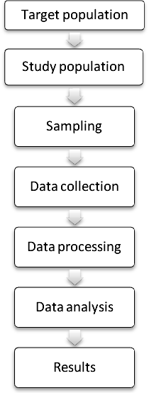
RESULTS
RESULTS
In this study, data on 200 stone quarry workers from Companiganj and Gowainghat Upazila, Sylhet were collected using systematic questionnaire and spirometry. Moreover, information on 100 control respondents from Sylhet MAG Osmani medical college hospital was collected. The data was analysed in three steps. In the first step, all workers (n=200) were included in the analyses; in the second step, analyses were conducted using information only from those who have been diagnosed as COPD (n=78) and finally, analyses were conducted using 206 respondents, in which 106 were cases, exposed to both silica dust and smoking and 100 were control exposed to smoking only.

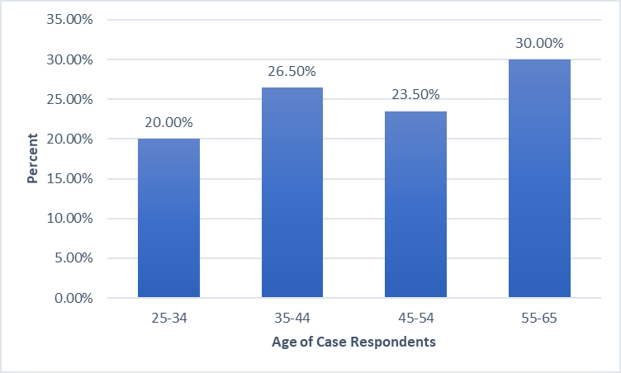
Figure I: Distribution of the respondents based on age group (n=200)
Figure I shows the distribution of age groups of 200 workers. The age of the patients range from 25 to 65 years with mean age of 45.57(SD ± 11.48) years. Among the different age groups, the highest number of workers (30.0%) belong to 55-65 years of age group and smallest percentage of workers (20%) belong to 25-34 years of age group.

Table I: Distribution respondents based on sex (n=200)
Sex of Respondent | Frequency | Percent
Male | 131 | 65.5
Female | 69 | 34.5
Total | 200 | 100.0

Table I represents the percentage of gender of the 200 workers. Among male and female, a significant number of workers 65.5% (n=131) were male and smaller percentage of workers 34.5% (n=69) were female.

Table II: Distribution of respondents based on educational level (n=200)

Education | Frequency | Percent
Illiterate | 166 | 83.0
Primary | 29 | 14.5
Secondary | 5 | 2.5
Total | 200 | 100.0

Table II shows that majority of the respondents (83%) were illiterate, 24.5% have education level up to primary and only 2.5% have secondary education.
Table III: Distribution respondents based on Smoking status of (n=200)
Smoking Status | Frequency | Percent
Yes | 106 | 53.0
No | 94 | 47.0
Total | 200 | 100.0

Table III represents the percentage of the workers based on smoking status. Among the quarry workers, most of the workers (53%) were smoker and remaining workers (47%) were non-smoker.

Table IV: Distribution of pattern of lung function among the respondents (n=200)
Pattern | Frequency | Percent
Obstruction (Non reversible) | 78 | 39.0
Obstruction (Reversible) | 11 | 5.5
Restriction | 36 | 18.0
Normal | 75 | 37.5
Total | 200 | 100

Table IV shows that among the 200 workers, 39% (n=78) were diagnosed as non-reversible obstruction (NR) that is COPD and 5.5% (n=11) have reversible obstruction. Restrictive pattern was found in 18% (n=36) and 37.5% (n=75) has normal lung function.

Table V: Distribution of COPD among the Smokers and non-smokers (n=200)
Smoking | COPD |  | Total | p-value
Smoking | No  (n=122) | Yes  (n=78) | Total | p-value
Yes | 56 (45.9) | 50 (64.1) | 106 (53.0) | 0.012*
No | 66 (54.1) | 28 (35.9) | 94 (47.0) | 0.012*
*P-value calculated from the Chi-square test.

Table V represents the percentage of COPD with the workers smoking status. Among the 200 workers 78 had COPD. Among them, 64.1% (n=50) were smoker and 35.9% (n=28) were non-smoker. The Chi-square test showed that the association is statistically significant at 5% level of significance.

Table VI: Distribution of respondents according to length of service of (n=200)
Working Length | Frequency | Percent
5-10 Years | 118 | 59.0
10-15 Years | 43 | 21.5
15+ Years | 39 | 19.5
Total | 200 | 100.0

Table VI represents the percentage of the workers in different service length. Among the different groups, the highest number of workers 59% (n=118) has a service length between 5-10years and smallest percentage of workers 19.5% (n=39) has a service length of more than 15 years.

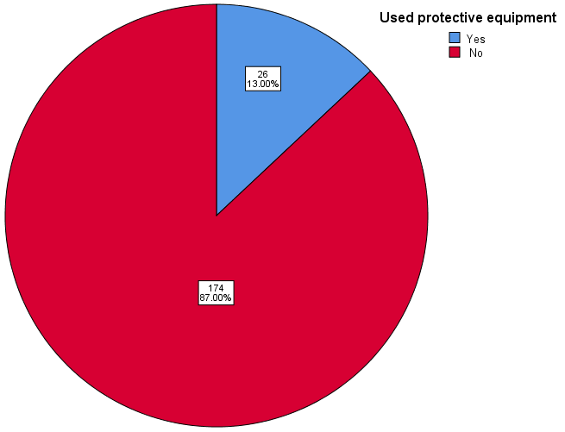
Figure II: Distribution of Protective equipment using among the respondents (n=200)

Figure II represents the percentage of the workers using protective equipment during work. Among the 200 respondents, 87% (n=174) worker were not used any sorts of protective equipment and 13% (n=26) of workers were used the protective equipment.

Table VII: Distribution of the respondents based on body mass index (BMI) category (n=200)
BMI Category | Frequency | Percent
Underweight | 42 | 21.0
Normal | 141 | 70.5
Overweight | 17 | 8.5
Total | 200 | 100

Table VII represents the percentage of BMI category of workers. Among underweight, normal and overweight workers, the highest number of workers (70.5%, n=141) belong to normal BMI and smallest percentage of workers (8.5%, n=17) were overweight, rest were underweight.

Table VIII: Frequency of respiratory symptoms among the respondents (n=200)
Cough | Frequency | Percent
Present | 100 | 50
Absent | 100 | 50
Total | 200 | 100
Sputum Production
Present | 57 | 28.5
Absent | 143 | 71.5
Total | 200 | 100
Breathlessness
Present | 95 | 47.5
Absent | 105 | 52.5
Total | 200 | 100

Table VIII represents the frequency of respiratory symptoms of the workers. Among the respondents, 52% have cough, 28.5% have associated sputum production and 47.5% have breathlessness.

In this section, analyses were conducted only for diagnosed COPD patients (n=78). Here the data were presented using several frequency tables and graphical representations.

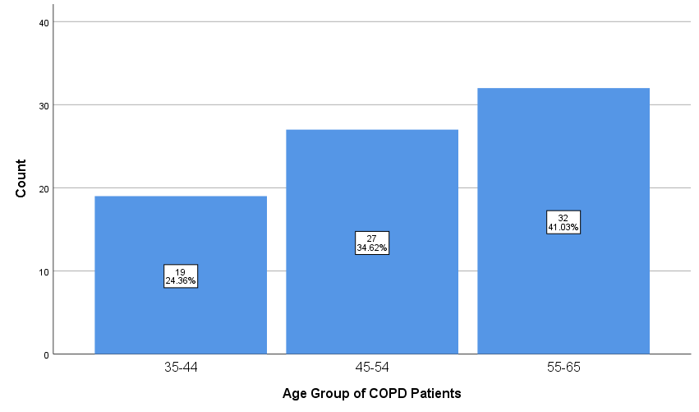
Figure III: Distribution of COPD patients based on age group (n=78)
Figure III represents the percentage of age groups of 78 COPD patients (Non reversible Obstruction only). Among the different age groups, the highest number of workers (41.0%, n=32) belong to 55-65 years of age group and no COPD patients were found between 25-34 years of age group.

Table IX: Distribution of COPD patient based on gender (n=78)
Sex | Frequency | Percent
Male | 60 | 76.9
Female | 18 | 23.1
Total | 78 | 100

Table IX represents the percentage of gender of workers who were diagnosed as COPD. Among the 78 COPD patient, 76.9% (n=60) were male and 23.1% (n=18) were female.

Table X: Distribution of gender and smoking status of the respondents (n=78)
Smoking | Sex |  | Total | p-value
Smoking | Male  (n=60) | Female  (n=18) | Total | p-value
Yes | 47 (78.3) | 3 (16.7) | 50 (64.1) | <0.001
No | 13 (21.7) | 15 (83.3) | 28 (35.9) | <0.001

Table X represents the percentage of smoking status with the gender of COPD patient. Among the COPD patient (n=78) 60 were male and 18 were female. Among the male, 78.3% (n=47) were smoker and 21.7% (n=13) were non-smoker. Among the female 16.7% (n=3) were smoker and 83.3% (n=15) were non-smoker. This association is statistically significant at 5% level of significant.

Table XI: Distribution of smoker respondents based on pack year smoked (n=50) *
Pack Year | Frequency | Percent
Greater than 10 | 46 | 92.0
Less than or equal to 10 | 4 | 8.0

Table XI represents the percentage of smoking pack year of the smoker respondents. Among 50 workers, most of the workers (92%) were smoked greater than 10 pack year and 8% were smoked less than 10 pack year.

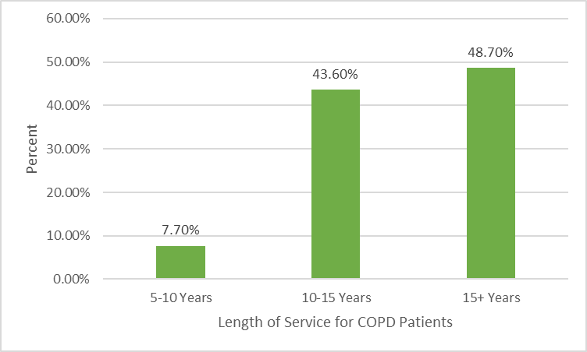
Figure IV: Distribution of service length of the COPD patients (n=78)

Figure IV represents the percentage of COPD among the workers of different service length. Among the COPD patient (48.7%) has a service length of more than 15 years and 43.6% & 7.7% has a service length in between 10-15 years and 5-10 years respectively.

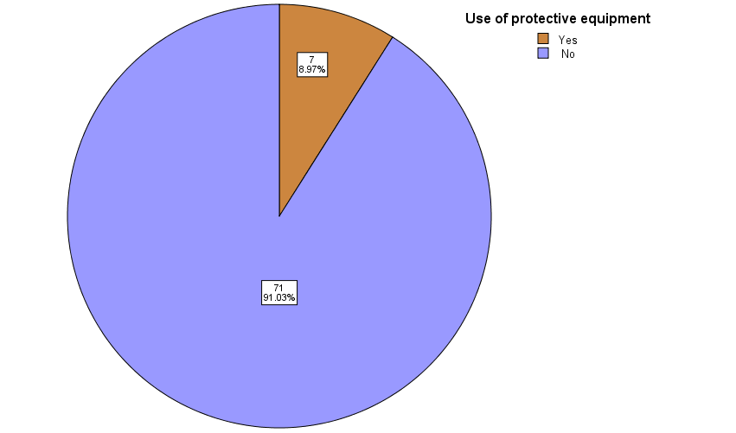
Figure V: Distribution of protective equipment using among the COPD patients (n=78)

Figure V represents the percentage of the COPD patient using protective equipment during work. Among the 78 COPD patient only 8.9% (n=7) were using protective equipment and remaining 91% (n=71) were not used any sorts of protective equipment during work.

Table XII: Distribution of GOLD severity grading among the COPD patients (n=78)
Gold Severity Grade | Frequency | Percent
Mild (FEV1>80%) | 8 | 10.3
Moderate (FEV150-79%) | 46 | 59.0
Severe (FEV1 30-49) | 22 | 28.2
Very Severe (FEV1 <30) | 2 | 2.6
Total | 78 | 100

Table XII shows that among the 78 workers, 10.3% (n=8) were in mild and 59% (n=46) were moderate grade. 28.2% (n=22) and 2.6% (n=2) has severe and very severe diseases, respectively.

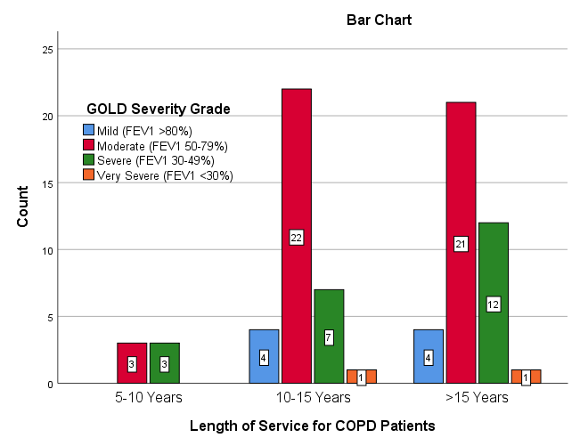
Figure VI: Distribution of service length and Gold Severity of COPD patients (n=78)

Figure VI represents the relationship of length of service and GOLD severity grade among the COPD patient. It has been shown that, the number of severe and very severe disease increased along the increasing length of service.

In this section, the analysis was done between case (exposed to silica dust & smoking) and control (exposed to only smoking) respondents. Here, the total number of respondents was 206 (106 in silica exposed group and 100 in unexposed group)

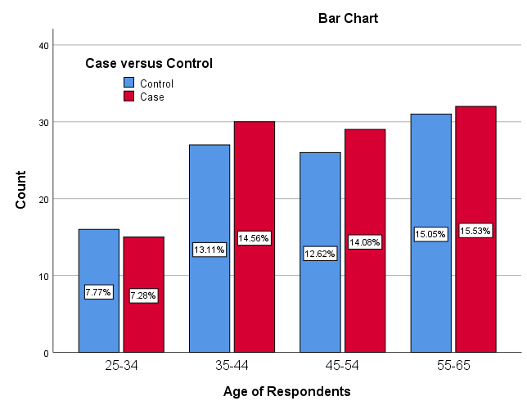
Figure VII: Distribution of case and control among the different age group
Figure VII shows the distribution of case and control among the different age group. It is observed that the age distribution between case and control groups was approximately similar. For example, in age group 35-44, the percentage of cases was 14.56 and the percentage of control was 13.11.

Table XIII: Distribution of pattern of lung function in case and control respondent
Pattern | Control |  | Case |  | P-value
Pattern | Frequency | Percent | Frequency | Percent | P-value
Obstruction (Non-Reversible) | 23 | 23.0 | 50 | 47.2 | <0.001
Obstruction (Reversible) | 6 | 6.0 | 4 | 3.8 | <0.001
Restriction | 7 | 7.0 | 19 | 17.9 | <0.001
Normal | 64 | 64.0 | 33 | 31.1 | <0.001
Total | 100 |  | 106 |  | <0.001

Table XIII shows the pattern of lung function between case and control. Among the case subjects 47.2% developed COPD and among the control group only 23% developed COPD.

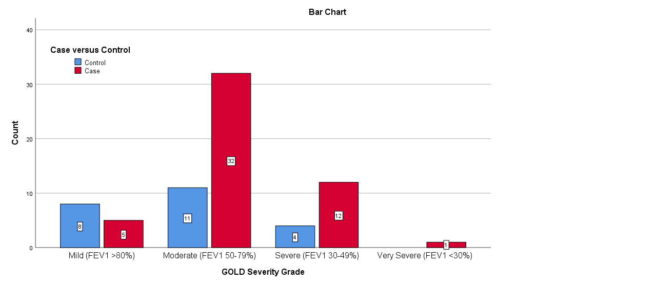
Figure VIII: Distribution of case and control among the different GOLD severity grade

Figure VIII shows the Distribution of case and control among the different GOLD severity grade. Here it was observed that moderate, severe and very severe disease were more prevalent among the case subject (smoking & silica exposed) than that of control (only exposed to smoking).

Table XIV: Association between Exposure to smoking plus Silica (vs Smoking) and COPD (Logistic regression analysis)
Exposure | COPD |  |  | OR | 95% CI | P-value
Exposure | No | Yes | Total | OR | 95% CI | P-value
Smoker & Silica exposure | 56 (42.1) | 50 (68.5) | 106 | 2.99 | [1.64-5.46] | <0.001
Smoker | 77 (57.9) | 23 (31.5) | 100 | Ref. | - | <0.001
OR: Odds Ratio; CI: Confidence Interval
Table XIV represent the odds ratios and 95% confidence intervals (CI) for COPD of different exposure. The logistic regression analysis shows that workers who were smoker and exposed to silica dust were significantly (p<0.001) more likely to developed COPD (OR 2.99; 95% CI 1.64–5.46) compared to the only smoking exposure group.

DISCUSSION
DISCUSSION
5.1 Discussion
Occupational exposure is one of the two most important risk factor for COPD development. An estimated 15-30% of COPD cases are attributable to occupational exposure (Torén and Järvholm, 2014). Silica dust is one of the most important occupational respiratory toxin (Tilert et al. 2013).
This cross-sectional observational study was conducted in Bholagang of companigang upozilla and jaflong of Gowainghat upozilla among the stone quarry workers during the time period from 1st January 2018 to 31st December 2020. Control respondent was taken from inpatient department of Medicine, Sylhet MAG Osmani Medical College.
In this study, we assessed the association between silica dust exposure and COPD among the stone quarry workers versus control subjects in Sylhet. Here we established the diagnosis of COPD by compatible history and spirometry as per GOLD guideline. We also assessed the prevalence of COPD among the smokers exposed to silica dust. Moreover, we analysed data using different GOLD severity scales of COPD.
Among the different pattern of lung function, we found 39% of no reversible obstruction, that is COPD among the 200 participant who were exposed to silica dust. This finding is close to the studies conducted in Peshawar, Pakistan and Wales, UK. These studies showed that 35% of workers in dust generating industry in Peshawar, Pakistan, and 33% of slate mining workers exposed to silica dust in Wales, UK were suffering from COPD (Iftikhar et al. (2009); Reynolds et al. (2017). Out of 200 participants, 78 workers were developed COPD and among them, 47.1% were smoker. The prevalence of COPD among the non-smokers exposed to silica dust was 28%. Moreover, 18% of workers shows the restrictive pattern of lung function and very few (5%) workers have reversible obstruction and 37.5% has normal lung function. Moreover, out of 100 control all were smoker and among them 23% developed COPD.
With respect to age, we found that highest number of worker (30%) with COPD belong to the 55-65 years of age. Our results showed that there is increasing trend of COPD with the increasing of age. A study conducted in Bangladesh were they found that the mean age of COPD patients was 57 years (Alam et al., 2015). Another study found that those with higher age group (40-60 years) were more prone (61%) to developed the disease and this association was statistically significant (p<0.05). The effect of age on COPD might be due to prolonged exposure as the aged workers have spent more years in the trade (Iftikhar et al., 2009). In NICE study conducted by Yoshinosuke et al, in Japan, shows COPD is significantly more prevalent in older people. 3.5% in 40-49 years old Vs. 24.4% in those >70 years of age (Ali et al. 2019)and this increasing prevalence with increasing of age is consistent with our study.
Among the 200 participants 65.5% were male & 34.5% were female. Among the COPD cases (n=78) 76.9% were male and 23.1% were female. This result indicates male are more prone to developed COPD than female. A prevalence study conducted in Bangladesh also found similar results that gender (male) was an important contributing factor to COPD development (Biswas & Chowdhury 2017). It was consistent with an international study that also showed male predominance with 92.9% males and 7.1% females (Dilektasli et al. 2016; Reechaipichitkul 2014) observed 86.4% males and 13.6% females in their study. (Furqan & Paracha 2014) found that 85.7% of COPD patients were male and 14.3% of patients were female. Male preponderance of COPD was also reported in several other studies (Alamoudi & Alamoudi 2007; Lin et al. 2007). But one study conducted in Nigeria found that men and women are almost equally distributed in the quarry workers (Nwibo et al. 2012).
Regarding smoking status, Among the 200 participant 106(53%) were smoker and 96(47%) were non-smoker. Among the 78 COPD patients who were exposed to silica dust and smoking (n=50), among them 92% were smoked more than 10 pack year and only 8% smoked less than 10 pack year. In BOLD-BD study, it has shown that about 80% smokers need to smoke only around 10 pack years to catch the disease and the study has considered this finding as more alarming than the international findings, where 20 pack-years are set as a bench mark in developing COPD (Aghilinejad, Jammati & Farshad 2006).
In regard to non-smokers COPD we found among the 60 males, 13(21.7%) and among the 18 female, 15 (83.3%) were developed COPD. These non-smokers COPD is possibly due to unprotected exposure to silica dust for a prolonged period. These findings are consistent with a study where they found, in never smokers there were significant reduction of lung function in miners exposed to silica dust (Iftikhar et al., 2009). Another study found that 18% of the non- smokers COPD is attributable to occupational exposure (Öngen 2010). A retrospective cohort study found that non-smoking dusty trade workers run the risk of developing occupational COPD six times more than smoking dusty trade workers (Mazitova et al., 2012).
We observed that prevalence of COPD among the quarry workers was increasing with longer length of service, which is supported by a study conducted by (Cho et al. 2015). Another study in Andhra Pradesh, India found that %reduction of pulmonary function value in quarry workers are positively correlate with duration of work (Kiran Kumar et al. 2014). We noticed that the severity of the disease increased along with the increasing length of service. We also noticed that the severity of disease is more prone to cases subjects than that of control group.
Regarding protective equipment used among the quarry workers, we found that only 13% of workers using protective equipment during their work and among the COPD patient only 8.97% were uses protective equipment. In our study sample, none of the workers avail any medical facilities in their working industry. Data on the availability of medical care in the quarry industrial site and use of protective equipment by the quarry workers indicated that there was a total absence of medical care in the study area and a near absence of protective equipment usage by the workers. Most of the workers (75.5%) were belong to normal BMI category.
We found that almost all of the participants were working in the quarry industrial site on a full-time basis, indicating that majority of them are at a high risk of exposure to the respirable quarry dust. Moreover, almost all cases subjects are illiterate, suggesting a low level of awareness of the respondents about the health implications of the respirable quarry dust.
A high prevalence of respiratory symptoms was noted in this study; the most common symptoms were cough (52%), 28.5% have associated sputum production and 47.5% have shortness of breath. These results are comparable with the results of previous studies in Iran and Rio de Janeiro, Brazil. The study in Iran (Aghilinejad, Jammati & Farshad 2006) reported irritative cough in 75% of the respondents, while that in Rio de Janeiro (Lemle et al. n.d.) reported cough in 31.9% with expectoration in 41.7%.It therefore, seems reasonable to associate the respiratory problems recorded in the present study with the respirable quarry dust; a similar study reported association between chronic exposure to silica dust generated from crushing of granite rocks with impaired lung function and some respiratory and non-respiratory symptoms (Urom, Antai & Osim 2005).
The logistic regression analysis shows that workers who were exposed to both smoking and silica dust were two-fold increased risk of developing COPD (OR 2.99; 95% CI 1.64–5.46) than that of control subject (only smoker). A study showed that the combination of smoking and occupational exposure was associated with a nearly five-fold increase risk of COPD development. Another study showed that decline in lung function values was significantly higher among individuals with both silica and tobacco exposure than in those with only smoking exposure (Nwibo et al. 2012). The synergistic effect of tobacco smoke and occupational silica dust exposure on COPD development has been well documented in various other studies (Iftikhar et al., 2009).

5.2 Strengths and Limitations of the Study
Strengths
This study is one of the big cross-sectional studies in Sylhet region as well as in Bangladesh.
We collected data and assessed respondents with proper clinical guidelines.
Limitations
The study is a cross-sectional, so conclusion for causal association from this study should be explained carefully.
We collected data on control subjects only from hospital settings and all were male and smokers.

CONCLUSION AND RECOMMENDATION

6.1 CONCLUSION
The study revealed that silica dust associated with COPD irrespective of smoking and the severity of the disease increased along with the increasing the length of service in stone quarry workers of sylhet. Furthermore, the severity of disease is more prone to cases subjects who is exposed to silica dust than that of control group. We also conclude that the prevalence of COPD among the smokers and non-smokers exposed to silica dust was 64.1% and 35.9%, respectively and the association between smoking status and COPD for exposed to silica dust respondents was statistically significant. Finally, it was shown that, the workers who were exposed to both silica dust and smoking are more likely (two-fold increase risk) to develop the COPD as compared to the control group (only smokers) which was statistically significant.
6.2 RECOMMENDATIONS
Based on the major findings of the study, the following recommendations could be considered:
As our study was a cross-sectional study, further longitudinal study should be conducted to assess the association between silica dust and COPD over time.
As our control group only considered male respondents, further study could be considered with both genders.
The size of the sample for cases and control groups were not similar, control sample size smaller than cases. It would be more effective if further study could be carried out with larger sample size.
As it is evident from our study that the burden of COPD on dust workers in Sylhet is high and one of the major public health problems in Bangladesh, policy makers should take proper strategy to support and provide awareness among the stone quarry workers (e.g. use protective mask during work) in order to reduce the COPD burden.

A study emphasis on non-smoker COPD and they noted that more attention is necessary for non-smoker as other smoke is present inside and outside the home in developing country (Sharma and Singh, 2017).

References
Adeloye, D, Basquill, C, Papana, A, Chan, KY, Rudan, I & Campbell, H 2015, ‘An estimate of the prevalence of COPD in Africa: A systematic analysis’., COPD: Journal of Chronic Obstructive Pulmonary Disease, vol. 12, no. 1, pp.71–81.
Afonso, ASM, Verhamme, KMC, Sturkenboom, MCJM & Brusselle, GGO 2011, ‘COPD in the general population: Prevalence, incidence and survival’., Respiratory Medicine, vol. 105, no. 12, pp.1872–1884.
Aghilinejad, M, Jammati, MR & Farshad, AA 2006, Prevalence of Silicosis among Workers in Stone-Cutter and Silica Powder Production Factories.
Agustí, AGN, Noguera, A, Sauleda, J, Sala, E, Pons, J & Busquets, X 2003, ‘Systemic effects of chronic obstructive pulmonary disease’., European Respiratory Journal, vol. 21, no. 2, pp.347–360. Available from: http://www.ncbi.nlm.nih.gov/pubmed/12608452. [18 February 2020].
Aït-Khaled, N, Enarson, D & Bousquet, J 2001, ‘Chronic respiratory diseases in developing countries: The burden and strategies for prevention and management’., Bulletin of the World Health Organization, vol. 79, no. 10, pp.971–979.
Alam, DS, Chowdhury, MA, Siddiquee, AT, Ahmed, S & Clemens, JD 2015, ‘Prevalence and determinants of chronic obstructive pulmonary disease (COPD) in Bangladesh’., COPD: Journal of Chronic Obstructive Pulmonary Disease, vol. 12, no. 6, pp.658–667.
Alamoudi, OSB & Alamoudi, OS 2007, ‘Bacterial infection and risk factors in outpatients with acute exacerbation of chronic obstructive pulmonary disease: A 2-year prospective study’., Respirology, vol. 12, pp.283–287.
Ali, MA, Islam, MS, Majumdar, SC, Haque, MA & Sardar, AH 2019, ‘Role of Spirometry in Early Diagnosis of COPD among Smokers’., TAJ: Journal of Teachers Association, vol. 32, no. 1, pp.33–38.
Alim, MA, Sarker, MAB, Selim, S, Karim, MR, Yoshida, Y & Hamajima, N 2014, ‘Respiratory involvements among women exposed to the smoke of traditional biomass fuel and gas fuel in a district of Bangladesh’., Environmental Health and Preventive Medicine, vol. 19, no. 2, pp.126–134.
Ameille, J, Dalphin, JC, Descatha, A & Pairon, JC 2006, ‘La bronchopneumopathie chronique obstructive professionnelle: Une maladie méconnue’., Revue des Maladies Respiratoires, vol. 23, no. SUPPL. 4 Available from: https://www.em-consulte.com/rmr/article/146313. [21 January 2020].
American thoracic society statement: Occupational contribution to the burden of airway disease 2003, American Journal of Respiratory and Critical Care Medicine, vol. 167, no. 5, pp.787–797.
Andersen, ZJ, Hvidberg, M, Jensen, SS, Ketzel, M, Loft, S, Sørensen, M, Tjønneland, A, Overvad, K & Raaschou-Nielsen, O 2011, ‘Chronic obstructive pulmonary disease and long-term exposure to traffic-related air pollution: A cohort study’., American Journal of Respiratory and Critical Care Medicine, vol. 183, no. 4, pp.455–461. Available from: http://www.ncbi.nlm.nih.gov/pubmed/20870755. [8 March 2020].
Angelis, N, Porpodis, K, Zarogoulidis, P, Spyratos, D, Kioumis, I, Papaiwannou, A, Pitsiou, G, Tsakiridis, K, Mpakas, A, Arikas, S, Tsiouda, T, Katsikogiannis, N, Kougioumtzi, I, Machairiotis, N, Argyriou, M, Kessisis, G & Zarogoulidis, K 2014, ‘Airway inflammation in chronic obstructive pulmonary disease’., Journal of Thoracic Disease, vol. 6, no. SUPPL1, p.S167.
Antuni, JD & Barnes, PJ 2016, ‘Evaluation of Individuals at Risk for COPD: Beyond the Scope of GOLD’., Chronic Obstructive Pulmonary Diseases: Journal of the COPD Foundation, vol. 3, no. 3, pp.653–667.
Atsou, K, Chouaid, C & Hejblum, G 2011, ‘Variability of the chronic obstructive pulmonary disease key epidemiological data in Europe: systematic review’., BMC Medicine, vol. 9, no. 1, p.7. Available from: http://bmcmedicine.biomedcentral.com/articles/10.1186/1741-7015-9-7. [21 January 2020].
Balmes, JR 2010, ‘‘When smoke gets in your lungs’’, Proceedings of the American Thoracic Society , pp.98–101.
Barnes, PJ 2012, ‘‘Chronic Obstructive Pulmonary Disease (COPD)’’ in Chemical Biology: Approaches to Drug Discovery and Development to Targeting Disease , pp.245–265. Available from: https://www.who.int/news-room/fact-sheets/detail/chronic-obstructive-pulmonary-disease-(copd). [21 January 2020].
Barr, RG, Herbstman, J, Speizer, FE & Camargo, CA 2002, ‘Validation of self-reported chronic obstructive pulmonary disease in a cohort study of nurses.’, American journal of epidemiology, vol. 155, no. 10, pp.965–71. Available from: http://www.ncbi.nlm.nih.gov/pubmed/11994237. [21 February 2020].
Benfield, T, Lange, P & Vestbo, J 2008, ‘COPD stage and risk of hospitalization for infectious disease’., Chest, vol. 134, no. 1, pp.46–53. Available from: http://www.ncbi.nlm.nih.gov/pubmed/18403661. [21 February 2020].
Biswas, RR & Chowdhury, F 2017, ‘Risk factors of chronic obstructive pulmonary disease among rural women, Chittagong, Bangladesh’., Egyptian Journal of Bronchology, vol. 11, no. 3, p.188. Available from: http://www.ejbronchology.eg.net/text.asp?2017/11/3/188/211395. [21 January 2020].
Biswas, RSR, Paul, S, Rahaman, MR, Sayeed, MA, Hoque, MG, Hossain, MA, Hassan, MMU & Faiz, M 2016, ‘Indoor Biomass Fuel Smoke Exposure as a Risk Factor for Chronic Obstructive Pulmonary Disease (COPD) for Women of Rural Bangladesh’., Chattagram Maa-O-Shishu Hospital Medical College Journal, vol. 15, no. 1, pp.8–11.
Blanc, PD 2012, ‘‘Occupation and COPD: A brief review’’, Journal of Asthma , pp.2–4.
Blanc, PD, Iribarren, C, Trupin, L, Earnest, G, Katz, PP, Balmes, J, Sidney, S & Eisner, MD 2009a, ‘Occupational exposures and the risk of COPD: Dusty trades revisited’., Thorax, vol. 64, no. 1, pp.6–12.
Blanc, PD, Menezes, AMB, Plana, E, Mannino, DM, Hallala, PC, Toren, K, Eisner, MD & Zock, JP 2009b, ‘Occupational exposures and COPD: An ecological analysis of international data’., European Respiratory Journal, vol. 33, no. 2, pp.298–304. Available from: http://www.ncbi.nlm.nih.gov/pubmed/19010980. [21 February 2020].
Blanco, I, Diego, I, Bueno, P, Fernández, E, Casas-Maldonado, F, Esquinas, C, Soriano, JB & Miravitlles, M 2018, ‘Geographical distribution of COPD prevalence in Europe, estimated by an inverse distance weighting interpolation technique’., International Journal of COPD, vol. 13, pp.57–67.
Blum, A, Simsolo, C, Sirchan, R & Haiek, S 2011, ‘“Obesity Paradox” in chronic obstructive pulmonary disease’., Israel Medical Association Journal, vol. 13, no. 11, pp.672–675. Available from: https://www.researchgate.net/publication/221779720_Obesity_Paradox_in_Chronic_Obstructive_Pulmonary_Disease. [21 February 2020].
Borné, Y, Ashraf, W, Zaigham, S & Frantz, S 2019, ‘Socioeconomic circumstances and incidence of chronic obstructive pulmonary disease (COPD) in an urban population in Sweden’., COPD: Journal of Chronic Obstructive Pulmonary Disease, vol. 16, no. 1, pp.51–57. Available from: https://www.tandfonline.com/doi/full/10.1080/15412555.2019.1582618. [22 January 2020].
Boukhenouna, S, Wilson, MA, Bahmed, K & Kosmider, B 2018, ‘Reactive oxygen species in chronic obstructive pulmonary disease’., Oxidative Medicine and Cellular Longevity, vol. 2018.
Cabrera López, C, Juliá Serdá, G, Cabrera Lacalzada, C, Martín Medina, A, Gullón Blanco, JA, García Bello, MÁ & Cabrera Navarro, P 2014, ‘Prevalence of Chronic Obstructive Pulmonary Disease in the Canary Islands’., Archivos de Bronconeumología (English Edition), vol. 50, no. 7, pp.272–277.
Capistrano, SJ, van Reyk, D, Chen, H & Oliver, BG 2017, ‘Evidence of biomass smoke exposure as a causative factor for the development of COPD’., Toxics, vol. 5, no. 4.
Carey, RN, Driscoll, TR, Peters, S, Glass, DC, Reid, A, Benke, G & Fritschi, L 2014, ‘Estimated prevalence of exposure to occupational carcinogens in Australia (2011-2012)’., Occupational and Environmental Medicine, vol. 71, no. 1, pp.55–62. Available from: http://www.ncbi.nlm.nih.gov/pubmed/24158310. [21 February 2020].
Cazzola, M, Puxeddu, E, Bettoncelli, G, Novelli, L, Segreti, A, Cricelli, C & Calzetta, L 2011, ‘The prevalence of asthma and COPD in Italy: A practice-based study’., Respiratory Medicine, vol. 105, no. 3, pp.386–391.
Celli, BR, MacNee, W, Agusti, A, Anzueto, A, Berg, B, Buist, AS, Calverley, PMA, Chavannes, N, Dillard, T, Fahy, B, Fein, A, Heffner, J, Lareau, S, Meek, P, Martinez, F, McNicholas, W, Muris, J, Austegard, E, Pauwels, R, Rennard, S, Rossi, A, Siafakas, N, Tiep, B, Vestbo, J, Wouters, E & ZuWallack, R 2004, ‘Standards for the diagnosis and treatment of patients with COPD: A summary of the ATS/ERS position paper’., European Respiratory Journal, vol. 23, no. 6, pp.932–946.
Cho, YM, Lee, J, Choi, M, Choi, WS, Myong, JP, Kim, HR & Koo, JW 2015, ‘Work-related COPD after years of occupational exposure’., Annals of Occupational and Environmental Medicine, vol. 27, no. 1.
Churg, A & Wright, JL 2002, ‘Airway wall remodeling induced by occupational mineral dusts and air pollutant particles.’, Chest, vol. 122, no. 6 Suppl, pp.306S-309S. Available from: http://www.ncbi.nlm.nih.gov/pubmed/12475806. [8 March 2020].
Ciapponi, A, Alison, L, Agustina, M, Demián, G, Silvana, C & Edgardo, S 2014, ‘The epidemiology and burden of COPD in latin America and the caribbean: Systematic review and meta-analysis’., COPD: Journal of Chronic Obstructive Pulmonary Disease, vol. 11, no. 3, pp.339–350.
Dement, J, Welch, L, Ringen, K, Quinn, P, Chen, A & Haas, S 2015, ‘A case-control study of airways obstruction among construction workers’., American Journal of Industrial Medicine, vol. 58, no. 10, pp.1083–1097. Available from: http://www.ncbi.nlm.nih.gov/pubmed/26123003. [18 February 2020].
Dement, JM, Welch, L, Ringen, K, Bingham, E & Quinn, P 2010, ‘Airways obstruction among older construction and trade workers at department of energy nuclear sites’., American Journal of Industrial Medicine, vol. 53, no. 3, pp.224–240. Available from: http://www.ncbi.nlm.nih.gov/pubmed/20025074. [21 February 2020].
Dhadke, VN, Dhadke, S V & Raut, N 2015, ‘Clinical Profile in Chronic Obstructive Pulmonary Disease Patients and their Evaluation with Spirometry and 2D Echo’., International Journal of Current Research, vol. 7, no. 2, pp.12480–88. Available from: http://www.journalcra.com/article/clinical-profile-chronic-obstructive-pulmonary-disease-patients-and-their-evaluation. [21 February 2020].
Dilektasli, AG, Demirdogen Cetinoglu, E, Aylin, N, Ozturk, A, Coskun, F, Ozkaya, G, Ursavas, A, Ozakin, C, Karadag, M & Uzaslan, E 2016, ‘Bacterial etiology in acute hospitalized chronic obstructive pulmonary disease exacerbations’., Eur Res J, vol. 2, no. 2, pp.99–106. Available from: http://www.eurj.org. [8 March 2020].
Domej, W, Oettl, K & Renner, W 2014, ‘Oxidative stress and free radicals in COPD-implications and relevance for treatment’., International Journal of COPD, vol. 9, pp.1207–1224.
Van Eeden, SF & Sin, DD 2013, ‘Oxidative stress in chronic obstructive pulmonary disease: A lung and systemic process’., Canadian Respiratory Journal, vol. 20, no. 1, pp.27–29.
Eisner, MD, Anthonisen, N, Coultas, D, Kuenzli, N, Perez-Padilla, R, Postma, D, Romieu, I, Silverman, EK & Balmes, JR 2010a, ‘An official American Thoracic Society public policy statement: Novel risk factors and the global burden of chronic obstructive pulmonary disease’., American Journal of Respiratory and Critical Care Medicine, vol. 182, no. 5, pp.693–718.
Eisner, MD, Anthonisen, N, Coultas, D, Kuenzli, N, Perez-Padilla, R, Postma, D, Romieu, I, Silverman, EK & Balmes, JR 2010b, ‘An official American Thoracic Society public policy statement: Novel risk factors and the global burden of chronic obstructive pulmonary disease’., American Journal of Respiratory and Critical Care Medicine, vol. 182, no. 5, pp.693–718. Available from: http://www.ncbi.nlm.nih.gov/pubmed/20802169. [8 March 2020].
Ezzati, M, Lopez, AD, Rodgers, A & Murray, CJL 2004, Comparative Quantification of Health Risks.
Fabricius, P, Løkke, A, Marott, JL, Vestbo, J & Lange, P 2011, ‘Prevalence of COPD in Copenhagen’., Respiratory Medicine, vol. 105, no. 3, pp.410–417.
Fell, AKM, Sikkeland, LIB, Svendsen, MV & Kongerud, J 2010, ‘Airway inflammation in cement production workers’., Occupational and Environmental Medicine, vol. 67, no. 6, pp.395–400. Available from: http://www.ncbi.nlm.nih.gov/pubmed/19854695. [21 February 2020].
Finney, LJ, Feary, JR, Leonardi-Bee, J, Gordon, SB & Mortimer, K 2013, ‘Chronic obstructive pulmonary disease in sub-Saharan Africa: A systematic review’., International Journal of Tuberculosis and Lung Disease, vol. 17, no. 5, pp.583–589.
Furqan, S & Paracha, SAU 2014, ‘Frequency of Streptococcus pneumonia and Haemophilus influenza in acute exacerbation of chronic obstructive airway disease and their sensitivity to levofloxacin.’, JPMA. The Journal of the Pakistan Medical Association, vol. 64, no. 4, pp.399–402. Available from: http://www.ncbi.nlm.nih.gov/pubmed/24864632. [8 March 2020].
García-Lucio, J, Peinado, VI, de Jover, L, del Pozo, R, Blanco, I, Bonjoch, C, Coll-Bonfill, N, Paul, T, Tura-Ceide, O & Barberà, JA 2018, ‘Imbalance between endothelial damage and repair capacity in chronic obstructive pulmonary disease’ ed.A Di Stefano., PLOS ONE, vol. 13, no. 4, p.e0195724. Available from: https://dx.plos.org/10.1371/journal.pone.0195724. [18 February 2020].
Van Gemert, F, Kirenga, B, Chavannes, N, Kamya, M, Luzige, S, Musinguzi, P, Turyagaruka, J, Jones, R, Tsiligianni, I, Williams, S, de Jong, C & van der Molen, T 2015, ‘Prevalence of chronic obstructive pulmonary disease and associated risk factors in Uganda (FRESH AIR Uganda): A prospective cross-sectional observational study’., The Lancet Global Health, vol. 3, no. 1, pp.e44–e51.
Gibson, GJ, Loddenkemper, R, Lundbäck, B & Sibille, Y 2013, ‘Respiratory health and disease in Europe: The new European Lung White Book’., European Respiratory Journal, vol. 42, no. 3, pp.559–563.
GOLD 2019, Global Initiative for Chronic Obstructive L ung D isease. Available from: www.goldcopd.org. [21 February 2020].
Gómez Sáenz, JT, Quintano Jiménez, JA, Hidalgo Requena, A, González Béjar, M, Gérez Callejas, MJ, Zangróniz Uruñuela, MR, Moreno Vilaseca, A & Hernández García, R 2014, ‘Enfermedad pulmonar obstructiva crónica: Morbimortalidad e impacto sanitario’., Semergen, vol. 40, no. 4, pp.198–204.
Govender, N, Lalloo, UG & Naidoo, RN 2011, ‘Occupational exposures and chronic obstructive pulmonary disease: A hospital based case - Control study’., Thorax, vol. 66, no. 7, pp.597–601.
Grigsby, M, Siddharthan, T, Chowdhury, MAH, Siddiquee, A, Rubinstein, A, Sobrino, E, Miranda, JJ, Bernabe-Ortiz, A, Alam, D & Checkley, W 2016, ‘Socioeconomic status and COPD among low-and middle-income countries’., International Journal of COPD, vol. 11, no. 1, pp.2497–2507.
Harber, P, Tashkin, DP, Simmons, M, Crawford, L, Hnizdo, E & Connett, J 2007, ‘Effect of occupational exposures on decline of lung function in early chronic obstructive pulmonary disease’., American Journal of Respiratory and Critical Care Medicine, vol. 176, no. 10, pp.994–1000.
Hart, JE, Laden, F, Eisen, EA, Smith, TJ & Garshick, E 2009, ‘Chronic obstructive pulmonary disease mortality ir railroad workers’., Occupational and Environmental Medicine, vol. 66, no. 4, pp.221–226.
Helvaci, MR, Aydin, LY & Aydin, Y 2012, ‘Chronic obstructive pulmonary disease may be one of the terminal end points of metabolic syndrome’., Pakistan Journal of Medical Sciences, vol. 28, no. 3, pp.376–379. Available from: www.pjms.com.pk. [21 February 2020].
Hiemstra, PS, McCray, PB & Bals, R 2015, ‘The innate immune function of airway epithelial cells in inflammatory lung disease’., European Respiratory Journal, vol. 45, no. 4, pp.1150–1162.
Hnizdo, E. Vallyathan, V 2002, Mechanisms of crystalline silica and coal-induced emphysema development. Available from: https://www.cdc.gov/niosh/nioshtic-2/20027161.html. [8 March 2020].
Hnizdo, E, Baskind, E & Sluis-Cremer, GK 1990, ‘Combined effect of silica dust exposure and tobacco smoking on the prevalence of respiratory impairments among gold miners’., Scandinavian Journal of Work, Environment and Health, vol. 16, no. 6, pp.411–422.
Hnizdo, E, Sullivan, PA, Bang, KM & Wagner, G 2002, ‘Association between chronic obstructive pulmonary disease and employment by industry and occupation in the US population: A study of data from the Third National Health and Nutrition Examination Survey’., American Journal of Epidemiology, vol. 156, no. 8, pp.738–746.
Hnizdo, E & Vallyathan, V 2003, ‘Chronic obstructive pulmonary disease due to occupational exposure to silica dust: A review of epidemiological and pathological evidence’., Occupational and Environmental Medicine, vol. 60, no. 4, pp.237–243.
Hooper, R, Burney, P, Vollmer, WM, McBurnie, MA, Gislason, T, Tan, WC, Jithoo, A, Kocabas, A, Weltee, T & Buist, AS 2012, ‘Risk factors for COPD spirometrically defined from the lower limit of normal in the BOLD project’., European Respiratory Journal, vol. 39, no. 6, pp.1343–1353.
Hu, G, Zhou, Y, Tian, J, Yao, W, Li, J, Li, B & Ran, P 2010, ‘Risk of COPD from exposure to biomass smoke: A metaanalysis’., Chest, vol. 138, no. 1, pp.20–31.
Iftikhar, B, Khan, MH, Hussain, H, Iqbal, M & Jadoon, GS 2009a, Relationship Between Silica Dust Exposure and Chronic Obstructive Pulmonary Disease in Workers of Dust Generating Industries of District Peshawar., vol. 7, no. 1.
Iftikhar, B, Khan, MH, Hussain, H, Iqbal, M & Jadoon, GS 2009b, Relationship Between Silica Dust Exposure and Chronic Obstructive Pulmonary Disease in Workers of Dust Generating Industries of District Peshawar., vol. 7, no. 1 Available from: http://www.gjms.com.pk/ojs24/index.php/gjms/article/view/158. [8 March 2020].
Irwig, LM & Rocks, P 1978, ‘Lung function and respiratory symptoms in silicotic and nonsilicotic gold miners’., American Review of Respiratory Disease, vol. 117, no. 3, pp.429–435.
Islam, MS, Hossain, MM, Pasha, MM, Azad, AK & Murshed, KM 2013, ‘Prevalence and risk factors of chronic obstructive pulmonary disease (COPD) in Dhaka city population.’, Mymensingh medical journal : MMJ, vol. 22, no. 3, pp.547–551.
James P 2016, ‘Non-Communicable Diseases in Bangladesh Current Scenario and Future Directions Non-communicable Diseases in Bangladesh: Current Scenario and Future Directions Publisher Bangladesh Health Watch Secretariat’. Available from: www.jpgsph.org. [26 February 2020].
John J. Reilly, J. EKSSDS 2012, ‘Bronchopneumopathie chronique obstructive’., Revue des Maladies Respiratoires Actualites, vol. 4, no. 7, pp.697–702. Available from: https://accessmedicine.mhmedical.com/content.aspx?bookid=1130&sectionid=79745089. [8 March 2020].
De Jong, K, Boezen, HM, Kromhout, H, Vermeulen, R, Vonk, JM & Postma, DS 2014, ‘Occupational exposure to vapors, gases, dusts, and fumes is associated with small airways obstruction’., American Journal of Respiratory and Critical Care Medicine, vol. 189, no. 4, pp.487–490. Available from: http://www.ncbi.nlm.nih.gov/pubmed/24528319. [8 March 2020].
Jordan, RE, Cheng, KK, Miller, MR & Adab, P 2011, ‘Passive smoking and chronic obstructive pulmonary disease: Cross-sectional analysis of data from the Health Survey for England’., BMJ Open, vol. 1, no. 2.
Kanervisto, M, Vasankari, T, Laitinen, T, Heliövaara, M, Jousilahti, P & Saarelainen, S 2011, ‘Low socioeconomic status is associated with chronic obstructive airway diseases’., Respiratory Medicine, vol. 105, no. 8, pp.1140–1146.
Kiran Kumar, CH, Mallikarjuna Reddy, N, Singh M, SB, Krishna, BH, Sasikala, P, ShravyaKeerthi, G, Siva Kumar, A V. & Kareem, SK 2014, ‘Deterioration of pulmonary function in stone quarry workers’., Biomedical Research (India), vol. 25, no. 2, pp.261–268. Available from: http://www.biomedres.info/biomedical-research/deterioration-of-pulmonary-function-in-stone-quarry-workers.html. [8 March 2020].
Kirkham, PA & Barnes, PJ 2013, ‘Oxidative stress in COPD’., Chest, vol. 144, no. 1, pp.266–273.
Koeverden, I Van, Blanc, PD, Bowler, RP & Arjomandi, M 2015, ‘Secondhand tobacco smoke and COPD risk in smokers: A COPDGene study cohort subgroup analysis’., COPD: Journal of Chronic Obstructive Pulmonary Disease, vol. 12, no. 2, pp.182–189.
Kubo, H, Asai, K, Kojima, K, Sugitani, A, Kyomoto, Y, Okamoto, A, Yamada, K, Ijiri, N, Watanabe, T, Hirata, K & Kawaguchi, T 2019, ‘Exercise ameliorates emphysema of cigarette smoke-induced COPD in mice through the exercise-irisin-Nrf2 axis’., International Journal of COPD, vol. 14, pp.2507–2516.
Kurmi, OP, Semple, S, Simkhada, P, Cairns S Smith, W & Ayres, JG 2010, ‘COPD and chronic bronchitis risk of indoor air pollution from solid fuel: A systematic review and meta-analysis’., Thorax, vol. 65, no. 3, pp.221–228.
Lahousse, L, Seys, LJM, Joos, GF, Franco, OH, Stricker, BH & Brusselle, GG 2017, ‘Epidemiology and impact of chronic bronchitis in chronic obstructive pulmonary disease’., European Respiratory Journal, vol. 50, no. 2.
Lai, H, Liu, Y, Zhou, M, Shi, T, Zhou, Y, Weng, S & Chen, W 2018, ‘Combined effect of silica dust exposure and cigarette smoking on total and cause-specific mortality in iron miners: A cohort study’., Environmental Health: A Global Access Science Source, vol. 17, no. 1, p.46. Available from: https://ehjournal.biomedcentral.com/articles/10.1186/s12940-018-0391-0. [18 February 2020].
Lamprecht, B, McBurnie, MA, Vollmer, WM, Gudmundsson, G, Welte, T, Nizankowska-Mogilnicka, E, Studnicka, M, Bateman, E, Anto, JM, Burney, P, Mannino, DM & Buist, SA 2011, ‘COPD in never smokers: Results from the population-based burden of obstructive lung disease study’., Chest, vol. 139, no. 4, pp.752–763. Available from: http://www.ncbi.nlm.nih.gov/pubmed/20884729. [18 February 2020].
Lemle, A, de Araújo, AJ, Lapa e Silva, JR, Lima, F de P, Cardoso, AP, Câmara, W de M, de Lucca, W, Marchiori, E, Carnevalli, LC & Colucci, AL n.d., ‘Respiratory symptoms and spirometric tests of quarry workers in Rio de Janeiro’., Revista da Associacao Medica Brasileira (1992), vol. 40, no. 1, pp.23–35. Available from: http://www.ncbi.nlm.nih.gov/pubmed/8061690. [8 March 2020].
Lerner, CA, Sundar, IK & Rahman, I 2016, ‘Mitochondrial redox system, dynamics, and dysfunction in lung inflammaging and COPD’., International Journal of Biochemistry and Cell Biology, vol. 81, no. Pt B, pp.294–306.
Lin, SH, Kuo, PH, Hsueh, PR, Yang, PC & Kuo, SH 2007, ‘Sputum bacteriology in hospitalized patients with acute exacerbation of chronic obstructive pulmonary disease in Taiwan with an emphasis on Klebsiella pneumoniae and Pseudomonas aeruginosa’., Respirology, vol. 12, no. 1, pp.81–87. Available from: http://www.ncbi.nlm.nih.gov/pubmed/17207030. [8 March 2020].
Louhelainen, N, Rytilä, P, Haahtela, T, Kinnula, VL & Djukanović, R 2009, ‘Persistence of oxidant and protease burden in the airways after smoking cessation’., BMC Pulmonary Medicine, vol. 9, no. 1, p.25. Available from: https://bmcpulmmed.biomedcentral.com/articles/10.1186/1471-2466-9-25. [18 February 2020].
Lozano, R, Naghavi, M, Foreman, K, Lim, S, Shibuya, K, Aboyans, V, Abraham, J, Adair, T, Aggarwal, R, Ahn, SY, AlMazroa, MA, Alvarado, M, Anderson, HR, Anderson, LM, Andrews, KG, Atkinson, C, Baddour, LM, Barker-Collo, S, Bartels, DH, Bell, ML, Benjamin, EJ, Bennett, D, Bhalla, K, Bikbov, B, Bin Abdulhak, A, Birbeck, G, Blyth, F, Bolliger, I, Boufous, S, Bucello, C, Burch, M, Burney, P, Carapetis, J, Chen, H, Chou, D, Chugh, SS, Coffeng, LE, Colan, SD, Colquhoun, S, Colson, KE, Condon, J, Connor, MD, Cooper, LT, Corriere, M, Cortinovis, M, Courville De Vaccaro, K, Couser, W, Cowie, BC, Criqui, MH, Cross, M, Dabhadkar, KC, Dahodwala, N, De Leo, D, Degenhardt, L, Delossantos, A, Denenberg, J, Des Jarlais, DC, Dharmaratne, SD, Dorsey, ER, Driscoll, T, Duber, H, Ebel, B, Erwin, PJ, Espindola, P, Ezzati, M, Feigin, V, Flaxman, AD, Forouzanfar, MH, Fowkes, FGR, Franklin, R, Fransen, M, Freeman, MK, Gabriel, SE, Gakidou, E, Gaspari, F, Gillum, RF, Gonzalez-Medina, D, Halasa, YA, Haring, D, Harrison, JE, Havmoeller, R, Hay, RJ, Hoen, B, Hotez, PJ, Hoy, D, Jacobsen, KH, James, SL, Jasrasaria, R, Jayaraman, S, Johns, N, Karthikeyan, G, Kassebaum, N, Keren, A, Khoo, JP, Knowlton, LM, Kobusingye, O, Koranteng, A, Krishnamurthi, R, Lipnick, M, Lipshultz, SE, Lockett Ohno, S, Mabweijano, J, MacIntyre, MF, Mallinger, L, March, L, Marks, GB, Marks, R, Matsumori, A, Matzopoulos, R, Mayosi, BM, McAnulty, JH, McDermott, MM, McGrath, J, Memish, ZA, Mensah, GA, Merriman, TR, Michaud, C, Miller, M, Miller, TR, Mock, C, Mocumbi, AO, Mokdad, AA, Moran, A, Mulholland, K, Nair, MN, Naldi, L, Narayan, KMV, Nasseri, K, Norman, P, O’Donnell, M, Omer, SB, Ortblad, K, Osborne, R, Ozgediz, D, Pahari, B, Pandian, JD, Panozo Rivero, A, Perez Padilla, R, Perez-Ruiz, F, Perico, N, Phillips, D, Pierce, K, Pope, CA, Porrini, E, Pourmalek, F, Raju, M, Ranganathan, D, Rehm, JT, Rein, DB, Remuzzi, G, Rivara, FP, Roberts, T, Rodriguez De León, F, Rosenfeld, LC, Rushton, L, Sacco, RL, Salomon, JA, Sampson, U, Sanman, E, Schwebel, DC, Segui-Gomez, M, Shepard, DS, Singh, D, Singleton, J, Sliwa, K, Smith, E, Steer, A, Taylor, JA, Thomas, B, Tleyjeh, IM, Towbin, JA, Truelsen, T, Undurraga, EA, Venketasubramanian, N, Vijayakumar, L, Vos, T, Wagner, GR, Wang, M, Wang, W, Watt, K, Weinstock, MA, Weintraub, R, Wilkinson, JD, Woolf, AD, Wulf, S, Yeh, PH, Yip, P, Zabetian, A, Zheng, ZJ, Lopez, AD & Murray, CJL 2012, ‘Global and regional mortality from 235 causes of death for 20 age groups in 1990 and 2010: A systematic analysis for the Global Burden of Disease Study 2010’., The Lancet, vol. 380, no. 9859, pp.2095–2128.
Madhurmay, Suryakant, Kumar, H, Kumar, S, Prasad, R, Verma, AK & Singh, AK 2019, ‘Study of association between exposure to indoor air pollution and chronic obstructive pulmonary disease among nonsmokers in a North Indian population – A case–control study’., Indian Journal of Respiratory Care, vol. 8, no. 2, p.71.
Mahfuz, M, Ahmed, T, Ahmad, SA & Khan, MH 2014, ‘Altered Pulmonary Function among the Transport Workers in Dhaka City’., Health, vol. 06, no. 16, pp.2144–2153.
Mannino, DM, Homa, DM, Akinbami, LJ, Ford, ES & Redd, SC 2002, ‘Chronic obstructive pulmonary disease surveillance--United States, 1971-2000.’, Respiratory care, vol. 47, no. 10, pp.1184–1199.
De Marco, R, Accordini, S, Marcon, A, Cerveri, I, Antó, JM, Gislason, T, Heinrich, J, Janson, C, Jarvis, D, Kuenzli, N, Leynaert, B, Sunyer, J, Svanes, C, Wjst, M & Burney, P 2011, ‘Risk factors for chronic obstructive pulmonary disease in a European cohort of young adults’., American Journal of Respiratory and Critical Care Medicine, vol. 183, no. 7, pp.891–897.
Mathers, CD & Loncar, D 2006, ‘Projections of Global Mortality and Burden of Disease from 2002 to 2030’ ed.J Samet., PLoS Medicine, vol. 3, no. 11, p.e442.
De Matteis, S, Jarvis, D, Hutchings, S, Darnton, A, Fishwick, D, Sadhra, S, Rushton, L & Cullinan, P 2016, ‘Occupations associated with COPD risk in the large population-based UK Biobank cohort study’., Occupational and Environmental Medicine, vol. 73, no. 6, pp.378–384.
Mazitova, NN, Saveliev, AA, Berheeva, ZM & Amirov, NK 2012a, ‘COPD and occupation: A retrospective cohort study of industrial workers’., Arhiv za Higijenu Rada i Toksikologiju, vol. 63, no. 3, pp.345–356.
Mazitova, NN, Saveliev, AA, Berheeva, ZM & Amirov, NK 2012b, ‘COPD and occupation: A retrospective cohort study of industrial workers’., Arhiv za Higijenu Rada i Toksikologiju, vol. 63, no. 3, pp.345–356. Available from: http://www.ncbi.nlm.nih.gov/pubmed/23152384. [8 March 2020].
McGuinness, A & Sapey, E 2017, ‘Oxidative Stress in COPD: Sources, Markers, and Potential Mechanisms’., Journal of Clinical Medicine, vol. 6, no. 2, p.21.
Meijer, E, Kromhout, H & Heederik, D 2001, ‘Respiratory effects of exposure to low levels of concrete dust containing crystalline silica’., American Journal of Industrial Medicine, vol. 40, no. 2, pp.133–140.
Menezes, AMB, Perez-Padilla, R, Jardim, JRB, Muiño, A, Lopez, MV, Valdivia, G, De Oca, MM, Talamo, C, Hallal, PC & Victora, CG 2005, ‘Chronic obstructive pulmonary disease in five Latin American cities (the PLATINO study): A prevalence study’., Lancet, vol. 366, no. 9500, pp.1875–1881.
Mirza, S, Clay, RD, Koslow, MA & Scanlon, PD 2018, ‘COPD Guidelines: A Review of the 2018 GOLD Report’., Mayo Clinic Proceedings, vol. 93, no. 10, pp.1488–1502. Available from: http://www.ncbi.nlm.nih.gov/pubmed/30286833. [18 February 2020].
Ni, L, Chuang, CC & Zuo, L 2015, ‘Fine particulate matter in acute exacerbation of COPD’., Frontiers in Physiology, vol. 6, no. OCT.
Nwibo, AN, Ugwuja, EI, Nwambeke, NO, Emelumadu, OF & Ogbonnaya, LU 2012, ‘Pulmonary problems among quarry workers of stone crushing industrial site at Umuoghara, Ebonyi State, Nigeria’., International Journal of Occupational and Environmental Medicine, vol. 3, no. 4, pp.178–185.
Ocakli, B, Acarturk, E, Aksoy, E, Gungor, S, Ciyiltepe, F, Oztas, S, Ozmen, I, Agca, MC, Salturk, C, Adiguzel, N & Karakurt, Z 2018, ‘The impact of exposure to biomass smoke versus cigarette smoke on inflammatory markers and pulmonary function parameters in patients with chronic respiratory failure’., International Journal of COPD, vol. 13, pp.1261–1267.
Omland, Ø, Würtz, ET, Aasen, TB, Blanc, P, Brisman, J, Miller, MR, Pedersen, OF, Schlünssen, V, Sigsgaard, T, Ulrik, CS & Viskum, S 2014, ‘Occupational chronic obstructive pulmonary disease: A systematic literature review’., Scandinavian Journal of Work, Environment and Health, vol. 40, no. 1, pp.19–35. Available from: http://www.ncbi.nlm.nih.gov/pubmed/24220056. [8 March 2020].
Öngen, DE 2010, ‘‘Cognitive emotion regulation in the prediction of depression and submissive behavior: Gender and grade level differences in Turkish adolescents’’, Procedia - Social and Behavioral Sciences , pp.1516–1523.
Paulin, LM, Diette, GB, Blanc, PD, Putcha, N, Eisner, MD, Kanner, RE, Belli, AJ, Christenson, S, Tashkin, DP, Han, ML, Graham Barr, R & Hansel, NN 2015, ‘Occupational exposures are associated with worse morbidity in patients with chronic obstructive pulmonary disease’., American Journal of Respiratory and Critical Care Medicine, vol. 191, no. 5, pp.557–565.
Ralston, S, Penman, ID, Strachan, MWJ, Hobson, RP, Britton, R & Davidson, S 2018, Davidson’s principles and practice of medicine.
Reechaipichitkul, W 2014, ‘Precipitating causes and outcomes of chronic obstructive pulmonary disease exacerbation at a tertiary care center in northeast Thailand’., Asian Biomedicine, vol. 8, no. 2, pp.229–236.
Rennard, S, Decramer, M, Calverley, PMA, Pride, NB, Soriano, JB, Vermeire, PA & Vestbo, J 2002, ‘Impact of COPD in North America and Europe in 2000: Subjects’ perspective of Confronting COPD International Survey’., European Respiratory Journal, vol. 20, no. 4, pp.799–805. Available from: http://www.ncbi.nlm.nih.gov/pubmed/12412667. [18 February 2020].
Reynolds, CJ, MacNeill, SJ, Williams, J, Hodges, NG, Campbell, MJ, Newman Taylor, AJ & Cullinan, P 2017, ‘Chronic obstructive pulmonary disease in Welsh slate miners.’, Occupational medicine (Oxford, England), vol. 67, no. 1, pp.20–25. Available from: http://www.ncbi.nlm.nih.gov/pubmed/27816911. [21 February 2020].
Robinson, J, Tuder, R & Hunt, J 2013, ‘Alpha-1 antitrypsin and the pathogenesis of emphysema’., Minerva Pneumologica, vol. 52, no. 4, pp.137–147. Available from: https://www.researchgate.net/publication/259367798_Alpha-1_antitrypsin_and_the_pathogenesis_of_emphysema. [18 February 2020].
Rushton, L 2007, ‘Chronic obstructive pulmonary disease and occupational exposure to silica’., Reviews on Environmental Health, vol. 22, no. 4, pp.255–272.
Rycroft, CE, Heyes, A, Lanza, L & Becker, K 2012, ‘Epidemiology of chronic obstructive pulmonary disease: A literature review’., International Journal of COPD, vol. 7, pp.457–494.
Salvi, S & Barnes, PJ 2010, ‘Is exposure to biomass smoke the biggest risk factor for COPD globally?’, Chest, vol. 138, no. 1, pp.3–6.
Salvi, SS & Barnes, PJ 2009, ‘Chronic obstructive pulmonary disease in non-smokers’., The Lancet, vol. 374, no. 9691, pp.733–743.
Saroar Hosan, M, Shariful Islam, M, Rahman, T & Asif Hassan, M 2017, Prevalence of Bangladeshi Patient’s in COPD Disorder. Available from: www.ijipsr.com. [18 February 2020].
Seaton, A, Seaton, D & Leitch, AG 2008, ‘Crofton and Douglas’s Respiratory Diseases: Fifth Edition’.
Smith, J & Woodcock, A 2006, ‘Cough and its importance in COPD.’, International journal of chronic obstructive pulmonary disease, vol. 1, no. 3, pp.305–314.
Soriano, JB & Rodríguez-Roisin, R 2011, ‘‘Chronic obstructive pulmonary disease overview: Epidemiology, risk factors, and clinical presentation’’, Proceedings of the American Thoracic Society , pp.363–367. Available from: http://www.ncbi.nlm.nih.gov/pubmed/21816993. [18 February 2020].
Sutradhar, I, Das Gupta, R, Hasan, M, Wazib, A & Sarker, M 2019, ‘Prevalence and Risk Factors of Chronic Obstructive Pulmonary Disease in Bangladesh: A Systematic Review’., Cureus.
Tageldin, MA, Nafti, S, Khan, JA, Nejjari, C, Beji, M, Mahboub, B, Obeidat, NM, Uzaslan, E, Sayiner, A, Wali, S, Rashid, N & El Hasnaoui, A 2012, ‘Distribution of COPD-related symptoms in the Middle East and North Africa: Results of the BREATHE study’., Respiratory Medicine, vol. 106, no. SUPPL. 2.
Tan, WC & Ng, TP 2008, ‘COPD in Asia: Where east meets west’., Chest, vol. 133, no. 2, pp.517–527. Available from: http://www.ncbi.nlm.nih.gov/pubmed/18252918. [18 February 2020].
Tilert, T, Dillon, C, Paulose-Ram, R, Hnizdo, E & Doney, B 2013, ‘Estimating the U.S. prevalence of chronic obstructive pulmonary disease using pre- and post-bronchodilator spirometry: The National Health and Nutrition Examination Survey (NHANES) 2007-2010’., Respiratory Research, vol. 14, no. 1.
Torén, K & Järvholm, B 2014a, ‘Effect of occupational exposure to vapors, gases, dusts, and fumes on copd mortality risk among swedish construction workers’., Chest, vol. 145, no. 5, pp.992–997. Available from: http://www.ncbi.nlm.nih.gov/pubmed/24264472. [21 February 2020].
Torén, K & Järvholm, B 2014b, ‘Effect of occupational exposure to vapors, gases, dusts, and fumes on copd mortality risk among swedish construction workers’., Chest, vol. 145, no. 5, pp.992–997. Available from: http://www.ncbi.nlm.nih.gov/pubmed/24264472. [8 March 2020].
Torres-Durán, M, Lopez-Campos, JL, Barrecheguren, M, Miravitlles, M, Martinez-Delgado, B, Castillo, S, Escribano, A, Baloira, A, Navarro-Garcia, MM, Pellicer, D, Bañuls, L, Magallón, M, Casas, F & Dasí, F 2018, ‘Alpha-1 antitrypsin deficiency: Outstanding questions and future directions’., Orphanet Journal of Rare Diseases, vol. 13, no. 1, p.114. Available from: http://www.ncbi.nlm.nih.gov/pubmed/29996870. [18 February 2020].
Tse, LA, Yu, ITS, Leung, CC, Tam, W & Wong, TW 2007, ‘Mortality from non-malignant respiratory diseases among people with silicosis in Hong Kong: Exposure-response analyses for exposure to silica dust’., Occupational and Environmental Medicine, vol. 64, no. 2, pp.87–92. Available from: http://www.ncbi.nlm.nih.gov/pubmed/16973737. [21 February 2020].
Urom, S, Antai, A & Osim, E 2005, ‘Symptoms And Lung Function Values In Nigerian Men And Women Exposed To Dust Generated From Crushing Of Granite Rocks In Calabar, Nigeria’., Nigerian Journal of Physiological Sciences, vol. 19, no. 1, pp.41–47.
Vos, T, Barber, RM, Bell, B, Bertozzi-Villa, A, Biryukov, S, Bolliger, I, Charlson, F, Davis, A, Degenhardt, L, Dicker, D, Duan, L, Erskine, H, Feigin, VL, Ferrari, AJ, Fitzmaurice, C, Fleming, T, Graetz, N, Guinovart, C, Haagsma, J, Hansen, GM, Hanson, SW, Heuton, KR, Higashi, H, Kassebaum, N, Kyu, H, Laurie, E, Liang, X, Lofgren, K, Lozano, R, MacIntyre, MF, Moradi-Lakeh, M, Naghavi, M, Nguyen, G, Odell, S, Ortblad, K, Roberts, DA, Roth, GA, Sandar, L, Serina, PT, Stanaway, JD, Steiner, C, Thomas, B, Vollset, SE, Whiteford, H, Wolock, TM, Ye, P, Zhou, M, Ãvila, MA, Aasvang, GM, Abbafati, C, Ozgoren, AA, Abd-Allah, F, Aziz, MIA, Abera, SF, Aboyans, V, Abraham, JP, Abraham, B, Abubakar, I, Abu-Raddad, LJ, Abu-Rmeileh, NME, Aburto, TC, Achoki, T, Ackerman, IN, Adelekan, A, Ademi, Z, Adou, AK, Adsuar, JC, Arnlov, J, Agardh, EE, Al Khabouri, MJ, Alam, SS, Alasfoor, D, Albittar, MI, Alegretti, MA, Aleman, A V., Alemu, ZA, Alfonso-Cristancho, R, Alhabib, S, Ali, R, Alla, F, Allebeck, P, Allen, PJ, AlMazroa, MA, Alsharif, U, Alvarez, E, Alvis-Guzman, N, Ameli, O, Amini, H, Ammar, W, Anderson, BO, Anderson, HR, Antonio, CAT, Anwari, P, Apfel, H, Arsenijevic, VSA, Artaman, A, Asghar, RJ, Assadi, R, Atkins, LS, Atkinson, C, Badawi, A, Bahit, MC, Bakfalouni, T, Balakrishnan, K, Balalla, S, Banerjee, A, Barker-Collo, SL, Barquera, S, Barregard, L, Barrero, LH, Basu, S, Basu, A, Baxter, A, Beardsley, J, Bedi, N, Beghi, E, Bekele, T, Bell, ML, Benjet, C, Bennett, DA, Bensenor, IM, Benzian, H, Bernabe, E, Beyene, TJ, Bhala, N, Bhalla, A, Bhutta, Z, Bienhoff, K, Bikbov, B, Abdulhak, A Bin, Blore, JD, Blyth, FM, Bohensky, MA, Basara, BB, Borges, G, Bornstein, NM, Bose, D, Boufous, S, Bourne, RR, Boyers, LN, Brainin, M, Brauer, M, Brayne, CEG, Brazinova, A, Breitborde, NJK, Brenner, H, Briggs, ADM, Brooks, PM, Brown, J, Brugha, TS, Buchbinder, R, Buckle, GC, Bukhman, G, Bulloch, AG, Burch, M, Burnett, R, Cardenas, R, Cabral, NL, Campos-Nonato, IR, Campuzano, JC, Carapetis, JR, Carpenter, DO, Caso, V, Castaneda-Orjuela, CA, Catala-Lopez, F, Chadha, VK, Chang, JC, Chen, H, Chen, W, Chiang, PP, Chimed-Ochir, O, Chowdhury, R, Christensen, H, Christophi, CA, Chugh, SS, Cirillo, M, Coggeshall, M, Cohen, A, Colistro, V, Colquhoun, SM, Contreras, AG, Cooper, LT, Cooper, C, Cooperrider, K, Coresh, J, Cortinovis, M, Criqui, MH, Crump, JA, Cuevas-Nasu, L, Dandona, R, Dandona, L, Dansereau, E, Dantes, HG, Dargan, PI, Davey, G, Davitoiu, D V., Dayama, A, De La Cruz-Gongora, V, De La Vega, SF, De Leo, D, Del Pozo-Cruz, B, Dellavalle, RP, Deribe, K, Derrett, S, Des Jarlais, DC, Dessalegn, M, DeVeber, GA, Dharmaratne, SD, Diaz-Torne, C, Ding, EL, Dokova, K, Dorsey, ER, Driscoll, TR, Duber, H, Durrani, AM, Edmond, KM, Ellenbogen, RG, Endres, M, Ermakov, SP, Eshrati, B, Esteghamati, A, Estep, K, Fahimi, S, Farzadfar, F, Fay, DFJ, Felson, DT, Fereshtehnejad, SM, Fernandes, JG, Ferri, CP, Flaxman, A, Foigt, N, Foreman, KJ, Fowkes, FGR, Franklin, RC, Furst, T, Futran, ND, Gabbe, BJ, Gankpe, FG, Garcia-Guerra, FA, Geleijnse, JM, Gessner, BD, Gibney, KB, Gillum, RF, Ginawi, IA, Giroud, M, Giussani, G, Goenka, S, Goginashvili, K, Gona, P, De Cosio, TG, Gosselin, RA, Gotay, CC, Goto, A, Gouda, HN, Guerrant, RL, Gugnani, HC, Gunnell, D, Gupta, Rajeev, Gupta, Rahul, Gutierrez, RA, Hafezi-Nejad, N, Hagan, H, Halasa, Y, Hamadeh, RR, Hamavid, H, Hammami, M, Hankey, GJ, Hao, Y, Harb, HL, Haro, JM, Havmoeller, R, Hay, RJ, Hay, S, Hedayati, MT, Pi, IBH, Heydarpour, P, Hijar, M, Hoek, HW, Hoffman, HJ, Hornberger, JC, Hosgood, HD, Hossain, M, Hotez, PJ, Hoy, DG, Hsairi, M, Hu, H, Hu, G, Huang, JJ, Huang, C, Huiart, L, Husseini, A, Iannarone, M, Iburg, KM, Innos, K, Inoue, M, Jacobsen, KH, Jassal, SK, Jeemon, P, Jensen, PN, Jha, V, Jiang, G, Jiang, Y, Jonas, JB, Joseph, J, Juel, K, Kan, H, Karch, A, Karimkhani, C, Karthikeyan, G, Katz, R, Kaul, A, Kawakami, N, Kazi, DS, Kemp, AH, Kengne, AP, Khader, YS, Khalifa, SEAH, Khan, EA, Khan, G, Khang, YH, Khonelidze, I, Kieling, C, Kim, D, Kim, S, Kimokoti, RW, Kinfu, Y, Kinge, JM, Kissela, BM, Kivipelto, M, Knibbs, L, Knudsen, AK, Kokubo, Y, Kosen, S, Kramer, A, Kravchenko, M, Krishnamurthi, R V., Krishnaswami, S, Defo, BK, Bicer, BK, Kuipers, EJ, Kulkarni, VS, Kumar, K, Kumar, GA, Kwan, GF, Lai, T, Lalloo, R, Lam, H, Lan, Q, Lansingh, VC, Larson, H, Larsson, A, Lawrynowicz, AEB, Leasher, JL, Lee, JT, Leigh, J, Leung, R, Levi, M, Li, B, Li, Yichong, Li, Yongmei, Liang, J, Lim, S, Lin, HH, Lind, M, Lindsay, MP, Lipshultz, SE, Liu, S, Lloyd, BK, Ohno, SL, Logroscino, G, Looker, KJ, Lopez, AD, Lopez-Olmedo, N, Lortet-Tieulent, J, Lotufo, PA, Low, N, Lucas, RM, Lunevicius, R, Lyons, RA, Ma, J, Ma, S, MacKay, MT, Majdan, M, Malekzadeh, R, Mapoma, CC, Marcenes, W, March, LM, Margono, C, Marks, GB, Marzan, MB, Masci, JR, Mason-Jones, AJ, Matzopoulos, RG, Mayosi, BM, Mazorodze, TT, McGill, NW, McGrath, JJ, McKee, M, McLain, A, McMahon, BJ, Meaney, PA, Mehndiratta, MM, Mejia-Rodriguez, F, Mekonnen, W, Melaku, YA, Meltzer, M, Memish, ZA, Mensah, G, Meretoja, A, Mhimbira, FA, Micha, R, Miller, TR, Mills, EJ, Mitchell, PB, Mock, CN, Moffitt, TE, Ibrahim, NM, Mohammad, KA, Mokdad, AH, Mola, GL, Monasta, L, Montico, M, Montine, TJ, Moore, AR, Moran, AE, Morawska, L, Mori, R, Moschandreas, J, Moturi, WN, Moyer, M, Mozaffarian, D, Mueller, UO, Mukaigawara, M, Murdoch, ME, Murray, J, Murthy, KS, Naghavi, P, Nahas, Z, Naheed, A, Naidoo, KS, Naldi, L, Nand, D, Nangia, V, Narayan, KMV, Nash, D, Nejjari, C, Neupane, SP, Newman, LM, Newton, CR, Ng, M, Ngalesoni, FN, Nhung, NT, Nisar, MI, Nolte, S, Norheim, OF, Norman, RE, Norrving, B, Nyakarahuka, L, Oh, IH, Ohkubo, T, Omer, SB, Opio, JN, Ortiz, A, Pandian, JD, Panelo, CIA, Papachristou, C, Park, EK, Parry, CD, Caicedo, AJP, Patten, SB, Paul, VK, Pavlin, BI, Pearce, N, Pedraza, LS, Pellegrini, CA, Pereira, DM, Perez-Ruiz, FP, Perico, N, Pervaiz, A, Pesudovs, K, Peterson, CB, Petzold, M, Phillips, MR, Phillips, D, Phillips, B, Piel, FB, Plass, D, Poenaru, D, Polanczyk, G V., Polinder, S, Pope, CA, Popova, S, Poulton, RG, Pourmalek, F, Prabhakaran, D, Prasad, NM, Qato, D, Quistberg, DA, Rafay, A, Rahimi, K, Rahimi-Movaghar, V, Rahman, SU, Raju, M, Rakovac, I, Rana, SM, Razavi, H, Refaat, A, Rehm, J, Remuzzi, G, Resnikoff, S, Ribeiro, AL, Riccio, PM, Richardson, L, Richardus, JH, Riederer, AM, Robinson, M, Roca, A, Rodriguez, A, Rojas-Rueda, D, Ronfani, L, Rothenbacher, D, Roy, N, Ruhago, GM, Sabin, N, Sacco, RL, Ksoreide, K, Saha, S, Sahathevan, R, Sahraian, MA, Sampson, U, Sanabria, JR, Sanchez-Riera, L, Santos, IS, Satpathy, M, Saunders, JE, Sawhney, M, Saylan, MI, Scarborough, P, Schoettker, B, Schneider, IJC, Schwebel, DC, Scott, JG, Seedat, S, Sepanlou, SG, Serdar, B, Servan-Mori, EE, Shackelford, K, Shaheen, A, Shahraz, S, Levy, TS, Shangguan, S, She, J, Sheikhbahaei, S, Shepard, DS, Shi, P, Shibuya, K, Shinohara, Y, Shiri, R, Shishani, K, Shiue, I, Shrime, MG, Sigfusdottir, ID, Silberberg, DH, Simard, EP, Sindi, S, Singh, JA, Singh, L, Skirbekk, V, Sliwa, K, Soljak, M, Soneji, S, Soshnikov, SS, Speyer, P, Sposato, LA, Sreeramareddy, CT, Stoeckl, H, Stathopoulou, VK, Steckling, N, Stein, MB, Stein, DJ, Steiner, TJ, Stewart, A, Stork, E, Stovner, LJ, Stroumpoulis, K, Sturua, L, Sunguya, BF, Swaroop, M, Sykes, BL, Tabb, KM, Takahashi, K, Tan, F, Tandon, N, Tanne, D, Tanner, M, Tavakkoli, M, Taylor, HR, Te Ao, BJ, Temesgen, AM, Have, M Ten, Tenkorang, EY, Terkawi, AS, Theadom, AM, Thomas, E, Thorne-Lyman, AL, Thrift, AG, Tleyjeh, IM, Tonelli, M, Topouzis, F, Towbin, JA, Toyoshima, H, Traebert, J, Tran, BX, Trasande, L, Trillini, M, Truelsen, T, Trujillo, U, Tsilimbaris, M, Tuzcu, EM, Ukwaja, KN, Undurraga, EA, Uzun, SB, Van Brakel, WH, Van De Vijver, S, Dingenen, R Van, Van Gool, CH, Varakin, YY, Vasankari, TJ, Vavilala, MS, Veerman, LJ, Velasquez-Melendez, G, Venketasubramanian, N, Vijayakumar, L, Villalpando, S, Violante, FS, Vlassov, V V., Waller, S, Wallin, MT, Wan, X, Wang, L, Wang, J, Wang, Y, Warouw, TS, Weichenthal, S, Weiderpass, E, Weintraub, RG, Werdecker, A, Wessells, KR, Westerman, R, Wilkinson, JD, Williams, HC, Williams, TN, Woldeyohannes, SM, Wolfe, CDA, Wong, JQ, Wong, H, Woolf, AD, Wright, JL, Wurtz, B, Xu, G, Yang, G, Yano, Y, Yenesew, MA, Yentur, GK, Yip, P, Yonemoto, N, Yoon, SJ, Younis, M, Yu, C, Kim, KY, Zaki, MES, Zhang, Y, Zhao, Z, Zhao, Y, Zhu, J, Zonies, D, Zunt, JR, Salomon, JA & Murray, CJL 2015, ‘Global, regional, and national incidence, prevalence, and years lived with disability for 301 acute and chronic diseases and injuries in 188 countries, 1990-2013: A systematic analysis for the Global Burden of Disease Study 2013’., The Lancet, vol. 386, no. 9995, pp.743–800.
Wang, C, Xu, J, Yang, L, Xu, Y, Zhang, Xiangyan, Bai, C, Kang, J, Ran, P, Shen, H, Wen, F, Huang, K, Yao, W, Sun, T, Shan, G, Yang, T, Lin, Y, Wu, S, Zhu, J, Wang, R, Shi, Z, Zhao, J, Ye, X, Song, Y, Wang, Q, Zhou, Y, Ding, L, Yang, T, Chen, Y, Guo, Y, Xiao, F, Lu, Y, Peng, X, Zhang, B, Xiao, D, Chen, CS, Wang, Z, Zhang, H, Bu, X, Zhang, Xiaolei, An, L, Zhang, S, Cao, Z, Zhan, Q, Yang, Y, Cao, B, Dai, H, Liang, L & He, J 2018, ‘Prevalence and risk factors of chronic obstructive pulmonary disease in China (the China Pulmonary Health [CPH] study): a national cross-sectional study’., The Lancet, vol. 391, no. 10131, pp.1706–1717. Available from: http://www.ncbi.nlm.nih.gov/pubmed/29650248. [18 February 2020].
Wang, Y, Xu, J, Meng, Y, Adcock, IM & Yao, X 2018, ‘Role of inflammatory cells in airway remodeling in COPD’., International Journal of COPD, vol. 13, pp.3341–3348.
Wiles, FJ & Faure, MH 1975, ‘Chronic obstructive lung disease in gold miners.’, Inhaled particles, vol. 4 Pt 2, pp.727–35. Available from: http://www.ncbi.nlm.nih.gov/pubmed/1236246. [21 January 2020].
Yacobi, NR, Fazllolahi, F, Kim, YH, Sipos, A, Borok, Z, Kim, KJ & Crandall, ED 2011, ‘Nanomaterial interactions with and trafficking across the lung alveolar epithelial barrier: Implications for health effects of air-pollution particles’., Air Quality, Atmosphere and Health, vol. 4, no. 1, pp.65–78.
Yassin, AS, Yebesi, F & Tingle, R 2005, ‘Occupational exposure to crystalline silica dust in the United States, 1988-2003’., Environmental Health Perspectives, vol. 113, no. 3, pp.255–260.
Yin, P, Zhang, M, Li, Y, Jiang, Y & Zhao, W 2011, ‘Prevalence of COPD and its association with socioeconomic status in China: Findings from China Chronic Disease Risk Factor Surveillance 2007’., BMC Public Health, vol. 11, no. 1, p.586. Available from: http://bmcpublichealth.biomedcentral.com/articles/10.1186/1471-2458-11-586. [22 January 2020].
Yue, L & Yao, H 2016, ‘Mitochondrial dysfunction in inflammatory responses and cellular senescence: pathogenesis and pharmacological targets for chronic lung diseases’., British Journal of Pharmacology, vol. 173, no. 15, pp.2305–2318.
Al Zaabi, A, Asad, F, Abdou, J, Al Musaabi, H, Al Saiari, MB, Mohammed Buhussien, AS, Nagelkerke, N & Soriano, JB 2011, ‘Prevalence of COPD in Abu Dhabi, United Arab Emirates’., Respiratory Medicine, vol. 105, no. 4, pp.566–570.

Appendix-1
Data collection sheet
SL.No : Date:
Name :
Age :
Sex : 1. Male 2. Female
Education : 1. Illiterate 2.Primary 3. Above
Socioeconomic condition:
Address :
Mobile No :
Smoking status: 1) smoker 2)nonsmoker
Duration of smoking: 1) 1-5 years 2) 6-10 years 3) 11-15 years 4) 16-20 years.
Stickes used per day: 1) 1-5 2) 5-10 3) 10-15.
Peak years:
Length of service: 1) 1-5 years 2) 6-10 years 3) 10-15 years 4) > 15 years
Working hours: 1) <8 hours 2) >8hours
Use of biomass fuel during cooking: 1. Yes 2. No
Is there any facility that you can avail if you fell
sick in your workplace ? 1. Yes 2.No
If yes, what it is?
Do you use any sort of protective equipment while working? 1. Yes 2. No
If yes, what are they?
Respiratory symptom:
Cough:
Present/absent
Duration years
Dry/productive
2. Sputum production:
Do you bring up plegum for as much as 3 months in a year for 2 consecutive year? 1) yes 2) No
3. Breathlessness: MRC grading
0. No breathlessness except with streneous exercise
1. Are you troubled by shortness of breath when
hurrying on level ground or walking up a slight hill?
2. Do you get short of breath walking with
other people of your own age on level ground?
3. Do you have to stop for breath when
walking at your own pace on level ground?
4. Too breathless to leave the house or breathless when dressing
or undressing
Result of spirometry:
FVC ( litres) 1) 2) 3) 3)
FEV1 ( litres) 1) 2) 3) 3)
FEV1/FVC ( from best of each) =

Classification of airflow limitation severity of COPD
(based on post bronchodilator FEV1) in patient with FEV1/FVC ratio <0.70.

 | FEV1% predicted | Severity | Stage
GOLD-1 | >80% | Mild | Stage-1
GOLD-2 | 50-79% | Moderate | Stage-2
GOLD-3 | 30-49% | Severe | Stage-3
GOLD-4 | <30% | Very severe | Stage-4

Appendix-2
Informed Written Consent (English):
Getting full information about the purpose, procedure and utility of this study, I give consent to participate in this study. I have not been influenced by anybody or groups or my fundamental human rights have not been violated due to participation in this study. I am assured that confidentiality of all gathered information will be maintained. This information will be used only for study purpose.
My participation in this study is entirely voluntary. I have right to withdraw my consent and discontinue participation at any time.
I will not get any remuneration due to participation in this study.
I am willingly giving signature to this consent form.

Signature of the participant/left thumb print

Signature of the witness/left thumb print Signature of the researcher with date
m¤§wZcÎ
এই গবেষণা কর্মের উদ্দেশ্য, পদ্বতি ও উপযোগিতা সম্পর্কে পূর্ণ ধারণা পেয়ে, আমি এতে অংশ গ্রহণের সম্মতি প্রদান করছি।গবেষণা কর্মে অংশ গ্রহণের জন্য আমি কোন ব্যক্তি বা গোষ্ঠীর দ্বারা প্রভাবিত হইনি অথবা আমার কোন মৌলিক মানবাধিকার ক্ষুন্ন হয়নি। আমি নিশ্চিত হয়েছি যে এই গবেষণা থেকে সংগৃহিত তথ্যাবলী সম্পুর্ণ গোপন রাখা হবে।এই তথ্যাদি কেবলমাত্র গবেষণার কাজেই ব্যবহার করা হবে।
এই গবেষণায় অংশগ্রহন সম্পুর্ন আমার ইচ্ছাধীন। আমি ইচ্ছা করলে গবেষণায় অংশ গ্রহণ না করতে পারি এবং যেকোন মুহুর্তে আমি আমার সম্মতি প্রত্যাহার করার অধিকার রাখি।
এই গবেষণায় অংশগ্রহনের জন্য আমি কোন সম্মানী প্রাপ্য হব না। আমি স্বেচ্চায় এই সম্মতিপত্রে স্বাক্ষর করছি।

অংশগ্রহণকারীর স্বাক্ষর/বাম বৃদ্ধাঙ্গুলির ছাপ

সাক্ষীর স্বাক্ষর/বাম বৃদ্ধাঙ্গুলির ছাপ গবেষকের স্বাক্ষর ওতারিখ

