N=200

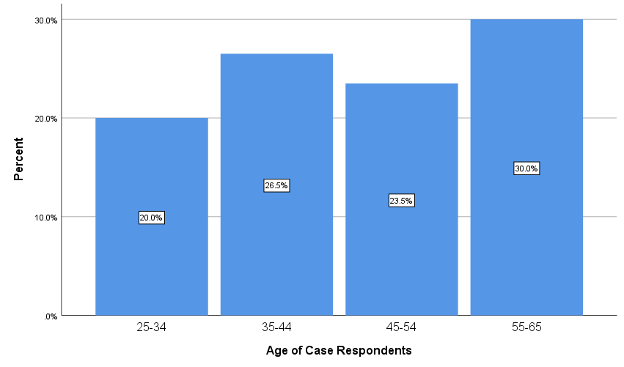

**Figure: Distribution of the respondents based on age group (n=200)**

|  |  |  |  |
| --- | --- | --- | --- |
| **Sex of Respondent** | | Frequency | Percent |
|  | Male | 131 | 65.5 |
| Female | 69 | 34.5 |
| Total | 200 | 100.0 |

|  |  |  |  |  |  |
| --- | --- | --- | --- | --- | --- |
| **Smoking** | | | | | |
|  | | Frequency | Percent | Valid Percent | Cumulative Percent |
| Valid | 1 Yes | 106 | 53.0 | 53.0 | 53.0 |
| 2 No | 94 | 47.0 | 47.0 | 100.0 |
| Total | 200 | 100.0 | 100.0 |  |

|  |  |  |  |  |  |
| --- | --- | --- | --- | --- | --- |
| **Smoking * Disease Crosstabulation** | | | | | |
|  | | | Disease | | Total |
| .00 COPD No | 1.00 COPD Yes |
| Smoking | 1 Yes | Count | 56 | 50 | 106 |
| % within Disease | 45.9% | 64.1% | 53.0% |
| 2 No | Count | 66 | 28 | 94 |
| % within Disease | 54.1% | 35.9% | 47.0% |
| Total | | Count | 122 | 78 | 200 |
| % within Disease | 100.0% | 100.0% | 100.0% |

|  |  |  |  |  |  |
| --- | --- | --- | --- | --- | --- |
| **Chi-Square Tests** | | | | | |
|  | Value | df | Asymptotic Significance (2-sided) | Exact Sig. (2-sided) | Exact Sig. (1-sided) |
| Pearson Chi-Square | 6.328a | 1 | .012 |  |  |
| Continuity Correctionb | 5.618 | 1 | .018 |  |  |
| Likelihood Ratio | 6.390 | 1 | .011 |  |  |
| Fisher's Exact Test |  |  |  | .014 | .009 |
| Linear-by-Linear Association | 6.296 | 1 | .012 |  |  |
| N of Valid Cases | 200 |  |  |  |  |
| a. 0 cells (0.0%) have expected count less than 5. The minimum expected count is 36.66. | | | | | |
| b. Computed only for a 2x2 table | | | | | |

|  |  |  |  |  |  |
| --- | --- | --- | --- | --- | --- |
| **Length_Service** | | | | | |
|  | | Frequency | Percent | Valid Percent | Cumulative Percent |
| Valid | 1 5-10 Years | 118 | 59.0 | 59.0 | 59.0 |
| 2 10-15 Years | 43 | 21.5 | 21.5 | 80.5 |
| 3 >15 Years | 39 | 19.5 | 19.5 | 100.0 |
| Total | 200 | 100.0 | 100.0 |  |

|  |  |  |  |  |  |
| --- | --- | --- | --- | --- | --- |
| **protective_equipment** | | | | | |
|  | | Frequency | Percent | Valid Percent | Cumulative Percent |
| Valid | 1 | 26 | 13.0 | 13.0 | 13.0 |
| 2 | 174 | 87.0 | 87.0 | 100.0 |
| Total | 200 | 100.0 | 100.0 |  |

|  |  |  |  |  |  |
| --- | --- | --- | --- | --- | --- |
| **BMI_Cat** | | | | | |
|  | | Frequency | Percent | Valid Percent | Cumulative Percent |
| Valid | 1.00 Underweight | 42 | 21.0 | 21.0 | 21.0 |
| 2.00 Normal | 141 | 70.5 | 70.5 | 91.5 |
| 3.00 Overweight | 17 | 8.5 | 8.5 | 100.0 |
| Total | 200 | 100.0 | 100.0 |  |

|  |  |  |  |
| --- | --- | --- | --- |
|  | | Count | Table N % |
| Cough | 1 Yes | 100 | 50.0 |
| 2 No | 100 | 50.0 |
| Sputum_Production | 1 Yes | 57 | 28.5 |
| 2 No | 143 | 71.5 |
| Breathlesness | 1 Present | 95 | 47.5 |
| 2 Absent | 105 | 52.5 |

|  |  |  |  |  |  |
| --- | --- | --- | --- | --- | --- |
| **Pattern** | | | | | |
|  | | Frequency | Percent | Valid Percent | Cumulative Percent |
| Valid | 1 Obstruction(NR) | 78 | 39.0 | 39.0 | 39.0 |
| 2 Obstruction(R) | 11 | 5.5 | 5.5 | 44.5 |
| 3 Restriction | 36 | 18.0 | 18.0 | 62.5 |
| 4 Normal | 75 | 37.5 | 37.5 | 100.0 |
| Total | 200 | 100.0 | 100.0 |  |

N=78

|  |  |  |  |  |
| --- | --- | --- | --- | --- |
|  | |  | Count | Table N % |
| Age_Cat | 1.00 25-34 |  | 0 | .0 |
| 2.00 35-44 |  | 19 | 24.4 |
| 3.00 45-54 |  | 27 | 34.6 |
| 4.00 55-65 |  | 32 | 41.0 |
| Sex | 1 Male |  | 60 | 76.9 |
| 2 Female |  | 18 | 23.1 |

|  |  |  |  |  |  |
| --- | --- | --- | --- | --- | --- |
| **Smoking * Sex Crosstabulation** | | | | | |
|  | | | Sex | | Total |
| 1 Male | 2 Female |
| Smoking | 1 Yes | Count | 47 | 3 | 50 |
| % within Sex | 78.3% | 16.7% | 64.1% |
| 2 No | Count | 13 | 15 | 28 |
| % within Sex | 21.7% | 83.3% | 35.9% |
| Total | | Count | 60 | 18 | 78 |
| % within Sex | 100.0% | 100.0% | 100.0% |

|  |  |  |  |  |  |
| --- | --- | --- | --- | --- | --- |
| **Pack_Year_cat** | | | | | |
|  | | Frequency | Percent | Valid Percent | Cumulative Percent |
| Valid | 1 >10 Packs per year | 46 | 59.0 | 92.0 | 92.0 |
| 2 <=10 Packs per year | 4 | 5.1 | 8.0 | 100.0 |
| Total | 50 | 64.1 | 100.0 |  |
| Missing | System | 28 | 35.9 |  |  |
| Total | | 78 | 100.0 |  |  |

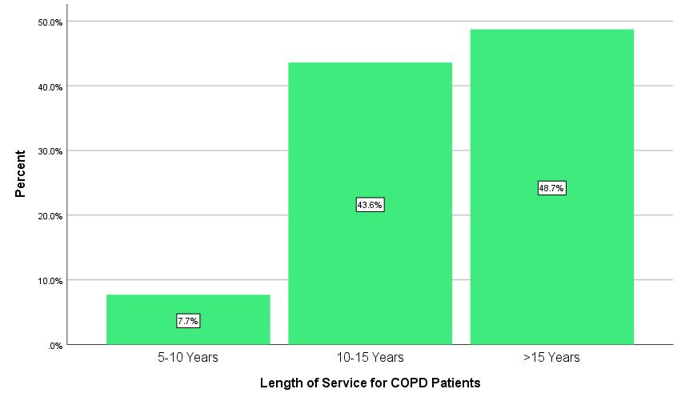

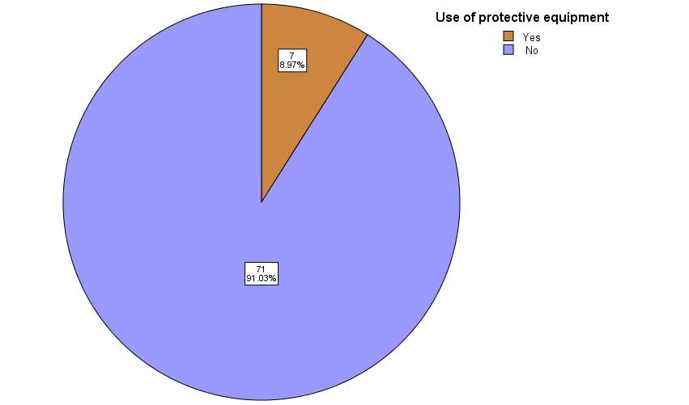

|  |  |  |  |  |  |
| --- | --- | --- | --- | --- | --- |
| **GOLD Severity Grade** | | | | | |
|  | | Frequency | Percent | Valid Percent | Cumulative Percent |
| Valid | 1 Mild (FEV1 >80%) | 8 | 10.3 | 10.3 | 10.3 |
| 2 Moderate (FEV1 50-79%) | 46 | 59.0 | 59.0 | 69.2 |
| 3 Severe (FEV1 30-49%) | 22 | 28.2 | 28.2 | 97.4 |
| 4 Very Severe (FEV1 <30%) | 2 | 2.6 | 2.6 | 100.0 |
| Total | 78 | 100.0 | 100.0 |  |

|  |  |  |  |  |  |  |  |
| --- | --- | --- | --- | --- | --- | --- | --- |
| **Length_Service * GOLD Severity Grade Crosstabulation** | | | | | | | |
|  | | | GOLD Severity Grade | | | | Total |
| 1 Mild (FEV1 >80%) | 2 Moderate (FEV1 50-79%) | 3 Severe (FEV1 30-49%) | 4 Very Severe (FEV1 <30%) |
| Length_Service | 1 5-10 Years | Count | 0 | 3 | 3 | 0 | 6 |
| % within GOLD Severity Grade | 0.0% | 6.5% | 13.6% | 0.0% | 7.7% |
| 2 10-15 Years | Count | 4 | 22 | 7 | 1 | 34 |
| % within GOLD Severity Grade | 50.0% | 47.8% | 31.8% | 50.0% | 43.6% |
| 3 >15 Years | Count | 4 | 21 | 12 | 1 | 38 |
| % within GOLD Severity Grade | 50.0% | 45.7% | 54.5% | 50.0% | 48.7% |
| Total | | Count | 8 | 46 | 22 | 2 | 78 |
| % within GOLD Severity Grade | 100.0% | 100.0% | 100.0% | 100.0% | 100.0% |

|  |  |  |  |
| --- | --- | --- | --- |
| **Chi-Square Tests** | | | |
|  | Value | df | Asymptotic Significance (2-sided) |
| Pearson Chi-Square | 3.090a | 6 | .797 |
| Likelihood Ratio | 3.732 | 6 | .713 |
| Linear-by-Linear Association | .011 | 1 | .917 |
| N of Valid Cases | 78 |  |  |
| a. 8 cells (66.7%) have expected count less than 5. The minimum expected count is .15. | | | |

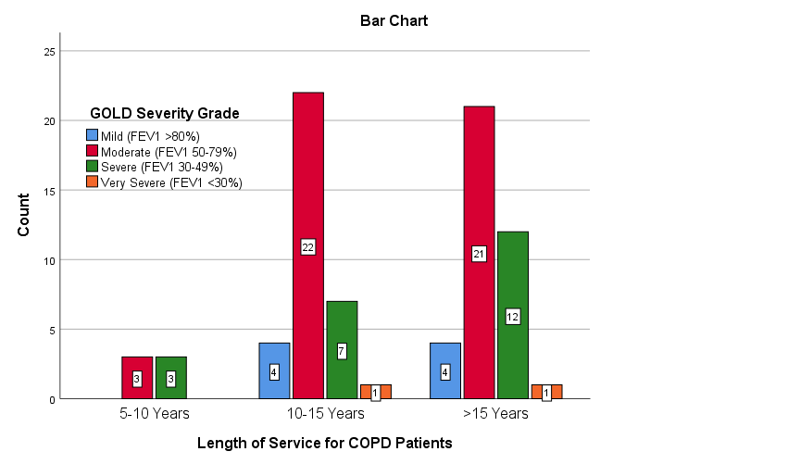

Analyses using data case and control together

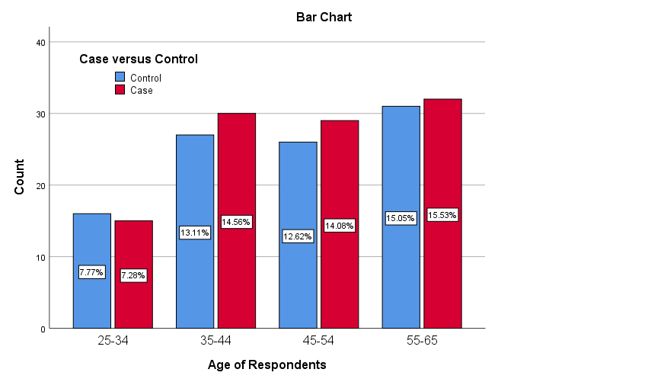

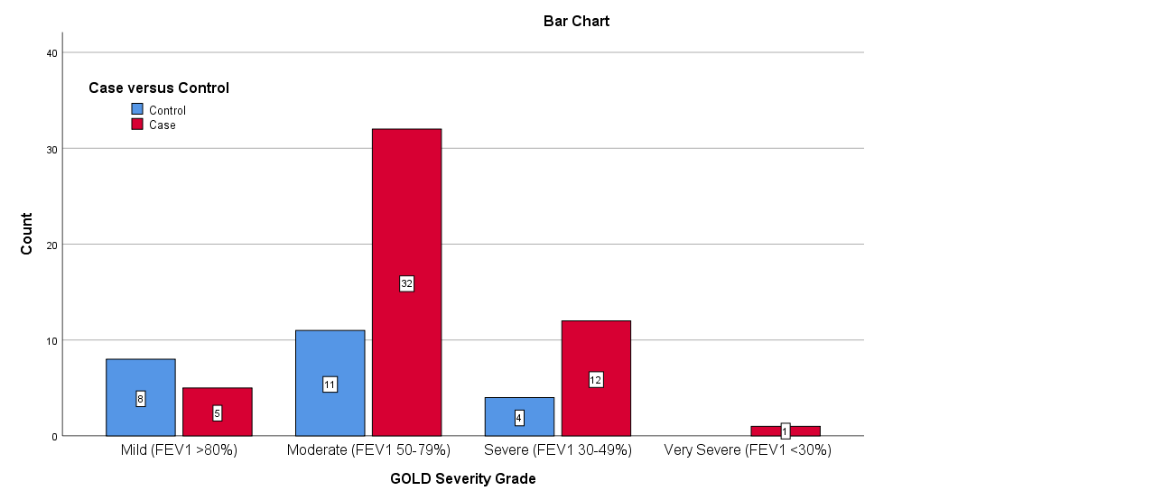

Association between Exposure to smoking plus Silica (vs Smoking) and COPD

|  |  |  |  |  |  |  |
| --- | --- | --- | --- | --- | --- | --- |
| Exposure | Outcome | | | |  |  |
| No COPD | | COPD | | OR with 95% CI | P-value |
| Count | Column N % | Count | Column N % |  |  |
| Smoker | 77 | 57.9% | 23 | 31.5% | 1.00 | <0.001 |
| Smoker & Silica exposure | 56 | 42.1% | 50 | 68.5% | 2.99 [1.64-5.46] |

OR: Odds Ratio; CI: Confidence Interval

N=106

Smoker+Slica exposure

|  |  |  |  |  |  |
| --- | --- | --- | --- | --- | --- |
| **Pattern** | | | | | |
|  | | Frequency | Percent | Valid Percent | Cumulative Percent |
| Valid | 1 Obstruction (NR) | 50 | 47.2 | 47.2 | 47.2 |
| 2 Obstruction(R) | 4 | 3.8 | 3.8 | 50.9 |
| 3 Restriction | 19 | 17.9 | 17.9 | 68.9 |
| 4 Normal | 33 | 31.1 | 31.1 | 100.0 |
| Total | 106 | 100.0 | 100.0 |  |