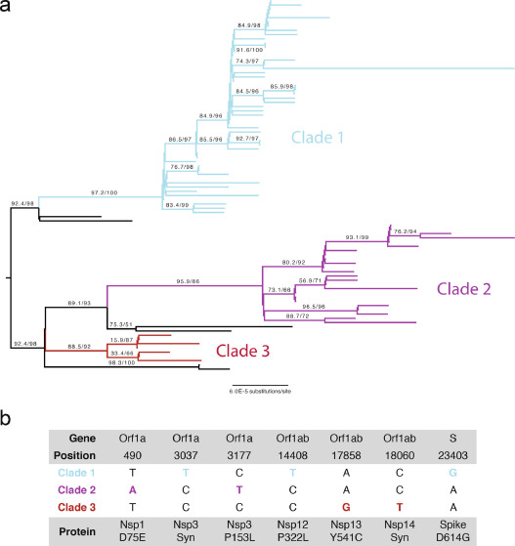

**Fig. 1Phylogenetic Analysis of SARS-CoV-2 Isolates in Chicago. a) ML phylogenetic tree of 88 SARS-CoV-2 specimen genomes from Northwestern Memorial Hospital and Lake Forest Hospital. All non-zero statistical support values for each branch are indicated. Black branches represent sequenced isolates that do not belong to any of the three major clades. Midpoint rooting was used for representation purposes. b) Clade-defining mutations at the US level. Positions are numbered according to the reference genome (NC_045512.2).**

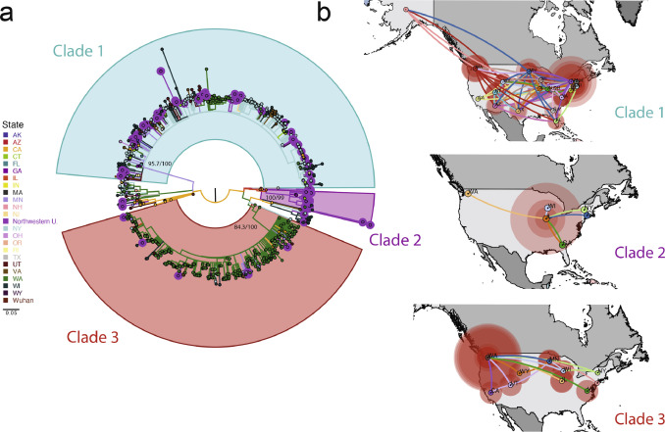

**Fig. 2Phylogenetic and Phylogeographic Analysis of Chicago Isolates compared to the US Epidemic. a) ML phylogenetic reconstruction of full genome sequences from the United States. We included sequences from Northwestern and all sequences from the US available in GISAID as of April 4, 2020. Branches are colored by location and tips corresponding to Northwestern sequences are highlighted. Well-supported clades of the tree that include our defined Chicago clades are indicated; approximate likelihood-ratio test (aLRT) and bootstrap values of the main clade branches are indicated proximal to the branch points. b) Phylogeographic patterns of US isolates in three major clades represented in the Chicago collection under a discrete diffusion model. Westward movements are indicated by lines with an upward curvature, eastward movements are indicated by lines with a downward curvature, lines are colored according to the most probable geographical location of their descendent node, and circle sizes around a node are proportional to the number of lineages maintaining that location.**

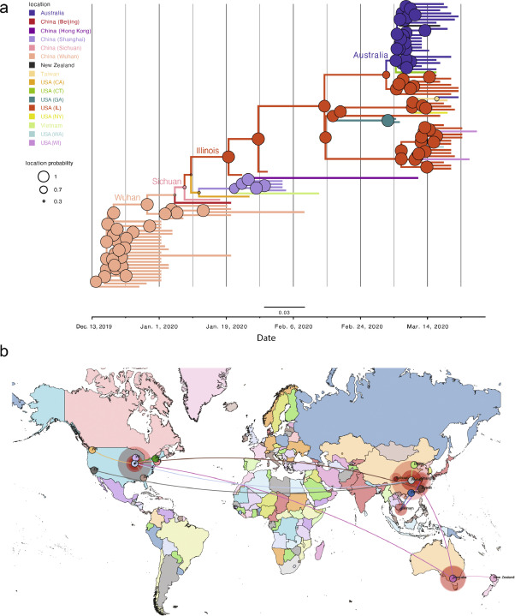

**Fig. 3Phylogenetic and Phylogeographic Analysis of Chicago Isolates compared to the Global Pandemic. a) Phylodynamic tree of US and global Clade 2 related genome sequences. We used global sequences phylogenetically related to Clade 2 available in the GISAID database and performed the analysis encompassing simultaneous estimation of sequence and discrete (geographic) trait data. The depicted phylogenetic tree corresponds to the maximum clade credibility tree. Branch colors represent the most probable geographical location of their descendent node inferred through Bayesian reconstruction of the ancestral state. X-axis corresponds to the inferred date. b) Phylogeographic reconstruction of the origin of Clade 2 under a discrete diffusion model. Westward movements are indicated by lines with an upward curvature, eastward movements are indicated by lines with a downward curvature, lines are colored according to the most probable geographical location of their descendent node, and circle sizes around a node are proportional to the number of lineages maintaining that location.**

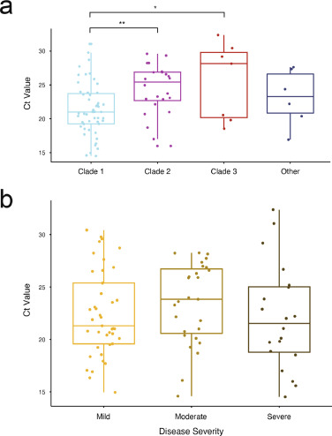

**Fig. 4Associations between Viral Clade and Ct Value and Disease Severity. a) PCR Cycle threshold (Ct) values of patient samples grouped by major Clade assignment. b) Specimen Ct values by maximum disease severity. Mild (blue) = no hospital admission; Moderate (red) = hospital admission, but no ICU stay; Severe (green) = ICU admission. In both panels, horizontal lines in each box represent the median value and the lower and upper error bars are the interquartile ranges. Significance is indicated for the comparisons performed within each fitted model (* = q-value<0.05; ** = q-value <0.01).**

<https://www.thelancet.com/journals/ebiom/article/PIIS2352-3964(20)30488-6/fulltext>

<https://www.nature.com/articles/s41564-020-0770-5>

[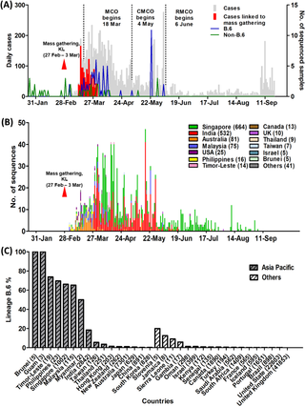](https://journals.plos.org/plosntds/article/figure/image?size=medium&id=info:doi/10.1371/journal.pntd.0008744.g002)

Download:

* [PPT](https://journals.plos.org/plosntds/article/figure/powerpoint?id=info:doi/10.1371/journal.pntd.0008744.g002)

**Fig 2.**

**(A) Epidemic curve of COVID-19 in Malaysia and time course of reported total cases, Tablighi-associated cases, and lineages based on 115 Malaysian sequences, from the first reported case on 25 January to 20 September 2020.** The Tablighi Jamaat gathering in Kuala Lumpur is labelled as “mass gathering, KL”. The different phases of lockdown are shown, comprising the movement control order (MCO), conditional movement control order (CMCO) and recovery movement control order (RMCO). **(B) Time course of global reported lineage B.6 SARS-CoV-2 sequences available in the GISAID database (as of 20 September 2020).** The timescale of the horizontal axis is the same as (A). Countries with fewer than 5 lineage B.6 sequences are included in “others”, comprising Brazil (1), China (3), France (1), Gambia (1), Guam (3), Hong Kong (1), Iceland (1), Jamaica (1), Japan (4), Kenya (1), Myanmar (1), New Zealand (3), Oman (4), Portugal (2), Saudi Arabia (2), Senegal (1), Sierra Leone (1), South Africa (4), South Korea (2), Slovenia (1) and Turkey (1). **(C) The percentage rates of lineage B.6 sequences over total available complete sequences (in brackets) from each country available at GISAID as of 20 September 2020.** Asia Pacific countries are colored grey.

<https://journals.plos.org/plosntds/article?id=10.1371/journal.pntd.0008744>

<https://www.biorxiv.org/content/10.1101/2020.04.17.046086v1.full.pdf>

[[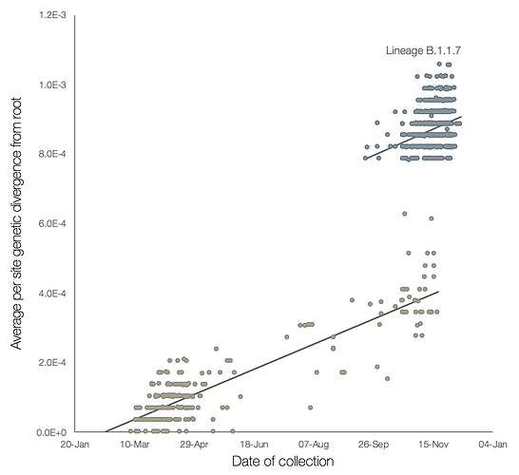](https://virological.org/uploads/default/original/2X/8/80b48244e0484fe8ba8b30722792f4b45462e314.png)](https://virological.org/uploads/default/original/2X/8/80b48244e0484fe8ba8b30722792f4b45462e314.png" \o "B.1.1.7.ml.tree.tempest.v2)

**[B.1.1.7.ml.tree.tempest.v21379×1261 103 KB](https://virological.org/uploads/default/original/2X/8/80b48244e0484fe8ba8b30722792f4b45462e314.png" \o "B.1.1.7.ml.tree.tempest.v2)**

**Figure 2** | Regression of root-to-tip genetic distances against sampling dates, for sequences belonging to lineage B.1.1.7 (blue) and those in its immediate outgroup in the global phylogenetic tree (brown). The regression lines are fitted to the two sets independently. The regression gradient is an estimate of the rate of sequence evolution. These rates are 5.6E-4 and 5.3E-4 nucleotide changes/site/year for the B.1.1.7 and outgroup data sets, respectively.

<https://virological.org/t/preliminary-genomic-characterisation-of-an-emergent-sars-cov-2-lineage-in-the-uk-defined-by-a-novel-set-of-spike-mutations/563>

<https://www.nature.com/articles/s41467-020-20688-x>

<https://www.sciencedirect.com/science/article/pii/S2319417020300445>

<https://www.researchgate.net/publication/346160472_Global_dynamics_of_SARS-CoV-2_clades_and_their_relation_to_COVID-19_epidemiology/fulltext/5fbcd56f92851c933f523b99/Global-dynamics-of-SARS-CoV-2-clades-and-their-relation-to-COVID-19-epidemiology.pdf>

<https://www.medrxiv.org/content/10.1101/2020.09.24.20201228v1.full.pdf>

<https://www.biorxiv.org/content/10.1101/2020.11.30.402487v2.full>