**Tables and figures**

**Table 1.** The summary of Simple Exponential Smoothing (SES), Auto-Regressive Integrated Moving Average (ARIMA), Autoregressive Integrated Moving Average with Explanatory Variables (ARIMAX), Bayesian Structural Time Series (BSTS), Automatic forecasting time-series model (Prophet), Mann-Kendall (M-K) trend and Sen’s slope analysis.

|  |  |  |  |
| --- | --- | --- | --- |
| **Method & Period** | **R2** | **RMSE** | **MAE** |
| ***Simple Exponential Smoothing*** | | | |
| Overall | 95.29% | 0.02 | 0.01 |
|  |  |  |  |
| ***Auto-Regressive Integrated Moving Average*** | | | |
| Overall ARIMA (5,2,1) | 99.20% | 0.91 | 0.44 |
| ***Autoregressive Integrated Moving Average with Explanatory Variables*** | | |  |
| Overall ARIMAX (1,0,1) | 98.13% | 0.16 | 0.02 |
|  |  |  |  |
| ***Bayesian Structural Time Series*** |  |  |  |
|  |  |  |  |
| Overall | 84.78% | 0.15 | 0.02 |
| ***Automatic Forecasting time-series model*** | | | |
| Overall | 97.46% | 0.02 | 0.01 |
| ***Mann-Kendell trend analysis*** | **tau** | **P** | |
|  | 0.54 | <0.001 | |
| ***Sen’s slop test*** | **Sen’s Slope** | **95% CI** | |
|  | 0.008 | 0.007 to 0.009 | |

*RMSE: Root Mean Square Error; MAE: Mean Absolute Error*

**Table 2.** Factors associated with reported case-fatality rate (rCFR) of COVID-19 using ARIMAX, BSTS and beta regression model.

|  |  |  |  |
| --- | --- | --- | --- |
| Variables | Beta Regression model | | |
|  | IRR | 95%CI | P-value |
| Precipitation | 1.01 | 1.01-1.02 | <0.001 |
| Relative Humidity | **0.99** | **0.98-0.99** | <0.001 |
| Temperature Maximum | 0.99 | 0.98-1.01 | 0.069 |
| Temperature Minimum | **0.98** | **0.97-0.99** | <0.001 |
| Dew | **1.03** | **1.02-1.05** | **<0.001** |
| Wind Speed | **0.99** | **0.98-0.99** | **<0.001** |

**Figure 2.** The rCFR of COVID-19 in different divisions of Bangladesh

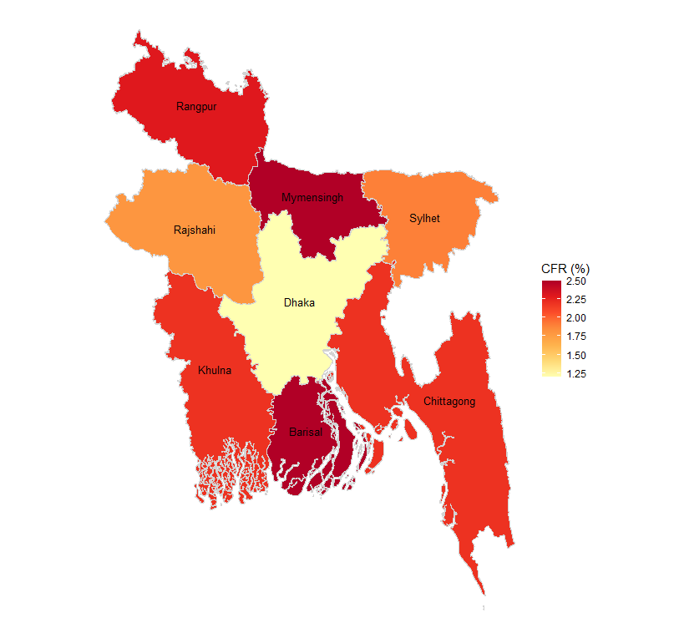

**Figure 3.**

|  |
| --- |
| E:\Study\ResearchProject\Aminul\Weather\Prophet.tiff |
| Prophet |
| E:\Study\ResearchProject\Aminul\Weather\ARIMA.tiff |
| ARIMA |
| E:\Study\ResearchProject\Aminul\Weather\ARIMAX.tiff |
| ARIMAX |
| E:\Study\ResearchProject\Aminul\Weather\BSTS.tiff |
| BSTS |
| E:\Study\ResearchProject\Aminul\Weather\SES.tiff |
| SES |