Title: Cognitive Impairment in Substance Use Disorder Patients.

Investigator:
Dr. Mohammad Humayun Kabir
MD (psychiatry), Phase-B student,
Department of Psychiatry,
Sylhet M A G Osmani medical College

Guide :
Dr. R.K.S Royle
Associate Professor and Head
Department of psychiatry,
Sylhet M A G Osmani medical College

Co-guide:
Dr. Ahmed Riad Chowdhury
Assistant Professor,
Department of psychiatry,
Sylhet M A G Osmani medical College
TABLE AND CONTENTS
Chapter No | Title | Page No.
List of tables
List of figures
Abbreviations
Abstract
Chapter-1 | Introduction
1.1 | Background
1.2 | Rationale of the Study
1.3 | Research Question
1.4 | Hypothesis
1.5 | Aims and Objectives
Chapter-2 | Literature Review
2.1 | An overview of cognitive impairment
2.2 | Signs and Symptoms of Cognitive Impairment
2.3 | Types of Cognitive Impairment
2.4 | Concept of Substance related disorder
2.5 | Types of Substances (classes of drugs)
2.6 | Features of substance use disorders
2.7 | Adults with substance use disorders
2.8 | Major illicit substances
2.9 | Routes of substance use
Chapter-3 | Methodology
3.1 | Study design
3.2 | Place of study
3.3 | Duration of study
3.4 | Target population
3.5 | Study population
3.6 | Enrollment criteria
3.7 | Variables
3.8 | Ethical Consideration
3.9 | Operational definitions
3.10 | Research Instruments
3.11 | Procedure of the Data Collection
3.12 | Data analysis
3.13 | Quality Assurance Strategy
3.14 | Confidentiality
Chapter-4 | Results
Chapter-5 | Discussion
5.1 | Discussion
5.2 | Strengths and Limitations of the Study
Chapter-6 | Conclusion and recommendation
6.1 | Conclusion
6.2 | Recommendations
Chapter-7 | References
Appendices

LIST OF TABLES
Table | Title | Page
Table I | Mean, standard deviation, minimum and maximum values of cognitive impairment scores for substance use disorder patients versus control subjects
Table II | Distribution of respondents by number of substance use
Table III | Mean, standard deviation, minimum and maximum values of cognitive impairment scores for substance use disorder by various substance
Table IV | ANOVA table of cognitive impairment scores for substance use disorder patients versus control subjects
Table V | Mean, standard deviation, minimum and maximum values of cognitive impairment scores for substance use disorder patients by sex
Table VI | Mean, standard deviation, minimum and maximum values of cognitive impairment scores for substance use disorder patients by different various substance use
Table VII | ANOVA table of cognitive impairment scores for substance use disorder patients by different various substance use
Table VIII | ANOVA of cognitive impairment scores for substance use disorder patients by different socio-economic status
Table IX | ANOVA of cognitive impairment scores for substance use disorder patients by different significant socio-economic variables
Table X | Frequency distribution of respondents according to marital status
Table XI | Age distribution of the respondents for both case and control subjects
Table XII | Distribution of the respondents according to sex
Table XIII | Cognitive impairment total scores (average score) according to sex
Table XIV | Distribution of the respondents according to religion
Table XV | Distribution of the respondents according to habitant
Table XVI | Distribution of the respondents according to education
Table XVII | Distribution of the respondents according to occupation
Table XVIII | Distribution of the respondents according to family income
Table XIX | Distribution of the respondents according to self-income
Table XX | Comparison of family history of psychiatric illness between control group and substance user group
Table XXI | Frequency distribution of household composition among respondents
Table XXII | Distribution of drug usage among family members among respondents
Table XXIII | Details of combination of at least two or more drugs currently being used by respondents
Table XXIV | Duration of currently using drugs among respondents
Table XXV | Details of combination of at least two or more drugs previously used by respondents
Table XVI | Details of combination of at least two or more drugs previously being used by respondents.

LIST OF FIGURES
Table | Title | Page
Figure I | Cognitive impairment scores (average total score) for substance use disorder patients versus control subjects
Figure II | Mean total score of respondents by number of substance use
Figure III | Mean total score of respondents by number of substance use
Figure IV | Mean total score of respondents by number of substance use and cognitive impairment type
Figure V | Total mean score of the respondents for both case and control subjects according to age group
Figure VI | Total mean score of the respondents for both case and control subjects according to age group
Figure VII | Cognitive impairment scores (average score) to age of the respondents of case versus control groups
Figure VIII | Cognitive impairment total scores (average score) according to sex of respondents of cases and controls
Figure IX | Age of onset of taking drugs among respondents in substance use group
Figure X | Types of drugs (at least one drug) being used at the beginning among respondents in substance use group
Figure XI | Distribution of routes of substances intake among respondents
Figure XII | Number of treatments received by respondents
Figure XIII | Distribution of daily expenses for drugs among respondents in substance use group
Figure XIV | Hospital admission due to substance use among respondents
Figure XV | Number of hospitalization due to substance use among respondents

ABBREVIATIONS

ABSTRACT
Introduction: Cognitive impairment can arise from virtually any poorly controlled chronic disease of the brain or the body’s organs, including hypertension, high cholesterol, heart disease, stroke, hypothyroidism, diabetes, kidney disease, infections, depression, anxiety, bipolar disorder, multiple sclerosis, epilepsy, certain medications that get into the brain can impair cognition, such as tranquilizers, anticonvulsants, antipsychotics, older antidepressants, pain medications, older bladder incontinence medications and substance use and addictive disorders. Most substances of abuse directly or indirectly target the brain’s reward system by flooding the circuit with dopamine which is related to emotion and feelings of pleasure. When activated at normal levels, this system rewards our natural behaviors. Over stimulating the system with drugs, however, produces euphoric effects, which strongly reinforce the behavior of drug use—teaching the user to repeat it.
Objective: To assess the cognitive impairments among the substance use disorder patients.
Methodology: This study is a cross-sectional and comparative study. Study was conducted at 1. The department of psychiatry, Sylhet M.A. G Osmani Medical College, Sylhet. 2. Monorog Hospital .3. R. R Hospital. 4. Shahjalal Mental Hospital and Research Center. During 1st March, 2018 to 29th February 2020. Substance related disorder patients who attended for treatment to the department of psychiatry and apparently healthy persons attending with other patients who have no history of substance abuse and biological relationship with cases were included in this study. General characteristics of the patients was presented in terms of percentage, mean and standard deviation. Chi-square test and Students t-test was used for qualitative and quantitative variable respectively. Comparison and association were tested using the independent t-test, Chi Square test, ANOVA test and others.

Results: Out of 140 substance users, which was multiple response question, the results revealed the no substance users was (50%), addiction in single drug use (0.7%). Addiction in 2,3 and 4 drugs used by single user at a time were 15.7%, 12.9% and 20.7%, respectively. The mean total score was 91 for single drug users, 72 for two drug users and 70 was for 3 or more drug users. Among the total mean score of cognitive impairment of no substance user was 83.81 (SD = 7.01). The most prevalent substance was tobacco (n=54), followed by cocaine (n=8), alcohol (n=3), Yaba (n=2), sedatives (n=1), phencyclidine (n=1) and others (n=1). Among substance user, the mean cognitive impairment score in tobacco user was 70.30 (SD=10.03).
Conclusion: A prevalence of ..% for cognitive impairments was found in addiction care and, therefore, detection of cognitive impairments at an early stage of treatment is important to determine the course of treatment and maximize treatment outcome. Control group and substance users show significant difference in cognitive impairment total mean score. However, other drug groups (Cannabinoids combination, Heroine, users not taking any drugs currently) showing significantly lower scores. For life quality perception, significantly highest score was recorded in control group, followed by users that did not taking any drugs currently, while the lowest score rate was recorded for using combing Cannabinoids and other drugs. Cannabinoids, Heroin, and other drugs users scored showing lower rate than control but higher rate than Cannabinoids combination other drugs. The findings of this study showed that substance use patients had overall lower cognition compared to control.

INTRODUCTION
1.1 Background
Cognition in its broadest sense as meaning all the mental activities that allow us to perceive, integrate and conceptualize the world around us. These include the global functions of consciousness, attention, and orientation and the specific domains of memory, executive function, language, praxis and perception (Marwick & Birrell 2013). Human cognition is conscious and unconscious, concrete or abstract, as well as intuitive and conceptual. It encompasses processes such as memory, association, concept formation, pattern recognition, language, attention, perception, action, problem solving, and mental imagery (Perlovsky & Ilin 2012).
Cognition fundamentally controls our thoughts and behaviors, and these are regulated by discrete brain circuits which are underpinned by a number of neurotransmitter systems. There are several brain chemicals which play major roles in regulating cognitive processes; including dopamine, noradrenaline, serotonin, acetylcholine, glutamate and GABA. Our distinct cognitive functions arise because of processes occurring within certain parts of our brain, but only some of these, end up entering our conscious awareness (Earl 2014).
Cognitive impairment can arise from virtually any poorly controlled chronic disease of the brain or the body’s organs, including hypertension, high cholesterol, heart disease, stroke, hypothyroidism, diabetes, kidney disease, infections, depression, anxiety, bipolar disorder, multiple sclerosis, epilepsy, certain medications that get into the brain can impair cognition, such as tranquilizers, anticonvulsants, antipsychotics, older antidepressants, pain medications, older bladder incontinence medications and substance use and addictive disorders.
Substance use disorder (SUD) is characterized by an intense, enduring, and often irresistible desire for subjective effects of substances (cravings); impaired insight; poor judgment and risky decision-making about substance-seeking behavior; markedly reduced desire for naturally rewarding social relationships and activities; reduced sensitivity to euphoric effects of substances over time (tolerance); uncomfortable and sometimes life-threatening withdrawal symptoms that develop when stopping substance use; negative emotions when unable to obtain access to substances (e.g., dysphoria, anxiety, irritability); compulsive substance seeking that persists despite repeated damaging consequences to self, family, and society; and multiple relapses (Volkow & Baler 2014).

The prevalence of cognitive impairment in rural areas is higher than that in urban areas (Tang, Zhang & Wu 2007). There was a range of 18.9%–22.4% for cognitive impairment in people >60 years of age (Sherina, Rampal & Mustaqim 2004). In rural areas of northern China, the prevalence of dementia and Alzheimer’s disease in residents aged 60 years and older is 7.7% and 5.4%, respectively (Cristina et al. 2001), while that of cognitive impairment and dementia is 73.2% among the elderly aged 80 years and older (Ji et al. 2015). The raw prevalence of cognitive impairment was 32.4% overall, 25.6% in men and 38.1% in women (Ren et al. 2018a). The prevalence of cognitive impairment reported from different regions of the world varies widely between 3% and 42% (Ward et al. 2012). Previously published studies from India estimate prevalence between 15% and 33% (Das et al. 2007).
Most substances of abuse directly or indirectly target the brain’s reward system by flooding the circuit with dopamine which is related to emotion and feelings of pleasure. When activated at normal levels, this system rewards our natural behaviors. Over stimulating the system with drugs, however, produces euphoric effects, which strongly reinforce the behavior of drug use—teaching the user to repeat it (Wyatt 2015).
The structural brain abnormalities and associated cognitive and behavioral disruptions seen in individuals with SUD are so striking that many experts have come to refer to the disorder as a disease of the brain (Kennedy & Adolphs 2012). Different patterns of disease expression can be seen for the various substances of abuse depending on factors, such as dosing, duration of use, route of administration (e.g., intravenous versus inhalation), and even gender and culture (Spanagel 2017). Neuroimaging studies in drug-dependent individuals have also documented significant functional and structural alterations in several brain regions. These regions include neocortical, mesolimbic, and neostriata brain regions that are known to be impacted by administration of licit and illicit drugs in both clinical and preclinical studies. Cognitive Impairment, particularly in executive functioning and decision-making are now recognized as common features of substance dependence (Kenney & Gould 2008) with 69% of polydrug users (including cocaine and opiates) have been found to exhibit global executive functioning impairment (Ersche et al. 2006).
Although these estimates do not include people with alco-holism who develop permanent cognitive deficits such as Wernicke-Korsakoff syndrome, they do include the enduring visuospatial information-processing deficits observed in people without dementia and with alcohol use disorders (Zahr & Pfefferbaum 2017). Several studies have shown that drug abuse has a neurotoxic effect on brain circuitries, leading to structural and functional modifications, particularly in the dopaminergic mesolimbic system of reward (Tomkins and Sellers, 2001).
According to a report published UNODC (United Nations Office on Drugs and Crime), age of first volatile substance use is approximately 11, whereas average age of first cannabis use is 16, and average age of first ecstasy use is 17 years worldwide. Individual who are sensation seekers, impulsive, or behavioral disinhibited appear more prone to develop addiction to both licit and illicit substances (Yazici et al. 2015). In this context, it is to be noted that not all individuals who try these drugs become addicted as about only 20% of people who have tried drugs become addicts (Cadet & Bisagno 2013).
Substance use disorders (SUDs) are highly prevalent psychiatric clinical conditions with lifetime prevalence in community samples of about 2–3% in the United States (SAMHSA 2014) and 30–75% in clinical samples worldwide (Cadet & Bisagno 2013). In Italy, about 1% of the general population is diagnosed with SUDs, whereas 16% of youths aged 15–24 years use drugs in Europe (Kumpfer 2014). Substance use disorders in youth have become an increasingly worrying issue; drug users younger than 25 years of age are estimated to represent 27% of the whole addicted population (McLellan, 2017).
National Institute of Mental Health (NIMH), Dhaka in collaboration with World Health Organization (WHO) conducted a multi-centric community-based study during 2003-2005 which revealed that 0.63% of the adult population (18 years and above) in Bangladesh had substance dependence (Maruf, Khan & Jahan 2016).
According to the Diagnostic and Statistical Manual of Mental Disorder, fifth edition (DSM-5), the abuse able drugs are divided into following categories; Alcohol, Cannabis, Hallucinogens, Inhalant, Opioids, Stimulants, Tobacco, Sedatives/Hypnotic/Anxiolytic, and Others.
The major illicit substances available in Bangladesh are-
- Opium (Heroin, Pethidine, Cocaine)
- Cannabis (Ganja, Chorosh, Bhang, Hashish)
- Stimulant (Yaba, Ectasy, Viagra)
- Sleeping pill (Tranquilizer, Diazepam) and
- Cough syrup (Phensidyl, Dexpotent) etc.
In Sylhet, highest 95.24% are addicted to cannabis as a principal drug and second highest (61.90 %) involved in yaba addiction. Around 50% of the drug addicts involved in heroin addiction, 47.62% addicted in alcohol, 42.33% addicted in phensedyl, 19.05% drug addicts regularly take pethidine/morphine injection. Cocaine and opium were taken by 7.14% and 2.38% of the drug addicts respectively (Shazzad et al. 2014).
An estimated around 5 percent of the global adult population aged 15-64 years, used drugs at least once in 2015. Even more worrisome is the fact that about 0.6 percent of the global adult population, suffer from drug use disorders (Casey et al. 2018).
Estimates regarding the prevalence of cognitive impairment in patients with SUDs vary widely and range from about 30%to 80% (Gupta, Murthy & Rao 2018). These deficits may range from the relatively subtle temporary effects of cannabis use (Shrivastava, Johnston & Tsuang 2011) to the moderate executive control deficits observed in chronic cocaine users even after several months of abstinence (Cadet & Bisagno 2016).
Some studies have shown that cognitively impaired patients with SUDs cannot be adequately identified by drug counselors via clinical impression or through self-report (Kelly & Daley 2013). If accounting for and addressing the presence of cognitive deficits among substance-abusing patients involves, as a first step, identifying those with neuropsychological impairment, treatment providers and researchers alike need a practical neurocognitive assessment approach for patients with SUDs that is both accurate and comparatively less labor intensive (Verdejo-Garcia et al. 2019).
More specifically, an association has been reported between cognitive deficits and low treatment adherence , poor attendance at outpatient therapy sessions, low willingness to change, reduced self-insight, denial of substance abuse, increased impulsivity, and less abstinence from the substance of abuse following treatment termination (Kelly & Daley 2013). Impaired executive function has also been linked to medical and legal problems among this patient group (Cohen 2014).
With neurocognitive deficits recognized as an adverse variable affecting recovery and treatment adherence in SUD patients, a thorough examination of cognitive functioning, including assessment of executive function, is of paramount importance with regard to formulation of an effective and clear individual treatment plan, and by this to facilitate improved everyday coping and functioning in this patient population.
Cognitive assessment refers to the objective measurement of distinct cognitive abilities, such as working memory, inhibition, cognitive flexibility, psychomotor speed and sustained attention. Cognition can be measured using a variety of methods, each varying in their level of objectivity and sensitivity (Billard 2017).
Following instruments are mostly used for assessment of cognitions:
- Mini Mental State Examination (MMSE).
- The Montreal Cognitive Assessment (MoCA).
- The Addenbrookes’ Cognitive Examination –iii.
All address cognitive functions of the patients but ACE-iii is superior to MMSE and there is no bangle validated MoCA Scale. The Addenbrooke’s Cognitive Examination-III (ACE-III) is a brief cognitive test that assesses five cognitive domains: attention, memory, verbal fluency, language and visuospatial abilities. The total score is 100 with higher scores indicating better cognitive functioning. Administration of the ACE-III takes, on average, 15 minutes and scoring takes about 5 minutes. The diagnostic accuracy of ACE as a brief ‘bedside’ cognitive screening instrument led to its widespread adoption. The original ACE included the mini-mental state examination (MMSE) or Folstein test, along with fronto-executive and extra visuospatial items.
The original 26 components were combined to produce five sub scores, each representing a specific cognitive domain: attention/orientation (18 points), memory (26 points), fluency (14 points), language (26 points) and visuospatial function (16 points)—100 in Total. It gives a cut-off score for the five sub domains against controls and takes between12 and 20 min (average 16).
Testing shows that ACE-III cognitive domains correlate significantly with standardized neuropsychological tests used in the assessment of attention, language, verbal memory and visuospatial function. It also compared very favorably with its predecessor, the ACER, with similar levels of sensitivity and specificity and the two tests correlated significantly (r = 0.99, P < 0.01). The ACE-III also continues to show high sensitivity and specificity at cut-offs previously recommended:
(i) 88 (sensitivity = 1.0; specificity = 0.96) and
(ii) 82 (sensitivity = 0.93; specificity = 1.0). Internal
reliability of the ACE-III, measured by Cronbach’s α
Coefficient was 0.88.
The assessment focuses on five cognitive domains:
• Attention
• Memory
• Verbal fluency
• Language
• Visuospatial abilities
1.2 Rationale of the Study
Cognitive impairment in patients with substance use disorders (SUDs) contributes to poorer treatment outcomes including decreased treatment retention and less abstinence from substances of abuse. Cognitive dysfunction has also been shown to have negative impaction therapeutic mechanisms of change. It is also associated with less treatment adherence, less treatment engagement, less readiness to change, lower self-efficacy, decreased insight, and increased denial of addiction and greater reflection of impulsivity.
As per researcher knowledge, due to the limited studies regarding cognitive impairments of substance use disorder patients in Bangladesh, it is worth the endeavor to investigate the association of substance dependency and cognitive impairments to explore and to have better understanding of this aspect and which can also be useful for comprehensive management of this population especially in Sylhet region.
1.3 Research Question
What are the cognitive impairments occur in substance use disorder patients?
1.4 Hypothesis
Substance use significantly impairs the cognitive functions of substance use disorder patients.
1.5 Aims and Objectives
General objective: To assess the cognitive impairments among the substance use disorder patients.
Specific objectives:
- To find out the any possible relationship between socio-demographic factors with the substance use disorder patients.
- To find out the relationship between various types of substance used and cognitive impairments.
- To find out the relationship between routes of substance administration and cognitive impairments.

Literature Review
Literature search strategy
2.1 An overview of cognitive impairment
Cognition in its broadest sense as meaning all the mental activities that allow us to perceive, integrate and conceptualize the world around us. These include the global functions of consciousness, attention, and orientation and the specific domains of memory, executive function, language, praxis and perception (Birrel 2013).
According to modern neuroscience, object perception involves bottom-up signals from sensory organs and top-down signals from internal mind’s representations (memories) of objects. During perception, the mind matches subsets of bottom-up signals corresponding to objects with representations of object in the mind (and top-down signals). This produces object recognition; it activates brain signals leading to mental and behavioral responses (Perlovsky & Ilin 2012).
Moreover, cognition is the mental action or process of acquiring knowledge and understanding through thought, experience, and the senses. Human cognition can be conscious and unconscious, concrete or abstract, as well as intuitive (like knowledge of a language) and conceptual (like a model of a language). It encompasses many aspects of intellectual functions and processes such as attention, the formation of knowledge, memory and working memory, judgment and evaluation, reasoning and computation, problem solving and decision making, comprehension and production of language (Zhang 2019).
Furthermore, cognitive mechanisms driving the human mind both toward and away from creativity are related to ancient mechanisms of adaptive behavior. A paradoxical role of language is discussed: on the one hand, language makes higher cognition possible; on the other, language enables heuristic thinking, using millennial truths instead of original creative thinking. Creativity requires overcoming cognitive dissonances and choosing task relevance over salience. Functions of conceptual, emotional, conscious, and unconscious mechanisms are analyzed and related to various brain regions (Perlovsky & Levine 2012).
Cognition fundamentally controls our thoughts and behaviors, and these are regulated by discrete brain circuits which are underpinned by several neurotransmitter systems. There are several brain chemicals which play major roles in regulating cognitive processes; including dopamine, noradrenaline, serotonin, acetylcholine, glutamate and GABA. Our distinct cognitive functions arise because of processes occurring within certain parts of our brain, but only some of these, end up entering our conscious awareness (Valenzuela, Puglia & Zucca 2011).
Cognition in a broad sense means information processing. It denotes a relatively high level of processing of specific information including thinking, memory, perception, motivation, skilled movements and language. The hippocampus contains the neural circuitry crucial for cognitive functions such as learning and memory. It refers to the perceptual and intellectual aspects of mental functioning. Among the specific functions that may be assessed in determining the intactness or adequacy of cognition are orientation, the ability to learn necessary skills, solve problems, think abstractly, reason and make judgements, the ability to retain and recall events, mathematical ability and other forms of symbol manipulation, control over primitive reactions and behavior, language use and comprehension, attention, perception and praxis (Trivedi 2006).
Memory, attention, perception, action, problem solving, and mental imagery are functions of cognitive development central to adaptive capability. These functions originate early in life and continue to develop through adolescence and adulthood before starting to decline in old age. Cognitive impairment is not caused by any one disease or condition, nor is it limited to a specific age group. Several studies have demonstrated that the provision of a cognitively enriched environment in early life can lead to improvements in intellectual performance and in cognitive, language, and motor indices (Juturu 2015).
Cognitive impairment is a broad term that encompasses a multitude of diseases, both genetic and acquired, and brain damage caused via accidents. It is defined as difficulty processing thoughts that lead to memory loss, decision-making difficulties, inability to concentrate, and learning difficulties. This impairment is not confined to people of a certain age, gender or any other demographic. Anyone can be impaired through an action, inaction, or a genetic abnormality. Heart failure and atrial fibrillation are risk factors for cognitive impairment and late-life anxiety is also associated with cognitive impairment (Hugo & Ganguli 2014).
Cognitive impairment can arise from virtually any poorly controlled chronic disease of the brain or the body’s organs, including hypertension, high cholesterol, heart disease, stroke, hypothyroidism, diabetes, kidney disease, infections, depression, anxiety, bipolar disorder, multiple sclerosis, epilepsy, certain medications that get into the brain can impair cognition, such as tranquilizers, anticonvulsants, antipsychotics, older antidepressants, pain medications, older bladder incontinence medications and substance use and addictive disorders. Cognitive impairment creates significant challenges for patients, their families and friends, and clinicians who provide their health care. Early recognition allows for diagnosis and appropriate treatment, education, psychosocial support, and engagement in shared decision-making regarding life planning, health care, involvement in research, and financial matters (Morley et al. 2015). Cognitive impairment results in a person having trouble remembering, learning new things, concentrating, or making decisions that affect his or her everyday life. Cognitive impairment ranges from mild to severe. With mild impairment, people may notice changes in cognitive functions but still be able to do their everyday activities. Severe levels of impairment can lead to losing the ability to understand the meaning or importance of something and the ability to talk or write, resulting in the inability to live independently (Juturu 2015).
Cognitive Impairment, particularly in executive functioning and decision-making are now recognized as common features of substance dependence with 69% of polydrug users (including cocaine and opiates) have been found to exhibit global executive functioning impairment (Fernández-Serrano et al. 2010).
Although these estimates do not include people with alco-holism who develop permanent Cognitive deficits such as Wernicke-Korsakoff syndrome, they do include the enduring visuospatial information-processing deficits observed in people without dementia and with alcohol use disorders (Schandler et al. 1996).
2.2 Signs and Symptoms of Cognitive Impairment
Family and friends might notice that someone with cognitive impairment is confused, or agitated, or very moody. They might notice a change in their speech or behavior, or that they have difficulty with their usual daily tasks. Cognitive impairment can come and go. In this situation, it is often called delirium. Delirium can be a sign of serious medical problems. Cognitive impairment can be mild, or severe, or anything in between.
Functional cognitive disorder is probably best considered as a form of functional neurological symptom disorder, with similar root causes to other conversion disorders. The diagnostic criteria for functional neurological symptom disorder require motor or sensory symptoms that are incompatible with recognized neurological or medical conditions, cannot be better explained by an alternative diagnosis and cause significant distress or functional impairment. Functional cognitive disorder closely resembles this but has cognitive rather than motor or sensory symptoms. The risk factors are also similar: previous childhood adversity, stressful life events and maladaptive personality traits. Patients may have a pre-existing diagnosis of a psychiatric condition, typically mild depression or anxiety. The presence of a major psychiatric diagnosis such as severe depression or bipolar disorder is an exclusion criteria for functional cognitive disorder, as major mental health problems can themselves cause significant cognitive difficulties (Pennington et al. 2015).
Cognitive Impairment may result in the inability to (Trivedi 2006):
- pay attention
- process information
- quickly remember and recall information
- respond to information quickly
- think critically, plan, organize and solve problems
- initiate speech

2.3 Types of Cognitive Impairment
Cognitive disorders are a part of the neurocognitive disorder classification in the fifth edition of the Diagnostic and Statistical Manual of Mental Disorders (DSM-V). Cognitive disorders are defined as any disorder that significantly impairs the cognitive function of an individual to the point where normal functioning in society is impossible without treatment.
In the DSM-5, Neurocognitive Disorders are a group of disorders in which the primary clinical deficit is in cognitive function, and that are acquired rather than developmental, that is, impaired cognition has not been present since birth or very early life, and thus represents a decline from a previously attained level of functioning. In DSM-IV, Neurocognitive Disorders (NCDs) were known as “Dementia, Delirium, Amnestic, and Other Cognitive Disorders (Ganguli et al. 2011).

In DSM-V, the neurocognitive disorders (NCDs) (referred to in DSM-IV as "Dementia, Delirium, Amnestic, and Other Cognitive Disorders") begin with delirium, followed by the syndromes of major NCD, mild NCD, and their etiological subtypes. The major or mild NCD subtypes are NCD due to Alzheimer's disease; vascular NCD; NCD with Lewy bodies; NCD due to Parkinson's disease; frontotemporal NCD; NCD due to traumatic brain injury; NCD due to HIV infection; substance/medication-induced NCD; NCD due to Huntington's disease; NCD due to prion disease; NCD due to another medical condition; NCD due to multiple etiologies; and unspecified NCD. The NCD category encompasses the group of disorders in which the primary clinical deficit is in cognitive function, and that are acquired rather than developmental. Although cognitive deficits are present in many if not all mental disorders (e.g., schizophrenia, bipolar disorders), only disorders whose core features are cognitive are included in the NCD category. The NCDs are those in which impaired cognition has not been present since birth or very early life, and thus represents a decline from a previously attained level of functioning.

The NCDs are unique among DSM-5 categories in that these are syndromes for which the underlying pathology, and frequently the etiology as well, can potentially be determined. The various underlying disease entities have all been the subject of extensive research, clinical experience, and expert consensus on diagnostic criteria. The DSM-5 criteria for these disorders have been developed in close consultation with the expert groups for each of the disease entities and align as closely as possible with the current consensus criteria for each of them. The potential utility of biomarkers is also discussed in relation to diagnosis. Dementia is subsumed imder the newly named entity major neurocognitive disorder, although the term dementia is not precluded from use in the etiological subtypes in which that term is standard. Furthermore, DSM-5 recognizes a less severe level of cognitive impairment, mild neurocognitive disorder, which can also be a focus of care, and which in DSM-IV was subsumed under "Cognitive Disorder Not Otherwise Specified." Diagnostic criteria are provided for both these syndromic entities, followed by diagnostic criteria for the different etiological subtypes. Several of the NCDs frequently coexist with one another, and their relationships may be multiply characterized under different chapter subheadings, including "Differential Diagnosis" (e.g., NCD due to Alzheimer's disease vs. vascular NCD), "Risk and Prognostic Factors" (e.g., vascular pathology increasing the clinical expression of Alzheimer's disease), and/or "Comorbidity" (e.g., mixed Alzheimer's disease-vascular pathology).
The term dementia is retained in DSM-5 for continuity and may be used in settings where physicians and patients are accustomed to this term. Although dementia is the customary term for disorders like the degenerative dementias that usually affect older adults, the term neurocognitive disorder is widely used and often preferred for conditions affecting younger individuals, such as impairment secondary to traumatic brain injury or HIV infection. Furthermore, the major NCD definition is somewhat broader than the term dementia, in that individuals with substantial decline in a single domain can receive this diagnosis, most notably the DSM-IV category of "Amnestic Disorder," which would now be diagnosed as major NCD due to another medical condition and for which the term dementia would not be used.

Some common cognitive disorders include:
- Dementia
- Developmental disorders
- Motor skill disorders
- Amnesia
- Substance-induced cognitive impairment

History of substance use
Understanding the natural history of substance use disorders, including their course, causes, and the modifiable individual and environmental characteristics that influence them, is essential for developing medical and public health interventions to reduce this burden of disease. Incidence is the onset of disease in a newly affected individual. Prospective studies of the incidence of substance use disorders are rare because of the expense and challenges of the needed sample sizes, retention, and long follow-up times. Early studies varied widely in design, generated widely varying incidence rates, and presented limited or no examinations of sociodemographic variables (e.g., sex, age) or psychiatric conditions as risk factors for incidence (Eaton et al. 1989). Historically speaking, the beliefs and practices of the Christian religion, for one, provided both support for the consumption of wine and also warned against excessive use [4]. Indeed, while the church held largely favorable views regarding the consumption of alcohol in moderation, it also considered over-indulgence to be a sin (Hanson 2013). As the field of mental health has come to recognize that the process of human development is inexorably linked to and fundamentally shaped by the environment in which we are enmeshed, so, too, is the ever-unfolding process of conceptualizing substance use shaped by the habits, beliefs, and traditions of the larger society. Top-down cultural influences can be seen to exert notable effects on substance use and perceptions of substance use, particularly in the 19th century. The influence of industrialization upon the attitudes and perceptions of substance users is readily apparent as America progressed into the industrial revolution. The rapid change from an agricultural to an industrial economy during this time was largely a result from the establishment of the factory system, where labor was carried out by individuals in a centralized location on a large scale (Robinson & Adinoff 2016).

2.4 Concept of Substance related disorder
The substance-related disorders are divided into two groups: 1. substance use disorders and 2. substance-induced disorders. The following conditions may be classified as substance- induced: intoxication, withdrawal, and other substance/medication-induced mental disorders (psychotic disorders, bipolar and related disorders, depressive disorders, anxiety disorders, obsessive-compulsive and related disorders, sleep disorders, sexual dysfunctions, delirium, and neurocognitive disorders) (DSMV 2016).
McLellan (2017) defined as any psychoactive compound with the potential to cause health and social problems, including addiction. These substances may be legal (e.g., alcohol and tobacco); illegal (e.g., heroin and cocaine); or controlled for use by licensed prescribers for medical purposes such as hydrocodone or oxycodone (e.g., Oxycontin, Vicodin, and Lortab).

The essential feature of a substance use disorder is a cluster of cognitive, behavioral, and physiological symptoms indicating that the individual continues using the substance despite significant substance-related problems. As seen in Table 1, the diagnosis of a substance use disorder can be applied to all 10 classes included in this chapter except caffeine.
For certain classes some symptoms are less salient, and in a few instances not all symptoms apply (e.g., withdrawal symptoms are not specified for phencyclidine use disorder, other hallucinogen use disorder, or inhalant use disorder).
An important characteristic of substance use disorders is an underlying change in brain circuits that may persist beyond detoxification, particularly in individuals with severe disorders. The behavioral effects of these brain changes may be exhibited in the repeated relapses and intense drug craving when the individuals are exposed to drug-related stimuli. These persistent drug effects may benefit from long-term approaches to treatment.
Overall, the diagnosis of a substance use disorder is based on a pathological pattern of behaviors related to use of the substance. To assist with organization. Criterion A criteria can be considered to fit within overall groupings of impaired control, social impairment, risky use, and pharmacological criteria. Impaired control over substance use is the first criteria grouping
(Criteria 1-4). The individual may take the substance in larger amounts or over a longer period than was originally intended (Criterion 1). The individual may express a persistent desire to cut down or regulate substance use and may report multiple unsuccessful efforts to decrease or discontinue use (Criterion 2). The individual may spend a great deal of time obtaining the substance, using the substance, or recovering from its effects (Criterion 3). In some instances of more severe substance use disorders, virtually all of the individual's daily activities revolve around the substance. Craving (Criterion 4) is manifested by an intense desire or urge for the drug that may occur at any time but is more likely when in an environment where the drug previously was obtained or used. Craving has also been shown to involve classical conditioning and is associated with activation of specific reward structures in the brain. Craving is queried by asking if there has ever been a time when they had such strong urges to take the drug that they could not think of anything else. Current craving is often used as a treatment outcome measure because it may be a signal of impending relapse.
Social impairment is the second grouping of criteria (Criteria 5-7). Recurrent substance use may result in a failure to fulfill major role obligations at work, school, or home (Criterion 5). The individual may continue substance use despite having persistent or recurrent social or interpersonal problems caused or exacerbated by the effects of the substance (Criterion 6). Important social, occupational, or recreational activities may be given up or reduced because of substance use (Criterion 7). The individual may withdraw from family activities and hobbies in order to use the substance.
Risky use of the substance is the third grouping of criteria (Criteria 8-9). This may take the form of recurrent substance use in situations in which it is physically hazardous (Criterion 8). The individual may continue substance use despite knowledge of having a persistent or recurrent physical or psychological problem that is likely to have been caused or exacerbated by the substance (Criterion 9). The key issue in evaluating this criterion is not the existence of the problem, but rather the individual's failure to abstain from using the substance despite the difficulty it is causing.
Pharmacological criteria are the final grouping (Criteria 10 and 11). Tolerance (Criterion 10) is signaled by requiring a markedly increased dose of the substance to achieve the desired effect or a markedly reduced effect when the usual dose is consumed. The degree to which tolerance develops varies greatly across different individuals as well as across substances and may involve a variety of central nervous system effects. For example, tolerance to respiratory depression and tolerance to sedating and motor coordination may develop at different rates, depending on the substance. Tolerance may be difficult to determine by history alone, and laboratory tests may be helpful (e.g., high blood levels of the substance coupled with little evidence of intoxication suggest that tolerance is likely). Tolerance must also be distinguished from individual variability in the initial sensitivity to the effects of particular substances. For example, some first-time alcohol drinkers show very little evidence of intoxication with three or four drinks, whereas others of similar weight and drinking histories have slurred speech and incoordination. Withdrawal (Criterion 11) is a syndrome that occurs when blood or tissue concentrations of a substance decline in an individual who had maintained prolonged heavy use of the substance. After developing withdrawal symptoms, the individual is likely to consume the substance to relieve the symptoms. Withdrawal symptoms vary greatly across the classes of substances, and separate criteria sets for withdrawal are provided for the drug classes. Marked and generally easily measured physiological signs of withdrawal are common with alcohol, opioids, and sedatives, hypnotics, and anxiolytics. Withdrawal signs and symptoms with stimulants (amphetamines and cocaine), as well as tobacco and cannabis, are often present but may be less apparent. Significant withdrawal has not been documented in humans after repeated use of phencyclidine, other hallucinogens, and inhalants; therefore, this criterion is not included for these substances. Neither tolerance nor withdrawal is necessary for a diagnosis of a substance use disorder. However, for most classes of substances, a past history of withdrawal is associated with a more severe clinical course (i.e., an earlier onset of a substance use disorder, higher levels of substance intake, and a greater number of substance-related problems). Symptoms of tolerance and withdrawal occurring during appropriate medical treatment with prescribed medications (e.g., opioid analgesics, sedatives, stimulants) are specifically not counted when diagnosing a substance use disorder. The appearance of normal, expected pharmacological tolerance and withdrawal during the course of medical treatment has been known to lead to an erroneous diagnosis of "addiction" even when these were the only symptoms present. Individuals whose only symptoms are those that occur as a result of medical treatment (i.e., tolerance and withdrawal as part of medical care when the medications are taken as prescribed) should not receive a diagnosis solely on the basis of these symptoms. However, prescription medications can be used inappropriately, and a substance use disorder can be correctly diagnosed when there are other symptoms of compulsive, drug-seeking behavior.
Substance use disorder (SUD) is characterized by an intense, enduring, and often irresistible desire for subjective effects of substances (cravings); impaired insight; poor judgment and risky decision-making about substance-seeking behavior; markedly reduced desire for naturally rewarding social relationships and activities; reduced sensitivity to euphoric effects of substances over time (tolerance); uncomfortable and sometimes life-threatening withdrawal symptoms that develop when stopping substance use; negative emotions when unable to obtain access to substances (e.g., dysphoria, anxiety, irritability); compulsive substance seeking that persists despite repeated damaging consequences to self, family, and society; and multiple relapses (Najavits et al. 2017).
Substance use disorder (SUD, alcohol or illicit drug dependence or abuse) and substance misuse are associated with numerous health and social problems and increase the risk of hospitalization, nursing home placement and death among older adults. Moreover, 90% of older adults use prescription and over-the-counter medications, and many medications interact adversely with alcohol or illicit drugs. At least 25% of older adults use psychoactive medications with abuse potential. In addition, older adults experiencing emotional and social problems (e.g. bereavement, loneliness, social isolation) and medical problems (e.g. chronic pain, insomnia, dementia, depression or anxiety) are at greater risk for substance use. The same problems may also be aggravated by SUD (Han et al. 2009).
Substance use disorders also engender cognitive, social, and psychiatric problems. Prolonged abuse of alcohol is associated with impairment in abstraction, problem solving, memory, and perceptual-motor tasks. Polydrug abuse, especially the use of opiates and depressant drugs, also compromises cognitive function. Related social impairment includes family, occupational, health, and legal problems (CAREY, CAREY & SIMONS 2003).
Most substances of abuse directly or indirectly target the brain’s reward system by flooding the circuit with dopamine which is related to emotion and feelings of pleasure. When activated at normal levels, this system rewards our natural behaviors. Over stimulating the system with drugs, however, produces euphoric effects, which strongly reinforce the behavior of drug use—teaching the user to repeat it. The structural brain abnormalities and associated cognitive and behavioral disruptions seen in individuals with SUD are so striking that many experts have come to refer to the disorder as a disease of the brain (National Institute of Health US Biological Sciences Curriculum Study & NIH Curriculum Supplement Series 2007).
2.5 Types of Substances (classes of drugs)
The substance-related disorders encompass 10 separate classes of drugs: alcohol; caffeine; cannabis; hallucinogens (with separate categories for phencyclidine [or similarly acting aryl cyclohexylamines] and other hallucinogens); inhalants; opioids; sedatives, hypnotics, and anxiolytics; stimulants (amphetamine-type substances, cocaine, and other stimulants); tobacco; and other (or unknown) substances. These 10 classes are not fully distinct. All drugs that are taken in excess have in common direct activation of the brain reward system, which is involved in the reinforcement of behaviors and the production of memories. They produce such an intense activation of the reward system that normal activities may be neglected. Instead of achieving reward system activation through adaptive behaviors, drugs of abuse directly activate the reward pathways. The pharmacological mechanisms by which each class of drugs produces reward are different, but the drugs typically activate the system and produce feelings of pleasure, often referred to as a ''high." Furthermore, individuals with lower levels of self-control, which may reflect impairments of brain inhibitory mechanisms, may be particularly predisposed to develop substance use disorders, suggesting that the roots of substance use disorders for some persons can be seen in behaviors long before the onset of actual substance use itself (DSMV 2016).
These substances can be arrayed into seven classes based on their pharmacological and behavioral effects (McLellan 2017b):
- Nicotine — cigarettes, vapor-cigarettes, cigars, chewing tobacco, and snuff
- Alcohol — including all forms of beer, wine, and distilled liquors
- Cannabinoids — Marijuana, hashish, hash oil, and edible cannabinoids
- Opioids — Heroin, methadone, buprenorphine, Oxycodone, Vicodin, and Lortab
- Depressants — Benzodiazepines (e.g., Valium, Librium, and Xanax) and Barbiturates (e.g., Seconal)
- Stimulants — Cocaine, amphetamine, methamphetamine, methylphenidate (e.g., Ritalin), and atomoxetine (e.g., Strattera)
- Hallucinogens — LSD, mescaline, and MDMA (e.g., Ecstasy)

Other types of drugs:

Major substance illicit substances that found in Bangladesh as well as in Sylhet:
- Opium — Heroin, Pethidine, Cocaine
- Cannabis (Marijuana) — Ganja, Chorosh, Bhang, hashish
- Stimulant — Yaba (methamphetamine 30% and caffeine 70%), Ecstasy, Viagra(sildenafil)
- Sleeping pill — Tranquilizer, Diazepam
- Cough syrup — Phensidyl (codeine, pseudoephedrine and chlorpheniramine), Dexpotent
- Glue (Shazzad et al. 2014)

2.6 Features of substance use disorders
The essential feature of a substance use disorder is a cluster of cognitive, behavioral, and physiological symptoms indicating that the individual continues using the substance despite significant substance-related problems. As seen in Table 1, the diagnosis of a substance use disorder can be applied to all 10 classes included in this chapter except caffeine.
For certain classes some symptoms are less salient, and in a few instances not all symptoms apply (e.g., withdrawal symptoms are not specified for phencyclidine use disorder, other hallucinogen use disorder, or inhalant use disorder).
An important characteristic of substance use disorders is an underlying change in brain circuits that may persist beyond detoxification, particularly in individuals with severe disorders.
The behavioral effects of these brain changes may be exhibited in the repeated relapses and intense drug craving when the individuals are exposed to drug-related stimuli. These persistent drug effects may benefit from long-term approaches to treatment.
Overall, the diagnosis of a substance use disorder is based on a pathological pattern of behaviors related to use of the substance. To assist with organization. Criterion A criteria can be considered to fit within overall groupings of impaired control, social impairment, risky use, and pharmacological criteria. Impaired control over substance use is the first criteria grouping (Criteria 1-4). The individual may take the substance in larger amounts or over a longer period than was originally intended (Criterion 1). The individual may express a persistent desire to cut down or regulate substance use and may report multiple unsuccessful efforts to decrease or discontinue use (Criterion 2). The individual may spend a great deal of time obtaining the substance, using the substance, or recovering from its effects (Criterion 3). In some instances of more severe substance use disorders, virtually all of the individual's daily activities revolve around the substance. Craving (Criterion 4) is manifested by an intense desire or urge for the drug that may occur at any time but is more likely when in an environment where the drug previously was obtained or used. Craving has also been shown to involve classical conditioning and is associated with activation of specific reward structures in the brain. Craving is queried by asking if there has ever been a time when they had such strong urges to take the drug that they could not think of anything else. Current craving is often used as a treatment outcome measure because it may be a signal of impending relapse.
Social impairment is the second grouping of criteria (Criteria 5-7). Recurrent substance use may result in a failure to fulfill major role obligations at work, school, or home (Criterion 5).
The individual may continue substance use despite having persistent or recurrent social or interpersonal problems caused or exacerbated by the effects of the substance (Criterion 6). Important social, occupational, or recreational activities may be given up or reduced because of substance use (Criterion 7). The individual may withdraw from family activities and hobbies in order to use the substance.
Risky use of the substance is the third grouping of criteria (Criteria 8-9). This may take the form of recurrent substance use in situations in which it is physically hazardous (Criterion 8). The individual may continue substance use despite knowledge of having a persistent or recurrent physical or psychological problem that is likely to have been caused or exacerbated by the substance (Criterion 9). The key issue in evaluating this criterion is not the existence of the problem, but rather the individual's failure to abstain from using the substance despite the difficulty it is causing.
Patients with severe mental illnesses such as schizophrenia and bipolar disorder are more likely to have substance use disorders than the general population. Substance use disorders in these patients are associated with a variety of negative outcomes, including relapses and rehospitalizations, homelessness, violence, and higher use of services (Mueser et al. 2000).
Different patterns of disease expression can be seen for the various substances of abuse depending on factors, such as dosing, duration of use, route of administration (e.g., intravenous versus inhalation), and even gender and culture (Najavits et al. 2017).
Scientific breakthroughs have revolutionized the understanding of substance use disorders. For example, severe substance use disorders, commonly called addictions, were once viewed largely as a moral failing or character flaw but are now understood to be chronic illnesses characterized by clinically significant impairments in health, social function, and voluntary control over substance use. Although the mechanisms may be different, addiction has many features in common with disorders such as diabetes, asthma, and hypertension. All of these disorders are chronic, subject to relapse, and influenced by genetic, developmental, behavioral, social, and environmental factors. In all of these disorders, affected individuals may have difficulty in complying with the prescribed treatment (McLellan et al. 2000).

2.7 Adults with substance use disorders
Age-related changes in brain structure and function are not uniform across the whole brain or across individuals, age-related changes in cognition are not uniform across all cognitive domains or across all older individuals. The basic cognitive functions most affected by age are attention and memory. Neither of these are unitary functions, however, and evidence suggests that some aspects of attention and memory hold up well with age while others show significant declines. Perception (although considered by many to be a precognitive function) also shows significant age-related declines attributable mainly to declining sensory capacities. Deficits at these early processing stages could affect cognitive functions later in the processing stream. Higher-level cognitive functions such as language processing and decision making may also be affected by age. These tasks naturally rely on more basic cognitive functions and will generally show deficits to the extent that those fundamental processes are impaired.
Cognitive Impairment Among General Adults
There is general consensus from cross-sectional studies that type 1 diabetes is associated with cognitive deficits in adults compared to normal control subjects. In a meta-analysis of 33 studies of cognition in adults with type 1 diabetes, Brands et al. reported poorer performance compared to control subjects in the domains of intelligence, information processing speed, psychomotor efficiency, attention, cognitive flexibility, and visual perception (d = 0.3–0.7) (Brands et al. 2005). However, in adults with childhood-onset type 1 diabetes, these differences could represent stable cognitive impairments since childhood, with some authors speculating that there is no further cognitive decline in adults apart from the cognitive effects of diabetes complications (Biessels, Deary & Ryan 2008). There was a range of 18.9%–22.4% for cognitive impairment in people >60 years of age (Ren et al. 2018b). Cognitive impairment and dementia are increasing globally and are predicted to increase proportionately more in developing regions (World 2013). Projections indicate that by 2050 the number of individuals older than 60 years will be approximately 2 billion and will account for 22% of the world’s population. Four fifths of the people older than 60 years will be living in developing countries in Africa, Asia or Latin America (United Nations DESA 2009). It is estimated that 35.6 million people are currently living with dementia worldwide and that the number will nearly double every 20 years, reaching 115.4 million in 2050, with the majority living in developing countries.8 Of the total number of people with dementia worldwide, 57.7% lived in developing countries in 2010 and a proportionate increase to 70.5% by 2050 is anticipated (World Health Organization and Alzheimer’s disease International 2012). Consequently, the health and social burden of cognitive impairment and dementia will rise dramatically in these regions (COETZEE 2001).
Literature related to control subjects
Cognitive change as a normal process of aging has been well documented in the scientific literature. Some cognitive abilities, such as vocabulary, are resilient to brain aging and may even improve with age. Other abilities, such as conceptual reasoning, memory, and processing speed, decline gradually over time (Harada, Natelson Love & Triebel 2013). Concepts of crystallized and fluid intelligence are used to describe patterns of cognitive change over the lifespan. Crystallized intelligence refers to skills, ability, and knowledge that is overlearned, well-practiced, and familiar (Semrud-Clikeman & Swaiman 2017). Vocabulary and general knowledge are examples of crystallized abilities. Crystallized abilities remain stable or gradually improve at a rate of 0.02 to 0.003 standard deviations per year through the sixth and seventh decades of life (Salthouse 2012). Because crystallized intelligence is due to accumulation of information based on one’s life experiences, older adults tend to perform better at tasks requiring this type of intelligence when compared to younger adults.
Processing speed refers to the speed with which cognitive activities are performed as well as the speed of motor responses. This fluid ability begins to decline in the third decade of life and continues throughout the lifespan (Salthouse et al. 1995). Many of the cognitive changes reported in healthy older adults are the result of slowed processing speed. This “slowing” can negatively impact performance on many neuropsychological tests designed to measure other cognitive domains (e.g., verbal fluency). Thus, a decline in processing speed can have implications across a variety of cognitive domains.
Attention refers to the ability to concentrate and focus on specific stimuli. Simple auditory attention span (also known as immediate memory) as measured by repetition of a string of digits shows only a slight decline in late life (Semrud-Clikeman & Swaiman 2017).
One of the most common cognitive complaints among older adults is change in memory. Indeed, as a group older adult do not perform as well as younger adults on a variety of learning and memory tests. Age-related memory changes may be related to slowed processing speed (Luszcz & Bryana 1999).
Language is a complex cognitive domain composed of both crystallized and fluid cognitive abilities. Overall language ability remains intact with aging. Vocabulary remains stable and even improves over time (Park & Reuter-Lorenz 2009).
Cognitive Impairment Among Adults with Substance Use Disorder
Cognitive Impairment (CI), particularly in executive functioning and decision-making are now recognized as common features of substance dependence, exhibited in 50-80% of persons with alcohol use disorders (Bates, Bowden & Barry 2002). A recent meta-analysis concluded that CI is widespread and detectable up to one year following abstinence in alcohol-dependent individuals (Bates, Bowden & Barry 2002), whilst 69% of polydrug users (including cocaine and opiates) have been found to exhibit global executive functioning impairment (Fernández-Serrano et al. 2010).
Persons living with a severe and persistent mental illness (SPMI; e.g., schizophrenia, bipolar disorder) often abuse alcohol or other drugs. At least 20% of all persons diagnosed with a SPMI have a current substance use disorder (SUD), and approximately 50% meet criteria for a SUD during their life (Regier et al. 1990).
Neuroimaging studies in drug-dependent individuals have also documented significant functional and structural alterations in several brain regions .These regions include neocortical, mesolimbic, and neostriata brain regions that are known to be impacted by administration of licit and illicit drugs in both clinical and preclinical studies (Goldstein & Volkow 2002).
According to United Nations Office on drugs and Crime, in 2015, around a quarter of a billion people used drugs, and approximately 29.5 million showed drug use disorders, including dependence (Drug & Trends 2017).
According to a report published by UNODC (United Nations Office on Drugs and Crime), age of first volatile substance use is approximately 11, whereas average age of first cannabis use is 16, and average age of first ecstasy use is 17 years worldwide (United Nations Office on Drugs an Crime 2008). It has been found that the age of first substance use in Turkey is 14. Adolescents constitute the most important risk group in substance use. The most frequent substance use disorders among adolescents are harmful use and abuse. Addiction is rarely seen until late adolescence (Drost et al. 2016). The programs which may assist in the problem of substance use are prevention and early intervention programs. There are two important reasons with regard to these programs: labor spent and cost of substance use prevention programs are less than the labor and cost spent for treatment and reintegration of substance addicts. Prevention of use in early stages provides for the reduction in substance addiction and increase in lifetime (Collins, Cuddy & Martin 2017).
Substance use disorders (SUDs) are highly prevalent psychiatric clinical conditions with lifetime prevalence in community samples of about 2–3% in the United States and 30–75% in clinical samples worldwide (Verheul et al. 2000). In Italy, about 1% of the general population is diagnosed with SUDs, whereas 16% of youths aged 15–24 years use drugs in Europe (Di Blasi et al. 2015). Substance use disorders in youth have become an increasingly worrying issue; drug users younger than 25 years of age are estimated to represent 27% of the whole addicted population (EMCDDA 2017).
National Institute of Mental Health (NIMH), Dhaka in collaboration with World Health Organization (WHO) conducted a multi-centric community-based study during 2003-2005 which revealed that 0.63% of the adult population (18 years and above) in Bangladesh had substance dependence (WHO 2006).
According to a non-government organization “Green Sylhet” there are more than 5,000 men and women drug addicts in the district including in the city. There are more than 10 rehabilitation centers in Sylhet region. Maximum patients who are taking the treatment in these rehabilitation centers are16 to 40 years age (Hasin et al. 2013).
The major illicit substances available in Bangladesh are-
- Opium (Heroin, Pethedine, Cocaine) Cannabis (Ganja, Chorosh, Bhang, Hashish)
- Stimulant (Yaba, Ectasy, Viagra)
- Sleeping pill (Tranquilizer, Diazepam) and
- Cough syrup (Phensidyl, Dexpotent) etc. (Md. Abdul Ahad et al. 2017)

Worldwide, studies have shown that marijuana is the most common or one of the most commonly used illicit drugs among college/University students. Estimates suggest that 8.5% of students initiate marijuana use in the first year of college in the United States (US). Aside from marijuana, use of other illicit drugs such as ecstasy, amphetamines, cocaine, hallucinogens, opiates, inhalants and steroids have been reported during college/University schooling (Gazibara et al. 2018). According to the European Drug Report 2017, 26.3% of the European population tried cannabis at least once, with additional estimates of 5.2% for cocaine, 4.2% for 3,4-Methylenedioxymethamphetamine (MDMA) and 3.8% for amphetamines, with injecting drug use showing a decline (European Monitoring Centre for Drugs and Drug Addiction. 2017). Studies that have focused on tobacco smoking (Vasilj et al. 2009) have reported a very high smoking incidence among the overall population (approximately 50% of men and 30% of women were daily smokers). In terms of alcohol consumption, the authors highlighted a high risk for alcoholism in the Mostar region, with 9.9% of the overall population, 11.1% of college-age students, and 14.4% of the high-school population being at risk (Škobić et al. 2010).

(Wu 2010)Alcohol is used by 41% to 97% of adults in their lifetimes, and tobacco products are consumed by 17% to 74% of adults. In addition, cannabis is the illicit drug most commonly used, but use varies widely from a low rate of 0.3% in the People’s Republic of China to a high lifetime rate of 42% in the United States and New Zealand. Lifetime cocaine use ranges from less than 1% in some countries to 16.2% in the United States. These country-level variations highlight that substance use is fairly heterogeneous both within a region and across countries.

In Sylhet, highest 95.24% are addicted to cannabis as a principal drug and second highest (61.90 %) involved in yaba addiction. Around 50% of the drug addicts involved in heroin addiction, 47.62% addicted in alcohol, 42.33% addicted in phensedyl, 19.05% drug addicts regularly take pethidine/morphine injection. Cocaine and opium were taken by 7.14% and 2.38% of the drug addicts respectively (Md Abdul Ahad et al. 2017).
An estimated around 5 percent of the global adult population aged 15-64 years, used drugs at least once in 2015. Even more worrisome is the fact that about 0.6 percent of the global adult population, suffer from drug use disorders (Degenhardt et al. 2013).
Estimates regarding the prevalence of cognitive impairment in patients with SUDs vary widely and range from about 30%to 80% (Gupta, Murthy & Rao 2018). These deficits may range from the relatively subtle temporary effects of cannabis use (Shrivastava, Johnston & Tsuang 2011) to the moderate executive control deficits observed in chronic cocaine users even after several months of abstinence (Cadet & Bisagno 2016).
Some studies have shown that cognitively impaired patients with SUDs cannot be adequately identified by drug counselors via clinical impression or through self-report (Kelly & Daley 2013). If accounting for and addressing the presence of cognitive deficits among substance-abusing patients involves, as a first step, identifying those with neuropsychological impairment, treatment providers and researchers alike need a practical neurocognitive assessment approach for patients with SUDs that is both accurate and comparatively less labor intensive (Copersino et al. 2009).
More specifically, an association has been reported between cognitive deficits and low treatment adherence (Rohde et al. 2017), poor attendance at outpatient therapy sessions (Milward, Lynskey & Strang 2014), low willingness to change, reduced self-insight, denial of substance abuse, increased impulsivity, and less abstinence from the substance of abuse following treatment termination (Rinn 2002). Impaired executive function has also been linked to medical and legal problems among this patient group (Bickel et al. 2012).
With neurocognitive deficits recognized as an adverse variable affecting recovery and treatment adherence in SUD patients, a thorough examination of cognitive functioning, including assessment of executive function, is of paramount importance with regard to formulation of an effective and clear individual treatment plan, and by this to facilitate improved everyday coping and functioning in this patient population (Hagen et al. 2016).
Following instruments are mostly used for assessment of cognitions:
- Mini Mental State Examination (MMSE).
- The Montreal Cognitive Assessment (MoCA).
- The Addenbrookes’ Cognitive Examination –iii.
All address cognitive functions of the patients but ACE-iii is superior to MMSE and there is no bangle validated MoCA Scale. The Addenbrooke’s Cognitive Examination-III (ACE-III) is a brief cognitive test that assesses five cognitive domains: attention, memory, verbal fluency, language and visuospatial abilities. The total score is 100 with higher scores indicating better cognitive functioning. Administration of the ACE-III takes, on average, 15 minutes and scoring takes about 5 minutes. The diagnostic accuracy of ACE as a brief ‘bedside’ cognitive screening instrument led to its widespread adoption. The original ACE included the mini-mental state examination (MMSE) or Folstein test, along with front-executive and extra visuospatial items (Senda et al. 2019).
The original 26 components were combined to produce five sub scores, each representing a specific cognitive domain: attention/orientation (18 points), memory (26 points), fluency (14 points), language (26 points) and visuospatial function (16 points)—100 in Total.
The results of each activity are scored to give a total score out of 100 (18 points for attention, 26 for memory, 14 for fluency, 26 for language, 16 for visuospatial processing). The score needs to be interpreted in the context of the patient's overall history and examination, but a score of 88 and above is considered normal; below 83 is abnormal; and between 83 and 87 is inconclusive.

It gives a cut-off score for the five sub domains against controls and takes between12 and 20 min (average 16. Testing shows that ACE-III cognitive domains correlate significantly with standardized neuropsychological tests used in the assessment of attention, language, verbal memory and visuospatial function. It also compared very favorably with its predecessor, the ACER, with similar levels of sensitivity and specificity and the two tests correlated significantly (r = 0.99, P < 0.01). The ACE-III also continues to show high sensitivity and specificity at cut-offs previously recommended: (I) 88 (sensitivity = 1.0; specificity = 0.96) and (ii) 82 (sensitivity = 0.93; specificity = 1.0). Internal reliability of the ACE-III, measured by Cronbach’s α Coefficient was 0.88. The assessment focuses on five cognitive domains:
- Attention
- Memory
- Verbal fluency
- Language
- Visuospatial abilities (Velayudhan et al. 2014).

2.8 Major illicit substances
Several studies have shown that drug abuse has a neurotoxic effect on brain circuitries, leading to structural and functional modifications, particularly in the dopaminergic mesolimbic system of reward (Tomkins & Sellers 2001b). Many drugs produce cognition-related symptoms. These include:
- Cocaine deficits in cognitive flexibility (Kelley et al. 2005);
- Amphetamine deficits in attention and impulse control (Dalley et al. 2005);
- opioids—deficits in cognitive flexibility (Lyvers & Yakimoff 2003);
- Alcohol deficits in working memory and attention (Moriyama et al. 2006);
- cannabis—deficits in cognitive flexibility and attention (Pope, Gruber & Yurgelun-Todd 2001); and
- Nicotine deficits in working memory and declarative learning (Kenney & Gould 2008)
- This section provides information on major illicit substances in Bangladesh and their effects on physical and mental health.
According to the Diagnostic and statistical Manual of Mental Disorder, fifth edition (DSM-5), the abuseable drugs are divided into following categories; Alcohol, Cannabis, Hallucinogens, Inhalant, Opioid, Sedatives/Hypnotic/Anxiolytic, Stimulants, Tobacco and Others (Bedrick 2008).
The major illicit substances available in Bangladesh are-
Opium (Heroin, Pethidine, Cocaine)
Opium is the name of the liquid produced inside the seed pods of the opium poppy plant. The opium liquid is comprised of morphine (about 12% in some poppy plant varieties), codeine (about 2%), thebaine, and other alkaloids. These chemicals as well as the seeds and other parts of the plant can be processed to produce powerful pain medication drugs. The morphine can also be processed into heroin (Haber, Pergolizzi & LeQuang 2019).
In 2014, approximately 0.4% of the global adult population used illicit opiates (e.g. opium, heroin). Ninety five percent of these drugs were supplied by three global production networks chains: the Afghanistan network, the Golden Triangle network, and the Mexico-Columbia network (Miltenburg 2018).
In the United States, it has since become associated with opioids, commonly morphine and heroin and their derivatives, such as hydrocodone. The term is, today, imprecisely defined and typically has negative connotations. When used in a legal context in the U.S., a narcotic drug is simply one that is totally prohibited, or one that is used in violation of strict governmental regulation, such as heroin or morphine. From a pharmacological standpoint, it is not a useful term, as it is given by the fact that spirit and wine are classified differently due to their intoxicating power; while the narcotic principle to opium and tobacco imparts commensurate properties (Islam & Faruque Hossain 2017).
In countries such as Mexico and Guatemala, no cases of opium misuse had been reported by the 1990s, despite the existence of opium poppy crops in those countries (Negrete 1978). In turn, the National Survey on Psychoactive Drugs, conducted in Argentina in 2017 with the population ages 12–65 years, reported a lifetime prevalence of 0.1% for use of heroin, opium, and morphine. A somewhat similar result was obtained in Colombia in 2013, where only 1.07% of the population had ever used opiates and no differences were found in use by gender. Those ages 18–34 years reported the most use. In that study, 0.14% of the respondents had used heroin at least once, and 0.03% reported use during the prior year (Bagley 2013).
In the United States, an advertising strategy that focused on cancer patients and on physicians with the highest indices of analgesic prescriptions led to a 402% increase in the prescription of oxycodone, which is recommended as a less addictive alternative to morphine. After the 2017 declaration of the opioid crisis as the worst drug epidemic in the country and a national emergency in the United States, the pharmaceutical industry used the same strategies to target Latin America as its potentially strongest market (Pacurucu-Castillo et al. 2019).
In India total number of registered addicts of opium were 1,10,866 in 2001. Opium dependence is gradually increasing in certain states of India, especially Rajasthan, Punjab, Haryana, M.P. etc. In rural areas of Western Rajasthan opium has also being used as ceremonial drink during the vital events, festivals and social functions. Opium dependence is widely prevalent in rural areas of western Rajasthan where crude opium is consumed with a social acceptance by a notable proportion (8.0%) of adult male population. Later on, they become addicted to it (Pawan et al. 2011).
In terms of geographical location Bangladesh is situated in the central point of the world's biggest growing narcotics zone: the 'golden crescent' (Afghanistan, Pakistan, and Iran) and the 'golden triangle' (Myanmar, Laos, and Thailand). So, the country has become a major transit point for drug dealers. They are routing their shipments through this country to the markets of other parts of the world including Europe, Africa and America. Besides this, India, which is an important producer of opium and other substances located around Bangladesh. Though there was no available exact estimation of substance abusers in Bangladesh, on the basis of different and statistics, it can be estimated that the number may be more than 6 million and these people spend over 70 million BDT every day on illegal narcotics (Mohit et al. 2011). The major illicit drugs available in Bangladesh are opium derivatives (heroin, pethidine), cannabis (marijuana, ganja, chorosh, bhang, hashish), stimulants (yaba, cocaine), sleeping pills, cough syrup (phensidyl, dexpotent etc.) and few others (Md Abdul Ahad et al. 2017).
Kms et al (2018) reported that most commonly used category of drugs was heroin were 55.1% and second most abused drug was cannabis (ganja) were 43.2% and methamphetamines (Yabba) were 30.5% among the respondents.
Cannabis (Ganja, Chorosh, Bhang, Hashish)
Cannabis is the most widely used illicit substance across the world, and its main psychoactive ingredient, Δ9-tetrahydrocannabinol (THC), has been associated with memory impairments (Broyd et al. 2016). As a potential factor impacting memory, cannabis intoxication is an issue of particular interest from a legal perspective. That is, testimonies by eyewitnesses or suspects are oftentimes the only piece of evidence that triers of fact can use for legal decision making, and, thus, gathering reliable testimony is crucial. However, memory performance is imperfect, resulting sometimes in false memories (Otgaar et al. 2016), and such false memories can have disastrous consequences in legal cases (e.g., wrongful convictions or false accusations). This phenomenon of false memory, combined with the fact that cannabis-intoxicated eyewitnesses and suspects are common (Evans, Schreiber Compo & Russano 2009), stresses the need to examine whether cannabis might facilitate false-memory production.
Cannabis has been tried by many European young adults and by most young adults in the USA and Australia. Most cannabis use is intermittent and time-limited: most users stop in their mid to late 20s, and very few engage in daily cannabis use over a period of years. In the USA and Australia, about 10% of those who ever use cannabis become daily users, and another 20–30% use the drug weekly. Because of uncertainties about THC content, heavy cannabis use is generally defined as daily or near daily use. This pattern of use over years places users at greatest risk of adverse health and psychological consequences. Daily cannabis users are more likely to be male, to be less well educated, to use alcohol and tobacco regularly, and to use amphetamines, hallucinogens, psychostimulants, sedatives, and opioids.
The most common unpleasant side-effects of occasional cannabis use are anxiety and panic reactions. These effects may be reported by naïve users, and they are a common reason for discontinuation of use; more experienced users may occasionally report these effects after receiving a much larger than usual dose of THC. Cannabis smoking or ingestion of THC increases heart rate by 20–50% within a few minutes to a quarter of an hour; this effect lasts for up to 3 h. Blood pressure is increased while the person is sitting, and decreased while standing. These effects are of negligible clinical significance in healthy young users because tolerance develops to them.2 The acute toxicity of cannabinoids is very low. There are no confirmed published cases worldwide of human deaths from cannabis poisoning, and the dose of THC required to produce 50% mortality in rodents is extremely high compared with other commonly used drugs.
Chronic heavy cannabis smoking is associated with increased symptoms of chronic bronchitis, such as coughing, production of sputum, and wheezing. Lung function is significantly poorer and there are significantly greater abnormalities in the large airways of marijuana smokers than in non-smokers. Tashkin and colleagues have reported evidence of an additive effect of marijuana and tobacco smoking on histopathological abnormalities in lung tissue.
Bloom and colleagues reported similar additive effects on bronchitic symptoms in an epidemiological study of the respiratory effects of smoking “non-tobacco” cigarettes in 990 individuals aged under 40 years in Tucson, Arizona, USA. Non-tobacco smokers reported more coughing, phlegm production, and wheeze than non-smokers, irrespective of whether they also smoked tobacco. Those who had never smoked any substance had the best respiratory functioning, followed in order of decreasing function by current tobacco smokers, current non-tobacco smokers, and current smokers of both tobacco and non-tobacco cigarettes. Non-tobacco smoking alone had a larger effect on respiratory function
Cannabis is the world’s most widely used illicit drug. Globally, its use appears to be increasing, with an estimated 162 million (4%) of the world’s adults using it in 2004, a 10% increase on use in the mid-1990s. Cannabis is used in every region, with the percentage of adults estimated to have used cannabis in the past year at 13% each in North America and Oceania, 6% in Western Europe, 6% in Africa, 3% in South and Eastern Europe, and 2% each in Central and South America. Because of their larger populations Asia and Africa each account for 23% of estimated global use, followed by Europe and North America (18% each), and South America and Oceania with 5% and 2% respectively (UNODC 2008). The best data on the prevalence of cannabis use and its correlates come from Anglophone countries such as the United States, Canada and Australia, and from Europe, where rates of use among young people have been higher for longer than in most other developed countries (Shi, Lenzi & An 2015). In the United States in 2005, 40% of the adult population reported trying cannabis at some time in their life and 13% of adolescents reported use in the past year. In Australia in 2004, 34% of adults aged 15 and older reported using cannabis at some time in their lives. In the late 1990s and early 2000s, the median rate of lifetime cannabis use among European adults aged between 18 and 64 years was 15%, with a high of 31% in the Czech Republic and a low of 2% in Romania.
Stimulant (Yaba, Ecstasy, Viagra, Methamphetamine)
As the name implies, these drugs stimulate the user. Stimulants are a class of psychoactive drug that increase activity in the brain whereby these drugs can temporarily elevate alertness, mood and awareness. Some stimulant drugs are legal widely used however; many stimulants can also be addicting. Stimulants share many commonalities, but each has unique properties and mechanisms of action.
Yaba is typically produced in a round pill form. There are many different versions of yaba, and the most common are red, orange, or lime green in color and carry logos such as "R" or "WY". They are small and round, roughly 6 millimeters (0.24 in) in diameter, which means they can be packed inside a plastic soda straw for easy transportation or in a reusable "mint" container. Ya ba tablets typically are consumed orally. Users also place the yaba tablet on aluminum foil and heat it from below. As the tablet melts, vapors rise and are inhaled ("chasing the dragon"). The drug also may be administered by crushing the tablets into powder, which is then snorted or mixed with a solvent and injected (National Drug Intelligence Center 2006). When swallowed in pill form the duration of the drug's effect is between 8–16 hours, as compared to 1–3 hours when smoked, while the intensity is considerably reduced. The peak of the drug's effect is followed by a comedown period lasting 6–10 hours, during which the user may have difficulty sleeping or eating. Many users report that it takes them up to 24 hours after consumption to be able to fall asleep. Yaba is not commonly injected as many intravenous users prefer the pure product instead (methamphetamine, called "ice" in Southeast Asia). This illegal drug is especially popular in Thailand, where it is imported from Burma or Laos even though it is sometimes manufactured locally in Thailand. Typical yaba users are working males, aged 16–40 years old, and its use is not uncommon among both female and male sex workers in Thailand and Cambodia.
Ecstasy is often used in combination with other drugs, and the increase in use and abuse of the drug is demonstrated in the increases in the numbers of clients seeking treatment who report a primary, secondary, or tertiary problem with ecstasy (exhibit 24). The most common combination was use with marijuana.
Sleeping pill (Midazolam, Diazepam)
Around the world, sleeping pills are prescribed to decrease or eliminate anxiety, produce sedation, control certain types of seizures, induce and maintain sleep, and relax skeletal muscles. Benzodiazepines are present in most sleeping tablets (hypnotics), and can also be used as sedatives before surgical operations, as light anesthetics during operations, and to lessen muscle spasms, such as occur with sports injuries. Some benzodiazepines can be used to treat some forms of epilepsy.
The neurobiology of sleep and substance abuse interconnects, such that alterations in one process have consequences for the other. Acute exposure to drugs of abuse disrupts sleep by affecting sleep latency, duration, and quality (Angarita et al. 2016). With chronic administration, sleep disruption becomes more severe, and during abstinence, insomnia with a negative effect prevails, which drives drug craving and contributes to impulsivity and relapse. Sleep impairments associated with drug abuse also contribute to cognitive dysfunction in addicted individuals.
Further, because sleep is important in memory consolidation and the process of extinction, sleep dysfunction might interfere with the learning of non-reinforced drug associations needed for recovery. Notably, current medication therapies for opioid, alcohol, or nicotine addiction do not reverse sleep dysfunctions, and this may be an obstacle to recovery (Dunn et al. 2018). Whereas exposure to drugs of abuse is causal to sleep dysfunctions that further promote chronic use, sleep disorders in turn are risk factors for substance abuse and their severity can predict the prognosis of substance use disorders (SUD) (Dolsen & Harvey 2017). Sleep disruption results in a cumulation of risk factors that drive drug abuse, including increasing the sensitivity to pain, acting as a stressor, and biasing toward a negative effect.
Cough syrup (Phensydil, Dexpotent)
Phensydil is the combination of codeine, pseudoephedrine and chlorpheniramine. Phensydil is a cough prevention medicine which contains codin phosphate originated from Opium. Though it is illegal in Bangladesh; but it comes in Bangladesh through Golden Crescent route. Its looks like syrup and smell very acute. It creates feelings like heroin. When heroin is unavailable and costly, heroin abusers take phencydil as an alternative drug.
Phensydil and other cough syrups are illegally brought into the State with forged documents and at times are hidden under other commodities like in trucks and buses. Once inside, they find their way to Bangladesh, with which Tripura shares two thirds of its border. The drug is generally sent in its original packaging. Since liquor is banned in Bangladesh, the drug became a popular alternative for alcohol. Phensydil used to contain codeine phosphate along with hydrochloride ephedrine and promethazine, a unique combination for addiction. This is what made it a popular drug of abuse and unfortunately the trend still continues even after the chemical formulation was changed.
2.9 Routes of substance use
Smoking
Smoking is one of the most common routes of drug administration, encapsulating tobacco, marijuana, opium, heroin, cocaine and various other substances. Whenever someone draws in on a cigarette, the smoke goes to the lungs and is then rapidly absorbed into the bloodstream. This makes it one of the fastest ways for someone to experience a high as the chemicals are transferred to the necessary bodily receptors in seconds. There are several side effects to smoking which can pose significant risks to the smoker’s health, regardless of the drug involved. An individual who smokes tobacco, marijuana, opium or heroin has a higher chance of experiencing the following: Heart disease, mouth, throat and lung cancer, heart attacks and strokes, chronic obstructive pulmonary disease (including emphysema and chronic bronchitis), high blood pressure (hypertension), bacterial pneumonia and other lung infections Drugs, such as cannabis and crack, pose greater risks than tobacco to a smoker primarily because they are designed to be inhaled in order for a high to be experienced. In standard cigarettes, the smoke does not necessarily need to enter the lungs and the majority of the above effects can be eliminated.
Nasal
The snorting of drugs (also called insufflation) is conducted mostly by users of tobacco, cocaine, heroin, ecstasy and amphetamines. Around 30 to 60% of the snorted chemicals will enter the bloodstream through the mucus membrane in the nose. The rest is then swallowed and moves down to the stomach where it finally reaches the blood. In general, the high is experienced within about 15 minutes from the time of snorting. There are several health risks associated with insufflating drugs. Most famously, drugs such as cocaine have been known to damage the inside lining of the nostrils, damaging the nasal cavity and even destroying the septum, the wall of cartilage between the two nostrils. As well as this, sharing bank notes, straws or pens to snort drugs can result in the spreading of infectious diseases such as hepatitis C and HIV. Other potential dangers also exist, but these vary depending on the drug being taken.
Swallowing/Oral Intake
One of the simplest ways of taking drugs is through the mouth and allows the drugs to move onto the stomach where they are absorbed by the stomach lining and then enter the bloodstream. The most common drugs to be taken in this way are alcohol, marijuana, opium, amphetamines, ecstasy, LSD and magic mushrooms. Swallowing is one of the safest ways to take drugs for several reasons. Firstly, the substance will be slowly absorbed through the stomach lining resulting in effects which are less extreme and therefore less dangerous. Secondly, an individual’s digestive system is designed to induce vomiting if that person ingests anything risky. There have, however, been cases of people dying from swallowing cocaine, showing that there are still some dangers present with this particular route of administration.
Injections
This route of administration is a recent development in the drug scene and involves a syringe full of an illicit substance being injected directly into the blood stream. This can be done in three different ways: subcutaneous Injections: Directly into the soft tissue just beneath the skin. Intravenous Injections: Directly into a vein found under the surface of the skin. Intramuscular Injections: Directly into a muscle found deeper in the body. This is one of the more popular methods of drug use as the full effects are felt almost immediately, typically within 3 to 5 seconds. It also bypasses many of the body’s defenses and delivers more of the drug to the brain. This is why injecting illicit substances is one of the more dangerous routes of administration as substances which would have normally been rejected by the stomach or blocked by the skin can enter into the bloodstream without any trouble. This can then lead to the following dangers: Increased chance of infection due to contaminated needles or drugs. Those who share syringes also run the risk of spreading blood-borne diseases, such as HIV and hepatitis. Scarring of the veins. This is caused by blunt syringes and can lead to the vein collapsing. Arterial damage at the injection site, which can lead to hemorrhaging, distal ischemia, gangrene, endarteritis and thrombosis. There is also an increased chance of addiction for those who take drugs via injections. This is because the heightened feelings that they experience may lead them to come back and repeat the action simply to relive the previous emotions.
However, among all the routes of substance, injection drug use (IDU) is proven to be of higher risk and had poorer health outcomes than non-IDUs. People who inject drugs (PWID) face some of the most severe health consequences associated with drug use. Almost 12 million people worldwide inject drugs, of whom one in eight (1.6 million) are living with HIV and more than half (6.1 million) are living with hepatitis C (WORLD DRUG REPORT, 2017).
Substance use also carries risks of other adverse health outcomes. For example, injection of drugs carries risks if non-sterile injecting equipment is used, because of potential exposure to HIV and viral hepatitis, other infections, and other injection-related injuries and diseases such as sepsis, thrombosis, and endocarditis. Alcohol use increases the risk of unintentional and intentional injury, and both non-communicable (eg, cancer, gastrointestinal, and cardiovascular) and infectious (eg, tuberculosis and pneumonia) diseases. Use of both alcohol and drugs can cause harm to others (Degenhardt et al. 2018).
Adolescence represents a time in biological and social development that is associated with increased risk-taking behaviors; as such, experimentation with drugs and alcohol often begins in adolescence. Young brains are still changing as synaptic pruning continues into early adulthood, making the possibility for long-term negative effects of substance involvement even more profound. On the other end of the age spectrum, older adults also represent an extremely vulnerable group. The physiological changes that occur as a result of the natural aging process result in an increased use of multiple medications, drug and alcohol sensitivity, and the likelihood of co-occurring health conditions; thus, the risk for and consequences of SUDs are magnified (Schulte & Hser 2014).

Substance use problems are among the leading contributors to the global burden of disease. The magnitude of societal burden resulting from substance abuse is enormous. Substance abuse not only affects personal health and accomplishments, but also negatively effects on the cognition of abusers’ family members (e.g., financial security, mental health, social networks, and productivity) and the functioning of society at large (e.g., the criminal justice and health care systems). For example, in the United States, the direct and indirect economic cost to individual users, their families, and society was estimated to be $21.9 billion for heroin addiction and $184.6 billion for alcohol use problems per year. Indeed, problems associated with substance abuse are so pervasive that they can affect nearly every aspect of the abuser’s life. These problems may include: employment issues, injuries, violence, assaults, child neglect or abuse, incarceration, suicidal behaviors, psychiatric disorders, cognitive impairments, transmission of sexually transmitted diseases (eg, HIV/AIDS), damage to multiple organs (eg, respiratory, immune, digestive, cardiovascular, reproductive, and pancreatic systems), and mortality. In particular, substance use-related behaviors are a major contributor to the HIV/AIDS epidemic, either through sharing of injection equipment or substance use-related risky/unprotected sexual behavior (Wu 2010).
Substance use to the prevention of risk factors opened up new possibilities, particularly since it was expanded to include interventions at the early developmental stages. Nonetheless, it has also been observed that exposure to risk factors, even if these are extremely numerous, does not inevitably lead to substance use or escalation to dependence. In fact, children raised in problematic family environments, even if they live in environments where substances are easily available, may reach adulthood without having experimented with substances, due to the presence of protective factors that offset existing risk factors. Protective factors can also be found in different domains: a) at the individual level (e.g., high self-esteem or a risk avoidance personality trait); b) in the family (e.g., living with parents able to meet their children's affective needs); c) at school (e.g., school adherence); d) among peers (e.g., close peers with a low tolerance of drug use); e) in the community (e.g., strong social networks). Although these factors can protect the individual from risk, they should not be regarded as the absence of risk. Risk factors indicate where it is necessary to intervene and protective factors show how to do so (Medina-Mora 2005).

Treatment Options
Addiction are now commonly accepted as diseases of the brain caused by the impact of the drug itself on the brain (direct effects and neuroadaptations) and modified by various environmental factors. These factors include epigenetic changes, addict mindset, and social influences, including peer pressure, family environment, and especially, response to stress and stressors (Kreek et al. 2012). Addiction was historically viewed as a disease of “weak personality” and was not systematically addressed by the scientific and medical communities until the latter half of the 20th century. Pioneering studies in the 1960s and 1970s led to the development of methadone, the first (and still effective and widely used) treatment for the long-term management of addictions to heroin and other opiates (KREEK 2006). During the 1980s, efforts coalesced around the investigation and development of pharmacological treatments for other drugs of abuse, including alcohol and cocaine, though there are still no approved medications for the treatment of cocaine addiction.
Further, the presence of specific variants of multiple genes may enhance or decrease the vulnerability to developing specific addictions. These gene variants may function synergistically with genetic polymorphisms involved in common comorbid conditions, such as anxiety or depression, and stress responsivity. Addictions can also be comorbid with major infectious disorders, such as HIV/AIDS (Novick, Khan & Kreek 1986).

METHODOLOGY
3.1 Study design
Cross-sectional and comparative study
3.2 Place of study
Study was conducted at 1. The department of psychiatry, Sylhet M.A. G Osmani Medical College, Sylhet. 2. Monorog Hospital .3. R. R Hospital. 4. Shahjalal Mental Hospital and Research Center.
3.3 Duration of study
1st March, 2018 to 29th February 2020.
3.4 Target population
Substance related disorder patients who attended for treatment to the department of psychiatry, Sylhet M A G Osmani Medical College, Sylhet; RR Medical Hospital, Monorog Hospital and Shahjalal Mental Health & Research Center and apparently healthy persons attending with other patients who have no history of substance abuse and biological relationship with cases.
3.5 Study population
Case: In target population who fulfill the inclusion criteria.
Control: Age and sex matched apparently healthy persons attending with other patients who have no history of substance abuse and biological relationship with cases.
Sampling method:
Purposive sampling
Sample size:
Sample size was calculated by using Fruchure and Guilford formula considering by 5% precision level (marginal error) and over all prevalence (P)
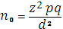
[Where, n= required sample size.
Z= confidence limit=1.96
p= 0.63%=0.0063
q = 1-p = 1-0.006=0.9937
d = marginal error considered as 5% (0.05).]
n = z²pq/d²
= (1.96)² × 0.006 × 0.9937 / (.o5)²
=3.8416×0.0063×0.9937/0.0025
= 9.6198
According to this formula the required sample size was 10
For standard study, minimum 30 sample was taken for each group.
3.6 Enrollment criteria
Inclusion criteria:
Case:
- Substance use disorder patients within the range of 18 years and above of either sex.
- After adequate clinical improvement if Substance use disorder patients is in intoxicated or withdrawal state.
Control: Age and sex matched apparently healthy persons attending with other patients who have no history of substance abuse and biological relationship with cases.
Exclusion criteria: (both case and control)
- Those who was refused to give consent
- Patients who have co-morbid psychiatric disorders.
- Patients those who are mute, stupor us and unable to communicate with the researcher/interviewer.
- Patients have co-morbid known medical illness which has significant impact on cognitive functions of that patient.
3.7 Variables
Outcome variables:
- Cognitive score
- Social relationships score
- Environment score
Demographic variables:
- Age
- Sex
- Marital condition
- Educational status
- Socio-economic condition
- Types of substance use
- Routes of substance use
3.8 Ethical Consideration
I shall be duly careful about the ethical issues related to this study. The following criteria was set to ensure maintaining the ethical values:
Before starting this study, the research protocol was approved by the IRB (Institutional Review Board) of Sylhet M. A. G Osmani Medical College Sylhet. In this study precaution was taken to protect confidentiality of the participants. Informed written consent was obtained from the subject without any influences. The contents of the consent requirements was included to explain the nature and purpose of the study, the procedure of the study, all information regarding benefits and hazard to all participants, explanation that they have the right to refuse or accept to participate in the study &full understanding of the results of this research and their probable welfare implications.
It should be noted that the subjects were not gain financial benefit from this study, and the study was not involved collection of any body organ, tissue or fluid. Subjects was assured that Data obtained from the study was used only for the research purpose. Through this research, patient would not be confronted with any physical, psychological or social risks. Participant’s basic human rights would not be violated in any way.
If the participants have any question or any other problems, they was requested to contact with the investigator.
3.9 Operational definitions
Drug/Substance refers to “any chemical substance which affects bodily function, mood, perception or consciousness which has potential for misuse and which may be harmful to the individual or the society(Kornblum, Julian & Smith 2003).
According to UNODC, Illicit drugs are used to describe drugs which are under international control (and which May or may not licit medical purposes) but which are produced, trafficked and/or consumed illicitly.
Substance abuse refers to the harmful or hazardous use of psychoactive substances, including alcohol and illicit drugs.
Substance use disorder is a cluster of cognitive, behavioral, and physiological symptoms indicating that the individual continues using the substance despite significant substance-related problems(American Psychiatric Association 2013).
Substance Use Disorder by DSM-5: It is a cluster of cognitive, behavioral, and physiological symptoms contribute to the continued use of a substance despite significant substance-related problems.
A maladaptive pattern of substance use leading to clinically significant impairment or distress, as manifested by 2 (or more) of the following, occurring within a 12-month period:
Ddependence syndrome - a cluster of behavioral, cognitive, and physiological phenomena that develop after repeated substance use and that typically include a strong desire to take the drug, difficulties in controlling its use, persisting in its use despite harmful consequences, a higher priority given to drug use than to other activities and obligations, increased tolerance, and sometimes a physical withdrawal state(American Psychiatric Association 2013).
Intoxication refers to the clinically significant problematic behavioral or psychological changes (e.g., belligerence, mood liability, impaired judgment) which are attributable to the physiological effects of the substance on the central nervous system and develop during or shortly after use of the substance. The most common changes in intoxication involve disturbances of perception, wakefulness, attention, thinking, judgment, psychomotor behavior, and interpersonal behavior (American Psychiatric Association 2013).
Tolerance is a state in which, after repeated administration, a drug produces a decreased effect, or increasing doses are required to produce the same effect(Cowen, Harrison & Burns 2012).
Withdrawal state refers to a group of symptoms and signs that occur when a drug is reduced or withdrawn, which last for a limited time. The nature of withdrawal state is related to the class of substance used(Cowen, Harrison & Burns 2012)
Cognition is the mental action or process of acquiring knowledge and understanding through thought, experience, and the senses. It encompasses processes such as attention, "Concentration", problem solving and decision making, comprehension and production of language. Cognitive processes use existing knowledge and generate new knowledge
3.10 Research Instruments
1. The Adden Brooke’s Cognitive Examination-III (ACE-III) is a brief cognitive test that assesses five cognitive domains: attention, memory, verbal fluency, language and visuospatial abilities. The total score is 100 with higher scores indicating better cognitive functioning. Administration of the ACE-III takes, on average, 15 minutes and scoring takes about 5 minutes. The diagnostic accuracy of ACE as a brief ‘bedside’ cognitive screening instrument led to its widespread adoption. The original ACE included the mini-mental state examination (MMSE) or Holstein test, along with front-executive and extra visuospatial items.
The original 26 components were combined to produce five sub scores, each representing a specific cognitive domain: attention/orientation (18 Points), memory (26 points), fluency (14 points), language (26 points) and visuospatial function (16 points)—100 in Total. It gives a cut-off score for the five sub domains against controls and takes between12 and 20 min (average 16.
Testing shows that ACE-III cognitive domains correlate significantly with standardized neuropsychological tests used in the assessment of attention, language, verbal memory and visuospatial function. It also compared very favorably with its predecessor, the ACER, with similar levels of sensitivity and specificity and the two tests correlated significantly (r = 0.99, P < 0.01). The ACE-III also continues to show high sensitivity and specificity at cut-offs
previously recommended:
(i) 88 (sensitivity = 1.0; specificity = 0.96) and
(ii) 82 (sensitivity = 0.93; specificity = 1.0). Internal
Reliability of the ACE-III, measured by Cranach’s α
Coefficient was 0.88.
The assessment focuses on five cognitive domains:
• Attention
• Memory
• Verbal fluency
• Language
• Visuospatial abilities
2. Diagnostic and Statistical Manual of Mental Disorder (DSM-5):
Since its first publication in 1952, DSM has been reviewed and revised four times. Since then, knowledge about psychiatric disorders, including substance use disorders, has advanced greatly. To take the advances into account, a new version, DSM-5, was published in 2013. In DSM-5, both ICD-9-CM and ICD-10-CM codes are attached to the relevant disorders in the classification. DSM-5 Diagnostic Codes (ICD-10-CM) for Substance Use Disorder is F.10 to F.18(American Psychiatric Association 2013).
- Pre-designed structured questionnaire to identify the socio demographic characteristics:
Several socio demographic variables such as age, gender, educational level, marital status, occupation, monthly income, type of substance use, duration of substance use, routes of administration etc. of the patients were included in the questionnaire. During the interview, investigator was used Bangla version of questionnaire.
3.11 Procedure of the Data Collection
A prior permission was taken from the head of the department of psychiatry, SOMCH, Sylhet and the director/authority of non-government health related hospital include Sylhet Monorog Hospital, RR Medical Hospital, and Shahjalal Mental Health & Research Center. In addition, all official procedure was also be maintained.
Patients with Substance Use disorders would be selected as sample from the place of study. Clinical diagnosis of Substance Use Disorder patients was done by investigator himself according to the DSM-5 and confirmed by consultant psychiatrist
Age and sex matched apparently healthy persons attending with other patients was evaluated by proper history taking for control of this study.
The investigator collected data from both outdoor and indoor of psychiatry department of SOMCH, and also from Sylhet Monorog Hospital, RR Medical Hospital,and Shahjalal Mental Health & Research Center.
- Patients and control were informed about the purpose of the study and ethical issues.
- Then, after taking the written consent, data collection procedure was initiated by the investigator himself through one to one interview.
Pre-Testing:
Prior to the study pre-testing was carried out among patients equivalent to 10% of total study population to test the applicability of the methodology including the research instruments. Some modification in the questions may be made out and was finalized.
3.12 Data analysis
After collecting the data, it would be checked and rechecked for omission, inconsistencies and improbabilities. Then data cleaning was performed followed by editing, coding and entering into the computer. Computer software Statistical Package for Social Sciences, 22ndVersion (SPSS- 22) was used for analysis. General characteristics of the patients was presented in terms of percentage, mean and standard deviation. Chi-square test and Students t-test was used for qualitative and quantitative variable respectively. Comparison and association were tested using the independent t-test, Chi Square test, ANOVA test and others.
The level of significance was considered as 0.05. If a P-value for a variable less than 0.05 then the effect of the variable considered as statistically significant. Result was presented as text, tables and figures like pyramid diagram, component bar diagram, bar diagram, pie chart etc.
3.13 Quality Assurance Strategy
1. Researcher was adequately trained about the confidentiality, proper
interview technique, using proper language.
2. Permission was obtained from the Chairman, department of Psychiatry
and from the subjects.
3. Careful selection of the translators
4. Direct supervision by the guide
5. Review of the study status was done fortnightly by the investigator with the guide. Ten percent data was checked randomly.
6. Data was collected using structured questionnaire approved by expert committee.
7. After collection, all data was checked for inadequacy. Data was strictly monitored, preserved, not to be manipulated bothers in different stages of the study.
9. Data processing and statistical analysis was done by statistician.
3.14 Confidentiality
Both during research and in future, confidentiality was maintained as follows:
1. Name of the participant not was disclosed.
2. Each participant was assigned with an identification number by the researcher. Data was protected by coding of socio-demographic data. Personal records were maintained accordingly.
3. Research findings was used only for scientific presentation and publications anonymously.
4. Data obtained through this research project was not be handed over to anybody else not involved with it.
Unintentional disclosure was avoided by consultation where it cannot be overheard, and by avoiding discussion between professional staff in places where it might be overheard.
Rights of the participating patient:
The subject has the freedom of choice to withdraw himself or withhold information at any time during study. This was not affected the cognition impairment and treatment that he is already receiving from the institution.
Substance Use Disorder by DSM-5:
It is a cluster of cognitive, behavioral, and physiological symptoms contribute to the continued use of a substance despite significant substance-related problems.
A maladaptive pattern of substance use leading to clinically significant impairment or distress, as manifested by 2 (or more) of the following, occurring within a 12-month period:
Criterion A criteria can be considered to fit within overall groupings of impaired control, social impairment, risky use, and pharmacological criteria
Impaired control (Criteria 1-4)
- The individual may take the substance in larger amounts or over a longer period than was originally intended (Criterion 1).
- The individual may express a persistent desire to cut down or regulate substance use and may report multiple unsuccessful efforts to decrease or discontinue use (Criterion 2).
- The individual may spend a great deal of time obtaining the substance, using the substance, or recovering from its effects (Criterion 3).
- Craving (Criterion 4) is manifested by an intense desire or urge for the drug that may occur at any time but is more likely when in an environment where the drug previously was obtained or used.
Social impairment (Criteria 5-7)
- Recurrent substance use may result in a failure to fulfill major role obligations at work, school, or home (Criterion5).
- The individual may continue substance use despite having persistent or recurrent social or interpersonal problems caused or exacerbated by the effects of the substance (Criterion6).
- Important social, occupational, or recreational activities may be given up or reduced because of substance use (Criterion 7).
Risky use (Criteria 8-9).
- This may take the form of recurrent substance use in situations in which it is physically hazardous (Criterion8).
- The individual may continue substance use despite knowledge of having a persistent or recurrent physical or psychological problem that is likely to have been caused or exacerbated by the substance (Criterion 9).
Pharmacological (Criteria 10 and 11).
- Tolerance (Criterion10) is signaled by requiring a markedly increased dose of the substance to achieve the desired effect or a markedly reduced effect when the usual dose is consumed
- Withdrawal (Criterion 11) is a syndrome that occurs when blood or tissue concentrations of a substance decline in an individual who had maintained prolonged heavy use of the substance
From the brain, and from the brain alone, arise our pleasures, joys, laughter and jokes, as Well as our sorrows, pains, griefs and tears. Through it, in particular, we think, see, hear, and Distinguish the ugly from the beautiful, the bad from the good, and the pleasant from the unpleasant All the time the brain is quiet, a man can think properly Attributed to Hippocrates, 5th century BCE (Quoted by Kandelet al., 1991).
RESULTS
Of all the possible cognitive variables that has been tested between the substance and non-substances user to get the cognitive impairment scores, all the cognitive variables were significant (P-value: <0.001) when we analysed two-sample t-test in control and case group. Respondents not using substance performed better on attention than those substance use disorder patients [M diff = 2.00 (SD = 0.00), P = <0.001]. Respondents with substance use disorder performed significantly worse on memory abilities than those not using any types of substances [M diff = 4.00 (SD = 1.00), P = <0.001] and those using substances [M diff = 2.00 (SD = 1.00), P = <0.001] has lower fluency score than those who were not substance user. Additionally, patients using substance disorder performed worse on language test score than those nonsubstance users, similar result was finding on Visio spatial abilities (Table I).

Table I: Mean, standard deviation, minimum and maximum values of cognitive impairment scores for substance use disorder patients versus control subjects
Cognitive variables | Control subjects |  |  |  | Substance use disorder patients |  |  |  |  | P-value*
Cognitive variables | Mean | SD | Min | Max | Mean | SD | Min | Max |  | P-value*
Attention | 16 | 2 | 11 | 18 | 14 | 2 | 7 | 18 |  | <0.001
Memory | 22 | 3 | 16 | 26 | 18 | 4 | 10 | 26 |  | <0.001
Fluency | 10 | 2 | 5 | 14 | 8 | 3 | 0 | 13 |  | <0.001
Language | 23 | 2 | 18 | 26 | 20 | 3 | 9 | 25 |  | <0.001
Visio Spatial Abilities | 14 | 2 | 8 | 16 | 12 | 3 | 4 | 16 |  | <0.001
Total Score | 84 | 7 | 68 | 99 | 71 | 10 | 45 | 91 |  | <0.001
SD: Standard Deviation *P-value calculated based on two-sample t-test.

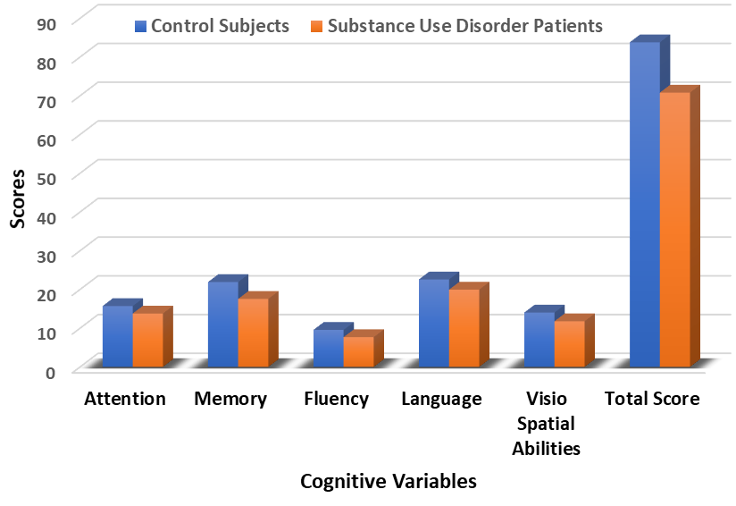
Figure I: Cognitive impairment scores (average total score) for substance use disorder patients versus control subjects

Table-II shows that out of 140 substance users, which was multiple response question, the results revealed the no substance users was (50%), addiction in single drug use (0.7%). Addiction in 2,3 and 4 drugs used by single user at a time were 15.7%, 12.9% and 20.7%, respectively.

Table II: Distribution of respondents by number of substance use
Types Drugs User | Frequency | Percent
No Drug user | 70 | 50.0
Single Drug User | 1 | 0.7
2 Drugs User | 22 | 15.7
3 Drugs User | 18 | 12.9
4 Drugs User | 29 | 20.7
Total | 140 | 100.0

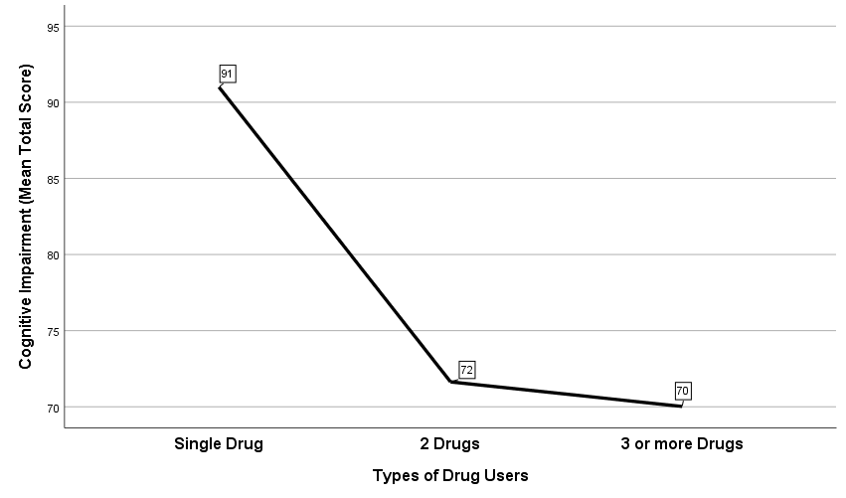

Figure II: Mean total score of respondents by number of substance use

In the current sample, among 140 patients, the mean total score was 91 for single drug users, 72 for two drug users and 70 was for 3 or more drug users.
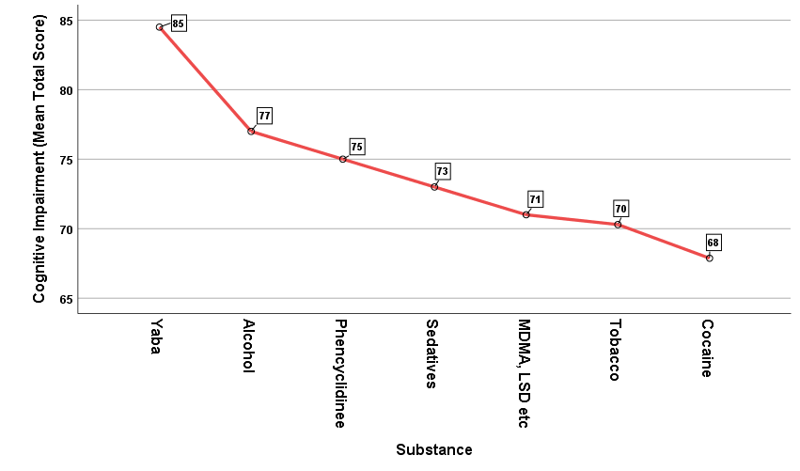
Figure III: Mean total score of respondents by number of substance use

From Table-III, a total of 140 respondents was included. Among them, the total mean score of cognitive impairment of no substance user was 83.81 (SD = 7.01). The most prevalent substance was tobacco (n=54), followed by cocaine (n=8), alcohol (n=3), Yaba (n=2), sedatives (n=1), phencyclidine (n=1) and others (n=1). Among substance user, the mean cognitive impairment score in tobacco user was 70.30 (SD=10.03).

Table III: Mean, standard deviation, minimum and maximum values of cognitive impairment scores for substance use disorder by various substance

Substance | N | Minimum | Maximum | Mean | SD | 95% Confidence Interval for Mean
 |  |  |  |  |  | Lower Bound | Upper Bound
No User | 70 | 68 | 99 | 83.81 | 7.008 | 82.14 | 85.49
Yaba | 2 | 78 | 91 | 84.50 | 9.192 | 1.91 | 167.09
Alcohol | 3 | 67 | 84 | 77.00 | 8.888 | 54.92 | 99.08
Sedatives | 1 | 73 | 73 | 73.00 | . | . | .
Tobacco | 54 | 45 | 89 | 70.30 | 10.033 | 67.56 | 73.03
Cocaine | 8 | 59 | 81 | 67.88 | 8.254 | 60.97 | 74.78
Phencyclidinee | 1 | 75 | 75 | 75.00 | . | . | .
MDMA, LSD etc | 1 | 71 | 71 | 71.00 | . | . | .
Total | 140 | 45 | 99 | 77.32 | 10.709 | 75.53 | 79.11

In these results, the null hypothesis states that the mean of total cognitive imparement scores values of 8 different substance user was not equal. Because the p-value is 0.000, which is less than the significance level of 0.05, we can conclude that some of the substance users have different means (Table IV).

Table IV: ANOVA table of cognitive impairment scores for substance use disorder patients versus control subjects
 | Total Score |  |  | F | Sig.
 | Sum of Squares | df | Mean Square | F | Sig.
Between Groups | 6497.316 | 7 | 928.188 | 12.974 | .000
Within Groups | 9443.220 | 132 | 71.540
Total | 15940.536 | 139

The descriptive table provides the total mean score on various cognitive imparement by sex, including the mean, minimum and maximum, as well as when all groups are combined (Total). In the current sample, among 140 patients, the mean total score of attention was 15 in male and 14 in female. In memory test, 20 in male and 20 in female. Fluency score was 9 in both male and female (Table V).

Table V: Mean, standard deviation, minimum and maximum values of cognitive impairment scores for substance use disorder patients by sex
Cognitive variables | Sex of the respondents
Cognitive variables | Male |  |  |  | Female
Cognitive variables | Minimum | Maximum | Mean | SD | Minimum | Maximum | Mean | SD
Attention | 7 | 18 | 15 | 2 | 10 | 18 | 14 | 2
Memory | 10 | 26 | 20 | 4 | 13 | 26 | 20 | 4
Fluency | 0 | 14 | 9 | 3 | 5 | 14 | 9 | 2
Language | 9 | 26 | 22 | 3 | 14 | 24 | 20 | 3
Visio Spatial Abilities | 4 | 16 | 13 | 2 | 6 | 16 | 13 | 3
Total Score | 45 | 99 | 78 | 10 | 55 | 98 | 76 | 12

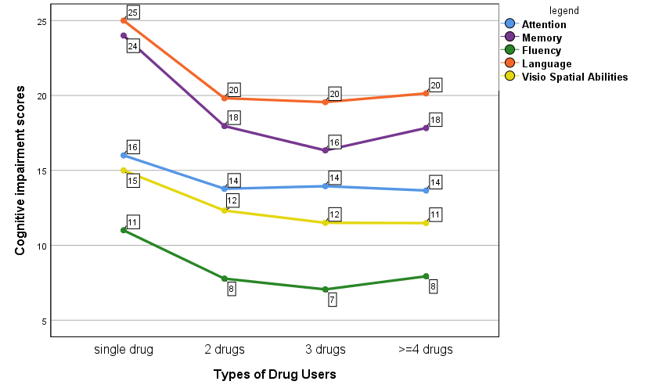
Figure IV: Mean total score of respondents by number of substance use and cognitive impairment type

From the above figure, the mean total score for single drug users was 11, 15, 16, 24 and 25 in fluency, Visio spatial abilities, attention, memory and language, respectively. This score is lowest when respondents use greater than 4 drugs (Figure-IV).

Table VI: Mean, standard deviation, minimum and maximum values of cognitive impairment scores for substance use disorder patients by different various substance use

 |  |  | Total Score |  |  |  | Min | Max
Substance Use | N | Mean | SD | Std. Error | 95% CI |  | Min | Max
 |  |  |  |  | Lower Bound | Upper Bound | Min | Max
Smoking | 8 | 73.13 | 6.896 | 2.438 | 67.36 | 78.89 | 60 | 80
Swalling | 7 | 68.57 | 5.503 | 2.080 | 63.48 | 73.66 | 59 | 76
Smoking & Swallowing | 44 | 70.75 | 10.522 | 1.586 | 67.55 | 73.95 | 45 | 91
Swalling & Nasal | 5 | 70.20 | 11.692 | 5.229 | 55.68 | 84.72 | 59 | 84
Swalling & Injection | 2 | 83.00 | 8.485 | 6.000 | 6.76 | 159.24 | 77 | 89
Swalling & Buccal | 4 | 65.75 | 9.605 | 4.802 | 50.47 | 81.03 | 60 | 80
Total | 70 | 70.83 | 9.817 | 1.173 | 68.49 | 73.17 | 45 | 91

In Table-VI, a total of 70 respondents was included. Among them, the total mean score of cognitive impairment of was 73.13 (SD = 6.90) who only take substance by smoking and the total mean score of cognitive impairment was 68.57 (SD = 5.50) who only take substance by swelling. Total 44 respondents were taking substance both smoking and swelling, they score 70.75 (SD = 10.52).

Table VII: ANOVA table of cognitive impairment scores for substance use disorder patients by different various substance use
 | Sum of Squares | df | Mean Square | F | Sig.
Between Groups | 479.554 | 5 | 95.911 | .995 | .428
Within Groups | 6170.389 | 64 | 96.412 | .995 | .428
Total | 6649.943 | 69 |  | .995 | .428

In these results, the null hypothesis states that the mean of total cognitive impairment scores values on different route using for substance was not statistically significantly different. Because the p-value is greater than the significance level of 0.05, we can conclude that some of the routes have similar means (Table-VII).
Table VIII: ANOVA of cognitive impairment scores for substance use disorder patients by different socio-economic status
Source | F Value | P-value
Intercept | 1257.081 | .000
Case vs control | 55.961 | .000
sex | .350 | .555
marital status | 1.648 | .197
Age Group | 2.061 | .109
Habitant | .933 | .336
Occupation | .594 | .735
Education | 3.767 | .003
Religion | 1.073 | .302
Family income (monthly) | .126 | .945
Hpsychiatricillness_fmembers | .502 | .480

Table IX: ANOVA of cognitive impairment scores for substance use disorder patients by different significant socio-economic variables
Source | F Value | P-value
Corrected Model | 21.581 | .000
Intercept | 4865.596 | .000
Case_1_control_0 | 84.254 | .000
Education | 6.460 | .000
Adjusted R Squared = 47%
From the above table, total of the respondents has some association between case vs control group and educational status of the respondents, as p-value is less than 0.05 (Table IX).

Table X: Frequency distribution of respondents according to marital status
Marital Status | Control |  | Case |  | P-value
Marital Status | Count | % | Count | % | P-value
Single | 31 | 44.3 | 23 | 32.9 | 0.057
Married | 38 | 54.3 | 40 | 57.1 | 0.057
Others | 1 | 1.4 | 7 | 10.0 | 0.057
Total | 70 | 100 | 69 | 100 | 0.057

Frequency distribution of respondents according to marital status is represented in Table-X. Chi-square test showed that there was no significant difference (p=0.057) between control group and substance user group. There were 31 unmarried (44.3%) and 38 married (54.3%) and 1 (1.4%) others marital status respondents in control group whereas in case group, there were 23 unmarried (32.9%), 40 married (57.1%) and 1 other marital status (10%).
Table XI: Age distribution of the respondents for both case and control subjects
 |  | Control Subjects |  |  | Case Subjects |  |  | P-value
 |  | Mean | Count | % | Mean | Count | % | P-value
Age; Mean (±SD) |  | 30 (9.7) |  |  | 35 (9.4) |  |  | 0.003*
Age Group  (years) | 18-25 |  | 30 | 42.9 |  | 13 | 18.6 | 0.007**
Age Group  (years) | 26-35 |  | 25 | 35.7 |  | 27 | 38.6 | 0.007**
Age Group  (years) | 36-45 |  | 8 | 11.4 |  | 19 | 27.1 | 0.007**
Age Group  (years) | 45+ |  | 7 | 10.0 |  | 11 | 15.7 | 0.007**
*Two independent sample t-test, **Chi-Square (χ²) test and

Table-XI shows the mean age among respondents. The mean age for control group was 30 whereas for case group, it was 35 years. Independent t-test showed that there has some significant difference between groups (p = 0.003).
Table-XI also represents the percentage of the respondents of different age group. Among the different age groups, the highest number of respondents 42.9% (n=30) has age between 18-25 years in control group and 38.6% (n=27) has age between 26-35 years in case group.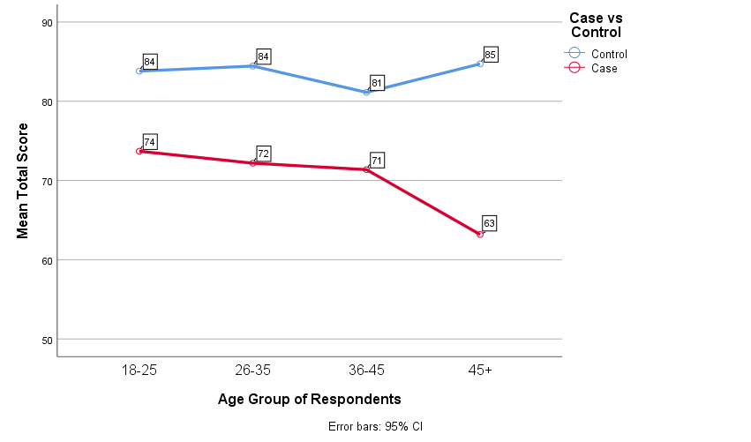
Figure V: Total mean score of the respondents for both case and control subjects according to age group

Figure-V shows the mean total score by respondents among control and case group according to their age. The total mean score in respondents age between 18-25 years were 74 in case group and 84 in control group. The total mean score in respondents age between 26-35 years were 72 in case group and 84 in control group. The total mean score in respondents age between 36-45 years were 71 in case group and 81 in control group and the total mean score in respondents age above 45 years were 63 in case group and 85 in control group.

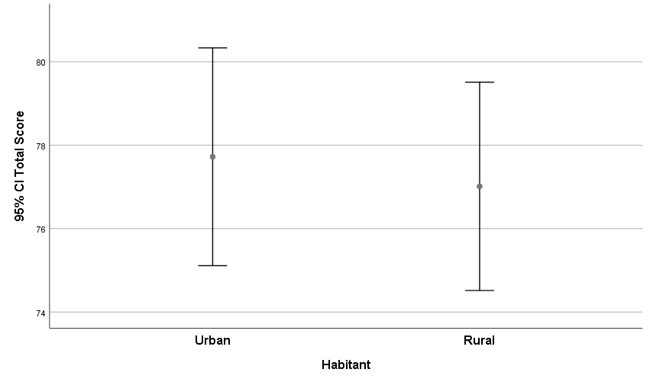
Figure VI: Total mean score of the respondents for both case and control subjects according to age group

Figure-VI shows that the urban respondents’ cognitive impairment scores were higher than the rural scores.

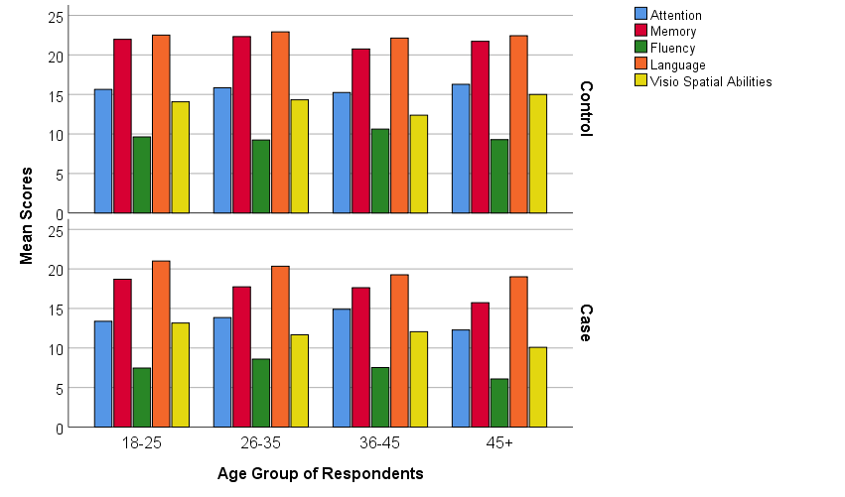
Figure VII: Cognitive impairment scores (average score) to age of the respondents of case versus control groups

The above Figure shows that the mean scores for memory and language were higher for both case and control groups and across the age groups (Figure-VII).

Table XII: Distribution of the respondents according to sex
Sex | Control |  |  |  | Case |  |  | P-value
Sex | Count |  | Column N % |  | Count |  | Column N % | P-value
Male | 55 | 78.6 |  | 60 |  | 85.7 |  | 0.27
Female | 15 | 21.4 |  | 10 |  | 14.3 |  | 0.27

Frequency distribution of respondents according to sex is represented in Table-XII. Chi-square test showed that there was no significant difference (p=0.27) between control group and substance user group. Male respondents make up 78.6% (55 respondents) of control group 85.7% (60 respondents) of substance user group whereas female respondents make up another 21.4% and 14.3% of case and control group, respectively.

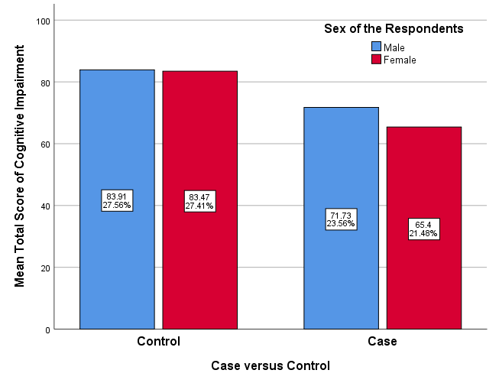
Figure VIII: Cognitive impairment total scores (average score) according to sex of respondents of cases and controls

Table XIII: Cognitive impairment total scores (average score) according to sex
 | Sex | N | Mean | Std. Deviation | Std. Error Mean | P-value
Total Score | Male | 115 | 77.56 | 10.49 | 0.98 | 0.58
Total Score | Female | 25 | 76.24 | 11.82 | 2.37 | 0.58

Figure-VIII shows the cognitive impairment total scores (average score) according to sex of respondents of cases and controls. The total mean score in male control group was 27.56% and 27.41% was achieved by female respondents and in case group the total mean score in male was 23.56% and 21.48% was achieved by female respondents.

Table XIV: Distribution of the respondents according to religion
Religion | Control |  | Case |  | P-value
Religion | Count | Column N % | Count | Column N % | P-value
Muslim | 59 | 84.3 | 62 | 88.6 | 0.46
Hindu | 11 | 15.7 | 8 | 11.4 | 0.46

Table-XIV shows the distribution of respondents according to religion. Chi-square test shows no significant difference between two groups (p=0.46). In control group, 84.3% of respondents (59) were Muslim while the other 15.7% (11) were Hindus whereas in substance user group, 88.6% (62) were Muslim and the other 11.4% (8) were Hindus.
Table XV: Distribution of the respondents according to habitant
Habitant | Control |  | Case |  | P-value
Habitant | Count | Column N % | Count | Column N % | P-value
Urban | 25 | 35.7 | 36 | 51.4 | 0.61
Rural | 45 | 64.3 | 34 | 48.6 | 0.61

Frequency distribution of respondents according to habitat is demonstrated in Table-XV. Chi-square test showed that there was no significant difference (p=0.61) between control group and substance user group. There were 25 respondents (35.7%) living in urban and 45 respondents (64.3%) living in rural area in substance non-user group whereas in substance user group, 51.4% (36 respondents) come from urban area while another 48.6% (34) come from rural area.
Table XVI: Distribution of the respondents according to education
Education | Control |  | Case |  | P-value
Education | Count | Column N % | Count | Column N % | P-value
Illiterate | 3 | 4.3 | 3 | 4.3 | 0.165
Primary | 21 | 30.0 | 29 | 41.4 | 0.165
Secondary | 30 | 42.9 | 26 | 37.1 | 0.165
Higher Secondary | 8 | 11.4 | 11 | 15.7 | 0.165
Graduate | 4 | 5.7 | 1 | 1.4 | 0.165
Postgraduate & above | 4 | 5.7 | 0 | 0.0 | 0.165

Table-XVI shows frequency distribution of respondents according to educational background. Chi-square test showed that there was no significant difference (p=0.165) between control group and substance user group. In control group, most of the respondents 30(42.9%) had secondary level group. In Case group, most of the respondents 29 (41.4%) had primary level group.

Table XVII: Distribution of the respondents according to occupation
Occupation | Control |  | Case |  | p-value
Occupation | Count | Column N % | Count | Column N % | p-value
Farmer | 2 | 2.9 | 3 | 4.3 | 0.033
Service | 29 | 41.4 | 10 | 14.3 | 0.033
Business | 15 | 21.4 | 19 | 27.1 | 0.033
Student | 3 | 4.3 | 4 | 5.7 | 0.033
House wife | 7 | 10.0 | 10 | 14.3 | 0.033
Unemployed | 5 | 7.1 | 6 | 8.6 | 0.033
Others | 9 | 12.9 | 18 | 25.7 | 0.033

Table-XVII represents frequency distribution of respondents according to occupation. Chi-square test showed that there was significant difference (p<0.05) between control group and substance user group. In control group, most of the respondents 41.4% (29) were in service holders. In substance user group, only 27.1% (19) were in business group.

Table XVIII: Distribution of the respondents according to family income
Family income per month | Control |  | Case |  | P-value
Family income per month | Count | Column N % | Count | Column N % | P-value
5k-10k | 13 | 18.6 | 6 | 8.6 | 0.006
10k-25k | 32 | 45.7 | 20 | 28.6 | 0.006
25k-50k | 20 | 28.6 | 28 | 40.0 | 0.006
50k+ | 5 | 7.1 | 16 | 22.9 | 0.006

Frequency distribution of respondents according to family income is shown in Table-XVIII. Chi-square test showed significant difference (p=0.006) between control group and substance user group. In non-substance user group, monthly family income between 5000-10000 taka for 13 respondents (18.6%), 10000-25000 taka for 32 respondents (45.7%), 25000-50000 taka for 20 respondents (28.6%) and >50000 taka for 5 respondents (7.1%). In substance user group, 6 respondents (8.6%) came from family that earned <10000 taka monthly, 20 respondents (28.6%) came from family that earned 10000-25000 taka monthly, 28 respondents (40.0%) came from family that earned 25000-50000 taka monthly and monthly family income for other 16 respondents (22.9%) was >50000 taka.

Table XIX: Distribution of the respondents according to self-income
Self-Income per month | Control |  | Case |  | P-value
Self-Income per month | Count | Column N % | Count | Column N % | P-value
<10K | 14 | 20.0 | 10 | 14.3
10-20K | 26 | 37.1 | 16 | 22.9
20-30K | 14 | 20.0 | 7 | 10.0 | <0.001
>30K | 3 | 4.3 | 26 | 37.1
No income | 13 | 18.6 | 11 | 15.7

Frequency distribution of respondents according to self-income is shown in Table-XIX. Chi-square test showed significant difference (p=<0.001) between control group and substance user group. In non-substance user group, highest monthly self-income between 10000-20000 taka for 26 respondents (37.1%). In substance user group, highest monthly self-income in 26 respondents (37.1%) was >30000 taka.

Table XX: Comparison of family history of psychiatric illness between control group and substance user group
History of psychiatric illness in family members | Control |  | Case |  | P-value
History of psychiatric illness in family members | Count | Column N % | Count | Column N % | P-value
Present | 5 | 7.2 | 9 | 12.9 | 0.429
Absent | 64 | 92.8 | 61 | 87.1 | 0.429

Table-XX shows the comparison of family history of psychiatric illness between the respondents in control group and substance user group. Chi-square test showed that there was no significant difference (p=0.429) between control group and substance user group. In control group, 5 out of 69 respondents (7.2%) had family suffering from psychiatric illness whereas the number of respondents with family suffering from psychiatric illness in case group was 9 or 12.9%.

Table XXI: Frequency distribution of household composition among respondents
Household composition | Control |  | Case |  | P-Value
Household composition | Count | Column N % | Count | Column N % | P-Value
Nuclear | 46 | 65.7 | 43 | 61.4 | 0.60
Joint | 24 | 34.3 | 27 | 38.6 | 0.60

Table-XXI represents the frequency distribution of household composition among respondents in control group and substance user group. Chi-square test showed no significant difference (p=0.60) between control group and substance user group. In control group, 46 out of 70 respondents (65.7%) were from nuclear family and 24 respondents (34.3%) from joint family. In case group, 43 out of 60 respondents (61.4%) were from nuclear family and 27 respondents (38.6%) from joint family.

Table XXII: Distribution of drug usage among family members among respondents
History of drug use by family members | Control |  | Case |  | P-value
History of drug use by family members | Count | Column N % | Count | Column N % | P-value
Yes | 39 | 55.7 | 29 | 41.4 | 0.09
No | 31 | 44.3 | 41 | 58.6 | 0.09

Table-XXII showed distribution of drug usage among family members between substance user and non-user group. Chi-square test showed no significant difference (p=0.09) between control group and substance user group. In control group, there were 39 out of 70 respondents (55.7%) admitted having drug users among family members and the rest 44.3% (31 respondents) did not have any family members using drugs. In case group, there were 29 out of 70 respondents (41.4%) admitted to have drug users among family members and the rest 58.6% (41 respondents) did not have any family members using drugs.

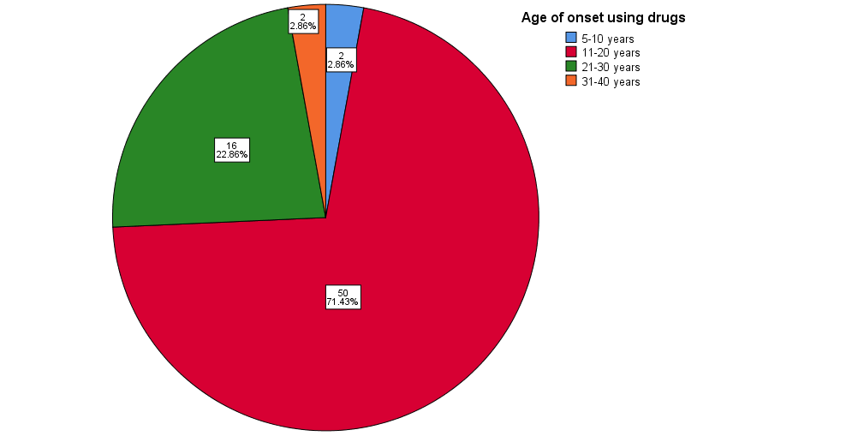

Figure IX: Age of onset of taking drugs among respondents in substance use group
Figure-IX demonstrates age of onset of taking drugs among respondents in substance use group where 2.86% of respondents admitted started taking drugs as early as 5-10 years old, 71.43%, 22.86%, and 2.86% of respondents started taking drugs at the age of 11-20 years old, 21-30 years old and 31-40 years old, respectively.

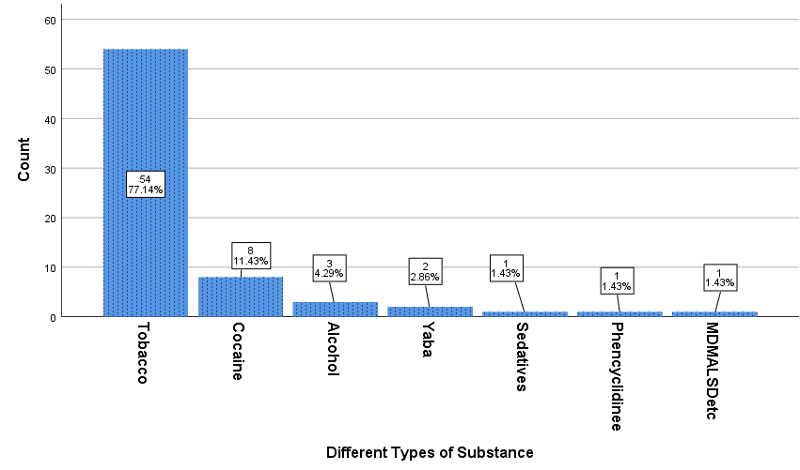
Figure X: Types of drugs (at least one drug) being used at the beginning among respondents in substance use group

Figure-X represents type of drugs being used at the beginning among respondents in substance use group. There were 54 (77.14%) of them use single drugs as starter whereas 8 (11.43%) of respondents had started with cocaine. The details of the drugs combination are shown in the following Table x.

Table XXIII: Details of combination of at least two or more drugs currently being used by respondents
 | Frequency | Percent
1 | 5 | 7.1
1,12 | 1 | 1.4
1,2,4,6,7 | 1 | 1.4
1,2,6 | 1 | 1.4
1,2,6,10 | 3 | 4.3
1,3,4,6 | 1 | 1.4
1,4,6 | 1 | 1.4
1,4,6,9 | 1 | 1.4
1,4,9 | 1 | 1.4
1,6 | 7 | 10.0
1,6,7,9 | 1 | 1.4
1,6,9 | 4 | 5.7
1,9 | 4 | 5.7
10 | 1 | 1.4
2 | 2 | 2.9
2,4 | 1 | 1.4
2,4,6,7,9 | 1 | 1.4
2,6,7,9 | 1 | 1.4
2,9,10 | 1 | 1.4
3 | 1 | 1.4
4,9 | 2 | 2.9
6 | 2 | 2.9
6,9 | 6 | 8.6
7 | 1 | 1.4
7,9 | 1 | 1.4
7,9,13 | 4 | 5.7
9 | 1 | 1.4
9,13 | 14 | 20.0
Total | 70 | 100.0

Table XXIV: Duration of currently using drugs among respondents
Duration of currently using drugs (Years) | Frequency | Percent
1-5 | 9 | 12.9
6-10 | 15 | 21.4
11-15 | 9 | 12.9
16-20 | 16 | 22.9
20+ | 21 | 30.0
Total | 70 | 100.0

Figure-XI shows the duration of substance usage among respondents. Highest percentage of duration among respondents was 20+ years (30%), followed by 16-20 years (22.9%) and 6-10 years (21.4%). 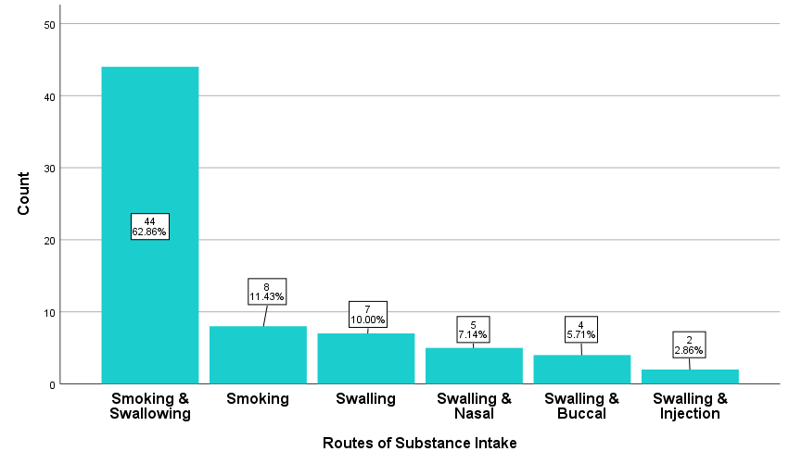
Figure XI: Distribution of routes of substances intake among respondents

Figure-XI shows distribution of routes of substance intake among respondents in substance use group. Majority of respondents (62.86%) taking the substance through smoking + swallowing.

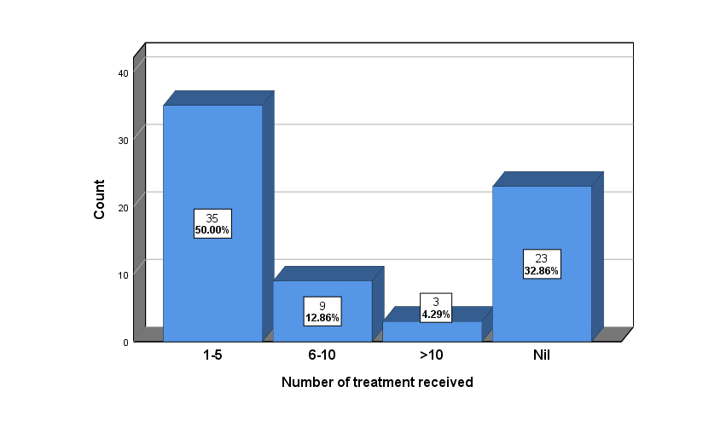
Figure XII: Number of treatments received by respondents

Figure-XII shows the number of treatments received by respondents among substance use group. There were 35 respondents (50%) received treatments 1-5 times, 9 respondents (12.86%) received treatments 6-10 times and 3 respondents (4.29%) had received treatments more than 10 times. Respondents that had never received any treatments make up 32.86% of the total respondents.
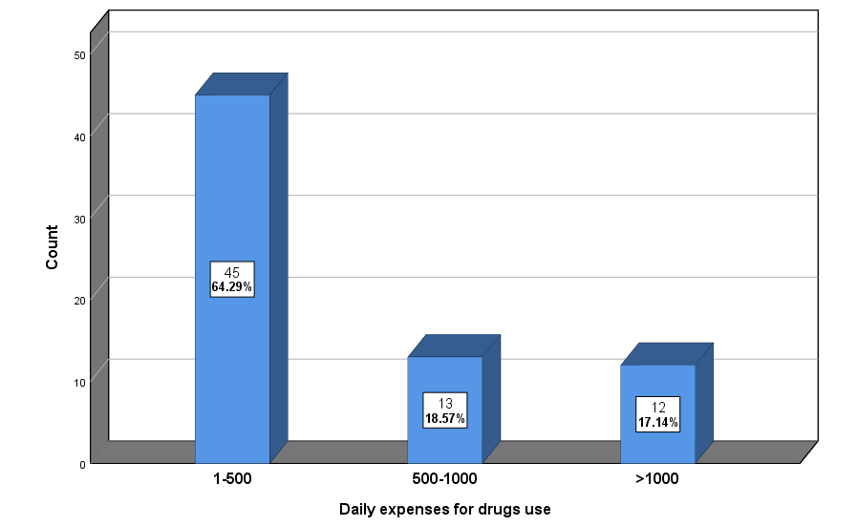
Figure XIII: Distribution of daily expenses for drugs among respondents in substance use group

Figure-XIII shows daily expenses for drugs among respondents that fall under substance use group. Majority (64.29%) spent 1-500 taka daily for drugs, followed by 500-1000 taka (18.57%) and >1000 taka (17.14%).

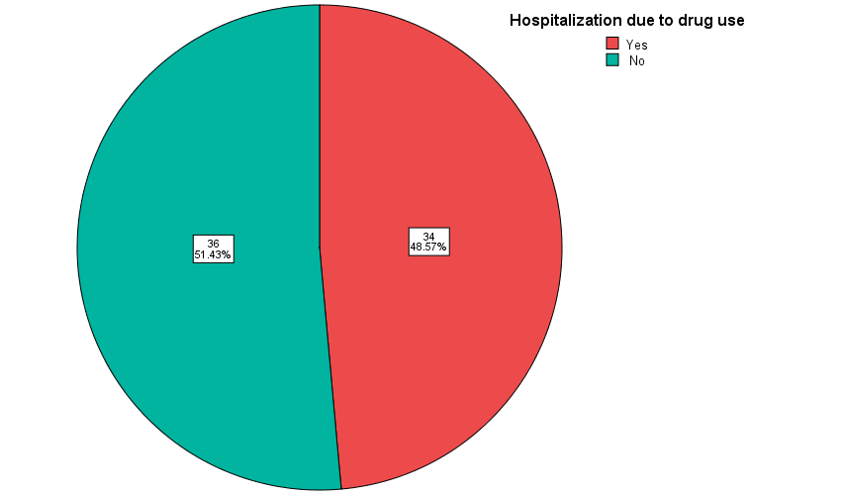
Figure XIV: Hospital admission due to substance use among respondents

Figure-XIV shows hospital admission among respondents due to substance use. 34 respondents (48.57%) were admitted to hospital and 36 respondents (51.43%) had never been admitted to the hospital due to substance use. The details of the data can be seen in the following figure.

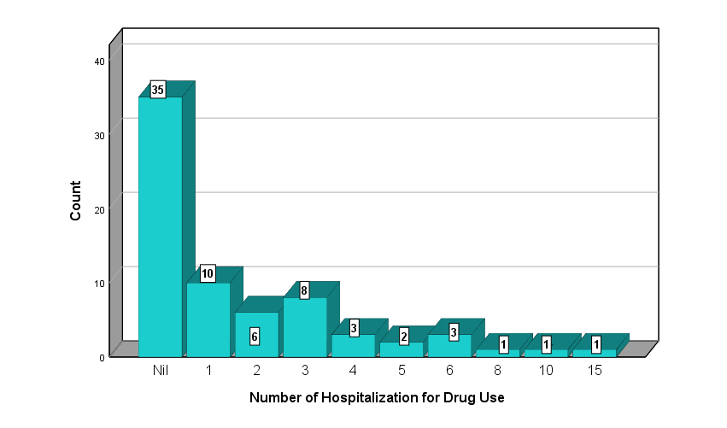
Figure XV: Number of hospitalization due to substance use among respondents

Table-XV represents type of drugs being previously among respondents in substance use group. The details of the drugs combination are shown in the following Table XXV.

Table XXV: Details of combination of at least two or more drugs previously used by respondents
 | Frequency | Percent | Valid Percent | Cumulative Percent
1,2,6 | 1 | 1.4 | 1.4 | 1.4
1,2,6,10 | 1 | 1.4 | 1.4 | 2.9
1,2,6,9 | 2 | 2.9 | 2.9 | 5.7
1,2,6,9,10 | 1 | 1.4 | 1.4 | 7.1
1,3,4,6,10 | 1 | 1.4 | 1.4 | 8.6
1,3,4,6,9 | 1 | 1.4 | 1.4 | 10.0
1,3,6 | 1 | 1.4 | 1.4 | 11.4
1,3,6,9 | 1 | 1.4 | 1.4 | 12.9
1,4,6,7,9 | 1 | 1.4 | 1.4 | 14.3
1,4,6,9 | 2 | 2.9 | 2.9 | 17.1
1,4,9 | 1 | 1.4 | 1.4 | 18.6
1,6,10 | 1 | 1.4 | 1.4 | 20.0
1,6,9 | 8 | 11.4 | 11.4 | 31.4
1,9 | 10 | 14.3 | 14.3 | 45.7
1,9,10,12 | 1 | 1.4 | 1.4 | 47.1
1,9,13 | 1 | 1.4 | 1.4 | 48.6
1,9,6 | 1 | 1.4 | 1.4 | 50.0
2,4,5,6,5,6 | 1 | 1.4 | 1.4 | 51.4
2,4,9 | 1 | 1.4 | 1.4 | 52.9
2,6,10 | 1 | 1.4 | 1.4 | 54.3
2,9 | 1 | 1.4 | 1.4 | 55.7
4,9 | 2 | 2.9 | 2.9 | 58.6
6,9 | 8 | 11.4 | 11.4 | 70.0
7 | 1 | 1.4 | 1.4 | 71.4
7,9 | 3 | 4.3 | 4.3 | 75.7
9 | 13 | 18.6 | 18.6 | 94.3
9,10 | 1 | 1.4 | 1.4 | 95.7
9,13 | 3 | 4.3 | 4.3 | 100.0
Total | 70 | 100.0 | 100.0

Table XVI: Details of combination of at least two or more drugs previously being used by respondents.
Name of substance | Frequency
Cannabinoids + Alcohol
Cannabinoids + Heroin
Cannabinoids + Yaba
Cannabinoids + Alcohol + Inhalant
Cannabinoids + Alcohol + Sedatives
Cannabinoids + Heroin + Alcohol
Cannabinoids + Phensydil + Sedatives
Cannabinoids + Phensydil + Yaba
Cannabinoids + Yaba + Alcohol
Cannabinoids + Heroin + Alcohol, Inhalant
Cannabinoids + Heroin + Phensydil + Yaba
Cannabinoids + Phensydil + Alcohol + Sedatives
Cannabinoids + Phensydil + Yaba + Alcohol
Cannabinoids + Heroin + Yaba + Alcohol + Sedatives
Cannabinoids + Heroin + Yaba + Alcohol + Others
Cannabinoids + Phensydil + Yaba + Alcohol + Inhalant
Cannabinoids + Heroin + Phensydil + Yaba + Alcohol + Sedatives
Heroin + Inhalant
Heroin + Phensydil + Yaba
Yaba + Sedatives
Total

DISCUSSION
5.1 Discussion
The aim of the present study was to estimate cognitive functioning in the varying patterns of substance users and non-users. The findings differed between the different age group of participants among case and control group.
From the results sections, comparing the control group and substance use group, variables include educational background, occupation, family income, family history of psychiatric illness and household composition showed significant difference between two groups whereas the other socio-demographic variables include age, sex, religion, marital status, habitant and monthly personal income did not show significant difference.

The mean age for control group was 30 whereas for case group, case was 35 years old. Independent t-test showed that there was significant difference between groups (p = 0.003). Sex variable showed insignificant difference between control and case too (p=0.27) where the percentage of male was 78.6% in control and 85.7% in case group.
There was no significant difference in religion between control and case group. In control group, 84.3% of respondents were Muslim while the other 15.7% were Hindus whereas in case group, 88.6% were Muslim and the other 11.4% were Hindus. It was expected to have higher percentage of Muslims respondents compared to other religions due to Bangladesh is occupied by more than 90% Muslims and less than 10% Hindus. There was also no significant difference between the control group and substance user group on marital status. There were 44.3% unmarried and 54.3% married respondents in control group whereas in substance user group, there were 32.9% unmarried, 57.1% married and 10% were divorced respondents. The recorded data is in line with a study (Astals et al. 2008) where they reported that there was higher percentage of single respondents (54%) compared to married (30.1%) and divorced (15.9%) in their investigation of impact of substance dependence.

For habitat variable, chi-square results showed no significant difference between control group and substance user group. There were 35.7% respondents living in urban and 64.3% respondents living in rural area in control whereas in case group, 51.4% coming from urban area while the other 48.6% coming from rural area. The results also indicate that there was higher number of respondents from urban area compared to rural area, among the substance use group.

Chi-square test also showed that there was no significant difference (p=0.60) between control group and substance user group for household composition. In control group, 65.7% respondents were from nuclear family, 34.3% from joint family, whereas in case group, 61.4% were from nuclear family, 38.6% from joint family. (Astals et al. 2008) had a similar findings in their research on 189 opioid-dependent patients where they observed higher percentage of patients living in joint family (73%) compared to opioid-dependent patients living alone (20.1%) and the rest were homeless (6.9%).
There was significant difference on monthly self-income between case and control group. Chi-square test showed that there was significant difference between control and substance user group on monthly family income. The results of monthly self-income showed that there was higher percentage of respondents without monthly income in control group (18.6%) compared to case (15.7%) and 37.1% of respondents in control earning 10000-20000 monthly compared to 22.9% in case group. Contradicting the above results, case having comparatively higher family income compared to control, where 45.7% of the respondents in control group earned more than 10000-25000 taka monthly, compared to only 28.6% in case group. (Grant et al. 2009) reported similar results where odd ratio of drugs dependency was higher in higher income family (1.4) compared to lower income family (1.0).

Case also showing higher percentage of family members having psychiatric illness (12.9%) compared to control group (7.2%). Previous studies have linked depressive disorder with substance abuse and dependency, where patients suffering from depressions and other mental disorders develop higher chances of developing substance use disorder (Darke et al. 2008).

The social transitions that occur during adolescence and young adulthood (age of 10–24 years) are essential for a young person’s later life trajectories. This study indicates that in this state the total mean score of cognitive impairment was 74 on substance abusers and 84 on non-user group. In the age group 26-35 the total cognitive impairment score was 72 in case group and 84 in control group. The cognitive impairment score was lowest in the age group 45+, in this group the total cognitive impairment score was 63 in case group and it is highest among all age group in control group (95).
This study showed the results on of onset using drugs, 50% of respondents admitted started taking drugs as early as 11-20 years old. Another study conducted in Nepal among drug users revealed that majority (95.0%) of the drug users-initiated substance use before they reach 25 years. Furthermore, more than 81.2% drug users have experience of first-time drug intake before the age of 20 years and more than 32% of drug users took drug first time in their life as early as 15 years. Whereas in Bangladesh, about 80% from 2.5 million of the drug addicts are youths aged 15 to 30 years old (Shazzad et al. 2014).
The distribution of onset of taking drug, main drugs and current drugs of substance use respondents showed that tobacco was the major drugs used in all categories. Data collected for onset of drugs also showed that substance use respondents combining Cannabis with other substances such as alcohol, Heroin, Yaba and Phensydil.

Substance dependency is widely known to be negatively affecting the users, physically and mentally, thus affecting overall cognition. It has already proven that abuse of drugs has a wide range of adverse effects on human civilization. Drugs have the capacity to alter mood, perception, cognition and behavior and therefore have the potential to influence, either positively or negatively, cognitive impairment (Frisher et al. 2004). The negative side effects of substance dependency varied form one drug to another. For instance, Phensydil users are prone to drowsiness, constipation and orthostatic hypotension, Pethidine users are prone to decrease in kidney function, toxic leukoencephalopathy, slurred speech and walking difficulty in Heroin users, nausea, vomiting, dizziness, diaphoresis, urinary retention and over dosage may cause muscle flaccidity, respiratory depression, obtundedness, cold and clammy skin, hypotension and coma whereby acute adverse effects of Cannabis include anxiety and panic attack, psychotic symptoms, chronic bronchitis and impaired respiratory function in regular smokers and subtle cognitive impairment (daily users of 10 and above) (Shazzad et al. 2014).

The findings of this study supported the previous research where there is apparent decline in overall cognitive impairment score among substance users. The results showed that control group scored higher total score in cognitive impairment. However, the score was not significantly difference in Cannabis user group. The rest of the groups scored lower cognitive score. For perception of cognitive impairment score, control group scored higher rate, followed by followed by users that did not taking any drugs currently while the lowest score rate was recorded for using combing Cannabinoids and other drugs. Respondents using Cannabinoids, Heroin, and other drugs users shown to scored lower compared to control group. For health satisfaction variable, highest score was recorded in control group, but the scores were not significantly different than Cannabinoids users, users taking other drugs and users that currently not taking any drugs. Heroin users scored significantly lower compared to the previous groups of users and lowest score was recorded by users combining Cannabinoids and other substances.

Mini mental scale MMS
Montreal cognitive assessment scale MoCA
Addenbrook’s Cognitive Examination ACE version 3 this scale is used in this study, so compare our results with above scales.

According to ACE-III score method, respondents not using substance performed on attention, memory, fluency, language, visio-spatial abilities were mean score 16, 22, 10, 23, and 14, respectively. (Wang et al. 2019) used MoCA scale and also ACE-III scale, they get total mean score 26 and 91 in ACE-III scale. In our study, by using ACE-III scale, the total mean score was 84, it’s slightly lower than that study. (Wang et al. 2019) also found the total mean score in attention, memory, language, verbal fluency and visuospatial score was 17, 24, 23, 10, and 15, respectively in control subject.

The total mean score by ACE-III in substance patients in this study was 71 and in attention, memory, fluency, language, visio-spatial abilities were mean score 14, 18 8, 20, and 12, respectively. According to Wang et al. (2019), in case group the total mean MoCA score was 20 and the total mean ACE-III score was 73 The total mean ACE-III score in our study lower than that study. Another study also found that, the average score obtained on the MMSE was 26.7 and the mean value on the MoCA was 20.7 points (Schulte & Hser 2014).
The current study found a prevalence of cognitive impairments of ..% in the total sample, ranging mean 8 for fluency to 20 for language in substance group. Patients using yaba had a higher total mean score (84.50) than those using cocaine (67.88) and it was found that in the total sample female patients scored significantly higher than male patients. There were significantly different results were obtained for all cognitive function measures investigated and across different groups and types of substance users after adjusting for a wide range of confounding factors. Among them, sex, marital status, age group, habitant, occupation, religion and family income were not related to total scores.
Previous research shows a prevalence of cognitive impairments in patients with Substance use disorder (SUD) ranging from 30% to 80% (Copersino et al. 2009). The prevalence in our study little higher from this range, yet is still remarkable as cognitive impairments are found to affect treatment outcomes. There was a significant difference in case vs control group between total score, and education was found to have an effect on total score in this study.
SUD patients may experience more psychological complaints than healthy people, and they are not always abstinent at intake. The p-value is less than 0.05 in all cognitive variables between case and control respondents.
We found some improvement in cognitive performance from control subjects that were not taking substance. However, we believe that much of that improvement was due to practice effects since immediate memory, which is highly sensitive to previous experience with the test materials.

5.2 Strengths and Limitations of the Study
Some strengths to our study are in the design, which was kept as close to clinical practice as possible. Consequently, a large number of patients using different substances, whether or not abstinent and with a variety of psychological complaints, could be included. Therefore, results are representative of clinical practice. There are some limitations to the current study. First, it was impossible to perfectly balance the number of patients for each primary‐problem substance. Users of cocaine, amphetamines and ecstasy were therefore combined into ‘stimulants’ and the relatively small number of patients using opioids lowered the power of the analyses that included this group. The small number of patients using sedatives and gamma‐hydroxybutyrate were not included in the comparisons making it impossible to conclude about consequences on cognitive functioning for these substances.

Further research on program outcomes through the administration of standardised instruments at commencement, completion, and 3 months post-treatment would further demonstrate the impact of the program on participants including those without cognitive impairments. Comparing the experiences of people with and without cognitive impairments could clarify which program components have the most impact. More research to establish an evidence-base for best practice in drug and alcohol treatment by comparing resident outcomes attained in this program to those found in conventional residential drug and alcohol treatment programs would be useful for the treatment sector. In addition, given that we did not use alternate form tests at the two testing sessions, and that we did not have repeat testing of the control subjects (to control for the effects of prior exposure to the tests and test materials), we cannot rule out the possibility that all of the improvement shown by the substance dependent group was the result of prior exposure to the tests and test materials.

Conclusion and Recommendations

6.1 Conclusion
In conclusion, a prevalence of 31% for cognitive impairments was found in addiction care and, therefore, detection of cognitive impairments at an early stage of treatment is important to determine the course of treatment and maximize treatment outcome. Control group and substance users show significant difference in cognitive impairment total mean score. However, other drug groups (Cannabinoids combination, Heroine, users not taking any drugs currently) showing significantly lower scores. For life quality perception, significantly highest score was recorded in control group, followed by users that did not taking any drugs currently, while the lowest score rate was recorded for using combing Cannabinoids and other drugs. Cannabinoids, Heroin, and other drugs users scored showing lower rate than control but higher rate than Cannabinoids combination other drugs. The findings of this study showed that substance use patients had overall lower cognitive impairment score compared to control.

6.2 Recommendations
Cognition is an important parameter of one’s total wellbeing, its deterioration should be highlighted to those subjects and their family members which may create a negative impact on their mind and help refrain them from taking substances. Psychiatrist, psychologists and those have social services for this group of population should come forward with a holistic approach to combat the situation keeping in mind that it has extreme negative impact not only on the particular patients but also to the society as a whole. For better understanding of the issues, further multi-centered prospective and population-based studies with appropriate research tools can be carried out.

Reference
Ahad, Md. Abdul, Chowdhury, DM, Kundu, DI, Tanny, NZ & Rahman, DMW 2017, ‘Causes of Drug Addiction among Youth in Sylhet City of Bangladesh’., IOSR Journal of Humanities and Social Science, vol. 22, no. 05, pp.27–31. Available from: http://healthdocbox.com/Substance_Abuse/69128005-Causes-of-drug-addiction-among-youth-in-sylhet-city-of-bangladesh.html. [23 February 2020].
Ahad, Md Abdul, Chowdhury, M, Islam, MB & Alam, F 2017, ‘Socioeconomic Status of Young Drug Addicts in Sylhet City, Bangladesh’., IOSR Journal Of Humanities And Social Science (IOSR-JHSS, vol. 22, no. 6, pp.84–91. Available from: www.iosrjournals.org. [23 February 2020].
American Psychiatric Association 2013, ‘Diagnostic and Statistical Manual of Mental Disorders: DSM-5’., American Psychiatric Association, p.991.
Angarita, GA, Emadi, N, Hodges, S & Morgan, PT 2016, ‘Sleep abnormalities associated with alcohol, cannabis, cocaine, and opiate use: A comprehensive review’., Addiction Science and Clinical Practice, vol. 11, no. 1, pp.1–17.
Astals, M, Domingo-Salvany, A, Buenaventura, CC, Tato, J, Vazquez, JM, Martín-Santos, R & Torrens, M 2008, ‘Impact of substance dependence and dual diagnosis on the quality of life of heroin users seeking treatment’., Substance Use and Misuse, vol. 43, no. 5, pp.612–632. Available from: http://www.ncbi.nlm.nih.gov/pubmed/18393080. [11 March 2020].
Bagley, B 2013, ‘The evolution of drug trafficking and organized crime in Latin America’., Sociologia, Problemas e Praticas, vol. 71, pp.99–123. Available from: https://journals.openedition.org/spp/1010. [23 February 2020].
Bates, ME, Bowden, SC & Barry, D 2002, ‘Neurocognitive impairment associated with alcohol use disorders: Implications for treatment’., Experimental and Clinical Psychopharmacology, vol. 10, no. 3, pp.193–212.
Bedrick, JD 2008, ‘A Reviews of: “Study Guide to Substance Abuse Treatment: A Companion to The American Psychiatric Publishing Textbook of Substance Abuse Treatment, Third Edition”’., American Journal on Addictions, vol. 17, no. 3, pp.251–251.
Bickel, WK, Jarmolowicz, DP, Mueller, ET, Gatchalian, KM & McClure, SM 2012, ‘Are executive function and impulsivity antipodes? A conceptual reconstruction with special reference to addiction’., Psychopharmacology, vol. 221, no. 3, pp.361–387.
Biessels, GJ, Deary, IJ & Ryan, CM 2008, ‘Cognition and diabetes: a lifespan perspective’., The Lancet Neurology, vol. 7, no. 2, pp.184–190.
Billard, C 2017, ‘Avant-propos: Les fonctions exécutives chez l’enfant... Où en est-on ?’, ANAE - Approche Neuropsychologique des Apprentissages chez l’Enfant, vol. 29, no. 146, pp.13–15.
Birrel, M 2013, Clinical Crash Course Psychiatry , 4th edn , Mosby Elsevier, Edinburgh.
Di Blasi, M, Pavia, L, Cavani, P, Lo Verso, G & Schimmenti, A 2015, ‘Cannabis Use and Social Anxiety in Adolescence: The Role of Facilitation Expectancies’., Journal of Child & Adolescent Substance Abuse, vol. 24, no. 6, pp.397–404. Available from: http://www.tandfonline.com/doi/full/10.1080/1067828X.2013.872066. [21 February 2020].
Brands, AMA, Biessels, GJ, De Haan, EHF, Kappelle, LJ & Kessels, RPC 2005, ‘The effects of type 1 diabetes on cognitive performance: A meta-analysis’., Diabetes Care, vol. 28, no. 3, pp.726–735.
Broyd, SJ, Van Hell, HH, Beale, C, Yücel, M & Solowij, N 2016, ‘Acute and chronic effects of cannabinoids on human cognition - A systematic review’., Biological Psychiatry, vol. 79, no. 7, pp.557–567.
Cadet, JL & Bisagno, V 2013, ‘The primacy of cognition in the manifestations of substance use disorders’., Frontiers in Neurology, vol. 4 NOV.
Cadet, JL & Bisagno, V 2016, ‘Neuropsychological consequences of chronic drug use: Relevance to treatment approaches’., Frontiers in Psychiatry, vol. 6, no. JAN.
CAREY, KB, CAREY, MP & SIMONS, JS 2003, ‘CORRELATES OF SUBSTANCE USE DISORDER AMONG PSYCHIATRIC OUTPATIENTS: FOCUS ON COGNITION, SOCIAL ROLE FUNCTIONING, AND PSYCHIATRIC STATUS’., The Journal of Nervous and Mental Disease, vol. 191, no. 5, pp.300–308.
Casey, BJ, Cannonier, T, Conley, MI, Cohen, AO, Barch, DM, Heitzeg, MM, Soules, ME, Teslovich, T, Dellarco, D V., Garavan, H, Orr, CA, Wager, TD, Banich, MT, Speer, NK, Sutherland, MT, Riedel, MC, Dick, AS, Bjork, JM, Thomas, KM, Chaarani, B, Mejia, MH, Hagler, DJ, Daniela Cornejo, M, Sicat, CS, Harms, MP, Dosenbach, NUF, Rosenberg, M, Earl, E, Bartsch, H, Watts, R, Polimeni, JR, Kuperman, JM, Fair, DA & Dale, AM 2018, ‘The Adolescent Brain Cognitive Development (ABCD) study: Imaging acquisition across 21 sites’., Developmental Cognitive Neuroscience, vol. 32, pp.43–54.
COETZEE, N 2001, ‘Health futures. A handbook for health professionals.’, Journal of Epidemiology & Community Health, vol. 55, no. 10, pp.768b – 768.
Cohen, RA 2014, ‘The Neuropsychology of Attention’. Available from: https://books.google.com.bd/books?id=S-W7BAAAQBAJ&pg=PA500&lpg=PA500&dq=Impaired+executive+function+has+also+been+linked+to+medical+and+legal+problems+among+this+patient+grou&source=bl&ots=bykFljwVY7&sig=ACfU3U0cb94mgG3nQ3zEm16aAxWOBJP_lQ&hl=en&sa=X&ved=2. [11 March 2020].
Collins, BJ, Cuddy, K & Martin, AP 2017, ‘Assessing the effectiveness and cost-effectiveness of drug intervention programs: UK case study’., Journal of Addictive Diseases, vol. 36, no. 1, pp.5–13. Available from: http://www.ncbi.nlm.nih.gov/pubmed/27135713. [21 February 2020].
Copersino, ML, Fals-Stewart, W, Fitzmaurice, G, Schretlen, DJ, Sokoloff, J & Weiss, RD 2009, ‘Rapid Cognitive Screening of Patients With Substance Use Disorders’., Experimental and Clinical Psychopharmacology, vol. 17, no. 5, pp.337–344.
Cowen, P, Harrison, P & Burns, T 2012, ‘Shorter Oxford Textbook of Psychiatry’., Oxford Univeristy Press, no. 6, pp.138–139.
Cristina, S, Nicolosi, A, Hauser, WA, Leite, MLC, Gerosa, E & Nappi, G 2001, ‘The prevalence of dementia and cognitive deficit in a rural population of 2442 residents in northern Italy. A door-to-door survey’., European Journal of Neurology, vol. 8, no. 6, pp.595–600. Available from: http://www.ncbi.nlm.nih.gov/pubmed/11784344. [13 March 2020].
Dalley, JW, Theobald, DEH, Berry, D, Milstein, JA, Lääne, K, Everitt, BJ & Robbins, TW 2005, ‘Cognitive sequelae of intravenous amphetamine self-administration in rats: Evidence for selective effects on attentional performance’., Neuropsychopharmacology, vol. 30, no. 3, pp.525–537. Available from: http://www.ncbi.nlm.nih.gov/pubmed/15508024. [20 February 2020].
Darke, S, Kaye, S, McKetin, R & Duflou, J 2008, ‘Major physical and psychological harms of methamphetamine use’., Drug and Alcohol Review, vol. 27, no. 3, pp.253–262. Available from: http://www.ncbi.nlm.nih.gov/pubmed/18368606. [11 March 2020].
Das, SK, Bose, P, Biswas, A, Dutt, A, Banerjee, TK, Hazra, A, Raut, DK, Chaudhuri, A & Roy, T 2007, ‘An epidemiologic study of mild cognitive impairment in Kolkata, India’., Neurology, vol. 68, no. 23, pp.2019–2026. Available from: http://www.ncbi.nlm.nih.gov/pubmed/17548552. [14 March 2020].
Degenhardt, L, Charlson, F, Ferrari, A, Santomauro, D, Erskine, H, Mantilla-Herrara, A, Whiteford, H, Leung, J, Naghavi, M, Griswold, M, Rehm, J, Hall, W, Sartorius, B, Scott, J, Vollset, SE, Knudsen, AK, Haro, JM, Patton, G, Kopec, J, Carvalho Malta, D, Topor-Madry, R, McGrath, J, Haagsma, J, Allebeck, P, Phillips, M, Salomon, J, Hay, S, Foreman, K, Lim, S, Mokdad, A, Smith, M, Gakidou, E, Murray, C & Vos, T 2018, ‘The global burden of disease attributable to alcohol and drug use in 195 countries and territories, 1990–2016: a systematic analysis for the Global Burden of Disease Study 2016’., The Lancet Psychiatry, vol. 5, no. 12, pp.987–1012.
Degenhardt, L, Whiteford, HA, Ferrari, AJ, Baxter, AJ, Charlson, FJ, Hall, WD, Freedman, G, Burstein, R, Johns, N, Engell, RE, Flaxman, A, Murray, CJL & Vos, T 2013, ‘Global burden of disease attributable to illicit drug use and dependence: Findings from the Global Burden of Disease Study 2010’., The Lancet, vol. 382, no. 9904, pp.1564–1574.
Dolsen, MR & Harvey, AG 2017, ‘Life-time history of insomnia and hypersomnia symptoms as correlates of alcohol, cocaine and heroin use and relapse among adults seeking substance use treatment in the United States from 1991 to 1994’., Addiction, vol. 112, no. 6, pp.1104–1111. Available from: https://onlinelibrary.wiley.com/doi/abs/10.1111/add.13772. [24 February 2020].
Drost, RM, Paulus, ATG, Jander, AF, Mercken, L, De Vries, H, Ruwaard, D & Evers, SM 2016, ‘A web-based computer-tailored alcohol prevention program for adolescents: Cost-Effectiveness and intersectoral costs and benefits’., Journal of Medical Internet Research, vol. 18, no. 4, p.e93. Available from: http://www.ncbi.nlm.nih.gov/pubmed/27103154. [21 February 2020].
Drug, G & Trends, M 2017, World Drug Report 2017 : 29 . 5 million people globally suffer from drug use disorders , opioids the most harmful., no. June, pp.2012–2013. Available from: https://www.unodc.org/unodc/en/press/releases/2017/June/world-drug-report-2017_-29-5-million-people-globally-suffer-from-drug-use-disorders--opioids-the-most-harmful.html. [20 February 2020].
DSMV 2016, ‘Diagnostic and statistical manual of mental disorders’., The Curated Reference Collection in Neuroscience and Biobehavioral Psychology Available from: www.DSM5.org.
Dunn, KE, Finan, PH, Andrew Tompkins, D & Strain, EC 2018, ‘Frequency and correlates of sleep disturbance in methadone and buprenorphine-maintained patients’., Addictive Behaviors, vol. 76, pp.8–14.
Earl, B 2014, ‘The biological function of consciousness’., Frontiers in Psychology, vol. 5, no. AUG.
Eaton, WW, Kramer, M, Anthony, JC, Dryman, A, Shapiro, S & Locke, BZ 1989, ‘The incidence of specific DIS/DSM‐III mental disorders: data from the NIMH Epidemiologic Catchment Area Program’., Acta Psychiatrica Scandinavica, vol. 79, no. 2, pp.163–178. Available from: http://www.ncbi.nlm.nih.gov/pubmed/2784251. [14 March 2020].
EMCDDA 2017, ‘European Drug Report’. Available from: http://www.emcdda.europa.eu/edr2013. [21 February 2020].
Ersche, KD, Clark, L, London, M, Robbins, TW & Sahakian, BJ 2006, ‘Profile of executive and memory function associated with amphetamine and opiate dependence’., Neuropsychopharmacology, vol. 31, no. 5, pp.1036–1047.
European Monitoring Centre for Drugs and Drug Addiction. 2017, European drug report 2017 : trends and developments , Office for Official Publications of the European Communities.
Evans, JR, Schreiber Compo, N & Russano, MB 2009, ‘Intoxicated Witnesses and Suspects: Procedures and Prevalence According to Law Enforcement’., Psychology, Public Policy, and Law, vol. 15, no. 3, pp.194–221.
Fernández-Serrano, MJ, Pérez-García, M, Perales, JC & Verdejo-García, A 2010, ‘Prevalence of executive dysfunction in cocaine, heroin and alcohol users enrolled in therapeutic communities’., European Journal of Pharmacology, vol. 626, no. 1, pp.104–112.
Frisher, M, Collins, J, Millson, D, Crome, I & Croft, P 2004, ‘Prevalence of comorbid psychiatric illness and substance misuse in primary care in England and Wales’., Journal of Epidemiology and Community Health, vol. 58, no. 12, pp.1036–1041.
Ganguli, M, Blacker, D, Blazer, DG, Grant, I, Jeste, D V., Paulsen, JS, Petersen, RC & Sachdev, PS 2011, ‘Classification of neurocognitive disorders in DSM-5: A work in progress’., American Journal of Geriatric Psychiatry, vol. 19, no. 3, pp.205–210.
Gazibara, T, Milic, M, Parlic, M, Stevanovic, J, Lazic, D, Maric, G, Kisic-Tepavcevic, D & Pekmezovic, T 2018, ‘Illict drug use and academia in North Kosovo: Prevalence, patterns, predictors and health-related quality of life’ ed.J Xu., PLOS ONE, vol. 13, no. 7, p.e0199921. Available from: https://dx.plos.org/10.1371/journal.pone.0199921. [14 March 2020].
Goldstein, RZ & Volkow, ND 2002, ‘Drug addiction and its underlying neurobiological basis: Neuroimaging evidence for the involvement of the frontal cortex’., American Journal of Psychiatry, vol. 159, no. 10, pp.1642–1652.
Grant, BF, Goldstein, RB, Chou, SP, Huang, B, Stinson, FS, Dawson, DA, Saha, TD, Smith, SM, Pulay, AJ, Pickering, RP, Ruan, WJ & Compton, WM 2009, ‘Sociodemographic and psychopathologic predictors of first incidence of DSM-IV substance use, mood and anxiety disorders: Results from the Wave 2 National Epidemiologic Survey on Alcohol and Related Conditions’., Molecular Psychiatry, vol. 14, no. 11, pp.1051–1066. Available from: http://www.ncbi.nlm.nih.gov/pubmed/18427559. [11 March 2020].
Gupta, A, Murthy, P & Rao, S 2018, ‘Brief screening for cognitive impairment in addictive disorders’., Indian Journal of Psychiatry, vol. 60, no. 8, pp.S451–S456.
Haber, I, Pergolizzi, J & LeQuang, JA 2019, ‘Poppy Seed Tea: A Short Review and Case Study’., Pain and Therapy, vol. 8, no. 1, pp.151–155.
Hagen, E, Erga, AH, Hagen, KP, Nesvåg, SM, McKay, JR, Lundervold, AJ & Walderhaug, E 2016, ‘Assessment of executive function in patients with substance use disorder: A comparison of inventory- and performance-based assessment’., Journal of Substance Abuse Treatment, vol. 66, pp.1–8.
Han, B, Gfroerer, JC, Colliver, JD & Penne, MA 2009, ‘Substance use disorder among older adults in the United States in 2020’., Addiction, vol. 104, no. 1, pp.88–96.
Hanson, DJ 2013, ‘‘Historical evolution of alcohol consumption in society’’ in Alcohol , pp.3–12. Available from: https://books.google.com.bd/books?hl=en&lr=&id=wNsJuM6KqGoC&oi=fnd&pg=PA3&ots=RrvujVOAu6&sig=7MH_jzrCvMuiCS8ivNTNKeWxWhs&redir_esc=y#v=onepage&q&f=false. [14 March 2020].
Harada, CN, Natelson Love, MC & Triebel, KL 2013, ‘Normal cognitive aging’., Clinics in Geriatric Medicine, vol. 29, no. 4, pp.737–752.
Hasin, DS, O’Brien, CP, Auriacombe, M, Borges, G, Bucholz, K, Budney, A, Compton, WM, Crowley, T, Ling, W, Petry, NM, Schuckit, M & Grant, BF 2013, ‘DSM-5 criteria for substance use disorders: Recommendations and rationale’., American Journal of Psychiatry, vol. 170, no. 8, pp.834–851.
Hugo, J & Ganguli, M 2014, ‘Dementia and Cognitive Impairment. Epidemiology, Diagnosis, and Treatment.’, Clinics in Geriatric Medicine, vol. 30, no. 3, pp.421–442.
Islam, A & Faruque Hossain, M 2017, International Journal of Sociology and Anthropology Drug abuse and its impact on Bangladesh., vol. 9, no. 11, pp.143–156. Available from: http://www.academicjournals.org/IJSA. [23 February 2020].
Ji, Y, Shi, Z, Zhang, Y, Liu, Shuling, Liu, Shuai, Yue, W, Liu, M, Huo, YR, Wang, J & Wisniewski, T 2015, ‘Prevalence of dementia and main subtypes in rural northern China’., Dementia and Geriatric Cognitive Disorders, vol. 39, no. 5–6, pp.294–302. Available from: http://www.ncbi.nlm.nih.gov/pubmed/25792116. [13 March 2020].
Juturu, V 2015, ‘‘Lutein, Brain, and Neurological Functions’’ in Bioactive Nutraceuticals and Dietary Supplements in Neurological and Brain Disease: Prevention and Therapy , Elsevier Inc., Elsevier Inc., pp.41–47.
Kelley, BJ, Yeager, KR, Pepper, TH & Beversdorf, DQ 2005, ‘Cognitive impairment in acute cocaine withdrawal’., Cognitive and Behavioral Neurology, vol. 18, no. 2, pp.108–112.
Kelly, TM & Daley, DC 2013, ‘Integrated treatment of substance use and psychiatric disorders’., Social Work in Public Health, vol. 28, no. 3–4, pp.388–406.
Kennedy, DP & Adolphs, R 2012, ‘The social brain in psychiatric and neurological disorders’., Trends in Cognitive Sciences, vol. 16, no. 11, pp.559–572.
Kenney, JW & Gould, TJ 2008, ‘Modulation of hippocampus-dependent learning and synaptic plasticity by nicotine’., Molecular Neurobiology, vol. 38, no. 1, pp.101–121. Available from: http://www.ncbi.nlm.nih.gov/pubmed/18690555. [20 February 2020].
Kms, H, As, K, Fb, M, Ah, M & Hossain, KMS 2018, Prevalence of Oral and Dental Diseases and Oral Hygiene Practices among Illicit Drug Abusers.
Kornblum, W, Julian, J & Smith, CD 2003, Social Problems , Oxford University Press (OUP).
KREEK, MJ 2006, ‘Methadone-Related Opioid Agonist Pharmacotherapy for Heroin Addiction: History, Recent Molecular and Neurochemical Research and Future in Mainstream Medicine’., Annals of the New York Academy of Sciences, vol. 909, no. 1, pp.186–216.
Kreek, MJ, Levran, O, Reed, B, Schlussman, SD, Zhou, Y & Butelman, ER 2012, ‘Opiate addiction and cocaine addiction: Underlying molecular neurobiology and genetics’., Journal of Clinical Investigation, vol. 122, no. 10, pp.3387–3391.
Kumpfer, KL 2014, ‘Family-Based Interventions for the Prevention of Substance Abuse and Other Impulse Control Disorders in Girls’., ISRN Addiction, vol. 2014.
Luszcz, MA & Bryana, J 1999, ‘Toward understanding age-related memory loss in late adulthood’., Gerontology, vol. 45, no. 1, pp.2–9.
Lyvers, M & Yakimoff, M 2003, ‘Neuropsychological correlates of opioid dependence and withdrawal’., Addictive Behaviors, vol. 28, no. 3, pp.605–611.
Maruf, MM, Khan, MZR & Jahan, N 2016, ‘Pattern of substance use: Study in a de-addiction clinic’., Oman Medical Journal, vol. 31, no. 5, pp.327–331.
Marwick, K & Birrell, S 2013, 4th Edition Crash Course: Psychiatry. Available from: https://books.google.com.bd/books?id=VZp7DwAAQBAJ&pg=PA59&lpg=PA59&dq=Cognition+in+its+broadest+sense+as+meaning+all+the+mental+activities+that+allow+us+to+perceive,+integrate+and+conceptualize+the+world+around+us.+These+include+the+global+functions+of+co. [10 March 2020].
McLellan, AT 2017a, ‘Substance Misuse and Substance use Disorders: Why do they Matter in Healthcare?’, Transactions of the American Clinical and Climatological Association, vol. 128, pp.112–130.
McLellan, AT 2017b, ‘Substance Misuse and Substance use Disorders: Why do they Matter in Healthcare?’, Transactions of the American Clinical and Climatological Association, vol. 128, pp.112–130.
McLellan, AT, Lewis, DC, O’Brien, CP & Kleber, HD 2000, ‘Drug dependence, a chronic medical illness implications for treatment, insurance, and outcomes evaluation’., Journal of the American Medical Association, vol. 284, no. 13, pp.1689–1695.
Medina-Mora, ME 2005, ‘Prevention of substance abuse: a brief overview.’, World psychiatry : official journal of the World Psychiatric Association (WPA), vol. 4, no. 1, pp.25–30. Available from: http://www.ncbi.nlm.nih.gov/pubmed/16633497. [14 March 2020].
Miltenburg, J 2018, ‘Supply chains for iilicit products: Case study of the global opiate production networks’ ed.S Liu., Cogent Business & Management, vol. 5, no. 1 Available from: https://www.cogentoa.com/article/10.1080/23311975.2018.1423871. [23 February 2020].
Milward, J, Lynskey, M & Strang, J 2014, ‘Solving the problem of non-attendance in substance abuse services’., Drug and Alcohol Review, vol. 33, no. 6, pp.625–636.
Mohit, M, Maruf, M, Ahmed, H & Alam, M 2011, ‘Depression and Physical Illnesses: an Update’., Bangladesh Medical Journal, vol. 40, no. 1, pp.53–58.
Moriyama, Y, Muramatsu, T, Kato, M, Mimura, M & Kashima, H 2006, ‘Family history of alcoholism and cognitive recovery in subacute withdrawal’., Psychiatry and Clinical Neurosciences, vol. 60, no. 1, pp.85–89. Available from: http://www.ncbi.nlm.nih.gov/pubmed/16472363. [20 February 2020].
Morley, JE, Morris, JC, Berg-Weger, M, Borson, S, Carpenter, BD, del Campo, N, Dubois, B, Fargo, K, Fitten, LJ, Flaherty, JH, Ganguli, M, Grossberg, GT, Malmstrom, TK, Petersen, RD, Rodriguez, C, Saykin, AJ, Scheltens, P, Tangalos, EG, Verghese, J, Wilcock, G, Winblad, B, Woo, J & Vellas, B 2015, ‘Brain Health: The Importance of Recognizing Cognitive Impairment: An IAGG Consensus Conference’., Journal of the American Medical Directors Association, vol. 16, no. 9, pp.731–739.
Mueser, KT, Yarnold, PR, Rosenberg, SD, Swett, C, Miles, KM & Hill, D 2000, ‘Substance use disorder in hospitalized severely mentally ill psychiatric patients: Prevalence, correlates, and subgroups’., Schizophrenia Bulletin, vol. 26, no. 1, pp.179–192.
Najavits, LM, Hyman, SM, Ruglass, LM, Hien, DA & Read, JP 2017, ‘‘Substance use disorder and trauma.’’ in APA handbook of trauma psychology: Foundations in knowledge (Vol. 1). , American Psychological Association, American Psychological Association, pp.195–213.
National Drug Intelligence Center 2006, ‘Yaba Fast Facts’ Fast Facts , 01 July. Available from: https://www.justice.gov/archive/ndic/pubs5/5048/index.htm. [24 February 2020].
National Institute of Health US Biological Sciences Curriculum Study & NIH Curriculum Supplement Series 2007, ‘Information about mental illness and the brain’., NIH Curriculum Supplement Series, vol. National I Available from: https://www.ncbi.nlm.nih.gov/books/NBK20369/. [4 February 2020].
Negrete, JC 1978, ‘Coca Leaf Chewing: a Public Health Assessment’., British Journal of Addiction to Alcohol & Other Drugs, vol. 73, no. 3, pp.283–290. Available from: http://doi.wiley.com/10.1111/j.1360-0443.1978.tb00155.x. [23 February 2020].
Novick, DM, Khan, I & Kreek, MJ 1986, ‘Acquired immunodeficiency syndrome and infection with hepatitis viruses in individuals abusing drugs by injection.’, Bulletin on narcotics, vol. 38, no. 1–2, pp.15–25. Available from: http://www.ncbi.nlm.nih.gov/pubmed/3779178. [24 February 2020].
Otgaar, H, Howe, ML, Brackmann, N & Smeets, T 2016, ‘The malleability of developmental trends in neutral and negative memory illusions’., Journal of Experimental Psychology: General, vol. 145, no. 1, pp.31–55. Available from: https://psycnet.apa.org/fulltext/2015-58122-002.html. [24 February 2020].
Pacurucu-Castillo, SF, Ordóñez-Mancheno, JM, Hernández-Cruz, A & Alarcón, RD 2019, ‘World Opioid and Substance Use Epidemic: A Latin American Perspective’., Psychiatric Research and Clinical Practice, vol. 1, no. 1, pp.32–38. Available from: http://prcp.psychiatryonline.org/doi/10.1176/appi.prcp.20180009. [23 February 2020].
Park, DC & Reuter-Lorenz, P 2009, ‘The Adaptive Brain: Aging and Neurocognitive Scaffolding’., Annual Review of Psychology, vol. 60, no. 1, pp.173–196.
Pawan, M, Choudhary, R, Mathur, R, Choudhary, M & Kamla, M 2011, ‘Study On Harmful Effects Of Opium On Liver And Lungs In Chronic Opium Addicts Of Western Rajasthan’., Journal of Bangladesh Society of Physiologist, vol. 6, no. 2, pp.122–126.
Pennington, C, Newson, M, Hayre, A & Coulthard, E 2015, ‘Functional cognitive disorder: What is it and what to do about it?’, Practical Neurology, vol. 15, no. 6, pp.436–444.
Perlovsky, L & Ilin, R 2012, ‘Brain. conscious and unconscious mechanisms of cognition, emotions, and language’., Brain Sciences, vol. 2, no. 4, pp.790–834.
Perlovsky, LI & Levine, DS 2012, ‘The Drive for Creativity and the Escape from Creativity: Neurocognitive Mechanisms’., Cognitive Computation, vol. 4, no. 3, pp.292–305.
Pope, HG, Gruber, AJ & Yurgelun-Todd, D 2001, ‘Residual neuropsychologic effects of cannabis.’, Current psychiatry reports, vol. 3, no. 6, pp.507–512. Available from: http://www.ncbi.nlm.nih.gov/pubmed/11707165. [20 February 2020].
Regier, DA, Farmer, ME, Rae, DS, Locke, BZ, Keith, SJ, Judd, LL & Goodwin, FK 1990, ‘Comorbidity of Mental Disorders With Alcohol and Other Drug Abuse: Results From the Epidemiologic Catchment Area (ECA) Study’., JAMA: The Journal of the American Medical Association, vol. 264, no. 19, pp.2511–2518.
Ren, L, Bai, L, Wu, Y, Ni, J, Shi, M, Lu, H, Tu, J, Ning, X, Lei, P & Wang, J 2018a, ‘Prevalence of and Risk Factors for Cognitive Impairment Among Elderly Without Cardio- and Cerebrovascular Diseases: A Population-Based Study in Rural China’., Frontiers in Aging Neuroscience, vol. 10, no. MAR, p.62. Available from: http://journal.frontiersin.org/article/10.3389/fnagi.2018.00062/full. [13 March 2020].
Ren, L, Bai, L, Wu, Y, Ni, J, Shi, M, Lu, H, Tu, J, Ning, X, Lei, P & Wang, J 2018b, ‘Prevalence of and risk factors for cognitive impairment among elderly without cardio-and cerebrovascular diseases: A population-based study in rural China’., Frontiers in Aging Neuroscience, vol. 10, no. MAR.
Rinn, W 2002, ‘Addiction Denial and Cognitive Dysfunction: A Preliminary Investigation’., Journal of Neuropsychiatry, vol. 14, no. 1, pp.52–57.
Robinson, SM & Adinoff, B 2016, ‘The classification of substance use disorders: Historical, contextual, and conceptual considerations’., Behavioral Sciences, vol. 6, no. 3.
Rohde, D, Merriman, NA, Doyle, F, Bennett, K, Williams, D & Hickey, A 2017, ‘Does cognitive impairment impact adherence? A systematic review and meta-analysis of the association between cognitive impairment and medication non-adherence in stroke’., PLoS ONE, vol. 12, no. 12.
Salthouse, T 2012, ‘Consequences of Age-Related Cognitive Declines’., Annual Review of Psychology, vol. 63, no. 1, pp.201–226. Available from: http://www.ncbi.nlm.nih.gov/pubmed/21740223. [11 March 2020].
Salthouse, TA, Fristoe, NM, Lineweaver, TT & Coon, VE 1995, ‘Aging of attention: Does the ability to divide decline?’, Memory & Cognition, vol. 23, no. 1, pp.59–71.
Schandler, SL, Clegg, AD, Thomas, CS & Cohen, MJ 1996, ‘Visuospatial information processing in intoxicated, recently detoxified, and long-term abstinent alcoholics.’, Journal of substance abuse, vol. 8, no. 3, pp.321–33. Available from: http://www.ncbi.nlm.nih.gov/pubmed/8934437. [5 February 2020].
Schulte, MT & Hser, YI 2014, ‘Substance use and associated health conditions throughout the lifespan’., Public Health Reviews, vol. 35, no. 2.
Semrud-Clikeman, M & Swaiman, KF 2017, ‘‘Neuropsychological Assessment’’ in Swaiman’s Pediatric Neurology: Principles and Practice: Sixth Edition , pp.65–72. Available from: https://books.google.com.bd/books?hl=en&lr=&id=FroDVkVKA2EC&oi=fnd&pg=PA3&ots=q60h1RPm8N&sig=as50cWX0VjmlKDrIRjwN0vo7g7c&redir_esc=y#v=onepage&q&f=false. [11 March 2020].
Senda, M, Terada, S, Takenoshita, S, Hayashi, S, Yabe, M, Imai, N, Horiuchi, M & Yamada, N 2019, ‘Diagnostic utility of the Addenbrooke’s Cognitive Examination – III (ACE-III), Mini-ACE, Mini-Mental State Examination, Montreal Cognitive Assessment, and Hasegawa Dementia Scale-Revised for detecting mild cognitive impairment and dementia’., Psychogeriatrics Available from: http://www.ncbi.nlm.nih.gov/pubmed/31448862. [23 February 2020].
Shazzad, MN, Abdal, SJ, Majumder, MSM, Sohel, J ul A, Ali, SMM & Ahmed, S 2014, ‘Drug Addiction in Bangladesh and its Effect’., Medicine Today, vol. 25, no. 2, pp.84–89.
Sherina, MS, Rampal, L & Mustaqim, A 2004, ‘Cognitive impairment among the elderly in a rural community in Malaysia’., Medical Journal of Malaysia, vol. 59, no. 2, pp.252–257.
Shi, Y, Lenzi, M & An, R 2015, ‘Cannabis Liberalization and Adolescent Cannabis Use: A Cross-National Study in 38 Countries’ ed.CM Doran., PLOS ONE, vol. 10, no. 11, p.e0143562. Available from: https://dx.plos.org/10.1371/journal.pone.0143562. [24 February 2020].
Shrivastava, A, Johnston, M & Tsuang, M 2011, ‘Cannabis use and cognitive dysfunction’., Indian Journal of Psychiatry, vol. 53, no. 3, pp.187–191.
Škobić, H, Sinanović, O, Bovan, NŠ, Ivanković, A & Škobić, NP 2010, ‘Prevalence of alcohol abuse and alcoholism in general population of Mostar region, Bosnia and Herzegovina’., Collegium Antropologicum, vol. 34, no. SUPPL. 1, pp.29–31.
Spanagel, R 2017, ‘Animal models of addiction’., Dialogues in Clinical Neuroscience, vol. 19, no. 3, pp.247–258.
Tang, Z, Zhang, X-Q & Wu, X-G 2007, ‘Prevalence of the Mild Cognitive Impairment among Elderly in Beijing.’, Chinese Mental Health Journal, vol. 21, no. 2, pp.116–118. Available from: http://search.ebscohost.com/login.aspx?direct=true&db=psyh&AN=2007-02954-010&amp%5Cnlang=de&site=ehost-live&scope=site. [13 March 2020].
Tomkins, DM & Sellers, EM 2001a, ‘Addiction and the brain: The role of neurotransmitters in the cause and treatment of drug dependence’., CMAJ, vol. 164, no. 6, pp.817–821.
Tomkins, DM & Sellers, EM 2001b, ‘Addiction and the brain: The role of neurotransmitters in the cause and treatment of drug dependence’., CMAJ, vol. 164, no. 6, pp.817–821.
Trivedi, J 2006, ‘Cognitive deficits in psychiatric disorders: Current status’., Indian Journal of Psychiatry, vol. 48, no. 1, p.10.
United Nations DESA 2009, Wold Population Ageing 2009.
United Nations Office on Drugs an Crime 2008, 2008 WORLD DRUG REPORT Acknowledgements. Available from: https://www.unodc.org/documents/wdr/WDR_2008/WDR_2008_eng_web.pdf. [21 February 2020].
UNODC 2008, World drug report 2007 United Nations Office on Drugs and Crime., p.170. Available from: https://www.unodc.org/unodc/en/data-and-analysis/WDR-2006.html. [24 February 2020].
Valenzuela, CF, Puglia, MP & Zucca, S 2011, ‘Focus on: Neurotransmitter systems’., Alcohol Research and Health, vol. 34, no. 1, pp.106–120.
Vasilj, I, Pilav, A, Maslov, B & Polasek, O 2009, ‘Cardiovascular risk factors research in Bosnia and Herzegovina.’, Collegium antropologicum, vol. 33 Suppl 2, pp.185–8. Available from: http://www.ncbi.nlm.nih.gov/pubmed/20120411. [14 March 2020].
Velayudhan, L, Ryu, SH, Raczek, M, Philpot, M, Lindesay, J, Critchfield, M & Livingston, G 2014, ‘Review of brief cognitive tests for patients with suspected dementia’., International Psychogeriatrics, vol. 26, no. 8, pp.1247–1262.
Verdejo-Garcia, A, Lorenzetti, V, Manning, V, Piercy, H, Bruno, R, Hester, R, Pennington, D, Tolomeo, S, Arunogiri, S, Bates, ME, Bowden-Jones, H, Campanella, S, Daughters, SB, Kouimtsidis, C, Lubman, DI, Meyerhoff, DJ, Ralph, A, Rezapour, T, Tavakoli, H, Zare-Bidoky, M, Zilverstand, A, Steele, D, Moeller, SJ, Paulus, M, Baldacchino, A & Ekhtiari, H 2019, ‘A Roadmap for Integrating Neuroscience Into Addiction Treatment: A Consensus of the Neuroscience Interest Group of the International Society of Addiction Medicine’., Frontiers in Psychiatry, vol. 10, p.877.
Verheul, R, Kranzler, HR, Poling, J, Tennen, H, Ball, S & Rounsaville, BJ 2000, ‘Axis I and axis II disorders in alcoholics and drug addicts: Fact or artifact’., Journal of Studies on Alcohol, vol. 61, no. 1, pp.101–110. Available from: http://www.ncbi.nlm.nih.gov/pubmed/10627103. [21 February 2020].
Volkow, ND & Baler, RD 2014, ‘Addiction science: Uncovering neurobiological complexity’., Neuropharmacology, vol. 76, no. PART B, pp.235–249.
Wang, BR, Zheng, HF, Xu, C, Sun, Y, Zhang, YD & Shi, JQ 2019, ‘Comparative diagnostic accuracy of ACE-III and moca for detecting mild cognitive impairment’., Neuropsychiatric Disease and Treatment, vol. 15, pp.2647–2653.
Ward, A, Arrighi, HM, Michels, S & Cedarbaum, JM 2012, ‘Mild cognitive impairment: Disparity of incidence and prevalence estimates’., Alzheimer’s and Dementia, vol. 8, no. 1, pp.14–21. Available from: http://www.ncbi.nlm.nih.gov/pubmed/22265588. [14 March 2020].
WHO 2006, ‘WHO-AIMS Report on Mental Health System in Ethiopia’.
World 2013, ‘WHO | The World Health Report 2008 - primary Health Care (Now More Than Ever)’ Who , World Health Organization.
WORLD DRUG 2017, ‘‘Twenty-seventh session of the commission on narcotic drugs’’, Bulletin on Narcotics , pp.1–20. Available from: https://www.unaids.org/en/resources/presscentre/pressreleaseandstatementarchive/2018/march/20180315_61-session-commission-on-narcotic-drugs. [24 February 2020].
World Health Organization and Alzheimer’s disease International 2012, ‘DEMENTIA A public Helath Priority’., World Health Organization, pp.1–4. Available from: https://www.who.int/mental_health/publications/dementia_report_2012/en/. [11 March 2020].
Wu, L-T 2010, ‘Substance abuse and rehabilitation: responding to the global burden of diseases attributable to substance abuse’., Substance Abuse and Rehabilitation, vol. 1, p.5.
Wyatt, CA 2015, Out of Numbness: A Story of Addiction and Recovery. Available from: https://books.google.com.bd/books?id=QlLnCgAAQBAJ&pg=PT20&lpg=PT20&dq=Over+stimulating+the+system+with+drugs,+however,+produces+euphoric+effects,+which+strongly+reinforce+the+behavior+of+drug+use—teaching+the+user+to+repeat+it&source=bl&ots=0-hnbtmf_F&sig. [10 March 2020].
Yazici, AB, Yazici, E, Kumsar, NA & Eerol, A 2015, ‘Addiction profile in probation practices in Turkey: 5-year data analysis’., Neuropsychiatric Disease and Treatment, vol. 11, pp.2259–2263.
Zahr, NM & Pfefferbaum, A 2017, ‘Alcohol’s Effects on the Brain: Neuroimaging Results in Humans and Animal Models’., Alcohol research : current reviews, vol. 38, no. 2, pp.183–206.
Zhang, J 2019, Cognitive Functions of the Brain: Perception, Attention and Memory. Available from: http://arxiv.org/abs/1907.02863. [2 February 2020].

Contact details:
The research objectives, procedure and ethical issues have been explained to the patients in details. For further information about this research, subject may contact the researchers Dr.Mohammad Humayun Kabir, Department of Psychiatry, SOMCH, Mobile no- 01822841868
Permission letter
After having comprehended the full nature, objective, method and utility of this research, I am giving my consent to its ethical value. I have not been coerced into participating in this research by any person or anybody /group and neither have my basic human rights been violated. Therefore, one the basis of the above discussed matters; I am providing and authorizing my signature through self-motivation

Researcher’s name Subject’s name

Researcher’s signature Subject’s signature/thumb impression

Date: ………………..
অবহিতকরণ পত্র
গবেষণার নাম: Cognitive Impairment Among Substance Use Disorder Patients.
গবেষকের নাম: মোহাম্মাদ হুমায়ুন কবীর
প্রতিষ্ঠানের নাম :সিলেট এমএজি ওসমানী মেডিকেল কলেজ হাসপাতাল, সিলেট।
- এই গবেষণা কর্মের ধরন, উদ্দেশ্য এবং পদ্ধতি সম্পর্কে জানতে পেরেছেন কি?হ্যাঁ/না
- এই গবেষণারজন্য যে, আপনাকে শারীরিক, মানসিক এবং সামাজিক কোন ঝুঁকির সম্মুখীন হতে হবে না, এ বিষয়ে নিশ্চিত হয়েছেন? হ্যাঁ/না
- এই গবেষণারফলে আপনার শরীর বা মনে যে কোন ক্ষত বা আঘাত সৃষ্টি হবে না, এ বিষয়ে অবহিত হয়েছেন কি? হ্যাঁ/না
- এই গবেষণারফলাফল এবং সম্ভাব্য কল্যাণের বিষয়ে আপনার ধারনা স্পষ্ট হয়েছে কি?হ্যাঁ/না
- এইগবেষণা কর্মে© অংশগ্রহন, সহযোগিতা দান অথবা বিরত থাকার সিদ্ধান্ত আপনি স্বাধীন ভাবে গ্রহণ করতে পেরেছেন কি? হ্যাঁ/না
- এইগবেষণা কর্মে© অংশগ্রহনর ফলে আপনার মৌলিক মানবাধিকার ক্ষুন্ন হয়েছে কি? হ্যাঁ/না
- আপনি কি জানেন আপনার তথ্যাবলীর গোপনীয়তা বজায় রাখা হবে? হ্যাঁ/না
- এইগবেষণা কর্মে© অংশগ্রহনের জন্য আপনাকে কোন প্রকার পারিশ্রমিক অথবা ভ্রমণ ভাতা দেয়া হবে না, এ বিষয়ে অবহিত হয়েছেন কি? হ্যাঁ/না

Information letter:
Title of the study: Cognitive Impairment in Substance Use Disorder Patients.
Investigator’s name: Dr. Mohammad Humayun kabir
Institution: Sylhet MAG Osmani Medical College Hospital, Sylhet.
- Do you know the type, purpose and procedure of this study? Yes/No.
- Are you sure that you will not face any physical, psychological and social risk for this study? Yes/No.
- Are you sure this study will not cause any physical or psychological harm?
Yes/No.
- Have you clear idea about the result and wellbeing of this study? Yes/No.
- Do you have freedom to refuse, participate or help in this study? Yes/No.
- Do you loss any fundamental human rights due to participation in this study?
Yes/No.
- Do you know that the confidentiality of your information will be maintained
Yes/No.
- Do you know that you will get no remuneration or travel expenses due to participation in this study? Yes/No.

সম্মতি পত্র
Patient ID no:
এইগবেষণা কর্মের ধরন, উদ্দেশ্য, পদ্ধতি ও উপযোগিতা সম্পর্কে পূর্ণ ধারনা পাইয়া এবং নীতিগত বৈশিষ্ট সমূহের প্রতি আমার সম্মতি প্রকাশ করছি।গবেষণা কর্মে অংশগ্রহণের জন্য আমি কোন ব্যক্তি বা গোষ্ঠীর দ্বারা প্রভাবিত হই নাই অথবা আমার মৌলিক মানবাধিকার ক্ষুন্ন হয় নাই। আমি নিশ্চিত হয়েছি যে, এই গবেষণা থেকে সংগৃহীত তথ্যাবলী সম্পূর্ন গোপন রাখা হবে। এই তথ্যাবলী কেবল মাত্র গবেষণার কাজেই ব্যবহার করা হবে। আমার ব্যক্তিগত তথ্যাদি গবেষণাকারী ছাড়া অন্য কারো নিকট প্রকাশ করা হবে না।আমাকে জানানো হয়েছে যে, এই গবেষণা সম্পূর্ন আমার ইচ্ছাধীন। যেকন মুহুর্তে আমি আমার সম্মতি প্রত্যাহার করার অধিকার রাখি। আমার এই প্রত্যাহার/প্রত্যাখ্যান আমার অথবা আমার রোগীর চিকিৎসার উপর কোনরূপ প্রভাব ফেলবে না। এইগবেষণা কর্মে© অংশগ্রহনেরজন্য আমি কোন প্রকার উপঢৌকন বা ভ্রমণ ভাতা প্রাপ্য হব না।
অতএব, যথাযত পর্যালোচনা সাপেক্ষে আমি স্ব-প্রনোদিত হয়ে এই সম্মতি পতে স্বাক্ষর করছি।
অংশগ্রহণকারীর স্বাক্ষর অথবা বাম বৃদ্ধাঙ্গুলীর ছাপ

গবেষকের স্বাক্ষর ও তারিখঃ
Consent Form
Patient ID no:
Getting full information about the purpose, procedure and utility of this study, I give consent to participate in the study “Cognitive Impairment among Substance Use disorder Patients: A Multi-Centric Study.” conducted by Dr.Mohammad Humayun Kabir. I have not been influenced by anybody or my fundamental human rights have not been violated due to participation in this study. I am assured that confidentiality of all gathered information will be maintained and will be used only for study purpose and my personal information will not be disclosed to others.
My participation in this study is entirely voluntary. I have right to withdraw my consent and discontinue participation at any time without prejudice to me or effect on medical care of my patients. I did not get remuneration or travel expenses due to participation in this study.
I am willingly giving signature to this consent form.
Signature / Left thumb impression of the participant
Signature of the investigator & date
Questionnaire to identify socio-demographic factors associated with Substance Use disorders.
Structured Questionnaire for Socio-Demography and relevant information’s
Serial no |  | Date |  | Reg. no
Name of the Institution /Drug
& Rehabilitation Centre

Participant’s information’s:
- Name |  |  | - Age
- Sex
  Male | 1
  Female | 2
- Religion
  Muslim | 1
  Hindu | 2
  Christian | 3
  Buddhist | 4
  Others | 5
- Marrital Status
  Unmarried | 1
  Married | 2
  Divorced | 3
  Widow | 4
- Educational status
  Primary | 1
  Secondary | 2
  Graduate | 3
  Others | 4
- Occupations
  Farmer | 1
  Service | 2
  Business | 3
  Unemployed | 4
  Others | 5
- Family Income
  Low | 1
  Middle | 2
  High | 3
- Habitant
  Urban | 1
  Rural | 2
- Family history of Psychiatric illness
  Present | 1
  Absent | 2
- Household composition
  Nuclear | 1
  Joint | 2
  with others | 3
  alone | 4
  Homeless | 5
  Others | 6
- Monthly self-income
  < 10000 | 1
  10000-20000 | 2
  20000-30000 | 3
  >30000 | 4
  No income | 5
- Do any of your family members use drugs
  Yes | 1
  No | 2
- Age of onset of taking drugs
  Year
- Name of the drug which was used first
  Canabinoids | 1
  Heroin | 2
  Phensydil | 3
  Yaba | 4
  Pethidine | 5
  Alcohol | 6
  Sedatives | 7
  Others | 9
  Inhalant | 8
- Name of the drug/s which is currently using
  Canabinoids | 1
  Heroin | 2
  Phensydil | 3
  Yaba | 4
  Pethidine | 5
  Alcohol | 6
  Sedatives | 7
  Others | 9
  Inhalant | 8
- Have you using more than one drug currently?
  Yes | 1
  No | 2
Month
If yes, what is the duration
Year

- Which is your main drug of abuse?
- Duration of presently using drug or drugs
  Name |  | Year |  | Month
  Name |  | Year |  | Month
  Name |  | Year |  | Month
  Name |  | Year |  | Month
- Routes of use currently taking drug/drugs
  Smoking | 1
  Swallowing | 2
  Nasal | 3
  Injection | 4
- Previously used drug or drugs
  Canabinoids | 1
  Heroin | 2
  Phensydil | 3
  Yaba | 4
  Pethidine | 5
  Alcohol | 6
  Sedatives | 7
  Inhalant | 8
- Have you got treatment for drug abuse
  Yes | 1
  No | 2
 |  | If yes, how many times?
- Daily money spent for drug abuse |  | Taka
- How many times you admitted into hospital?
  Yes | 1
  No | 2
 |  | If yes, how many times?

