**Figures**

**Fig 1:**

**Fig 2:**

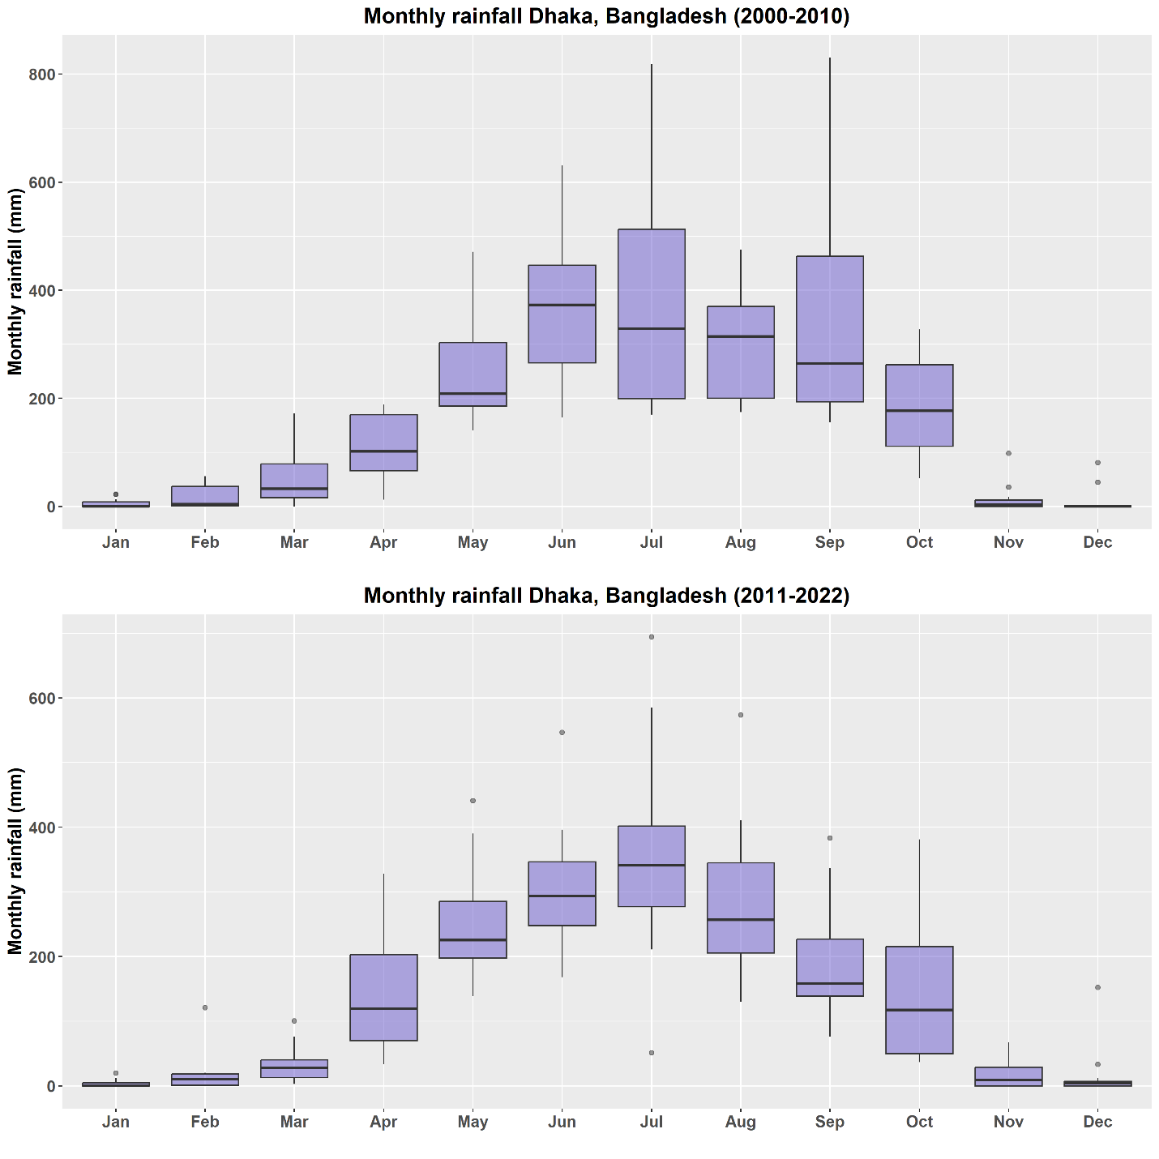

**Fig 3:**

**Fig 4:**

