Table 1. Summary statistics

|  |  |  |  |  |  |  |  |
| --- | --- | --- | --- | --- | --- | --- | --- |
|  | Cases | | |  | Deaths | | |
|  | Minimum | Mean (SD) | Maximum | Total | Minimum | Mean (SD) | Maximum |
| 2000 | 0 | 462.58 (684.63) | 2290 | 5551 |  |  |  |
| 2001 | 0 | 202.5 (255.76) | 655 | 2430 |  |  |  |
| 2002 | 0 | 519.33 (1004.11) | 3281 | 6232 |  |  |  |
| 2003 | 0 | 40.5 (108.19) | 372 | 486 |  |  |  |
| 2004 | 0 | 327.83 (460.57) | 1261 | 3934 |  |  |  |
| 2005 | 0 | 87.33 (132.56) | 337 | 1048 |  |  |  |
| 2006 | 0 | 183.33 (314.48) | 972 | 2200 |  |  |  |
| 2007 | 0 | 38.83 (66.92) | 179 | 466 |  |  |  |
| 2008 | 0 | 96.08 (161.2) | 475 | 1153 |  |  |  |
| 2009 | 0 | 39.5 (71.66) | 188 | 474 |  |  |  |
| 2010 | 0 | 34.08 (66.38) | 183 | 409 |  |  |  |
| 2011 | 0 | 113.25 (200.89) | 691 | 1359 |  |  |  |
| 2012 | 0 | 55.92 (81.71) | 262 | 671 |  |  |  |
| 2013 | 0 | 145.75 (177.14) | 495 | 1749 |  |  |  |
| 2014 | 0 | 31.25 (33.27) | 82 | 375 |  |  |  |
| 2015 | 0 | 263.5 (375.09) | 965 | 3162 |  |  |  |
| 2016 | 3 | 505 (588.63) | 1544 | 6060 |  |  |  |
| 2017 | 36 | 230.75 (165.27) | 512 | 2769 |  |  |  |
| 2018 | 7 | 845.67 (1064.1) | 3087 | 10148 |  |  |  |
| 2019 | 17 | 8446.17 (15226.54) | 52636 | 101354 |  |  |  |
| 2020 | 10 | 117.08 (155.13) | 546 | 1405 |  |  |  |
| 2021 | 3 | 2369.08 (3054.99) | 7841 | 28429 |  |  |  |
| 2022 | 20 | 1788 (3257.83) | 9911 | 16092 |  |  |  |
| Overall | 0 | 725.11 (3642.55) | 52636 | 197956 |  |  |  |

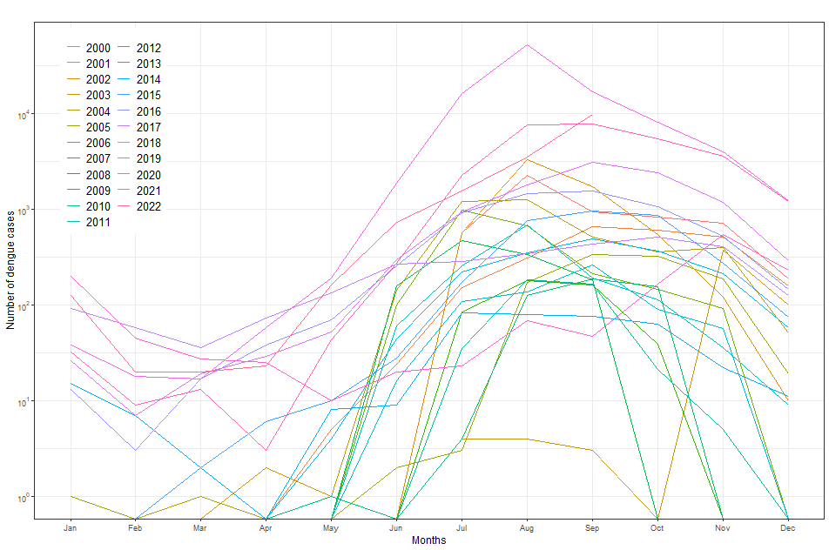

Fig. 1. Number of dengue cases reported through national dengue fever surveillance in Bangladesh, 2000–2022.

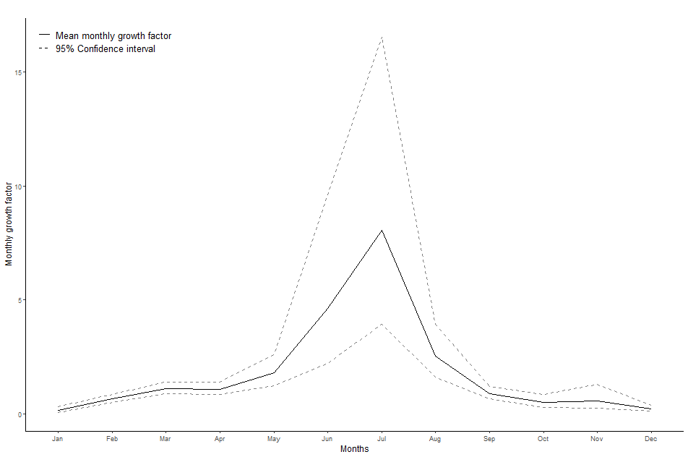

Fig. 2. The monthly growth factor (GF) of dengue cases in Bangladesh (2000–2022).

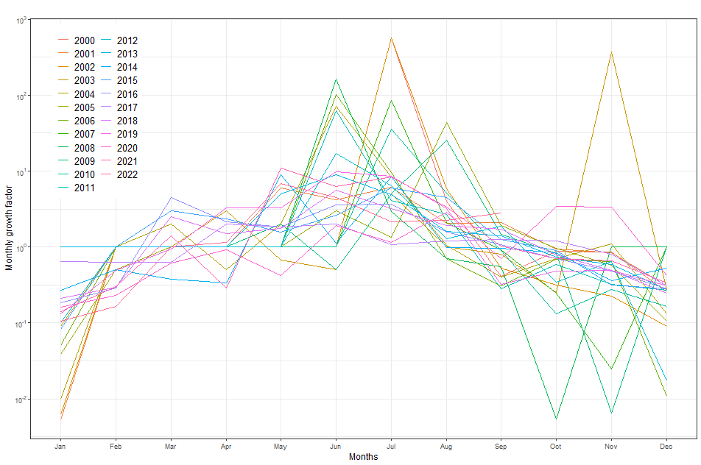

Fig. 3. The monthly growth factor (GF) of dengue cases in Bangladesh (2008–2019).

|  |
| --- |
|  |
|  |
|  |

Fig. 4. Top: Observed and predicted dengue cases using a simple exponential smoothing (SES) model. Middle: Observed and predicted dengue cases using an auto-regressive integrated moving average (ARIMA) model. Bottom: Observed and predicted dengue cases using an automatic forecasting time-series model (Prophet). Black dots = observed data; the blue line = predictive CFR; the shaded area = 95%confidence interval of predicted dengue cases.

**Table 1.** The summary of Simple Exponential Smoothing (SES), Auto-Regressive Integrated Moving Average (ARIMA), Automatic forecasting time-series model (Prophet), Mann-Kendall (M-K) trend and Sen’s slope analysis. The SES, ARIMA and Prophet models used dengue cases data. The Kendall’s Tau value permits a comparison of the strength of correlation between two data series 28.

|  |  |  |  |
| --- | --- | --- | --- |
| **Method & Period** | **R2** | **RMSE** | **MAE** |
| ***Simple Exponential Smoothing*** | | | |
| Overall | 17.88% | 3294.91 | 674.91 |
|  |  |  |  |
| ***Auto-Regressive Integrated Moving Average*** | | | |
| Overall ARIMA (1,1,2) | 33.74% | 2959.59 | 579.30 |
|  |  |  |  |
| ***Automatic Forecasting time-series model*** | | | |
| Overall | 9.31% | 3462.52 | 1439.25 |
| ***Mann-Kendell trend analysis*** | | | |
|  | **tau** | **P** | |
|  | 0.26 | <0.001 | |
| *Sen’s slop test* | | | |
|  | Sen’s Slope | 95% CI | |
|  | 0.15 | 0.08 to 0.29 | |

*RMSE: Root Mean Square Error; MAE: Mean Absolute Error*