Proposed Title: Burden of water, sanitation and hygiene related diseases in India: prevalence, health care cost and effect of community level factors (https://www.sciencedirect.com/science/article/pii/S2213398421001950)

Number of dengue fever infections, in 2019 = DengueCase (https://ourworldindata.org/grapher/dengue-incidence)

Unsafe water, sanitation, and hygiene services deaths = UNWASHD (https://data.who.int/indicators/i/ED50112)

Investment in water and sanitation with private participation (current US$) = POPUSESAFEDW

(https://data.worldbank.org/indicator/IE.PPI.WATR.CD?locations=BD&view=chart)

Water and sanitation development assistance as part of official government spending plans = WASHDEV (https://data.who.int/indicators/i/4AF995F)

Population using safely managed drinking-water services = POPUSESAFEW (https://data.who.int/indicators/i/1548EA3)

People using at least basic sanitation services (% of population) = BASSAN (https://data.worldbank.org/indicator/SH.STA.BASS.ZS?locations=BD&view=chart)

People using safely managed sanitation services (% of population) = POPUSESAFES (https://data.worldbank.org/indicator/SH.STA.SMSS.ZS?locations=BD&view=chart)

Safely treated domestic wastewater flows (% of population) = SAFETWASH (https://data.who.int/indicators/i/A37BDD6)

People with basic handwashing facilities including soap and water (% of population) = BASHAN (https://data.worldbank.org/indicator/SH.STA.HYGN.ZS?view=chart)



Figure: Dengue and WASH situation over the world



Figure: Dengue and WASH situation of Top 10 countries

Table: Regression

|  |  |  |
| --- | --- | --- |
| Variables | Coefficients (95% CI) | P-value |
| UNWASHD | 0.14 (-0.04 to 0.32) | 0.12234 |
| POPUSESAFEDW | 0.22 (0.09 to 0.34) | 0.00107* |
| WASHDEV | 0.01 (-0.12 to 0.14) | 0.89674 |
| POPUSESAFEW | -0.18 (-0.36 to 0.00) | 0.05591 |
| BASSAN | 0.06 (-0.14 to 0.26) | 0.54027 |
| POPUSESAFES | 0.10 (-0.12 to 0.31) | 0.37250 |
| SAFETWASH | 0.09 (-0.13 to 0.31 | 0.43989 |
| BASHAN | 0.14 (0.01 to 0.28) | 0.03398 |

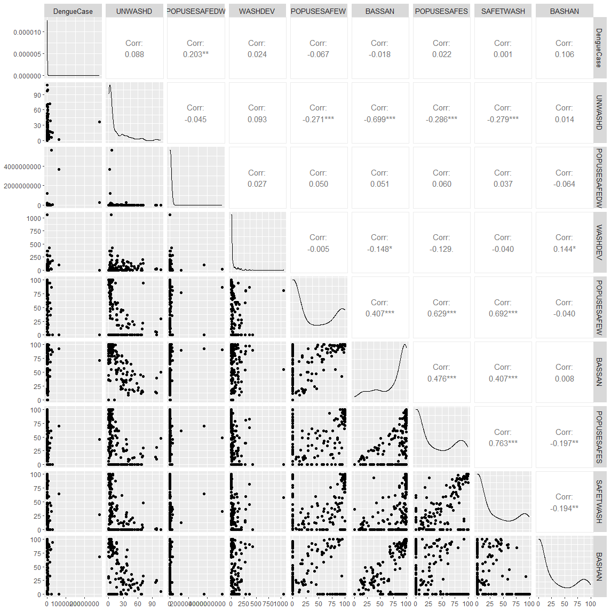

Fig: Correlation