2. Materials and Methods

2.1. Flooded Area

During monsoon, optical satellite does not get surface image due to clouds. So, it cannot delineate or identify the flooded area. But SAR (Synthetic Aperture Radar) satellite emits its own waves, which can penetrate clouds and interacts with the earth’s surface. Those waves come back to the satellite from the surface. So, SAR satellites, especially Sentinel-1 proved effective to calculate the area of waterbody as well as flood extent. VV (i.e., Vertical-polarized wave transmitted returns as Vertical-polarized signal) polarization is used to identify waterbody (McCormack et al., 2022; Schmitt, 2020; Zhang et al., 2020). In this study, the flooded area is our dependent variable.

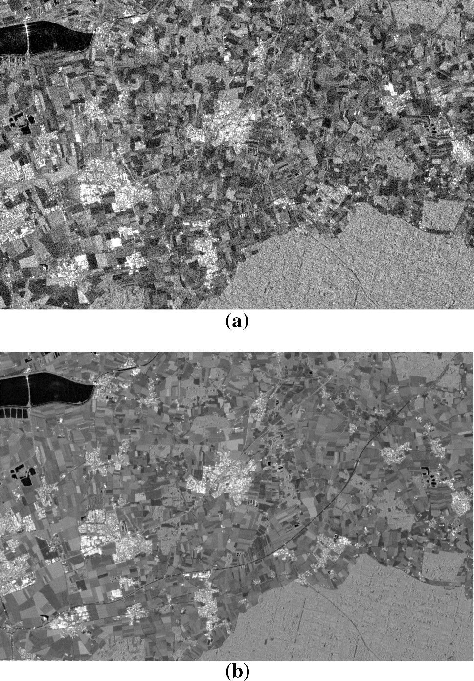

**Fig: Sentinel 1 SAR Image (Schmitt, 2020)**

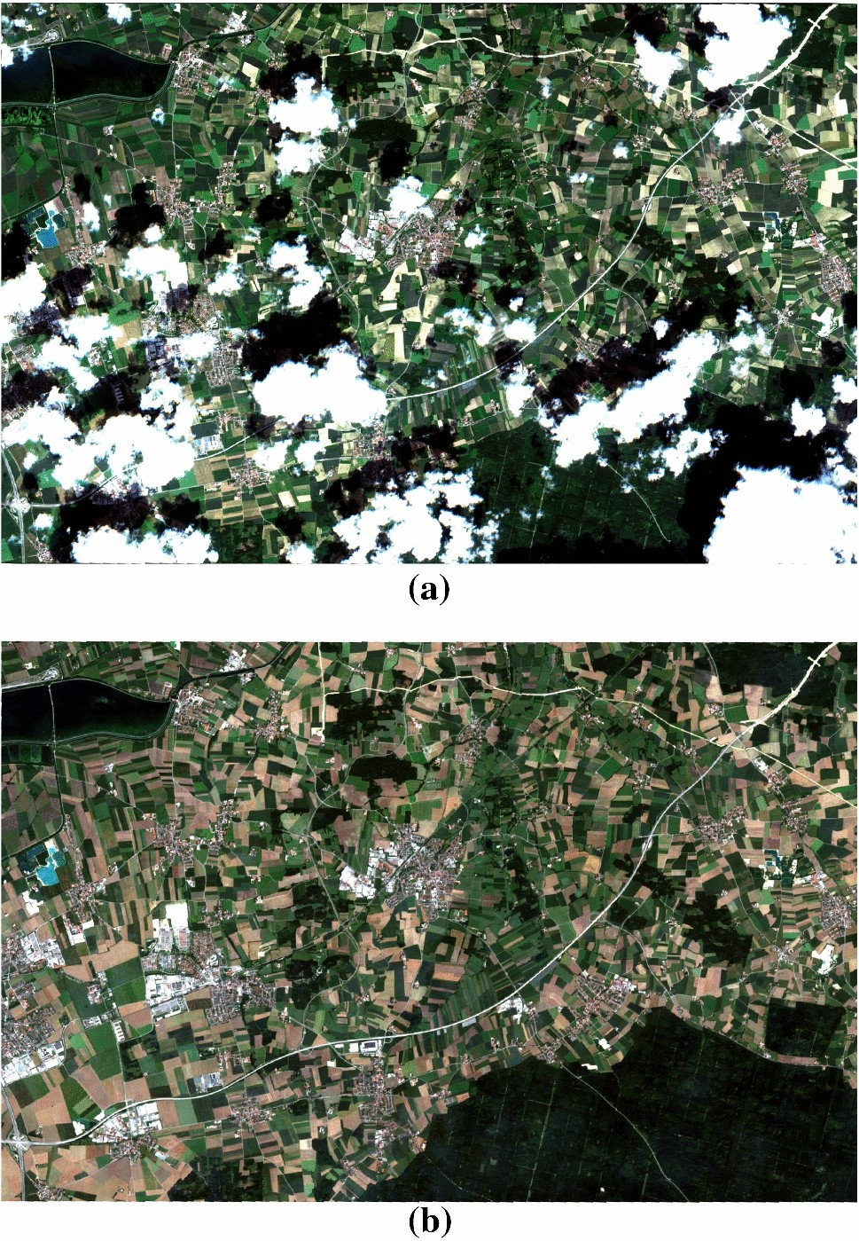

**Fig: Sentinel 2 Optical Image (Schmitt, 2020)**

2.2. Meteorological Factors

We used NASA’s Prediction of Worldwide Energy Resources webpage (NASA, 2022) on a daily interval to collate meteorological variables including wind velocity (m/s) at 10 m height (maximum wind speed), Temperatures (°C), Relative humidity [RH, (%)], Rainfall (mm), UV index, Surface pressure (kPa), Dew point (°C), and Wind direction available from https://power.larc.nasa.gov/data-access-viewer (Supplementary data SD2).

2.3. Time Series Models

The sampled variables were used to choose by time series models namely Seasonal Auto-Regressive Integrated Moving Average (SARIMA) model. The SARIMA model was employed to examine the trend in flooded areas. We forecasted the flooded area for the upcoming year.

ARIMA is one of the most widely applied time series analysis techniques which captures seasonal, trend, and other cyclic patterns in the data to forecast the future values of the series. Model identification, parameter estimation, and model diagnostic checking are the three stages in ARIMA modeling. After seasonality and stationarity have been identified, The SARIMA model should be applied and it takes both overall trends and seasonal changes into account, which is widely used in modeling time series [13–15]. We established and selected the best SARIMA model (p, d, q) × (P, D, Q) according to the steps introduced by Box and Jenkins [Ziegler, T.; Mamahit, A.; Cox, N.J. 65 years of influenza surveillance by a World Health Organization-coordinated global network. Influenza Other Resp. Viruses 2018, 12, 558–565.] (Figure 1). Autoregressive lags, moving average lags, seasonal autoregressive lags, and seasonal moving average lags are indicated by p, q, P, and Q, respectively.

Regression model

A regression model was developed to quantify the relationship between flood areas and meteorological variables. The flood areas were treated as the dependent variable, while the meteorological variables were considered independent variables. The model was constructed using a linear regression technique based on the nature of the dependent variable.

2.3.5. Empirical evaluation

The prediction of the flooded area was evaluated using four SARIMA models which were to ensure robust prediction by coefficient of determination (R2), root mean square error (RMSE), and mean absolute error (MAE).

2.3.6. Statistical analysis

Spearman rank correlation coefficients were used to study meteorological variables and flooded area. The evolution of flooded area was examined using a time series model. We used the regression models to determine whether there is a link between flooded area with meteorological variables using R software. The flooded area is the dependent variable whereas meteorological variables are the independent variables in both models. The association is validated using the coefficient, 95% confidence interval (CI), and the corresponding P-value.

Descriptive

|  |  |  |  |  |  |  |
| --- | --- | --- | --- | --- | --- | --- |
|  | Sylhet | | | Sunamganj | | |
| Variables | Mean ± SD | Minimum | Maximum | Mean ± SD | Minimum | Maximum |
| Flooded area | 7348662 ± 3918292 | 1017401 | 20222012 | 12025545  ± 6859884 | 751928.6 | 28653583 |
| Temperature (°C) | 24.28 ± 4.2 | 13.17 | 31.42 | 24.58 ± 4.16 | 12.75 | 31.47 |
| Dew/frost point temperature (°C) | 19.99 ± 5.76 | 3.28 | 28.11 | 20 ± 6 | 3.26 | 28.1 |
| Relative humidity (%) | 78.64 ± 11.78 | 29.25 | 95.62 | 77.59 ± 13.22 | 29.75 | 95.94 |
| Precipitation (mm/day) | 13.68 ± 23.91 | 0 | 175.17 | 13.31 ± 23.14 | 0 | 170.37 |
| Surface pressure (kPa) | 99.68 ± 0.52 | 97.94 | 100.72 | 100.01 ± 0.52 | 98.31 | 101.09 |
| Wind speed (m/s) | 1.44 ± 0.49 | 0.63 | 4.62 | 1.4 ± 0.54 | 0.59 | 5.37 |
| UV Index | 1.44 ± 0.51 | 0.18 | 2.87 | 1.34 ± 0.48 | 0.16 | 2.74 |
| Wind direction | 166.66 ± 44.25 | 37.81 | 297.88 | 164.8 ± 44.76 | 49.12 | 318.25 |

According to meteorological factors in Table 1, for Sylhet district, the mean of the flooded area is 7348662, with a standard deviation (SD) of 3918292, a minimum of 1017401, and a maximum of 20222012 (Table 1). The mean temperature is 24.28, with a standard deviation (SD) of 4.2, a minimum of 13.17, and a maximum of 28.11. In addition, the mean of the dew point, RH, precipitation, surface pressure, wind speed, UV index, and wind direction is 19.99, 78.64, 13.68, 99.68, 1.44, 1.44, and 166.66, respectively. For Sunamganj district, the mean of the flooded area is 12025545, with a standard deviation (SD) of 6859884, a minimum of 751928.6, and a maximum of 28653583 (Table 1). The mean temperature is 24.58, with a standard deviation (SD) of 4.16, a minimum of 12.75, and a maximum of 31.47. In addition, the mean of the dew point, RH, precipitation, surface pressure, wind speed, UV index, and wind direction is 20, 77.59, 13.31, 100.01, 1.4, 1.34, and 164.8, respectively.

Correlation plot

|  |
| --- |
|  |
| Sylhet |

In Sylhet district, the Spearman rank correlation coefficients among meteorological variables and flooded areas suggest a significant but weak correlation (Figure 1). The flooded area and wind speed exhibit a significant positive correlation (r = 0.262, p<0.05). However, temperature, dew point, relative humidity, rainfall, UV Index, and wind direction has a positive significant association with the flooded area. Surface pressure exhibits a negative significant correlation with flooded areas (r = -0.441, p<0.05).

|  |
| --- |
|  |
| Sunamganj |

Similarly, in the Sunamganj district, the Spearman rank correlation coefficients among meteorological variables and flooded areas suggest a significant but weak correlation (Figure 1). The flooded area and wind speed exhibit a significant positive correlation (r = 0.178, p<0.05). However, temperature, dew point, relative humidity, rainfall, UV Index, and wind direction has a positive significant association with the flooded area. Surface pressure exhibits a negative significant correlation with daily dengue cases (r = -0.373, p<0.05).

Time series plot of confirmed cases for different methods

|  |
| --- |
|  |
|  |
|  |
| Sunamganj |

We observed a constant trend between observed and predictive flooded areas in the Sylhet district. We found the SARIMA model with R2, RMSE, and MAE of 92.57%, 1067512, and 346711.3. Flooded areas in the Sunamganj district showed R2, RMSE, and MAE of 74.70%, 3449754, and 2213229 in the SARIMA model. In the M–K trend analysis, we identified an increasing trend (P<0.001 and tau = 0.126). Using Sen’s slope test, we find that the slope is 915.861 (95% CI: 686.139- 1160.071) (Table 2).

|  |  |  |  |  |  |  |  |
| --- | --- | --- | --- | --- | --- | --- | --- |
|  | Sylhet | | | | Sylhet | | |
| Method & Period | *R2* | RMSE | | MAE | *R2* | RMSE | MAE |
| *Seasonal Auto-Regressive Integrated Moving Average* | | | |  |  |  |  |
| SARIMA | 92.57% | 1067512 | | 346711.3 | 74.70% | 3449754 | 2213229 |
| *Mann-Kendell trend analysis* | | | |  |  |  |  |
|  | Tau | | p-value |  | Tau | p-value |  |
|  | 0.126 | | <0.001 |  | 0.0278 | 0.068131 |  |
| *Sen’s slop test* | | | |  |  |  |  |
|  | Sen’s Slope | | 95% CI |  | Sen’s Slope | 95% CI |  |
|  | 915.861 | | 686.139 to 1160.0713 |  | 480.2868 | -13.17793  to 1006.18104 |  |

*RMSE: Root Mean Square Error; MAE: Mean Absolute Error*

In the regression model, wind speed (0.094 [95% CI: 0.044 to 0.144]), relative humidity 0.055 [0.005 to 0.106]), rainfall 0.036 [-0.023 to 0.095]), UV index 0.044 [-0.0173 to 0.106]), and Wind Direction 0.137 [0.095 to 0.1785]), have a significant positive association with the flooded area. This relation is also true for Sunamganj district. However, temperature and surface pressure were found to be negative relation with flooded areas in both districts.

Factors associated with flooded area in Bangladesh using the ARIMAX model

|  |  |  |  |  |  |  |
| --- | --- | --- | --- | --- | --- | --- |
| Variables | Sylhet | | | Sunamganj | | |
|  | Coef. | 95%CI | P-value | Coef. | 95%CI | P-value |
| Wind Speed | 0.094 | 0.044 to 0.144 | <0.001 *** | 0.006 | -0.060 to 0.048 | 0.824 |
| Temperature | -0.231 | -0.310 to -0.152 | <0.001 *** | -0.135 | -0.211 to -0.059 | 0.001 *** |
| Relative humidity | 0.055 | 0.005 to 0.106 | 0.030 * | 0.459 | 0.409 to 0.509 | <0.001 *** |
| Rainfall | 0.036 | -0.023 to 0.095 | 0.231 | 0.115 | 0.055 to 0.175 | 0.001 *** |
| UV Index | 0.044 | -0.0173 to 0.106 | 0.158 | 0.038 | -0.097 to 0.062 | 0.212 |
| Surface pressure | -0.479 | -0.560 to -0.398 | <0.001 *** | -0.079 | -0.160 to -0.002 | 0.056 |
| Wind Direction | 0.137 | 0.095 to 0.1785 | <0.001 *** | 0.088 | 0.049 to 0.127 | 0.001 *** |
|  | Adjusted R-squared: 0.2384 | | | Adjusted R-squared: 0.2659 | | |

McCormack, T., Campanyà, J., & Naughton, O. (2022). A methodology for mapping annual flood extent using multi-temporal Sentinel-1 imagery. *Remote Sensing of Environment*, *282*, 113273.

Schmitt, M. (2020). Potential of large-scale inland water body mapping from sentinel-1/2 data on the example of bavaria’s lakes and rivers. *PFG–Journal of Photogrammetry, Remote Sensing and Geoinformation Science*, *88*(3-4), 271-289.

Zhang, M., Chen, F., Liang, D., Tian, B., & Yang, A. (2020). Use of Sentinel-1 GRD SAR images to delineate flood extent in Pakistan. *Sustainability*, *12*(14), 5784.