Table: Descriptive statistics of various factors for confirmed rabies cases

|  |  |  |  |  |
| --- | --- | --- | --- | --- |
|  | Mean | SD | Min | Max |
| Others Animal Bites | 2074.45 | 2631.87 | 0 | 15507 |
| Dog Bites | 1885.58 | 2354.25 | 0 | 14484 |
| Total Bites | 3983.95 | 4465.61 | 0 | 23812 |
| Male | 2042.38 | 2337.98 | 0 | 12456 |
| Female | 1862.73 | 2230.94 | 0 | 12164 |
| Under 15 years | 1668.13 | 2006.94 | 0 | 13067 |
| Category 2 | 2934.16 | 3605.29 | 0 | 20054 |
| Category 3 | 671.61 | 1890.14 | 0 | 13606 |
| ARV | 4064.33 | 5168.74 | 0 | 23812 |
| RIG | 234.11 | 327.96 | 0 | 1773 |

The descriptive statistics for dog bites, other animal bites, total bites, male, female, under-15 years old, category 2, category 3, ARV, and RIG of confirmed rabies cases are shown in Table 2. Accordingly, in our study, the mean number of bites from other animals was found to be 2074.45, with a standard deviation of 2631.87. The smallest number of bites from other animals was determined to be 0 and the maximum number to be 15507.

Additionally, we observed that the range of dog bites detected was 0 to 14484, with a mean of 1885.58 and a standard deviation of 2354.25. The range of identified bites was between 0 and 23812, with a mean of 3983.95 and a standard deviation of 4465.61.

The range discovered was from 0 to 23812, and the mean ARV was 4064.33 with a standard deviation of 5168.74. The RIG ranged from 0 to 1773, with a mean of 234.11 and a standard deviation of 327.96.

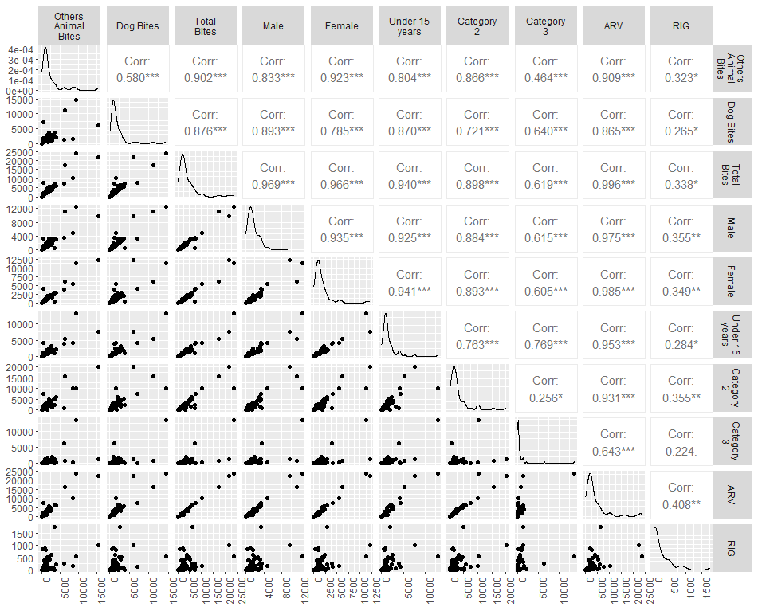

Fig: Spearman rank correlation coefficients between various factors for confirmed rabies cases

The Spearman rank correlation coefficients between key rabies patient characteristics and ARV variables point to a statistically significant association between these two variables (Figure 1). Dog bites (r = 0.865, p<0.05), other animal bites (r = 0.909, p<0.05), and total bites (r = 0.996, p<0.05) all show a strong positive correlation with the ARV. ARV is also strongly correlated with both male (r = 0.975, p<0.05) and female patients (r = 0.985, p<0.05) in patients.

[You can also add some correlation from the graph if you feel too important to mention in the same way]

Table: Association with age category and various factors of rabies patients in Bangladesh.

|  |  |  |  |
| --- | --- | --- | --- |
|  | Age Category | | P-value |
|  | ≤15 | >15 |  |
| Vaccination (n=) |  |  |  |
| Absent | 21 (13.04) | 14 (8.70) | 0.004* |
| Present | 0 (0.00) | 5 (3.11) |  |
| Sex (n=) |  |  |  |
| Female | 30 (18.63) | 10 (6.21) | 0.180 |
| Male | 75 (46.58) | 46 (28.57) |  |
| Residence |  |  |  |
| Rural | 29 (18.01) | 13 (8.07) | 0.881 |
| Urban | 6 (3.73) | 3 (1.86) |  |
|  |  |  |  |

13.04% of rabies patients in Bangladesh under the age of 15 who were reported had not received the vaccine prior to being harmed. Only 3.11% of people with rabies older than 15 years old had the vaccine before being harmed. The majority of patients (46.58%) are male and under the age of 15 years old. Additionally, the majority of patients are men (28.57%) among those older than 15 years old. The majority of patients (18.01%) are under the age of 15 and come from rural areas.