Youtube Video: https://www.youtube.com/watch?v=OZGdKYzUYvU&list=PLjC4UKOOcfDQtElvsn1ZCAHatLtqDrTgQ

API

.net 7

1. Create Model

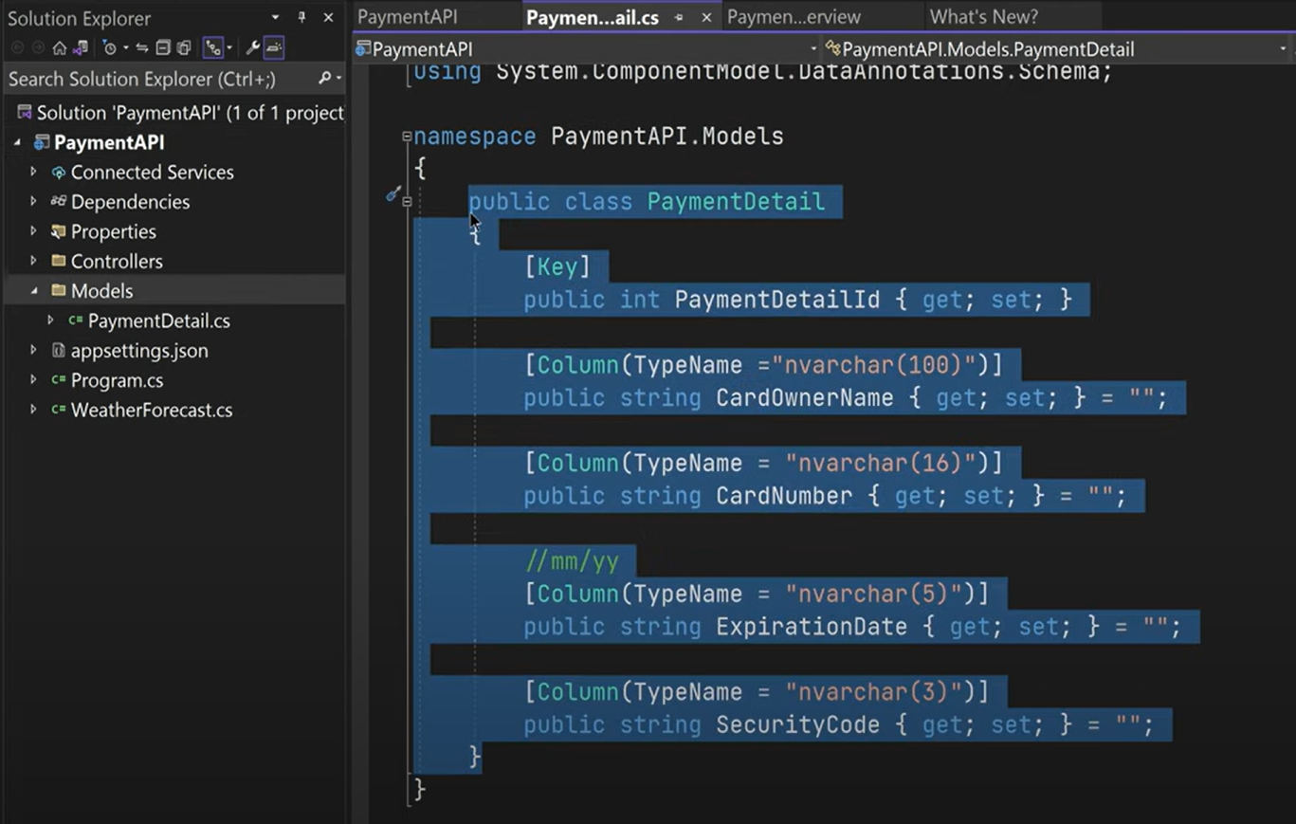

1. DB Context

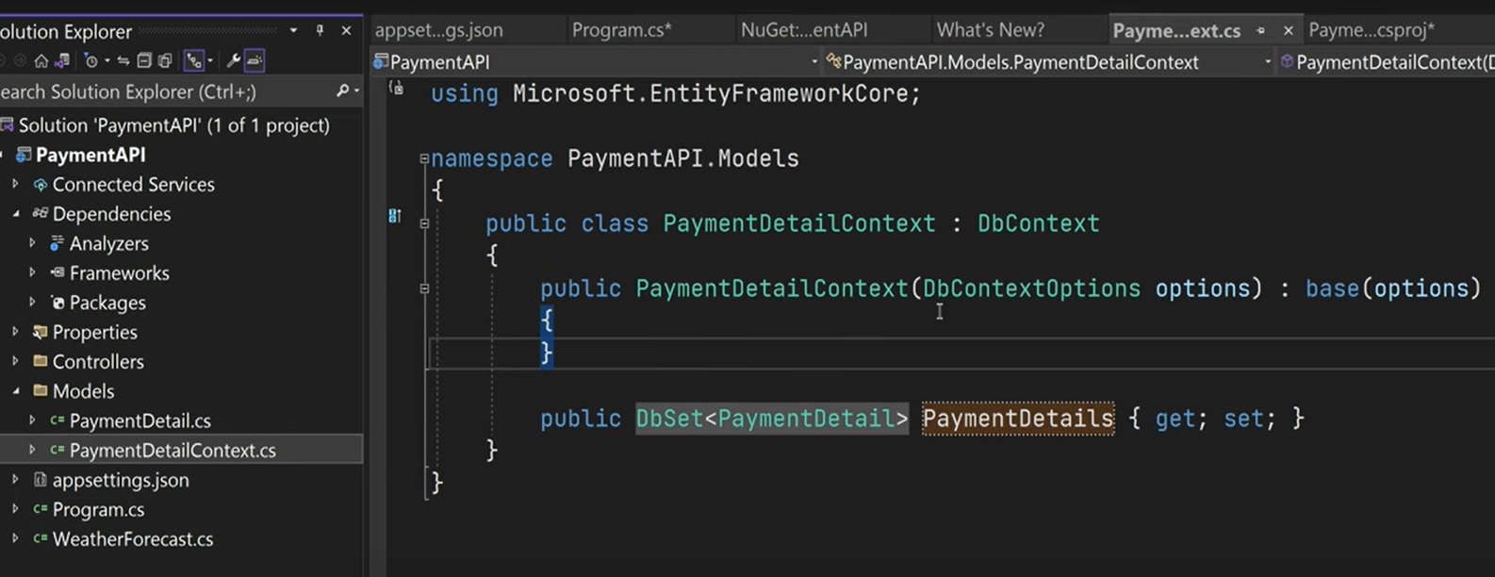

1. Build
2. Add-Migration

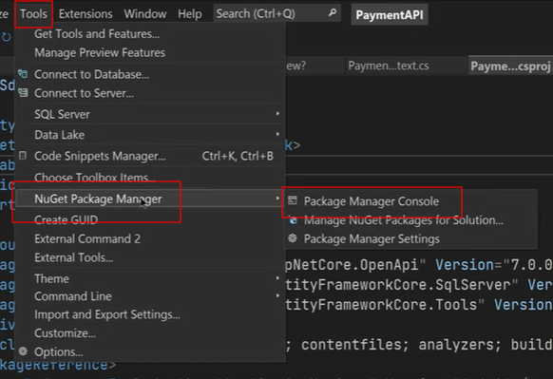

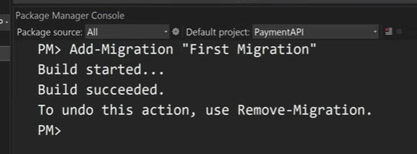

1. Update-Database

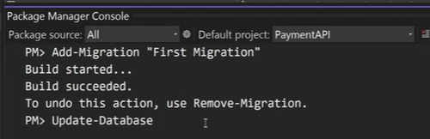

1. Controller: Solution Explorer>>Add>>Controller>> add below Controller 