Supplementary Information

Measuring the effect of aerobic exercise training on novel lipid biomarkers: A systematic review and multivariate meta-analysis of randomised controlled trials.

Title:

Estimating the effect of aerobic exercise training on novel lipid biomarkers: a systematic review and multivariate meta-analysis of randomized controlled trials.

Running heading:

Aerobic exercise training and novel lipid biomarkers: A systematic review and multivariate meta-analysis.

Gina Wood1 2*, Emily Taylor1, Vanessa Ng1, Anna Murrell3, Aditya Patil1, Tom van der Touw1, Mitch Wolden⁴, Nick Andronicos¹, Neil A Smart1

* Corresponding author at:
1 School of Science and Technology in the Faculty of Science, Agriculture, Business and Law, University of New England, Armidale, NSW, Australia 2351.
Email: gnadinew@une.edu.au
ORCID: 0000-0002-5096-4989
Emily Taylor ORCID: 0000-0001-8450-1125
Vanessa Ng ORCID: 0000-0001-7285-3916
Aditya Patil ORCID: 0000-0001-8215-5759
Tom van der Touw ORCID: 0000-0003-3507-1178
Nick Andronicos ORCID: 0000-0001-5881-2296
Neil A Smart ORCID: 0000-0002-8290-6409
² School of Allied Health, Curtin University, Bentley, WA, Australia 6102
³ School of Rural Medicine in the Faculty of Medicine and Health, University of New England, Armidale, NSW, Australia 2351.
Anna Murrell ORCID: 0000-0002-3841-2305
⁴ Physical Therapy Program, University of Jamestown, Fargo, ND, USA 58104
Mitch Wolden ORCID: 0000-0002-9390-1590
.

Table S1 Search Strategy example

MeSH and free text terms such as aerobic exercise training, physical activity, endurance exercise, lipids, lipoproteins, apolipoproteins, triglycerides, and cholesterol were used. Searches excluded studies of pregnant or lactating females; elite athletes; juveniles; current or previous incidence of cardiovascular disease, stroke, cancer, non-alcoholic fatty liver disease populations; chronic disease; and dietary and pharmaceutical interventions.

Web of Science example search | TOPIC:(random* control* trial*) AND  TOPIC:(*cholesterol* OR *lipoprotein* OR triglycer* OR lipid*) AND  TOPIC:(exercise OR physical activity OR aerobic training OR moderate intensity OR high intensity OR HIIT OR MICT OR endurance)  NOT TOPIC: (heart failure OR belief* OR *statin* OR diet* OR HIV OR cardiac rehabilitation OR NAFLD OR *Alzheimer* OR *stroke OR cancer OR athlete OR child* OR pregnan* or lactat* or adolescent OR juvenile OR bariatric OR renal failure OR polycystic OR depression)  NOT TOPIC:(systematic review* OR meta-analys*)  Timespan: All years. Databases: WOS, CABI, CCC, KJD, MEDLINE, RSCI, SCIELO.  Search language=Auto

Table S2 Intervention inclusion and exclusion criteria

Exclusion criteria | Studies using either an isometric, unconventional, resistance- or combined-training intervention, without separate AET interventions as comparators against a non-exercising control group, were excluded.  Studies using lifestyle, dietary or pharmaceutical interventions, without separate AET interventions as comparators against a non-exercising control group, were excluded.  Studies comparing multiple AET protocols without a non-exercising control group as comparator were excluded.  Studies which did not provide details of the AET protocol, such as session duration, intensity, number of sessions in the intervention, or other details which allowed estimation of volume of exercise if not reported, were excluded.
AET: aerobic exercise training

Table S3 TESTEX Assessment of Study Quality

One point is awarded per criterion, for a total maximum of 15 points.
Author Year | Eligibility criteria specified | Random-isation specified | Allocation concealment | Groups similar at baseline | Blinding of assessor | Outcomes measures assessed in 85% patients | Adverse events reported | Exercise adherence reported | Intention-to-treat analysis | Between-group statistical comparisons reported for primary outcome | Between-group statistical comparisons reported for secondary outcome | Point measures and measures of variability for all outcome measures | Activity monitoring in control groups | Relative exercise intensity remained constant | Exercise volume and energy expenditure given | Overall TESTEX  (/15)
Author Name, Year | 0 | 1 |  |  |  |  |  |  |  |  |  |  |  |  |  | =

Table S4 Assessed Within-Study Risk of Bias Factors

Author Year | Study non-randomised  or randomised | Minimum compliance level set | Habitual medication use reported | Dropout reason reported | Baseline fitness and effort determined | > 50% sessions supervised | Effort monitoring and measurement device | Risk of bias assesment  low, medium, or high
Author, Year
Either of low or high awarded as follows:
- Study non-randomised or randomised – low if randomised, high if non-randomised;¹
- For intervention groups, a minimum level of compliance to be counted as having participated in the intervention group or control group – low if a minimum level of compliance was set or reported, high if there was no minimum compliance level;
- Habitual medication use reported – low if reported, high if not reported;
- Drop-out reasons given – low if reported, high if not reported;
- Baseline fitness and effort determined – low if baseline fitness and effort was measured, high if not determined;
- > 50% of sessions supervised – low if > 50% of sessions were supervised, high if not; and
- Effort monitoring and measurement devices – low if digital recording devices were used, high if analog or no device.

Studies were scored overall low, medium, or high risk of bias according to the number of times either “low” or “high” was accorded. A low risk of bias was awarded for 0-2 instances of “high”, a medium risk of bias was awarded for 3-4 instances of “high”, and a high risk of bias was awarded for 5-7 instances of “high”. All factors were equally weighted.
¹ All studies were randomised

Sensitivity Analyses (K-1 sub-analysis)

Fig. S1 Random multivariate meta-analysis of joined outcomes Apo A1 + Apo A2 + HDL2 + HDL3 mmol/L with one study removed per line

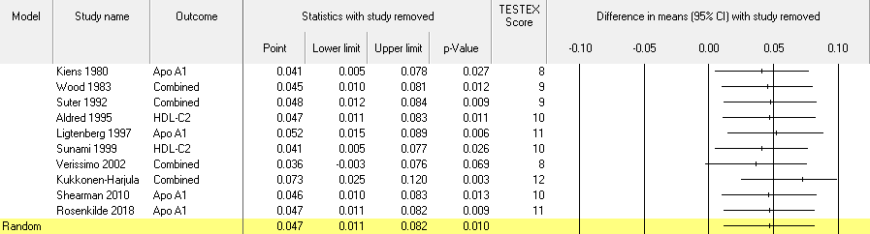
Random: random effects model; TESTEX: study quality score (numeric); CI: confidence interval; Apo: apolipoprotein; HDL-C: high-density lipoprotein cholesterol; Combined: joined outcomes.

Fig. S2 Random multivariate meta-analysis of joined outcomes Apo A1 + Apo A2 mg/dL with one study removed per line

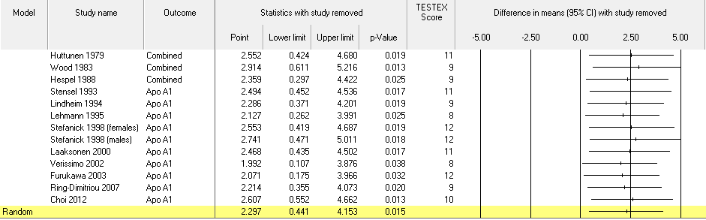
Random: random effects; TESTEX: study quality score (numeric); CI: confidence interval; Apo: apolipoprotein; Combined: joined outcomes.

Fig. S3 Random multivariate meta-analysis of joined outcomes TC/HDL-C + LDL-C/HDL-C + Apo B100/Apo A1 with one study removed per line

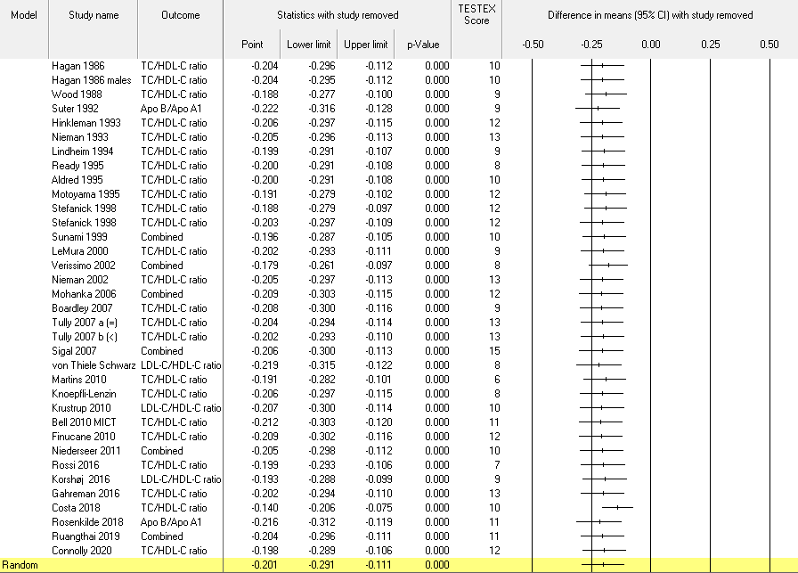
Random: random effects; TESTEX: study quality score (numeric); CI: confidence interval; Apo: apolipoprotein; TC: total cholesterol; HDL-C: high-density lipoprotein cholesterol; LDL-C: low-density lipoprotein cholesterol; Combined: joined outcomes; (=): exercise protocol equivalent to recommended exercise levels; (<): exercise protocol less than recommended exercise levels

Table S5 TESTEX Assessment of Study Quality

Author Year | Eligibility criteria specified | Random-isation specified | Allocation conceal-ment | Groups similar at baseline | Blinding of assessor | Outcomes measures assessed in 85% patients | Adverse events reported | Exercise adherence reported | Intention-to-treat analysis | Between-group statistical comparisons reported for primary outcome | Between-group statistical comparisons reported for secondary outcome | Point measures and measures of variability for all outcome measures | Activity monitoring in control groups | Relative exercise intensity remained constant | Exercise volume and energy expenditure given | Overall TESTEX  (/15)
Aldred 1995 | 1 | 0 | 0 | 1 | 1 | 1 | 0 | 1 | 0 | 1 | 1 | 1 | 0 | 1 | 1 | 10
Baker 1986 | 1 | 0 | 0 | 1 | 1 | 1 | 0 | 1 | 0 | 1 | 1 | 1 | 0 | 1 | 0 | 9
Bell 2010 | 1 | 0 | 1 | 1 | 1 | 0 | 0 | 1 | 0 | 1 | 1 | 1 | 1 | 1 | 1 | 11
Boardley 2007 | 1 | 0 | 0 | 1 | 1 | 1 | 0 | 1 | 0 | 1 | 1 | 1 | 0 | 1 | 0 | 9
Choi 2012 | 1 | 1 | 0 | 1 | 1 | 1 | 0 | 0 | 0 | 1 | 0 | 1 | 1 | 1 | 1 | 10
Connolly 2020 | 1 | 1 | 1 | 1 | 1 | 0 | 1 | 1 | 0 | 1 | 1 | 1 | 0 | 1 | 1 | 12
Costa 2018 | 1 | 1 | 1 | 1 | 1 | 0 | 0 | 1 | 1 | 1 | 1 | 1 | 0 | 0 | 0 | 10
Finucane 2010 | 1 | 1 | 0 | 1 | 1 | 1 | 1 | 1 | 0 | 1 | 1 | 1 | 0 | 1 | 1 | 12
Furukawa 2010 | 1 | 1 | 1 | 0 | 1 | 1 | 0 | 1 | 1 | 1 | 1 | 1 | 1 | 0 | 1 | 12
Gahreman 2016 | 1 | 1 | 1 | 1 | 1 | 1 | 1 | 1 | 0 | 1 | 1 | 1 | 0 | 1 | 1 | 13
Gordon 2008 | 1 | 0 | 0 | 1 | 1 | 1 | 0 | 1 | 0 | 1 | 1 | 1 | 0 | 1 | 1 | 10
Grandjean 1996 | 1 | 0 | 1 | 1 | 1 | 1 | 0 | 0 | 1 | 1 | 1 | 1 | 0 | 1 | 1 | 11
Hagan 1986 | 1 | 0 | 0 | 1 | 1 | 1 | 0 | 1 | 0 | 1 | 1 | 1 | 0 | 1 | 1 | 10
Hespel 1988 | 1 | 0 | 0 | 1 | 1 | 1 | 0 | 1 | 1 | 1 | 1 | 1 | 0 | 0 | 0 | 9
Hinkleman 1993 | 1 | 1 | 1 | 0 | 1 | 1 | 1 | 0 | 0 | 1 | 1 | 1 | 1 | 1 | 1 | 12
Huttunen 1979 | 1 | 0 | 1 | 1 | 1 | 1 | 0 | 1 | 0 | 1 | 1 | 1 | 0 | 1 | 1 | 11
Kiens 1980 | 1 | 1 | 0 | 0 | 1 | 0 | 0 | 1 | 0 | 1 | 1 | 1 | 0 | 0 | 1 | 8
Knoepfli-Lenzin 2010 | 1 | 0 | 0 | 0 | 1 | 0 | 1 | 1 | 0 | 1 | 1 | 1 | 0 | 0 | 1 | 8
Korshøj 2016 | 1 | 1 | 0 | 1 | 1 | 0 | 0 | 0 | 1 | 1 | 1 | 1 | 0 | 0 | 1 | 9
Krustrup 2010 | 1 | 0 | 0 | 1 | 1 | 0 | 1 | 1 | 0 | 1 | 1 | 1 | 0 | 1 | 1 | 10
Kukkonen-Harjula 1998 | 1 | 1 | 0 | 1 | 1 | 1 | 1 | 1 | 1 | 1 | 1 | 0 | 0 | 1 | 1 | 12
Laaksonen 2000 | 1 | 1 | 1 | 1 | 1 | 0 | 0 | 1 | 0 | 1 | 1 | 1 | 0 | 1 | 1 | 11
Lehmann 1995 | 1 | 0 | 0 | 1 | 1 | 1 | 0 | 0 | 0 | 0 | 1 | 1 | 0 | 1 | 1 | 8
LeMura 2000 | 0 | 1 | 0 | 0 | 1 | 1 | 0 | 0 | 0 | 1 | 1 | 1 | 1 | 1 | 1 | 9
Ligtenberg 1997 | 1 | 0 | 0 | 1 | 1 | 1 | 1 | 1 | 0 | 1 | 1 | 1 | 0 | 1 | 1 | 11
Lindheim 1994 | 1 | 0 | 0 | 0 | 1 | 1 | 0 | 0 | 1 | 0 | 1 | 1 | 1 | 1 | 1 | 9
Martins 2010 | 1 | 0 | 0 | 0 | 1 | 0 | 0 | 0 | 0 | 1 | 1 | 1 | 0 | 0 | 1 | 6
Mohanka 2006 | 1 | 1 | 0 | 1 | 1 | 1 | 0 | 1 | 1 | 1 | 1 | 1 | 1 | 0 | 1 | 12
Motoyama 1995 | 1 | 1 | 0 | 1 | 1 | 1 | 0 | 1 | 1 | 1 | 1 | 1 | 0 | 1 | 1 | 12
Niederseer 2011 | 1 | 0 | 0 | 1 | 1 | 0 | 1 | 1 | 0 | 1 | 1 | 1 | 0 | 1 | 1 | 10
Nieman 1993 | 1 | 0 | 0 | 1 | 1 | 1 | 1 | 1 | 1 | 1 | 1 | 1 | 1 | 1 | 1 | 13
Nieman 2002 | 1 | 0 | 1 | 1 | 1 | 1 | 0 | 1 | 1 | 1 | 1 | 1 | 1 | 1 | 1 | 13
Paolillo 2017 | 1 | 1 | 1 | 1 | 1 | 0 | 1 | 0 | 0 | 1 | 1 | 1 | 1 | 1 | 1 | 12
Ready 1995 | 1 | 0 | 0 | 0 | 1 | 0 | 0 | 1 | 0 | 1 | 1 | 1 | 0 | 1 | 1 | 8
Ring-Dimitriou 2007 | 1 | 0 | 0 | 1 | 1 | 0 | 1 | 1 | 0 | 1 | 1 | 1 | 0 | 1 | 0 | 9
Rosenkilde 2018 | 1 | 1 | 0 | 1 | 1 | 0 | 1 | 1 | 0 | 1 | 1 | 1 | 0 | 1 | 1 | 11
Rossi 2016 | 1 | 0 | 0 | 0 | 1 | 0 | 0 | 0 | 0 | 1 | 1 | 1 | 0 | 1 | 1 | 7
Ruangthai 2019 | 1 | 0 | 1 | 1 | 1 | 0 | 1 | 1 | 0 | 1 | 1 | 1 | 0 | 1 | 1 | 11
Shearman 2010 | 1 | 0 | 0 | 1 | 1 | 1 | 0 | 0 | 0 | 1 | 1 | 1 | 1 | 1 | 1 | 10
Sigal 2007 | 1 | 1 | 1 | 1 | 1 | 1 | 1 | 1 | 1 | 1 | 1 | 1 | 1 | 1 | 1 | 15
Slentz 2007 | 1 | 0 | 1 | 1 | 1 | 1 | 0 | 1 | 0 | 1 | 0 | 1 | 0 | 1 | 1 | 10
Stefanick 1998 | 1 | 1 | 1 | 1 | 1 | 1 | 0 | 1 | 0 | 1 | 1 | 1 | 0 | 1 | 1 | 12
Stensel 1993 | 1 | 0 | 1 | 0 | 1 | 1 | 1 | 1 | 0 | 1 | 1 | 1 | 0 | 1 | 1 | 11
Sunami 1999 | 1 | 0 | 0 | 1 | 1 | 1 | 0 | 1 | 0 | 1 | 1 | 1 | 0 | 1 | 1 | 10
Suter 1990 | 1 | 0 | 0 | 1 | 1 | 1 | 0 | 1 | 0 | 1 | 1 | 0 | 0 | 1 | 1 | 9
Suter 1992 | 1 | 0 | 0 | 1 | 1 | 1 | 0 | 1 | 0 | 1 | 1 | 0 | 0 | 1 | 1 | 9
Tully 2007 | 1 | 1 | 0 | 1 | 1 | 1 | 1 | 1 | 1 | 1 | 1 | 1 | 1 | 0 | 1 | 13
Verissimo 2002 | 1 | 0 | 0 | 1 | 1 | 1 | 1 | 0 | 0 | 1 | 0 | 0 | 0 | 1 | 1 | 8
Von Thiele Schwarz 2008 | 1 | 0 | 0 | 1 | 1 | 1 | 0 | 0 | 0 | 1 | 1 | 0 | 0 | 1 | 1 | 8
Wirth 1985 | 1 | 0 | 0 | 1 | 1 | 1 | 1 | 0 | 0 | 1 | 1 | 1 | 0 | 0 | 0 | 8
Wood 1983 | 1 | 1 | 0 | 1 | 1 | 1 | 0 | 0 | 0 | 1 | 1 | 1 | 0 | 0 | 1 | 9
Wood 1988 | 1 | 0 | 0 | 1 | 1 | 0 | 0 | 0 | 0 | 1 | 1 | 1 | 1 | 1 | 1 | 9

Table S6 Assessed Within-Study Risk of Bias Factors

Author Year | Study non-randomised  or randomised | Minimum compliance level set | Habitual medication use reported | Dropout reason reported | Baseline fitness and effort determined | > 50% sessions supervised | Effort monitoring and measurement device | Risk of bias assesment  low, medium, or high
Aldred 1995 | low | low | low | low | low | high | high | low
Baker 1986 | low | low | low | low | low | low | high | low
Bell 2010 | low | low | low | low | low | low | low | low
Boardley 2007 | low | low | low | high | high | low | high | medium
Choi 2012 | low | high | low | high | low | high | low | medium
Connolly 2020 | low | low | low | low | low | high | low | low
Costa 2018 | low | high | low | low | low | high | high | medium
Finucane 2010 | low | low | low | low | low | low | low | low
Furukawa 2003 | low | high | high | low | low | high | low | medium
Gahreman 2016 | low | high | low | low | low | low | low | low
Gordon 2008 | low | low | high | high | low | high | high | medium
Grandjean 1996 | low | low | high | high | low | high | high | medium
Hagan 1986 | low | low | high | high | low | low | high | medium
Hespel 1988 | low | low | low | low | low | low | high | low
Hinkleman 1993 | low | high | low | low | low | low | low | low
Huttunen 1979 | low | high | low | low | low | high | high | medium
Kiens 1980 | low | high | high | high | high | high | low | high
Knoepfli-Lenzin 2010 | low | low | high | low | low | low | low | low
Korshøj 2016 | low | high | high | high | low | low | low | medium
Krustrup 2010 | low | low | low | low | low | low | low | low
Kukkonen-Harjula 1998 | low | low | low | low | low | low | low | low
Laaksonen 2000 | low | high | low | low | low | low | high | low
Lehmann 1995 | low | low | low | low | low | high | high | low
LeMura 2000 | low | low | high | high | low | high | low | medium
Ligtenberg 1997 | low | low | low | low | low | high | high | low
Mohanka 2006 | low | low | low | high | low | high | low | low
Motoyama 1995 | low | high | low | low | low | low | high | low
Niederseer 2011 | low | high | low | high | low | low | low | low
Nieman 1993 | low | low | low | low | low | low | low | low
Nieman 2002 | low | low | high | low | low | low | low | low
Paolillo 2017 | low | high | high | low | low | low | low | low
Ready 1995 | low | low | high | low | low | high | high | medium
Ring-Dimitriou 2007 | low | high | high | low | low | low | high | medium
Rosenkilde 2018 | low | low | high | low | low | low | low | low
Rossi 2016 | low | low | high | low | high | high | high | medium
Ruangthai 2019 | low | low | low | low | low | low | low | low
Shearman 2010 | low | high | low | low | low | high | high | medium
Sigal 2007 | low | low | low | low | low | low | low | low
Slentz 2007 | low | low | high | high | low | low | low | low
Stefanick 1998 | low | high | high | high | low | low | high | medium
Stensel 1995 | low | high | low | low | low | high | low | low
Sunami 1999 | low | low | high | high | low | low | high | medium
Suter 1990 | low | low | high | high | low | high | low | medium
Suter 1992 | low | low | high | high | low | high | low | medium
Tully 2007 | low | high | high | low | low | high | high | medium
Verissimo 2002 | low | high | high | low | low | low | high | medium
von Thiele Schwarz 2008 | low | low | high | low | low | low | high | low
Wirth 1985 | low | high | high | low | low | low | high | medium
Wood 1983 | low | low | high | low | low | low | high | low
Wood 1988 | low | low | high | low | low | high | high | medium

We awarded either of low or high for the following factors:
- Study non-randomised or randomised – low if randomised, high if non-randomised;¹
- For intervention groups, a minimum level of compliance to be counted as having participated in the intervention group or control group – low if a minimum level of compliance was set or reported, high if there was no minimum compliance level;
- Habitual medication use reported – low if reported, high if not reported;
- Drop-out reasons given – low if reported, high if not reported;
- Baseline fitness and effort determined – low if baseline fitness and effort was measured, high if not determined;
- > 50% of sessions supervised – low if > 50% of sessions were supervised, high if not; and
- Effort monitoring and measurement devices – low if digital recording devices were used, high if analog or no device.

Studies were scored overall low, medium, or high risk of bias according to the number of times either “low” or “high” was accorded. A low risk of bias was awarded for 0-2 instances of “high”, a medium risk of bias was awarded for 3-4 instances of “high”, and a high risk of bias was awarded for 5-7 instances of “high”. All factors were equally weighted.
¹ All studies were randomised

Table S7 Multivariate and Univariate Random Effects Meta-analysis Summary Statistics per Lipid Outcome, Study Quality ≥10

Multivariate Analysis Model | Random, 95% CI, Maximum Likelihood, Knapp-Hartung, Mean Difference |  |  |  |  | Population N
Apolipoprotein, sub-fraction, ratio  Mean of combined outcomes | Point Estimate |  | Lower Limit | Upper Limit | p-value | Exercise | No Exercise | Total
Apo A1 + Apo A2 + HDL2 + HDL3 mmol/L SQ | 0.027 |  | -0.015 | 0.070 | 0.208 | 141 | 140 | 281
Apo A1 + Apo A2 mg/dL SQ | 1.775 |  | -0.725 | 4.275 | 0.164 | 255 | 243 | 498
Apo B100 + VLDL mmol/L SQ | -0.080 |  | -0.161 | 0.000 | 0.051 | 403 | 248 | 651
TC/HDL-C + LDL-C/HDL-C + Apo B100/Apo A1 SQ | -0.192 |  | -0.310 | -0.075 | 0.001 | 625 | 578 | 1203
HDL-C/TC + HDL-C/LDL-C + Apo A1/Apo B100 SQ (Shearman 2010)) |  | 0.100 | -0.145 | 0.345 | 0.423 | 20 | 17 | 37
Univariate Analysis Model | Random, 95% CI, Maximum Likelihood, Knapp-Hartung, Mean Difference |  |  |  |  | Population N
Apolipoprotein, sub-fraction, ratio | Point Estimate |  | Lower Limit | Upper Limit | p-value | Exercise | No Exercise | Total
Apo B100 mg/dL SQ | -2.073 |  | -4.896 | 0.750 | 0.150 | 211 | 197 | 408
Apo: apolipoprotein; CI: confidence interval, HDL/HDL-C: high-density lipoprotein(-cholesterol); N: sample size per group and total; Random: random effects model; SQ: study quality; TC: total cholesterol: VLDL: very low-density lipoprotein cholesterol;

Small Study Effects

- Apo A1 + Apo A2 + HDL2 + HDL3 mmol/L
S8a. Classic fail-safe N and Orwin’s fail-safe N 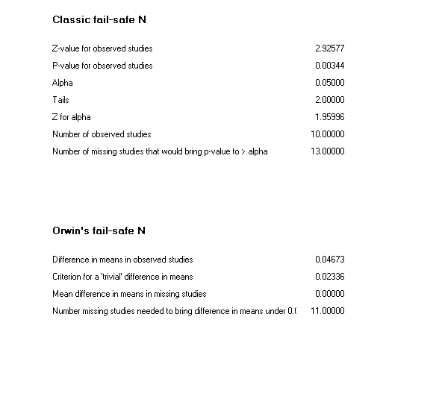
S8b. Begg and Mazumdar rank correlation 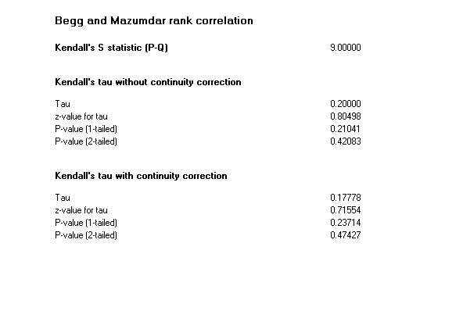
S8c. Egger’s regression intercept 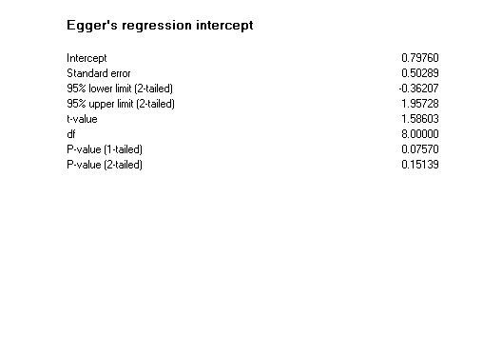
S8d. Duval and Tweedie’s trim and fill 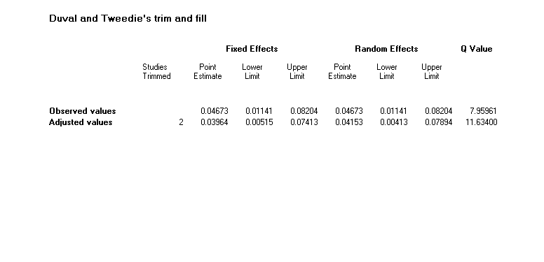

Fig. S4a. Funnel Plot of Precision by Difference in Means (random effects)
Fig. S4b. Funnel Plot of Standard Error by Difference in Means (random effects)

- Apo A1 + Apo A2 mg/dL
S9a. Classic fail-safe N and Orwin’s fail-safe N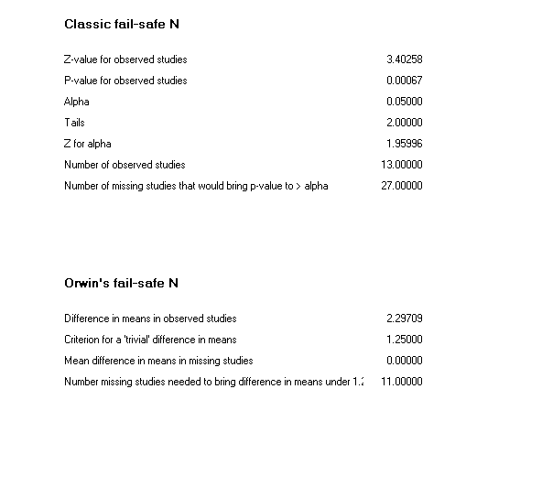
S9b. Begg and Mazumdar rank correlation 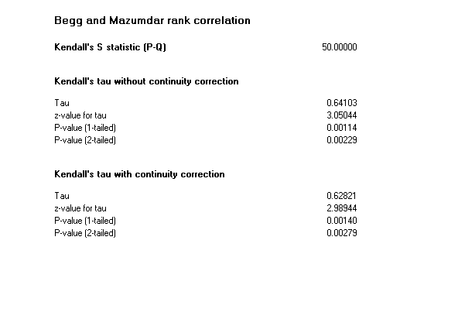
S9c. Egger’s regression intercept
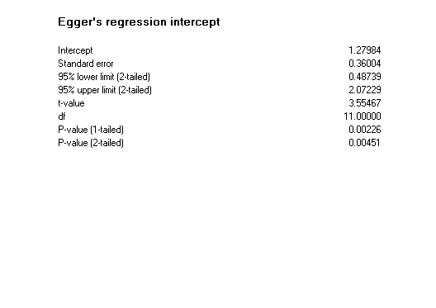
S9d. Duval and Tweedie’s trim and fill 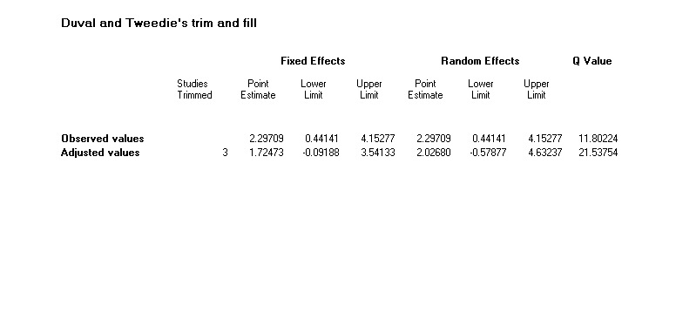

Fig. S5a. Funnel Plot of Precision by Difference in Means (random effects)
Fig. S5b. Funnel Plot of Standard Error by Difference in Means (random effects)

- Apo B100 + VLDL-C mmol/L SQ
S10a. Classic fail-safe N and Orwin’s fail-safe N 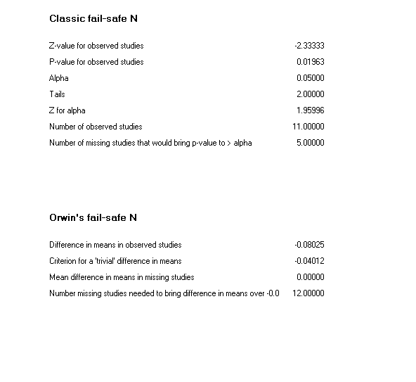
S10b.Begg and Mazumdar rank correlation 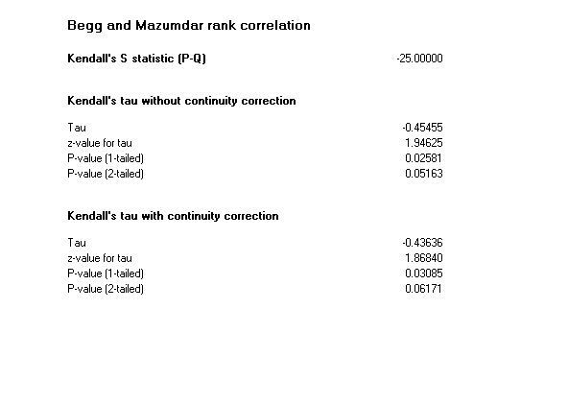
S10c. Egger’s regression intercept 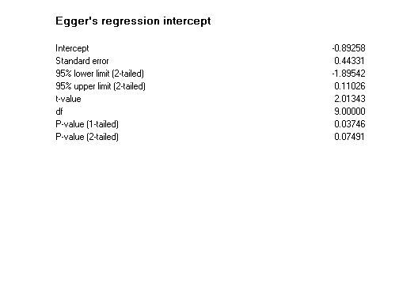
S10d. Duval and Tweedie’s trim and fill 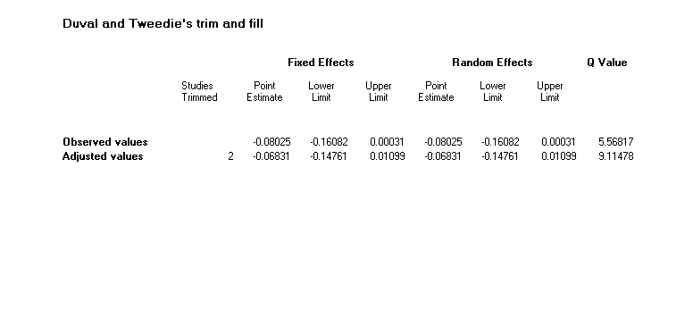

Fig. S6a. Funnel Plot of Precision by Difference in Means (random effects)
Figure S6b. Funnel Plot of Standard Error by Difference in Means (random effects)

- TC/HDL-C + LDL-C/HDL-C + Apo B100/Apo A1
S11a. Classic fail-safe N and Orwin’s fail-safe N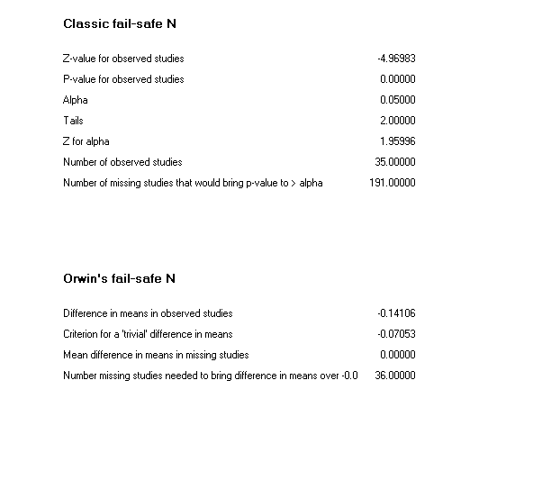
S11b. Begg and Mazumdar rank correlation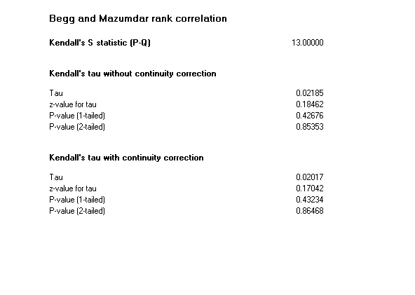
S11c. Egger’s regression intercept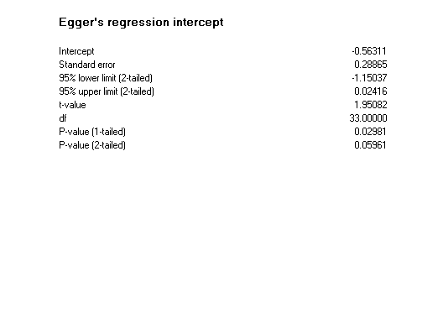
S11d. Duval and Tweedie’s trim and fill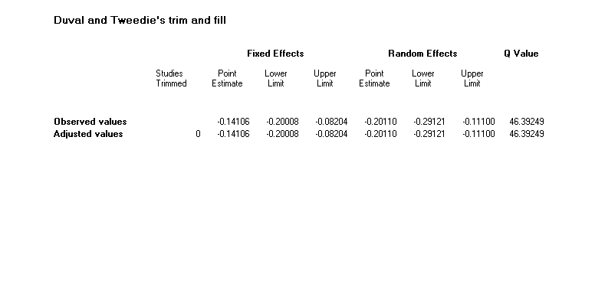

Fig. S7a. Funnel Plot of Precision by Difference in Means (random effects)
Fig. S7b. Funnel Plot of Standard Error by Difference in Means (random effects)

Table S12 Heterogeneity reporting for I² and τ²
Outcome | Hetereogeneity |  |  |  | τ²
 | Q-value | Df [Q] | P  value | I² % | τ² | Standard Error | Variance | τ
Apo A1 + Apo A2 + HDL2 + HDL3 mmol/L | 7.96 | 9 | 0.54 | 0.00 | 0.00 | 0.00 | 0.00 | 0.01
Apo A1 + Apo A2 mg/dL | 11.82 | 12 | 0.46 | 0.00 | 0.00 | 5.48 | 30.01 | 0.00
TC/HDLC + LDL-C/HDL-C + Apo B100/ Apo A1 | 46.39 | 34 | 0.08 | 26.71 | 0.01 | 0.01 | 0.00 | 0.12
HDL-C/TC + HDL-C/LDL-C + Apo A1/Apo B100 | 1.6 | 4 | 0.81 | 0.00 | 0.00 | 0.00 | 0.00 | 0.00
Apo B100 + VLDL mmol/L | 7.42 | 16 | 0.96 | 0.00 | 0.00 | 0.01 | 0.00 | 0.00
Apo B100 mg/dL | 9.92 | 12 | 0.62 | 0.00 | 0.00 | 4.99 | 24.89 | 0.00
Apo: apolipoprotein; HDL-C: high-density lipoprotein cholesterol; mmol/L: millimoles per litre; mg/dL: milligram per decilitre; VLDL: very low-density lipoprotein; TC: total cholesterol.

Meta-regression Analyses
Table S13a TC/HDL-C + LDL-C/HDL-C + Apo B100/Apo A1 (intervention variables)
Increments for Model 1, Random effects (ML), Knapp Hartung, Difference in means
TC/HDL-C + LDL-C/HDL-C + Apo B100/Apo A1
 | Current Model |  | Test of Model (a) |  |  |  | Goodness of fit (b) |  |  | Change from prior (c) |  | Test of change (c)
Covariate | Tau² | R² | F | df1 | df2 | P-value | Q | df | P-value | Tau² | R² | F | df1 | df2 | P-value
Intercept | 0.0144 | 0
Intensity VO2max % | 0.0084 | 0.41 | 1.62 | 1 | 33 | 0.2126 | 41.45 | 33 | 0.1485 | -0.006 | 0.41 | 1.62 | 1 | 33 | 0.2126 | F=1.00, df=4, dfErr=30, p=0.4213
Intervention Duration (Weeks) | 0.0069 | 0.52 | 0.87 | 2 | 32 | 0.4286 | 40.92 | 32 | 0.134 | -0.0015 | 0.1 | 0.05 | 1 | 32 | 0.8297
Sessions per week | 0.0038 | 0.74 | 0.88 | 3 | 31 | 0.4602 | 40.24 | 31 | 0.1238 | -0.0032 | 0.22 | 0.42 | 1 | 31 | 0.5222
Minutes per session | 0.0023 | 0.84 | 1 | 4 | 30 | 0.4213 | 39.18 | 30 | 0.1217 | -0.0015 | 0.11 | 0.87 | 1 | 30 | 0.3587

Table S13b TC/HDL-C + LDL-C/HDL-C + Apo B100/Apo A1 (study variables)
Increments for Model 1, Random effects (ML), Knapp Hartung, Difference in means
TC/HDL-C + LDL-C/HDL-C + Ao B100/Apo A1
 | Current Model |  | Test of Model (a) |  |  |  | Goodness of fit (b) |  |  | Change from prior (c)(d) |  | Test of change (c)
Covariate | Tau² | R² | F | df1 | df2 | P-value | Q | df | P-value | Tau² | R² | F | df1 | df2 | P-value
Intercept | 0.0144 | 0
Year | 0.0134 | 0.07 | 0.05 | 1 | 33 | 0.8214 | 43.82 | 33 | 0.0987 | -0.001 | 0.07 | 0.05 | 1 | 33 | 0.8214 | F=0.29, df=4, dfErr=30, p=0.8795
Total Number of Participants | 0.0141 | 0.02 | 0.26 | 2 | 32 | 0.774 | 43.69 | 32 | 0.0815 | 0.0007 | -0.05 | 0.47 | 1 | 32 | 0.4969
Number of extracted outcomes | 0.015 | 0 | 0.17 | 3 | 31 | 0.9145 | 42.67 | 31 | 0.0791 | 0.0009 | -0.02 | 0.01 | 1 | 31 | 0.9143
TESTEX Score | 0.0174 | 0 | 0.29 | 4 | 30 | 0.8795 | 42.58 | 30 | 0.0638 | 0.0025 | 0 | 0.63 | 1 | 30 | 0.4348

Table S14a Apo A1 + Apo A2 + HDL2 + HDL3 mmol/L (intervention variables)

Increments for Model 1, Random effects (ML), Knapp Hartung, Difference in means
Apo A1 + Apo A2 + HDL2 + HDL3 mmol/L
Intervention variables

 | Current Model |  | Test of Model (a) |  |  |  |  | Goodness of fit (b) |  |  |  | Change from prior (c) |  |  | Test of change (c)
Covariate | Tau² | R² |  | F | df1 | df2 | P-value |  | Q | df | P-value |  | Tau² | R² |  | F | df1 | df2 | P-value
Intercept | 0.0002 | 0
Intensity VO2max % | 0 | 1.00 |  | 1.1 | 1 | 8 | 0.325 |  | 6.86 | 8 | 0.5518 |  | -0.0002 | 1.00 |  | 1.1 | 1 | 8 | 0.325 |  | F=1.24, df=4, dfErr=5, p=0.4024
Intervention Duration (Weeks) | 0 | 1.00 |  | 0.66 | 2 | 7 | 0.5458 |  | 6.64 | 7 | 0.4676 |  | 0 | 0 |  | 0.22 | 1 | 7 | 0.6514
Sessions per week | 0 | 1.00 |  | 1.65 | 3 | 6 | 0.2759 |  | 3.02 | 6 | 0.8062 |  | 0 | 0 |  | 3.62 | 1 | 6 | 0.1059
Minutes per session | 0 | 1.00 |  | 1.24 | 4 | 5 | 0.4024 |  | 3.02 | 5 | 0.6971 |  | 0 | 0 |  | 0 | 1 | 5 | 0.9676

Table S14b Apo A1 + Apo A2 + HDL2 + HDL3 mmol/L (study variables)
Increments for Model 1, Random effects (ML), Knapp Hartung, Difference in means
Apo A1 + Apo A2 + HDL2 + HDL3 mmol/L
Study variables
 | Current Model |  | Test of Model (a) |  |  |  | Goodness of fit (b) |  |  | Change from prior (c) |  | Test of change (c)
Covariate | Tau² | R² | F | df1 | df2 | P-value | Q | df | P-value | Tau² | R² | F | df1 | df2 | P-value
Intercept | 0.0002 | 0
Year | 0 | 1.00 | 1.96 | 1 | 8 | 0.1992 | 6 | 8 | 0.6471 | -0.0002 | 1.00 | 1.96 | 1 | 8 | 0.1992 | F=1.14, df=4, dfErr=5, p=0.4329
Total Number of Participants | 0 | 1.00 | 1.34 | 2 | 7 | 0.3225 | 5.29 | 7 | 0.625 | 0 | 0 | 0.71 | 1 | 7 | 0.4262
Number of extracted outcomes | 0 | 1.00 | 1.11 | 3 | 6 | 0.4153 | 4.63 | 6 | 0.5927 | 0 | 0 | 0.66 | 1 | 6 | 0.447
TESTEX Score | 0 | 1.00 | 1.14 | 4 | 5 | 0.4329 | 3.39 | 5 | 0.6401 | 0 | 0 | 1.24 | 1 | 5 | 0.317

