Wooden Solar Tracker: Proof of Concept
Project Goal
I want to build a simple and cost-effective wooden dual axis solar tracker suitable for personal or small business use. From this goal, I can derive three main constraints:
Heavy machinery is often not easily available for the target audience, hence the tracker should be small enough that it can installed on the site by at most two people using only muscle power. A solar panel rated at 600KW has dimensions of approximately 2m x 1.5m and weighs about 30kg. A pair of such panels can be handled by a pair of human hands, so I set the tracker's total output at approximately 1Kwh.
Tracker should be easily mountable not only on rooftops, but also as "buried" pedestals in the ground.
The project requires both mechanical and software components, and the software should be capable of managing between 8 and 32 trackers.
Rationale and Demand
Solar panels with dual axis trackers are an uncommon sight. There is good reason for this: trackers are expensive, whereas solar panels are comparatively cheap. In other words, it is economically not worth investing in dual axis trackers when buying additional panels is less expensive. This project, thus, has two important potential contributions:
- I want to test my idea that a wooden tracker can be made of commodity components in a regular woodworking shop. Wood is cheap and easy-to-process, and the final cost of the tracker will be significantly lower than current options.
- The software developed by the project will likely have its own value and many potential applications, regardless if the wooden tracker works as intended at the estimated cost.
Road Map
I will build at least 1 dual axis wooden tracker at 1/3 of target size. Whereas the sizes are clear (it should bear 2 panels of 700x500mm), the weight and capacity to withstand wind load are less obvious. 1/3 of the panel's length and height yields 1/9 of area, so I am leaving this question open.
I will evaluate several mechanical designs (tentative).
My vision of the software architecture is a central computer that orchestrates the entire solar field and provides management and monitoring capabilities to the operator. It will be connected to an anemometer (wind speed sensor) and sun position sensor (or GPS sensor + astronomical algorithms for sun position calculation). This control center will need to handle strong wind escape maneuvers, snow shake movements, broadcasts of sun position, etc. It will also need to record performance data and serve as an entry point for the operator.
Each tracker will be equipped with a pair of linear actuators (or pair of DC motors), a tilt sensor (or accelerometer), an LED to indicate tracker's motion (awesomeness!), a temperature sensor, an electric sensor, and a networking device. An Arduino board for each tracker will also be needed to manage the aforementioned components and communicate with the control center.
Current Progress
On the image: Pre-alpha of the dual axis tracker is almost done. The second linear actuator is in transit and expected to arrive by TIMEFRAME.
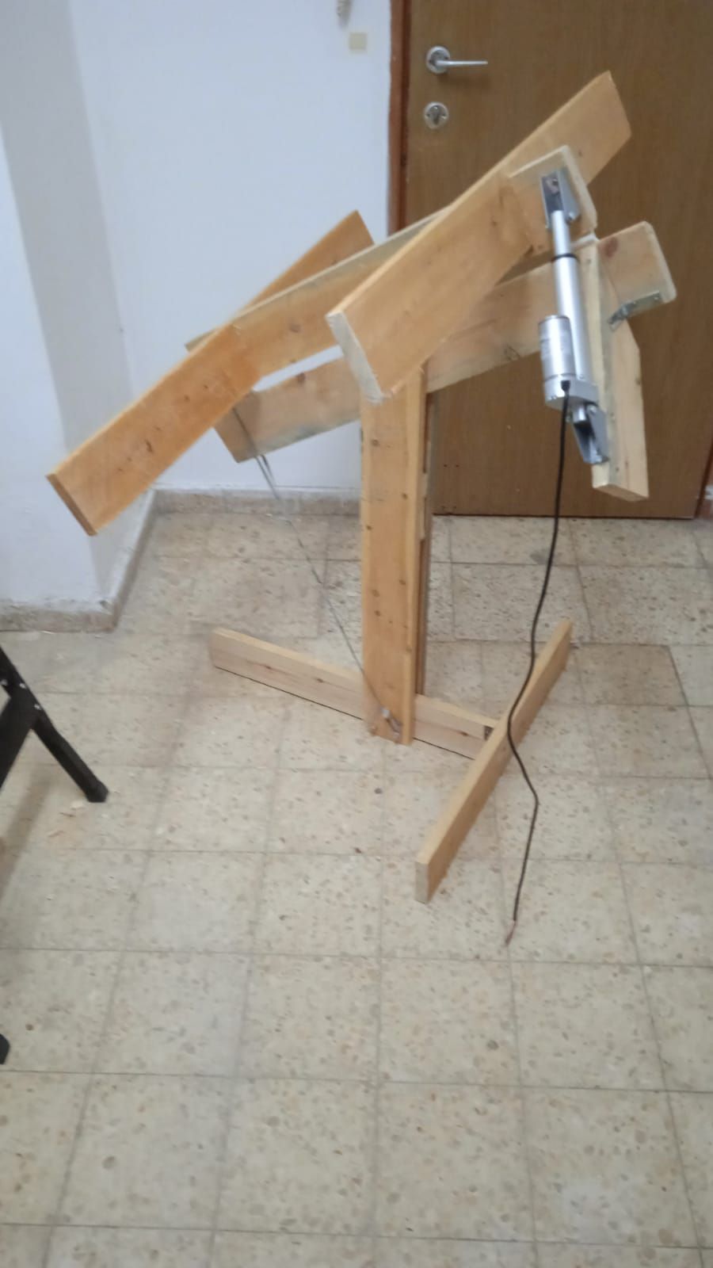
Software �going to start soon.

