Q2

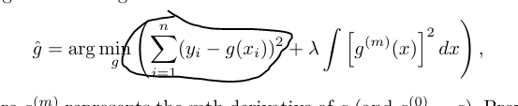

For all of (a) – (d): this sigma not counted, because is positive and constant. Arg min forces the integral to be near 0

(a) m = 0 -> 0 => g(x) = 0 will minimize the area (integral)

(b) m = 1-> 0 => = constant (c)

- m = 2 -> 0 => = c*x + d

- m = 3 -> 0 => = c*x^2 + d*x + k

(e) The integral not counted. In this case g is a spline itself.

Q3
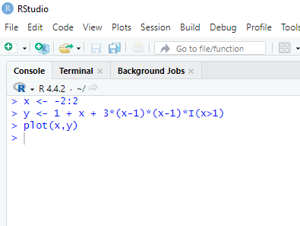
*** PLOT ON THE NEXT PAGE ***

