Capital University (formerly Helwan University)
Faculty of Computing & Artificial Intelligence
AI310 & CS361 Artificial Intelligence · Fall (Semester 1) 2026–2027
Project 27
Using a Genetic Algorithm and a Memetic Algorithm for Function Optimisation
Project documentation (draft)
Table 1. Team members
# | Name | ID | Programme / department
1 | [TEAM: full name] | [ID] | [programme]
2 | [TEAM: full name] | [ID] | [programme]
3 | [TEAM: full name] | [ID] | [programme]
4 | [TEAM: full name] | [ID] | [programme]
5 | [TEAM: full name] | [ID] | [programme]
6 | [TEAM: full name] | [ID] | [programme]

Teaching assistant: [TEAM: TA name]
Discussion: Week 12/13, [TEAM: date]
Text highlighted in yellow is a placeholder for the team to complete before submission.
Contents
Abstract
1. Project idea in detail
1.1 The problem: global minimisation
1.2 The approach
1.3 Objectives
2. Main functionalities
2.1 The optimisation library (evoopt)
2.2 The experiment pipeline
2.3 The demo application
2.4 Quality assurance
3. Similar applications in the market
4. Literature review
5. Dataset: the benchmark functions
5.1 Definitions
5.2 Data produced by the experiments
6. Algorithms, approach and experimental results
6.1 Representation and the evaluation budget
6.2 The Genetic Algorithm
6.3 The Memetic Algorithm
6.4 Choosing the MA's settings: a pilot study
6.5 Baselines
6.6 Experimental setup
6.7 Results
6.8 Discussion
6.9 Conclusion
7. System analysis and design
7.1 Use cases
7.2 Packages
7.3 Classes
7.4 Behaviour
7.5 Experiment pipeline
8. Development platform
8.1 Project structure
8.2 Reproducing the results
9. Team members and roles
10. Use of AI tools
References
Appendix A. Results for all 30 problems

If the contents list looks empty, right-click it in Word and choose Update Field.

Abstract
This project implements a Genetic Algorithm (GA) and a Memetic Algorithm (MA), a GA extended with local search, and uses them to find the global minimum of 12 benchmark functions from the SFU Virtual Library of Simulation Experiments [1]. The functions cover all six landscape categories of the library and are tested in 2, 5, 10 and 30 dimensions, giving 30 problems. Both algorithms are written from scratch in Python. Every function evaluation of every algorithm, including the evaluations spent by local search, passes through one counter that enforces a budget of 10,000 × d evaluations, so the comparison is fair.
In a full experiment of 7,950 runs (30 independent seeds per setting), the MA was significantly better than the GA on 17 of 30 problems and tied on the other 13, never losing (Wilcoxon rank-sum test, α = 0.05; 12 / 18 / 0 after a Holm correction). Both algorithms beat random search on almost every problem. Against SciPy's Differential Evolution [12] the MA won 10, tied 16 and lost 4 problems. Eight ablation studies show which design choices matter: Hooke–Jeeves local search [9] and Lamarckian learning are essential, while a mutation that keeps the population diverse is what deceptive functions such as Schwefel need. The project also includes an interactive Streamlit application for demonstrating the algorithms.

1. Project idea in detail

1.1 The problem: global minimisation
Given a function f: ℝᵈ → ℝ and a box-shaped search domain, the task is to find the point x* where f takes its smallest value, the global minimum f* = f(x*). The algorithms only see function values: they have no gradients and no formula. This is black-box optimisation.
The problem is hard because real landscapes are not smooth bowls. They can have thousands of local minima (Rastrigin has about 10ᵈ), long curved valleys (Rosenbrock), large flat regions that give no direction (Easom, Michalewicz), or a misleading structure where the second-best region is far from the best one (Schwefel). A method that only walks downhill gets trapped in the first local minimum it meets; a method that only explores never refines its answer.

1.2 The approach
A Genetic Algorithm [2, 3] keeps a population of candidate solutions and improves it over generations with three operators inspired by natural selection: selection favours good individuals, crossover recombines two parents, and mutation makes small random changes. The population explores many regions at once, but a GA is slow at the final, precise part of the search.
A Memetic Algorithm [4, 5] adds individual learning: some individuals are improved by a local search before they compete. The idea is that the GA finds promising regions and the local search quickly reaches the bottom of each region. In this project the MA reuses the GA unchanged and replaces only one step, its learning step, with Hooke–Jeeves pattern search [9].
To compare the two algorithms fairly, every evaluation of f, including those made inside the local search, is counted against the same budget. The project then measures where and why the MA is better, with 30 independent runs per setting, statistical tests, and ablation studies of every design choice.

1.3 Objectives
- Implement a real-coded GA with several selection, crossover and mutation operators, from scratch.
- Implement an MA that adds local search to the same GA, with Lamarckian and Baldwinian learning.
- Find the global minimum of at least 5 benchmark functions; this project uses 12, covering all six SFU landscape categories.
- Compare GA and MA fairly (equal budgets and seeds) with statistical tests, against two baselines.
- Explain the results with ablation studies and provide an interactive application for the discussion.

2. Main functionalities
The project has three parts that share one Python library.

2.1 The optimisation library (evoopt)
- 12 benchmark functions with their search domains, known optima f* and minimisers x*, all verified by automated tests.
- A budgeted problem (Problem): the only way to evaluate f. It counts every evaluation, blocks evaluations past the budget, and records the best point and when it was found.
- Genetic Algorithm with tournament, roulette and rank selection; SBX, BLX-α and arithmetic crossover; polynomial, Gaussian and uniform mutation; and elitism.
- Memetic Algorithm with Hooke–Jeeves pattern search or stochastic hill climbing, Lamarckian or Baldwinian learning, and resumable local-search chains.
- Baselines: random search and SciPy's Differential Evolution, run through the same budget.

2.2 The experiment pipeline
- Runs the full experiment (7,950 runs) in parallel on 16 processes and saves every result.
- Produces summary tables, Wilcoxon rank-sum tests with a Holm correction, convergence curves, box plots and ablation figures.
- Command-line tools for single runs, quick GA-vs-MA comparisons and the pilot study that chose the MA's settings.

2.3 The demo application
A Streamlit web application with four pages: Watch a run shows the population moving over the landscape generation by generation; Explore landscapes shows each function in 3-D and as a contour map; GA vs MA races the two algorithms over several seeds with a significance verdict; Saved results browses the full experiment.
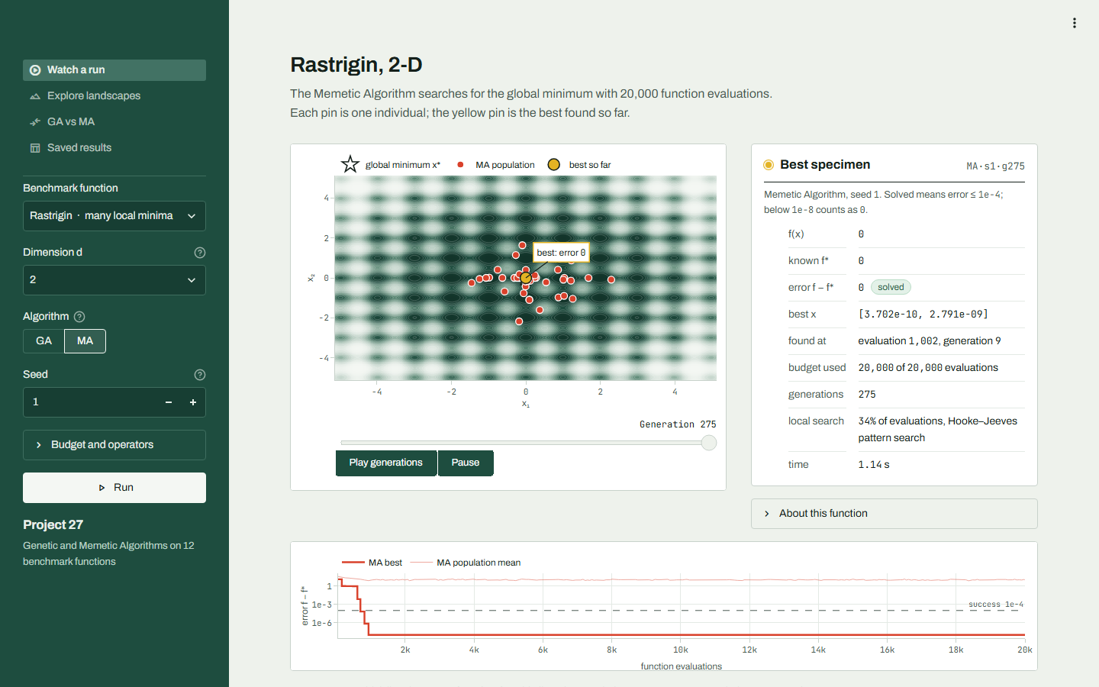
Figure 1. The Watch a run page: an MA population (red pins) on the 2-D Rastrigin landscape, the best solution (yellow), its details, and the convergence curve.
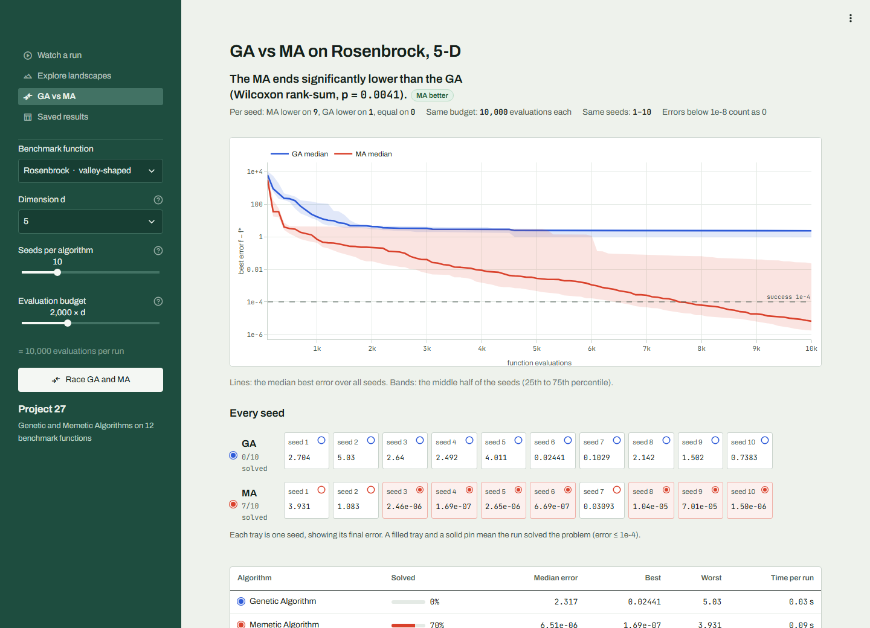
Figure 2. The GA vs MA page: median convergence of both algorithms over 10 seeds on Rosenbrock 5-D, and the final error of every seed.

2.4 Quality assurance
307 automated tests (pytest) check the library: every known optimum, every operator, the budget limit, reproducibility from a seed, the statistical analysis, and that every page of the application runs.

3. Similar applications in the market
[TEAM: write this section. Compare 4–6 of the tools below with our project: their algorithms, whether they offer a memetic/hybrid option, their benchmark support, and their interface. Verify every statement against the tool's documentation before submitting.]
Table 2. Candidate tools for the comparison (descriptions to be verified by the team)
Tool | Type | What to compare
MATLAB Global Optimization Toolbox | Commercial toolbox | Its ga solver can call a local solver at the end (hybrid function), which is close to a memetic idea; it also has patternsearch.
DEAP (Python) | Open-source EA framework | Building blocks for GAs and other evolutionary algorithms; you assemble the algorithm yourself.
pymoo (Python) | Open-source optimisation framework | Ready-made GA and DE; uses the same SBX and polynomial mutation operators as this project.
PyGAD (Python) | Open-source GA library | A beginner-friendly GA library; compare its operators and its lack of local search.
SciPy differential_evolution | Library function | Used in this project as an outside reference (Section 6.5).
Nevergrad (Meta) | Open-source gradient-free toolbox | Many black-box optimisers behind one interface; useful for a broader comparison.

4. Literature review
[TEAM: write this section. The course asks for 4–6 academic papers, one per team member. Each member reads one paper and writes about half a page: the problem it addresses, its method, its main result, and how it relates to this project. Check each reference before citing it.]
Table 3. Candidate papers, with how each relates to this project
Reference | Why it is relevant here
Holland (1975) [2]; Goldberg (1989) [3] | The foundations of genetic algorithms: selection, crossover, mutation, schema theory.
Moscato (1989) [4] | Introduced the term memetic algorithm: evolution combined with individual learning.
Krasnogor & Smith (2005) [5] | A model and taxonomy of memetic algorithms; discusses Lamarckian vs Baldwinian learning and how often to apply local search.
Neri & Cotta (2012) [6] | A literature review of memetic algorithms and memetic computing.
Molina et al. (2010) [7] | Memetic algorithms for continuous optimisation with local-search chains, the idea our MA uses to resume searches.
Deb & Agrawal (1995) [8] | Simulated binary crossover (SBX), our default crossover for real-valued genes.
Hooke & Jeeves (1961) [9] | The direct-search method used as our MA's local search.
Jamil & Yang (2013) [10] | A large survey of benchmark functions for global optimisation, with their formulas, domains and known minima.
Derrac et al. (2011) [11] | How to compare evolutionary algorithms with nonparametric tests such as the Wilcoxon test.

5. Dataset: the benchmark functions
This project optimises mathematical test functions rather than a data file. All 12 come from the publicly available SFU Virtual Library of Simulation Experiments [1], the source the course points to, and were chosen to cover all six of its landscape categories, so each kind of difficulty is represented. Scalable functions are tested at d = 2, 10 and 30; Michalewicz at d = 2, 5 and 10 (where its optimum is known); and the 2-D-only functions at d = 2. This gives 30 problems.
Table 4. The benchmark set (domain shown in 2-D; scalable functions use the same interval for every variable)
Function | Category | Domain | Dimensions | Global minimum f*
Sphere | Bowl-shaped | [-5.12, 5.12] | 2, 10, 30 | 0
Zakharov | Plate-shaped | [-5, 10] | 2, 10, 30 | 0
Rosenbrock | Valley-shaped | [-5, 10] | 2, 10, 30 | 0
Six-Hump Camel | Valley-shaped | x₁ ∈ [-3, 3], x₂ ∈ [-2, 2] | 2 | -1.03163
Michalewicz | Steep ridges / drops | [0, 3.14159] | 2, 5, 10 | -1.80130 (d=2); -4.68766 (d=5); -9.66015 (d=10)
Easom | Steep ridges / drops | [-100, 100] | 2 | -1
Rastrigin | Many local minima | [-5.12, 5.12] | 2, 10, 30 | 0
Ackley | Many local minima | [-32.768, 32.768] | 2, 10, 30 | 0
Griewank | Many local minima | [-600, 600] | 2, 10, 30 | 0
Schwefel | Many local minima | [-500, 500] | 2, 10, 30 | 0
Eggholder | Many local minima | [-512, 512] | 2 | -959.641
Styblinski-Tang | Other | [-5, 5] | 2, 10, 30 | -39.16617 · d

Precision of the optima. The library prints some optima rounded. Because the experiments measure errors down to 10⁻⁸, the optima were recomputed to full precision and checked by tests: Styblinski–Tang's minimum is −39.16617 · d (the library prints −39.16599 · d), and Schwefel's constant is 418.98288727. Michalewicz is separable (each term depends on one variable), so its exact 10-D optimum, −9.660152, was found one coordinate at a time.

5.1 Definitions
Sphere (bowl-shaped). Convex, unimodal and separable. The easiest case: it checks that an algorithm converges at all, and how fast.
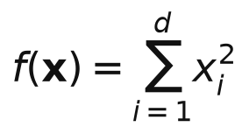
Zakharov (plate-shaped). Unimodal but non-separable: a flat plate around the optimum with steep quartic walls. Weighting by i couples all variables.
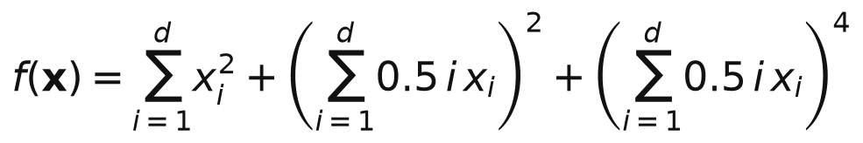
Rosenbrock (valley-shaped). The global minimum sits in a long, narrow, curved valley. Finding the valley is easy; following it to (1, ..., 1) is hard.
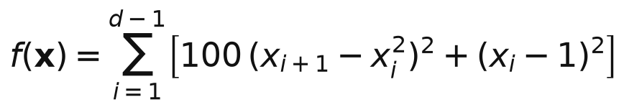
Six-Hump Camel (valley-shaped). Six local minima, two of which are global and symmetric. Tests whether the search can tell near-equal basins apart.
Michalewicz (steep ridges / drops). d! local minima separated by flat plateaus with steep, narrow ridges (m = 10). The plateaus give no gradient information at all.
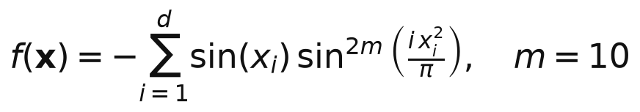
Easom (steep ridges / drops). Flat almost everywhere, with a single tiny well at (pi, pi) that covers a minute fraction of the domain: a needle in a haystack.
Rastrigin (many local minima). A bowl covered in a regular egg-crate of local minima (about 10ᵈ of them). Local search alone gets trapped almost immediately.
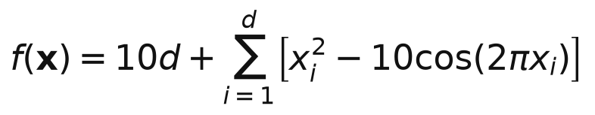
Ackley (many local minima). A nearly flat outer region full of small ripples, with a deep hole in the centre. Hill climbers stall on the flat outer plateau.
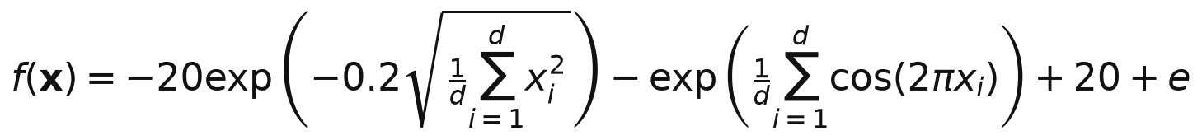
Griewank (many local minima). Looks like a smooth bowl from far away, but zooming in reveals a dense grid of local minima. The product term couples the variables.
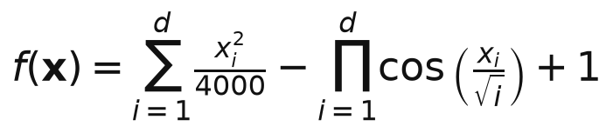
Schwefel (many local minima). Deceptive: the second-best minimum is far from the global one, near the opposite corner of the domain, so the search is pulled the wrong way.
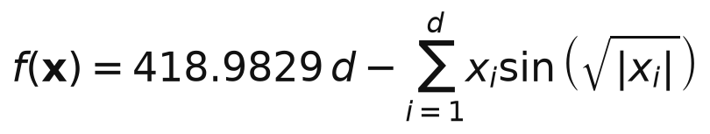
Eggholder (many local minima). Highly irregular with many deep local minima, and the global minimum lies exactly on the domain boundary (x1 = 512).
Styblinski-Tang (other). Separable with 2^{d} local minima. The global one is at x_{i} = -2.9035, slightly deeper than the mirror-image basin at x_{i} = +2.7468.
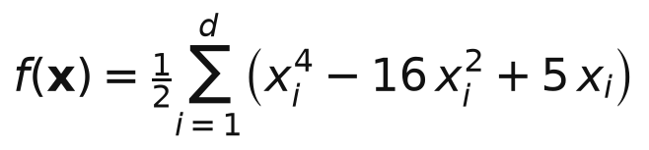
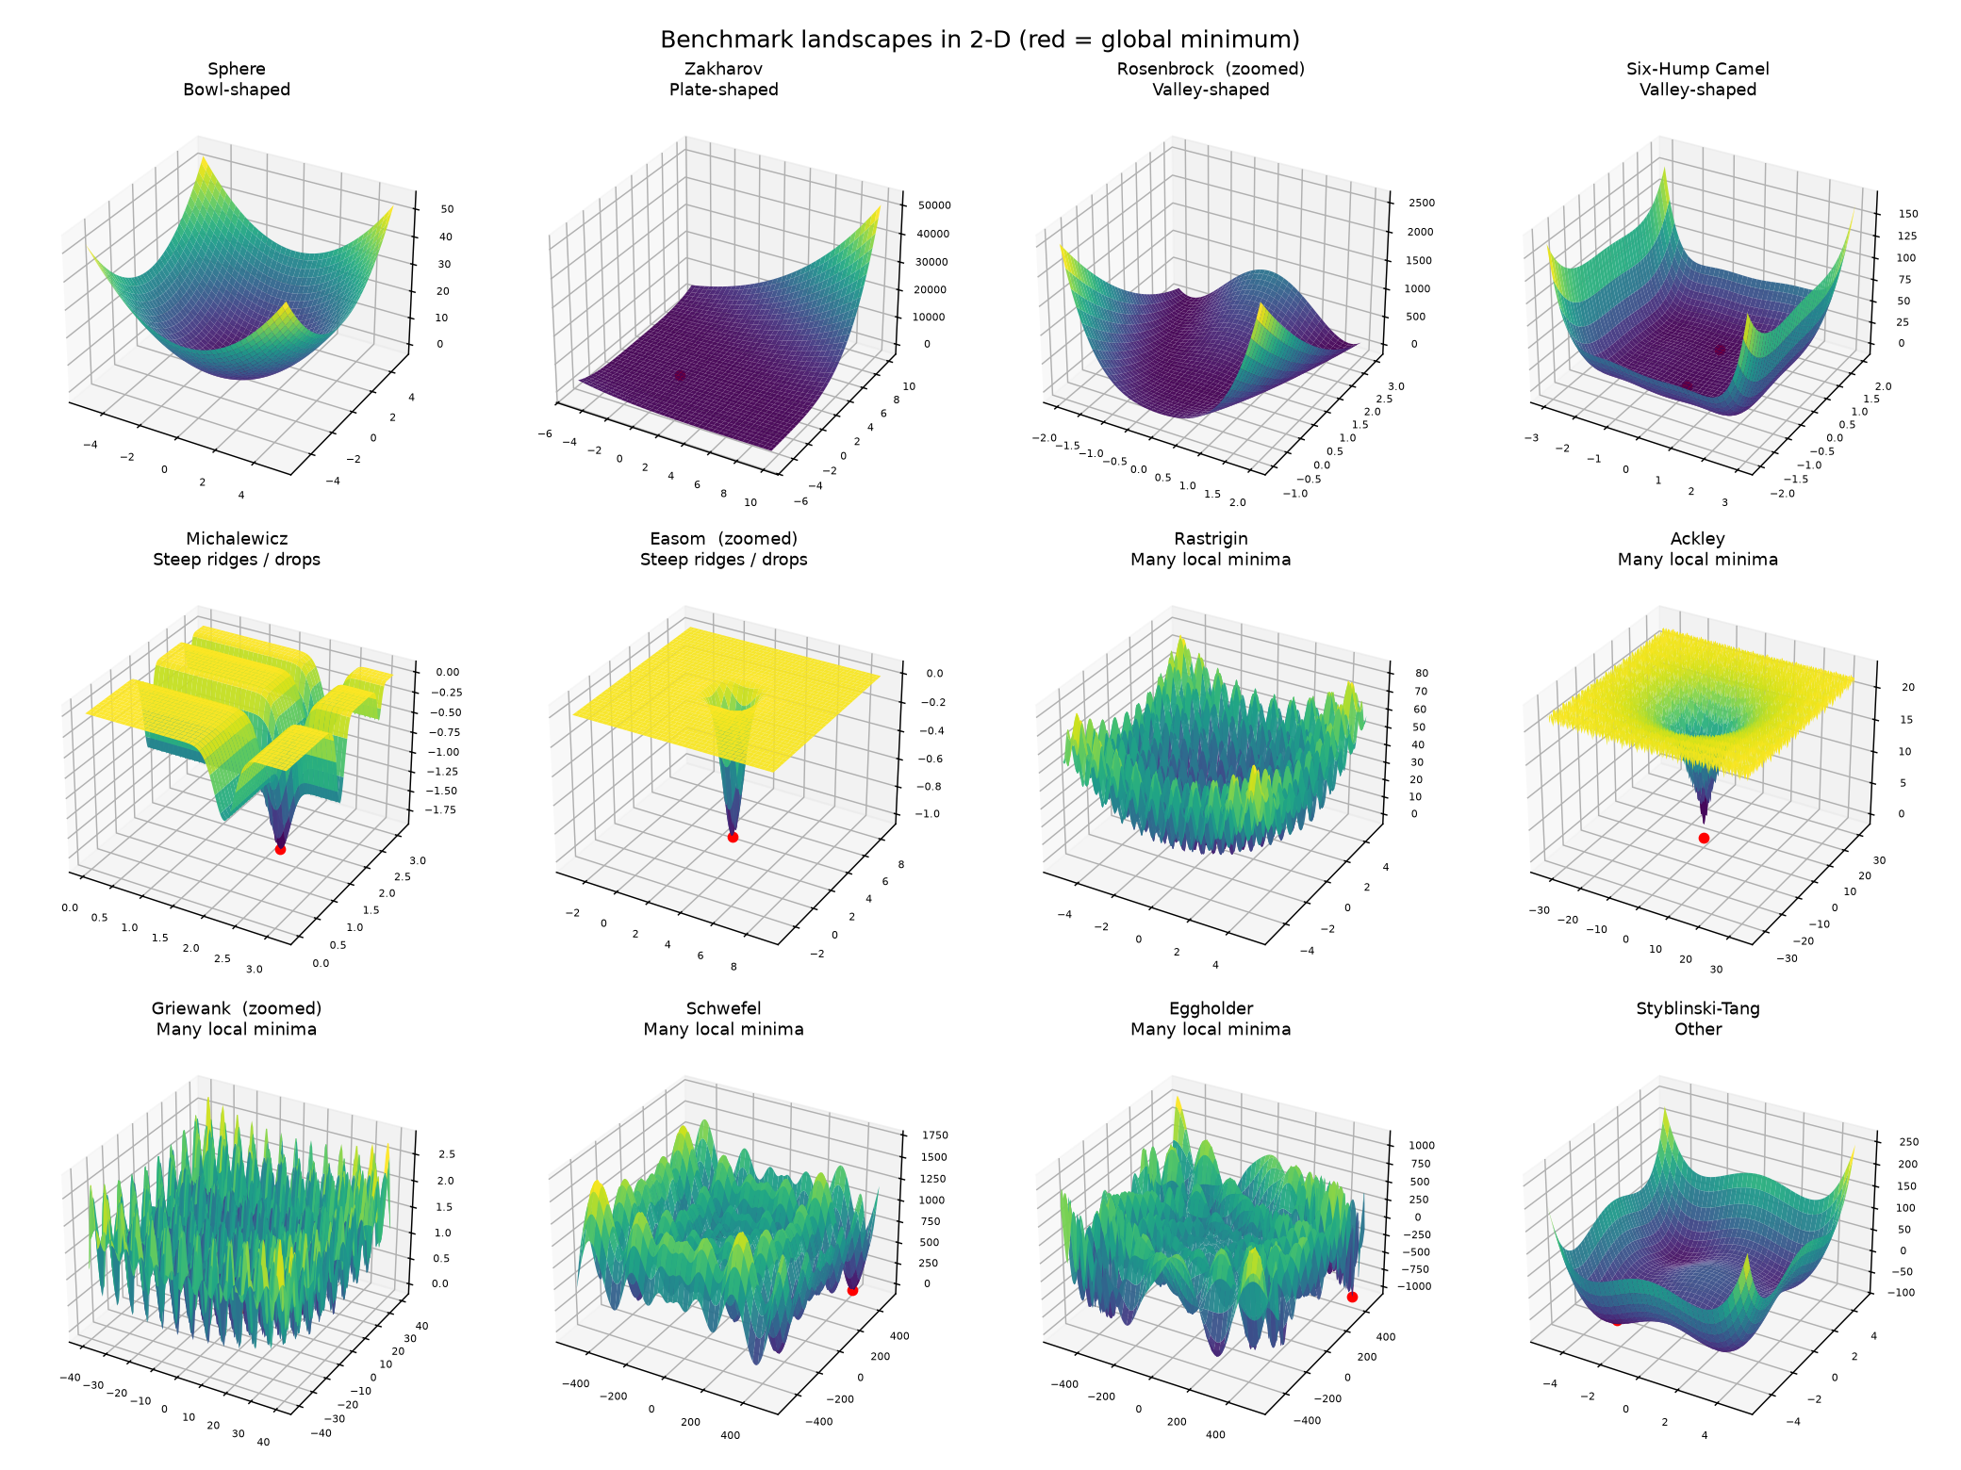
Figure 3. The 12 landscapes in 2-D; the red point marks the global minimum (Rosenbrock, Easom and Griewank are zoomed in).

5.2 Data produced by the experiments
Each experiment run produces one row of results (final error, success, evaluations needed, runtime) and a convergence curve. The full experiment stored 7,950 rows in experiments/results/full/ (runs.csv and curves.npy), from which every table and figure in Section 6 is computed.

6. Algorithms, approach and experimental results

6.1 Representation and the evaluation budget
A candidate solution (an individual) is a vector of d real numbers inside the domain; the GA operates directly on these values (real-coded GA). Its quality, or fitness, is f(x), and lower is better. Every algorithm evaluates f only through Problem.evaluate, which counts the evaluation and, once the budget of 10,000 × d evaluations is spent, returns +∞ so that the point can never be selected. The error of a run and its success are defined as:

6.2 The Genetic Algorithm
One generation performs selection, crossover, mutation, evaluation of the children, elitist replacement and a learning step that does nothing in the GA (Figure 12 shows the activity diagram). The operators are:
- Tournament selection (default): draw k = 3 individuals at random and keep the best; repeat for every parent. Larger k means stronger selection pressure.
- Roulette selection: chance proportional to how far an individual sits below the worst one (windowing, since we minimise).
- Rank selection [13]: chance depends only on rank, with selection pressure s ∈ [1, 2]:
- SBX crossover [8] (default, η_{c} = 15, applied to 90% of pairs): each gene is crossed with probability 0.5; children are spread symmetrically around the parents:
- BLX-α crossover [14]: each child gene is drawn uniformly from the parents' interval widened by α = 0.5 on both sides.
- Arithmetic crossover: children are weighted averages λp₁ + (1 − λ)p₂ of the parents.
- Polynomial mutation [15] (default, η_{m} = 20, probability 1/d per gene): mostly small steps, scaled to the distance to the bounds:
- Gaussian mutation: adds N(0, (0.1 × width)²) noise. Uniform mutation: replaces the gene with a random value in the domain.
- Elitism: the 2 best parents survive unchanged; the children fill the rest of the population.
Table 5. GA default settings
Setting | Default | Notes
Population size | 50 (d < 10), 100 (d ≥ 10) | N
Selection | tournament, k = 3 | roulette and rank available
Crossover | SBX, η_{c} = 15, p_{c} = 0.9 | BLX-α and arithmetic available
Mutation | polynomial, η_{m} = 20, p_{m} = 1/d | Gaussian and uniform available
Elitism | 2 individuals
Budget | 10,000 × d evaluations | stops the run

6.3 The Memetic Algorithm
The MA inherits the GA and overrides only its learning step (Figure 13). In each generation it refines the best individual with a long local search of 20 · d evaluations, and each child with probability 0.05 with a short one of 5 · d evaluations. The long search polishes the elite to high precision; the short searches settle children into the bottom of their basins, so selection compares basins rather than random points.
The local search is Hooke–Jeeves pattern search [9] (Figure 14). An exploratory move tries x_{i} ± h_{i} for each variable in turn and keeps the first improvement. When that succeeds, a pattern move jumps further in the direction that worked:
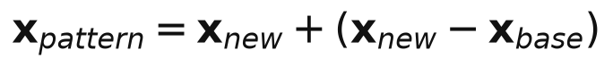
When no improvement is found the steps are halved. The alternative local search, stochastic hill climbing, is a (1+1) evolution strategy with Rechenberg's 1/5 success rule. Two further design choices complete the MA:
- Local-search chains [7]: the final step size of each refined individual is remembered, so its next search resumes where it stopped instead of restarting with a large step.
- Learning model: Lamarckian (default) writes the improved genes back into the individual; Baldwinian keeps the genes and updates only the fitness.
- Fairness: all local-search evaluations go through the same counter, so the MA never receives extra budget. A test checks that the MA with learning switched off produces exactly the same run as the GA.

6.4 Choosing the MA's settings: a pilot study
The local-search frequency and budget were chosen in a pilot study on 10 problems with separate seeds (100–104), so the choice could not be tuned on the seeds of the main experiment (0–29). A first round showed two different effects: a long search on the best individual gives very high precision on valley-shaped functions, while short searches on many children help on rugged functions such as Eggholder. The second round combined both:
Table 6. Pilot study, round 2: average rank over 10 problems (lower is better) and share of the budget spent on local search
Configuration | Local-search share | Average rank
GA | 0% | 7.30
best only, 20d | 27% | 3.70
20d + rate=0.02 child=2d | 50% | 4.10
20d + rate=0.02 child=5d | 64% | 3.60
20d + rate=0.05 child=2d | 64% | 4.00
20d + rate=0.05 child=5d (chosen) | 78% | 3.10
20d + rate=0.1 child=2d | 75% | 5.10
20d + rate=0.1 child=5d | 86% | 5.10

6.5 Baselines
- Random search (RS) samples the domain uniformly with the same budget. Any useful algorithm must beat it.
- SciPy Differential Evolution (DE) [12] is a well-known optimiser, run with SciPy's default settings through the same budget, as an outside reference point. It was not tuned.

6.6 Experimental setup
- 30 problems × 4 algorithms (GA, MA, RS, DE) × 30 independent seeds (0–29); the same seeds for every algorithm.
- Budget: 10,000 × d function evaluations per run. Success: final error ≤ 10⁻⁴.
- Following the CEC benchmark convention [16], errors below 10⁻⁸ are taken as 0 when results are compared, so floating-point rounding never counts as a difference.
- Statistics: Wilcoxon rank-sum test on the 30 final errors of two algorithms (α = 0.05) [11], and a Holm–Bonferroni correction [17] for the 30 tests per comparison.
- Ablations: 8 studies on 5 problems at d = 10, each changing one design choice; 4,350 further runs. In total 7,950 runs (6,900 distinct after merging identical settings).

6.7 Results

6.7.1 Overall comparison
Table 7. Wins / ties / losses of the first algorithm over the 30 problems
Comparison | Wins | Ties | Losses | After Holm correction
MA vs GA | 17 | 13 | 0 | 12 / 18 / 0
MA vs DE | 10 | 16 | 4 | 8 / 18 / 4
GA vs RS | 28 | 2 | 0 | 28 / 2 / 0
MA vs RS | 29 | 1 | 0 | 29 / 1 / 0

The MA is significantly better than the GA on 17 problems and never worse. The 13 ties are mostly problems that both algorithms solve in every run (Sphere, Six-Hump Camel, low-dimensional Rastrigin), where there is nothing left to win. Both algorithms clearly beat random search (28 / 2 / 0 and 29 / 1 / 0). The untuned DE reference wins on 4 problems, all with a separable, deceptive structure (Section 6.8).
Table 8. Selected problems: success rate over 30 runs and median final error (all 30 problems: Appendix A)
Problem | GA | MA | DE | RS | MA vs GA
Zakharov 30-D | 0%  median 0.0204 | 100%  median 2.8e-08 | 0%  median 31.7 | 0%  median 298 | better
Rosenbrock 10-D | 0%  median 4.27 | 100%  median 0 | 93%  median 0 | 0%  median 5.09e+03 | better
Rosenbrock 30-D | 0%  median 70.2 | 93%  median 0 | 0%  median 15.2 | 0%  median 2.9e+05 | better
Michalewicz 10-D | 53%  median 1.1e-06 | 43%  median 4.9e-03 | 3%  median 0.102 | 0%  median 4.19 | tie
Rastrigin 30-D | 100%  median 1.8e-08 | 97%  median 0 | 0%  median 159 | 0%  median 313 | better
Ackley 30-D | 100%  median 2.7e-05 | 100%  median 0 | 100%  median 3.3e-07 | 0%  median 19.5 | better
Griewank 30-D | 43%  median 7.4e-03 | 73%  median 0 | 50%  median 3.7e-03 | 0%  median 322 | better
Schwefel 10-D | 0%  median 474 | 3%  median 237 | 87%  median 0 | 0%  median 1.58e+03 | better
Eggholder 2-D | 53%  median 0 | 60%  median 0 | 10%  median 24.3 | 0%  median 9.59 | tie
Styblinski-Tang 10-D | 3%  median 42.4 | 7%  median 28.3 | 100%  median 0 | 0%  median 74.2 | better

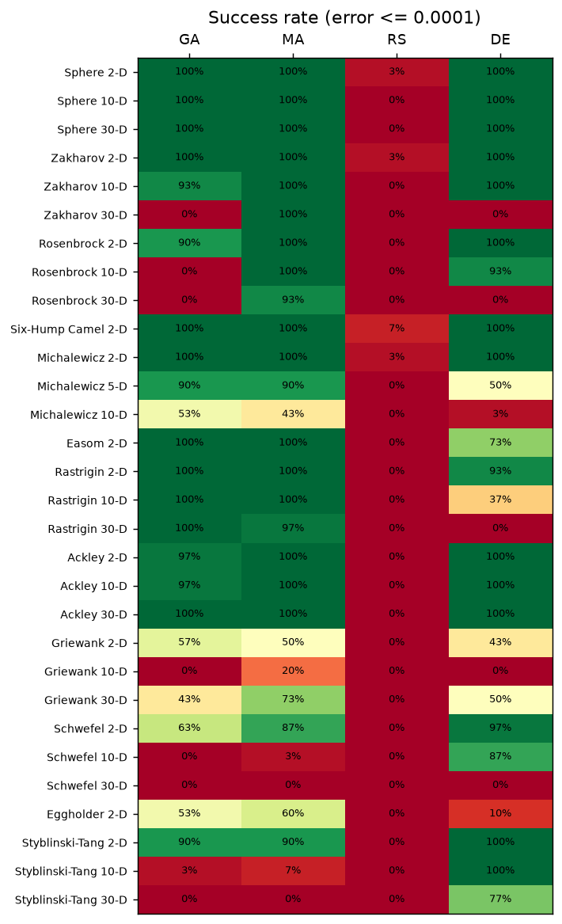
Figure 4. Success rate (error ≤ 10⁻⁴ in 30 runs) of every algorithm on every problem.
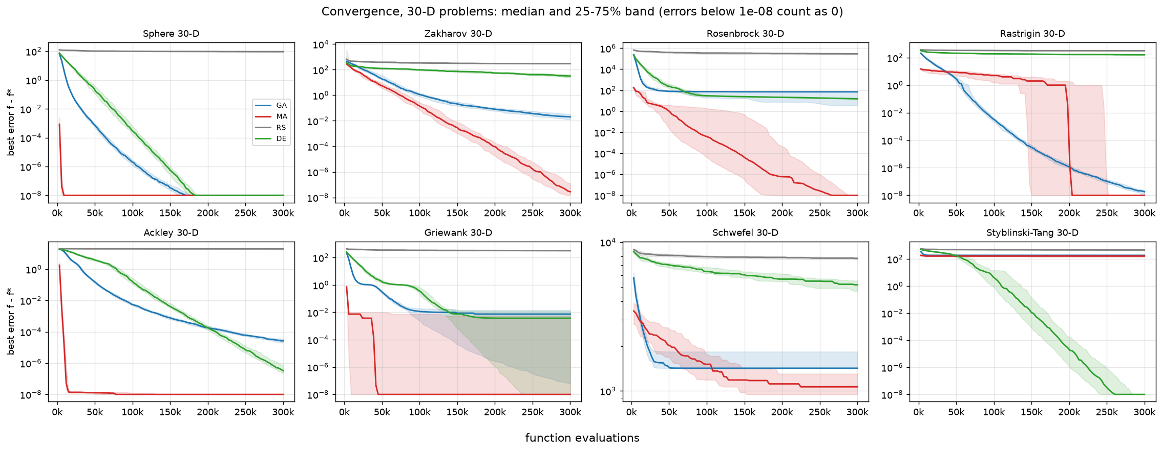
Figure 5. Convergence on the 30-D problems: median best error (line) and the middle half of the runs (band) against function evaluations.
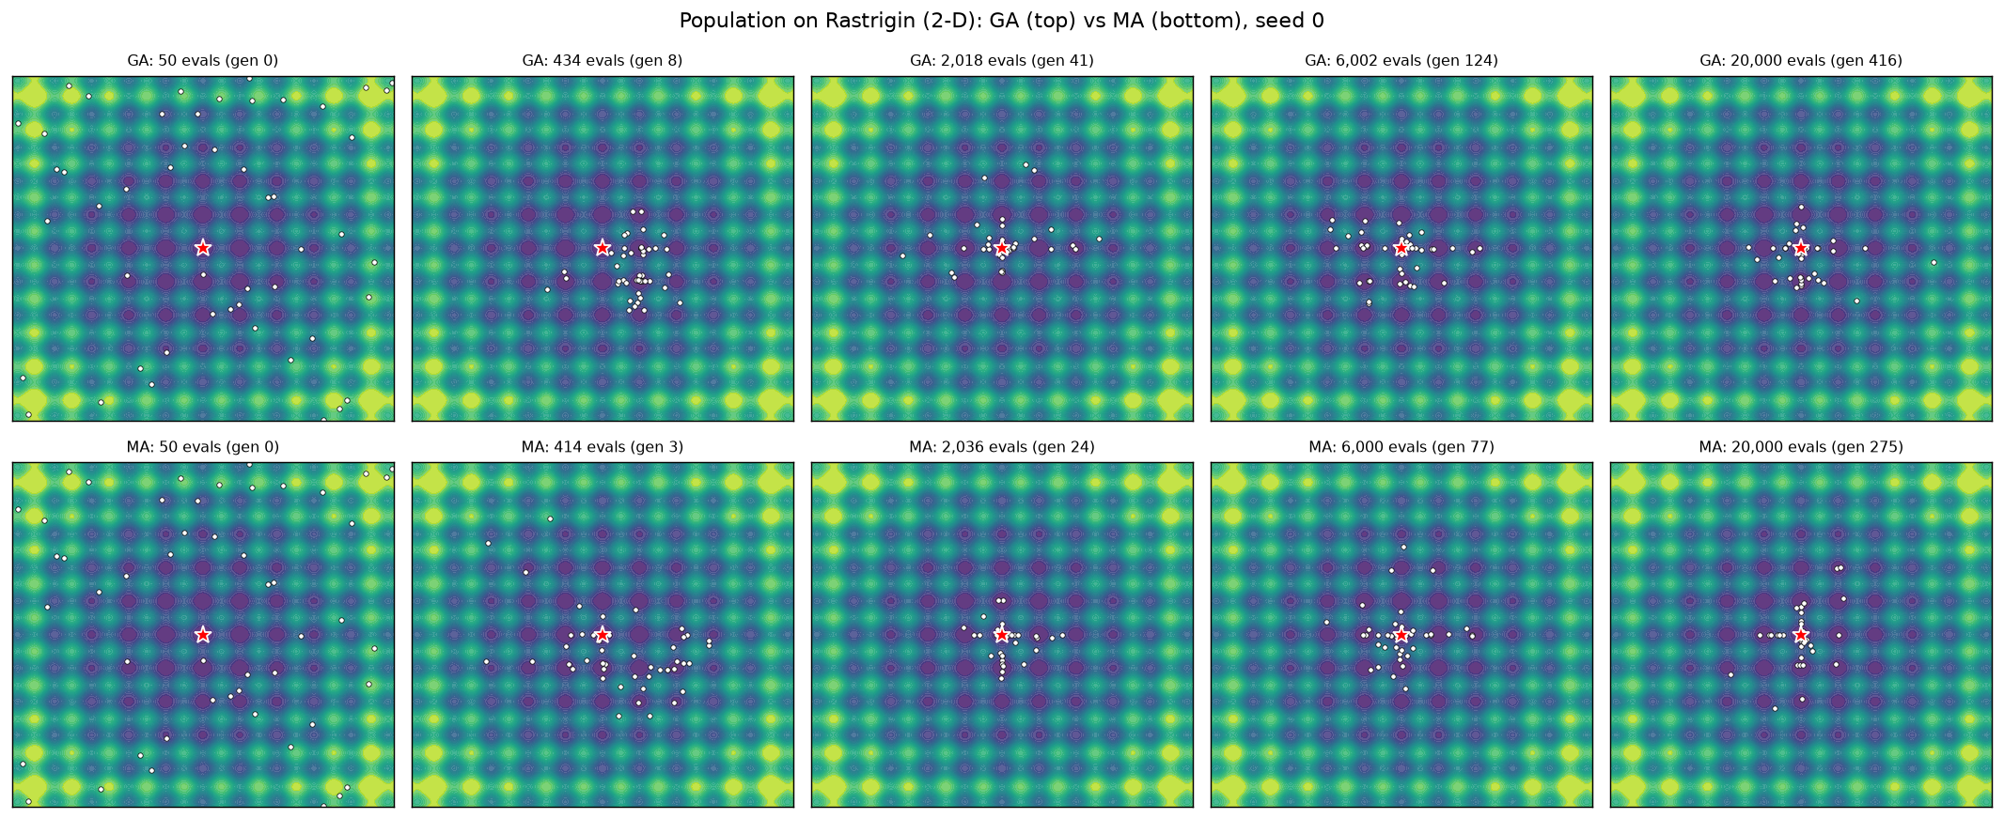
Figure 6. GA (top) and MA (bottom) populations on 2-D Rastrigin after the same numbers of evaluations.

6.7.2 Ablation studies
Each study changes one setting on Rastrigin, Rosenbrock, Ackley, Griewank and Schwefel at d = 10 (30 runs each) and compares it with the default by a Wilcoxon test.
Table 9. Ablation studies: main findings
Study | Finding
Local search | Hooke–Jeeves beats hill climbing on 4 of 5 problems (Rosenbrock: 100% vs 0% solved). Pattern moves follow valleys; random steps do not.
Learning model | Lamarckian beats Baldwinian on all 5; Baldwinian solves none. Under a fixed budget, discarding the improved genes wastes the learning evaluations.
Local-search rate | Refining 20% of children helps Schwefel (13% vs 3% solved) but hurts Rosenbrock (67% vs 100%): the rate trades exploration against precision.
Selection | Tournament is best; roulette and rank are significantly worse on Rastrigin, Ackley and Griewank.
Crossover | SBX is best overall; arithmetic crossover is better only on Rosenbrock, whose valley it can follow; BLX-α is worse on 4 of 5.
Mutation | Uniform mutation keeps the population diverse and solves Schwefel with both GA and MA (100% of runs); the MA with uniform mutation also solves Rastrigin, Ackley and 97% of Rosenbrock runs.
Population size | Under this budget smaller populations are better (20 > 50 > 100); 200 is worse, because fewer generations fit in the budget.
Mutation rate | 0.5/d and 1/d are equivalent; 2/d and 5/d are significantly worse (too disruptive).

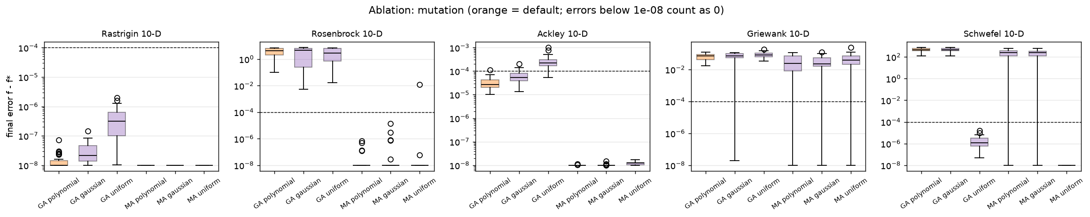
Figure 7. Mutation ablation: final errors of the GA and the MA with each mutation operator (orange = default).
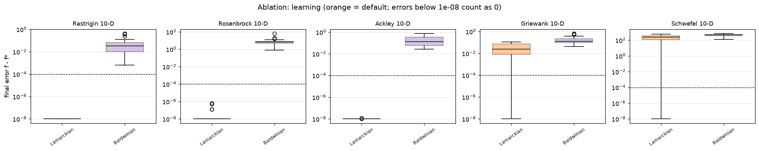
Figure 8. Learning ablation: Lamarckian (default) against Baldwinian learning.

6.7.3 Cost
Table 10. Mean runtime per run (seconds) and the MA's share of the budget spent in local search, by dimension
Dimension | GA | MA | DE | RS | MA local-search share
2-D | 0.16 | 0.41 | 0.18 | 0.01 | 36%
5-D | 0.41 | 1.28 | 0.85 | 0.04 | 57%
10-D | 0.57 | 2.61 | 1.49 | 0.08 | 74%
30-D | 2.87 | 8.99 | 7.75 | 0.35 | 90%

All algorithms use the same number of evaluations, but the MA takes 2–5 times longer in seconds, because local search evaluates one point at a time while the GA evaluates a whole population in one vectorised call. The share of the budget spent on local search grows with the dimension, since the local-search budgets are proportional to d.

6.8 Discussion
- Where the MA wins and why. Its largest gains are on valley-shaped and coupled (non-separable) functions: Rosenbrock, Zakharov, Griewank and Ackley at 30-D. Random mutations rarely move along a narrow valley, but Hooke–Jeeves pattern moves do. The GA finds the right region; the local search finishes the job.
- Where the MA does not help. On deceptive functions (Schwefel, Styblinski–Tang) the population converges into the wrong basin early. Local search only walks downhill, so it cannot leave that basin. The mutation ablation shows that the missing ingredient is diversity: uniform mutation solves Schwefel.
- Against DE. DE wins on Schwefel 10-D and Styblinski–Tang 10/30-D. Its mutation adds scaled differences between individuals, which allows large jumps between basins, and its crossover copies good coordinates one by one, which suits separable functions. The MA wins against DE on the coupled 30-D problems. DE was run with untuned defaults.
- Limitations. The results hold for this budget (10,000 × d) and these settings; a different budget can change the ranking. Wall-clock time favours the GA. The MA's settings were tuned on 10 problems, although with separate seeds.

6.9 Conclusion
Adding local search to the GA, with an equal evaluation budget, never made the result worse on any of the 30 problems and was significantly better on 17 (12 after the Holm correction), especially on valley-shaped and high-dimensional coupled functions. The design choices that make this work are Hooke–Jeeves pattern search, Lamarckian learning and resumable local-search chains. The remaining weakness, deceptive landscapes, is a diversity problem of the GA rather than of the local search, and the ablation studies point to uniform mutation as a remedy.

7. System analysis and design
The diagrams follow UML 2 notation. Their sources are in report/diagrams/ and can be regenerated with make_diagrams.py.

7.1 Use cases
Examiners use the demo application; team members can do the same and also run the command-line tools. Playing the generations and changing settings extend the main use case of watching a run; racing the algorithms always includes reading the significance verdict.
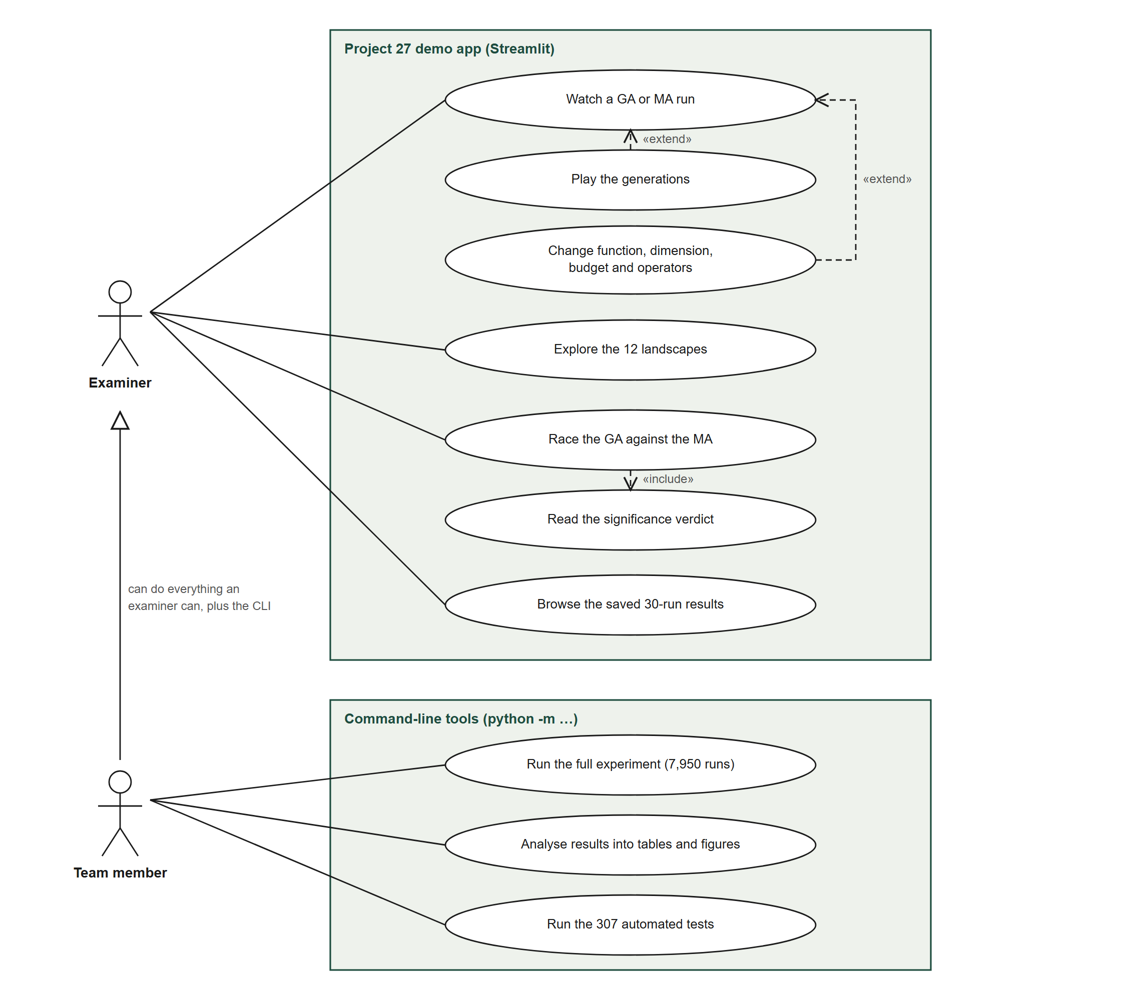
Figure 9. Use-case diagram.

7.2 Packages
The evoopt library has no dependencies on the other packages. The experiment scripts and the application import it; the experiments write the result files that the application reads.
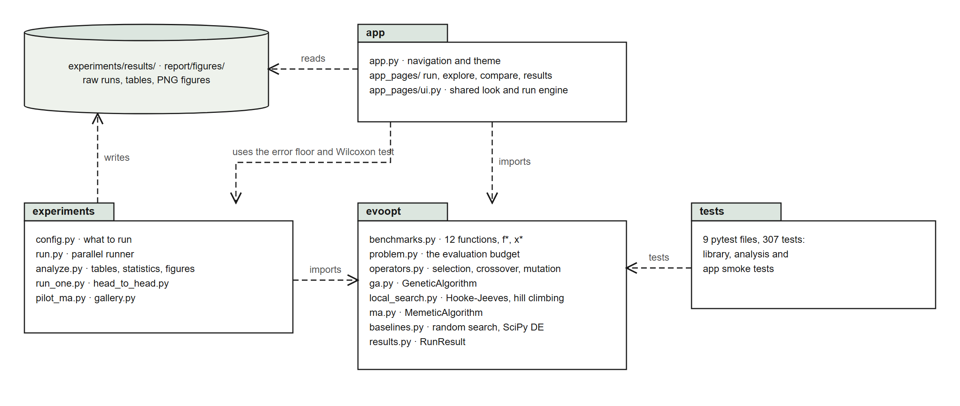
Figure 10. Package diagram.

7.3 Classes
GeneticAlgorithm, RandomSearch and ScipyDE share one interface: run(problem, seed) returns a RunResult. MemeticAlgorithm specialises the GA and overrides only learn(); MAConfig extends GAConfig. Every algorithm, and the local-search module, evaluates through Problem, which wraps one BenchmarkFunction.
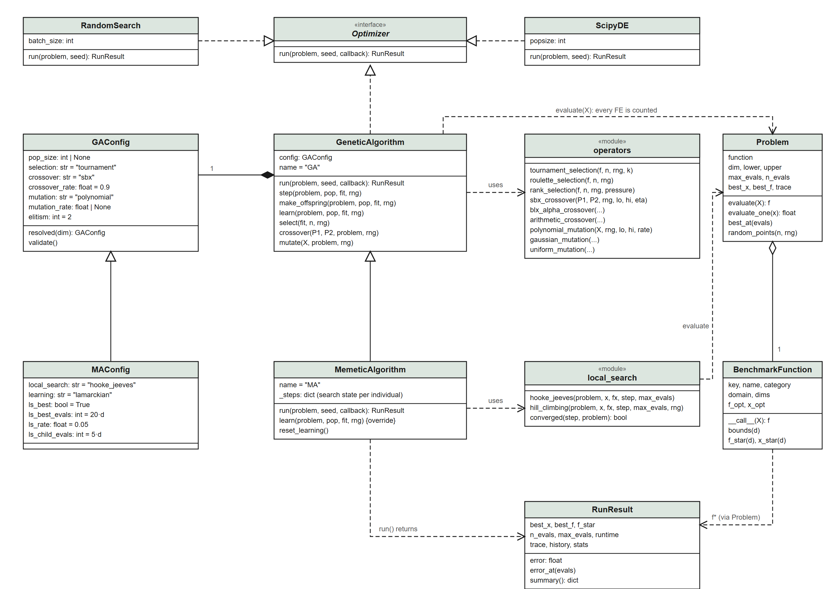
Figure 11. Class diagram of the evoopt library.

7.4 Behaviour
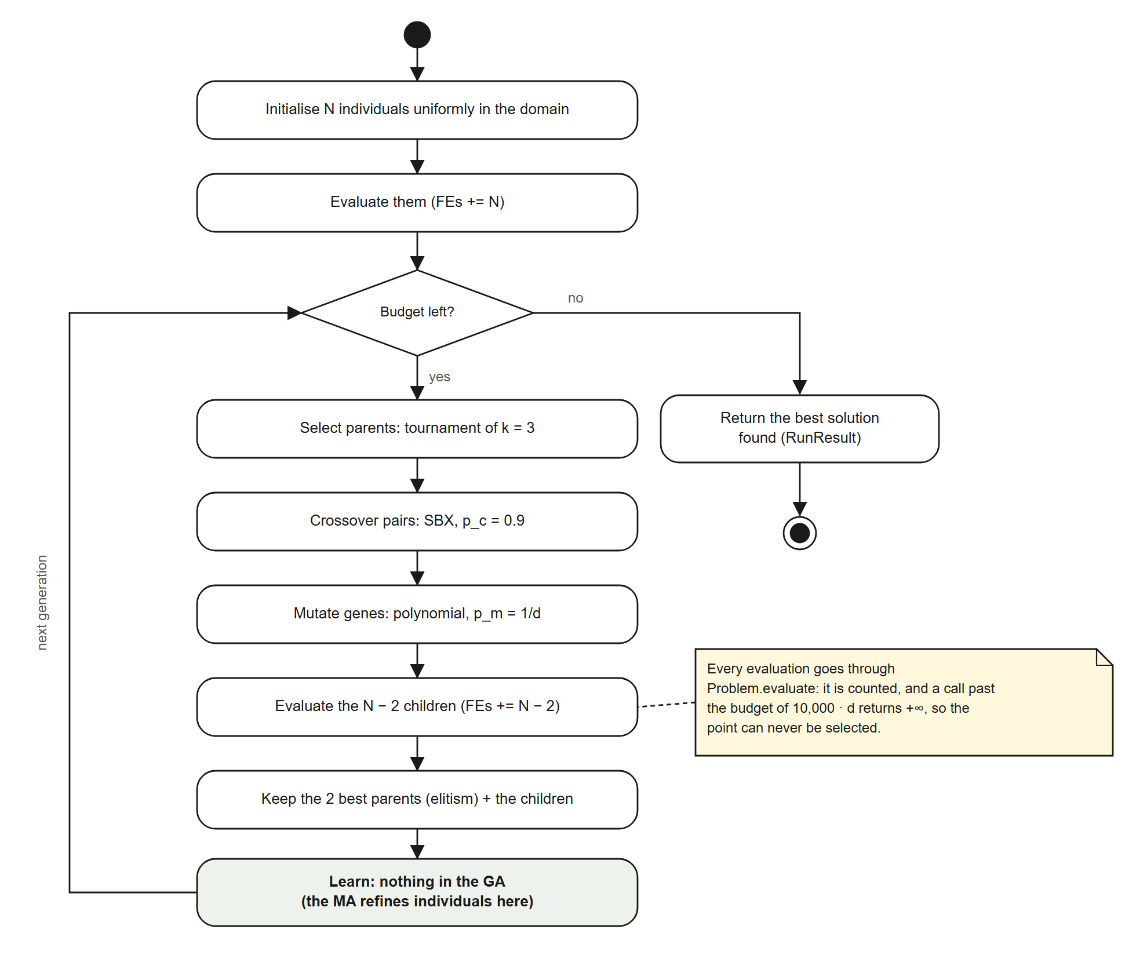
Figure 12. Activity diagram of one GA run.
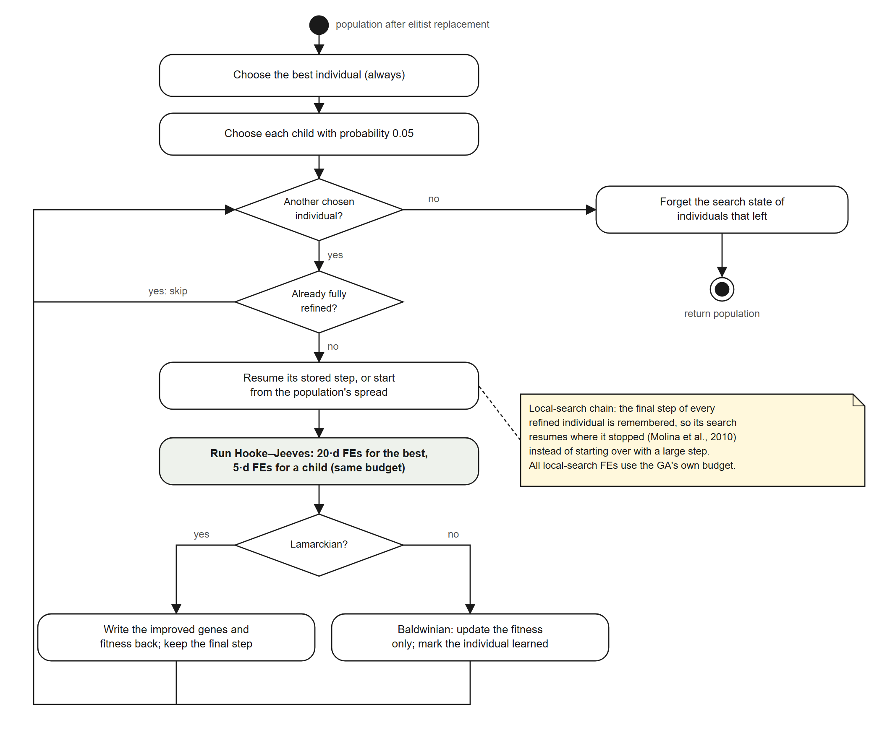
Figure 13. Activity diagram of the MA's learning step.
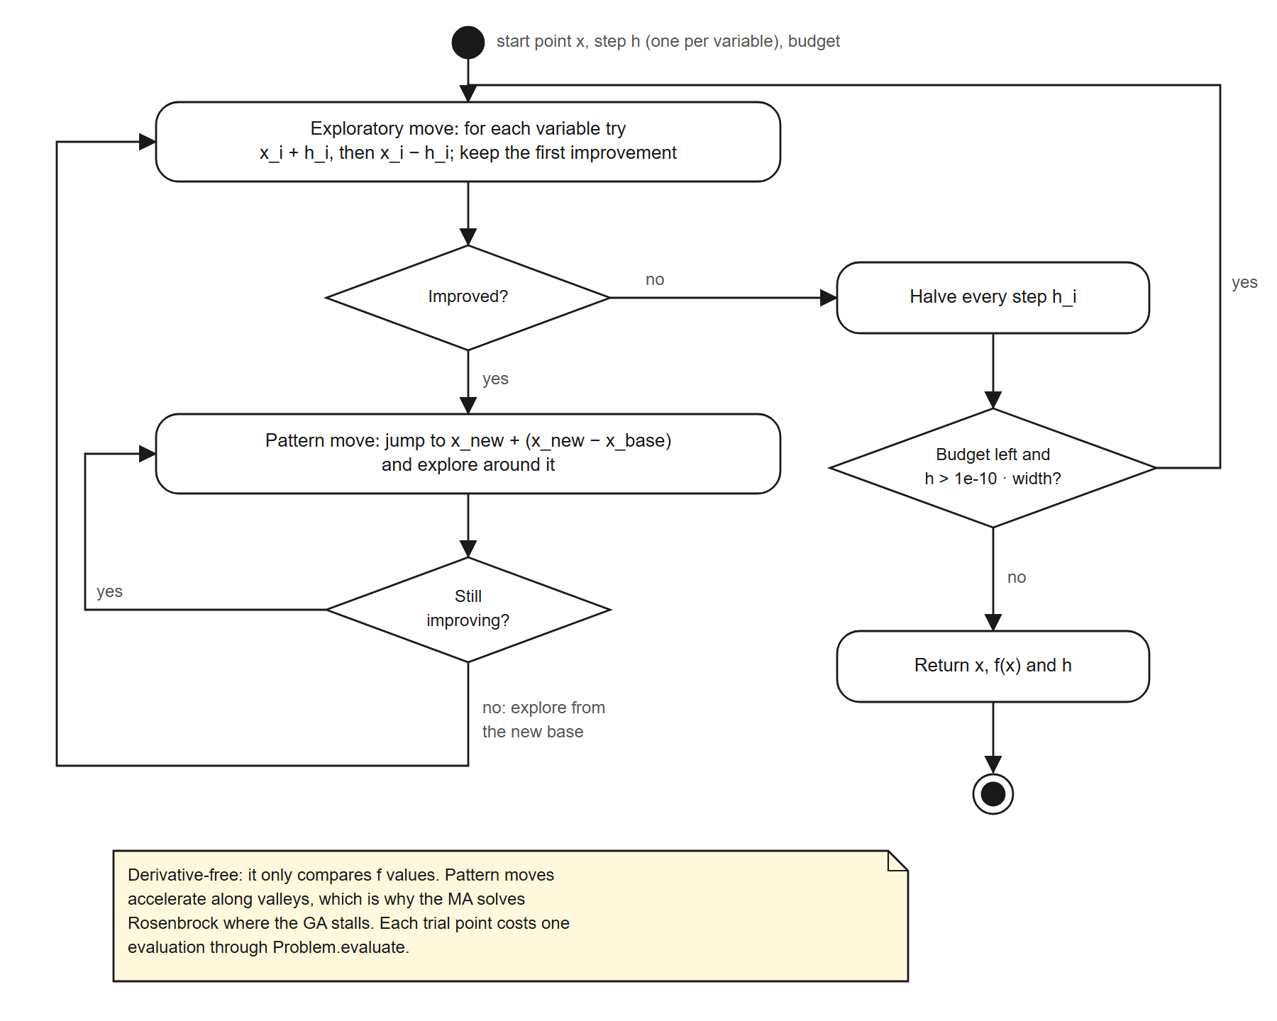
Figure 14. Activity diagram of Hooke–Jeeves pattern search.

7.5 Experiment pipeline
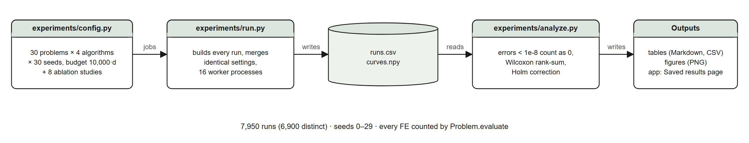
Figure 15. Data flow of the experiment, from configuration to tables and figures.

8. Development platform
Table 11. Software and hardware
Component | Version / detail
Language | Python 3.13.6
Numerical computing | NumPy 2.5.4, SciPy 1.18.1 (Wilcoxon test, Differential Evolution)
Data and figures | pandas 3.0.6, Matplotlib 3.11.2, Plotly 7.1.0
Application | Streamlit 1.66.1
Testing | pytest 9.1.1 (307 tests)
Operating system | Windows 11 (10.0.26300)
Hardware | Laptop with 24 logical CPU cores and 16 GB RAM; the experiment used 16 worker processes.
Version control | git

8.1 Project structure
- evoopt/ — the library: benchmarks, problem, operators, GA, local search, MA, baselines, results.
- experiments/ — configuration, parallel runner, analysis, and command-line tools.
- app.py, app_pages/ — the Streamlit application.
- tests/ — the pytest suite. report/ — this report, its figures and diagram sources.

8.2 Reproducing the results
All runs are seeded, so every result can be reproduced exactly. From the project folder:
- .venv\Scripts\python -m pip install -r requirements.txt — install the packages.
- .venv\Scripts\python -m experiments.run --mode full — run the 7,950 runs (about 10 minutes).
- .venv\Scripts\python -m experiments.analyze --mode full — write all tables and figures.
- .venv\Scripts\streamlit run app.py — start the demo application.
- .venv\Scripts\python -m pytest — run the tests.

9. Team members and roles
[TEAM: replace the suggested split below with each member's actual role. The course requires every member to contribute across all phases and the report to state each member's role.]
Table 12. Roles (suggested split — to be replaced)
Member | Role | Main work
[Member 1] | Benchmarks and problem | benchmarks.py, problem.py, dataset section
[Member 2] | Genetic Algorithm | operators.py, ga.py, GA section
[Member 3] | Memetic Algorithm | local_search.py, ma.py, pilot study
[Member 4] | Experiments and statistics | experiments/, results and discussion
[Member 5] | Demo application | app.py, app_pages/, design diagrams
[Member 6] | Report and literature | literature review, similar applications, editing

10. Use of AI tools
[TEAM: state how AI tools were used in the project, as the course allows, and confirm that every member can explain and defend the work in the discussion.]

References
Verify every reference before submission.
- Surjanovic, S., & Bingham, D. (2013). Virtual Library of Simulation Experiments: Test Functions and Datasets. Simon Fraser University. https://www.sfu.ca/~ssurjano/optimization.html
- Holland, J. H. (1975). Adaptation in Natural and Artificial Systems. University of Michigan Press.
- Goldberg, D. E. (1989). Genetic Algorithms in Search, Optimization, and Machine Learning. Addison-Wesley.
- Moscato, P. (1989). On evolution, search, optimization, genetic algorithms and martial arts: Towards memetic algorithms. Caltech Concurrent Computation Program, C3P Report 826.
- Krasnogor, N., & Smith, J. (2005). A tutorial for competent memetic algorithms: Model, taxonomy, and design issues. IEEE Transactions on Evolutionary Computation, 9(5), 474–488.
- Neri, F., & Cotta, C. (2012). Memetic algorithms and memetic computing optimization: A literature review. Swarm and Evolutionary Computation, 2, 1–14.
- Molina, D., Lozano, M., García-Martínez, C., & Herrera, F. (2010). Memetic algorithms for continuous optimisation based on local search chains. Evolutionary Computation, 18(1), 27–63.
- Deb, K., & Agrawal, R. B. (1995). Simulated binary crossover for continuous search space. Complex Systems, 9(2), 115–148.
- Hooke, R., & Jeeves, T. A. (1961). “Direct search” solution of numerical and statistical problems. Journal of the ACM, 8(2), 212–229.
- Jamil, M., & Yang, X.-S. (2013). A literature survey of benchmark functions for global optimisation problems. International Journal of Mathematical Modelling and Numerical Optimisation, 4(2), 150–194.
- Derrac, J., García, S., Molina, D., & Herrera, F. (2011). A practical tutorial on the use of nonparametric statistical tests as a methodology for comparing evolutionary and swarm intelligence algorithms. Swarm and Evolutionary Computation, 1(1), 3–18.
- Storn, R., & Price, K. (1997). Differential evolution: A simple and efficient heuristic for global optimization over continuous spaces. Journal of Global Optimization, 11(4), 341–359.
- Baker, J. E. (1985). Adaptive selection methods for genetic algorithms. Proceedings of the 1st International Conference on Genetic Algorithms, 101–111.
- Eshelman, L. J., & Schaffer, J. D. (1993). Real-coded genetic algorithms and interval-schemata. Foundations of Genetic Algorithms 2, 187–202.
- Deb, K., & Goyal, M. (1996). A combined genetic adaptive search (GeneAS) for engineering design. Computer Science and Informatics, 26(4), 30–45.
- Liang, J. J., Qu, B. Y., & Suganthan, P. N. (2013). Problem definitions and evaluation criteria for the CEC 2014 special session and competition on single objective real-parameter numerical optimization. Technical Report, Zhengzhou University and Nanyang Technological University.
- Holm, S. (1979). A simple sequentially rejective multiple test procedure. Scandinavian Journal of Statistics, 6(2), 65–70.

Appendix A. Results for all 30 problems
Table 13. Success rate over 30 runs and median final error for every problem (errors below 10⁻⁸ count as 0)
Problem | GA | MA | DE | RS | MA vs GA | MA vs DE
Sphere 2-D | 100% · 0 | 100% · 0 | 100% · 0 | 3% · 1.8e-03 | tie | tie
Sphere 10-D | 100% · 0 | 100% · 0 | 100% · 0 | 0% · 8.21 | tie | tie
Sphere 30-D | 100% · 0 | 100% · 0 | 100% · 0 | 0% · 93.4 | tie | tie
Zakharov 2-D | 100% · 0 | 100% · 0 | 100% · 0 | 3% · 3.2e-03 | tie | tie
Zakharov 10-D | 93% · 2.6e-05 | 100% · 0 | 100% · 0 | 0% · 30.8 | better | tie
Zakharov 30-D | 0% · 0.0204 | 100% · 2.8e-08 | 0% · 31.7 | 0% · 298 | better | better
Rosenbrock 2-D | 90% · 1.1e-05 | 100% · 0 | 100% · 0 | 0% · 0.0247 | better | tie
Rosenbrock 10-D | 0% · 4.27 | 100% · 0 | 93% · 0 | 0% · 5.09e+03 | better | tie
Rosenbrock 30-D | 0% · 70.2 | 93% · 0 | 0% · 15.2 | 0% · 2.9e+05 | better | better
Six-Hump Camel 2-D | 100% · 0 | 100% · 0 | 100% · 0 | 7% · 8.2e-04 | tie | tie
Michalewicz 2-D | 100% · 0 | 100% · 0 | 100% · 0 | 3% · 2.5e-03 | tie | tie
Michalewicz 5-D | 90% · 0 | 90% · 0 | 50% · 0.0209 | 0% · 1.16 | tie | better
Michalewicz 10-D | 53% · 1.1e-06 | 43% · 4.9e-03 | 3% · 0.102 | 0% · 4.19 | tie | better
Easom 2-D | 100% · 0 | 100% · 0 | 73% · 0 | 0% · 0.566 | better | tie
Rastrigin 2-D | 100% · 0 | 100% · 0 | 93% · 0 | 0% · 0.349 | tie | tie
Rastrigin 10-D | 100% · 0 | 100% · 0 | 37% · 0.995 | 0% · 58.1 | tie | better
Rastrigin 30-D | 100% · 1.8e-08 | 97% · 0 | 0% · 159 | 0% · 313 | better | better
Ackley 2-D | 97% · 1.9e-05 | 100% · 1.2e-08 | 100% · 0 | 0% · 2.01 | better | worse
Ackley 10-D | 97% · 2.7e-05 | 100% · 0 | 100% · 0 | 0% · 15.4 | better | tie
Ackley 30-D | 100% · 2.7e-05 | 100% · 0 | 100% · 3.3e-07 | 0% · 19.5 | better | better
Griewank 2-D | 57% · 2.3e-06 | 50% · 3.7e-03 | 43% · 7.4e-03 | 0% · 0.182 | better | tie
Griewank 10-D | 0% · 0.0689 | 20% · 0.0246 | 0% · 0.0514 | 0% · 29.2 | better | better
Griewank 30-D | 43% · 7.4e-03 | 73% · 0 | 50% · 3.7e-03 | 0% · 322 | better | better
Schwefel 2-D | 63% · 1.3e-08 | 87% · 0 | 97% · 0 | 0% · 1.94 | better | tie
Schwefel 10-D | 0% · 474 | 3% · 237 | 87% · 0 | 0% · 1.58e+03 | better | worse
Schwefel 30-D | 0% · 1.42e+03 | 0% · 1.07e+03 | 0% · 5.17e+03 | 0% · 7.77e+03 | better | better
Eggholder 2-D | 53% · 0 | 60% · 0 | 10% · 24.3 | 0% · 9.59 | tie | tie
Styblinski-Tang 2-D | 90% · 0 | 90% · 0 | 100% · 0 | 0% · 0.0211 | tie | tie
Styblinski-Tang 10-D | 3% · 42.4 | 7% · 28.3 | 100% · 0 | 0% · 74.2 | better | worse
Styblinski-Tang 30-D | 0% · 184 | 0% · 163 | 77% · 0 | 0% · 456 | tie | worse

