Clay Miller

Challenge 05

1. Allowance
2. Allowance lets spenders track their purchases. At first run, spenders enter the amount they have to spend each week (their “allowance”). Throughout the week, spenders enter their purchases, and their allowance balance decreases. The next week, any money left over is added to the weekly allowance. The allowance balance is always displayed, so spenders stay on track.
3. 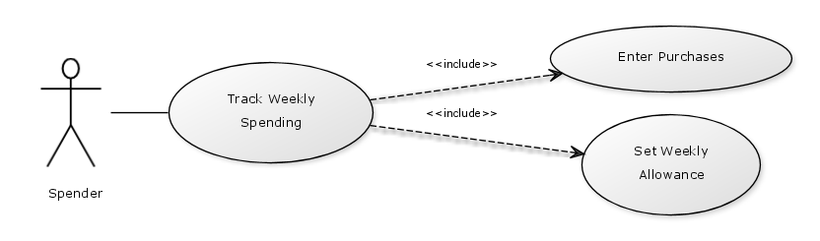

|  |  |
| --- | --- |
| **Name** | Track Weekly Spending |
| **Actor** | Spender |
| **Precondition** | Spender has money (an “allowance”). Spender has an Android phone that is compatible with the Allowance app. Spender downloads and installs the Allowance app. |
| **Steps** | 1. Spender opens the Allowance app. 2. App displays first-run wizard to spender. 3. Spender enters the amount they have to spend each week (their “allowance”). 4. Spender makes a purchase. 5. Spender opens the Allowance app. 6. App displays the current weekly allowance balance. 7. Spender enters the information for their recent purchase. 8. App displays updated weekly allowance balance. |
| **Postcondition** | App displays updated weekly allowance balance. At the end of the week, any money left over is added to the weekly allowance. |

1. 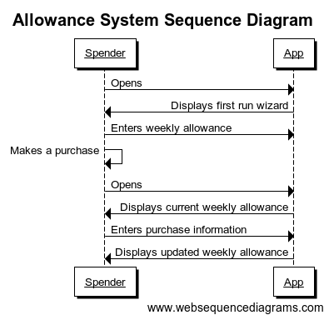
2. 