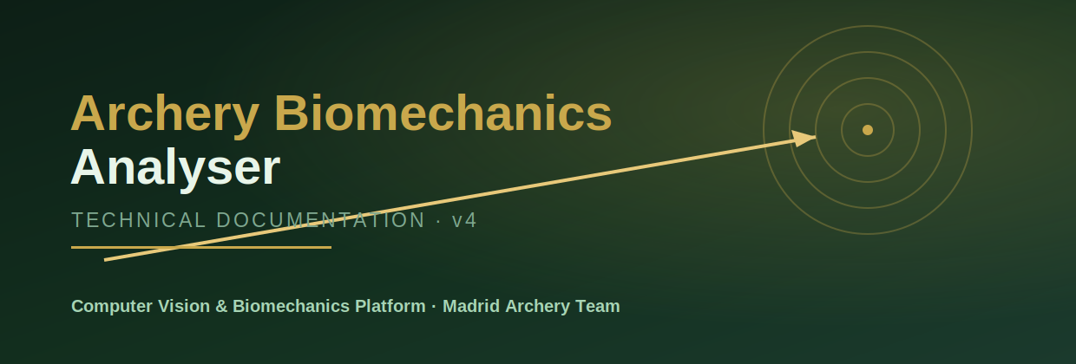
Technical Documentation
Markerless dual-plane biomechanical analysis of the archery shot
Version 4 · May 2026 · Alonso Martín Díez

Contents

1. Introduction
The Archery Biomechanics Analyser is a computer-vision platform that measures the biomechanics of the archery shot from ordinary action-camera footage. It was developed for, and validated with, the Madrid Archery Team. The system requires no motion-capture hardware and no physical markers: it relies entirely on markerless pose estimation applied to two synchronised camera planes.
In recurve and compound archery, accuracy is determined in the final hundreds of milliseconds before release. Micro-adjustments of the wrist, forearm and draw elbow at full draw have a disproportionate effect on where the arrow lands. This platform quantifies those movements frame by frame and turns them into a longitudinal, coach-readable record of each archer's technique.

1.1 Scope of this document
This document describes the system architecture, the biomechanical metrics and their computation, the processing pipeline, the calibration subsystem, the persistence model, the export subsystem, and the deployment and operating instructions. It is intended for developers maintaining the codebase and for technically-minded coaches who want to understand how each number is produced.
Measurement disclaimer
Reference ranges quoted throughout this document are practical coaching guidance distilled from the literature and from team data. They are not clinical thresholds. An “out of range” flag highlights a movement worth a coach’s attention; it is not a diagnosis.

2. System Overview
The platform analyses two camera planes simultaneously:
- Sagittal (lateral) plane — captures the draw arm, elbow flexion, wrist alignment and bow-arm cant.
- Top / zenithal plane — captures shoulder-line rotation and alignment seen from above.
Footage from both planes is processed through markerless pose estimation, temporally aligned, reduced to per-frame biomechanical metrics, segmented into individual shots, and finally exported as reports or persisted to per-archer profiles for longitudinal tracking.

2.1 Capability summary
Capability | Description
Dual-plane analysis | Synchronised sagittal + top-view processing
Markerless pose | MediaPipe Pose (complexity 2) + Holistic fallback
Eight metrics | Per-frame angles with reference ranges
Phase detection | Five-phase shot classification with timing
Shot segmentation | Automatic detection of shot cycles in long clips
Consistency Index | 0–100 repeatability score across shots
Live camera | Real-time webcam / action-cam / RTSP, single or dual
Calibration | ArUco or manual pixel-to-mm scaling
Profiles | Local JSON session history and progression
Exports | Excel, PDF, annotated MP4, CSV

3. Architecture
The codebase separates the user interface (Streamlit pages under app/) from the analysis engine (pure-Python modules under src/). UI pages orchestrate; the src modules contain all the science and have no Streamlit dependency, which keeps them unit-testable in isolation.
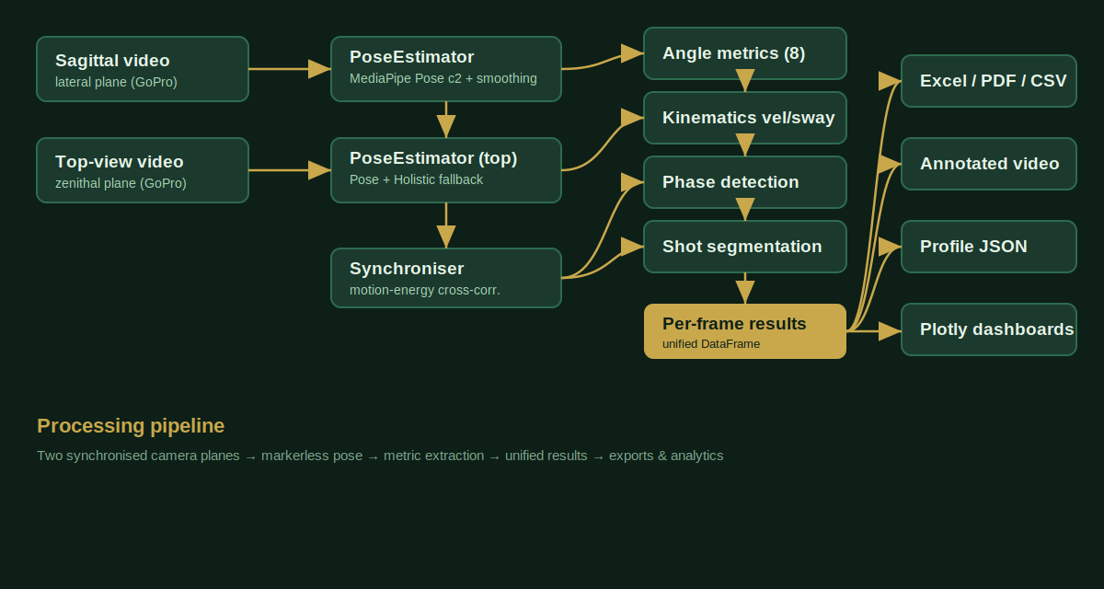
Figure 1 — End-to-end processing pipeline

3.1 Module responsibilities
Package | Responsibility
src/pose | Sagittal and top-view pose estimators with temporal smoothing
src/metrics | Angle metrics, kinematics, stability, consistency, phase detection
src/detection | Multi-shot segmentation from the elbow-angle signal
src/sync | Two-camera temporal synchronisation
src/calibration | ArUco and manual pixel-to-mm calibration
src/export | Excel, PDF, annotated-video and profile-JSON writers
app/pages | Streamlit UI: calibration, upload, live, profiles, analytics
app/_theme.py | Centralised CSS theme and reusable UI components

3.2 Design principles
- Engine / UI separation. Everything in src/ is framework-agnostic and importable without Streamlit.
- Stateless metric functions. Angle functions are pure: landmarks in, value or None out, with explicit visibility guards.
- Per-session trackers. Stateful trackers (stability, velocity, sway, phase) are instantiated per analysis run to avoid cross-session contamination.
- Graceful degradation. Missing landmarks, absent calibration, and unavailable codecs all degrade to a safe fallback rather than crashing.

4. Biomechanical Metrics
Eight metrics are computed per frame, plus two derived kinematic signals. Each angle is computed from MediaPipe's 33-landmark skeleton using planar (2-D) geometry within the relevant camera view.

4.1 Metric reference
Metric | Plane | Range | Meaning
Arm–Trunk | Sagittal | 60–130° | Draw-arm elevation vs torso
Elbow | Sagittal | 100–170° | Draw-arm flexion at full draw
Wrist | Sagittal | 140–180° | Wrist alignment / deviation
DFL | Sagittal | 0–30° | Draw Force Line alignment
Elbow–Wrist Vertical | Sagittal | 0–45° | Bow-forearm cant at release
Bow Cant | Sagittal | 0–20° | Bow tilt vs vertical
Shoulder Tilt | Top | 0–15° | Shoulder-line rotation
Stability (σ) | Sagittal | lower better | Steadiness of the hold

4.2 Angle computation
Joint angles use the standard three-point formula: the angle at vertex P2 formed by points P1–P2–P3 is the arc-cosine of the normalised dot product of the two vectors leaving P2.
def _angle_3pts(p1, p2, p3):
v1 = p1[:2] - p2[:2]
v2 = p3[:2] - p2[:2]
cos = clip(dot(v1, v2) / (|v1| * |v2|), -1, 1)
return degrees(arccos(cos))
Every angle passes through _safe(), which returns None unless all required landmarks exist and carry visibility above 0.1. This prevents spurious angles from being computed on landmarks the model could not actually see.

4.3 Dominant-side auto-detection
Because either arm may be the draw arm, auto_detect_side() compares the mean visibility of the right-arm landmarks (shoulder 12, elbow 14, wrist 16) against the left-arm landmarks (11, 13, 15) and selects the more visible side. The bow-arm metrics then use the opposite side automatically.

4.4 Derived kinematics
- Angular velocity (°/s). Frame-to-frame difference scaled by frame rate, smoothed with a three-point centred moving average, for the elbow and arm–trunk angles.
- Shoulder sway. Rolling 2-D positional dispersion of the draw-side shoulder landmark, capturing micro-movement during the hold.

5. Processing Pipeline

5.1 Pose estimation
Both estimators run MediaPipe Pose at model complexity 2 with inter-frame tracking enabled. The sagittal estimator applies a moving-average smoother over a configurable window. The top-view estimator additionally fuses a Holistic pass: for each landmark it prefers the Pose result when its visibility is at least 0.5, otherwise it falls back to Holistic, and finally carries forward the last valid frame. An exponential moving average smooths the fused result — important because the overhead viewpoint is harder for the model.

5.2 Synchronisation
If the two clips are within 5% of each other in frame count, the cameras are assumed to have started together and no offset is applied. Otherwise a per-frame motion-energy signal (mean absolute inter-frame difference on down-scaled greyscale frames) is built for each clip, and the temporal lag that maximises their normalised cross-correlation is selected. Matching the shape of the activity profile, rather than a single energy value, makes the alignment robust to the low-activity period before the shot begins.

5.3 Shot phase detection
Each frame is classified, from the elbow-angle dynamics, into one of five phases:
Phase | Trigger
pre_draw | Arm extended, elbow above 160°
draw | Elbow bending, between 90° and 160°
full_draw | Elbow stable (rolling σ below 3°)
release | Abrupt angle change above 15° across three frames
follow_through | Post-release, until the arm re-extends
Multi-shot re-arm
After a release the detector enters follow-through and locks. Rather than staying locked for the rest of the clip, it re-arms once a minimum dwell has elapsed and the arm extends past the re-arm threshold, so every shot in a multi-shot clip is phased correctly.

5.4 Shot segmentation
Independently of phase labelling, the elbow-angle series is scanned for complete shot cycles: an arm-extended start, a descent below the full-draw threshold, a local minimum (deepest bend), and a release rise. Detection gaps are linearly interpolated before scanning, and only cycles whose duration falls inside configurable bounds are accepted. Each accepted cycle is reported with its frame span, duration and minimum elbow angle.

5.5 Consistency Index
The Consistency Index quantifies how repeatable a movement pattern is across multiple shots or sessions. All series are time-normalised and interpolated onto a common 200-point grid; the inter-series standard deviation is computed at each point; the index is then 100 × (1 − mean standard deviation / value range), clipped to the 0–100 interval. A score of 100 means perfectly identical shots.

6. Calibration Subsystem
Real-world distance measurements require a known pixel-to-millimetre scale. Two methods are provided; all angle metrics work regardless of whether calibration is set.

6.1 ArUco auto-detection
Any DICT_4X4_50 marker is printed and its physical side length measured. The first 90 frames of the clip are scanned; for each detection the mean of the four marker sides in pixels is divided by the real side length in millimetres, and the median across detections is taken as the scale.

6.2 Manual reference
A known object in the frame — an arrow (≈ 620–710 mm) or a recurve riser (≈ 380 mm) — is measured in pixels; the scale is the pixel length divided by the real length. The page lists common reference objects with typical dimensions.

7. Persistence Model
Archer profiles are stored as human-readable JSON under data/profiles/, one file per archer. A profile records metadata (category, draw hand) and an ordered list of sessions; each session stores its label, date, frame count, the full per-frame data, and a per-metric summary of means and standard deviations.
JSON safety
All numeric values are sanitised before serialisation: NaN and infinities are converted to null, and NumPy scalar types are cast to native Python types. Empty DataFrames (for example a freshly created profile) produce an empty data object rather than invalid NaN tokens, so every profile is strict-JSON parseable.

8. Export Subsystem

8.1 Excel workbook
A three-sheet workbook is produced with openpyxl: a Summary sheet with per-metric statistics and an in-range status flag, a Raw Data sheet with the full frame-by-frame table, and a Charts sheet with a line chart of the angle time series and a bar chart of per-metric means. When no numeric metrics are present the Charts sheet degrades gracefully to a notice rather than failing.

8.2 PDF report
A three-page report is produced with ReportLab: page one carries the title, session metadata and the biomechanical summary table; page two embeds a Matplotlib-rendered time-series chart and, where available, an angular-velocity chart; page three presents shot-phase timing and the metric reference ranges with interpretation notes.

8.3 Annotated video
The sagittal clip can be re-rendered with colour-coded angle lines (green in range, amber borderline, red out of range), a metrics head-up display, the current shot phase, and an optional calibrated scale bar. The source bytes and per-frame results are cached in session state so the export remains available across interface refreshes.

9. Deployment & Operation

9.1 Requirements
Python 3.10 or newer. All Python dependencies are pinned in requirements.txt.

9.2 Installation
git clone <repository-url>
cd archery-biomechanics-analyser
python -m venv .venv
source .venv/bin/activate # Windows: .venv\Scripts\activate
pip install -r requirements.txt
streamlit run app/main_app.py
On first launch MediaPipe downloads its pose model (~30 MB), which needs an internet connection once; afterwards the platform runs fully offline.

9.3 Recommended workflow
- Optionally calibrate the pixel-to-mm scale on the Calibration page.
- Upload a paired sagittal and top-view clip, select metrics, and run the analysis.
- Enter an archer name so the session is appended to that archer's profile.
- Review progress with Shot Comparison, Radar Charts and the Coach Dashboard.

9.4 Dependency overview
Layer | Technology
UI framework | Streamlit
Pose estimation | MediaPipe Pose + Holistic
Computer vision | OpenCV (incl. ArUco)
Numerics | NumPy, pandas
Visualisation | Plotly
Excel export | openpyxl
PDF export | ReportLab + Matplotlib

10. Data Handling & Privacy
- All data stays local; profiles are plain JSON files under data/profiles/ and nothing is uploaded externally.
- Uploaded videos are written to temporary files only for the duration of processing and deleted immediately afterwards.
- Pose estimation extracts joint coordinates only; raw frames are never persisted unless an annotated video is explicitly exported.
- The repository ships four synthetic demonstration profiles so the analytics pages are populated on first run.

11. Roadmap
- Audio-spike synchronisation as an alternative to motion-energy alignment.
- Per-shot consistency scoring within a single clip.
- Configurable, archer-specific reference ranges.
- Release-timing analysis correlating wrist micro-movement with arrow grouping.
Archery Biomechanics Analyser — Technical Documentation v4. Developed by Alonso Martín Díez, Biomedical Engineering, Universidad Europea de Madrid, in collaboration with the Madrid Archery Team.

