AI-Driven Automation of Finite Element Simulations using LangChain and Code_Aster
This project was carried out as a training internship for two students at Politecnico di Torino,
in collaboration with S.T.A. DATA S.r.l.

Authors:
Saeideh Mohammadikish — s329781
Amir Yarmohamadi — s329783

University Promoter:
Politecnico di Torino

Academic Tutor:
Prof. Gianvito Urgese — gianvito.urgese@polito.it

Hosting Entity:
S.T.A. DATA S.r.l.

Company Tutor:
Ing. Davide Seni — davide.seni@stadata.com

November 2025

Proposed Report Structure
- Introduction
  - Background and motivation
  - Role of Code_Aster and Gmsh
  - Why integrating AI (LLMs) with FEM tools matters
  - Goals of this internship
- LangChain Overview
  - What LangChain is
  - Why it was chosen
  - Key concepts (LLM, Agent, Tool, Chain)
  - Examples of companies/projects using LangChain
- System Architecture
  - Overall workflow and pipeline
  - Folder structure
  - Data and file flow (Gmsh → Code_Aster → Visualization)
  - Diagram of the architecture
- Code Implementation
  - geo_generator.py — geometry creation
  - mesher_gmsh.py — meshing process
  - comm_generator.py — solver configuration
  - export_generator.py — export preparation
  - run_aster.py — simulation execution
  - Visualizer.py — results visualization
- Results and Discussion
  - Example of successful runs
  - Interpretation of generated plots
  - Performance and automation improvements
  - Challenges faced and how they were solved
- Conclusion and Future Work
  - Achievements
  - Key learnings
  - Possible extensions (AI-based optimization, SHM integration, etc.)
- Appendix
  - Example outputs, screenshots, code snippets

1. Introduction
In recent years, the integration of Artificial Intelligence (AI) into engineering workflows has opened new opportunities for automating repetitive and knowledge-intensive tasks. One of the most promising applications lies in the field of Finite Element Analysis (FEA), where simulation setup, execution, and post-processing often require significant manual effort and expertise. This internship project aims to explore how Large Language Models (LLMs) can assist in automating and managing FEA processes through the use of the LangChain framework and the open-source solver Code_Aster.
Code_Aster, originally developed by EDF (Électricité de France), is a powerful and open-source finite element software for structural and thermal analysis. It supports a wide range of simulations including linear and nonlinear mechanics, dynamics, and thermomechanics. One of its main advantages is its flexibility: Code_Aster can be used both through a graphical interface (via Salome-Meca) and through command-line or API-based automation, making it ideal for integration with AI-driven systems. Combined with Gmsh for geometry creation and meshing, it provides a robust environment for end-to-end numerical analysis—from model generation to result visualization.
Compared to other commercial alternatives such as ANSYS, Abaqus, or COMSOL, Code_Aster offers full transparency, scriptability, and cost efficiency, which are crucial for research and automation workflows.
The LangChain framework acts as the intelligent layer of the system, enabling the LLM to reason, call specific tools, and manage complex interactions. By connecting LangChain agents to customized Python tools, the model can generate geometry files, prepare solver input decks, execute simulations, and visualize results autonomously. This approach demonstrates how AI can enhance existing FEA workflows by reducing human intervention and bridging the gap between natural language instructions and executable simulation commands.
The goal of this internship was to design and implement a prototype of an AI-assisted pipeline capable of running structural analyses in Code_Aster autonomously. The system was built to understand user queries, generate the corresponding input files, execute the solver, and visualize the outputs—all through a modular and explainable structure. This work represents a step toward the digital transformation of traditional FEA workflows, combining engineering knowledge with the reasoning capabilities of modern language models.
During the internship period, Amir Yarmohamadi and Saeideh Mohammadikish collaboratively developed and tested the entire pipeline, working on both the conceptual design and the technical implementation. Their contribution included defining the system architecture, implementing the LangChain-based tools, configuring the Code_Aster environment, and validating the numerical results through real simulations. The internship provided an opportunity to combine their backgrounds in structural engineering and artificial intelligence, demonstrating how interdisciplinary collaboration can lead to more intelligent and automated simulation workflows.

2. LangChain Overview
LangChain is an open-source framework designed to facilitate the development of applications powered by Large Language Models (LLMs). Rather than using an LLM as a standalone chatbot, LangChain enables it to interact with external tools, APIs, and databases, allowing it to perform complex reasoning and take real actions. The framework provides the building blocks for integrating natural language understanding with structured programmatic control, which makes it ideal for intelligent automation systems like the one developed in this project.
At its core, LangChain organizes an application into several modular components:
- LLM (Large Language Model): the central reasoning engine that interprets natural language prompts and generates responses.
- Tools: Python functions or APIs that the model can call to perform specific tasks, such as file generation, running a simulation, or visualizing data.
- Agents: decision-making modules that determine which tool to use and when to use it based on the user’s intent.
- Chains: sequences of processing steps that link multiple tools or reasoning stages together.
- Memory: components that store contextual information across interactions, allowing for persistent and adaptive behavior.
In this project, LangChain was selected because it allows seamless integration between AI reasoning and engineering computation tools. By defining each Code_Aster-related operation as a separate LangChain Tool, the LLM could autonomously manage the full workflow: generating geometry and mesh files, creating solver input decks, executing the analysis, and visualizing results. This modular and interpretable design makes it easier to debug, extend, and scale the system while maintaining transparency in every step of the process.
LangChain has already been adopted by several major organizations and open-source projects pursuing similar intelligent automation goals. For instance, OpenAI’s ChatGPT plugins employ LangChain-like architectures to enable large language models to call external APIs securely; Zapier AI Actions use LangChain to connect LLMs to thousands of third-party web services; and Notion AI leverages it to perform dynamic reasoning and content generation within documents. Furthermore, open-source initiatives such as OpenDevin and AutoGPT use LangChain to build autonomous software engineering agents capable of complex decision-making and task execution.
In the context of this internship, LangChain served as the intelligent bridge between natural-language reasoning and numerical computation, transforming traditional finite element workflows into adaptive, AI-assisted pipelines.
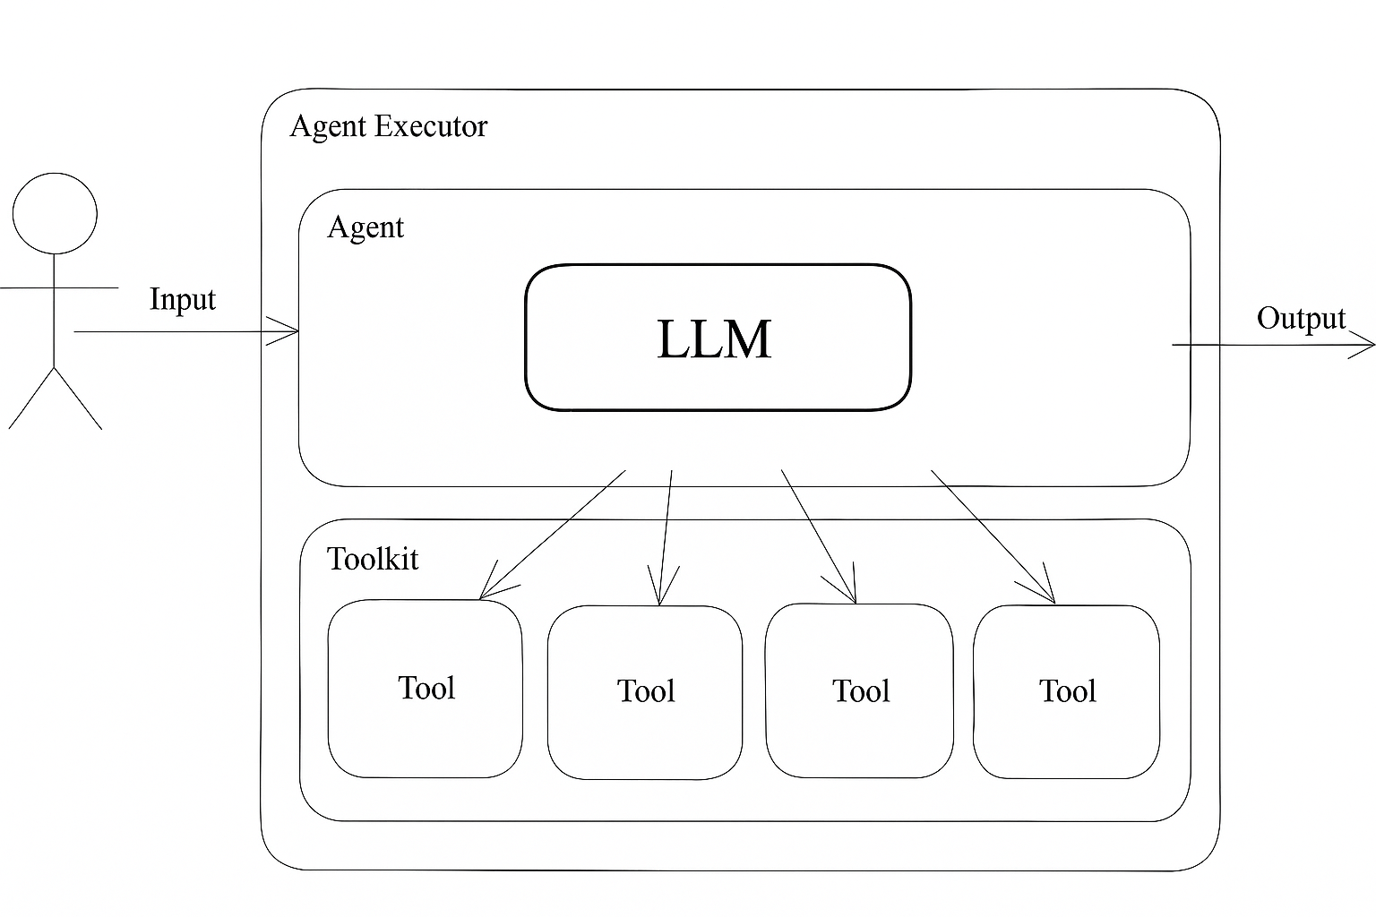
fig 01. LangChain Agent Architecture and Interaction Flow

3. Code_Aster Overview
Code_Aster is an open-source Finite Element Analysis (FEA) software developed and maintained by Électricité de France (EDF). It is one of the most advanced and well-documented open-source solvers for structural and thermal mechanics, widely used in research and industry for simulations involving elasticity, plasticity, dynamics, contact, fracture, and thermomechanical coupling. Its high flexibility and script-based design make it particularly suitable for integration with automated and AI-driven workflows such as the one developed in this project.

3.1. General Description
Code_Aster can be operated both through a graphical user interface (GUI) — typically via Salome-Meca, which provides pre- and post-processing tools — or directly from the command line, where it is invoked by the execution manager as_run.
It also integrates smoothly with Gmsh, an open-source geometry and meshing software, allowing users to define geometric models (.geo), convert them into mesh files (.med), and import them into Code_Aster for simulation.
The solver supports both linear and nonlinear analyses, static and dynamic problems, and a wide range of element types and material behaviors. Its modular input structure enables the user to define geometry, materials, boundary conditions, loads, and output options in a single, script-like file.

3.2. Syntax and Input Files
A standard Code_Aster analysis typically requires three key input files:
- .comm file: defines the analysis setup using Code_Aster commands (similar to Python syntax).
- .med file: contains the mesh geometry, often generated by Gmsh or Salome-Meca.
- .export file: specifies file paths and parameters for running the solver.
The .comm file is the core of the analysis. This syntax allows full control of the simulation logic while maintaining transparency and reproducibility. Because Code_Aster’s input language is highly structured and close to Python, it can be easily generated or modified by external scripts including those written in Python and managed by LLMs through LangChain.

3.3. Execution and API Integration
Code_Aster can be executed in multiple ways depending on the user environment and automation level:
Graphical Mode (Salome-Meca): suitable for interactive modeling, meshing, and result visualization.
Command-Line Mode: the solver is executed using the as_run command, which reads the .export file and launches the analysis. Example:
as_run model.export
Python or API-Based Automation: Code_Aster can also be integrated into Python scripts via subprocess calls or direct API bindings (e.g., code_aster.CA). This enables external control and automation of the solver, allowing it to be triggered dynamically by higher-level AI agents.
In this project, the execution was handled programmatically using a Python wrapper (run_aster.py), which invoked Code_Aster via the subprocess module. This made it possible for the LangChain agent to autonomously prepare, run, and monitor the analysis process while interacting with the solver as an external computational tool.

3.4. Advantages over Commercial Alternatives
Compared to proprietary solvers such as Abaqus, ANSYS, or COMSOL Multiphysics, Code_Aster offers several key advantages for research and automation:
Open-source and fully scriptable: ideal for integration with AI or algorithmic systems.
Extensive documentation and validation database: over 2,500 test cases verified by EDF.
High flexibility: supports Python-like logic, loops, and conditional execution inside .comm files.
Cost-effective and transparent: accessible to universities and small companies without licensing constraints.
Integration-ready: compatible with Gmsh, Salome-Meca, and modern APIs, making it an excellent choice for developing intelligent, automated FEA pipelines.

4. System Architecture

