Step 1: Install XAMPP, Run Apache and MySQL

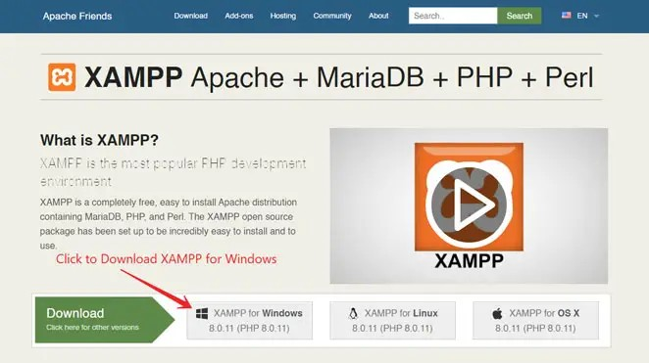To install XAMPP, visit the apachefriends.org website. Then, download and install XAMPP on your PC. Install version 7 and above

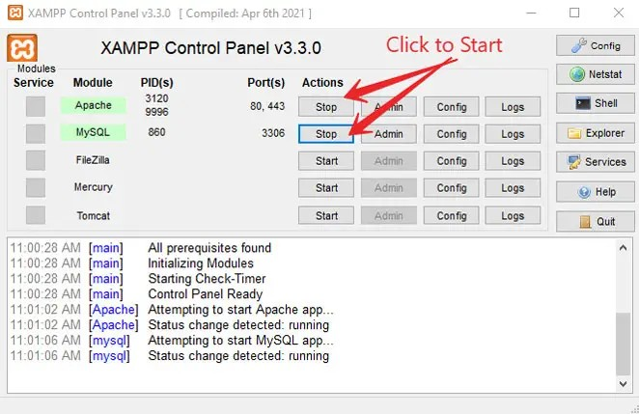After installing XAMPP on your PC, open it. Then run Apache and MySQL as shown in the image below.

Step 2: Place Your Project Folder on the Local Server

On a live web server your website files (aka your project files) are located in directories (mean folders). Same as the files and folders on your computer. Here, to run PHP code in XAMPP, your website files will store in the htdocs folder which is located in the XAMPP folder.

To do this, you have to copy-paste your PHP project folder into ‘htdocs‘ folder as shown in the image below and create a folder inside it with any name.

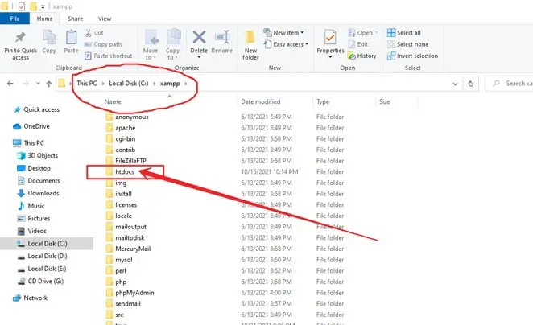

### 3. Create MySQL Database to Connect to Project

To do this, open your browser. And type localhost/PHPMyAdmin in your browser’s search bar and press enter.

Now see the next image below. In this image, on the left side, all databases are listed. Just click on the ***New*** button to add a new database.

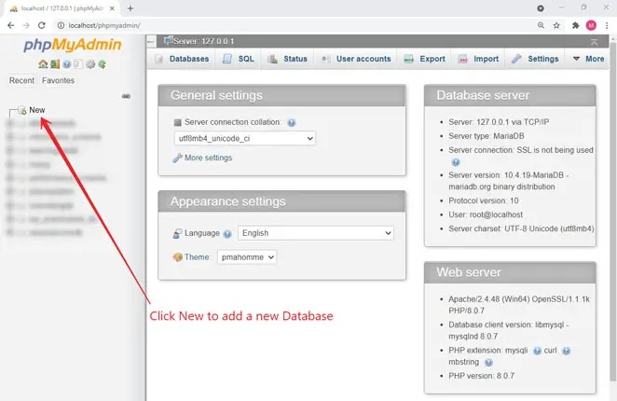

### On the next page, you will choose the name of your database. Name it dbrecruitment. After that click on Create button

Now click the import button on the top navbar and upload the database file sent to you.

### Step 4: Execute or Run Project in Your Browser

To do this, open your browser and type in the search bar **localhost/recruitment** And hit enter. This will launch the project