**AmericanEagle.com – Skill Assessment**

Website: **Beautiful Beginnings**

Name: **Sayeeda Tasmia**

**Summary:**

As per the requirement received by client, below are the items that haven’t been covered or developed yet or few existing codes has issues and need to be resolved to be able to fully test.

**Font –**

***Requirement*** - *We set up the Allura and Alex Brush font family stacks in the CSS, but we don't have the fonts included.*

I have included the font by using the code below.



Before –



After –



This is just an example, but you can see the changes of the font has been applied to the overall website.

**Site Logos –**

***Requirement*** *- We need to account for retina screens.*

I added a width and height for class **slide_bg**.

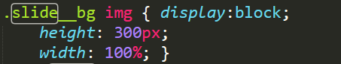

**Icons –**

***Requirement*** *- We haven't been able to add the icons to the setup yet.*

*- Hamburger menu, cart, and search icons haven't been added.*

I have set up icon for the url, created a hamburger menu, set up shopping cart icon with total number of items in the cart and also a search icon.

**URL Icon –**

Before –



After –



**Hamburger Menu –**

Before – Not implemented

After – Implemented

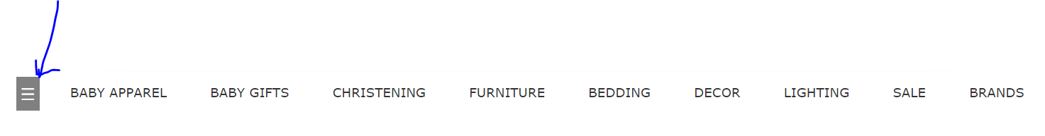

Upon clicking it displays the menu items.

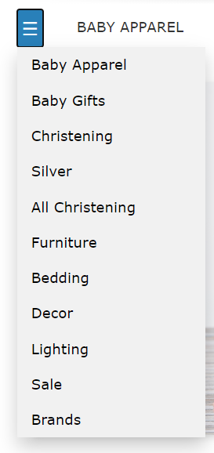

**Cart Icon –**

Before –



After –

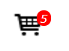 This cart icon also displays the number of items inside the cart which by default is 5. But I have also implemented a feature where upon adding new items to the cart the number of items displayed in the cart icon increases. This you can find it in the main.js and the html and CSS in the index.html and styling.css. Also added a new feature where on clicking the cart icon a pop-up window appears with number of items, description, quantity and subtotal with two buttons to either continue shopping or checkout.

Below is the screenshot.

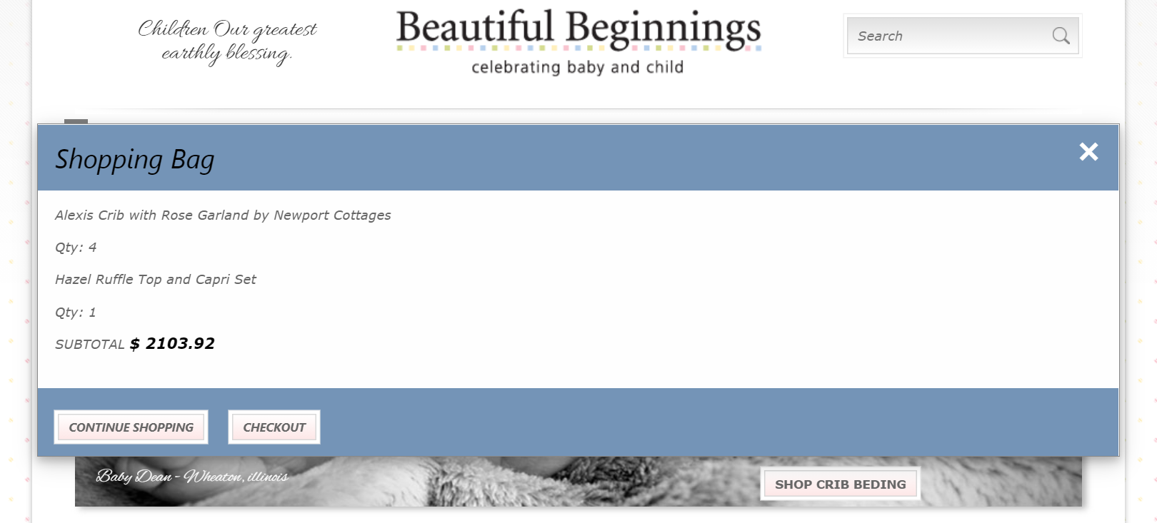

This is the pop-up window which appears upon clicking the shopping cart icon. If you click continue shopping it will take you to the site back.

**Search Icon –**

Before –



After –

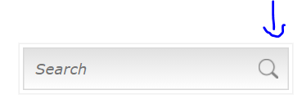

As you can see the arrow pointing towards the search icon which I added.

All these images you can find in the images folder and the HTML code for it in the index.html

**Navigation –**

*Requirement - We haven't setup functionality for the menu toggle to open up the bottom footer area in small screens.*

I did not quite understand this question and worked on the footer and made it look like this.

**Before** –

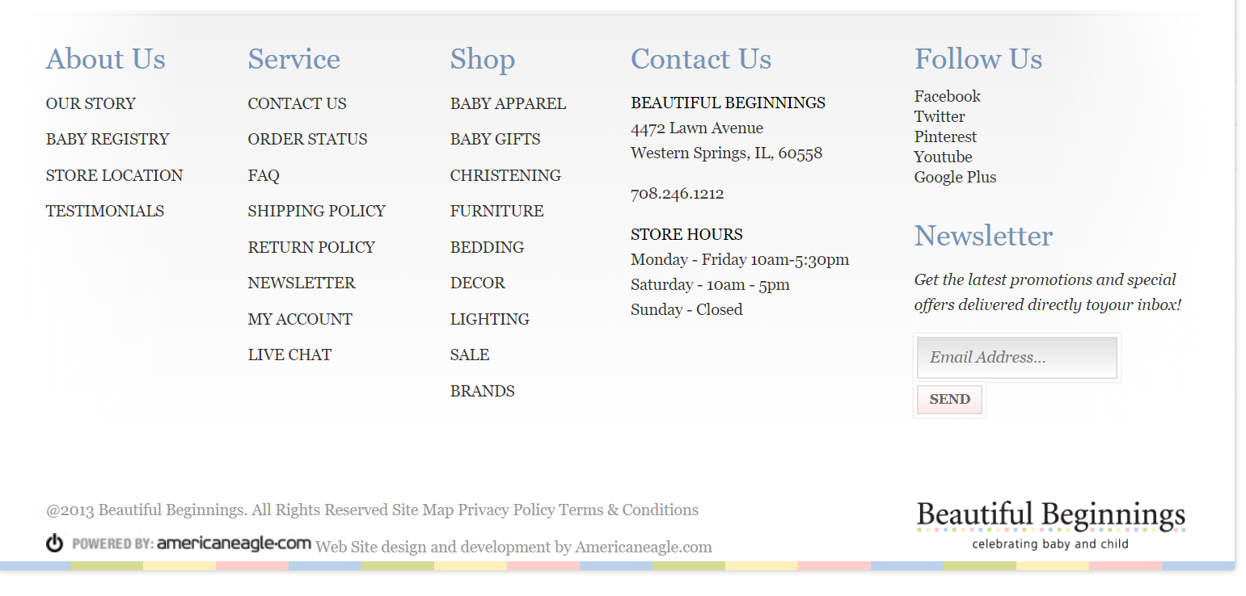

**After** - 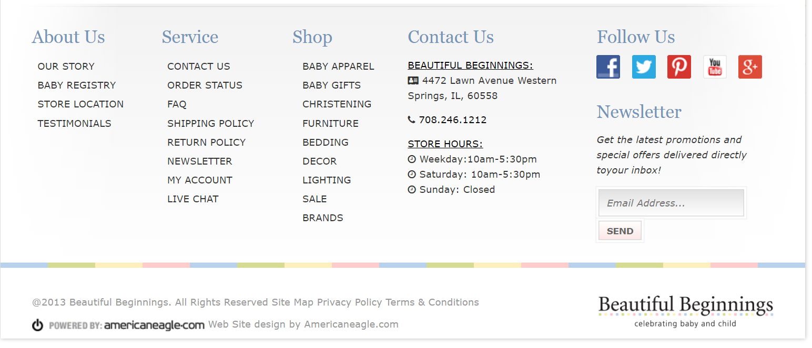

As you can see footer is separated in a presentable way.

**Slideshow –**

*Requirement –*

*- We need another slide created from the PSD*

*- The styling isn't right yet for slide content as well*

*- We also haven't been able to set up the slide functionality.*

So, with the existing work there was only one slide present and was displayed in the main page. I tried to add the animated slideshow with two more slides which keeps changing for every two second and dots below it to show which slide is currently been displayed out of three slides.

I picked images from google for the other two slides and the slideshow functionality works perfectly as expected.

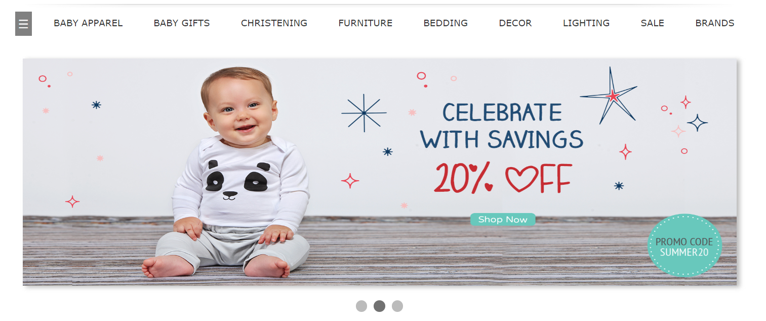

The first image is kept as it is but added two more slides and did the animation which you can see upon running the website.

Attaching just the snippet and not the whole CSS code. But you can find the code in styling.css file, and the JS in the main.js

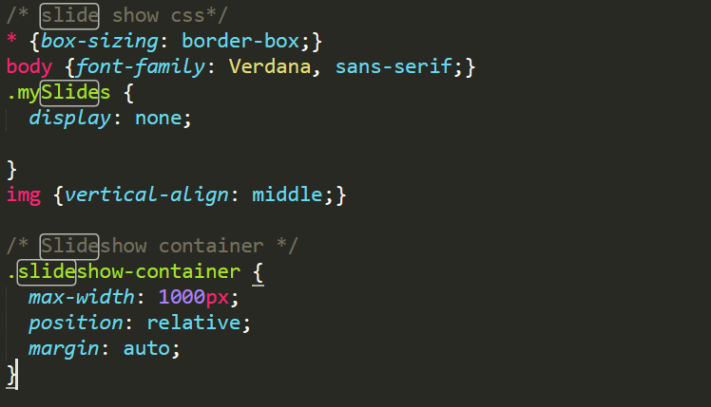

Below is the screenshot for the slideshow function in main.js

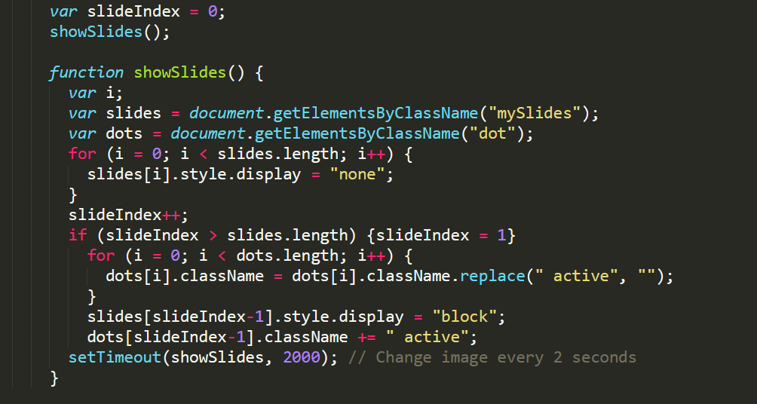

**Footer –**

*Requirement –*

*- We got a fair amount of responsive styles done for the site however the footer isn't quite there yet*

*- Social media icons need to be setup so some html changes there to put them in is fine.*

*- Expander accordion JavaScript functionality hasn't been setup or styled*

*- Footer bottom area: we unfortunately can't pull the html content out of its location*

*- Can we style up the setup, so it matches the desktop and mobile styles.*

I did the footer part and made it look better than before by separating the footer from the menus like About US, Shop, Service, Contact Us, Follow Us and Newsletter.

Worked on the social site as well where changed it from text such as FaceBook, Twitter, Pinterest, YouTube, Google Plus with the icons and upon hover the icons appear to be little bigger that will help the user understand where the cursor is and what he is about to click.

Before –



After –



The overall Footer looks like this:

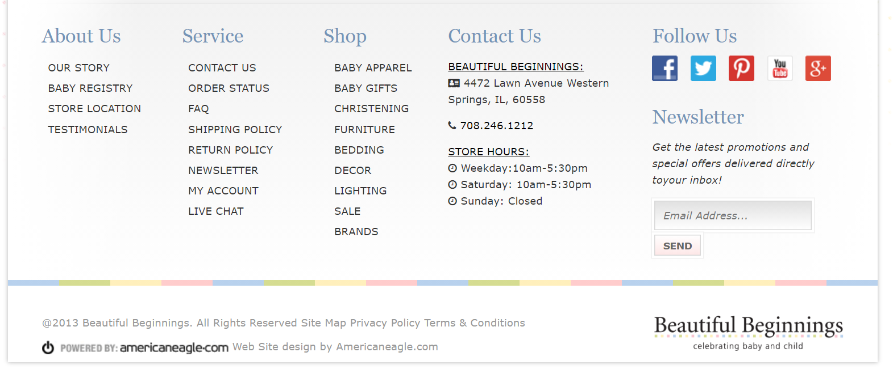

**Expander Accordion –**

Worked on the expander accordion where for the smaller screens the menu options like About Us, Shop and Service is collapsed, and user can click on it to expand and see the sub menu items.

This is a screenshot for a smaller screen –

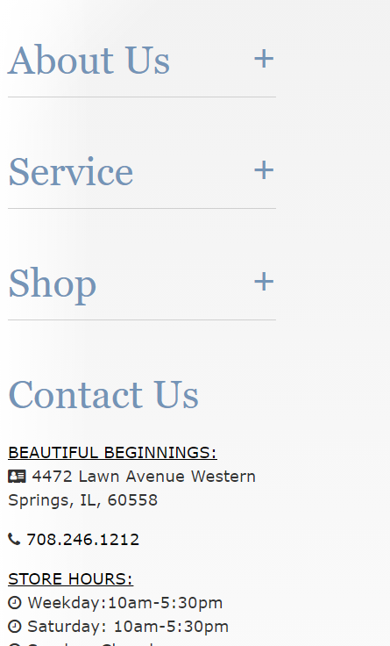

Upon clicking either the About Us or Service or Shop or by clicking the ‘+’ icon the expander works and displays the other items for that menu.

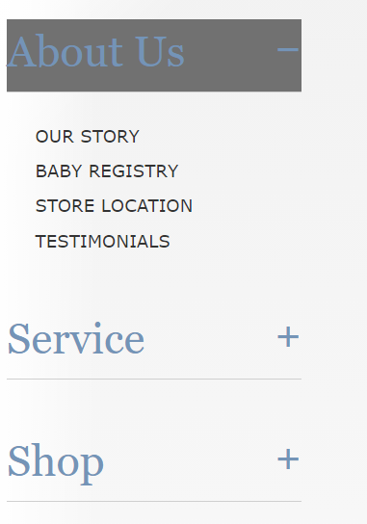

Similarly, it works for Service and shop and you can collapse it again.

**Responsive –**

*- For some reason the site isn't switching over to "mobile" styles in devices*

*- Also, when you shrink down the browser some sort of content is causing a horizontal scrollbar in smaller screens*

*- In between sizes for tablet portrait feel fairly empty, is there something we can style to make them look better.*

I was able to achieve the responsiveness but not fully. The things that does not appear in the mobile view are the footer part which comes after the Newsletter and the Nav bar though I tried making the hamburger appear in the mobile view. Rest others looks as expected. The image of the mobile view is been added to PSD folder in the name mobileView.png and desktop view in the name of desktopView.png

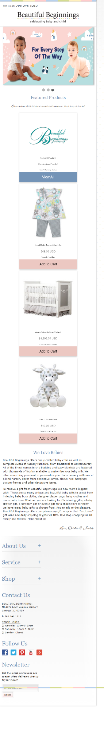

Desktop View

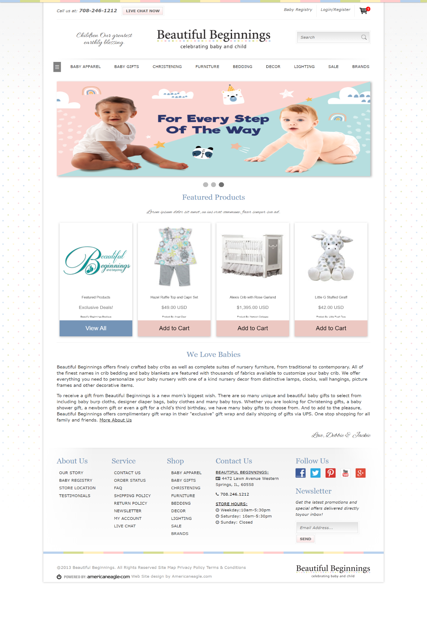

Along with all the requirements mentioned additional changes I have added is the shopping bag pop up window with the details of items and also add to cart functionality.

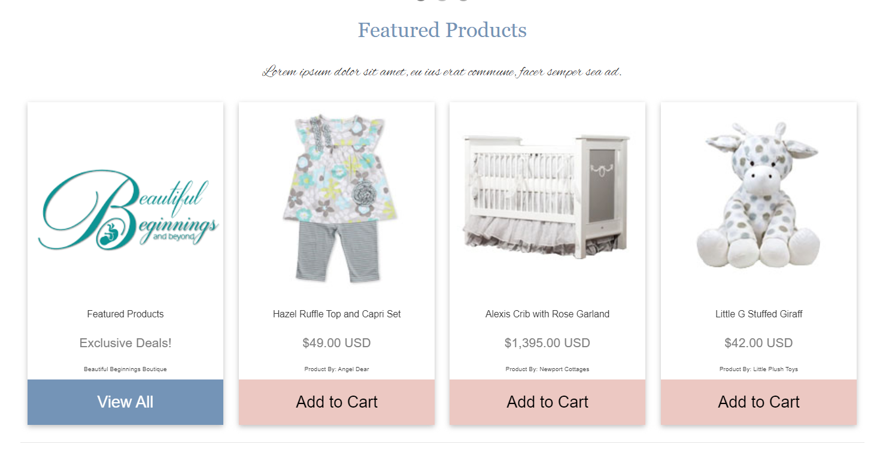

This Add to cart feature is functional and upon adding the shopping cart item increases. The JS code can be found in main.js and HTML and CSS in the index.html and main.css and also styling.css.

After adding an item to the cart, the cart item increases from 5 to 6.



Upon hovering on each item, the item appears to be bigger if the cursor is on the selected item.

This can be experienced while the website is open.

**Conclusion** –

I enjoyed working on this assignment and did my best. Please look at the website and do provide me a feedback. I have zipped the folder which has the index.html which is the only html page for this single page application and have new CSS files such as general.css, Styling.css and mobile.css under the CSS folder and the JavaScript code has been put in a separate file and can be retrieved from JS folder. I would appreciate if I get the feedback for my work. This website can be further improved by adding more features to it and can be made interactive. If given I would definitely like to implement Live Chat feature and sending newsletters for the entered email address and a lot more.

Thank You!