**RELATIONSHIP BETWEEN DIFFERENT FOOD ENVIRONMENT FACTORS**

Graph 1:

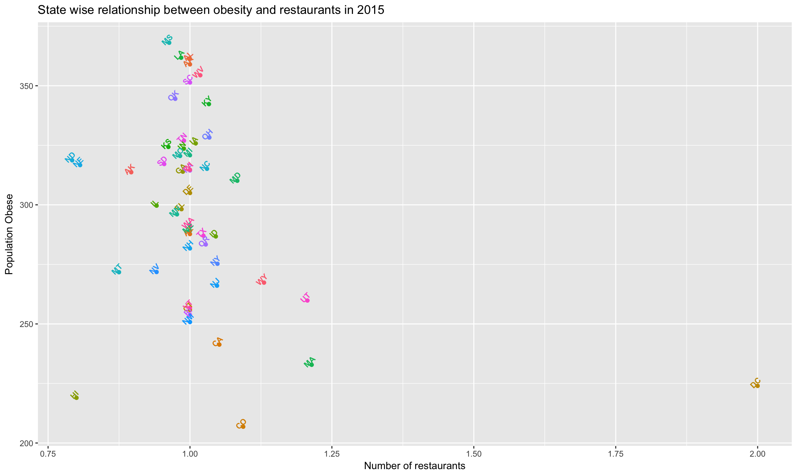

Graph 2:

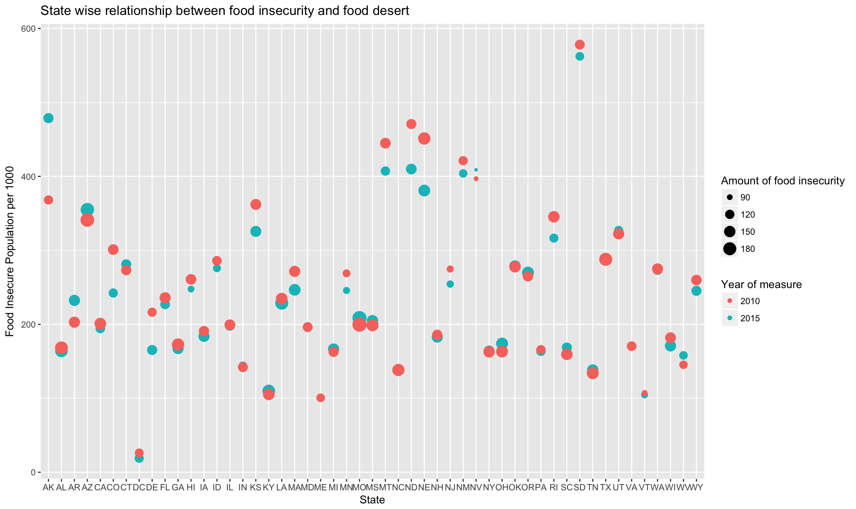

Graph 3:

