Validity
The CSX Core System Requirement Specification is valid for Phase I of the CSX Core System project between Siemens and CSX. Upon completion, this document will be utilized to execute Phase II, implementation, of the requirements identified within.

Scope
These requirements specifications
- are valid for the product CSX Core System with its components
- are valid for the duration of the whole life cycle from planning to discontinuation
- will be supplemented and updated during the phase I of the CSX Core System project
- are valid for all organizational units involved in the project
- will be established during phase 1

Document Conventions
This section describes the conventions used in this document for use cases and requirements.
Use cases and requirements together make up the functional requirements.
The use cases are focused on Core System functionality requiring user interaction.
Where there is no user interaction, requirements are used to describe the Core System functionality.

Use Case Template Format
Each Use Case is described in a standard template format. The following is a description of the template.
Title: Unique ID and title given to Use Case, in the following format: UC-["Feature"]-[NNN]: "Use Case Title"
Description: A high-level summary paragraph of the scenario that is being described for the specific Use Case.
Use Case Actor(s): A bulleted list of actors associated with the Use Case.
Preconditions: A bulleted list of conditions that must be set for the Use Case and are in effect prior to the Trigger event.
Trigger: The initial event that would start the Use Case scenario.
Successful End Condition: The expected result of the Use Case, based on the description and attributes of the Use Case as documented.
Normal Steps: The steps that must be completed in a numeric list, that results in the expected result of the Successful End Condition and contains no Exceptions or Extensions.
Exceptions: Any possible condition or event that might happen that is not expected as described in the Normal Steps, described in a cause and result format. These can be errors or alternative paths to the Use Case. The cause is listed as the main bullet and is preceded by the step or steps in the use case that the Exception applies to, for example if Exception Text A applies to step 3 through 5, the cause will be listed as “3-5: Exception Text A”. If the same Exception applies to multiple steps that are not consecutive, they are listed with a comma, e.g., “2,6: Exception Text Common”. If there is more than one Exception for the same steps, the steps number will be followed by a, b, etc. e.g., 3-5a: … 3-5b: … The result of the exception and associated steps are given in a numeric list. Additional branches within an exception step are denoted by indented lists beneath the step.
- If there are no Exceptions, then it should have "No Exceptions for this Use Case." listed.
Extensions: Any possible condition or event that does not currently exist that can be described as an addition to the feature in the Use Case described in a cause and result format. Extensions will still lead to the successful end condition but there may be specific cases where additional steps are needed. The cause is listed as the main bullet and is preceded by the step or steps in the use case that the Extension applies to, for example if Extension Text A applies to step 3 through 5, the cause will be listed as “3-5: Extension Text A”. If the Extension is additional steps, the numbering will be the next step, e.g., if there are 5 steps in the use case, the Extension would be labeled as “6: Extension next step”. If the same Extension applies to multiple steps that are not consecutive, they are listed with a comma, e.g., “2,6: Extension Text Common”. If there is more than one Extension for the same steps, the steps number will be followed by a, b, etc. e.g., 3-5a: … 3-5b: …The result of the extension and associated steps are are given in a numeric list. Additional branches within an extension step are denoted by indented lists beneath the step.
- If there are no Extensions, then it should have "No Extensions for this Use Case." listed.
Other Conventions used when describing Use Cases:
- All the fields in the Use Case must be filled in as described above
- Any Actors listed should be capitalized
- Systems or Sub-Systems listed should be capitalized

System Overview

Purpose of System
The CSX Core System is a system within the CSX Office Segment that provides the infrastructure and functionality to enable CSX’s vision for Autonomous Operations.
Dispatchers, field employees, yardmasters, bridge tenders etc. have access to the Core System, all able to view the same current state of the system, but with displays customized to their position, role, and responsibility. The different types of users can perform tasks and share information directly within the system, which reduces the need for verbal communication, increasing efficiency while reducing potential points of errors.
A core concept in the Core System is Exception Based Dispatching, which replaces traditional dispatching and aims at automating tasks where possible, requiring user intervention only in exception cases, which are circumstances that are outside the capabilities of current automation. The goal is to allow users of the Core System to monitor the system and focus on important tasks and emergencies – the exceptions, rather than on routine tasks.
Automation is provided by integrating existing and future systems with the Core System, as well as implementing advanced features within the Core System. Therefore, the Core System is easily extendable to enable additional automation over time.
Examples of automation include:
- Optimized routing via the integration of the Core System with MPP (the Meet/Pass Planner). The goal is to minimize train delays by recognizing and resolving conflicts dynamically and setting routes automatically.
- Electronic delivery of mandatory directives via the integration of the PTC BOS and the Core System. The goal of electronic delivery of mandatory directives is to minimize verbal radio communication, which is not only time consuming but also prone to errors.
- Placing Temporary Speed Restrictions in emergency situations, for example when a train experiences emergency braking, and notifying surrounding trains automatically. The goal is to ensure that affected areas are protected quickly and safely.
For tasks that cannot be automated or when exceptions occur, the Core System provides mechanisms to draw the user’s attention to important tasks that need to be performed manually. Assistance is provided to users of the Core System by displaying relevant context sensitive information.
The Core System is mission-critical and therefore provides multi-level redundancy (application redundancy, server redundancy, and data center redundancy). Furthermore, it implements an architecture that allows hardware, software, and configuration changes to be performed with zero downtime and supports on-premises, off-premises, and hybrid deployments.

Core System Context
The Core System context is illustrated in Figure 1 on the following page. The various interconnected systems are described in this chapter.

Core System Components
The Core System context is made up of two main components: the Core Office System and multiple Core System User Clients. The clients are utilized by dispatchers, office personnel, yard personnel, field employees, train crews, and any other authorized user to interact with the Core System.
The Core System User Client can run on many different platforms and environments depending on the needs of the user. For instance, a Dispatcher would interact with the Core System clients at their workstation, while a system administrator may interact with the Core System Client from their office desktop. Field employees and train crews are expected to utilize a common field device with the Core System client and other business applications. In the case of field employees utilizing the Core System from a field device, only the Core System client, not the field device itself, is considered to be within the Core System context.

Highly Integrated Systems
Certain office systems are considered “highly integrated” within the context of the Core System. These systems are the PTC BOS and the Meet/Pass Planner (MPP). The PTC BOS performs critical functions to deliver information to PTC-equipped trains. The MPP provides routing recommendations to the Core System to enable automated dispatching.

Support Services
The Core System interacts with numerous other systems within the CSX office environment. These support services provide authentication, bulletin data, crew data, weather data, and other relevant supporting services. These services, while crucial for Core System operations, are not considered highly integrated.
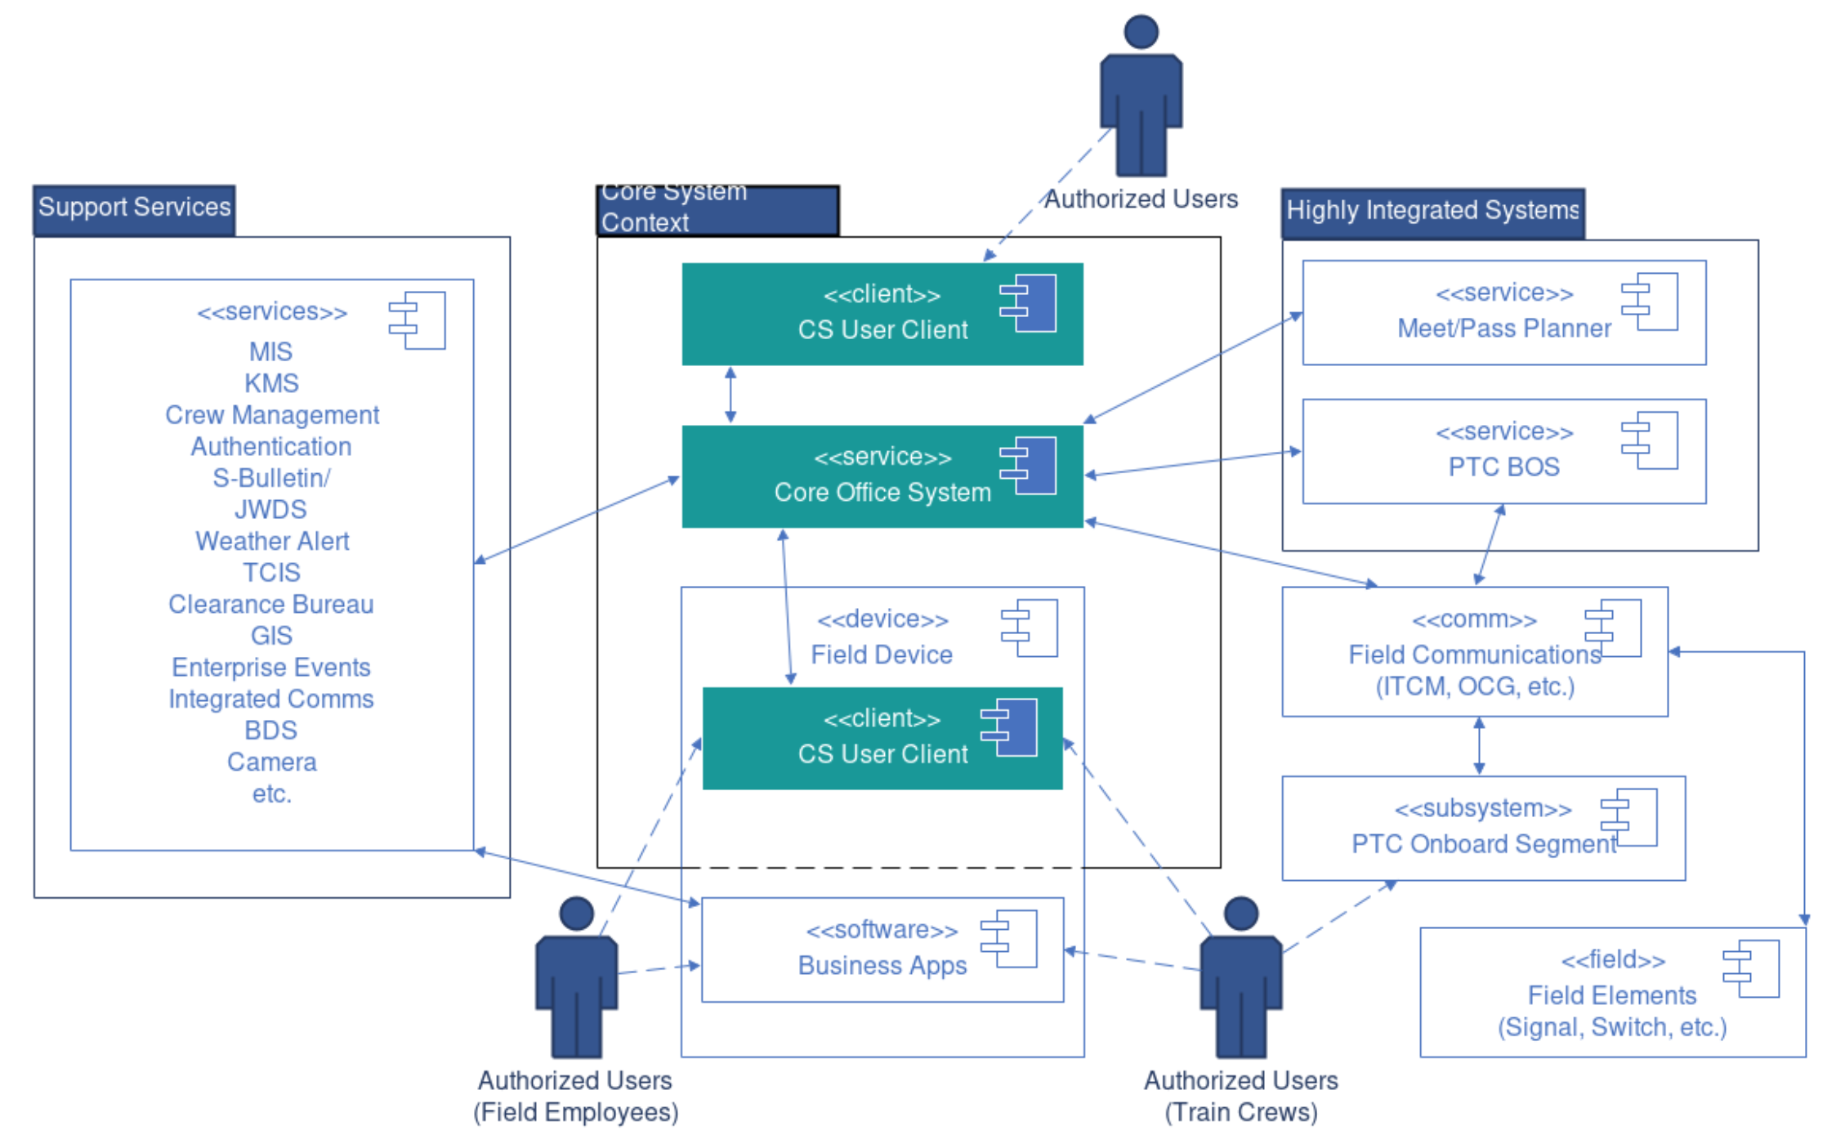
Figure 1. Core System Context

Actors
An actor can be a person or any external system with which the CSX Core System interacts. The external system actors are listed in the System Context section.

Dispatcher
One of the key stakeholders for the CSX Core System is the dispatcher. The dispatcher is responsible for directing and coordinating the safe and efficient movement of trains and on track equipment on a specific territory from a central and/or regional location.

Chief Dispatcher
The Chief Dispatcher directly supervises dispatch operations as well as ensuring the dispatchers working specific territories under the chief's control are performing their duties in a safe and efficient manner.

Bridge Tenders
Bridge Tenders operate and maintain bridges (on-site and remotely) to ensure the safe passage of water traffic and trains.

Crew Management
Crew Managers manage train and engine manpower. They call train crews for duty assignments and manage resource needs by location.

Database Manager
The Database Manager is a system administrative user of the CSX Core System that is responsible for managing configurations (e.g., users, system, track, interfaces), troubleshooting issues, monitoring the health of the CSX Core System, and setting up and maintaining environments.

Electronic Signal Specialist (ESS)
The ESS remotely troubleshoots field signal issues and dispatches signal maintainers. They are typically the first responders for field issues on the CSX Core System (e.g., inability to line a signal, hardware issue, infrastructure testing). ESS specialists have differing job responsibilities and corresponding ability to perform certain tasks.

Engineering Supervisor
These employees supervise a team of track workers. Engineering Supervisors will need to monitor the conditions in the field where track work is ongoing and may request track time.

Field Employees

Signal Field Employees
Signal Field Employees assist in the installation, repair and maintenance of various railroad signals and grade crossing protection equipment.

Engineering Field Employees
Engineering Field Employees work as a member of a crew to install new railroad track, maintain existing track and right-of-way.

Employee in Charge (EIC)
A designated roadway worker/lone worker qualified on Operating and On-Track Worker Rules and physical characteristics who is responsible for all movements and on-track safety for a roadway work group within working limits.

Foreign Railroad Employees (External)
A foreign railroad (External) is any railroad that does not use the CSX Core System to control traffic.

Foreign Railroad Employees (Internal)
A foreign railroad (Internal) is any railroad other than CSXT that uses the CSX Core System to control train traffic. Currently, this includes IHB and LIRC.

Foreign Railroad Chief Dispatcher
A Foreign Railroad Chief Dispatcher has the same responsibilities as a Chief Dispatcher with the difference that this person is employed and responsible for a division on a foreign railroad.

Foreign Railroad Dispatcher
A Foreign Railroad Dispatcher has the same responsibilities as a Dispatcher with the difference that this person is employed and responsible for a territory on a foreign railroad.

Emergency Operations

Local Police / Emergency Management Service (EMS)
Local Police/EMS will coordinate with PSCC for any CSX rail emergency situations that occur in that specific location.

Office of Emergency Management (OEM)
The Office of Emergency Management will coordinate with PSCC for any CSX rail emergency situations that occur in that specific location.

Locomotive Planning
This team plans which locomotives should be on which trains. They monitor locomotive-based data and ETAs of trains and locomotives.

Mechanical Department
The Mechanical Department inspects, repairs, and maintains freight cars and locomotives.

Network Planners
This team runs service planning which includes creating and updating train profiles and schedules. They access reports and analytics to facilitate necessary changes.

PTC Support
This team consists of the first contacts for train crews experiencing PTC-related issues in the field. They monitor the state of PTC interfaces, trains, messages, and will be notified of any pertinent events related to PTC.

Public Safety Communication Center (PSCC)
As the company’s security hub, the PSCC is in contact with CSX Police and emergency agencies across the system 24 hours a day, seven days a week. The center takes calls from CSX employees, the public and law enforcement officers regarding incidents on or near CSX property and plays a central role in initiating and coordinating emergency response efforts to everything from weather emergencies to grade crossing accidents and hazardous material releases.

Signal Supervisor
These employees supervise a team of signal engineers. Signal Supervisors will need to monitor the conditions in the field where signal work is ongoing and may request track time.

Tech Support (Tier 0)
Responsible for maintaining the infrastructure including the application of required and approved patches and upgrades to network software and devices. Tier 0 Tech Support provides 24/7 support to Network Operations for issue resolution.

Test Team
Responsible for the verification and validation of the CSX Core System releases. This is comprised of both CSX and Siemens teams. Defect Management infrastructure is critical to the coordinated activities to resolve and manage defects. This team ensures that the CSX Core System fully supports safe and efficient operations.

Training

Trainee
Trainees include:
- All Authorized Users that need instruction on the CSX Core System (initial release and updates)
- New Users
- Users training on a new territory

Trainer
Trainers include:
- CSX Core System Trainers that provide instruction on system functionality
- Dispatch Trainers that instruct new Dispatchers and those training on a new territory
- Field Employee that instructs new Field Employees and those training on a new territory

Transportation Manager

Manager of Train Operations (MTO)
The Manager of Train Operations (MTO) is responsible to oversee train operations in and out of their area of responsibility safely and efficiently.

Network Operations Manager (NOM)
This user manages a group of divisions. They monitor traffic on their territory and respond to critical events and delays.

Senior Transportation Manager
These users are the executive branch of CSX Transportation and oversee the entire rail network. They assess network analytics and delays, coordinate with Dispatchers, and ensure issue resolution.

Yardmaster
The Yardmaster ensures the safe, efficient operation of yard service for on-time movement of trains.

Train Crew
The train crew is responsible for operating trains to transport goods/passengers to their destinations in compliance with all applicable operating rules.

