Purpose
The Subsystem Requirement Specification (SSRS) is a collection of requirements that will be used for the design and development of the functionalities and features specified therein.
The subsystem requirements are derived from the requirements and use cases in the Core System Requirement Specification (SRS) that are applicable to this subsystem.
The SSRS factors in the applicable interfaces to entities or systems external to the Core System, with the interfaces being defined by the corresponding Interface Control Document (ICD).
The subsystem requirements are written from the subsystem point of view, with the subsystem being the subject (i.e., the subsystem shall). However, the subsystem requirements collectively will be serving the purpose of implementing the system level features set forth and described in the SRS.
The Subsystem Requirement Specification includes functional requirements, applicable diagrams and mock-ups, non-functional requirements, functional permissions, as well as definitions for applicable configuration parameters and notification events.

Scope
This Subsystem Requirement Specification:
- is established during the subsystem requirements authoring phase
- is valid for the subsystem specified in the title of this document, including its components
- is valid for the duration of the whole system life cycle
- is valid for all organizational units involved in the project

Train Management Subsystem Overview

Subsystem Purpose
The Train Management Subsystem is responsible for storing and managing Train data for the Core System. The Train Management Subsystem receives Train Profiles and Train Sheets from MIS. The Train Management Subsystem stores copies of this information and allows Authorized Users to access, create, modify, and cancel Train Sheets in the Core System. The Train Management Subsystem sends Train Sheet updates made by Authorized Users back to MIS.

Subsystem Context
The Train Management Subsystem interacts with the following internal and external components.
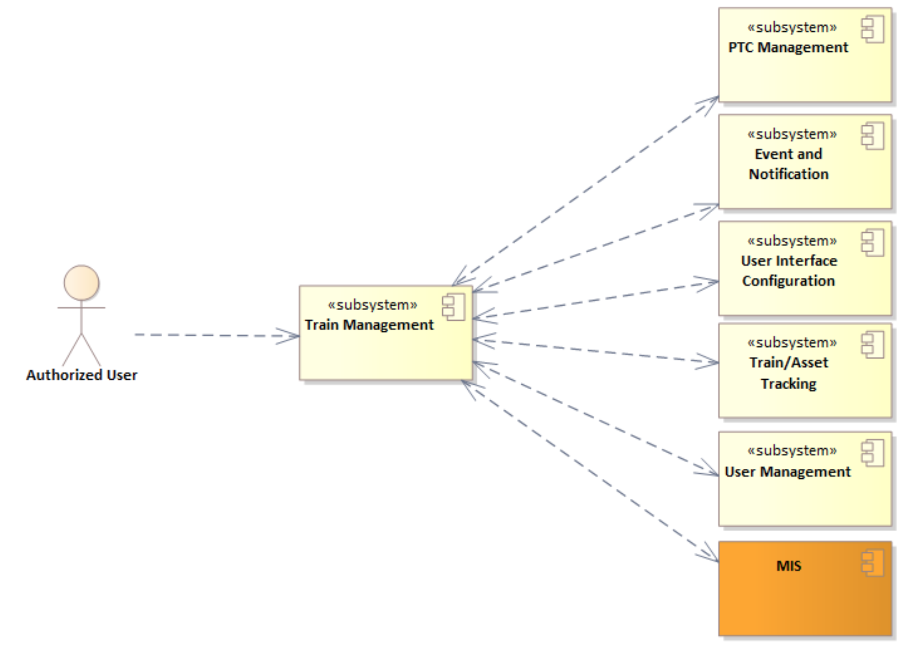
Figure 1. Context View of the Train Management Subsystem
The User Interface Configuration Subsystem is responsible for configuration management of configurable forms, including Train Sheets. The Train Management Subsystem utilizes the User Interface Configuration Subsystem to display the configured versions of the forms to Authorized Users.
The Train Management Subsystem receives Train Sheets and Train Profiles from MIS and provides information and updates to Train Sheets back to MIS and to Train tracking.

Actors
Dispatchers, Chief Dispatchers, and Train Crew Members are the typical users of the Train Management Subsystem. The User Management SSRS configures the user roles and permission levels of each user role for the Core System.
The term Authorized User is used throughout this document to indicate that the user is of a user role and has the permission level required to perform the action being described.
See Core System - SRS for more detailed descriptions of the following actors:
- Dispatcher
- Chief Dispatcher
- Train Crew

