Document Conventions
Contents
Please update the table of contents.

Purpose
This document will describe the style and conventions used for requirements definition in all the Core System Subsystem Requirements Specification (SSRS) documents.

Requirements Guidelines
This section provides some basic guidance to be used as a reference when writing SSRS requirements. The mentioned training and INCOSE guidelines should be the primary source for requirement writing techniques.
Siemens learning offers a requirements writing course that provides an excellent overview of these rules: Siemens Learning - Requirements Writing
Requirements should follow the INCOSE guidelines: INCOSE guide to writing requirements.

Requirement template
Functional Requirements should be written in the form of:
"When <triggering condition>, the System shall <action> [object] [constraint]."
Example: When <the User selects the delete option>, the System shall <delete> [the record] [within 10 ms].
- The <triggering condition> is the event that causes the requirement to "activate". "Whena User selects the delete option ..."
- The <action> is what the System must do when the triggering condition occurs. "... the System shalldelete ..."
- [object] is optional. This is the object upon which the System is acting. "... the System shall deletethe record."
- [constraint] is optional. This is a nonfunctional constraint within which the System must complete the action. "... the System shall delete the recordwithin 10 ms."

Tips for Good Requirements
​​

To Do
Tip | Explanation/Example
Requirements should be singular. | Requirements should include a single condition and a single action. Example: "When X, the System shall A and B." should instead be two requirements; "When X, the System shall A."; "When X, the System shall B."
Use the active voice. | "The System shall perform the action" instead of "The action shall be performed."
Write concise requirements | Separate the "reason" for a requirement from the requirement itself. If context is needed, it should be provided in narrative text around the requirement. However, the requirement should be complete and understandable without additional context (within reason).
Use unambiguous quantifiers | When describing a quantity or set of items, define in unambiguous terms. E.g. "each item in list x".
Be aware of implicit assumptions | Be cautious of requirements written assuming a certain understanding of the subject matter, or requirements that depend on a specific definition of a common term. Use a more precise term or define the term explicitly within the document.
Requirements do not specify internal interfaces | Requirements in which an action could result in an interface to another internal subsystem should be written without specifying that interface at the SSRS level since the final internal interface decision will be made at the design level.  Example of a requirement to use:  "When an Authorized User provides confirmation to save a PIM after modification, the Support Information Subsystem shall generate an event (EV-SIS.PIM.MODIFIED)."

To Avoid
Avoid | Explanation/Example
Description of features | Functional requirements should specify a triggering event and an action to take. Requirements of the form "The System shall be able to xxx" do not follow this format.
Design decisions | Do not include the "how" of a requirement in the document. E.g., "The System shall maintain 100 MB available memory by deleting old files". This requirement can end after "available memory".
Negative requirements | Do not write requirements of the form "The System shall not...". All requirements must be written from the context of something the system must do, instead of something the system must not do.
Unlimited quantifiers | Do not write requirements that have no limit on quantity or time such as: always, every, all, never, etc.. Theoretically, such requirements would require an infinite testing period for verification.
Weak quantifiers | Do not write requirements with weak quantities such as "many", "as few as possible", etc. These requirements are not testable because they are not explicit.
Internal subsystem interfaces and interactions | Requirements need to avoid describing interfaces and interactions between internal subsystems.  Example of a requirement to avoid:  "When an Authorized User submits an EC-1 Track Authority for creation, the Track Authority Subsystem shall send control requests to update switch positions to the Traffic Control Subsystem for delivery to the Signal System."

Document Structure
Documents should follow the appropriate GUIDE template. Contact the project's Polarion admin if you are not sure which template to use, or if you are unfamiliar with creating Polarion documents.
SSRS Documents should be organized by functionality. In some cases, this may follow the Use Case structure developed in the SRS, but in some cases it may not. For instance, validation requirements may be the same for many functions, and should be separated and not repeated within each function.

Terms and Abbreviation

Glossary Terms
All terms must be defined in the glossary and capitalized. The terms are defined in a separate document (Core System Project Glossary).

Abbreviations
Abbreviations must be defined at the first usage within a document and also in the document abbreviations listing. Abbreviations can also be defined periodically in the document if the author deems appropriate.

Style Guide

Capitalization

User Types and System Element Names
All user types (e.g., Authorized User) and system element names (e.g., the subsystems such as Train Management, Traffic Control) are capitalized.

Title Case
All chapter headings, section titles, requirements titles, etc. will use "title" case as per APA style guidelines. In title case, capitalize the following words in a title or heading:
- the first word of the title or heading, even if it is a minor word such as “The” or “A”
- the first word of a subtitle
- the first word after a colon, em dash, or end punctuation in a heading
- major words, including the second part of hyphenated major words (e.g., “Self-Report,” not “Self-report”)
- words of four letters or more (e.g., “With,” “Between,” “From”)
Lowercase only minor words that are three letters or fewer in a title or heading (except the first word in a title or subtitle or the first word after a colon, em dash, or end punctuation in a heading):
- short conjunctions (e.g., “and,” “as,” “but,” “for,” “if,” “nor,” “or,” “so,” “yet”)
- articles (“a,” “an,” “the”)
- short prepositions (e.g., “as,” “at,” “by,” “for,” “in,” “of,” “off,” “on,” “per,” “to,” “up,” “via”)

Notation and Tracking of Requirements
Requirements within Polarion are noted directly by the tool itself. The Requirements are clearly indicated with a requirement number. The following is an example requirement:

Example Requirement
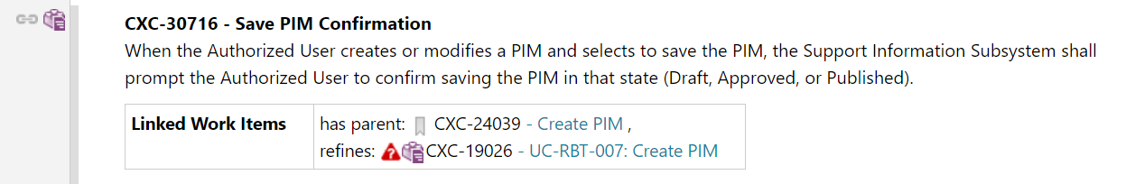
When exported from Polarion to Word or PDF format, the requirement title will be preserved indicating the item is a requirement:

Word Export Example
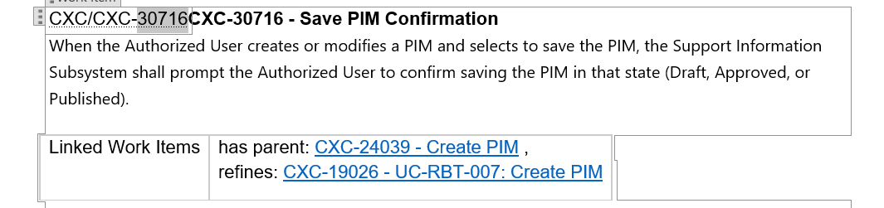

PDF Export Example
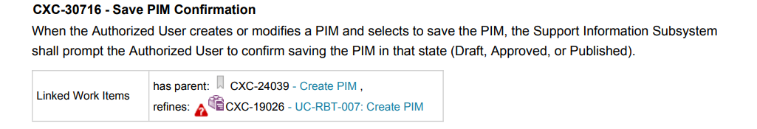

Requirement Fields
- Title - Summary of requirement
- Description - The text of the requirement
- Guidance (optional) - If further guidance or context is needed for the requirement, an optional guidance heading follows the requirement text containing the necessary guidance.
- Tracing fields:
  - has parent - The section within the SSRS that contains this requirement.
  - refines - The requirement within the SRS that this requirement traces to.
  - relates to - Other related requirements that are pertinent, but not traced to.

Default Configuration
The SSRS requirements are expected to define the behavior when filling out forms and saving data from those forms. For example, when issuing a track authority, a required data field is entering the limits of that authority. The authority cannot be issued until the limits (along with other data) are entered. The requirements must specify the minimum required data fields that must be entered to proceed on a form. For example, "If the Authorized User has entered at a minimum the Title for the new PIM, the Support Information Subsystem shall enable the option to save the PIM in the Draft state."
The Form Builder requirements provide the capability that the fields can change from required to optional and vice versa; however, the SSRSs should still be written in terms of the default "day 1" configuration that is provided by the software - the SSRSs should not account for different system behavior due to configuration changes in the Form Builder. Separate configuration specifications will be documented to describe what is configurable from the Form Builder for each form.

Notification Events
Notification Events can be generated from within any subsystem. In order to track all possible events, a common event format will be utilized across all SSRS documents. Each SSRS will have a table of events using the following format:
​​
Event ID | Feature | Description | Requirement(s)
EV-TM.XXX.YYY.ZZZ | Trainsheet | An example event for the Train Management Server Component. | <Link to Requirement>
EV-TM.AAA.BBB.CCC | Departure Checklist | An example event for the Train Management User Interface Component. | <Link to Requirement>
Requirements in general should avoid using the term "notify" since this can cause confusion with terminology used by the notification events. For example, instead of saying "... notify the Authorized User of the error", use the phrasing "... inform the Authorized User of the error".

Notification Event Fields
- Event ID - A unique string starting with the characters 'EV-SUBSYSTEM-FEATURE' where "SUBSYSTEM" will be replaced with the abbreviation of the Subsystem, "FEATURE" will be replaced by an abbreviation of the Feature and XXX.YYY.ZZZ or AAA.BBB.CCC are just free-format strings to make the name descriptive.
- Feature - The main feature for the event
- Description - A short explanation of the purpose and meaning of the event.
- Requirement(s) - The Requirement(s) that trigger the firing of this event.

Generation of Notification Events
There are a number of requirements in the SSRSs that define the generation or triggering of notification events. These requirements will use the following notation "...generate an event X," where X is the notification event to be generated. A generated event triggers configured Core System actions.

Configuration of Notification Events
TBD - this should reference a separate configuration events document with all these fields accounted for.
Note that Notification Events have the following that need to be specified in their configuration (some are in the table above but not all fields are in the table):
Event ID: ID for this notification event
Trigger:A description of the trigger for this notification event for use by the administrator configuring the notification events to better understand this notification event.
Description: Description of the notification – what is shown to the user. May be templated.
Classification: If this notification event is to be handled as a Task, Alert, Notice, or Logged Event
Steps:Steps (if any) for this notification event. Each step has associated text, which may be templated. Each step may be linked to a Core System function from the list of functions that the Core System supports.
Priority:The initial priority for this notification event. Priority will be linked with visual indication level on display.
Audible alert: If this notification event has an audible sound associated or not and the audible level
Visual alert: The type of visual alert to be associated with this notification event (e.g., an icon in the list, a red banner flashing on the screen, etc.).
Acknowledgement Required:If this notification event must be acknowledged or not.
Configured users to be notified:The list or type and/or scope of users to receive this task *
Transferable:Transfer options for this notification event
- Not transferable (e.g. for tasks such as a training this user needs to do themselves).
- Transferred automatically to next user in this position.
- Manually transferable – user can “transfer” this notification event to another user.
  - If manually transferable – optional users to be notified on transfer
Escalation plan if configured as a task or an alert (can have multiple escalation steps in the plan):
Time-based or event-based:if time-based, escalates after an amount of time has passed. If event-based, escalates on a pre-defined event.
Priority Increase: If priority is increased for current user on escalation.
Additional notifications:if other users are sent the task on escalation (and at what priority if so)
Escalation user list: Optional list of who is assigned this task if escalation means assigning this task to other users.
Reminder schedule:If this task can be snoozed, what the allowable options are for the user to snooze this task for (e.g., 1 minute, 5 minutes, an hour, a day, etc.).
Data Field: Data fields associated with this notification event, including location when relevant, Train ID if applicable, train speed, etc., as relevant to the event from a selection of fields the Core System supports.

Configurable Parameters
A subsystem may use any number of configurable parameters to help control the functional behavior. In order to track all possible configurable parameters, a common configurable parameter format will be utilized across all SSRS documents.
Each SSRS will have a table of configurable parameters using the following format:
​​
Param ID | Name | Feature | Requirement(s) | Type | Format | Default Value | Min | Max | Scope
CFG-CTC.XXX.YYY.ZZZ | Control Request Timeout | ​ | <link to Requirement> | Seconds | Numeric | 30 | 1 | 2400 | System
CFG-UM.AAA.BBB.CCC | Crew Hours Of Service Limit | ​ | <link to Requirement> | Time | HHMMSS | 120000 | 080000 | 240000 | System

Configurable Parameters Fields
- Param ID - A unique string ID for the configurable parameter starting with the characters 'CFG-SUBSYSTEM' where "SUBSYSTEM" will be replaced with the abbreviation of the the Subsystem and XXX.YYY.ZZZ or AAA.BBB.CCC are just free-format strings to make the name descriptive.
- Name - A unique descriptive name for the configurable parameter
- Feature - The main feature for the configurable parameter
- Requirement(s) - The Requirement(s) that trigger the firing of this event.
- Type - One of the following types:
  - String
  - Numeric
  - Time
  - Boolean
- Format - Only applicable for Time and Numeric configurable parameters.
  - Time - A field specifying the format of the time using ISO-8601 format specifiers.
  - Numeric - A field specifying the number of whole and decimal digit places including sign in the format "(precision, scale)" where precision is the total number of digits and scale is the number of digits after the decimal point. For example "(3,1)" would represent the range: -99.9 to 99.9.
- Default Value - The initial value populated in the system for this configurable parameter. Must be in the same format specified by the format field
- Min - Only applicable for Numeric and Time configurable parameters. Must be in the same format as specified by the format field. Represents the minimum allowable value for the configurable parameter.
- Max - Only applicable for Numeric and Time configurable parameters. Must be in the same format as specified by the format field. Represents the maximum allowable value for the configurable parameter.
- Scope - Defines the area for which the configurable parameter is applicable. Examples are system, subdivision, and control point.

Functional Permissions
When the term "Authorized User" is used in a requirement or diagram, it is implied that this user type has permissions for the particular functionality described. The individual requirements and diagrams should not describe checking
against the User Management subsystem whether the Authorized User has the user access permissions for that functionality - these steps will be abstracted out from the requirements and diagrams.
Each subsystem may have a number of functional permissions that governs access to that function for an Authorized User. In order to track all possible permissions, a common permissions format will be utilized across all SSRS documents.
Each SSRS will have a table of permissions using the following format:
Function | Description | Relevant Requirements
Create PIM | Create a new PIM as a draft | <Link to Requirement>
Modify PIM | Modify an existing PIM | <Link to Requirement>
​​

Logging
Logging capabilities will be described in general requirements (e.g., all incoming and outgoing messages must be logged, user inputs must be logged). Logging will also be specified in the specification of notification events (seeCXC-24377- Configuration of Notification Events). All notifications events are logged; notification events can be configured to not notify users if only logging is desired. Feature-specific (e.g., track authorities) logging requirements will not be provided (outside of the notification events); similarly, logging will not be depicted in feature-specific diagrams.

Tables
Tables can be used in an SSRS to present "non-requirements" information, but tables themselves cannot be requirements or contain requirements. Requirements must be specified as standalone work items, as described inCXC-21881- Notation and Tracking of Requirements.

Reference to Other Documents
When referring to another document within a Polarion document, ensure the document is listed in the References section at the end of the Polarion document in the following format:
[Short Title of Document]
Full Title of Document, version, date, document ID
For example:
[Core System - System Requirement Specification]
Core System - System Requirement Specification, version 1.2, 2024-07-24, 65194-RM-SPEC-00001
The Document ID is only applicable to other Polarion documents and is located in the footer of the document when exported to PDF.
For in line references to the document, use the short title of the document in square brackets, not bolded, and add a link in Polarion to the References sub-section header, such as:
The Support Information Subsystem shall interface with the external Rule Books and Timetables Repository according to the protocols defined in [Safety Bulletins ICD]
In this case, the [Safety Bulletins ICD] links to the Input Documents Section header.

