The Impact of medicaid expansion on tobacco use: a staggered difference-in-difference analysis using brfss data
A Thesis By

Parker Kenneth Morrow

Abstract:
This study examines the impact of Medicaid expansion under the Affordable Care Act (ACA) on tobacco use among U.S. adults, using Behavioral Risk Factor Surveillance System (BRFSS) data from pre- and post-ACA years. A staggered difference-in-differences approach is applied to capture variation in expansion timing across states, with survey weights incorporated to produce nationally representative estimates. Tobacco use is measured for both daily users and social or intermittent users, across all product types including e-cigarettes. Results indicate that Medicaid expansion had no statistically significant effect on smoking patterns among users, suggesting that behaviors remained relatively constant as tobacco products evolved during the ACA expansion period. These findings underscore the importance of understanding patterns of tobacco use when evaluating public health policy and suggest that targeted interventions and legislation may be needed to effectively reach tobacco users.

CHAPTER 1

INTRODUCTION
Smoking and tobacco use remain one of the leading preventable causes of mortality in the United States. According to the Centers for Disease Control and Prevention (CDC), cigarette smoking is responsible for nearly 480,000 deaths annually, including more than 40,000 deaths from exposure to secondhand smoke (2024). This means that one in five deaths in the U.S. is attributable to tobacco use. According to the CDC’s Smoking Cessation: Fast Facts, in 2022, over half of adults who smoke reported trying to quit during the past year but fewer than 1 in 10 succeed. Beyond the human toll, smoking imposes economic costs as the CDC also estimates that smoking-related illnesses cost the nation over $225 billion in medical care and more than $150 billion in lost productivity each year. This suggests there may be room for policy interventions like Medicaid expansion to increase access to cessation resources.
Despite the constant efforts and decades of progress in reducing smoking among adults, millions continue to smoke. This contributes to the ever-growing problem of healthcare costs and health disparities. Adults living below the federal poverty level exhibit substantially higher smoking prevalence than those above it. For example, in one CDC analysis, smoking prevalence among men below the poverty line was 41.1%, compared to 23.7% above it; among women, 32.5% versus 18.3% (Centers for Disease Control and Prevention [CDC], 2019). Similarly, educational attainment is strongly associated with smoking: in 2019, 31.6% of adults without a high school diploma reported current smoking, compared with 10.8% among those with a bachelor’s degree (CDC, 2019). Health insurance status also correlates with smoking behavior, with adults on Medicaid or uninsured showing higher tobacco use rates relative to those with private insurance (Cornelius et al., 2023). These disparities reflect both economic barriers and differences in access to cessation resources. These concerns raise the question of whether policies such as Medicaid expansion, which increased access to health insurance and cessation resources, can have an impact on tobacco use behaviors. This study asks: To what extent has Medicaid expansion influenced smoking prevalence and cessation attempts among low-income adults in the United States?
The landscape of tobacco use has also shifted over time. Since the early 2000s, cigarette smoking has been on a steady decline, but new nicotine products have emerged. E-cigarettes, first introduced in the mid-2010s, have become primarily popular among younger adults. Importantly, a considerable share of e-cigarette users report never having smoked traditional cigarettes: in 2021, approximately 30.3% of adult e-cigarette users had never smoked cigarettes (CDC, 2023), and among e-cigarette users aged 18–24, about two-thirds had never smoked cigarettes (CDC, 2024). This suggesting that e-cigarettes are not only a substitute but also a pathway for nicotine use. Understanding how Medicaid expansion affects smoking must therefore account for both historical declines in combustible tobacco and the rise of newer alternatives like e-cigarettes.
Several studies have investigated the effects of Medicaid expansion on smoking and tobacco use, but the evidence remains mixed on its effectiveness. Hilts et al. (2020, 2021), using Behavioral Risk Factors Surveillance Survey (BRFSS) data through 2019, found modest reductions in smoking prevalence in the short run, but effects dissolved in later years. Donahoe et al. (2019), relying on the CPS Tobacco Use Supplement, reported no significant impact on quit attempts or cessation rates among low-income adults, suggesting that coverage expansions alone may not be sufficient to change behavior. Bailey et al. (2020), analyzing electronic health record data from community health centers, found increased prescribing of cessation medications and modest improvements in quit rates, but these results were confined to clinical populations and may not generalize broadly. Similarly, Koma et al. (2017) reported small increases in recent cessation among expansion states, but only over the early 2011–2015 period.
Though these are important contributions, gaps remain in the literature. Most studies stop prior to 2020 and therefore do not capture the long-term effects post pandemic. Very few incorporate the usage of e-cigarettes and alternative nicotine products, which have grown in popularity since the mid-2010s. Finally, many studies rely on two-way fixed effects models, which recent econometric work has shown can be biased in staggered policy adoption settings. This thesis addresses these issues by using the BRFSS through 2023, accounting for e-cigarette use, and modeling with the Callaway and Sant’Anna (2021) staggered difference-in-differences estimator to recover dynamic treatment effects.
The Affordable Care Act (ACA), signed into law in 2010, represented the most significant overhaul of the U.S. healthcare system since Medicare and Medicaid were established in 1965. A central provision of the ACA was the option for states to expand Medicaid eligibility to cover adults with incomes up to 138% of the federal poverty level. This expansion primarily targeted low-income adults who were previously uninsured, including many without dependent children who did not qualify under traditional Medicaid rules. Beginning in 2014, states that chose to expand Medicaid received substantial federal support: the federal government covered 100% of the costs for the first three years (2014–2016), gradually reducing its share to 90% in subsequent years. While not all states expanded, those that did extended coverage to millions of low-income adults, which allows us to tackle the question whether increased access to public health insurance and tobacco cessation services reduced smoking rates among these populations.
The staggered timing of Medicaid expansion was the direct result of the 2012 Supreme Court decision in NFIB v. Sebelius, which ruled that while the Affordable Care Act (ACA) could expand Medicaid eligibility, the federal government could not force states to participate. This ruling transformed what was initially intended as a nationwide expansion into a state-level decision, producing wide variation in the timing and adoption of the policy. Some states expanded Medicaid eligibility immediately in 2014, others adopted expansion in subsequent years, and ten states have not expanded to date. This heterogeneity in rollout across states creates quasi-experimental conditions that can be used for causal inference. Specifically, it allows for the comparison of smoking outcomes in expansion states relative to those in non-expansion or not-yet-expanded states, forming the basis for a staggered difference-in-differences framework. While expansion decisions were influenced by political and fiscal considerations, the resulting variation across time and place provides a strong foundation for studying the policy’s impact on health behaviors such as smoking.
As a result of the Court’s ruling, states were allowed to decide independently whether to expand, generating a substantial variation for access to Medicaid:
- Early adopters (2014): Most expansion states implemented the policy at the first opportunity, including large states such as California, New York, and Illinois.
- Mid adopters (2015–2020): States like Louisiana (2016), Maine (2019), and Idaho (2020) expanded later.
- Late adopters (2021–2023): Missouri, Oklahoma, South Dakota, and North Carolina expanded only recently.
- Never adopters: As of 2023, ten states—including Texas, Florida, and Georgia—have not expanded Medicaid.
This staggered roll out creates a valuable experiment for evaluating the policy’s effects on health behaviors.
This thesis uses individual-level survey data from the Behavioral Risk Factor Surveillance System (BRFSS), a nationally representative health survey of U.S. adults covering health behaviors, chronic conditions, and preventive care. With over 400,000 respondents per year, the BRFSS covers all health behaviors, chronic conditions, and preventive care that the individual may use. The dataset spans 2009–2023, providing a large sample of about 6.7 million adults across all 50 states and the District of Columbia. Stratified sampling and post-stratification weights make the data nationally and state-level representative. Though strong, the BRFSS does rely on self-reported measures from the respondents and does not follow the same individuals over time. Nevertheless, the BRFSS is still a widely accepted dataset for public health research.
Tobacco outcomes are measured across multiple variables: cigarette use, other tobacco usage, and e-cigarette usage (introduced in 2016). Two outcome measures are constructed: (1) overall smoking prevalence, including e-cigarettes, and (2) traditional tobacco use excluding e-cigarettes. This classification allows me to capture both long-run declines in cigarette smoking and the rise of new nicotine products.
The analysis employs a staggered difference-in-differences framework to account for the variation in Medicaid expansion across states. This approach allows me to evaluate pre-treatment trends and to examine how treatment effects on smoking outcomes evolve over time. To isolate the effect of Medicaid expansion on smoking behavior, I distinguish between different types of tobacco use—such as cigarette smoking, e-cigarette use, and dual use—to separate policy effects from broader consumption trends.
Treatment effects are estimated using the methodology proposed by Callaway and Sant’Anna (2021). This specification differs from a traditional two-way fixed effects (TWFE) model in that it allows for heterogeneous treatment effects across expansion cohorts over time periods. Rather than creating and estimating a single effect of expansion, I estimate group-time average treatment effects. This approach avoids negative weighting with the TWFE in staggered settings and yields a more credible estimate. I estimate dynamic event study coefficients that capture the evolution of Medicaid expansion on smoking pre- and post-expansion. Pre-treatment estimates serve as a test for the parallel trends assumption, while post-treatment captures the short- and long-term outcomes. Unlike a static difference-to-difference estimator, this approach makes it possible to observe whether Medicaid expansion had immediate effects, delayed effects, or fading effects over time.
Furthermore, I use two models, one with the outcome variable of tobacco usage with e-cigarettes and the other relying on only traditional tobacco products. This allows me to capture the substitution effects and trends of alternative products.
A challenge to evaluating the impact of Medicaid is that adoption was not random. States chose whether and when to expand based on political, fiscal, and demographic factors, which could also be related to smoking behavior and tobacco control policies. Without attention, these confounders could bias the estimated treatment effects. States with Democratic leadership were substantially more likely to expand Medicaid early, while Republican-led states often delayed or did not expand. To address this, I stratify analyses by political leanings to account for differential adoption patterns. This creates an additional 4 staggered difference-in-differences that adjust for political leanings and product usage. This split DiD approach ensures that estimated treatment effects are not simply capturing partisan differences, but how the partisan differences affected smoking rates.
Lastly, there are issues related to data collection in the BRFSS. First, the e-cigarette variable for 2019 is missing, creating a gap in the series. Second, tobacco use is self-reported, which may understate prevalence. Third, questions on e-cigarettes were only introduced beginning in 2016, which may complicate outcome measurement. To address these concerns, I will: (1) compare results with and without e-cigarette outcomes; and (2) acknowledge limitations of self-reported behavior, while noting that BRFSS remains the most widely used surveillance dataset for tobacco outcomes.
The results suggest modest declines in cigarette smoking following Medicaid expansion, but these effects are generally small and statistically insignificant when considering the population as a whole. More importantly, the effectiveness of treatment effects differs once e-cigarette use is incorporated. When e-cigarette users are included in the analysis, the overall ATT remains near zero, and the previously observed declines in combustible cigarette use are offset. This indicates that while Medicaid expansion may have supported reductions in traditional cigarette smoking use, the parallel rise of vaping products impacted the impact on overall nicotine consumption.
When the results are split by state politics, the patterns are more refined. Democratic-leaning states exhibit unstable pre-trends and short-lived post-treatment dips that quickly rebound, providing little evidence of sustained reductions in smoking. By contrast, Republican-leaning states display more consistent post-expansion declines, particularly when e-cigarette users are included, with significant negative effects emerging in later periods. Together, these findings show the impact of Medicaid expansion across political ideology. These differences suggest that the effects of Medicaid expansion on smoking behavior may have been shaped by the political and policy environments of each state, with Republican-leaning states experiencing somewhat stronger and more durable post-expansion reductions.

CHAPTER 2

LITERATURE REVIEW
A growing body of research on the effects of Medicaid’s expansion on tobacco use and smoking has brought forth the question of its ability to prevent smoking. In a broad outlook, the research in this field falls into two categories of attention: studies of behavioral outcomes of smoking prevalence and quit attempts and studies of cessation coverage and its limitations across the United States.
In terms of behavioral outcomes of smoking prevalence and quit attempts in relation to Medicaid expansion, the paper titled “Impact of Medicaid expansion on smoking prevalence and past-year quit attempts" by Katy Ellis Hilts and colleagues investigates how expanding Medicaid and its broadened coverage of cessation counseling medications impacted smoking prevalence and quit attempts for low-income adults. The data source is the Behavioral Risk Factor Surveillance System (BRFSS) from 2011-2017. In their methodology, they use a standard Difference-in-difference regression to compare the patterns between states that expanded Medicaid and those that did not expand Medicaid. However, this reliance on a traditional two-way fixed effects (TWFE) approach may be problematic in staggered settings, like Medicaid expansion, by biasing the estimates as early adopting states serve as controls for later adopting states. In their models, they control for individual demographics like age, ethnicity, education, marital status, and also for state-level policies like excise taxes and smoke-free laws that are implemented.
For their findings, they find that the expansions were more likely to be within the 18-34 age bracket, Hispanic, educated, and unmarried when compared to the non-expansion states. For smoking prevalence, the expansion states had lower rates (29.2%) while non-expansion states were higher (32.5%) with significance (p < 0.001). Medicaid expansion was associated with a greater decrease in smoking prevalence (β = –0.017, p = 0.02) and this effect held with accounting for state-level policies (β = -0.017, p = 0.02) (Hilts et al., 2020). Though this expansion did have a greater impact on smoking prevalence, they find that expansion of Medicaid coverage did not increase quitting attempts but may have enhanced the success rates of those who were trying to quit. This then raises questions about whether expansion affects the success of quitting rather than motivating new attempts.
In a follow-up study, the data is extended through 2019 to confirm whether short-term declines in smoking prevalence remained. Though the decline was confirmed, they found that these gains were not sustained over the long term. The authors state, “Regression analyses indicate that Medicaid expansion was associated with reduced smoking prevalence in the first two years post-expansion (β=-0.019, p=0.04), but that this effect was not maintained at longer follow-up periods (β=-0.006, p=0.49).” Extending the data window to 2019 confirmed that these gains were not sustained over the long term, suggesting that Medicaid expansion alone may not be a substantial policy tool for increasing quit attempts or reducing smoking prevalence.
While the study provides evidence on the impacts of Medicaid expansion, the paper relies on a standard two-way fixed effects (TWFE) difference-differences framework, as the Callaway & Sant’Anna approach was released in 2021. TWFE can produce biased estimates in settings with staggered treatment adoption because already treated states are used as controls for later treated states. In addition, the studies did not account for the growing use of E-Cigarettes, which may be used as a substitute away from traditional cigarettes and tobacco use. An updated approach that avoids the potential issues inherent to TWFE may yield more reliable estimates of the impact of Medicaid expansion.
Another paper, “The Affordable Care Act Medicaid Expansion and Smoking Cessation Among Low-Income Smokers” by J Travis Donahoe et al. examined whether Medicaid expansion under the Affordable Care Act improved smoking cessation outcomes among low-income, childless adult smokers. For the data source, the 2010-2011 pre-expansion and 2014-2015 post-expansion waves of the Tobacco Use Supplement of the Current Population Survey was used. It was then linked with propensity scoring from a boosted logistic regression to individuals who are childless adults below 138% of the federal poverty level. The use of a Logistic Regression and propensity score weighting for individuals who are in states of expansion versus states with non-expansion.
Their findings show similar trends of no significant increase in quit attempts or no significant improvement in smoking cessation among expansion states versus non-expansion states. Even when adjusting for differences in state socioeconomic trends, welfare, and tobacco control policies, no significant improvements were found. This means that, despite expansion of insurance coverage and access to services for low-income smokers, Medicaid expansion did not lead to an increase in cessation or quit attempts. Discussing their findings, the authors argue that expanding coverage alone is not sufficient to reduce smoking. The authors explain that access to programs can moderate the impact of Medicare access on smoking outcomes stating “combined coverage of cessation aids and counseling therapy has been shown to increase probability of successful smoking cessation in Medicaid programs, but fewer than 33 states cover both of these services for all that were enrolled and few Medicaid smokers who try to quit use counseling services.” (Donahoe et al. (2019)).
The removal of administrative barriers, promotion of cessation barriers, and additional services of counseling and outreach could be addressed to help assist Medicaid. Even so, the time frame of Donahoe et al. is limited to the immediate pre- and post-expansion years (2010–2015), which may miss longer-term dynamics of smoking behavior. In addition, their reliance on logistic regression with propensity score weighting does not address the methodological challenges of staggered adoption across states. As with Hilts et al., their framework effectively assumes that treatment effects are homogeneous and that states can be compared at a single expansion date, which may introduce bias when states expand at different times.
Moreover, neither Donahoe et al. nor Hilts et al. incorporate the rise of e-cigarette use beginning in the mid-2010s, a trend that has altered the nicotine landscape and potentially offset gains in smoking cessation. These limitations highlight the need for an updated approach. Taken together, these studies suggest that while Medicaid expansion may reduce smoking prevalence modestly in the short term, it has not consistently translated into higher quit attempts or sustained prevalence reductions. This indicates that coverage alone is insufficient without addressing implementation barriers in cessation service uptake, such as awareness, counseling access, and administrative restrictions.
Though these papers show no significance of smoking cessation changes with Medicaid expansion, Steffani R Bailey et al. find a more optimistic result on patients from community health centers (CHC) who care for vulnerable patients who use tobacco. Using electronic health record data from 219 CHCs in 10 states that expanded Medicaid and individuals aged 19-64 with documented tobacco use with 6 months prior to expansion, the authors propensity score matched patients from 108 CHC’s in six non-expansion states. In a post-24-month follow-up period, Medicaid expansion states had higher odds of medication for smoking being ordered, follow-up visits, and higher odds of quitting when compared to the patients in non-expansion states. However, this paper only focuses on CHC patients, which may not generalize over to Medicaid beneficiaries. While these results contrast with the population level findings of the previous papers, they highlight that Medicaid access may be more effective in a clinical context where individuals are more deemed to receive structured treatment and support.
The paper “Medicaid Coverage Expansions and Cigarette Smoking Cessation Among Low-income Adults” by Jonathan W. Koma et al. also links to a positive outlook for smoking cessation among low-income adult smokers aged 18-64. Using the BRFSS from 2011-2015, they examined the association of Medicaid and recent smoking cessation and found an increase of 2.1% in recent smoking cessation. They also found similar increases among the ages of 18-64 years for females and males (1.9% and 2.2%). Methodologically, the study uses a TWFE difference-in-difference, which may be biased in staggered adoption settings like Medicaid. Furthermore, the short follow-up for Medicaid does not account for the rise of e-cigarettes in this period, which complicates smoking trends. These findings suggest that expansion may encourage early cessation attempts, but without support systems, these gains may fade. Compared with Hilts et al. (2020, 2021), who observed short-term but unsustained declines, and Donahoe et al. (2019), who found no significant effects, Koma et al. show the possibility of early benefits. However, the evidence remains mixed on whether expansion leads to long-term changes.
Lastly, the paper “Medicaid tobacco dependence treatment coverage and smoking outcomes among beneficiaries with substance use disorder” (Bejamin Le Cook et al.) examines whether comprehensive Medicaid tobacco dependence treatment (TDT) from Medicaid influenced smoking beneficiaries with past-year substance use disorder (SUD). Using data from the 2009–2018 National Survey on Drug Use and Health, the authors analyzed cessation, nicotine dependence, and cigarette use among Medicaid beneficiaries aged 18–64. The paper applied a TWFE difference-in-difference approach, while adjusting for demographics, co-occurring mental illness, and area-level provider supply, and found no significant association between comprehensive TDT coverage and smoking outcomes. Quit rates increased among individuals with SUD during the period, but did not statistically differ between states with comprehensive, partial, or no coverage. This concludes that Medicaid expansions alone were not sufficient to improve cessation outcomes for high-risk groups, showing the need for more proactive interventions.
While studies like Hilts et al. (2020, 2021) and Donahoe et al. (2019) show that expansion has limited effects on the general low-income population, Cook et al. demonstrate that even comprehensive coverage fails to generate improvements among particularly vulnerable subgroups. This shows the structural barriers that prevent Medicaid from showing positive cessation outcomes.
This thesis builds on the existing literature by using Behavioral Risk Factor Surveillance System (BRFSS) data from 2009 to 2023, harmonizing e-cigarette measures, and applying the Callaway & Sant’Anna (2021) estimator to estimate group-time average treatment effects. By doing so, the analysis provides a more accurate picture of how Medicaid expansion has shaped smoking and nicotine use behaviors over the past decade.

CHAPTER 3

DATA DESCRIPTION
The Behavioral Risk Factor Surveillance System (BRFSS) is a nationally representative, cross sectional, telephone survey dataset hosted by the Centers for Disease Control and Prevention (CDC) that attempts to capture and measure risk behaviors and preventive health practices. Started in 1984 with only 15 states, the BRFSS now captures all 50 states, the District of Columbia, and surrounding U.S territories. Each year, the BRFSS conducts over 400,000 adult interviews, making it the largest continuous health survey in the world.
The BRFSS is administered by the CDC through monthly telephone surveys. Respondents are contacted by a stratified random digit dialing system that takes samples from landlines and cell phones. The inclusion of cell phones was introduced in 2011 to help reach younger and lower-income adults who may not have access to a landline. The BRFSS does not sample households but samples the telephone numbers at which the respondent is connected. Stratification is based on geography, type of phone line, and demographics of the respondent. Each state has its own specific BRFSS survey, and within each state, phone numbers are stratified by geographic region. Separate identifications for landline and cell phone samples are collected while controlling for the growing significance of cell phone-only households. While the initial collection is done by geographic and phone type, final survey weights take into account the state's population and distributions of age, sex, race/ethnicity, education, marital status, home ownership, and telephone source. This contributes to a very large sample sizes of around 400,000 adults annually, allowing for a state-year analysis.
Through the surveys, the CDC collects data on health-related risk behaviors, chronic health conditions, like diabetes and heart disease, and also the individual’s use of preventive measures and services. The BRFSS also captures the individuals' use of smoking products. The span of traditional products, like cigarettes, chewing tobacco, and cigars, is captured through the selected years for the analysis, while e-cigarette and vaping products are added from 2016 on. The survey also incorporates survey weights to ensure population-representative estimates. The survey weights are particularly important as the sample data, without the weights, may not perfectly reflect the U.S. adult population. Certain groups are more or less likely to respond to telephone surveys, like the example of younger adults being more likely to respond by cell phone and older adults being more likely to respond by landline. This can also be seen by the response rates across race/ethnicity, income, and education. To capture these issues, the CDC builds survey weights for each respondent based on the demographics and characteristics of the respondent. The weight incorporates the probability of the selection of the respondent and adjustments to account for age, sex, race/ethnicity, education, marital status, and home ownership across the state-level population. Without them, estimates of smoking use and behaviors would be biased towards the groups who are more likely to respond to the survey.
Though the BRFSS captures a large number of individuals, the survey does not follow the same individuals over time throughout the years. The survey follows a repeated cross-sectional methodology to follow population trends. The data is released publicly annually by the CDC for full transparency and replication on reports issued by the CDC, making it an ideal dataset for studying population-level smoking trends in relation to the expansion of Medicaid.
My analysis includes BRFSS surveys from the years 2009 to 2023, as Medicaid expansions started in 2014. This allows for a sufficient amount of time to capture pre- and post-trends of smoking. The sample includes all individuals over the age of 18 with no exclusions based on gender, race/ethnicity, socioeconomic status, or location of the individual.
From this, two outcome variables were created with one being the individual as a smoker with the inclusion of e-cigarettes, and another variable restricts to traditional products (cigarettes and other tobacco). For outcome coding, all individuals who answered the survey as an every day or some day users of tobacco products were identified as a smoker, with an answer of not at all identifying them as a non-smoker.
Sample restrictions from the BRFSS are apparent as missing or invalid responses in the data may have excluded individuals from identifying from the smoker or non-smoker categories. Doing so, individuals who responded with a “Don’t Know” or “Refusal” were identified as not applicable and were dropped from the analysis. Being that the focus is on adult smoking behavior, all individuals are over the age of 18. Other limitations include that the consistency of vaping and e-cigarette usage is only from 2016 onward, so the outcome variable of the individual was a smoker with the inclusion of e-cigarettes starts accounting for e-cigarettes at the start of 2016. After applying these restrictions, the sample includes nearly 6,774,858 million respondents across 50 states and District of Columbia from 2009 to 2023.
In terms of external validity, Table 1 presents descriptive statistics for the weighted BRFSS sample from 2009-2023. The weighted sample closely resembles the U.S. adult population when analyzing demographics, behavioral, and policy relevant variables. Women represent 51% of the sample, which is very close to the benchmarks from the Census. The age distribution shows representative numbers across all adult age groups, ensuring that coverage for the younger and older generations are accounted for. Once the weights are applied, household income is skewed upward, with 55.5% of annual incomes being reported be above $100,000 and near 24.2% of incomes being reported below $50,000. This distribution is consistent with national income patterns.
Smoking status is also relatively aligned with CDC estimates as around 60% of adults reported not smoking, while 28% were daily smokers and 12% were periodic smokers. E-cigarette and other tobacco use prevalence, about 10% and 3%, reflect national estimates. In regards to health insurance coverage, 38% of adults report employer-sponsored coverage, 21% Medicare, 9% Medicaid, and roughly 32% are insured through other measures. Lastly, about two-thirds of respondents live in states that expanded Medicaid in 2014, while one-third live in states that never expanded, reflecting the national policy environment of Medicaid.
Altogether, the sample from 2009-2023 with the BRFSS can be generalized to the U.S. adult population with the results on Medicaid expansion and tobacco use, showing the external validity of the study. Prior research has also demonstrated that BRFSS post-stratification weighting yields demographic distributions closely aligned with the U.S. Census, supporting external validity of BRFSS estimates (Iachan et al., 2016; Pierannunzi et al., 2013). Still, within this regard, the survey based data may be an under representation for hard to reach or vulnerable groups, which may remain a limitation for the study.

Table 1. Summary of Variables

Variable | Category | Weighted %
Sex | Female / Male | 51.3 / 48.7
Age group | 18–34 | 29.5
 | 35–54 | 33.3
 | 55–64 | 15.9
 | 65+ | 21.3
Household income | < $50 k | 24.2
 | $50–99 k | 20.3
 | ≥ $100 k | 55.5
Smoking status | Not at all / Some days / Every day | 60.2 / 12.1 / 27.7
E-cigarette use | Not at all / Some days / Every day | 78.3 / 13.7 / 8.0
Insurance type | Employer / Medicare / Medicaid / Other | 37.9 / 21.2 / 9.0 / 31.9
Expansion group | Early adopters / Never adopters | 66.8 / 33.2

For Medicaid expansion by state, Table 2 summarizes the timing of Medicaid expansion across states, highlighting the staggered adoption pattern that creates both early- and late-treated groups as well as never-treated states, which together provide the variation necessary for the staggered difference-in-differences design.

Table 2. Expansion Status by State

Expansion Status | States | Year of Expansion
Early Adopters (2014) | AR, AZ, CA, CO, CT, DE, DC, HI, IL, IA, KY, MD, MA, MI, MN, NV, NJ, NM, NY, ND, OH, OR, RI, VT, WA, WV | 2014
Mid Adopters (2015–2020) | PA (2015), AK (2015), IN (2015), MT (2016), LA (2016), ME (2019), VA (2019), ID (2020), NE (2020), UT (2020) | 2015–2020
Late Adopters (2021–2023) | MO (2021), OK (2021), SD (2023), NC (2023) | 2021–2023
Never Expanded | AL, FL, GA, KS, MS, SC, TN, TX, WI, WY | —

From the data, the analysis finds the overall weighted prevalence of tobacco use from 2009-2023 using the variables combined for the smoker categorization. Overall trends, depicted by the orange line and includes all tobacco use minus e-cigarettes, have a steady decline from around 20% in 2009 to near 13% by 2023. This trends reflects the progress of reducing combustible tobacco use across the U.S. For overall trends plus e-cigarette use, depicted by the blue line, the prevalence of all tobacco use levels off and does not decline as steeply. The gap between the two lines highlights the usage of e-cigarettes as a substitute away from traditional cigarette use. Medicaid expansion (beginning 2014) occurred during a period of long-run decline in cigarettes. But because e-cigarette uptake grew, overall nicotine use stayed relatively flat with some decline after 2016. This complicates policy evaluation as insurance expansion may reduce cigarette smoking, but the effect is muted if individuals substitute into vaping.
Figure 1. Weighted Trends in Tobacco Use Excluding and Including E-Cigarettes
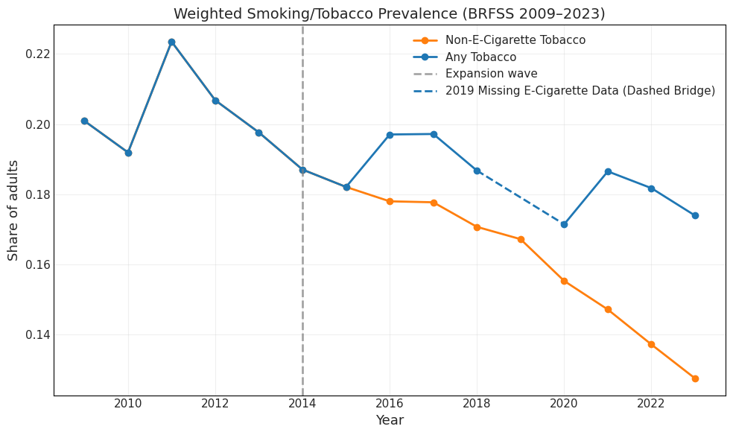
The weighted smoking prevalence of expansion states versus non-expansion states over time, shown in Figure 2, shows a fairly similar trend for smoking before expansion, supporting the parallel trends assumption for the difference-in-difference. Post-expansion states experienced lower rates of smoking when compared to non-expansion states. By 2020, expansion states reached a low near ~16–17%, while non-expansion states stayed closer to ~19–20%. This pattern is potentially consistent with an effect of Medicaid expansion, but the evidence is inconclusive. The apparent divergence in 2020 disappears by 2021, suggesting these differences may reflect noise rather than a systematic impact.. The gap between expansion and non-expansion states narrows again, suggesting that long-term effects may fade or that other factors (like e-cigarette uptake, COVID-19 disruptions, or state-level tobacco policy differences) complicate the picture.

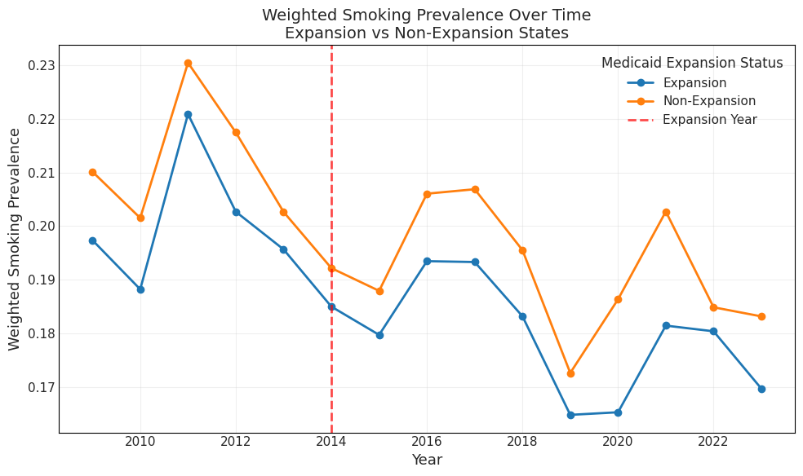
Figure 2. Trends in Weighted Smoking Prevalence by Medicaid Expansion Status

Smoking frequency is disproportionately concentrated among lower-income groups. For example, adults earning under $15k report the highest proportion of “every day” smoking, while higher income groups (> $75k, > $100k) have much lower proportions. Though smoking decreases as income rises, the middle income groups still show substantial smoking prevalence. These disparities reinforce that smoking is not just a health issue but also a socioeconomic one, disproportionately affecting low income populations. Because Medicaid primarily covers lower-income adults, this validates the importance of studying Medicaid expansion in relation to smoking outcomes as this group carries the largest burden.
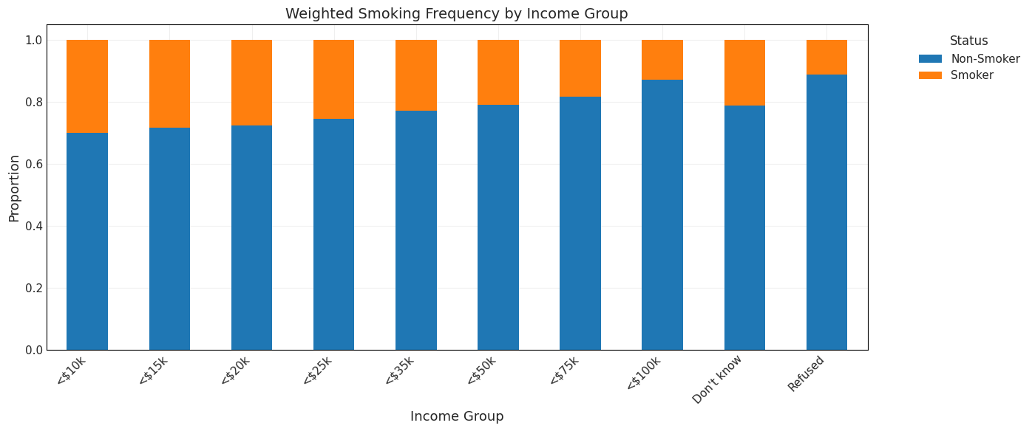
Figure 3. Weighted Smoking Prevalence by Household Income Group

In relation to physical and mental health, Table 4 reports that as health worsens, the proportion of smokers increases steadily. Among individuals reporting few or no poor health days, most are non-smokers. But as poor health days accumulate (15+ days per month), smoking prevalence becomes much higher. Smoking is both a contributor to poor health and a coping mechanism under stress or poor mental health. Since Medicaid serves populations with higher rates of both poor health and smoking, expansions in coverage could help address the dual burdens of health inequity.

Figure 4. Weighted Smoking Status by Number of Days in Poor Health
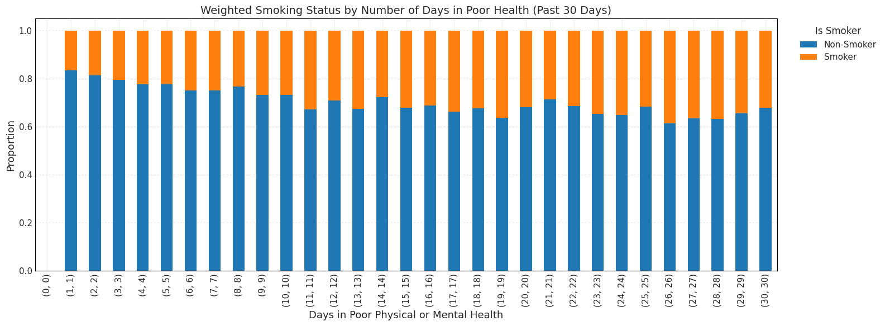
Young adults (25–34) show the highest smoking prevalence (~24%), followed closely by the 30–34 and 35-39 age ranges. Rates remain fairly stable through the 40s and early 50s, before gradually declining with age. A sharp decline is seen after age 60, with the lowest smoking rates among the 80+ population (~5%). This pattern suggests an age effect as younger and middle-aged adults are more likely to smoke, while older adults are less likely to report current smoking. In terms of Medicaid, cessation programs should prioritize younger adults, as they are at peak risk of continued smoking if the behavior persists into later life.

Figure 5. Proportion of Current Smokers Across Age Groups
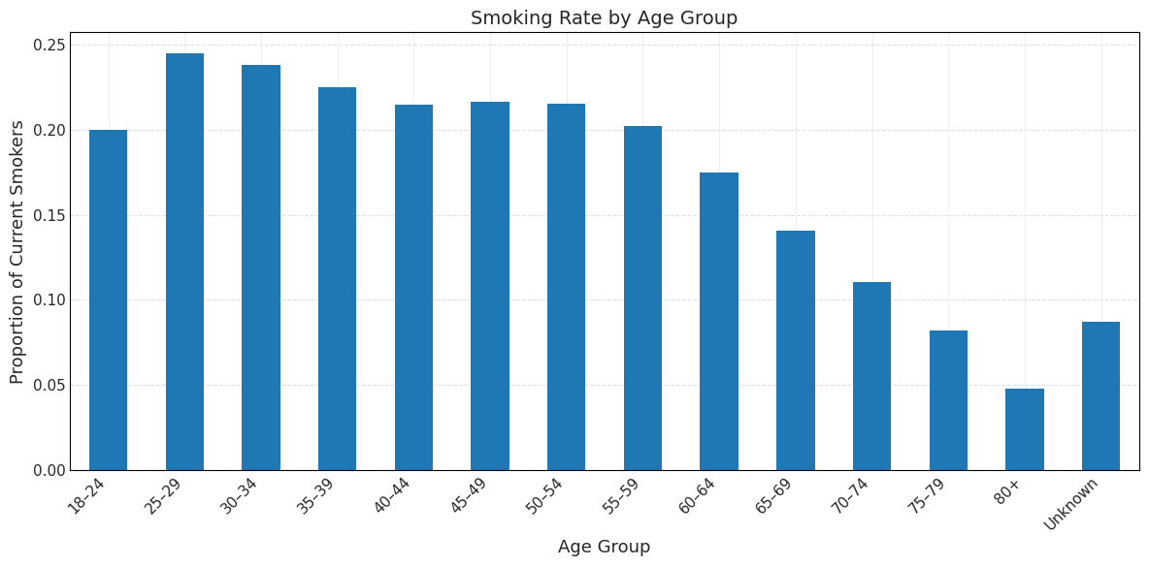
For insurance types, the lowest smoking rates are among CHIP, Medicare, and employer-sponsored plans. In terms for Medicaid, Medicaid enrollees (~28%) and Indian Health Service users (~31%) show the highest smoking prevalence, well above the national average. People with no coverage (~26%) also have very high rates, reflecting both financial and health access barriers. This gradient shows a strong link between insurance type and smoking prevalence as populations in public programs serving low-income or marginalized groups (Medicaid, IHS) have the highest burden of smoking, aligning with known socioeconomic disparities.

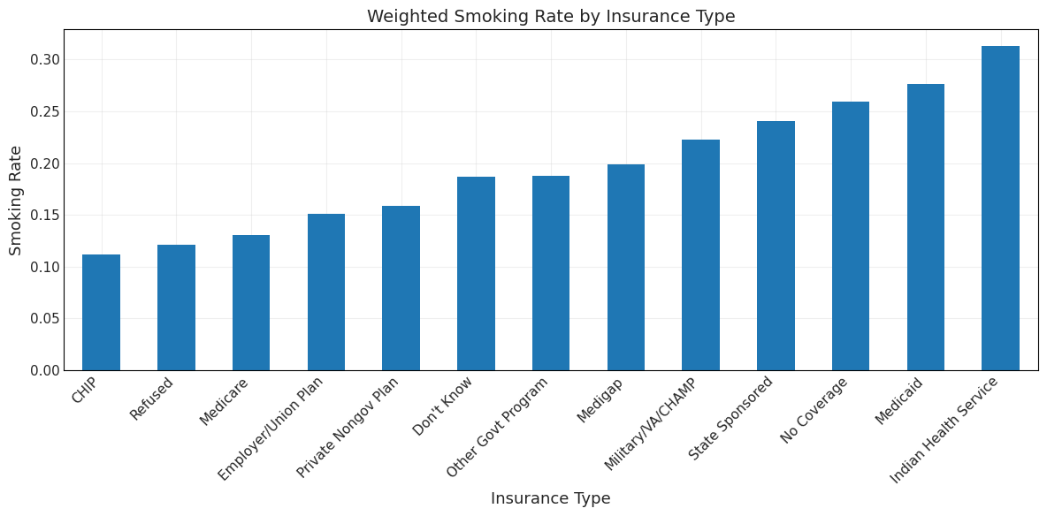
Figure 6. Proportion of Current Smokers Across Health Insurance Categories

In sum, the BRFSS provides a large, nationally representative dataset with information on smoking behavior across states and years, making it well-suited for policy evaluation. Its complex survey design and weighting ensure population-level representativeness, while the availability of consistent measures of cigarette use, other tobacco products, and e-cigarettes allows for flexible outcome definitions. The long time horizon from 2009 to 2023 provides sufficient pre- and post-expansion coverage to capture the dynamics of smoking behavior. By combining state-level expansion timing with individual-level smoking outcomes, this design provides the necessary conditions for a staggered difference-in-differences analysis using the Callaway and Sant’Anna (2021) estimator.

CHAPTER 4

METHODOLOGY
This study was conducted using the variation of Medicaid expansions across all 50 states and District of Columbia between 2014 and 2023. I applied the staggered difference-in-differences framework developed by Callaway and Sant’Anna (2021). This approach allows for comparisons between states that expanded Medicaid in a given year and states that had not yet expanded (or never expanded), while accounting for treatment effect heterogeneity and avoiding biases from traditional two-way fixed effects models. This then allows for the comparison of the treated states with the never treated states and not yet treated states for an estimation of the effectiveness of Medicaid.
For the identification of Medicaid expansion for treatment definition, a state is considered to treated in the year that it adopted Medicaid. The treatment year is coded as the first year the expansion took effect in that state (e.g., California = 2014, Louisiana = 2016 and more) to states that never expanded to be being coded as zero. The rollout in this scenario was not uniform, with some states expanding in 2014, others much later (2020–2023), and ten states never expanding (Table 1).
The analysis focuses on two binary outcome measures: (1) whether the individual is a smoker who does not use e-cigarettes, and (2) whether the individual is a smoker who uses e-cigarettes. Time effects are captured through year dummy variables for each survey year from 2009 to 2023, while state fixed effects control for time-invariant differences across states. Each observation in the BRFSS data is uniquely identified, as the survey is a repeated cross-section rather than a panel, meaning respondents are not followed over time. Medicaid expansion is coded at the state level, with each state’s implementation year corresponding to its treatment year; states that never expanded Medicaid are coded as 0 and serve as the control group. Standard errors are clustered at the state level to account for within-state correlation, since Medicaid expansion is determined at the state level. The analysis first estimates group-time average treatment effects on the treated (ATTs), followed by dynamic effects (pre- and post-expansion), and then computes overall effects across groups.
From these codings, two primary outcome variables were constructed. The first, any tobacco use, includes cigarettes, other traditional tobacco products, and e-cigarettes. The second, non-e-cigarette tobacco use, restricts the definition to cigarettes and other traditional tobacco products, excluding e-cigarettes.This dual outcome structure allows for comparisons between traditional smoking behaviors and broader nicotine use that incorporates vaping products.
For the outcome variable, smoking status was derived from the BRFSS question on current cigarette use, where responses of “every day” or “some days” were coded as 1 (current user), and “not at all” as 0 (non-user). Responses coded as “Don’t know” (7) or “Refused” (9) were set to missing and excluded from analysis. Similar coding was applied to other tobacco use variables (e.g., cigars, smokeless tobacco).
In the BRFSS, the use of survey weights is used to generate nationally representative estimates. The use of weights corrects for the complex survey design, including stratified sampling, unequal probabilities of selection, and differential non response across demographic groups. Before 2011, the BRFSS provided the sample weight variable _FINALWT, which was only based only on landline telephone sampling. Starting in 2011, the survey then introduced _LLCPWT, incorporating both landline and cell phone sampling, as well as iterative proportional fitting (raking) to better align the weighted sample with state population distributions by age, sex, race/ethnicity, education, marital status, home ownership, and telephone usage. In this analysis, _FINALWT is used for survey years prior to 2011, while _LLCPWT is used for 2011 to 2023. They were then combined into one survey weight column for the analysis. The descriptive statistics and causal estimates are weighted accordingly, to reflect population representative outcomes rather than raw survey responses for smoking prevalence and treatment effects.
In terms of the mathematical approach, the classic difference-in-difference with two-way fixed effects is widely used because it controls for both unit-specific time-invariant factors and time-specific shocks. This framework assumes that, absent the treatment, treated and untreated groups would follow parallel trends, and that treatment is the same over time. A standard specification would be:

$Y_{i,s,t}=α+γ_{s}+δ_{t}+τD_{s,t}+ϵ_{i,s,t}$ (1)
$$\begin{aligned}\text{Where:} \\ Y_{i,s,t}=\text{Smoking outcome \backslash \backslash (binary\backslash \backslash ) for individual }i\text{ in state }s\text{ and year }t \\ α=\text{Intercept \backslash \backslash (baseline level\backslash \backslash ) } \\ γ_{s}=\text{State fixed effects \backslash \backslash (time-invariant differences\backslash \backslash )} \\ δ_{t}=\text{Year fixed effects \backslash \backslash (nationwide shocks\backslash \backslash )} \\ D_{s,t}=\text{Indicator for Medicaid expansion for state }s\text{ at time }t \\ τ=\text{Treatment effect of Medicaid expansion} \\ ϵ_{i,s,t}=\text{Error term}\end{aligned}$$

The specification above is appropriate if all units are treated at the same time, which is not the case, given the staggered Medicaid expansions. To account for the staggered treatment, researchers often still apply a two-way fixed effects model:

$Y_{i,s,t}=α+γ_{s}+δ_{t}+τ_{g,t}D_{s,t}+ϵ_{i,s,t}$ (2)
$$\begin{aligned}\text{Where:} \\ Y_{st}=\text{Smoking outcome \backslash \backslash (binary\backslash \backslash ) for individual }i\text{ in state }s\text{ and year }t \\ α=\text{Intercept \backslash \backslash (baseline level\backslash \backslash )} \\ γ_{s}=\text{State fixed effects \backslash \backslash (time-invariant differences\backslash \backslash )} \\ δ_{t}=\text{Year fixed effects \backslash \backslash (nationwide shocks\backslash \backslash )} \\ D_{st}=\text{Indicator for Medicaid expansion in state s at time t} \\ τ_{g,t}=\text{Treatment effect for expansion cohort g at time t} \\ ϵ_{i,s,t}=\text{Error term}\end{aligned}$$

Even though this methodology is more general, in that it allows for heterogeneous effects across groups and time, Goodman-Bacon (2021) and Sun & Abraham (2021) highlight that it can yield biased estimates of treatment effects because it effectively uses outcomes from already-treated units as counterfactuals for not yet treated states. To avoid these issues, the Callaway & Sant’Anna (2021) approach is designed to avoid these comparisons:

$ATT\left(e\right)=E\left[Y_{i,s,t}\left(1\right)−Y_{i,s,t}\left(0\right)\text{|}t−g=e\right]$ (3)
$$\begin{aligned}\text{Where:} \\ ATT\left(e\right)=\text{Average treatment effect at event time e} \\ e=t−g=\text{Years relative to Medicaid expansion} \\ Y_{i,s,t}\left(1\right)=\text{Smoking outcome for individual }i\text{ in state }s\text{ and year }t\text{, if the state has expanded Medicaid} \\ Y_{i,s,t}\left(0\right)=\text{Counterfactual smoking outcome for the same individual if the state had not expanded Medicaid} \\ e<0=\text{Pre-treatment periods \backslash \backslash (used to test parallel trends\backslash \backslash )} \\ e≥0=\text{Post-treatment periods \backslash \backslash (captures short- and long-run effects\backslash \backslash )}\end{aligned}$$

The Callaway & Sant’Anna methodology defines cohorts by the period during which they receive the treatment, or expansion of Medicaid. For each group g and time t, the methodology compares the treated group’s outcome with never-treated units or not yet treated groups if they are still left untreated at time t. The control group used to compute ATT(g,t) is then restricted to states that have not yet been treated at that given time, eliminating the forbidden comparison problem. The treatment effects estimated for each cohort are then aggregated into a dynamic, event-study style effect, allowing for the comparisons of treatment across the timing of expansion, and the overall average effects, which are weighted across groups and times. Identification relies on the conditional parallel trends assumption: in the absence of expansion, smoking trends in treated states would have evolved like those in not-yet-treated or never-treated states.
Being that the results are dynamic, this allows for the assessment of the policy timing and persistence of tobacco use across the time of the expansions. This not only shows how significant the trend in cessation is but also how it evolves over the short and long term periods. The analysis relies on weights and difference-in-difference design but does not adjust for additional state-level controls. Omitting these may leave residual confounding, though including them could risk collinearity with expansion status. This would show whether the effects were stronger in the strong run or how the effects appear over time. Together with aggregated ATT estimates, the event study results provide both a snapshot (overall impact) and a timeline (dynamic path) of how Medicaid expansion affected smoking.
For interpretation of the ATT, the estimation uses the dynamic procedure to produce event-time coefficients that are centered around the year of Medicaid expansion. In this case, this would reflect the year of 2014 for states that expanded in 2014. The year immediately before Medicaid expansion, event time minus 1, serves as the baseline. All ATT estimates are then interpreted relative to smoking behaviors that happened in the baseline year. When the event time is pre-treatment, this is used to measure differences between treatment and control states before Medicaid expansion. This result should be statistically indistinguishable from zero if the parallel trends assumption holds. If the effect were to nonzero, this would suggest that possible violations or anticipatory effects of the expansion occurred. As the event time increases past zero, we can trace the relevance if the treatment effects over time after expansion. This shows whether smoking prevalence and outcomes in behavior declined, increased, or had no effect. Similarly, a negative value would mean that there was a reduction in smoking prevalence relative to baseline.
To explore the issue of endogeneity, as Medicaid expansions were not random, the staggered difference-in-difference estimation was also stratified by the state’s political leaning as of 2014, corresponding to the first majorwave of Medicaid expansions
. Political leaning for each state was proxied using a continuous index of partisan control in each state’s government, constructed from the share of Republican versus Democratic control of the state legislature and governorship in 2014. States with index values above 60% Republican control were classified as Republican-leaning, while those below 40% were categorized as Democratic-leaning.
Running the Callaway and Sant’Anna (2021) estimator separately allows for these subgroups to assess whether the relationship between Medicaid expansion and tobacco use differed in political environments at the time of the adoption. Because previous literature suggests that Medicaid expansion decisions were heavily influenced by state political ideology, estimating separate dynamic ATT paths for Republican and Democrat leaning states can help determine whether behavioral responses to expansion differed across political conditions.

Chapter 5

RESULTS AND DISCUSSION
This section reports the main empirical findings on the relationship between Medicaid expansion and smoking prevalence. I first describe descriptive trends across expansion and non-expansion states, followed by difference-in-differences estimates, dynamic event-study results, and robustness checks. Additional analyses consider the role of e-cigarette inclusion and exclusion.
Before turning to the difference-in-differences estimates, it is useful to recall that smoking prevalence fell over time in both expansion and non-expansion states (see Table 2 in data section). This suggests that any effect of Medicaid expansion must be distinguished from broader secular declines in smoking.
Before interpreting the treatment effect estimates, it is important to assess the parallel trends assumption. The pre-treatment coefficients (time periods –13 to –1) fluctuate closely around zero (Figures 7 and 8, and Tables 1 and 2 in Appendix B), suggesting no strong evidence of systematic divergence in smoking prevalence between Medicaid expansion and non-expansion states prior to the expansion. The only exception occurs at time period –7, where a statistically significant negative coefficient is observed. This appears to be an isolated result, which more reflects noise within the data rather than a constant pre-trend, which does not violate the parallel trends assumption.
Figure 7 reports the dynamic estimates of Medicaid expansion on cigarette and tobacco use prevalence when e-cigarette users are excluded. The overall average treatment effect (ATT) of Medicaid expansion on smoking prevalence, excluding e-cigarette users, is estimated at –0.0026 with a standard error of 0.0035 (95% CI: –0.0087, 0.0034). This implies a reduction of about 0.26 percentage points in smoking prevalence among expansion states relative to non-expansion states, though the estimate is not statistically distinguishable from zero. The only exception is time period -7 (-0.0097, 95% CI: -0.0151, -0.0043), which does show a significant negative coefficient. This isolated result suggests some noise in the pre-period but does not indicate a consistent pattern of divergence from the trend.
In post-expansion periods (periods 0 through 9), coefficients are dominantly negative, but are statistically indistinguishable from zero. Altogether, the results from table 7 suggest that Medicaid expansion has a near zero result on estimated reductions in smoking prevalence. There is no consistent evidence of immediate impacts, and the estimates remain statistically insignificant throughout most of the post-treatment period.

Figure 7. Dynamic Effects of Medicaid Expansion on Smoking Prevalence (Excluding E-Cigarette Users)
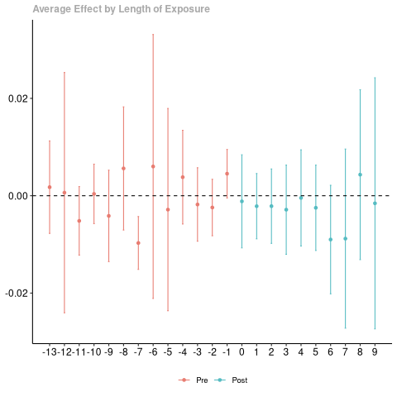

Figure 8 reports the dynamic event-study estimates of Medicaid expansion on smoking prevalence when all smokers, including e-cigarette users, are considered. The overall average treatment effect (ATT) is –0.0046 (SE = 0.0034, 95% CI: –0.0112 to 0.002), which corresponds to a 0.46 percentage point reduction in smoking prevalence among expansion states relative to non-expansion states. However, this estimate is not statistically significant, as the confidence interval includes zero.
For the pre-treatment period, from event times -13 through -1, the coefficients nearly replicate Table 1 as they fluctuate near zero. Several years, including event times –11 and –7, are statistically significant at conventional levels, and event time –1 shows a small positive variation. These variations do suggest variation in the pre period, which could potentially reflect sampling variability or differences between expansion and non-expansion states. Though these differences exist, the overall pattern does not indicate a pre-trend.
In the post-expansion period (event times 0 through 9), coefficients are predominantly negative, with estimates becoming larger in magnitude over time. The most significant result occurs at time period 6, the year 2020 for states that adopt in 2014, where the estimate is –0.0164 (SE = 0.0036, 95% CI: -0.0259, -0.0069), statistically significant at the 5 percent level. This suggests a reduction of 1.6 percentage points in smoking prevalence six years after expansion, which is likely to be an outlier. Although subsequent years continue to show negative estimates, –0.0114 at year 7, the confidence intervals widen and include zero, showing insignificance in the later periods.

Figure 8. Dynamic Effects of Medicaid Expansion on Smoking Prevalence Including E-Cigarette Users

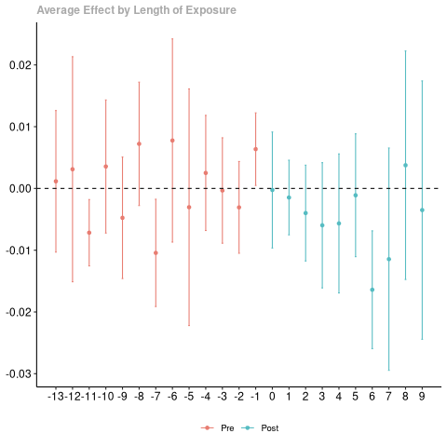

In an effort to examine potential heterogeneity in treatment effects, states were split into Democratic and Republican cohorts based on party control of the governor and legislature. Because political ideology was a key determinant of Medicaid expansion timing, this stratification allows for assessing whether the effects of expansion differ across states with distinct political orientations. By estimating separate staggered DiD models for Democratic and Republican states, the analysis accounts for potential confounding from policy environments, fiscal priorities, or health behaviors that align with partisan control. This approach does not fully eliminate endogeneity, but it provides a robustness check by examining whether expansion effects differ systematically across political contexts. Tables 2-6 present the dynamic event-study ATT results of both political ideologies including and excluding e-cigarette users.
For Democrat-leaning states without e-cigarette users, the results yield an overall ATT of –0.002 (SE = 0.0035, 95% CI: –0.0089, 0.0049), statistically indistinguishable from zero. Several event-time estimates are significant, including early positive effects at event times –9 and –8, followed by a significant negative spike at –4. These pre-treatment fluctuations indicating violation of the parallel trends assumption. Post-treatment, there is a pronounced decline at event time 2 (–0.0147, p < 0.05), but the effect diminishes thereafter and remains near zero in later years. Overall, these dynamics suggest that while some temporary reductions occurred, there is no evidence of a persistent effect of Medicaid expansion on smoking prevalence in Democratic-leaning states once e-cigarette use is considered.
The analysis stops at event time 5 due to the limited number of Democratic-leaning states remaining in the sample at later event times. Extending the event times further would substantially reduce precision and comparability, as fewer states contribute post-treatment observations. The truncated window therefore ensures that the estimates reflect consistent state coverage and reliable inference within the observed treatment periods.

Figure 9. Dynamic Effects of Medicaid Expansion on Tobacco Use in Democratic-Leaning States (Excluding E-Cigarette Users)

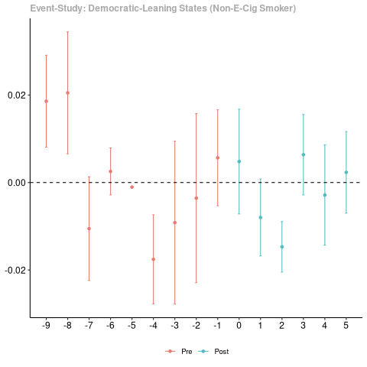

While still looking at Democratic states but including e-cigarette users, the overall ATT is –0.0007 (SE = 0.0035, 95% CI: –0.0076, 0.0062), statistically indistinguishable from zero. The pre-trends reveal some imbalances, with significant positive estimates at event times –9 and –8, and a significant negative estimate at event time –4. This indicates some early instability in the parallel trends assumption. In the post-treatment period, the effect turns negative at event time 2 (–0.0122, p < 0.05) and positive at event time 3 (0.0081, p < 0.05), but remains close to zero in later time periods. Overall, the estimated reductions in smoking among Democratic states appear statistically fragile and may reflect sampling variation rather than a consistent policy effect. The high volatility in state-year estimates suggests substantial noise in the data, which limits the ability to detect sustained post-expansion impacts.

Figure 10. Dynamic Effects of Medicaid Expansion on Tobacco Use in Democratic-Leaning States (Including E-Cigarette Users)

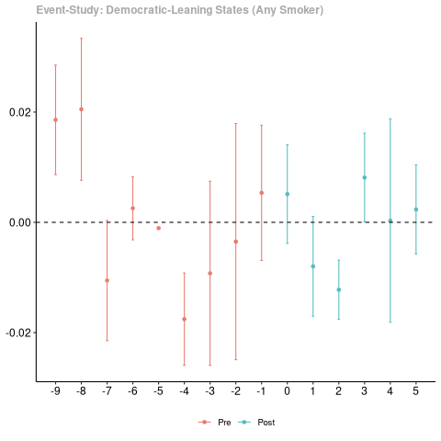

Republican-leaning states display more consistent treatment effects. When excluding e-cigarette users (Figure 11), the overall ATT is –0.0064 (SE = 0.0031, 95% CI: –0.0126, –0.0003), statistically significant at the 5% level. The pre-treatment period shows mostly stable estimates, with only one significant negative deviation at event time –7 (–0.0095, p < 0.05), indicating relatively balanced trends prior to expansion. In the post-treatment period, smoking prevalence declines steadily, with significant reductions observed at event times 0 (–0.0062, p < 0.05), 7 (–0.0186, p < 0.05), and 9 (–0.0179, p < 0.05). These findings suggest that Medicaid expansion was associated with a more pronounced and sustained decline in smoking prevalence within Republican-leaning states, contrasting with the noisier and short-lived effects observed among Democratic states.

Figure 11. Dynamic Effects of Medicaid Expansion on Smoking Prevalence in Republican-Leaning States (Excluding E-Cigarette Users)

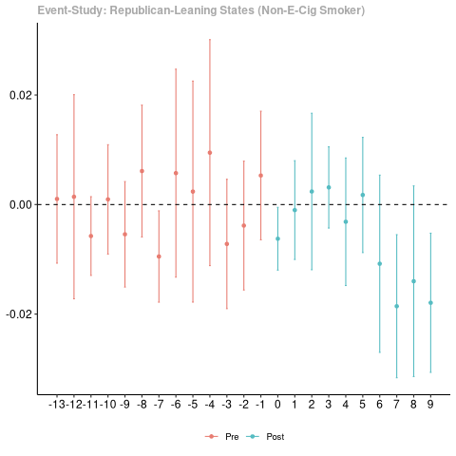

When including e-cigarette users (Figure 12), the overall ATT is –0.003 (SE = 0.0029, 95 % CI: –0.0087, 0.0028), statistically indistinguishable from zero. The pre-treatment period shows largely stable coefficients, with only one significant deviation at event time –7 (–0.0103, p < 0.05), suggesting balanced trends prior to expansion. After treatment, the pattern turns negative, with significant declines in smoking prevalence emerging at event times 7 (–0.0148, p < 0.05) and 9 (–0.0168, p < 0.05). These post-treatment effects indicate a downward trajectory in cigarette smoking among Republican-leaning states, though the overall effect remains modest. Compared to the model excluding e-cigarette users, the inclusion of vaping behavior reduces the precision of estimates, implying that substitution toward e-cigarettes may partially offset observed declines in combustible cigarette use.

Figure 12. Dynamic Effects of Medicaid Expansion on Smoking Prevalence in Republican-Leaning States (Including E-Cigarette Users)

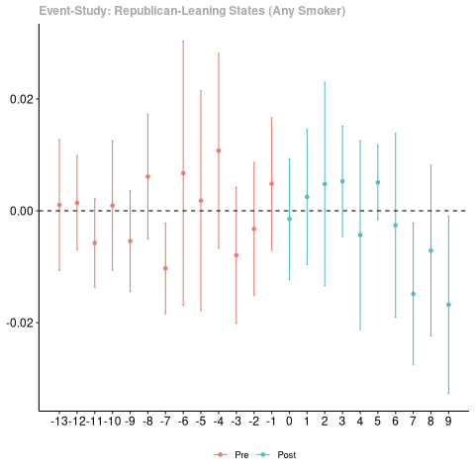

Taken together, the results suggest that the estimated effects of Medicaid expansion on smoking behavior are somewhat stronger in Republican-leaning states than in Democratic-leaning ones. However, the most statistically significant effects emerge several years after the expansion, which introduces uncertainty regarding the causal interpretation. Therefore, these patterns should be viewed as suggestive rather than conclusive evidence of heterogeneous treatment effects across political contexts. While Democratic states show noisy pre-trends and limited evidence of post-treatment effects, Republican states show more stable declines in smoking after Medicaid expansion. The inclusion of e-cigarette users strengthens estimated treatment effects in both groups, particularly in Republican states.
To conclude, This study examined the effects of Medicaid expansion on smoking and tobacco by utilizing the staggered adoption of the Affordable Care Act across the U.S. The results suggest that Medicaid expansion was associated with at most modest, statistically insignificant, declines in smoking prevalence. These effects were not sustained in the long run, and once e-cigarette use was included in the outcome definition, the effects largely disappeared. This pattern highlights the growing role of alternative nicotine products in shaping overall tobacco use behaviors, complicating the interpretation of expansion’s impact on smoking. Furthermore, when states were stratified by political control, Republican-led expansion states showed somewhat stronger reductions in smoking relative to Democratic-led states.
These findings align with and extend the existing literature surrounding this topic. Hilts et al. (2020) reported that Medicaid expansion was linked to short-term reductions in smoking prevalence, but these gains diminished over time. Similarly, Donahoe et al. (2019) found no significant effect of expansion on quit attempts among low-income adults, underscoring that insurance coverage alone is not enough to alter entrenched smoking behaviors. Bailey et al. (2022) showed that expansion increased the prescribing of cessation medications in community health centers but did not consistently translate into higher quit rates. Prior research points to a gap between the access to cessation services and behavior change regarding smoking prevalence. This study adds to the literature by extending the time period to 2023, as well as incorporating e-cigarette usage into the measurement of smoking.
The inconsistency of the effects of Medicaid expansion on smoking can be explained by several factors. First off, while the expansion helped insurance coverage and lowered the financial barriers to services, the utilization of the services may have remained very limited. Many states still imposed restrictions on coverage for the necessities to quit smoking, like counseling and nicotine replacement therapy. The awareness for the benefits of Medicaid coverage is often low among Medicaid enrollees, creating this disconnect in usage of cessation services. Secondly, smoking behaviors are influenced by a multitude of other factors beyond health insurance, like cigarette taxes, smoke-free air laws, and societal norms. Lastly, the rising usage of e-cigarettes during the study period likely redirected some smokers toward alternative nicotine products rather than toward full cessation, reducing the net effect of expansion on overall tobacco use.
From a public health policy perspective, the results suggest that Medicaid expansion should be viewed as a necessity, but not significant enough to achieve a meaningful reduction in smoking prevalence. Expanding insurance improves access to care and financial protection, but additional policies are needed to translate coverage into behavioral change. This may include proactive outreach to usage, the induction of counseling into primary care for users, easier access to nicotine replacement therapies, and more preventative public health measures in terms of tobacco use.
In terms of limitations, several factors must be noted when interpreting the results of the study. First, Medicaid expansions were not random in their implementation. The 2012 Supreme Court ruling made expansion optional, and states’ decisions were shaped by political, fiscal, and ideological factors. While splitting the analysis by the Republican and Democrat-controlled states helped with the concerns about political and endogenous concerns, endogeneity cannot be fully eliminated. For example, states that expanded Medicaid may take a more proactive approach in other public health initiatives that could affect smoking behavior. Though the Staggered DiD approach accounts for time-invariant differences across states and common national shocks, it cannot rule out influences on state specific policies in this regard. Therefore, the estimated effects should be interpreted as conditional associations rather than definitive causal impacts.
Second, the BRFSS data has some measurement challenges with self reporting and key variables having missing data. All tobacco-use variables are self measured from the survey respondent, which may underestimate the true smoking prevalence. This may create a bias in the scale of tobacco use for all users. Response rates have also declined over time, raising the potential for non-response bias, though the use of survey weights mitigates some of this concern. In addition to BRFSS issues, the question of E-Cigarette usage was not asked for the 2019 survey year, which introduced an inconsistency for the validity of E-Cigarette usage.
Third, the study design relies on the conditional parallel trends assumption to held credibility for the outcomes. While pre-trend testing provides some reassurance in the results, this assumption is ultimately untestable because of the nature of the Medicaid expansion across the states. Moreover, the staggered difference-in-differences framework assumes no strong anticipation effects and no spillovers across states, both of which may not hold perfectly in practice.
Lastly, the analysis is only limited to adults and does not do an analysis into subgroups like age, socioeconomic status, or the race and ethnicity of the respondent. Smoking behaviors and usage vary drastically across the respondents and the responses to Medicaid expansion may vary across sub populations, meaning the aggregate estimates presented here may mask important heterogeneity.

APPENDIX A: Reference to variable construction

In 2021, the question was updated to ECIGNOW1, which added a new category (1 = every day, 2 = some days, 3 = not at all, 4 = never). In 2022–2023, the survey introduced ECIGNOW2, which reordered the responses as follows:
1 = Never used e-cigarettes
2 = Every day
3 = Some days
4 = Not at all
To maintain consistency across survey years, responses from ECIGNOW2 were recoded to align with the 2021 scheme:
1 → 4 (never used)
2 → 1 (every day)
3 → 2 (some days)
4 → 3 (not at all)
This harmonization produced a unified ECIG_NOW variable spanning survey years 2016–2023, with 2019 excluded due to missing e-cigarette data.

APPENDIX B: RESULTS TABLES
Table 1. Dynamic ATT Estimates (Without E-Cigarette Users)

Overall ATT = –0.0026 (SE = 0.0031, 95 % CI: –0.0087 to 0.0034)
Event Time | Estimate | Std. Error | 95 % CI Lower | 95 % CI Upper
–13 | 0.0018 | 0.0035 | –0.0077 | 0.0113
–12 | 0.0006 | 0.0091 | –0.0240 | 0.0253
–11 | –0.0052 | 0.0026 | –0.0122 | 0.0019
–10 | 0.0004 | 0.0023 | –0.0057 | 0.0065
–9 | –0.0041 | 0.0035 | –0.0135 | 0.0052
–8 | 0.0056 | 0.0047 | –0.0070 | 0.0183
–7 | –0.0097 | 0.0020 | –0.0151 | –0.0043 *
–6 | 0.0060 | 0.0100 | –0.0211 | 0.0331
–5 | –0.0029 | 0.0077 | –0.0236 | 0.0179
–4 | 0.0038 | 0.0035 | –0.0058 | 0.0134
–3 | –0.0018 | 0.0028 | –0.0093 | 0.0057
–2 | –0.0024 | 0.0021 | –0.0082 | 0.0034
–1 | 0.0045 | 0.0018 | –0.0005 | 0.0095
0 | –0.0012 | 0.0035 | –0.0107 | 0.0084
1 | –0.0021 | 0.0025 | –0.0089 | 0.0046
2 | –0.0021 | 0.0028 | –0.0098 | 0.0055
3 | –0.0029 | 0.0034 | –0.0120 | 0.0063
4 | –0.0004 | 0.0036 | –0.0103 | 0.0094
5 | –0.0025 | 0.0032 | –0.0112 | 0.0063
6 | –0.0090 | 0.0041 | –0.0202 | 0.0022
7 | –0.0088 | 0.0068 | –0.0272 | 0.0096
8 | 0.0043 | 0.0064 | –0.0131 | 0.0218
9 | –0.0016 | 0.0095 | –0.0274 | 0.0242

Table 2. Dynamic ATT Estimates (With E-Cigarette Users)

Overall ATT = –0.0046 (SE = 0.0034, 95 % CI: –0.0112 to 0.002)
Event Time | Estimate | Std. Error | 95 % CI Lower | 95 % CI Upper
–13 | 0.0012 | 0.0043 | –0.0103 | 0.0126
–12 | 0.0031 | 0.0068 | –0.0151 | 0.0213
–11 | –0.0072 | 0.0020 | –0.0125 | –0.0018 *
–10 | 0.0036 | 0.0040 | –0.0072 | 0.0143
–9 | –0.0048 | 0.0037 | –0.0146 | 0.0051
–8 | 0.0072 | 0.0037 | –0.0028 | 0.0172
–7 | –0.0104 | 0.0033 | –0.0191 | –0.0017 *
–6 | 0.0078 | 0.0062 | –0.0087 | 0.0242
–5 | –0.0030 | 0.0072 | –0.0222 | 0.0161
–4 | 0.0025 | 0.0035 | –0.0068 | 0.0118
–3 | –0.0003 | 0.0032 | –0.0089 | 0.0082
–2 | –0.0031 | 0.0028 | –0.0105 | 0.0044
–1 | 0.0064 | 0.0022 | 0.0005 | 0.0122 *
0 | –0.0003 | 0.0035 | –0.0096 | 0.0091
1 | –0.0015 | 0.0023 | –0.0075 | 0.0046
2 | –0.0040 | 0.0029 | –0.0117 | 0.0038
3 | –0.0060 | 0.0038 | –0.0161 | 0.0042
4 | –0.0057 | 0.0042 | –0.0169 | 0.0056
5 | –0.0011 | 0.0037 | –0.0111 | 0.0088
6 | –0.0164 | 0.0036 | –0.0259 | –0.0069 *
7 | –0.0114 | 0.0067 | –0.0294 | 0.0065
8 | 0.0038 | 0.0069 | –0.0147 | 0.0223
9 | –0.0035 | 0.0078 | –0.0244 | 0.0174

Table 3. Dynamic ATT Estimates (Democratic without E-Cigarette Users)
Overall ATT: –0.002 (SE = 0.0035, 95% CI: –0.0089, 0.0049)
Event Time | Estimate | Std. Error | CI Lower | CI Upper
-9 | 0.0186 | 0.0046 | 0.0081 | 0.0291 *
-8 | 0.0205 | 0.0060 | 0.0066 | 0.0344 *
-7 | -0.0106 | 0.0051 | -0.0224 | 0.0013
-6 | 0.0025 | 0.0023 | -0.0028 | 0.0079
-5 | -0.0011 | NA | NA | NA
-4 | -0.0176 | 0.0044 | -0.0277 | -0.0074 *
-3 | -0.0092 | 0.0081 | -0.0278 | 0.0095
-2 | -0.0036 | 0.0084 | -0.0229 | 0.0158
-1 | 0.0056 | 0.0048 | -0.0053 | 0.0166
0 | 0.0048 | 0.0052 | -0.0072 | 0.0168
1 | -0.0080 | 0.0038 | -0.0168 | 0.0008
2 | -0.0147 | 0.0025 | -0.0205 | -0.0089 *
3 | 0.0064 | 0.0040 | -0.0028 | 0.0155
4 | -0.0029 | 0.0050 | -0.0143 | 0.0086
5 | 0.0023 | 0.0040 | -0.0070 | 0.0117

Table 4. Dynamic ATT Estimates (Democratic with E-Cigarette Users)
Overall ATT: –0.0007 (SE = 0.0035, 95% CI: –0.0076, 0.0062)
Event Time | Estimate | Std. Error | CI Lower | CI Upper
–9 | 0.0186 | 0.0046 | 0.0087 | 0.0285 *
–8 | 0.0205 | 0.0060 | 0.0076 | 0.0334 *
–7 | –0.0106 | 0.0051 | –0.0215 | 0.0004
–6 | 0.0025 | 0.0027 | –0.0032 | 0.0083
–5 | –0.0011 | NA | NA | NA
–4 | –0.0176 | 0.0039 | –0.0259 | –0.0092 *
–3 | –0.0092 | 0.0078 | –0.0259 | 0.0075
–2 | –0.0035 | 0.0100 | –0.0249 | 0.0179
–1 | 0.0053 | 0.0057 | –0.0069 | 0.0176
0 | 0.0051 | 0.0042 | –0.0038 | 0.0141
1 | –0.0080 | 0.0042 | –0.0170 | 0.0011
2 | –0.0122 | 0.0025 | –0.0176 | –0.0069 *
3 | 0.0081 | 0.0037 | 0.0001 | 0.0162 *
4 | 0.0003 | 0.0086 | –0.0181 | 0.0188
5 | 0.0023 | 0.0038 | –0.0057 | 0.0104

Table 5. Dynamic ATT Estimates (Republican without E-Cigarette Users)
Overall ATT: –0.0064 (SE = 0.0031, 95% CI: –0.0126, –0.0003)
Event Time | Estimate | Std. Error | CI Lower | CI Upper
-13 | 0.0010 | 0.0045 | -0.0107 | 0.0128
-12 | 0.0014 | 0.0072 | -0.0172 | 0.0201
-11 | -0.0057 | 0.0028 | -0.0129 | 0.0014
-10 | 0.0009 | 0.0039 | -0.0090 | 0.0109
-9 | -0.0054 | 0.0037 | -0.0151 | 0.0042
-8 | 0.0061 | 0.0047 | -0.0059 | 0.0182
-7 | -0.0095 | 0.0032 | -0.0178 | -0.0011 *
-6 | 0.0057 | 0.0074 | -0.0133 | 0.0247
-5 | 0.0024 | 0.0078 | -0.0178 | 0.0226
-4 | 0.0095 | 0.0080 | -0.0112 | 0.0301
-3 | -0.0072 | 0.0046 | -0.0190 | 0.0046
-2 | -0.0038 | 0.0046 | -0.0156 | 0.0079
-1 | 0.0053 | 0.0045 | -0.0064 | 0.0170
0 | -0.0062 | 0.0022 | -0.0120 | -0.0005 *
1 | -0.0010 | 0.0035 | -0.0100 | 0.0080
2 | 0.0024 | 0.0055 | -0.0119 | 0.0167
3 | 0.0031 | 0.0029 | -0.0043 | 0.0106
4 | -0.0031 | 0.0045 | -0.0148 | 0.0085
5 | 0.0017 | 0.0041 | -0.0088 | 0.0123
6 | -0.0108 | 0.0063 | -0.0270 | 0.0054
7 | -0.0186 | 0.0051 | -0.0316 | -0.0055 *
8 | -0.0140 | 0.0067 | -0.0314 | 0.0034
9 | -0.0179 | 0.0049 | -0.0307 | -0.0052 *

Table 6. Dynamic ATT Estimates (Republican with E-Cigarette Users)
Overall ATT: –0.003 (SE = 0.0029, 95% CI: –0.0087, 0.0028)
Event Time | Estimate | Std. Error | CI Lower | CI Upper
-13 | 0.0010 | 0.0048 | -0.0107 | 0.0127
-12 | 0.0014 | 0.0034 | -0.0070 | 0.0099
-11 | -0.0057 | 0.0032 | -0.0137 | 0.0022
-10 | 0.0009 | 0.0047 | -0.0106 | 0.0125
-9 | -0.0054 | 0.0037 | -0.0145 | 0.0036
-8 | 0.0061 | 0.0045 | -0.0050 | 0.0173
-7 | -0.0103 | 0.0033 | -0.0184 | -0.0022 *
-6 | 0.0067 | 0.0096 | -0.0169 | 0.0303
-5 | 0.0018 | 0.0080 | -0.0179 | 0.0215
-4 | 0.0107 | 0.0071 | -0.0067 | 0.0282
-3 | -0.0079 | 0.0049 | -0.0201 | 0.0042
-2 | -0.0032 | 0.0049 | -0.0152 | 0.0087
-1 | 0.0048 | 0.0048 | -0.0070 | 0.0166
0 | -0.0015 | 0.0044 | -0.0123 | 0.0093
1 | 0.0025 | 0.0049 | -0.0096 | 0.0146
2 | 0.0048 | 0.0074 | -0.0134 | 0.0230
3 | 0.0053 | 0.0040 | -0.0046 | 0.0151
4 | -0.0043 | 0.0069 | -0.0212 | 0.0125
5 | 0.0051 | 0.0027 | -0.0016 | 0.0117
6 | -0.0026 | 0.0067 | -0.0190 | 0.0139
7 | -0.0148 | 0.0051 | -0.0275 | -0.0022 *
8 | -0.0071 | 0.0062 | -0.0224 | 0.0081
9 | -0.0168 | 0.0065 | -0.0327 | -0.0009 *

REFERENCES
Bailey, S. R., Marino, M., Ezekiel-Herrera, D., Schmidt, T., Angier, H., Hoopes, M. J., DeVoe, J. E., Heintzman, J., & Huguet, N. (2020). Tobacco cessation in Affordable Care Act Medicaid expansion states versus non-expansion states. Nicotine & Tobacco Research, 22(6), 1016–1022. https://doi.org/10.1093/ntr/ntz087
Callaway, B., & Sant’Anna, P. H. C. (2021). Difference-in-differences with multiple time periods. Journal of Econometrics, 225(2), 200–230. https://doi.org/10.1016/j.jeconom.2020.12.001
Centers for Disease Control and Prevention. (2019). Socioeconomic differences in cigarette smoking among U.S. adults, 2019. Preventing Chronic Disease, 16, E91. https://doi.org/10.5888/pcd16.180553
Centers for Disease Control and Prevention. (2023, May 26). QuickStats: Percentage distribution of cigarette smoking status among current adult e-cigarette users, by age group — NHIS 2021. Morbidity and Mortality Weekly Report, 72(10), 292. https://www.cdc.gov/mmwr/volumes/72/wr/mm7210a7.htm
Centers for Disease Control and Prevention. (2023). Tobacco product use among adults — United States, 2021. Morbidity and Mortality Weekly Report, 72(18), 475–482. https://doi.org/10.15585/mmwr.mm7218a1
Centers for Disease Control and Prevention. (2024, September 17). Cigarette smoking: At a glance. U.S. Department of Health and Human Services. https://www.cdc.gov/tobacco/about/index.html
Centers for Disease Control and Prevention. (2024). E-cigarette use among adults. U.S. Department of Health and Human Services. https://www.cdc.gov/tobacco/e-cigarettes/adults.html
Centers for Disease Control and Prevention. (2024). Smoking cessation: Fast facts. U.S. Department of Health and Human Services. https://www.cdc.gov/tobacco/php/data-statistics/smoking-cessation/index.html
Donahoe, J. T., Norton, E. C., Elliott, M. R., Titus, A. R., Kalousová, L., & Fleischer, N. L. (2019). The Affordable Care Act Medicaid expansion and smoking cessation among low-income smokers. American Journal of Preventive Medicine, 57(6), e203–e210. https://doi.org/10.1016/j.amepre.2019.07.004
Hilts, K. E., Blackburn, J., Gibson, P. J., Yeager, V. A., Halverson, P. K., & Menachemi, N. (2021). Impact of Medicaid expansion on smoking prevalence and quit attempts among those newly eligible, 2011–2019. Tobacco Prevention & Cessation, 7, 16. https://doi.org/10.18332/tpc/139812
Iachan, R., Pierannunzi, C., Healey, K., Greenlund, K. J., Town, M., & Balluz, L. (2016). National weighting of data from the Behavioral Risk Factor Surveillance System (BRFSS). BMC Medical Research Methodology, 16(1), 155. https://doi.org/10.1186/s12874-016-0255-7
Koma, J. W., Donohue, J. M., Barry, C. L., Huskamp, H. A., & Jarlenski, M. (2017). Medicaid coverage expansions and cigarette smoking cessation among low-income adults. Medical Care, 55(12), 1023–1029. https://doi.org/10.1097/MLR.0000000000000821
Lê Cook, B., Flores, M., Progovac, A. M., Moyer, M., Holmes, K. E., Lê, T., Kumar, A., Levy, D., Saloner, B., & Wayne, G. F. (2025). Association of tobacco dependence treatment coverage expansion with smoking behaviors among Medicaid beneficiaries living with substance use disorder. American Journal of Preventive Medicine, 68(3), 485–496. https://doi.org/10.1016/j.amepre.2024.11.010
National Federation of Independent Business v. Sebelius, 567 U.S. 519 (2012). https://tile.loc.gov/storage-services/service/ll/usrep/usrep567/usrep567519/usrep567519.pdf

