King Demon Theme

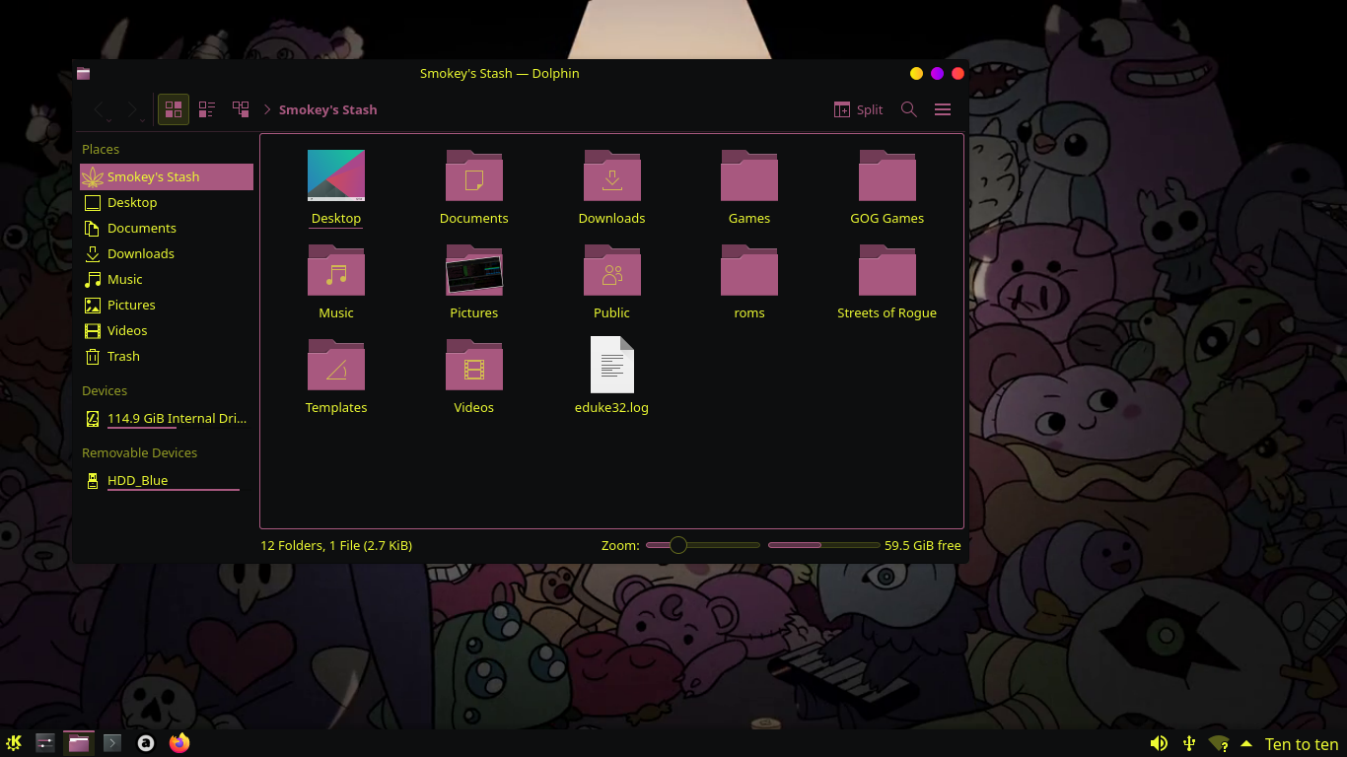

System Wide Install

Global = usr/share/plasma/look-and-feel
Plasma Style = usr/share/plasma/desktoptheme
Colors = usr/share/color-schemes
Window Decorations = usr/share/aurorae/themes
Cursors = usr/share/icons (maybe)

User Only Install

Global = home/.local/share/plasma/look-and-feel
Plasma Style = home/.local/share/plasma/desktoptheme
Colors = home/.local/share/color-schemes
Window Decorations = home/.local/share/aurorae/themes
Cursors = home/.icons (maybe = home/.local/share/icons)

(locations with maybe next to them where untested by me and I had no internet access while writing this, will update at a later date once I can confirm)

Settings

Global Theme = King Demon
Application Style = Breeze
Plasma Style = Materia Color
Colors = Breeze Darker – King Demon
Window Decorations = Sweet-Darker-text
Icons = Breeze Dark
Cursors = “Radioactive”
Login Screen (SDDM) = Breeze

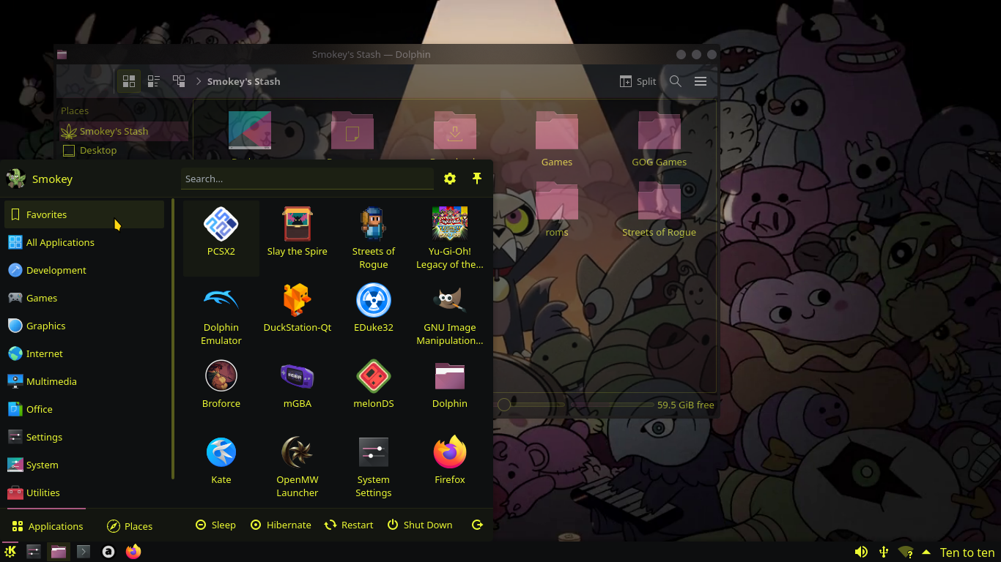

The only real work I did with this theme was to created the color scheme and edit a few lines in the other themes to get the colors from all themes to match. No changes where made to the cursors.
All real credit belongs to the creators of the original themes.

