Lab 1 Output:
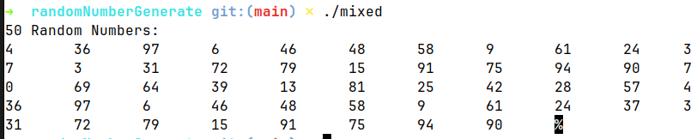

Lab 2 Output:

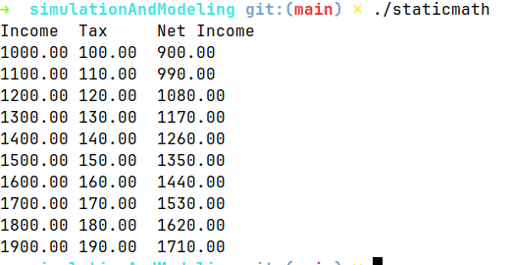

Lab 3 Output:

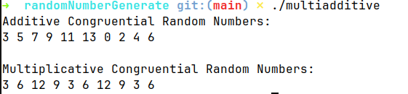
Lab 4 Output:

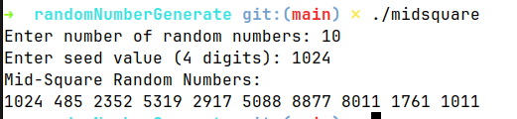

Lab 5 Output:

