Lab Report of Computer Network (CSC 263)



Submitted By: Submitted To:
Shudarsan Poudel Rajkumar Shrestha
BscCSIT 4th Sem

Table of Contents
1. Understanding the Network Equipment, Wiring in Details (CAT6 UTP EIA/TIA 568A/B Straight and Cross-Over Wiring and Testing) 4
a. To understand different network equipment: 4
b. To understand Color Coding Standard of UTP Cable: 5
c. To prepare straight-through and cross-over cables and Test it: 5
2. Practice on Basic Networking Commands (ifconfig/ipconfig, tcpdump, netstat, ip, hostname, route, tracert/traceroute) 8
Commands and Descriptions 8
3. Overview of IP Addressing and Subnetting 11
Objective 11
Terminologies 11
IPv4 Addressing 11
Subnetting 12
IP Address Classes & Network/Host Portion: 12
Private & Special Addresses 13
Subnetting Overview 13
Subnetting Examples 13
Example 1 – Class C Network 13
Default Subnet Mask and Addresses: 14
Conclusion: 14
4. Introduction to Packet Tracer: Basic Router Configuration 15
Objective 15
Overview 15
Basic Router Commands: 15
Step 1: Open Packet Tracer and Add Devices 16
Step 2: Configure Router Interfaces 16
Step 3: Configure PC 17
Step 4: Test Connectivity 17
Step 5: Save Configuration 17
Conclusion 17
5. Static Routing Implementation 18
Objective 18
Introduction to Static Routing 18
Key Features of Static Routing 18
Advantages of Static Routing 18
Drawbacks of Static Routing 18
Basic Static Routing Example in Packetracer 18
6. VLAN and VLAN Trunking 20
Objective 20
Introduction 20
Key Concepts 20
Topology Setup: 20
Step-by-Step Configuration 20
1. Assign IP Addresses to PCs 20
2. Create VLANs on Switch 1 (S1) 20
3. Assign Ports to VLANs on Switch 1 21
4. Create VLANs on Switch 2 (S2) 21
5. Assign Ports to VLANs on Switch 2 21
6. Configure Trunk Between Switch 1 and Switch 2 22
7. Implementation of RIP, EIGRP, OSPF and BGP 23
Objective(s): 23
Background: 23
Types of Routing Protocols: 23
Router Configuration Steps (Packet Tracer Example): 23
1. Interface Configuration 23
2. RIP Configuration 24
3. EIGRP Configuration 24
4. OSPF Configuration 24
5. BGP Configuration 24
Verification Commands: 25
Conclusion: 25
8. DHCP, WEB, DNS, EMAIL, FTP Server Configuration 26
Objectives: 26
Terminologies: 26
a. DHCP: 26
Components of DHCP 26
b. Web Server 27
c. DNS 27
How DNS Works: 28
d. Mail Server 28
What is FTP Useful For? 29

1. Understanding the Network Equipment, Wiring in Details (CAT6 UTP EIA/TIA 568A/B Straight and Cross-Over Wiring and Testing)

Objective:
- To study different network equipment used in LAN.
- To understand Color Coding Standard of UTP Cable
- To prepare straight-through and cross-over cables and Test it
Appartus Required: Crimper, RJ 45 Jack/Plug, LAN Cable Tester, UTP, Fiber Cable, Switch/Hub/Router

a. To understand different network equipment:
1. UTP (Unshielded Twisted Pair):
Most common LAN cable with 4 twisted pairs (8 wires).
Used with RJ-45 connectors, supports up to 10 Gbps (CAT6).
2. Fiber Optic Cable:
Transmits data as light signals for high speed and long distance.
Immune to interference, used in backbone and WAN networks.
3. Router:
Connects different networks (LAN to Internet).
Works on IP addresses and provides routing functions.
4. Switch:
Connects multiple devices within a LAN.
Forwards data using MAC addresses, faster than hubs.
5. Hub:
Simple device that broadcasts data to all ports.
Causes collisions, slower and less secure than switches.
6. Access Point (AP):
Provides wireless (Wi-Fi) access to a wired LAN.
Acts as a bridge between wired and wireless networks.
7. Patch Panel:
Organizes and terminates network cables in racks.
Used for structured cabling in LAN installations.
8. Firewall:
Security device that filters network traffic.
Protects LAN from unauthorized access and attacks.

b. To understand Color Coding Standard of UTP Cable:
UTP cables follow the EIA/TIA 568A and 568B standards for proper wiring and termination in RJ-45 connectors. These standards ensure compatibility and reliable communication.

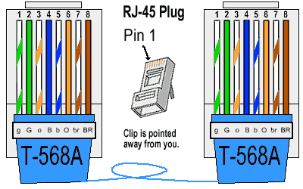

Fig: Color Coding Standard of UTP

NOTE:
In Straight-through cable, both ends use the same standard (A–A or B–B).
In Cross-over cable, one end uses 568A and the other end uses 568B.
Use Cases of 568A and 568B
568A Standard:
- Mostly used in residential wiring and government projects.
- Ensures backward compatibility with older telephone wiring.
568B Standard:
- Commonly used in commercial networks and data centers.
- Preferred in most Ethernet cabling systems worldwide.

c. To prepare straight-through and cross-over cables and Test it:

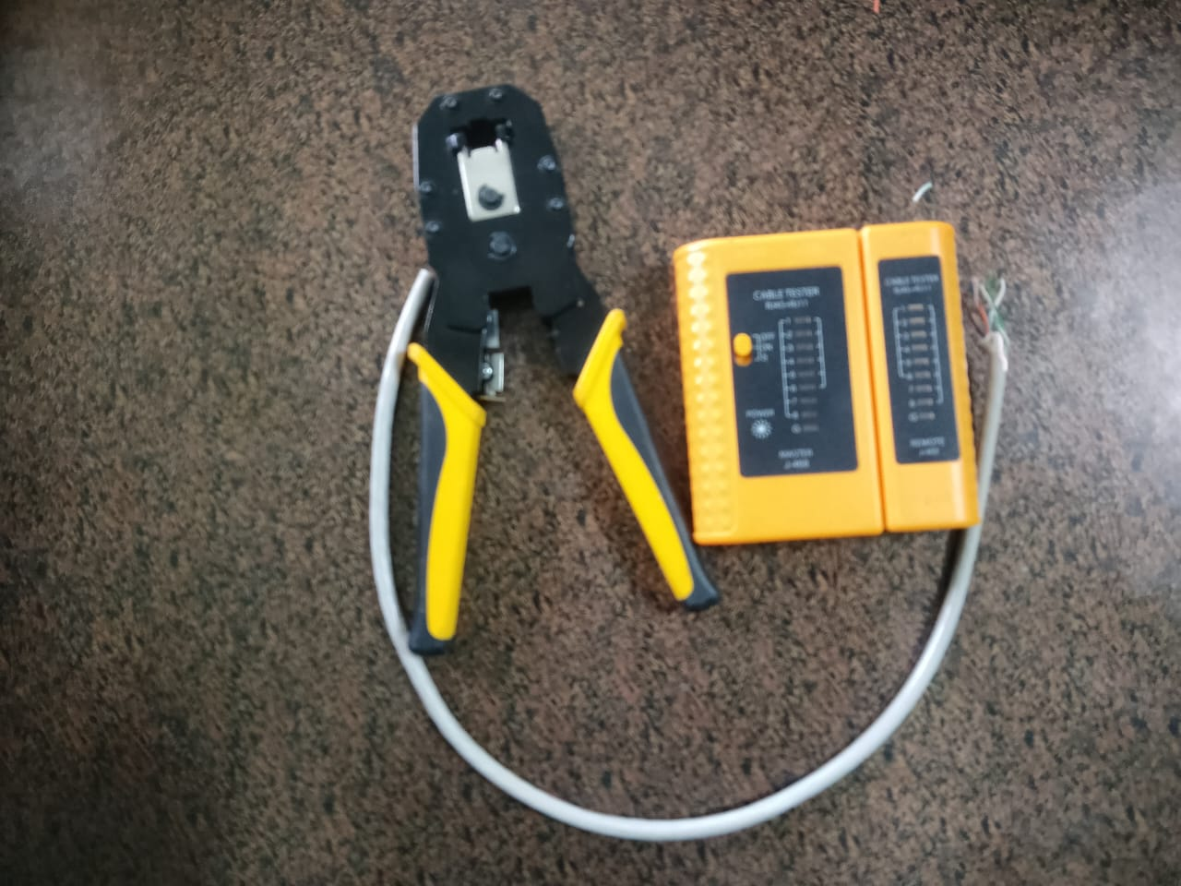
Here in Figure: Crimper, UTP Cable, LAN Tester, RJ 45 Jack

Step by Step Implementation:
Step 1: Stripe the Cable about 1.5 or 2 inch
Step 2: Make the Pair according to Color Coding Standard
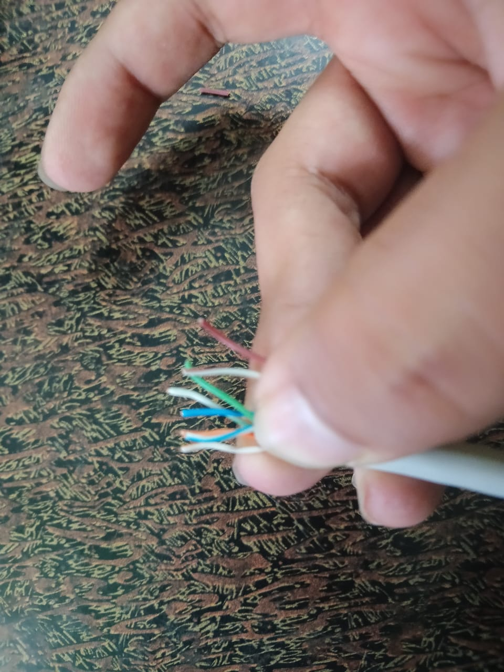

Fig: Making Pairs after stripping Cable

Step 3: Arrange and Insert the pairs in RJ45 Jack
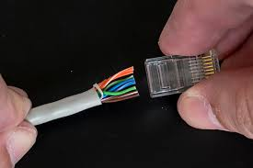
Step 4: Make same in another side of Cable (A-A) if you want to connect different devices i.e. PC to Router, or make (A-B) if you want to connect to Similar devices
A-A → Straight Cables
A-B → Cross-Over Cables
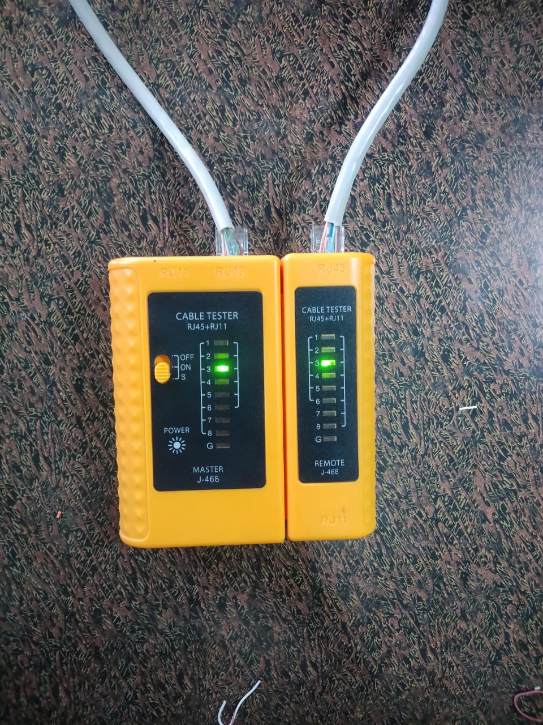

2. Practice on Basic Networking Commands (ifconfig/ipconfig, tcpdump, netstat, ip, hostname, route, tracert/traceroute)

Objective: To understand basic command line operation with Linux and network configuration, testing and verification.

Commands and Descriptions
- ifconfig / ipconfig
  - Used to display and configure network interface settings.
  - Shows IP address, MAC address, subnet mask, and status of interfaces.

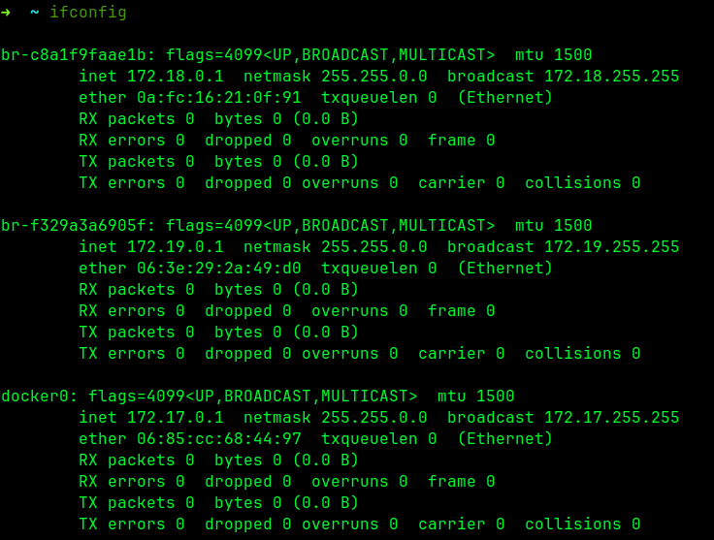

- ip
  - Modern replacement for ifconfig.
  - Can manage routes, addresses, neighbors, and interfaces.
  - Example: ip addr show displays all IP addresses.
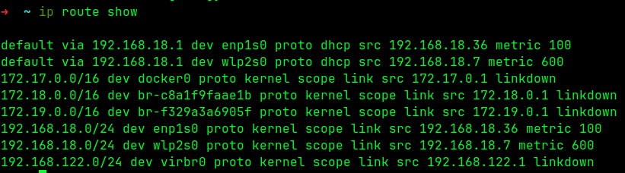
- hostname
  - Displays or sets the system’s hostname.
  - Example: hostname shows the current hostname, hostname newname sets a new one.
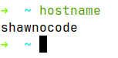

- netstat
  - Shows active connections, listening ports, routing tables, and interface statistics.
  - Example: netstat -tulnp shows all listening ports with processes.
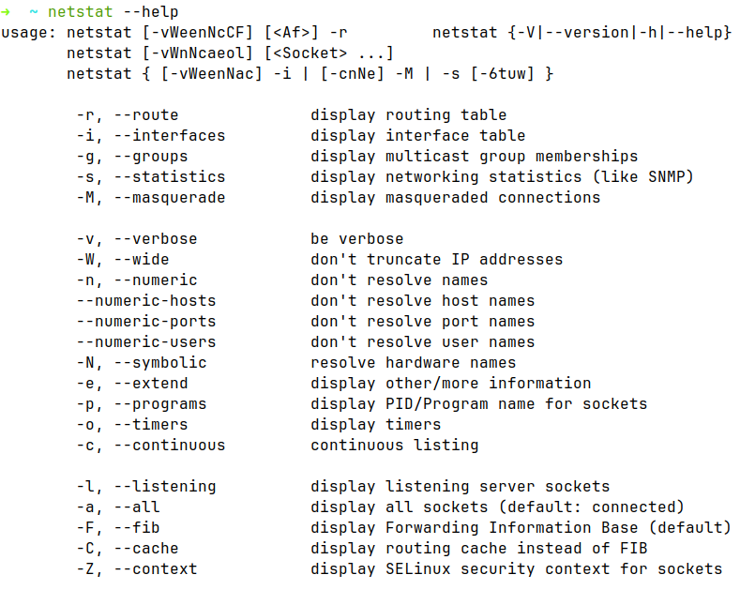

- route
  - Displays or modifies the routing table.
  - Example: route shows the kernel IP routing table.
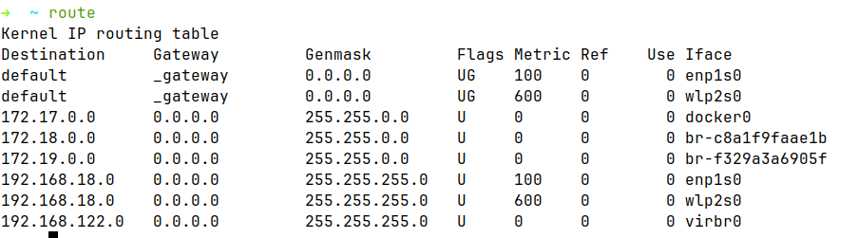
- traceroute / tracert
  - Shows the path packets take to reach a destination.
  - Helps in identifying routing problems or delays.
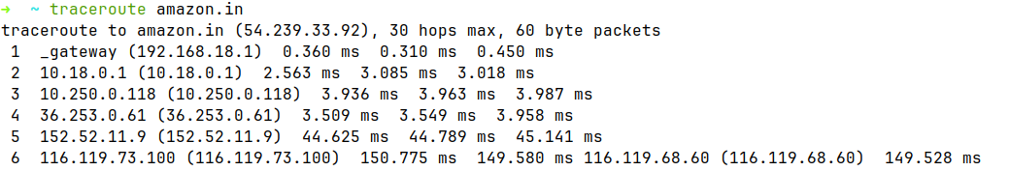
- tcpdump
  - A packet analyzer to capture and display network traffic.
  - Example: tcpdump -i eth0 captures traffic on interface eth0.
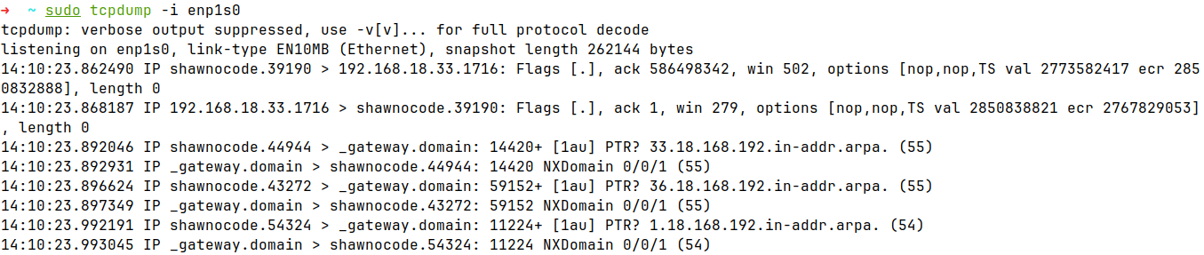

3. Overview of IP Addressing and Subnetting

Objective
- To understand the theoretical knowledge of IPv4 addressing and subnetting, including how IP addresses are structured and how networks are divided.

Terminologies
- IPv4 Address: A 32-bit number that identifies a device on a network, usually written like 192.168.1.1.
- Host Address: The IP of a device (computer, phone, etc.) on a network.
- Network: A group of devices that share the same starting part of their IP addresses.
- Broadcast Address: An address used to send data to all devices in a network; cannot be used by a single device.
- Subnet: A smaller part of a network where devices share part of the IP address.
- Subnetting: The process of dividing a network into smaller subnets.
- Subnet Mask: A number that shows which part of an IP is the network/subnet and which part is for devices.

IPv4 Addressing
- An IPv4 address is a 32-bit number used to identify devices on a network.
- Represented in dotted decimal notation: 192.168.1.10 (4 octets, 8 bits each).
- Each IP address has two parts:
  - Network ID – identifies the network.
  - Host ID – identifies a device on that network.
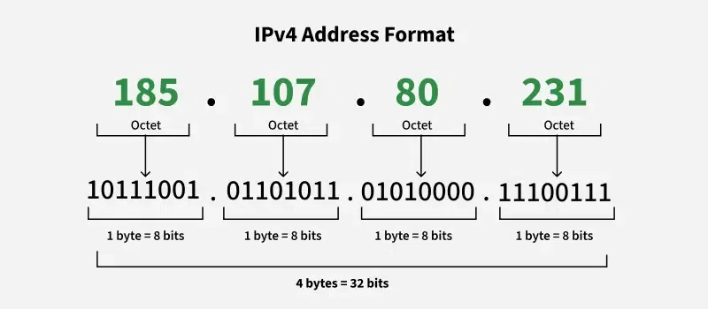
Fig: IPv4 Address Format

IPv4 Classes:

Class | Range | Default Subnet Mask | Usage
A | 1.0.0.0 – 126.0.0.0 | 255.0.0.0 | Large networks
B | 128.0.0.0 – 191.255.0.0 | 255.255.0.0 | Medium networks
C | 192.0.0.0 – 223.255.255.0 | 255.255.255.0 | Small networks
D | 224.0.0.0 – 239.255.255.255 | N/A | Multicast
E | 240.0.0.0 – 255.255.255.255 | N/A | Experimental

Subnetting
- Subnetting is the process of dividing a large network into smaller subnetworks.
- Benefits:
  - Efficient IP address usage.
  - Reduced network congestion.
  - Improved security and management.
Example:
- Network: 192.168.1.0/24 → 256 addresses
- Subnet mask: 255.255.255.192 → /26 → divides network into 4 subnets:
Subnet 1: 192.168.1.0 – 192.168.1.63
Subnet 2: 192.168.1.64 – 192.168.1.127
Subnet 3: 192.168.1.128 – 192.168.1.191
Subnet 4: 192.168.1.192 – 192.168.1.255

IP Address Classes & Network/Host Portion:
Class | Range | Network Portion | Host Portion | Default Subnet Mask
A | 0-127 | 1st octet | Last 3 octets | 255.0.0.0
B | 128-191 | 1st & 2nd octet | Last 2 octets | 255.255.0.0
C | 192-223 | 1st, 2nd, 3rd octet | Last octet | 255.255.255.0
D | 224-239 | N/A (multicast) | N/A | N/A
E | 240-255 | N/A (experimental) | N/A | N/A

Network portion: Identifies the network.
Host portion: Identifies devices in the network.

Private & Special Addresses
- Private Networks: Not routable on the internet.
  - Class A: 10.0.0.0 – 10.255.255.255
  - Class B: 172.16.0.0 – 172.31.255.255
  - Class C: 192.168.0.0 – 192.168.255.255
- APIPA (Auto IP): 169.254.0.0 – 169.254.255.255
- Special Addresses:
  - 127.0.0.0 → Loopback (self)
  - 224.0.0.0 → Multicast
  - 255.255.255.255 → Broadcast

Subnetting Overview
- Purpose: Divide networks into smaller subnets for efficient IP use.
- CIDR (Classless Inter-Domain Routing): Lets you borrow bits from host portion to create more subnets.
- Subnet Rules:
  - First IP → Subnet number
  - Last IP → Broadcast address
  - Remaining → Usable hosts
Example – Class A subnet:
- Original: 10.0.0.0/8 → 16,777,214 hosts
- Borrow 1 bit → 2 subnets, 8,388,606 hosts each

Subnetting Examples

Example 1 – Class C Network
Given:
- IP Address: 192.168.1.0
- Default Subnet Mask: 255.255.255.0 (/24)
- Requirement: Divide into 4 subnets
Step 1: Determine number of bits to borrow
- Number of subnets required = 4 → 2^n ≥ 4 → n = 2 bits
Step 2: New Subnet Mask
- Original mask: /24 → borrow 2 bits → /26
- Subnet mask: 255.255.255.192
Step 3: Calculate subnets
- Each subnet has 2^(8-2) = 64 addresses (62 usable)
- Subnets:

Default Subnet Mask and Addresses:
IP Address | Subnet Mask | Network Address | Broadcast Address
177.100.18.4 | 255.255.0.0 | 177.100.0.0 | 177.100.255.255
119.18.45.0 | 255.0.0.0 | 119.0.0.0 | 119.255.255.255
10.10.250.1 | 255.0.0.0 | 10.0.0.0 | 10.255.255.255
223.23.223.109 | 255.255.255.0 | 223.23.223.0 | 223.23.223.255
193.100.77.8 | 255.255.255.0 | 193.100.77.0 | 193.100.77.255

Conclusion:
Understanding IPv4 addressing and subnetting is essential for designing networks efficiently. Subnetting helps in allocating IP addresses optimally, reducing waste, and managing large networks easily.

4. Introduction to Packet Tracer: Basic Router Configuration

Objective
• To Understand Basic Commands for Router Configuration

Overview
Cisco Packet Tracer is a network simulation tool that allows students to configure routers, switches, and other devices without physical hardware.
In this lab, we focus on basic router configuration, including assigning IP addresses, configuring interfaces, and verifying connectivity.

Basic Router Commands:
Command | Purpose
enable | Enter privileged EXEC mode
configure terminal | Enter global configuration mode
hostname <name> | Set router’s hostname
interface <type> <number> | Enter interface configuration mode (e.g., interface gig0/0)
ip address <IP> <Subnet> | Assign IP address to interface
no shutdown | Enable the interface (bring it up)
exit | Exit from current mode
show running-config | Display current router configuration
show ip interface brief | Show interface status and IP addresses
ping <IP> | Test connectivity to another device

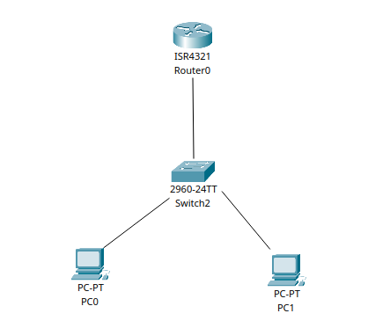
Setup in Packetracer

Step 1: Open Packet Tracer and Add Devices
- Open Cisco Packet Tracer.
- From the bottom-left device menu:
  - Click Routers → drag a router (e.g., Generic 2811) to the workspace.
  - Click End Devices → drag a PC to the workspace.
- Connect the router and PC using a copper straight-through cable:
  - Click Connections (lightning icon) → choose Copper Straight-Through → click router interface Gig0/0 → click PC NIC FastEthernet0.

Step 2: Configure Router Interfaces
- Click the router → go to CLI tab.
- Enter commands step by step:
Router> enable # Enter privileged mode
Router# configure terminal # Enter global config mode
Router(config)# hostname R1 # Set router name
R1(config)# interface gig0/0 # Enter interface configuration
R1(config-if)# ip address 192.168.1.1 255.255.255.0 # Assign IP
R1(config-if)# no shutdown # Activate the interface
R1(config-if)# exit # Exit interface mode
R1(config)# exit # Exit global config
R1# show ip interface brief # Check interface status

Step 3: Configure PC
- Click the PC → Desktop tab → IP Configuration.
- Enter:

Step 4: Test Connectivity
- Click PC → Desktop → Command Prompt.
- Ping the router:

Step 5: Save Configuration
- On router CLI run:
R1# copy running-config startup-config

Conclusion
- Learned basic router commands in Packet Tracer.
- Configured IP addresses and verified connectivity using ping.
- Understanding these basics is essential for designing and troubleshooting real networks.

5. Static Routing Implementation

Objective
• To understand the Static Routing, its Advantages and Drawbacks

Introduction to Static Routing
- Routing is the process of selecting a path for traffic in a network or between networks.
- Static Routing is a method where the network administrator manually defines the routes in the router’s routing table.
- Unlike dynamic routing, static routes do not change automatically; the administrator must update them if the network changes.

Key Features of Static Routing
- Manual configuration of paths between networks.
- Routes remain fixed unless manually modified.
- Works well for small networks with few routers.
- Reduces router overhead because no routing protocols are running.

Advantages of Static Routing
- Simple and Predictable: Routes are fixed and easy to understand.
- Low Overhead: No CPU or memory is consumed by routing protocols.
- Secure: Less vulnerable to routing attacks since routes are manually set.
- Reliable: No dependency on dynamic protocol updates.

Drawbacks of Static Routing
- Not Scalable: Hard to manage in large networks with many routers.
- Manual Updates Needed: Any network change requires updating all affected routers.
- No Automatic Failover: If a link fails, static routes do not adjust automatically.
- Time-Consuming: Configuring and maintaining many static routes is tedious.

Basic Static Routing Example in Packetracer
Scenario: Two routers (R1 and R2) connected via a network.

Step 1: Configure Router Interfaces
R1(config)# interface gig0/0
R1(config-if)# ip address 192.168.1.1 255.255.255.0
R1(config-if)# no shutdown
R1(config-if)# exit
R2(config)# interface gig0/0
R2(config-if)# ip address 192.168.2.1 255.255.255.0
R2(config-if)# no shutdown
R2(config-if)# exit
Step 2: Configure Static Routes
On R1:
R1(config)# ip route 192.168.2.0 255.255.255.0 192.168.1.2
On R2:
R2(config)# ip route 192.168.1.0 255.255.255.0 192.168.2.2
Step 3: Verify Connectivity
- Use ping from a PC on one network to a PC on the other network.
- Successful replies confirm correct static route configuration.
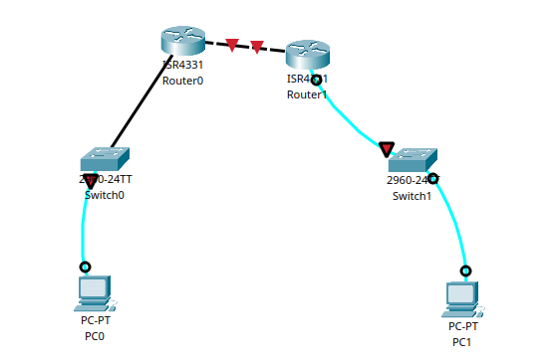

Fig: Static Routing Implementation in Packetracer

6. VLAN and VLAN Trunking

Objective
To understand LAN networking, creation of VLAN, IP addressing in the VLAN and VLAN Trunk.

Introduction
- VLAN (Virtual Local Area Network) is a logical subdivision of a LAN.
- VLANs allow network administrators to segment a physical network into multiple logical networks, improving security and performance.
- VLAN Trunking allows traffic from multiple VLANs to pass through a single physical link between switches.

Key Concepts
- Access Port: Port that belongs to a single VLAN; connects end devices like PCs.
- Trunk Port: Port that carries traffic for multiple VLANs; used between switches or between switch and router.
- VLAN ID: A unique number (1–4094) that identifies each VLAN.

Topology Setup:
- Switch 1 (S1) with 3 PCs (PC1, PC2, PC3).
- Switch 2 (S2) with 3 PCs (PC4, PC5, PC6).
- A trunk link connects Switch 1 and Switch 2.
We will make two VLANs:
- VLAN 10 (Sales Department) → PC1, PC2, PC4
- VLAN 20 (HR Department) → PC3, PC5, PC6

Step-by-Step Configuration

1. Assign IP Addresses to PCs
Example:
- VLAN 10: 192.168.10.1/24, 192.168.10.2/24, 192.168.10.3/24
- VLAN 20: 192.168.20.1/24, 192.168.20.2/24, 192.168.20.3/24
So each PC gets IP based on VLAN group.

2. Create VLANs on Switch 1 (S1)
Switch> enable
Switch# configure terminal
Switch(config)# vlan 10
Switch(config-vlan)# name Sales
Switch(config-vlan)# exit
Switch(config)# vlan 20
Switch(config-vlan)# name HR
Switch(config-vlan)# exit

3. Assign Ports to VLANs on Switch 1
Switch(config)# interface fa0/1
Switch(config-if)# switchport mode access
Switch(config-if)# switchport access vlan 10
Switch(config-if)# exit
Switch(config)# interface fa0/2
Switch(config-if)# switchport mode access
Switch(config-if)# switchport access vlan 10
Switch(config-if)# exit
Switch(config)# interface fa0/3
Switch(config-if)# switchport mode access
Switch(config-if)# switchport access vlan 20
Switch(config-if)# exit

4. Create VLANs on Switch 2 (S2)
Switch(config)# vlan 10
Switch(config-vlan)# name Sales
Switch(config-vlan)# exit
Switch(config)# vlan 20
Switch(config-vlan)# name HR
Switch(config-vlan)# exit

5. Assign Ports to VLANs on Switch 2
Switch(config)# interface fa0/1
Switch(config-if)# switchport mode access
Switch(config-if)# switchport access vlan 10
Switch(config-if)# exit

Switch(config)# interface fa0/2
Switch(config-if)# switchport mode access
Switch(config-if)# switchport access vlan 20
Switch(config-if)# exit
Switch(config)# interface fa0/3
Switch(config-if)# switchport mode access
Switch(config-if)# switchport access vlan 20
Switch(config-if)# exit

6. Configure Trunk Between Switch 1 and Switch 2
Switch(config)# interface fa0/24
Switch(config-if)# switchport mode trunk
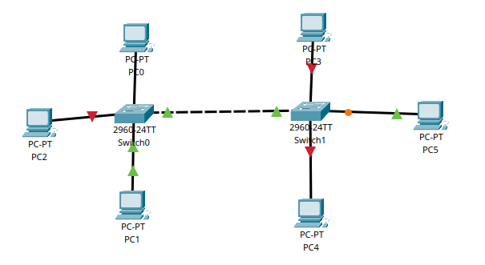
Switch(config-if)# exit

7. Implementation of RIP, EIGRP, OSPF and BGP

Objective(s):
- To understand the basic operation of different routing protocols (RIP, EIGRP, OSPF, and BGP).
- To configure and verify routing protocols in Packet Tracer.
- To analyze differences between Distance Vector, Link State, and Path Vector protocols.

Background:
Routing protocols are sets of rules used by routers to exchange information about networks. They do not move user data directly but instead update and maintain the routing table, which helps routers decide the best path to reach a destination.

Types of Routing Protocols:
- Interior Gateway Protocols (IGP): Work inside an Autonomous System (AS). Examples:
  - RIP (Routing Information Protocol): Distance vector protocol, simple, hop-count metric (max 15 hops).
  - EIGRP (Enhanced Interior Gateway Routing Protocol): Hybrid protocol, Cisco proprietary, uses bandwidth + delay as metrics.
  - OSPF (Open Shortest Path First): Link-state protocol, uses Dijkstra’s SPF algorithm, very scalable and secure.
- Exterior Gateway Protocols (EGP): Work between Autonomous Systems. Example:
  - BGP (Border Gateway Protocol): Path vector protocol, backbone of the internet, exchanges routing information between ISPs and large networks.

Router Configuration Steps (Packet Tracer Example):

1. Interface Configuration
On Router 1 (R1):
R1(config)#hostname R1
R1(config)#interface s0/0/0
R1(config-if)#ip address 192.168.5.1 255.255.255.0
R1(config-if)#clock rate 64000
R1(config-if)#no shutdown
R1(config)#interface fa0/0
R1(config-if)#ip address 192.168.1.1 255.255.255.0
R1(config-if)#no shutdown

On Router 2 (R2):
R2(config)#hostname R2
R2(config)#interface s0/0/0
R2(config-if)#ip address 192.168.5.2 255.255.255.0
R2(config-if)#no shutdown
R2(config)#interface fa0/0
R2(config-if)#ip address 192.168.3.1 255.255.255.0
R2(config-if)#no shutdown

2. RIP Configuration
R1(config)#router rip
R1(config-router)#version 2
R1(config-router)#network 192.168.1.0
R1(config-router)#network 192.168.5.0
R2(config)#router rip
R2(config-router)#version 2
R2(config-router)#network 192.168.3.0
R2(config-router)#network 192.168.5.0

3. EIGRP Configuration
R1(config)#no router rip
R1(config)#router eigrp 100
R1(config-router)#network 192.168.1.0
R1(config-router)#network 192.168.5.0
R2(config)#no router rip
R2(config)#router eigrp 100
R2(config-router)#network 192.168.3.0
R2(config-router)#network 192.168.5.0

4. OSPF Configuration
R1(config)#no router eigrp 100
R1(config)#router ospf 1
R1(config-router)#network 192.168.1.0 0.0.0.255 area 0
R1(config-router)#network 192.168.5.0 0.0.0.255 area 0
R2(config)#no router eigrp 100
R2(config)#router ospf 1
R2(config-router)#network 192.168.3.0 0.0.0.255 area 0
R2(config-router)#network 192.168.5.0 0.0.0.255 area 0

5. BGP Configuration
R1(config)#router bgp 100
R1(config-router)#network 192.168.1.0 mask 255.255.255.0
R1(config-router)#neighbor 192.168.5.2 remote-as 200
R2(config)#router bgp 200
R2(config-router)#network 192.168.3.0 mask 255.255.255.0
R2(config-router)#neighbor 192.168.5.1 remote-as 100

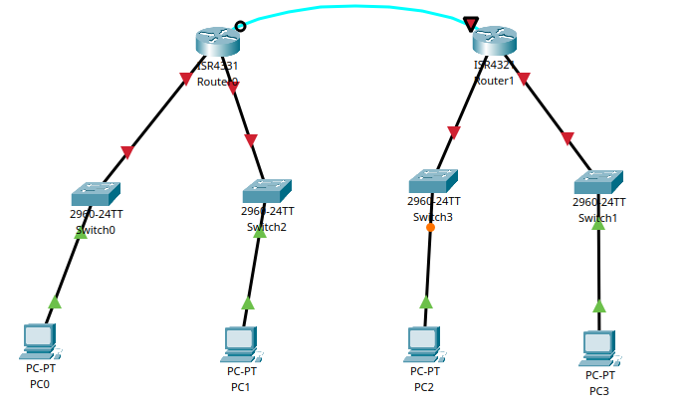

Verification Commands:
- ping <IP> → check connectivity
- show ip route → check routing table
- show running-config → check configurations

Conclusion:
- RIP is simple but only good for small networks.
- EIGRP is faster and efficient with multiple metrics.
- OSPF is scalable and widely used in enterprises.
- BGP is essential for routing between ISPs and across the internet.
- By configuring and testing each protocol, we understood how routers dynamically share routes and select the best path.

8. DHCP, WEB, DNS, EMAIL, FTP Server Configuration

Objectives:
- To understand the working principle of DHCP, WEB, DNS, EMAIL, and FTP Servers.

Terminologies:

a. DHCP:
Dynamic Host Configuration Protocol is a network protocol used to automate the process of assigning IP addresses and other network configuration parameters to devices (such as computers, smartphones and printers) on a network.
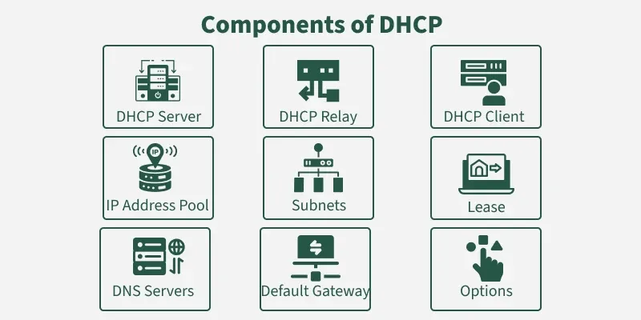

Components of DHCP
1. DHCP Server: It is typically a server or a router that holds the network configuration information.
2. DHCP Client: It is the endpoint that gets the configuration information from the server like any computer or mobile.
3. DHCP Relay Agent: If you have only one DHCP Server for multiple LAN’s then the DHCP relay agent present in every network will forward the DHCP request to the servers. This because the DHCP packets cannot travel across the router. Hence, the relay agent is required so that DHCP servers can handle the request from all the networks.
4. IP address pool: It contains the list of IP address which are available for assignment to the client.
5. Subnet Mask: It tells the host that in which network it is currently present.
6. Lease Time: It is the amount of time for which the IP address is available to the client. After this time the client must renew the IP address.
7. Gateway Address: The gateway address lets the host know where the gateway is to connect to the internet.

b. Web Server
A web server is a system either software, hardware, or both that stores, processes, and delivers web content to users over the Internet using the HTTP or HTTPS protocol. When a user’s browser sends a request (like visiting a website), the web server responds by delivering the appropriate resources, such as HTML pages, images, videos, or data.
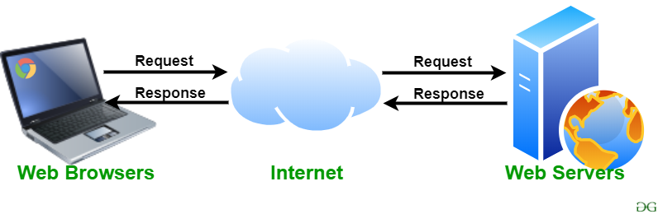

c. DNS
The domain name system (DNS) is a naming database in which internet domain names are located and translated into Internet Protocol (IP) addresses. The DNS maps the name people use to locate a website to the IP address that a computer uses to locate that website.
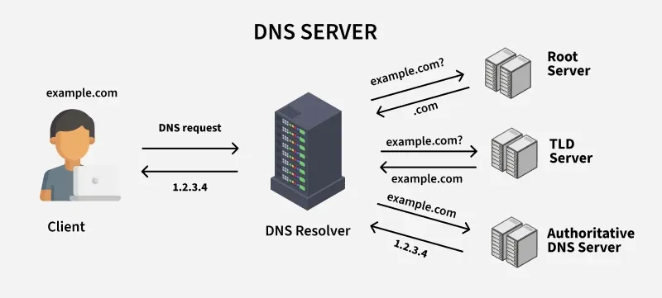

How DNS Works:
1. User Input: You enter a website address (for example, www.amazon.com) into your web browser.
- Local Cache Check: Your browser first checks its local cache to see if it has recently looked up the domain. If it finds the corresponding IP address, it uses that directly without querying external servers.
- DNS Resolver Query: If the IP address isn’t in the local cache, your computer sends a request to a DNS resolver. The resolver is typically provided by your Internet Service Provider (ISP) or your network settings.
- Root DNS Server: The resolver sends the request to a root DNS server. The root server doesn’t know the exact IP address for www.geeksforgeeks.org but knows which Top-Level Domain (TLD) server to query based on the domain’s extension (e.g., .org).
- TLD Server: The TLD server for .org directs the resolver to the authoritative DNS server for geeksforgeeks.org.
- Authoritative DNS Server: This server holds the actual DNS records for geeksforgeeks.org, including the IP address of the website’s server. It sends this IP address back to the resolver.
- Final Response: The DNS resolver sends the IP address to your computer, allowing it to connect to the website’s server and load the page.

d. Mail Server
A mail server (sometimes called an email server) is a software program that sends and receives email. Often, it is used as a blanket term for both mail transfer agents (MTA) and mail delivery agents (MDA), each of which perform a slightly different function.
Mail servers play a crucial role in the email delivery process. Without them, users would have no way of transferring those messages to and from other mail clients.
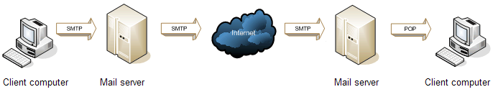
SMTP, POP3 and IMAP4
1. SMTP (Simple Mail Transfer Protocol) is a protocol that is used when e-mails are
delivered from clients to servers and from servers to other servers. It uses port 25, 2525
and 465.
2. POP3 (Post Office Protocol version 3) is used to retrieve email from the servers. It
uses port 110 and 995.
3. IMAP4 (Internet Message Access Protocol Version 4) is a further development of
the POP3 protocol and is used to read e-mail from mail servers. IMAP4 is not used as
much as POP3, but many modern mail servers have support for IMAP4. It uses por 143
and 993.

File Transfer Protocol (FTP):
File transfer protocol (FTP) is a method for moving files between computers on a network. It's a set of instructions that computers use to communicate and exchange files. You can use FTP to upload files to a server, download files from a server, or transfer data between computers on a local network.

What is FTP Useful For?
FTP is especially useful for:
- Transferring Large Files: FTP can transfer large files in one shot; thus applicable when hosting websites, backing up servers, or sharing files in large quantities.
- Remote File Management: Files on a remote server can be uploaded, downloaded, deleted, renamed, and copied according to the users’ choices.
- Automating File Transfers: FTP is a great protocol for the execution of file transfers on predefined scripts and employments.
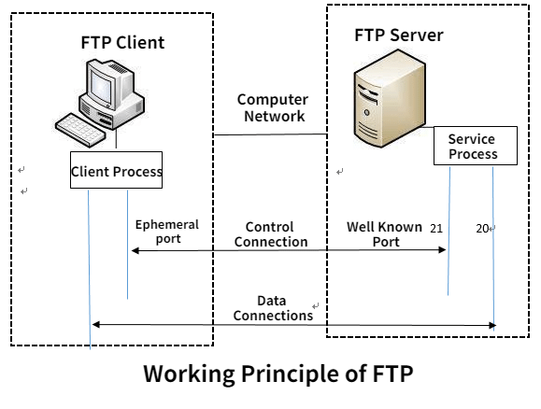
- Accessing Public Files: Anonymous FTP means that everybody irrespective of the identity is allowed to download some files with no permissions needed.

Lab Report of Computer Network (CSC 263)



Submitted By: Submitted To:
Safalta Shah Rajkumar Shrestha
BscCSIT 4th Sem

