5. Audio Processing and editing using Wavepad Application
1. Insert an Audio File
➜ Click on the "File" menu located at the top left corner of the WavePad interface.
➜ Select "Open" from the dropdown menu to import the audio file.
➜ Alternatively, drag and drop the audio file directly into WavePad.

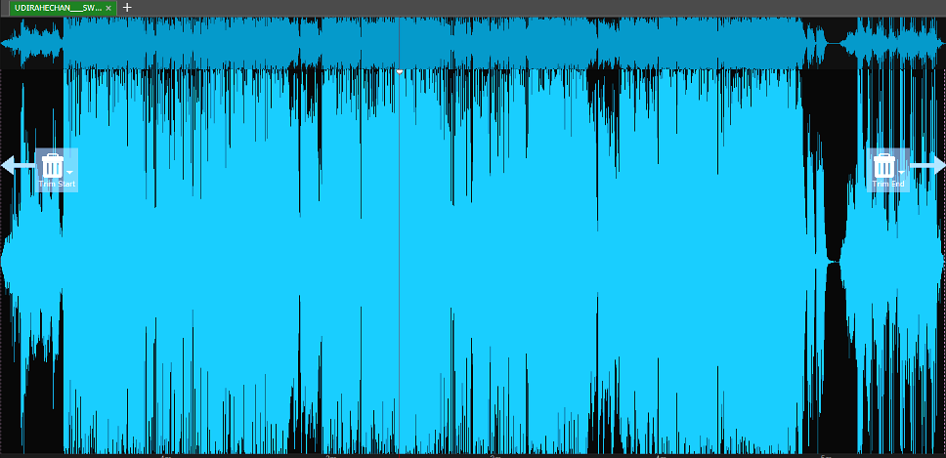
Fig 1 — Inserting an Audio File
2. Applying Audio Effects
A. Amplifying
➜ Navigate to "Effects" in the menu bar and select "Amplify" from the dropdown.
➜ Use the selection tool to choose the audio portion you wish to amplify (if needed).
➜ Adjust the amplification level using the slider or input field.
▸ Increase the value for a louder sound; decrease it for a softer output.

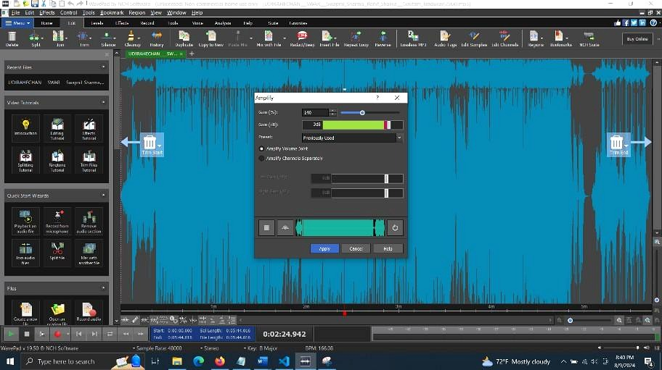
Fig 2 — Amplifying the Audio

B. Fade-In Effect
➜ Go to "Effects" in the menu bar.
➜ Select "Fade" from the dropdown menu, then choose "Fade In".
➜ Adjust the duration of the fade-in effect as needed.
➜ Click "OK" or "Apply" to apply the effect.

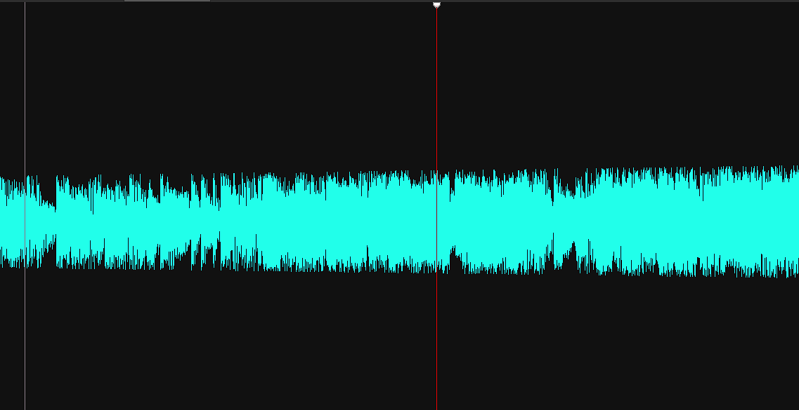
Fig 3 — Fade-In Effect
C. Fade-Out Effect
➜ Following the same initial steps as Fade-In and choose "Fade Out" instead.
➜ Adjusting the fade-out duration if necessary.
➜ Click "OK" or "Apply" to confirm.

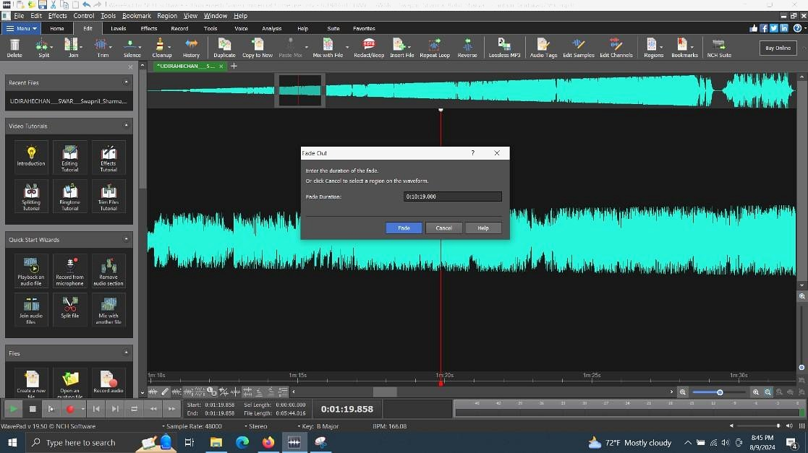
Fig 4 — Fade-Out Effect
D. Pitch Adjustment
➜ Go to "Effects" in the menu bar and select "Pitch".
➜ In the Pitch dialog box, adjust the semitones or cents value.
▸ Positive values raise the pitch; negative values lower it.
➜ Click "OK" or "Apply" to confirm the adjustment.

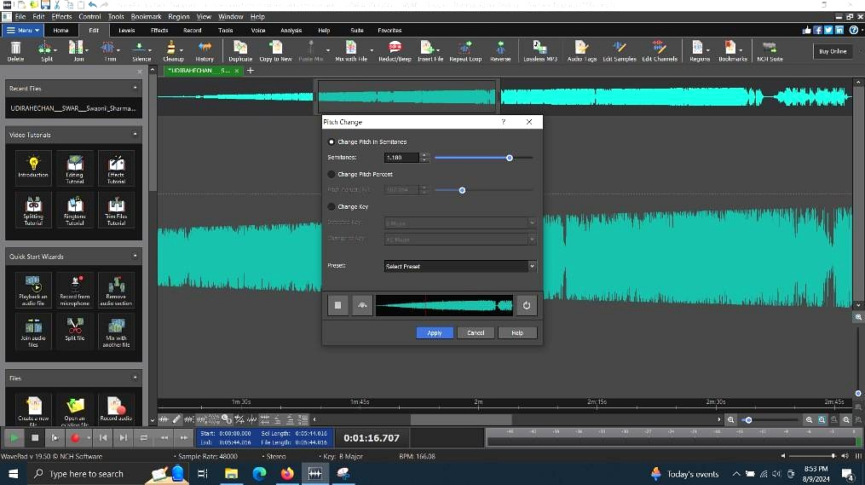
Fig 5 — Pitch Adjustment
E. Speed Adjustment
➜ Select the audio portion to adjust speed, if needed.
➜ Go to "Effects" > "Time/Pitch" in the menu bar.
➜ Adjust the percentage value in the Time/Pitch dialog.
▸ Increasing the percentage speeds up the audio; decreasing it slows it down.
➜ Click "OK" or "Apply" to confirm.

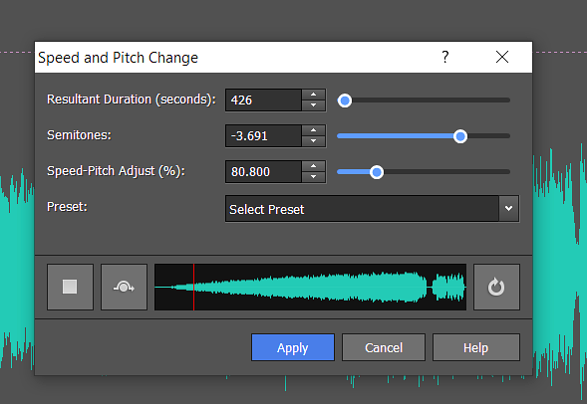
Fig 6 — Changing Audio Speed
3. Audio Editing Operations
A. Trim and Cut
To trim the audio:
➜ Use the selection tool to highlight the section you want to keep.
➜ Go to "Edit" > "Trim" — the selected portion will be retained; the rest removed.
To cut the audio:
➜ Highlight the section to remove using the selection tool.
➜ Go to "Edit" > "Cut" — the selected portion will be removed from the file.


Fig 7 — Trim and Cut Operations
B. Merging Audio Files
To merge audio files into a single track:
➜ Ensure both audio files are properly aligned on the timeline.
➜ Go to "File" > "Save Mix As" or "Export Mix".
➜ Select the desired file format and save location.
To mix the audio files together:
➜ Adjust the volume levels of each track for a balanced output.
➜ Apply additional effects such as equalization, reverb, or compression.

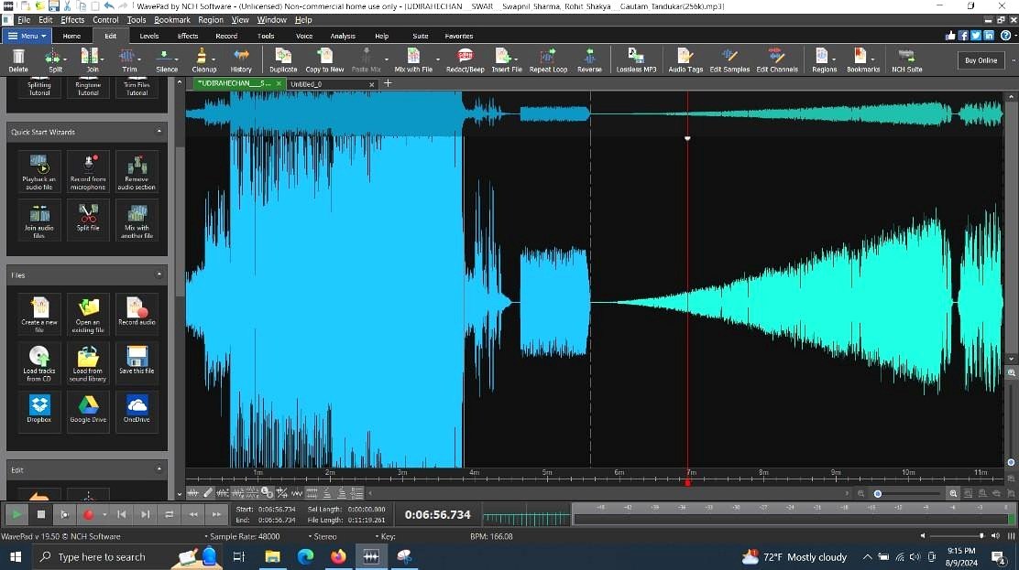
Fig 8 — Merging Audio Files

4. Text-to-Speech Conversion
➜ Click on "Tools" in the top menu of WavePad.
➜ Select "Text to Speech" from the dropdown — the TTS dialog box will open.
➜ Enter or paste your text into the provided text field.
➜ Choose the desired voice from the available options.
➜ Click "Synthesize Speech" to convert the text to audio.
➜ The synthesized speech will be inserted as a new audio track in WavePad.

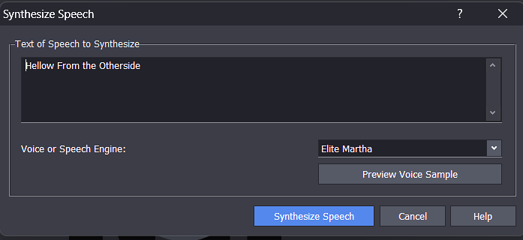
Fig 9 — Text-to-Speech Dialog
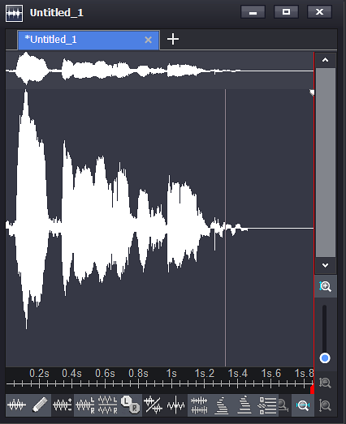
Fig 10 — Synthesized Audio Track

