1. Create a python program for bouncing ball

Objective:
To simulate the vertical motion of a bouncing ball using computer graphics.

Theory:
A bouncing ball animation works by repeatedly updating the ball’s position inside a loop and drawing it again on the screen. When the ball hits the top or bottom edge, its direction is flipped so it appears to bounce. The speed and smoothness are controlled using a timer or small delay between each update. Libraries such as pygame make it easier to draw shapes and manage smooth, real-time animations.

Algorithm:
- The program starts by initializing the pygame library and setting up the display window with a fixed width and height. The window title and basic colors (red and black) are also defined.
- The ball’s properties are then initialized, including its horizontal position (center of the screen), vertical starting position (near the top), radius, speed, and initial direction (set to DOWN).
- A clock object is created to control the frame rate, and a loop control variable (running) is set to True to begin the animation.
- The program enters a continuous loop that runs until the user closes the window. Inside the loop, it checks for user events, and if the close button is pressed, the loop stops.
- The program performs boundary checking:
  - If the ball reaches the bottom of the screen (ball_y ≥ height − 30), its direction changes to UP.
  - If the ball reaches the top (ball_y ≤ 30), its direction changes to DOWN.
- The screen is cleared by filling it with a black background.
- The ball is then drawn as a solid red circle at its current position.
- The position of the ball is updated based on its direction:
  - If the direction is DOWN, the ball moves downward (ball_y += ball_speed).
  - If the direction is UP, the ball moves upward (ball_y -= ball_speed).
- The display is refreshed to show the updated frame, and the clock limits the animation speed to 20 frames per second for smooth motion.
- Once the loop ends, the program exits pygame and closes the window

Python Program

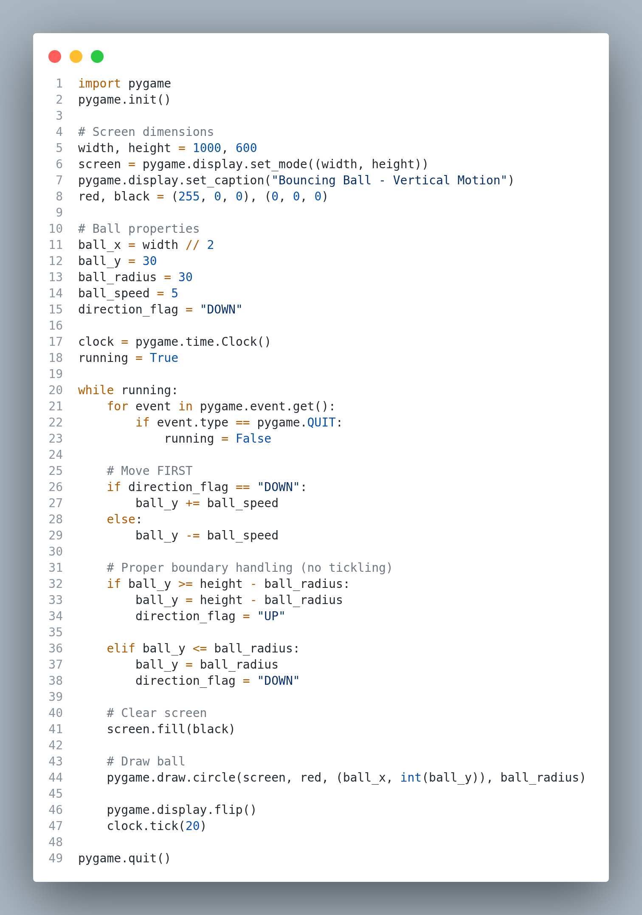
Output:

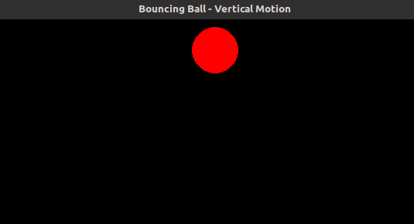
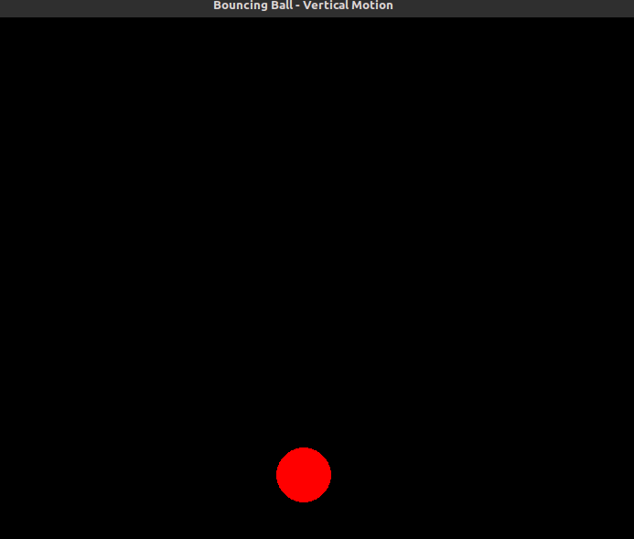

2. Create a python program for Moving Car

Objective:
To create smooth motion across the screen using the pygame graphics library.
Theory:
This animation shows how real-time movement can be achieved by continuously updating the position of an object—in this case, a car moving horizontally. The car’s x-coordinate is changed inside a loop, and during each cycle, the entire scene (background, road, car, and wheels) is redrawn at its new position. This repeated updating creates the effect of smooth motion.
When the car reaches the right side of the screen, its position is reset to the left side so that the movement can continue seamlessly. The pygame library is responsible for rendering the shapes and updating the display, while a controlled frame rate keeps the animation steady and visually smooth. Overall, this program demonstrates how continuous position updates, proper redrawing, and frame rate control work together to produce simple animations.

Algorithm: Moving Car Animation
- Initialize the system
  - Import and initialize pygame.
  - Set up the display window with width and height.
  - Define colors for the car, windows, wheels, road, and background.
  - Create a clock object to control the frame rate.
- Define the car drawing function
  - Draw the car body as a rectangle.
  - Draw the window and divide it with a line.
  - Draw left and right wheels with rims.
- Set initial car properties
  - Position the car horizontally (x) and vertically (y).
  - Set the horizontal speed of the car.
- Start the main loop
  - Continue looping until the user closes the window or presses any key.
  - Check events for quitting the program.
- Draw and update the scene
  - Fill the background with green.
  - Draw the road as a black rectangle.
  - Draw the car at its current position.
  - Update the car’s horizontal position using the speed.
  - If the car moves beyond the right edge, reset its x-position to the left (screen wrapping).
  - Refresh the display and maintain a consistent frame rate using the clock.
- Exit program
After exiting the loop, quit pygame and release all resources.
Source Code is given in next page

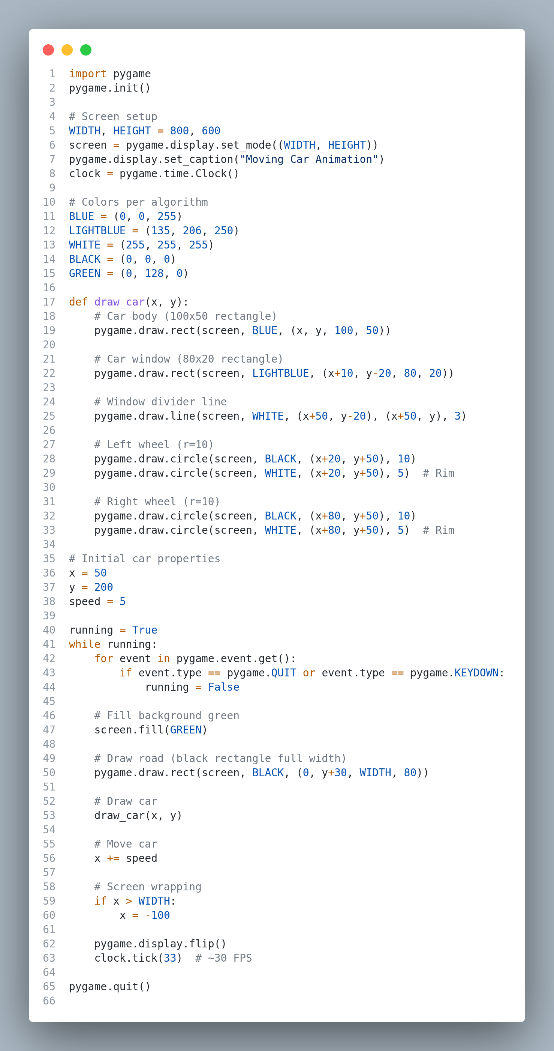
Output:
