MICRO FRONTEND ARCHITECTURE

Definition:
An architectural pattern where a single web application's UI is composed from multiple independently built, tested, and deployed applications, owned by different teams, that come together at runtime (or build time) into one product the user perceives as a single app.

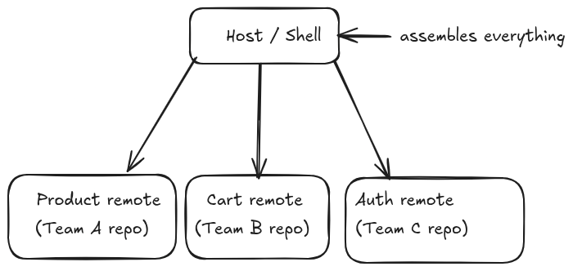

Why Do We Need It Micro Frontend?
Problem in a frontend monolith | How microfrontends address it
One repo, one build, one deploy pipeline for the whole product | Each team ships independently, on their own schedule
A bug in Team A's code blocks Team B's release | Deploys are decoupled — Team B ships even if Team A's build is broken
Merge conflicts scale with team size | Teams work in separate repos/codebases
Onboarding is hard (huge codebase, unclear ownership) | Each team owns a small, understandable slice
Tech stack is frozen for the whole org | Teams can use different frameworks/versions per app (though in practice most orgs standardize anyway)
Scaling org headcount doesn't scale delivery speed (everyone touches the same codebase) | Delivery speed scales roughly with team count, not codebase size

The core motivation is organizational, not technical. If you have one team and one codebase, microfrontends add cost for no benefit. They exist to solve Conway's Law problems — when your system architecture needs to mirror your team structure so that team boundaries = deployment boundaries.
This is worth being honest with yourself about: most companies that adopt MF do it because they have 3+ frontend teams stepping on each other, not because it's technically superior for a single team building one app.

MF Pros, Cons
Pros | Cons
Independent deployment — no cross-team release trains | Runtime coupling risk — a remote can be down/slow/broken and the host has to handle it
Independent codebases — smaller, focused repos | Harder debugging — a bug can span two apps' boundary, and stack traces cross app ownership
Teams can release on their own cadence | Version drift — shared deps (React, design system) can silently mismatch between apps
Fault isolation if designed well (one remote failing doesn't have to crash the whole page) | More infra to maintain — each remote needs its own build, deploy, CDN, monitoring
Enables incremental migrations (rewrite one remote at a time, not the whole app) | Bundle duplication risk if shared deps aren't configured correctly
Clear ownership boundaries | Testing end-to-end (host + all remotes together) is genuinely harder
Can scale team count without scaling coordination overhead | Initial setup complexity is real — MF is not "easier" than a monolith, it trades one set of problems for another
 | Network waterfall risk — loading remote code over HTTP adds latency vs. same-bundle imports
 | Design system consistency requires discipline (shared UI package), otherwise apps visually diverge

How MF works with Turborepo and Rsbuild:

The architecture usually has:
- Shell/host app: the main container that renders the layout and loads other apps.
- Remote apps: separate feature apps that expose parts of the UI.
- Shared packages: common UI, utilities, types, or config stored in the monorepo.
- Turborepo: task runner + dev proxy for local microfrontend routing.
- Rsbuild: builds each app and manages asset base paths.github+2

Note: Microfrontend with Turborepo and Rsbuild means splitting a frontend into separate apps inside one monorepo. Turborepo manages the workspace and local routing, Rsbuild builds each app, and Module Federation or shared packages are used to combine them. Apps communicate through props, shared state, browser events, or the host shell, while Rsbuild server.base ensures asset paths work correctly.

