# Lab report of Introduction to Information Technology St. Lawrence College

**Chabahil, Kathmandu**



# A lab report of

**“Introduction to Information Technology CSC-114” as required for the fulfillment of the**

# BSC. CSIT 1st Semester Affiliated to Tribhuvan University

**Submitted by: Submitted To:**

# Shudarsan Poudel Prajwal Bista

**Roll num: 32 Lecturer, IIT**



# CERTIFICATE FROM THE SUPERVISOR

This is to certify that the Lab report entitled “Introduction to Information Technology” is an academic work done by Shudarsan Poudel submitted in the partial fulfillment of the requirements for the degree of Bsc.CSIT at Faculty of Science, Tribhuvan University under my guidance and supervision. To the best of my knowledge, the work performed by him in the Lab report is his own creation.

Internal Examiner External Examiner

# ACKNOWLEDGEMENT

I would like to express my sincere gratitude to Mr. Prajwal Bista, my supervisor, for his invaluable guidance and support throughout the completion of this lab report. His expertise and insightful feedback have been instrumental in shaping the content and methodology of this work. I am also thankful to the faculty and staff of St. Lawrence College for providing a conducive learning environment and resources necessary for conducting this research.

I extend my appreciation to my classmates for their encouragement and assistance during this project. Finally, I acknowledge the support of my family for their unwavering encouragement and understanding during my academic pursuits.

# Table of Contents

CERTIFICATE FROM THE SUPERVISOR ii

1. Word Processing Software 1
   1. Write an application to apply for the post of Java Programmer along with your updated CV 1
   2. Prepare any type of form to fill up users details in any word processing software.

.......................................................................................................................................4

* 1. Prepare a 2-Month Calendar using Table 6
  2. Design a well-formatted newspaper page containing text, image, drop cap, etc 10

1. Spreadsheet Software 18
2. Create a marksheet of 10 students as per the following conditions 18
3. Prepare the bill of at least 10 items under the given conditions 19
4. Create a Salary Sheet of at least 7 staffs in an office along with graph and chart under the following conditions 20
5. Presentation Software 21
6. Prepare a presentation including at least 10 slides of any topic of your choice related to Information Technology. 21

# Word Processing Software

## Write an application to apply for the post of Java Programmer along with your updated CV.

Chabahil, Kathmandu December 12, 2023 To,

The Hiring Manager, Genese IT Solution, Kathmandu, Nepal Respected Hiring Manager,

I am writing to express my interest in the Java Programmer position at Genese IT Solution. with a Bsc. CSIT in Computer and hands-on experience in Java development, I am confident in my ability to contribute effectively to your team.

Enclosed is my updated resume, which provides details on my education, skills, and professional experience. I am excited about the opportunity to bring my expertise in Java, Spring Framework, Hibernate, and RESTful web services to Genese IT Solution.

Thank you for considering my application. I look forward to the possibility of discussing how I can contribute to your team in person.

Sincerely, Shudarsan Poudel Enclosure: Resume

**Curriculum Vitae**

## Name: SHUDARSAN POUDEL

Paste your recent passport size photo…

**Address: Bauddha-6, Ramhiti, Kathmandu Phone: 9801791084**

## Gmail: [shudarsanpoudel25@gmail.com](mailto:shudarsanpoudel25@gmail.com)

**Work Experience**

## Entry Mid-Level Java Developer

Kathmandu, Nepal

* Crafted an intuitive user interface for an internal tool using Java, increasing department efficiency by 20%.
* Led the optimization of a Java-based application, resulting in a 35% reduction in runtime.
* Implemented an effective API testing strategy, identified 25+ defects, and improved overall system reliability by 40%.

**Intern, Software Development**

* Contributed to enhancing the search engine with Java, impacting over 1 million users globally.
* Collaborated in code reviews, identified 20% of code bugs, and improved the final software quality**.**

**Education**

* Secondary Level –Bal Uddhar Secondary School (2078)

• +2(Computer engineering) –Bal Uddhar Secondary School (2080)

* Higher Level (B.Sc.CSIT) –St. Lawrence College(2080-Onwards)

**Skills**

* Proficiency in Java, including knowledge of Java 8.
* JAXB, Junit.
* Frameworks and Libraries.
* Web Technologies.
* Understanding of relational databases and SQL.

**Reference**

Prajwal Bista (Professor-IIT), Keshab Dangol (Chairman-St. Lawrence)

## Prepare any type of form to fill up users details in any word processing software.

 **MEMBERSHIP FORM**

**TECHNIUM**

Registration no:

**Empowering Innovation for a Digital Universe**

Paste your recent passport size photo.

**Personal Details:**

## Name:

First Name

Last Name

Email

**Email:**

## Phone:

XXXXXXXXXX

**Address:**

## Birth date:

MM/DD/YYYY

**Gender:**

* Male ☐ Female ☐ Other

## Membership Rules

I have read, understood, and accepted the rules for membership.

## Steps to make a Form:

1. Add the shapes and insert the logo of a company in that shape.
2. Insert the textbox for filling in personal details.
3. Insert the checkbox from the developer tab.

## Prepare a 2-Month Calendar using Table.



|  |  |  |  |  |  |  |
| --- | --- | --- | --- | --- | --- | --- |
| **JANUARY-2024** | | | | | | |
| **SUN** | **MON** | **TUE** | **WED** | **THU** | **FRI** | **SAT** |
|  | 1 | 2 | 3 | 4 | 5 | 6 |
| **7** | 8 | 9 | 10 | 11 | 12 | 13 |
| **14** | 15 | 16 | 17 | 18 | 19 | 20 |
| **21** | 22 | 23 | 24 | 25 | 26 | 27 |
| **28** | 29 | 30 |  |  |  |  |
|  |  |  |  |  |  |  |

|  |  |  |  |  |  |  |
| --- | --- | --- | --- | --- | --- | --- |
| **बैशाख** | | | | | | |
| **आइतबार** | **सोमबार** | **मंगलबार** | **बुधबार** | **बबहीबार** | **शुक्रबार** | **शबिबार** |
| **ियााँ वर्ष**  **1**  **14** | **2**  **15** | **3**  **16** | **4**  **17** | **5**  **18** | **6**  **19** | **7**  **20** |
| **8**  **21** | **9**  **22** | **10**  **23** | **11**  **24** | **12**  **25** | **13**  **26** | **14**  **27** |
| **15**  **28** | **16**  **29** | **17**  **30** | **18**  **1** | **19**  **2** | **20**  **3** | **21**  **4** |
| **22**  **5** | **23**  **6** | **24**  **7** | **25**  **8** | **26**  **9** | **27**  **10** | **28**  **11** |
| **29**  **12** | **30**  **13** | **31**  **14** |  |  |  |  |

आउने दिनहरु:

1 नयTाँ वर्ष

## Steps to make a Calendar:

* 1. Insert the 7*6 table from the insert menu.
  2. Go to table properties and specify height 2.5 to give margin.
  3. Give some colors from the home menu.
  4. Customize spacing from the Layout Section.
  5. To write something in the box, add textbox and make it no outline and no border.

1. **Design a well-formatted newspaper page containing text, image, drop cap, etc.**



# Virat Kohli and Anushka Sharma welcome baby boy ‘Akaay’



S

tar Indian batter Virat Kohli on Tue Anushka Sharma were blessed with are already proud parents of their thr opted out of the ongoing Test series

sday announced that he and his actress wife a baby boy on Feb 15. Virat Kohli and Anushka ee-year-old daughter Vamika. Kohli had earlier against England, citing personal reasons.

NEW DELHI: Star couple Virat Kohli and Anushka Sharma have blessed with a baby boy, the Indian Cricketer announced in an Instagram post on Tuesday.

Courtesy: Virat Kohli

## Steps to make Newspaper:

* 1. Make a headline using Word art.
  2. Underline the headline using the shapes and make it thicker.
  3. Insert the picture from the insert menu.
  4. Insert the Drop-Cap from the insert section.

## Design an attractive advertisement using Photoshop.

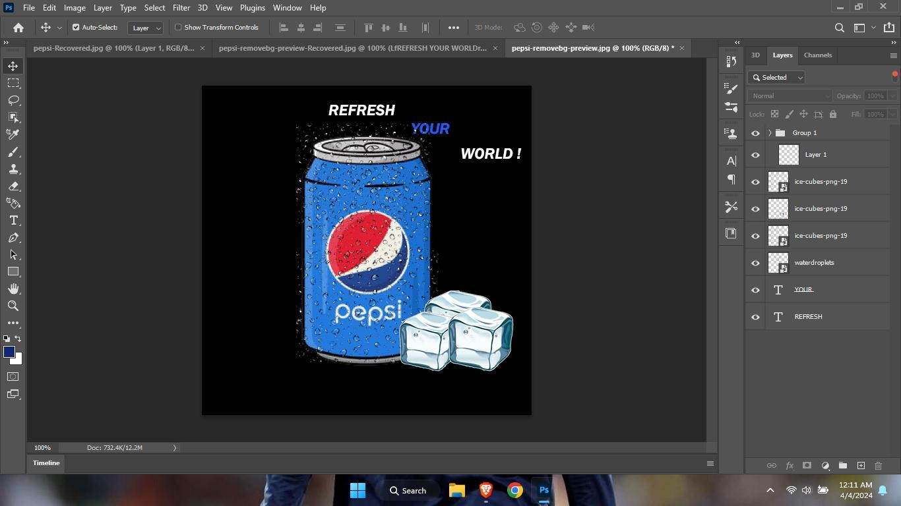

**Final Result:**



## Design an ID Card for your college using photoshop.

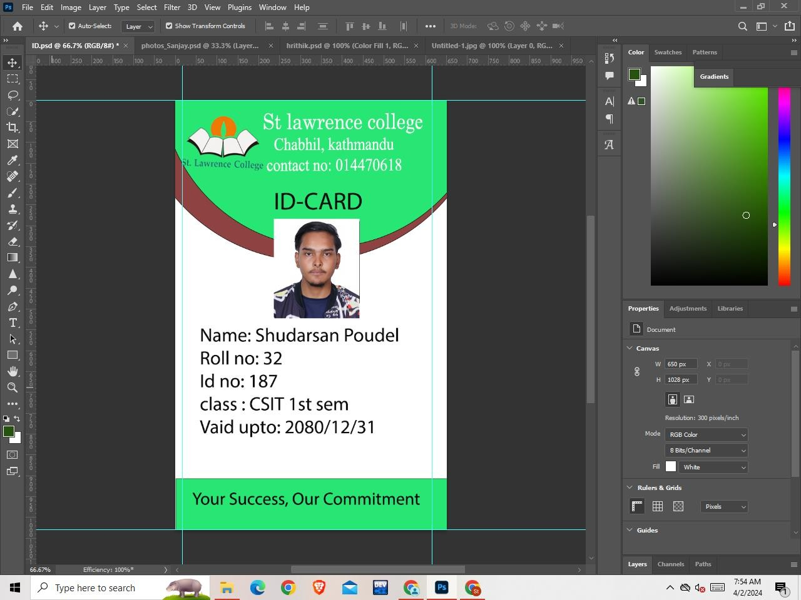

**Final Result:**

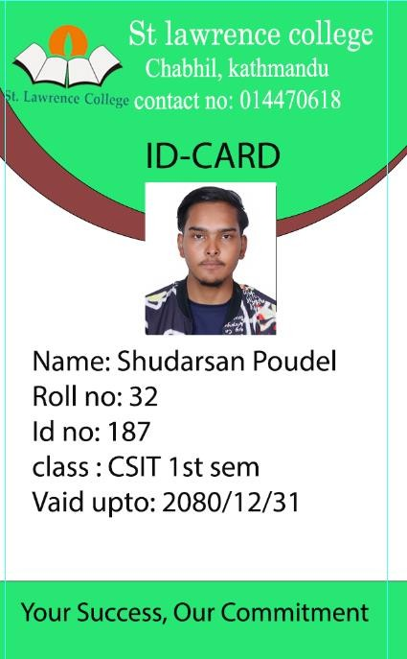

## Steps to make ID Card:

* + 1. Go to the Photoshop and make a new file.
    2. Then adjust the height and width of the new canvas created.
    3. Then select a rectangle tool and draw a rectangle inside the canvas.
    4. Press CTRL+R and as ruler appears and adjust the ruler according to the
    5. canvas rectangle.
    6. Remove the rectangle inbuilt color and inbuilt a plane whit color.
    7. Add a required design that you to be in your ID-Card.Select the text option and add the college name in the heading also.
    8. select the college logo and add it to the left top of the canvas.
    9. Add a rectangle and make your picture fit inside the rectangle by
    10. Dragging you photo layer below the rectangle layer
    11. Add some background and fill up the required information.
    12. ID-Card is ready.

## 7. Prepare your passport size photo with white background in Photoshop.

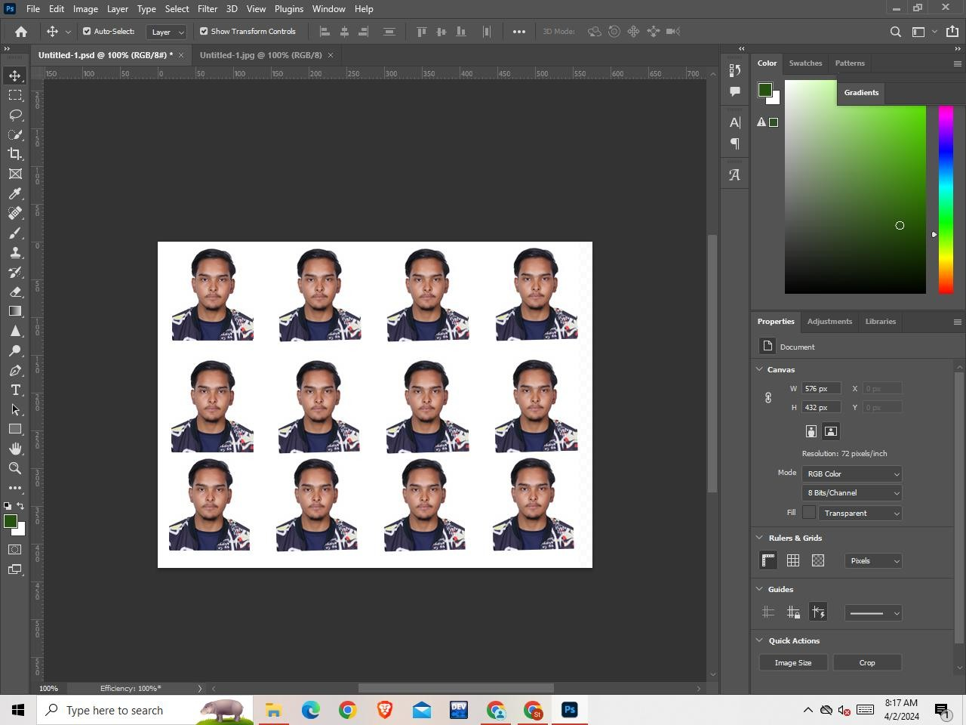

**Final Result:**

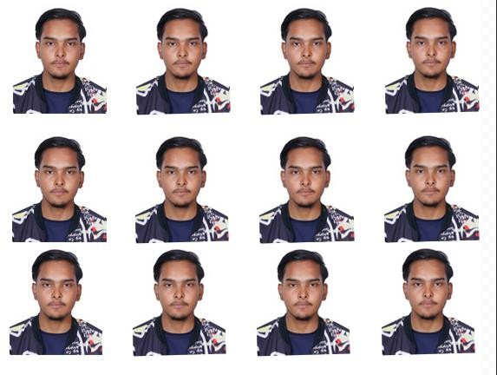

## Steps to make PP size photo with white background:

1. Go to photoshop, add image.
2. Go to navigation bar and click on select.
3. Click on subject, image portion will automatically selected.
4. In the layer option, click on vector mark.
5. Make a new canvas with the required height and width and enter 300 resolutions.
6. Drag your image to the new canvas.
7. Press Ctrl+J to make a single copy after copying in a row press Ctrl+E to make the group of the image.
8. Print the photo.

# Spreadsheet Software

## Create a marksheet of 10 students as per the following conditions:

* 1. Calculate total marks.
  2. Calculate result; whether the student has pass or fail the examination.
  3. Calculate the percentage of each student.
  4. Calculate the grade of each student where 90-100 is A+, 80-90 is A, 70-80 is B+, 60-70 is B, 50-60 is C and <50 is F(Fail).

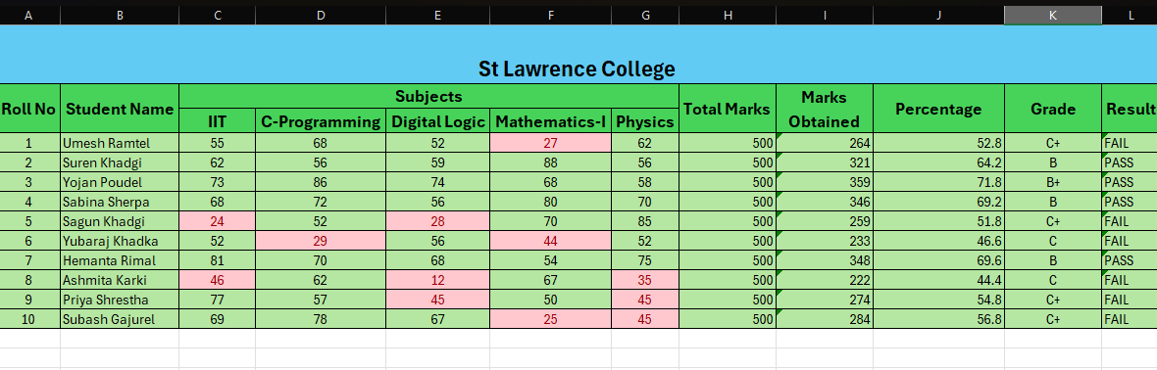

## Formula Involve in Marksheet:

1. Marks Obtained = SUM (C6:G6)
2. Percentage = I6/H6*100

3. Grade = IF(J6>=90, "A+", IF(J6>=80, "A", IF(J6>=70, "B+", IF(J6>=60, "B",

IF(J6>=50, "C+", IF(J6>=40, "C", IF(J6>=30, "D+", "F")))))))

4. Result = IF (MIN (C6:G6)>50,"PASS","FAIL")

## Prepare the bill of at least 10 items under the given conditions:

1. Enter the quantity and rate as per your choice.
2. Calculate the total amount of each item.
3. Calculate the net total, discount amount (5%), tax amount (13%) and grand total.

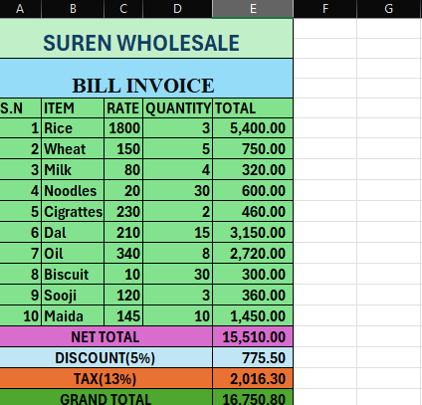

## Formula involves in Bill:

* 1. Total = C6*D6 (Rate*Quantity)
  2. Net Total = SUM (E6:E15)
  3. Discount = (5*E16)/100 (E16 = Grand Total) 4. Tax = (13*E16)/100

5. Grand Total = E16-E17+E18 (Net total – Discount + Tax)

## 10. Create a Salary Sheet of at least 7 staffs in an office along with graph and chart under the following conditions:

1. Enter at least 3 allowances and deduct PF @ 20% and Income Tax @ 10%.

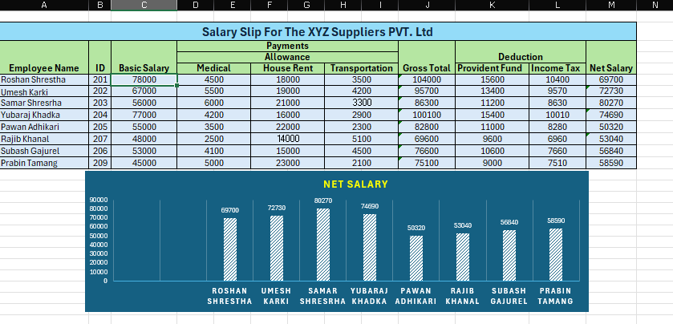

## Formula involved in Salary Sheet:

* 1. Gross Total = SUM (C6:I6).
  2. Provident Fund (PF-20%) = C6*20/100 (C6 = Basic Salary).
  3. Income Tax = J6*10/100 (J6 = Gross Total)
  4. Net Salary = J6-(K6+L6) (Gross total – (PF + Income Tax)

# Presentation Software

## 11. Prepare a presentation including at least 10 slides of any topic of your choice related to Information Technology.

