Vegetable Visual PLU Booklet
Cashier photo reference: match the produce in front of you to the picture, then read the PLU.

How to use this booklet
1. Find the section for the type of produce (the list below shows the sections).
2. Compare the item to the photos. Use the product name, not just the colour, to confirm the match.
3. Read the PLU printed above the name. Always check the sticker on the item if it is different.
4. Entries with a red DUPLICATE PLU badge share a code with another product in the master list. Check the sticker or ask a supervisor before ringing it in.

Image source key
Code Booklet: photo taken from the supplied code booklet (document images).
Produce Guide / Produce Sheets: photo taken from the supplied produce identification PDFs.
AI Generated: realistic computer-generated picture used only where no supplied photo existed. It shows a typical example only; confirm against the real product.

Sections
Section 1 Lettuce (6 entries)
Section 2 Leafy Greens (14 entries)
Section 3 Herbs (14 entries)
Section 4 Brassicas (13 entries)
Section 5 Root Vegetables (18 entries)
Section 6 Potatoes (22 entries)
Section 7 Onions (10 entries)
Section 8 Peppers (22 entries)
Section 9 Tomatoes (9 entries)
Section 10 Cucumbers (4 entries)
Section 11 Squash (34 entries)
Section 12 Asian Vegetables (18 entries)
Section 13 Specialty Vegetables (20 entries)
Section 14 Organic Vegetables (100 entries)
304 PLU entries in total. Master PLU list: FINAL_VEGETABLE_PLU_BOOKLET.

Section 1: Lettuce
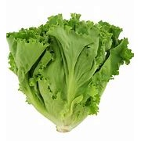  PLU: 4076  Leaf lettuce green  Category: Lettuce  Image Source: Code Booklet  Verification Status: ✅ VERIFIED PHOTO  ⚠ DUPLICATE PLU | 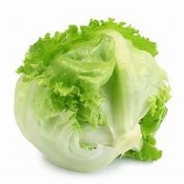  PLU: 4061  Lettuce Iceberg  Category: Lettuce  Image Source: Code Booklet  Verification Status: ✅ VERIFIED PHOTO | 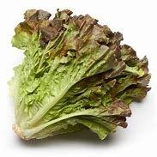  PLU: 4075  Lettuce Red Leaf  Category: Lettuce  Image Source: Code Booklet  Verification Status: ✅ VERIFIED PHOTO | 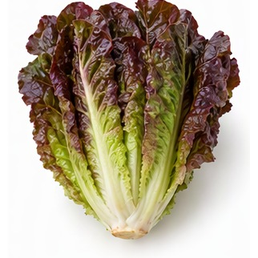  PLU: 3097  Lettuce Red Romaine  Category: Lettuce  Image Source: AI Generated  Verification Status: 🤖 AI GENERATED REFERENCE IMAGE
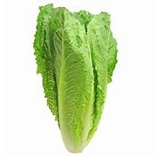  ⚠ DUPLICATE PLU  PLU: 4640  Lettuce Romaine  Category: Lettuce  Image Source: Code Booklet  Verification Status: ✅ VERIFIED PHOTO | ⚠ DUPLICATE PLU  PLU: 4640  Romaine  Category: Lettuce  Image Source: Code Booklet  Verification Status: ✅ VERIFIED PHOTO

Section 2: Leafy Greens
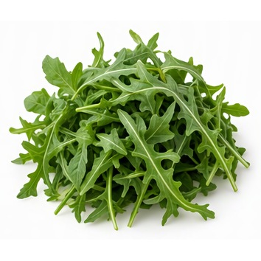  ⚠ DUPLICATE PLU  PLU: 4884  Arugla  Category: Leafy Green  Image Source: AI Generated  Verification Status: 🤖 AI GENERATED REFERENCE IMAGE | 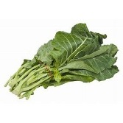  PLU: 4614  Collard Greens  Category: Leafy Green  Image Source: Code Booklet  Verification Status: ✅ VERIFIED PHOTO | 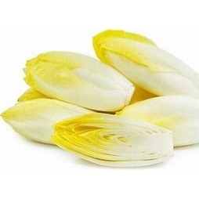  PLU: 4604  Endive  Category: Leafy Green  Image Source: Code Booklet  Verification Status: ⚠ APPROXIMATE PHOTO MATCH  Review note: Belgian endive shown; plain endive is curly/frisee | PLU: 4543  Endive Belgian (White)  Category: Leafy Green  Image Source: Code Booklet  Verification Status: ✅ VERIFIED PHOTO
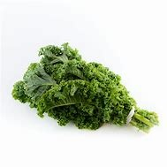  PLU: 4627  Kale  Category: Leafy Green  Image Source: Code Booklet  Verification Status: ✅ VERIFIED PHOTO | 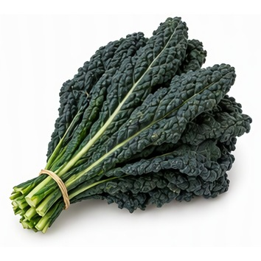  PLU: 4624  Kale Black  Category: Leafy Green  Image Source: AI Generated  Verification Status: 🤖 AI GENERATED REFERENCE IMAGE | 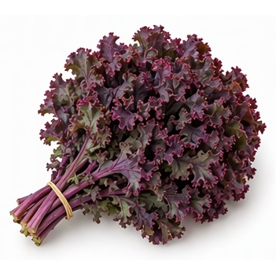  PLU: 3095  Kale Red  Category: Leafy Green  Image Source: AI Generated  Verification Status: 🤖 AI GENERATED REFERENCE IMAGE | PLU: 4623  Kale Red  Category: Leafy Green  Image Source: AI Generated  Verification Status: 🤖 AI GENERATED REFERENCE IMAGE
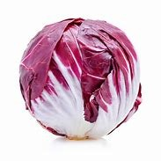  PLU: 4738  Radicchio  Category: Leafy Green  Image Source: Code Booklet  Verification Status: ✅ VERIFIED PHOTO | 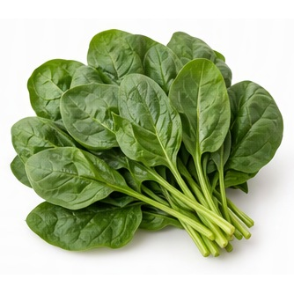  PLU: 4090  Spinach  Category: Leafy Green  Image Source: AI Generated  Verification Status: 🤖 AI GENERATED REFERENCE IMAGE | 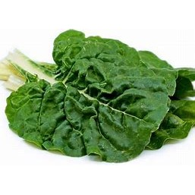  PLU: 4586  Swiss Chard Green  Category: Leafy Green  Image Source: Code Booklet  Verification Status: ✅ VERIFIED PHOTO | 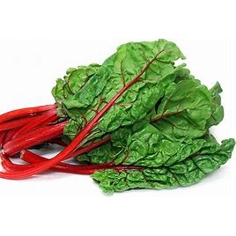  PLU: 4587  Swiss Chard Red  Category: Leafy Green  Image Source: Code Booklet  Verification Status: ✅ VERIFIED PHOTO
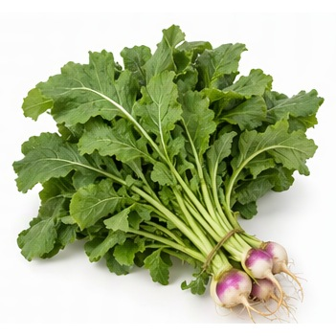  PLU: 4619  Turnip Greens  Category: Leafy Green  Image Source: AI Generated  Verification Status: 🤖 AI GENERATED REFERENCE IMAGE | 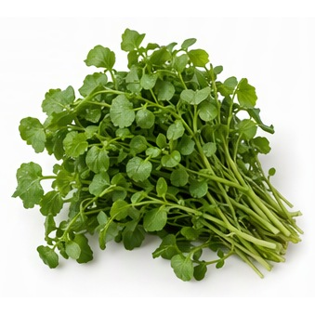  PLU: 4815  Watercress  Category: Leafy Green  Image Source: AI Generated  Verification Status: 🤖 AI GENERATED REFERENCE IMAGE

Section 3: Herbs
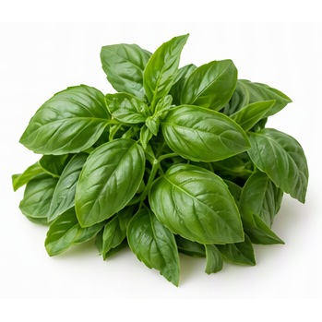  ⚠ DUPLICATE PLU  PLU: 4885  Basil  Category: Herb  Image Source: AI Generated  Verification Status: 🤖 AI GENERATED REFERENCE IMAGE | 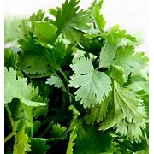  ⚠ DUPLICATE PLU  PLU: 4889  Cilantro  Category: Herb  Image Source: Code Booklet  Verification Status: ✅ VERIFIED PHOTO | 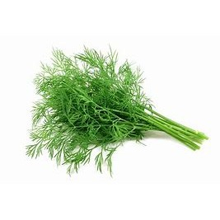  ⚠ DUPLICATE PLU  PLU: 4893  Dill Pickling  Category: Herb  Image Source: Code Booklet  Verification Status: ✅ VERIFIED PHOTO | ⚠ DUPLICATE PLU  PLU: 4884  Herbs Arugula  Category: Herb  Image Source: AI Generated  Verification Status: 🤖 AI GENERATED REFERENCE IMAGE
⚠ DUPLICATE PLU  PLU: 4885  Herbs Basil  Category: Herb  Image Source: AI Generated  Verification Status: 🤖 AI GENERATED REFERENCE IMAGE | ⚠ DUPLICATE PLU  PLU: 4889  Herbs Cilantro  Category: Herb  Image Source: Code Booklet  Verification Status: ✅ VERIFIED PHOTO | ⚠ DUPLICATE PLU  PLU: 4893  Herbs Dill Long  Category: Herb  Image Source: Code Booklet  Verification Status: ✅ VERIFIED PHOTO | 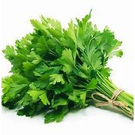  ⚠ DUPLICATE PLU  PLU: 4901  Herbs Italian Parsley  Category: Herb  Image Source: Code Booklet  Verification Status: ✅ VERIFIED PHOTO
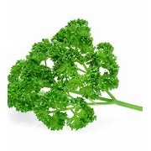  ⚠ DUPLICATE PLU  PLU: 4899  Herbs Parsley  Category: Herb  Image Source: Code Booklet  Verification Status: ✅ VERIFIED PHOTO | 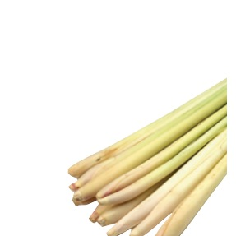  PLU: 4894  Lemon Grass  Category: Herb  Image Source: Produce Guide  Verification Status: ⚠ APPROXIMATE PHOTO MATCH  Review note: lemongrass pushed to lower-right corner with large empty area; recrop | 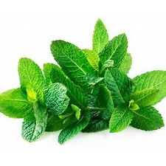  PLU: 4896  Mint  Category: Herb  Image Source: Code Booklet  Verification Status: ✅ VERIFIED PHOTO | ⚠ DUPLICATE PLU  PLU: 4899  Parsley Bunch  Category: Herb  Image Source: Code Booklet  Verification Status: ✅ VERIFIED PHOTO
⚠ DUPLICATE PLU  PLU: 4901  Parsley Italian  Category: Herb  Image Source: Code Booklet  Verification Status: ✅ VERIFIED PHOTO | 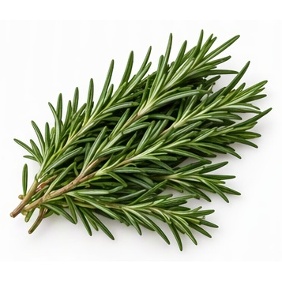  PLU: 4903  Rosemary  Category: Herb  Image Source: AI Generated  Verification Status: 🤖 AI GENERATED REFERENCE IMAGE

Section 4: Brassicas
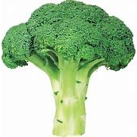  PLU: 4060  Broccoli Bunch  Category: Brassica  Image Source: Code Booklet  Verification Status: ✅ VERIFIED PHOTO | 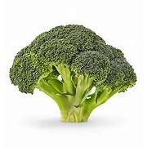  PLU: 3082  Broccoli Crowns  Category: Brassica  Image Source: Code Booklet  Verification Status: ✅ VERIFIED PHOTO | 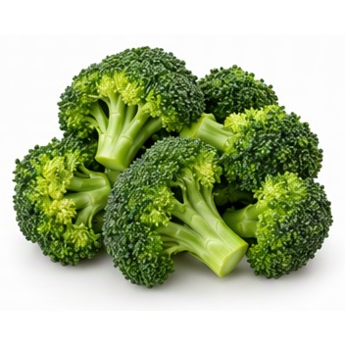  PLU: 4548  Broccoli Florettes  Category: Brassica  Image Source: AI Generated  Verification Status: 🤖 AI GENERATED REFERENCE IMAGE | 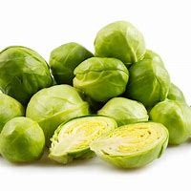  PLU: 4550  Brussel Sprouts  Category: Brassica  Image Source: Code Booklet  Verification Status: ✅ VERIFIED PHOTO
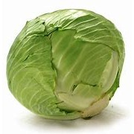  PLU: 4069  Cabbage Green  Category: Brassica  Image Source: Code Booklet  Verification Status: ✅ VERIFIED PHOTO | 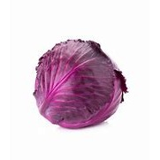  PLU: 4554  Cabbage Red  Category: Brassica  Image Source: Code Booklet  Verification Status: ✅ VERIFIED PHOTO | 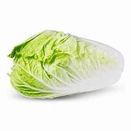  PLU: 4555  Cabbage Savoy  Category: Brassica  Image Source: Code Booklet  Verification Status: ❌ IMAGE REJECTED – REPLACEMENT NEEDED  Review note: shows napa cabbage; product is Savoy cabbage | PLU: 3214  Cabbage Sour  Category: Brassica  Image Source: Code Booklet  Verification Status: ⚠ APPROXIMATE PHOTO MATCH  Review note: green cabbage; sour cabbage product
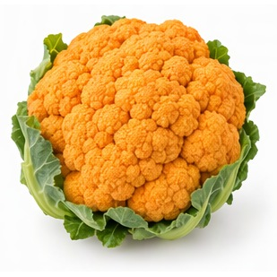  PLU: 4569  Cauliflower Orange Atl  Category: Brassica  Image Source: AI Generated  Verification Status: 🤖 AI GENERATED REFERENCE IMAGE | PLU: 3436  Cauliflower Orange Ont  Category: Brassica  Image Source: AI Generated  Verification Status: 🤖 AI GENERATED REFERENCE IMAGE | 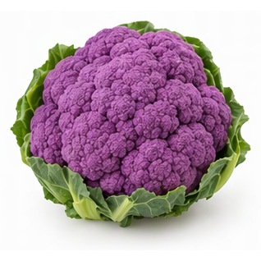  PLU: 4568  Cauliflower Purple  Category: Brassica  Image Source: AI Generated  Verification Status: 🤖 AI GENERATED REFERENCE IMAGE | 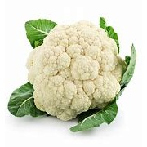  PLU: 4079  Cauliflower Small  Category: Brassica  Image Source: Code Booklet  Verification Status: ✅ VERIFIED PHOTO
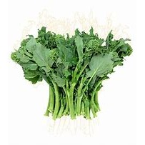

PLU: 4547
Rapini Bunch
Category: Brassica
Image Source: Code Booklet
Verification Status: ✅ VERIFIED PHOTO

Section 5: Root Vegetables
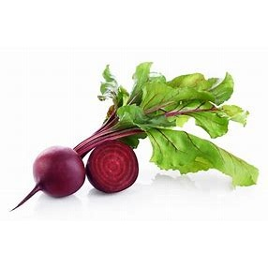  PLU: 4540  Beets Bulk  Category: Root Vegetable  Image Source: Code Booklet  Verification Status: ✅ VERIFIED PHOTO | PLU: 4539  Beets Bunch  Category: Root Vegetable  Image Source: Code Booklet  Verification Status: ✅ VERIFIED PHOTO | 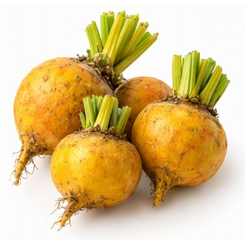  PLU: 12882  Beets Golden  Category: Root Vegetable  Image Source: AI Generated  Verification Status: 🤖 AI GENERATED REFERENCE IMAGE | 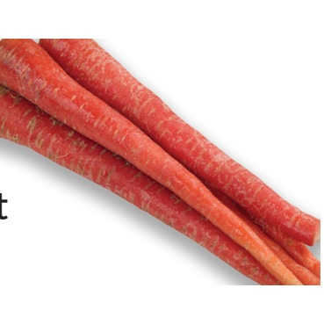  PLU: 4565  Carrot - Red  Category: Root Vegetable  Image Source: Produce Guide  Verification Status: ❌ IMAGE REJECTED – REPLACEMENT NEEDED  Review note: stray text fragment at left edge
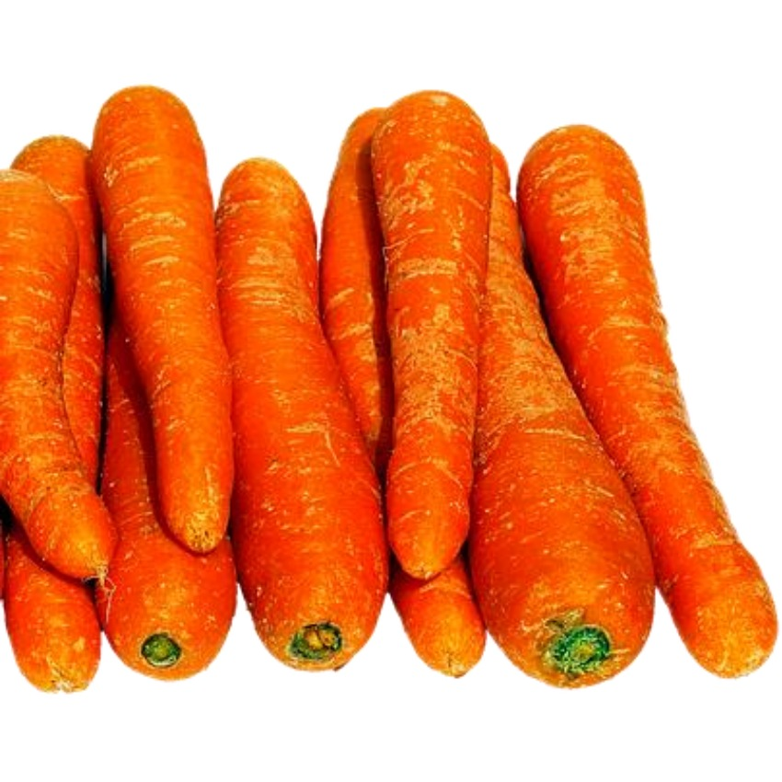  PLU: 4562  Carrots Bulk  Category: Root Vegetable  Image Source: Produce Sheets  Verification Status: ✅ VERIFIED PHOTO | 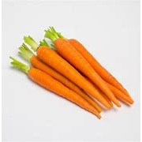  PLU: 4094  Carrots Bunch  Category: Root Vegetable  Image Source: Code Booklet  Verification Status: ✅ VERIFIED PHOTO | 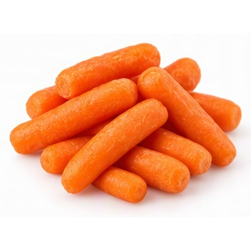  PLU: 4560  Carrotts Baby  Category: Root Vegetable  Image Source: AI Generated  Verification Status: 🤖 AI GENERATED REFERENCE IMAGE | 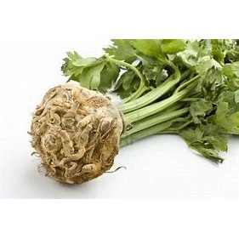  PLU: 4585  Celery Root  Category: Root Vegetable  Image Source: Code Booklet  Verification Status: ✅ VERIFIED PHOTO
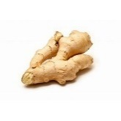  PLU: 4612  Ginger  Category: Root Vegetable  Image Source: Code Booklet  Verification Status: ✅ VERIFIED PHOTO | 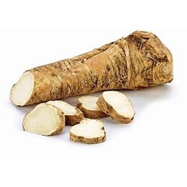  PLU: 4625  Horseradish Root  Category: Root Vegetable  Image Source: Code Booklet  Verification Status: ✅ VERIFIED PHOTO | 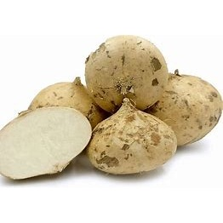  PLU: 4626  Jicama  Category: Root Vegetable  Image Source: Code Booklet  Verification Status: ✅ VERIFIED PHOTO | ⚠ DUPLICATE PLU  PLU: 41519  Jumbo Carrot  Category: Root Vegetable  Image Source: Code Booklet  Verification Status: ⚠ APPROXIMATE PHOTO MATCH  Review note: small carrot bunch; not jumbo
⚠ DUPLICATE PLU  PLU: 41519  Jumbo Carrots  Category: Root Vegetable  Image Source: Code Booklet  Verification Status: ⚠ APPROXIMATE PHOTO MATCH  Review note: small carrot bunch; not jumbo | 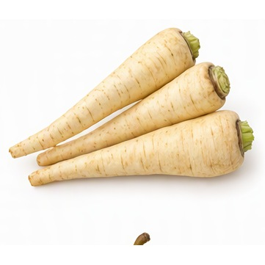  PLU: 4672  Parsnip  Category: Root Vegetable  Image Source: AI Generated  Verification Status: 🤖 AI GENERATED REFERENCE IMAGE | 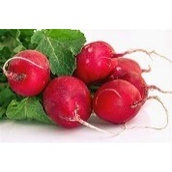  PLU: 4089  Radish Bunch Red  Category: Root Vegetable  Image Source: Code Booklet  Verification Status: ✅ VERIFIED PHOTO | 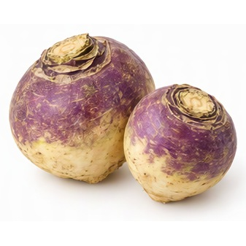  PLU: 4747  Rutabaga  Category: Root Vegetable  Image Source: AI Generated  Verification Status: 🤖 AI GENERATED REFERENCE IMAGE
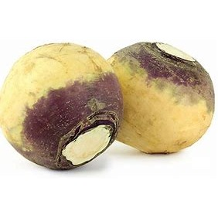  PLU: 4811  Turnip Purple Top  Category: Root Vegetable  Image Source: Code Booklet  Verification Status: ✅ VERIFIED PHOTO | 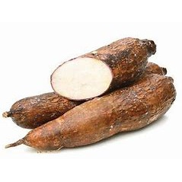  PLU: 4819  Yucca Root  Category: Root Vegetable  Image Source: Code Booklet  Verification Status: ✅ VERIFIED PHOTO

Section 6: Potatoes
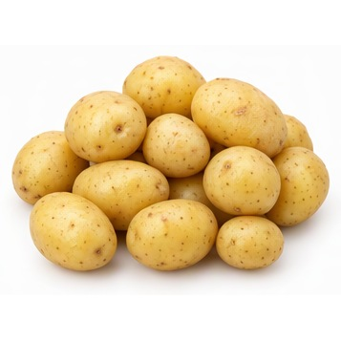  ⚠ DUPLICATE PLU  PLU: 60271  Potato Early Nugget  Category: Potato  Image Source: AI Generated  Verification Status: 🤖 AI GENERATED REFERENCE IMAGE  Review note: small yellow potatoes; Early Nugget plausible | 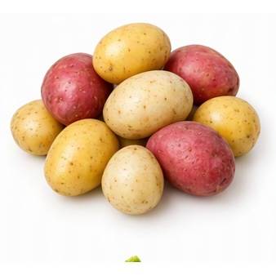  ⚠ DUPLICATE PLU  PLU: 4723  Potato Mini red  Category: Potato  Image Source: AI Generated  Verification Status: 🤖 AI GENERATED REFERENCE IMAGE  Review note: mixed red/yellow mini potatoes; not red only | ⚠ DUPLICATE PLU  PLU: 4724  Potato Mini white  Category: Potato  Image Source: AI Generated  Verification Status: ❌ IMAGE REJECTED – REPLACEMENT NEEDED  Review note: mixed red/yellow potatoes; product is Mini White | 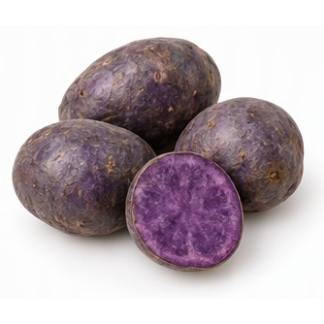  PLU: 3128  Potato Purple  Category: Potato  Image Source: AI Generated  Verification Status: 🤖 AI GENERATED REFERENCE IMAGE
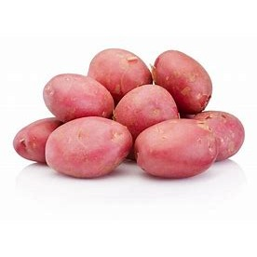  PLU: 4073  Potato Red  Category: Potato  Image Source: Code Booklet  Verification Status: ✅ VERIFIED PHOTO | ⚠ DUPLICATE PLU  PLU: 4723  Potato red creamer  Category: Potato  Image Source: AI Generated  Verification Status: 🤖 AI GENERATED REFERENCE IMAGE  Review note: mixed creamer potatoes; red only expected | ⚠ DUPLICATE PLU  PLU: 4723  Potato Red Creamer  Category: Potato  Image Source: AI Generated  Verification Status: 🤖 AI GENERATED REFERENCE IMAGE  Review note: mixed creamer potatoes; red only expected | 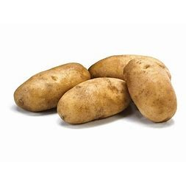  PLU: 4725  Potato Russet  Category: Potato  Image Source: Code Booklet  Verification Status: ✅ VERIFIED PHOTO
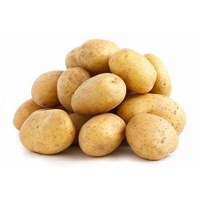  PLU: 4083  Potato White  Category: Potato  Image Source: Code Booklet  Verification Status: ✅ VERIFIED PHOTO | ⚠ DUPLICATE PLU  PLU: 4724  Potato White Creamer  Category: Potato  Image Source: AI Generated  Verification Status: ❌ IMAGE REJECTED – REPLACEMENT NEEDED  Review note: mixed red/yellow potatoes; product is White Creamer | 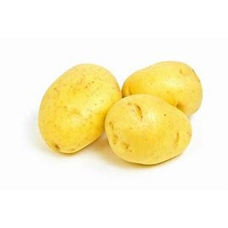  ⚠ DUPLICATE PLU  PLU: 4727  Potato Yellow  Category: Potato  Image Source: Code Booklet  Verification Status: ✅ VERIFIED PHOTO | PLU: 4730  Potato Yellow Creamer  Category: Potato  Image Source: AI Generated  Verification Status: ❌ IMAGE REJECTED – REPLACEMENT NEEDED  Review note: mixed red/white potatoes; product is Yellow Creamer
⚠ DUPLICATE PLU  PLU: 4727  Potato Yukon Gold  Category: Potato  Image Source: Code Booklet  Verification Status: ✅ VERIFIED PHOTO | 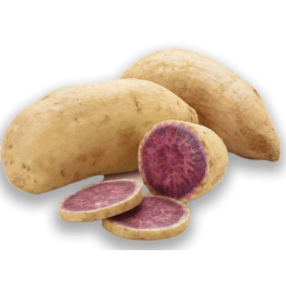  PLU: 3474  Sweet Potato Ben Yagi Purple  Category: Potato  Image Source: Produce Guide  Verification Status: ⚠ APPROXIMATE PHOTO MATCH  Review note: purple-flesh sweet potato; Ben Yagi variety not certain | 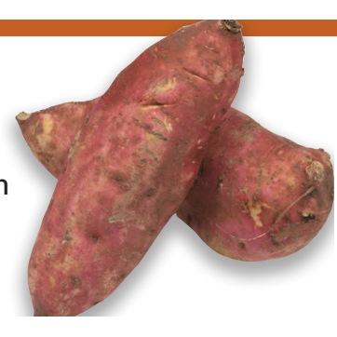  PLU: 4818  Sweet Potato japanese  Category: Potato  Image Source: Produce Guide  Verification Status: ❌ IMAGE REJECTED – REPLACEMENT NEEDED  Review note: orange bar and stray mark artifacts on image | 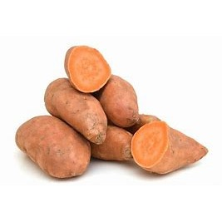  ⚠ DUPLICATE PLU  PLU: 4074  Sweet Potato red  Category: Potato  Image Source: Code Booklet  Verification Status: ✅ VERIFIED PHOTO
PLU: 3288  Sweet Potato Stokes Purple  Category: Potato  Image Source: Produce Guide  Verification Status: ✅ VERIFIED PHOTO | 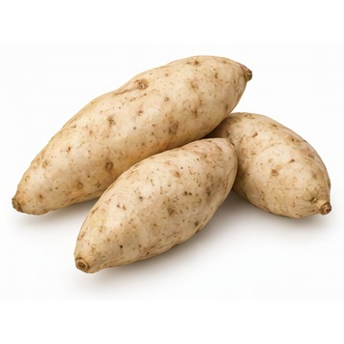  PLU: 4091  Sweet Potato White  Category: Potato  Image Source: AI Generated  Verification Status: 🤖 AI GENERATED REFERENCE IMAGE | ⚠ DUPLICATE PLU  PLU: 60271  Warba  Category: Potato  Image Source: AI Generated  Verification Status: 🤖 AI GENERATED REFERENCE IMAGE | ⚠ DUPLICATE PLU  PLU: 4074  Yam Garnet Red  Category: Potato  Image Source: Code Booklet  Verification Status: ✅ VERIFIED PHOTO
PLU: 3209  Yam Purple  Category: Potato  Image Source: Produce Guide  Verification Status: ⚠ APPROXIMATE PHOTO MATCH  Review note: purple-flesh tuber; plausible | PLU: 4816  Yams  Category: Potato  Image Source: Code Booklet  Verification Status: ⚠ APPROXIMATE PHOTO MATCH  Review note: orange sweet potatoes shown for yams

Section 7: Onions
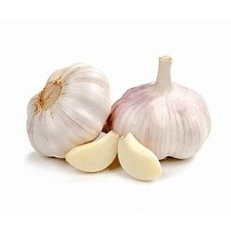  PLU: 3400  Garlic (Large)  Category: Onion  Image Source: Code Booklet  Verification Status: ✅ VERIFIED PHOTO | 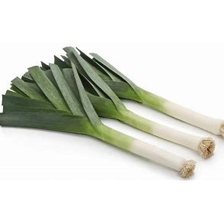  PLU: 3339  Leeks  Category: Onion  Image Source: Code Booklet  Verification Status: ✅ VERIFIED PHOTO | 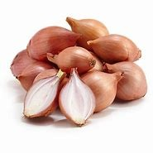  PLU: 4662  Onion Shallots  Category: Onion  Image Source: Code Booklet  Verification Status: ✅ VERIFIED PHOTO | 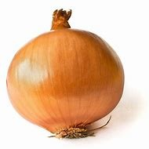  PLU: 4093  Onion Yellow  Category: Onion  Image Source: Code Booklet  Verification Status: ✅ VERIFIED PHOTO
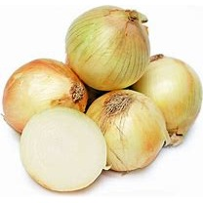  PLU: 4659  Onions Baby Vidalia  Category: Onion  Image Source: Code Booklet  Verification Status: ⚠ APPROXIMATE PHOTO MATCH  Review note: yellow onions; baby Vidalia not distinguishable | 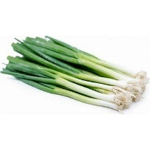  PLU: 4068  Onions Green  Category: Onion  Image Source: Code Booklet  Verification Status: ✅ VERIFIED PHOTO | 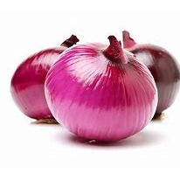  PLU: 4082  Onions Red  Category: Onion  Image Source: Code Booklet  Verification Status: ✅ VERIFIED PHOTO | PLU: 4163  Onions Walla Walla  Category: Onion  Image Source: Code Booklet  Verification Status: ⚠ APPROXIMATE PHOTO MATCH  Review note: yellow onions; Walla Walla not distinguishable
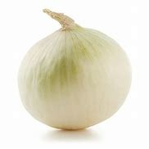  PLU: 4663  Onions White  Category: Onion  Image Source: Code Booklet  Verification Status: ✅ VERIFIED PHOTO | PLU: 4159  Vidalia Onions  Category: Onion  Image Source: Code Booklet  Verification Status: ⚠ APPROXIMATE PHOTO MATCH  Review note: yellow onions; Vidalia not distinguishable  ⚠ DUPLICATE PLU

Section 8: Peppers
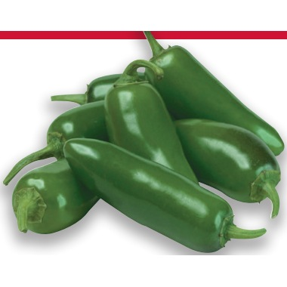  PLU: 4677  Pepper Anaheim  Category: Pepper  Image Source: Produce Guide  Verification Status: ❌ IMAGE REJECTED – REPLACEMENT NEEDED  Review note: red bar artifact; shows jalapeno-type peppers not clearly Anaheim | 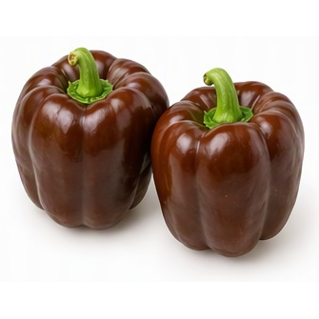  PLU: 3123  Pepper Brown  Category: Pepper  Image Source: AI Generated  Verification Status: 🤖 AI GENERATED REFERENCE IMAGE | 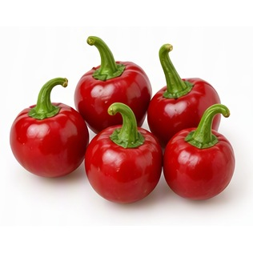  PLU: 4722  Pepper Cherry  Category: Pepper  Image Source: AI Generated  Verification Status: 🤖 AI GENERATED REFERENCE IMAGE | 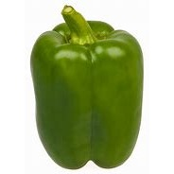  PLU: 4065  Pepper Green Bell Large  Category: Pepper  Image Source: Code Booklet  Verification Status: ✅ VERIFIED PHOTO
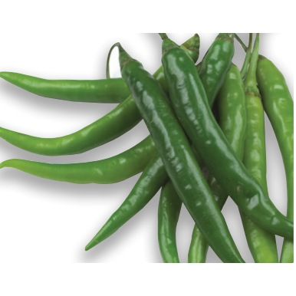  PLU: 4686  Pepper Green Chili  Category: Pepper  Image Source: Produce Guide  Verification Status: ✅ VERIFIED PHOTO | 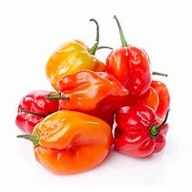  PLU: 3125  Pepper Habanero  Category: Pepper  Image Source: Code Booklet  Verification Status: ✅ VERIFIED PHOTO | 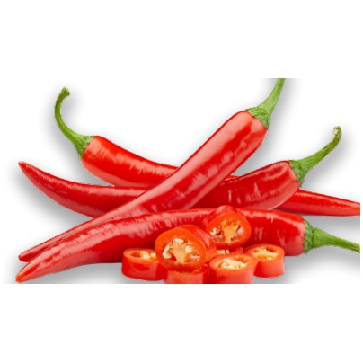  PLU: 4696  Pepper Hot Finger  Category: Pepper  Image Source: Produce Guide  Verification Status: ✅ VERIFIED PHOTO | 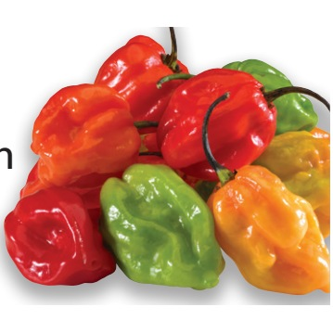  PLU: 4691  Pepper Hot Mix  Category: Pepper  Image Source: Produce Guide  Verification Status: ⚠ APPROXIMATE PHOTO MATCH  Review note: mixed hot peppers; stray mark at left edge
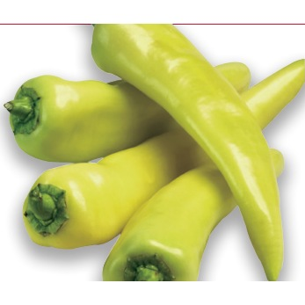  PLU: 4692  Pepper Hungarian  Category: Pepper  Image Source: Produce Guide  Verification Status: ❌ IMAGE REJECTED – REPLACEMENT NEEDED  Review note: thin red line artifact across top | 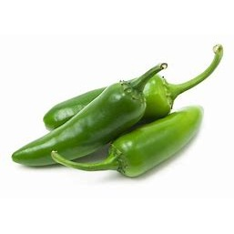  PLU: 4693  Pepper Jalapeno  Category: Pepper  Image Source: Code Booklet  Verification Status: ✅ VERIFIED PHOTO | PLU: 4707  Pepper Long Red Finger  Category: Pepper  Image Source: Produce Guide  Verification Status: ⚠ APPROXIMATE PHOTO MATCH  Review note: red finger chilies; same image as #397 | 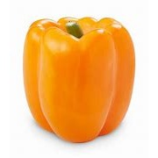  PLU: 3121  Pepper Orange Bell  Category: Pepper  Image Source: Code Booklet  Verification Status: ✅ VERIFIED PHOTO
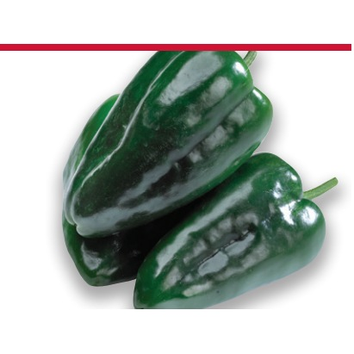  PLU: 4706  Pepper Poblano  Category: Pepper  Image Source: Produce Guide  Verification Status: ❌ IMAGE REJECTED – REPLACEMENT NEEDED  Review note: red bar artifact across top | 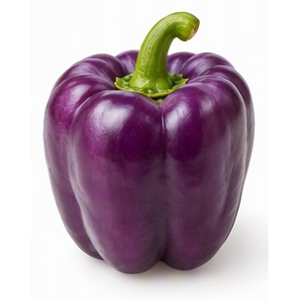  PLU: 3124  Pepper Purple Bell  Category: Pepper  Image Source: AI Generated  Verification Status: 🤖 AI GENERATED REFERENCE IMAGE | 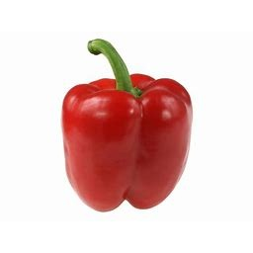  ⚠ DUPLICATE PLU  PLU: 4688  Pepper Red  Category: Pepper  Image Source: Code Booklet  Verification Status: ✅ VERIFIED PHOTO | 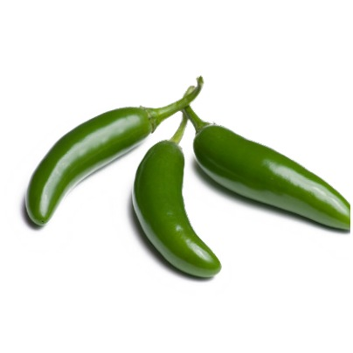  PLU: 4709  Pepper Serrano  Category: Pepper  Image Source: Produce Guide  Verification Status: ✅ VERIFIED PHOTO
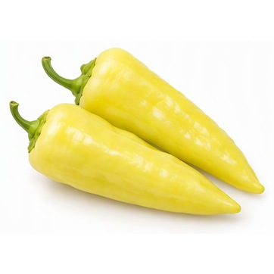  PLU: 4678  Pepper Sweet Banana  Category: Pepper  Image Source: AI Generated  Verification Status: 🤖 AI GENERATED REFERENCE IMAGE | ⚠ DUPLICATE PLU  PLU: 4688  Pepper Sweet Red  Category: Pepper  Image Source: Code Booklet  Verification Status: ✅ VERIFIED PHOTO | 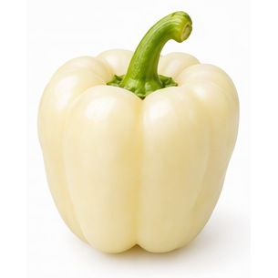  PLU: 3122  Pepper White  Category: Pepper  Image Source: AI Generated  Verification Status: 🤖 AI GENERATED REFERENCE IMAGE | 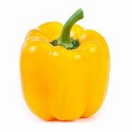  PLU: 4689  Pepper Yellow  Category: Pepper  Image Source: Code Booklet  Verification Status: ✅ VERIFIED PHOTO
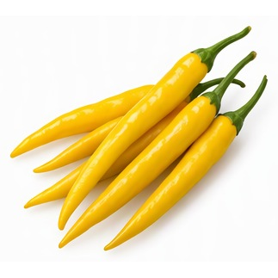  PLU: 4772  Pepper Yellow Chili  Category: Pepper  Image Source: AI Generated  Verification Status: 🤖 AI GENERATED REFERENCE IMAGE | PLU: 4705  Peppers Poblano  Category: Pepper  Image Source: Produce Guide  Verification Status: ❌ IMAGE REJECTED – REPLACEMENT NEEDED  Review note: red bar artifact across top

Section 9: Tomatoes
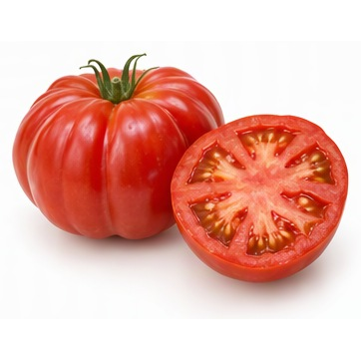  PLU: 3061  Beef Steak Tomato  Category: Tomato  Image Source: AI Generated  Verification Status: 🤖 AI GENERATED REFERENCE IMAGE | 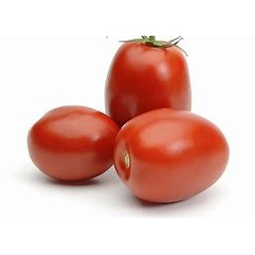  PLU: 4087  Roma Tomato  Category: Tomato  Image Source: Code Booklet  Verification Status: ✅ VERIFIED PHOTO | 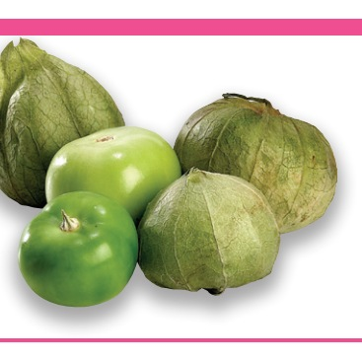  PLU: 4963  Tomatillos  Category: Tomato  Image Source: Produce Guide  Verification Status: ❌ IMAGE REJECTED – REPLACEMENT NEEDED  Review note: pink bar artifacts top and bottom | 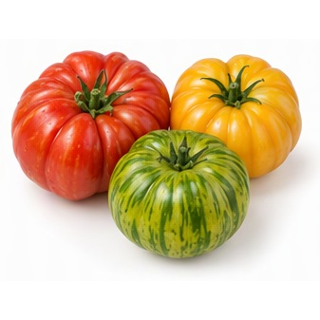  PLU: 3423  Tomato Heriloom  Category: Tomato  Image Source: AI Generated  Verification Status: 🤖 AI GENERATED REFERENCE IMAGE
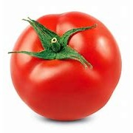  PLU: 4799  Tomato Hot House  Category: Tomato  Image Source: Code Booklet  Verification Status: ✅ VERIFIED PHOTO | PLU: 4798  Tomato Hot House Small  Category: Tomato  Image Source: Code Booklet  Verification Status: ✅ VERIFIED PHOTO | 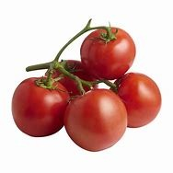  PLU: 4664  Tomato on the Vine  Category: Tomato  Image Source: Code Booklet  Verification Status: ✅ VERIFIED PHOTO | PLU: 4064  Tomato Vine ripe  Category: Tomato  Image Source: Code Booklet  Verification Status: ✅ VERIFIED PHOTO
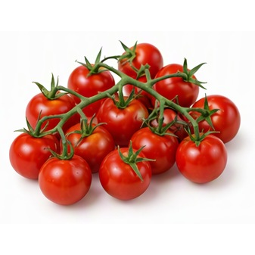

PLU: 3146
Tomatoes Cherry Vine
Category: Tomato
Image Source: AI Generated
Verification Status: 🤖 AI GENERATED REFERENCE IMAGE

Section 10: Cucumbers
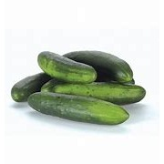  PLU: 4062  Cucumber Green (Field)  Category: Cucumber  Image Source: Code Booklet  Verification Status: ✅ VERIFIED PHOTO | 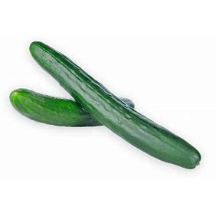  PLU: 4593  Cucumber Long English  Category: Cucumber  Image Source: Code Booklet  Verification Status: ✅ VERIFIED PHOTO | 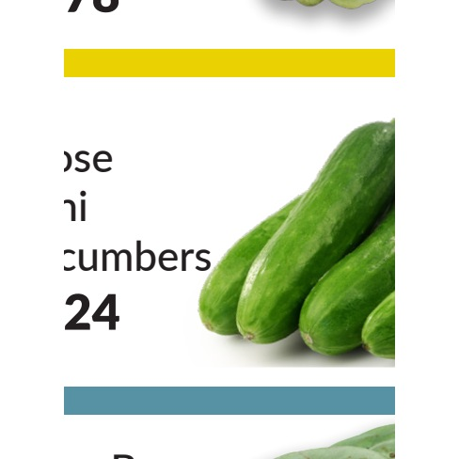  PLU: 4999  Cucumber Mini  Category: Cucumber  Image Source: Produce Guide  Verification Status: ❌ IMAGE REJECTED – REPLACEMENT NEEDED  Review note: screenshot fragment with text and colored bars | 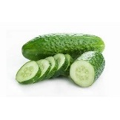  PLU: 4596  Cucumber Pickling  Category: Cucumber  Image Source: Code Booklet  Verification Status: ✅ VERIFIED PHOTO

Section 11: Squash
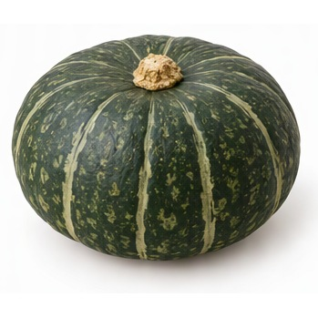  PLU: 4769  Kabocha  Category: Squash  Image Source: AI Generated  Verification Status: 🤖 AI GENERATED REFERENCE IMAGE | 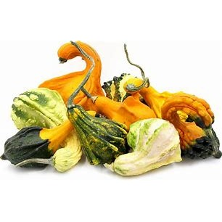  PLU: 3135  Ornamental Gourd  Category: Squash  Image Source: Code Booklet  Verification Status: ✅ VERIFIED PHOTO | 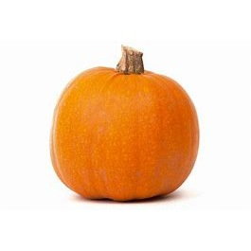  PLU: 3130  Pumpkin  Category: Squash  Image Source: Code Booklet  Verification Status: ✅ VERIFIED PHOTO | 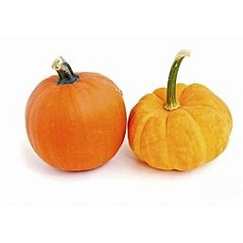  PLU: 4734  Pumpkin Mini  Category: Squash  Image Source: Code Booklet  Verification Status: ✅ VERIFIED PHOTO
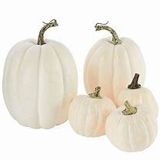  PLU: 3132  Pumpkin White  Category: Squash  Image Source: Code Booklet  Verification Status: ✅ VERIFIED PHOTO | 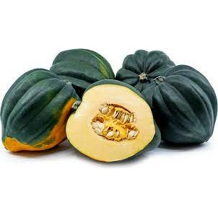  PLU: 8032  Squash Acorn Cut  Category: Squash  Image Source: Code Booklet  Verification Status: ✅ VERIFIED PHOTO | PLU: 4751  Squash Acorn Golden  Category: Squash  Image Source: Code Booklet  Verification Status: ❌ IMAGE REJECTED – REPLACEMENT NEEDED  Review note: dark green acorn squash shown; product is Golden Acorn | PLU: 4752  Squash Acorn White  Category: Squash  Image Source: Code Booklet  Verification Status: ❌ IMAGE REJECTED – REPLACEMENT NEEDED  Review note: dark green acorn squash shown; product is Acorn White
PLU: 4750  Squash Acorn/Pepper  Category: Squash  Image Source: Code Booklet  Verification Status: ✅ VERIFIED PHOTO | 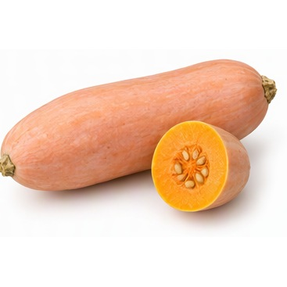  PLU: 4757  Squash Banana  Category: Squash  Image Source: AI Generated  Verification Status: 🤖 AI GENERATED REFERENCE IMAGE | 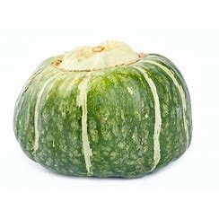  PLU: 4758  Squash Buttercup  Category: Squash  Image Source: Code Booklet  Verification Status: ✅ VERIFIED PHOTO | 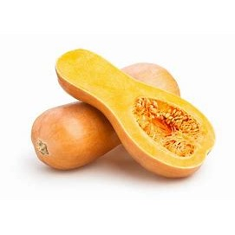  PLU: 4759  Squash Butternut  Category: Squash  Image Source: Code Booklet  Verification Status: ✅ VERIFIED PHOTO
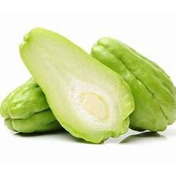  PLU: 4761  Squash Chayote  Category: Squash  Image Source: Code Booklet  Verification Status: ✅ VERIFIED PHOTO | PLU: 8180  Squash Chayote  Category: Squash  Image Source: Code Booklet  Verification Status: ✅ VERIFIED PHOTO | 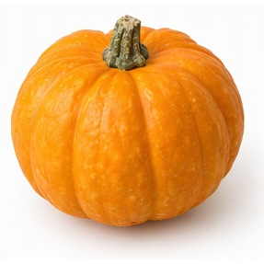  PLU: 4767  Squash Golden  Category: Squash  Image Source: AI Generated  Verification Status: 🤖 AI GENERATED REFERENCE IMAGE  Review note: orange round squash; Golden variety not certain | 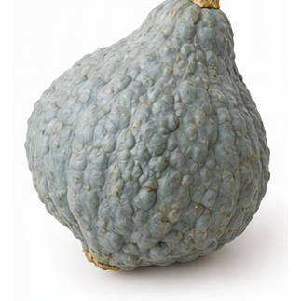  PLU: 4768  Squash Hubbard  Category: Squash  Image Source: AI Generated  Verification Status: 🤖 AI GENERATED REFERENCE IMAGE
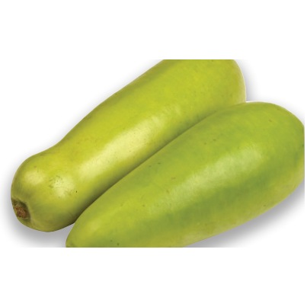  ⚠ DUPLICATE PLU  PLU: 3141  Squash Long  Category: Squash  Image Source: Produce Guide  Verification Status: ⚠ APPROXIMATE PHOTO MATCH  Review note: long pale green squash; plausible | ⚠ DUPLICATE PLU  PLU: 3141  Squash Opo  Category: Squash  Image Source: Produce Guide  Verification Status: ✅ VERIFIED PHOTO | 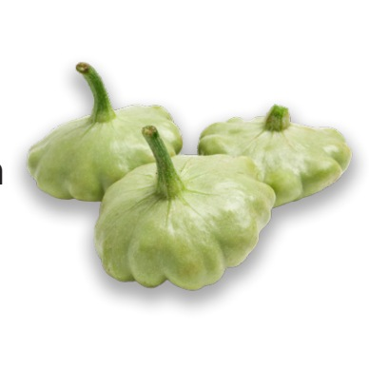  PLU: 4773  Squash Patty Pan  Category: Squash  Image Source: Produce Guide  Verification Status: ⚠ APPROXIMATE PHOTO MATCH  Review note: pattypan squash; stray mark at left edge | 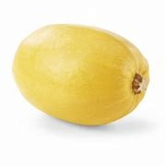  PLU: 4776  Squash Spaghetti  Category: Squash  Image Source: Code Booklet  Verification Status: ✅ VERIFIED PHOTO
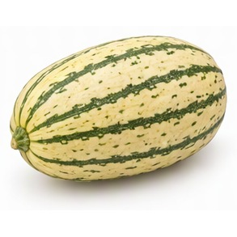  PLU: 4968  Squash Stripetti  Category: Squash  Image Source: AI Generated  Verification Status: 🤖 AI GENERATED REFERENCE IMAGE | 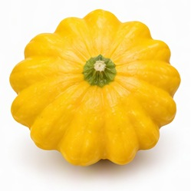  PLU: 4777  Squash Sunburst  Category: Squash  Image Source: AI Generated  Verification Status: 🤖 AI GENERATED REFERENCE IMAGE | 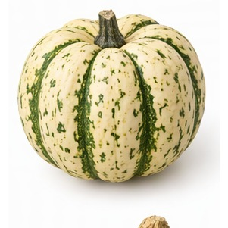  PLU: 4764  Squash Sweet Dumpling  Category: Squash  Image Source: AI Generated  Verification Status: 🤖 AI GENERATED REFERENCE IMAGE | 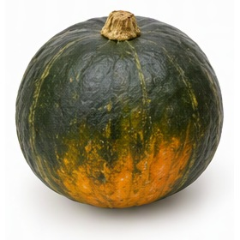  PLU: 4779  Squash Sweet Mama  Category: Squash  Image Source: AI Generated  Verification Status: 🤖 AI GENERATED REFERENCE IMAGE
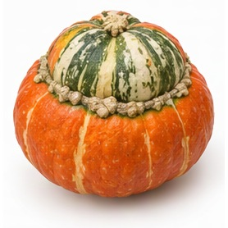  PLU: 4780  Squash Turban  Category: Squash  Image Source: AI Generated  Verification Status: 🤖 AI GENERATED REFERENCE IMAGE | PLU: 4774  Squash Uchiki Mama  Category: Squash  Image Source: AI Generated  Verification Status: 🤖 AI GENERATED REFERENCE IMAGE  Review note: dark green kabocha shown; Uchiki Kuri is orange | 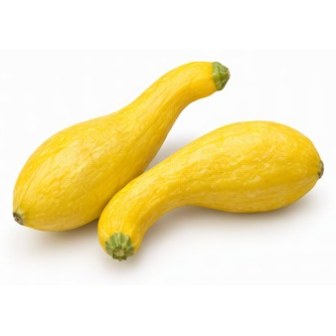  PLU: 4784  Squash Yelllow Crook  Category: Squash  Image Source: AI Generated  Verification Status: 🤖 AI GENERATED REFERENCE IMAGE | PLU: 4782  Squash Yellow  Category: Squash  Image Source: AI Generated  Verification Status: 🤖 AI GENERATED REFERENCE IMAGE
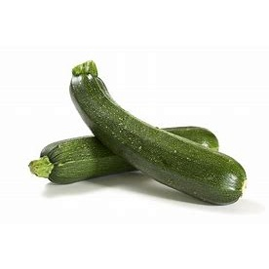  ⚠ DUPLICATE PLU  PLU: 4067  Squash Zucchini  Category: Squash  Image Source: Code Booklet  Verification Status: ✅ VERIFIED PHOTO | 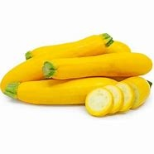  ⚠ DUPLICATE PLU  PLU: 4086  Squash Zucchini Yellow  Category: Squash  Image Source: Code Booklet  Verification Status: ✅ VERIFIED PHOTO | ⚠ DUPLICATE PLU  PLU: 4067  Zucchini  Category: Squash  Image Source: Code Booklet  Verification Status: ✅ VERIFIED PHOTO | 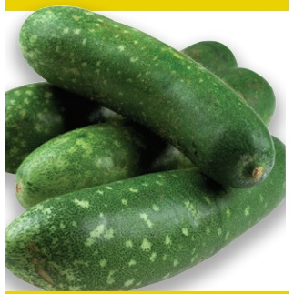  PLU: 3060  Zucchini Grey  Category: Squash  Image Source: Produce Guide  Verification Status: ❌ IMAGE REJECTED – REPLACEMENT NEEDED  Review note: yellow line artifacts; unclear grey zucchini
⚠ DUPLICATE PLU  PLU: 4067  Zucchini Squash  Category: Squash  Image Source: Code Booklet  Verification Status: ✅ VERIFIED PHOTO | ⚠ DUPLICATE PLU  PLU: 4086  Zucchini Yellow  Category: Squash  Image Source: Code Booklet  Verification Status: ✅ VERIFIED PHOTO

Section 12: Asian Vegetables
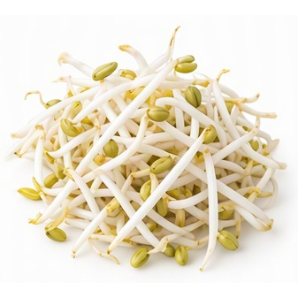  PLU: 4536  Bean Sprouts  Category: Asian Vegetable  Image Source: AI Generated  Verification Status: 🤖 AI GENERATED REFERENCE IMAGE | 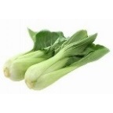  PLU: 4545  Bok Choy  Category: Asian Vegetable  Image Source: Code Booklet  Verification Status: ✅ VERIFIED PHOTO | PLU: 4989  Bok Choy Baby  Category: Asian Vegetable  Image Source: Code Booklet  Verification Status: ⚠ APPROXIMATE PHOTO MATCH  Review note: bok choy; same image as #461; not baby-specific | PLU: 4544  Bok Choy Mini  Category: Asian Vegetable  Image Source: Code Booklet  Verification Status: ⚠ APPROXIMATE PHOTO MATCH  Review note: bok choy; same image; not mini-specific
PLU: 3163  Bok Choy Shanghai  Category: Asian Vegetable  Image Source: Code Booklet  Verification Status: ⚠ APPROXIMATE PHOTO MATCH  Review note: bok choy; same image; not Shanghai-specific | 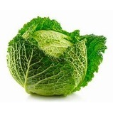  ⚠ DUPLICATE PLU  PLU: 4552  Cabbage Chinois Napa  Category: Asian Vegetable  Image Source: Code Booklet  Verification Status: ❌ IMAGE REJECTED – REPLACEMENT NEEDED  Review note: shows savoy cabbage; product is Napa cabbage | ⚠ DUPLICATE PLU  PLU: 4552  Cabbage Suey  Category: Asian Vegetable  Image Source: Code Booklet  Verification Status: ❌ IMAGE REJECTED – REPLACEMENT NEEDED  Review note: shows savoy cabbage; Suey choy is napa-type | 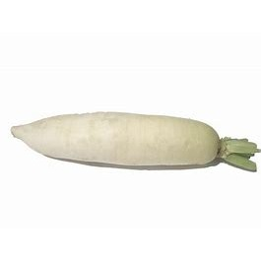  PLU: 4834  Daikon Korean  Category: Asian Vegetable  Image Source: Code Booklet  Verification Status: ⚠ APPROXIMATE PHOTO MATCH  Review note: daikon radish; Korean radish is shorter
⚠ DUPLICATE PLU  PLU: 4598  Daikon Root  Category: Asian Vegetable  Image Source: Code Booklet  Verification Status: ✅ VERIFIED PHOTO | 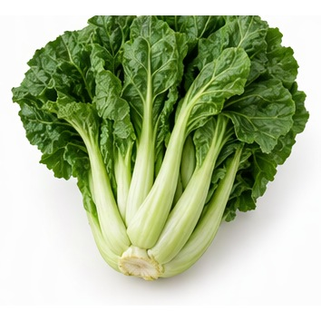  PLU: 4607  Gai Choy  Category: Asian Vegetable  Image Source: AI Generated  Verification Status: 🤖 AI GENERATED REFERENCE IMAGE | 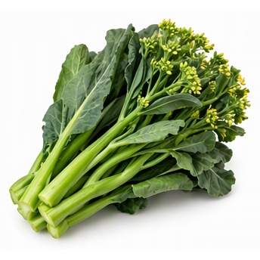  PLU: 3160  Gai Lan  Category: Asian Vegetable  Image Source: AI Generated  Verification Status: 🤖 AI GENERATED REFERENCE IMAGE | ⚠ DUPLICATE PLU  PLU: 4598  Lo Bok Daikon  Category: Asian Vegetable  Image Source: Code Booklet  Verification Status: ✅ VERIFIED PHOTO
⚠ DUPLICATE PLU  PLU: 4552  Nappa  Category: Asian Vegetable  Image Source: Code Booklet  Verification Status: ❌ IMAGE REJECTED – REPLACEMENT NEEDED  Review note: shows savoy cabbage; product is Nappa | 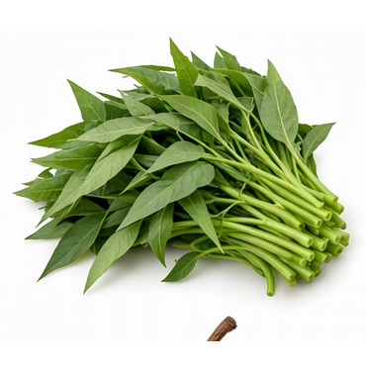  PLU: 3162  On Choy  Category: Asian Vegetable  Image Source: AI Generated  Verification Status: 🤖 AI GENERATED REFERENCE IMAGE | 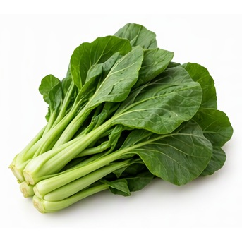  PLU: 81905  Sher Li Hon  Category: Asian Vegetable  Image Source: AI Generated  Verification Status: 🤖 AI GENERATED REFERENCE IMAGE  Review note: leafy Chinese green; plausible | 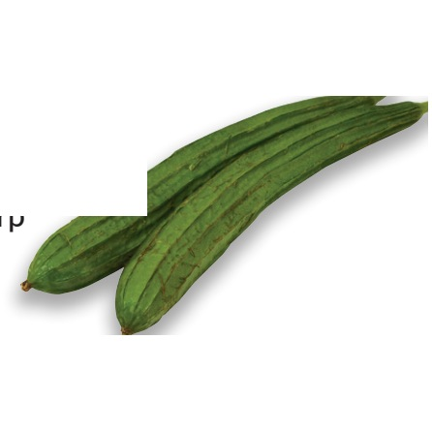  PLU: 4656  Sing Qua  Category: Asian Vegetable  Image Source: Produce Guide  Verification Status: ❌ IMAGE REJECTED – REPLACEMENT NEEDED  Review note: white box artifact and stray mark over image
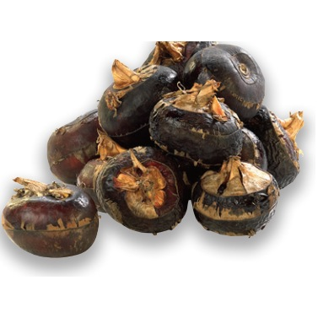  PLU: 4814  Water Chestnuts  Category: Asian Vegetable  Image Source: Produce Guide  Verification Status: ✅ VERIFIED PHOTO | 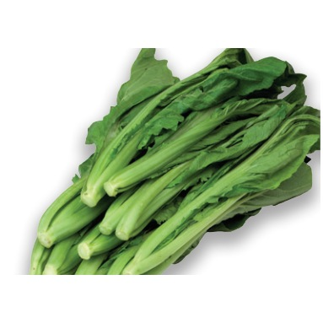  PLU: 3164  Yu Choy  Category: Asian Vegetable  Image Source: Produce Guide  Verification Status: ✅ VERIFIED PHOTO

Section 13: Specialty Vegetables
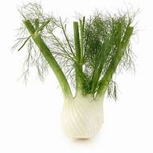  PLU: 4515  Anise Fennel  Category: Specialty Vegetable  Image Source: Code Booklet  Verification Status: ✅ VERIFIED PHOTO | 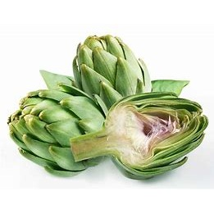  PLU: 4762  Artichoke XL  Category: Specialty Vegetable  Image Source: Code Booklet  Verification Status: ✅ VERIFIED PHOTO | PLU: 4084  Artichokes Large  Category: Specialty Vegetable  Image Source: Code Booklet  Verification Status: ✅ VERIFIED PHOTO | PLU: 4516  Artichokes Small  Category: Specialty Vegetable  Image Source: Code Booklet  Verification Status: ✅ VERIFIED PHOTO
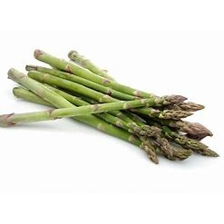  PLU: 4080  Asparagus Green  Category: Specialty Vegetable  Image Source: Code Booklet  Verification Status: ✅ VERIFIED PHOTO | 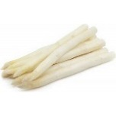  PLU: 4522  Asparagus White  Category: Specialty Vegetable  Image Source: Code Booklet  Verification Status: ✅ VERIFIED PHOTO | 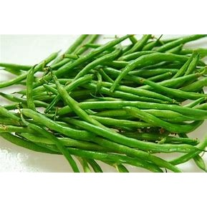  PLU: 4066  Beans Green  Category: Specialty Vegetable  Image Source: Code Booklet  Verification Status: ✅ VERIFIED PHOTO | 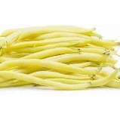  PLU: 4533  Beans Yellow Wax  Category: Specialty Vegetable  Image Source: Code Booklet  Verification Status: ✅ VERIFIED PHOTO
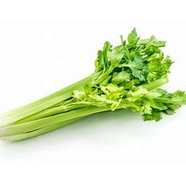  PLU: 4582  Celery Bunch  Category: Specialty Vegetable  Image Source: Code Booklet  Verification Status: ✅ VERIFIED PHOTO | 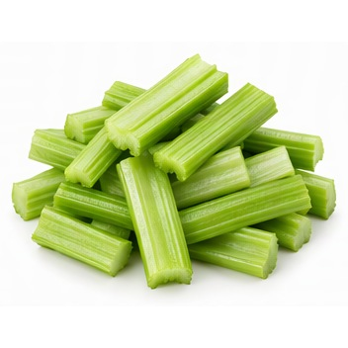  PLU: 4576  Celery Sticks  Category: Specialty Vegetable  Image Source: AI Generated  Verification Status: 🤖 AI GENERATED REFERENCE IMAGE | 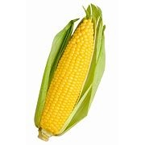  PLU: 4078  Corn  Category: Specialty Vegetable  Image Source: Code Booklet  Verification Status: ✅ VERIFIED PHOTO | 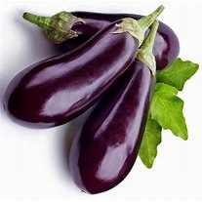  PLU: 4081  Eggplant  Category: Specialty Vegetable  Image Source: Code Booklet  Verification Status: ✅ VERIFIED PHOTO
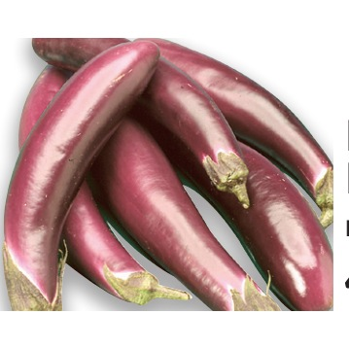  PLU: 3089  Eggplant Chinese  Category: Specialty Vegetable  Image Source: Produce Guide  Verification Status: ✅ VERIFIED PHOTO | PLU: 4599  Eggplant Italian  Category: Specialty Vegetable  Image Source: Code Booklet  Verification Status: ⚠ APPROXIMATE PHOTO MATCH  Review note: globe eggplant shown; Italian not distinguishable | 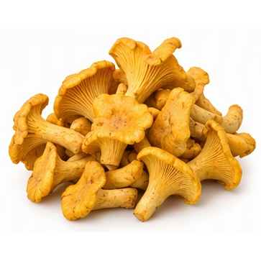  PLU: 4647  Mushroom Chantrelle  Category: Specialty Vegetable  Image Source: AI Generated  Verification Status: 🤖 AI GENERATED REFERENCE IMAGE | 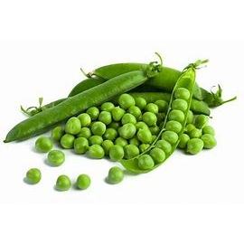  PLU: 4674  Peas Green (English)  Category: Specialty Vegetable  Image Source: Code Booklet  Verification Status: ✅ VERIFIED PHOTO
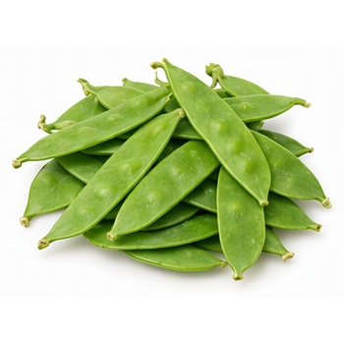  PLU: 4092  Peas Snow  Category: Specialty Vegetable  Image Source: AI Generated  Verification Status: 🤖 AI GENERATED REFERENCE IMAGE | 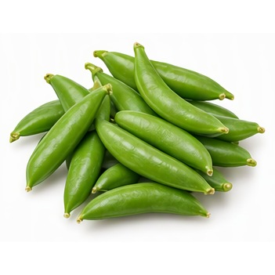  PLU: 4675  Peas Sugar Snap  Category: Specialty Vegetable  Image Source: AI Generated  Verification Status: 🤖 AI GENERATED REFERENCE IMAGE | 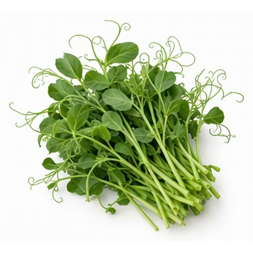  PLU: 4676  Peas Tips  Category: Specialty Vegetable  Image Source: AI Generated  Verification Status: 🤖 AI GENERATED REFERENCE IMAGE | 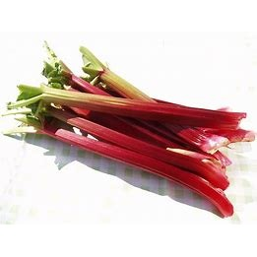  PLU: 4745  Rhubarb KG  Category: Specialty Vegetable  Image Source: Code Booklet  Verification Status: ✅ VERIFIED PHOTO

Section 14: Organic Vegetables
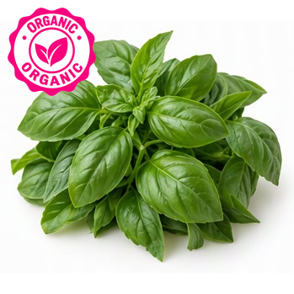  PLU: 94885  Organic Basil  Category: Organic Herb  Image Source: AI Generated  Verification Status: 🤖 AI GENERATED REFERENCE IMAGE | 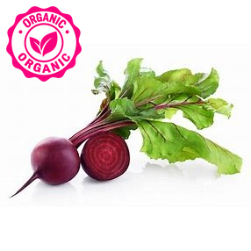  PLU: 94539  Organic Beets  Category: Organic Root Vegetable  Image Source: Code Booklet  Verification Status: ✅ VERIFIED PHOTO | 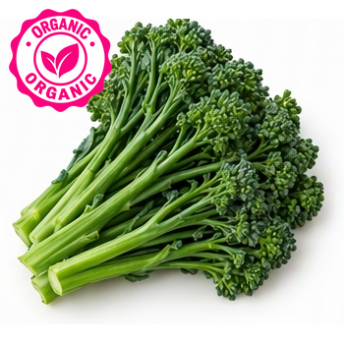  PLU: 93277  Organic Broccolini  Category: Organic Brassica  Image Source: AI Generated  Verification Status: 🤖 AI GENERATED REFERENCE IMAGE | 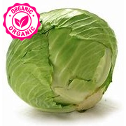  PLU: 94069  Organic Cabbage Green  Category: Organic Brassica  Image Source: Code Booklet  Verification Status: ✅ VERIFIED PHOTO
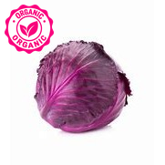  PLU: 94554  Organic Cabbage Red  Category: Organic Brassica  Image Source: Code Booklet  Verification Status: ✅ VERIFIED PHOTO | 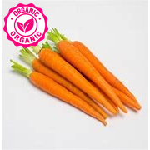  PLU: 94094  Organic Carrots Bunch  Category: Organic Root Vegetable  Image Source: Code Booklet  Verification Status: ✅ VERIFIED PHOTO | 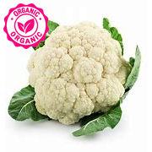  PLU: 94079  Organic Cauliflower  Category: Organic Brassica  Image Source: Code Booklet  Verification Status: ✅ VERIFIED PHOTO | 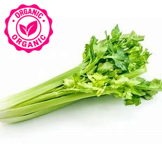  PLU: 94070  Organic Celery  Category: Organic Specialty Vegetable  Image Source: Code Booklet  Verification Status: ✅ VERIFIED PHOTO
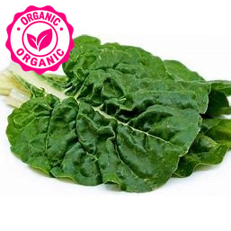  PLU: 94586  Organic Chard Green  Category: Organic Leafy Green  Image Source: Code Booklet  Verification Status: ✅ VERIFIED PHOTO | PLU: 94588  Organic Chard Rainbow  Category: Organic Leafy Green  Image Source: Code Booklet  Verification Status: ⚠ APPROXIMATE PHOTO MATCH  Review note: green chard only; rainbow stems not visible | 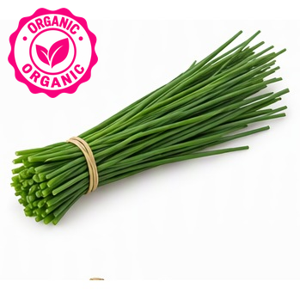  PLU: 94910  Organic Chives  Category: Organic Herb  Image Source: AI Generated  Verification Status: 🤖 AI GENERATED REFERENCE IMAGE | 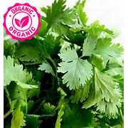  PLU: 94889  Organic Cilantro  Category: Organic Herb  Image Source: Code Booklet  Verification Status: ✅ VERIFIED PHOTO
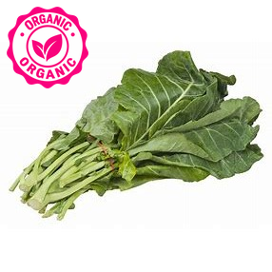  PLU: 94614  Organic Collard Greens  Category: Organic Leafy Green  Image Source: Code Booklet  Verification Status: ✅ VERIFIED PHOTO | 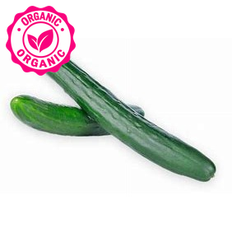  PLU: 94593  Organic Cucumber European  Category: Organic Cucumber  Image Source: Code Booklet  Verification Status: ✅ VERIFIED PHOTO | 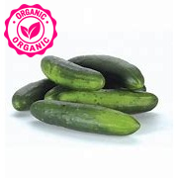  PLU: 94062  Organic Cucumber Field (Green)  Category: Organic Cucumber  Image Source: Code Booklet  Verification Status: ✅ VERIFIED PHOTO  ⚠ DUPLICATE PLU | 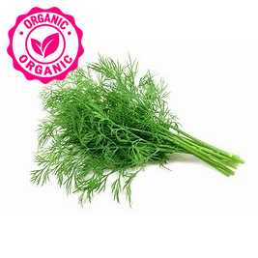  PLU: 94892  Organic Dill  Category: Organic Herb  Image Source: Code Booklet  Verification Status: ✅ VERIFIED PHOTO
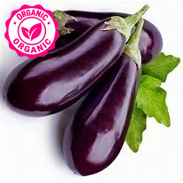  PLU: 94081  Organic Eggplant  Category: Organic Specialty Vegetable  Image Source: Code Booklet  Verification Status: ✅ VERIFIED PHOTO | 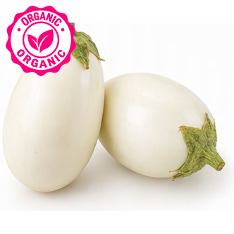  PLU: 94600  Organic Eggplant White  Category: Organic Specialty Vegetable  Image Source: AI Generated  Verification Status: 🤖 AI GENERATED REFERENCE IMAGE | 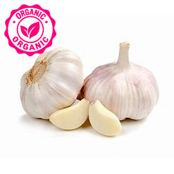  PLU: 94608  Organic Garlic  Category: Organic Onion  Image Source: Code Booklet  Verification Status: ✅ VERIFIED PHOTO | 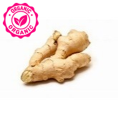  PLU: 94096  Organic Ginger Gold  Category: Organic Root Vegetable  Image Source: Code Booklet  Verification Status: ✅ VERIFIED PHOTO
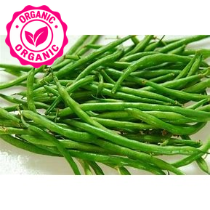  PLU: 94066  Organic Green Beans  Category: Organic Specialty Vegetable  Image Source: Code Booklet  Verification Status: ✅ VERIFIED PHOTO | 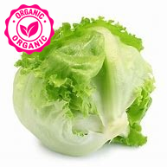  PLU: 94061  Organic Head Lettuce (iceburg)  Category: Organic Lettuce  Image Source: Code Booklet  Verification Status: ✅ VERIFIED PHOTO | 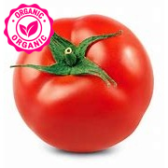  PLU: 94799  Organic Hot House Tomatoe  Category: Organic Tomato  Image Source: Code Booklet  Verification Status: ✅ VERIFIED PHOTO | 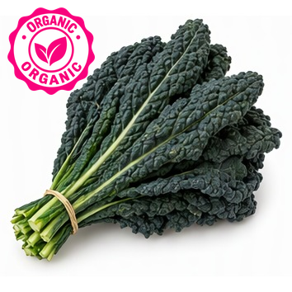  PLU: 94621  Organic Kale Black  Category: Organic Leafy Green  Image Source: AI Generated  Verification Status: 🤖 AI GENERATED REFERENCE IMAGE
PLU: 94624  Organic Kale Black  Category: Organic Leafy Green  Image Source: AI Generated  Verification Status: 🤖 AI GENERATED REFERENCE IMAGE | 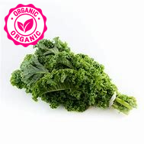  PLU: 94627  Organic Kale Greens  Category: Organic Leafy Green  Image Source: Code Booklet  Verification Status: ✅ VERIFIED PHOTO | 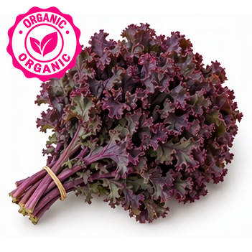  PLU: 94623  Organic Kale Red  Category: Organic Leafy Green  Image Source: AI Generated  Verification Status: 🤖 AI GENERATED REFERENCE IMAGE | PLU: 9463  Organic Kale Red  Category: Organic Leafy Green  Image Source: AI Generated  Verification Status: 🤖 AI GENERATED REFERENCE IMAGE
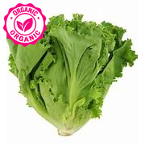  PLU: 94076  Organic Leaf Lettuce Green  Category: Organic Lettuce  Image Source: Code Booklet  Verification Status: ✅ VERIFIED PHOTO | PLU: 94075  Organic Leaf Lettuce Red  Category: Organic Lettuce  Image Source: Code Booklet  Verification Status: ❌ IMAGE REJECTED – REPLACEMENT NEEDED  Review note: green leaf lettuce shown; product is Red leaf | 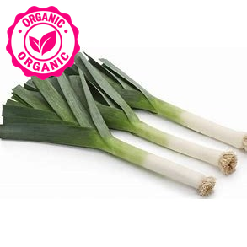  PLU: 94629  Organic Leeks  Category: Organic Onion  Image Source: Code Booklet  Verification Status: ✅ VERIFIED PHOTO | 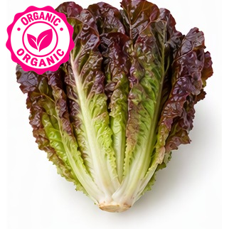  PLU: 93097  Organic Lettuc Red Romaine  Category: Organic Lettuce  Image Source: AI Generated  Verification Status: 🤖 AI GENERATED REFERENCE IMAGE
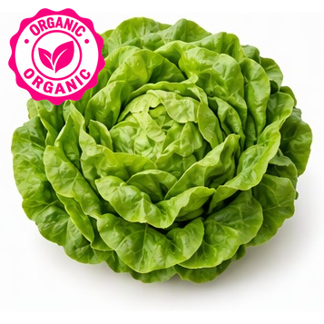  PLU: 94632  Organic Lettuce Boston/Butter  Category: Organic Lettuce  Image Source: AI Generated  Verification Status: 🤖 AI GENERATED REFERENCE IMAGE | 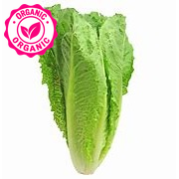  PLU: 94640  Organic Lettuce Romaine  Category: Organic Lettuce  Image Source: Code Booklet  Verification Status: ✅ VERIFIED PHOTO | 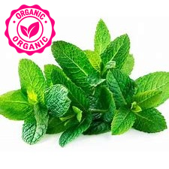  PLU: 94896  Organic Mint  Category: Organic Herb  Image Source: Code Booklet  Verification Status: ✅ VERIFIED PHOTO | 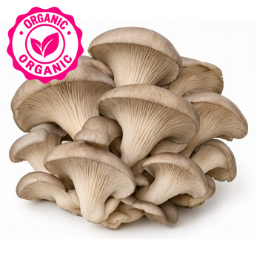  PLU: 94649  Organic Mushroom Oyster  Category: Organic Specialty Vegetable  Image Source: AI Generated  Verification Status: 🤖 AI GENERATED REFERENCE IMAGE
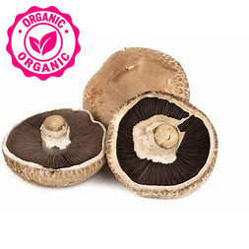  PLU: 94657  Organic Mushroom Portabello  Category: Organic Specialty Vegetable  Image Source: Code Booklet  Verification Status: ✅ VERIFIED PHOTO  ⚠ DUPLICATE PLU | 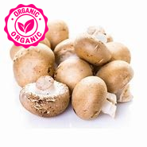  ⚠ DUPLICATE PLU  PLU: 94648  Organic Mushrooms Brown  Category: Organic Specialty Vegetable  Image Source: Code Booklet  Verification Status: ✅ VERIFIED PHOTO | ⚠ DUPLICATE PLU  PLU: 94648  Organic Mushrooms Crimini  Category: Organic Specialty Vegetable  Image Source: Code Booklet  Verification Status: ✅ VERIFIED PHOTO | 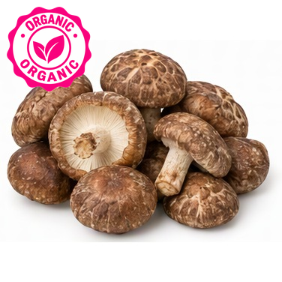  PLU: 94651  Organic Mushrooms Shitake  Category: Organic Specialty Vegetable  Image Source: AI Generated  Verification Status: 🤖 AI GENERATED REFERENCE IMAGE
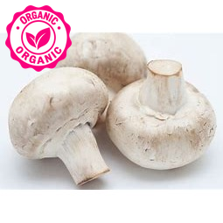  PLU: 94085  Organic Mushrooms White  Category: Organic Specialty Vegetable  Image Source: Code Booklet  Verification Status: ✅ VERIFIED PHOTO | 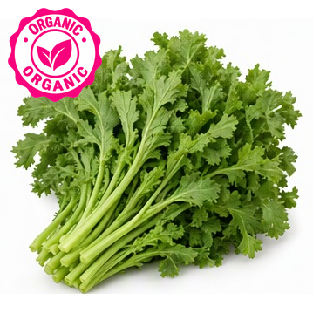  PLU: 94616  Organic Mustard Greens  Category: Organic Leafy Green  Image Source: AI Generated  Verification Status: 🤖 AI GENERATED REFERENCE IMAGE | 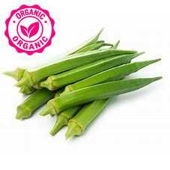  PLU: 94655  Organic Okra  Category: Organic Specialty Vegetable  Image Source: Code Booklet  Verification Status: ✅ VERIFIED PHOTO | 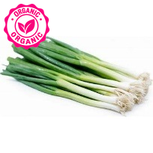  PLU: 94068  Organic Onion Green  Category: Organic Onion  Image Source: Code Booklet  Verification Status: ✅ VERIFIED PHOTO
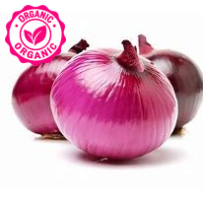  PLU: 94082  Organic Onion Red  Category: Organic Onion  Image Source: Code Booklet  Verification Status: ✅ VERIFIED PHOTO | 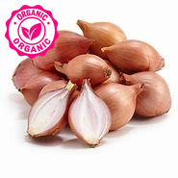  PLU: 94662  Organic Onion Shallots  Category: Organic Onion  Image Source: Code Booklet  Verification Status: ✅ VERIFIED PHOTO | 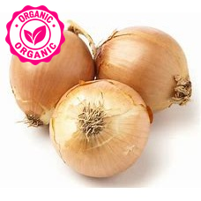  ⚠ DUPLICATE PLU  PLU: 94093  Organic Onion Spanish  Category: Organic Onion  Image Source: Code Booklet  Verification Status: ✅ VERIFIED PHOTO | 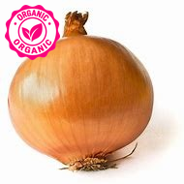  PLU: 94665  Organic Onion Yellow  Category: Organic Onion  Image Source: Code Booklet  Verification Status: ✅ VERIFIED PHOTO
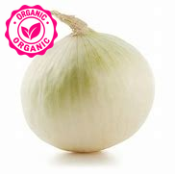  PLU: 94666  Organic Onions White  Category: Organic Onion  Image Source: Code Booklet  Verification Status: ✅ VERIFIED PHOTO | ⚠ DUPLICATE PLU  PLU: 94093  Organic Onions Yellow  Category: Organic Onion  Image Source: Code Booklet  Verification Status: ✅ VERIFIED PHOTO | 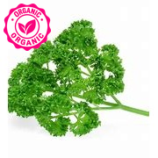  PLU: 94901  Organic Parsley  Category: Organic Herb  Image Source: Code Booklet  Verification Status: ✅ VERIFIED PHOTO | 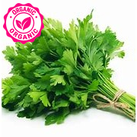  PLU: 94900  Organic Parsley Flat  Category: Organic Herb  Image Source: Code Booklet  Verification Status: ✅ VERIFIED PHOTO
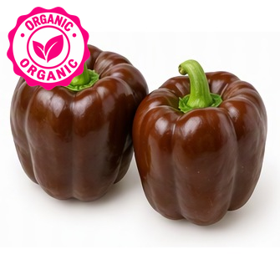  PLU: 94323  Organic Pepper Chocolate  Category: Organic Pepper  Image Source: AI Generated  Verification Status: 🤖 AI GENERATED REFERENCE IMAGE | 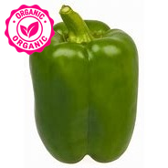  PLU: 94065  Organic Pepper Green  Category: Organic Pepper  Image Source: Code Booklet  Verification Status: ✅ VERIFIED PHOTO | PLU: 93120  Organic Pepper Green Bell  Category: Organic Pepper  Image Source: Code Booklet  Verification Status: ✅ VERIFIED PHOTO | 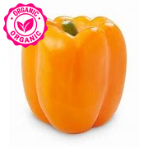  PLU: 93121  Organic Pepper Orange  Category: Organic Pepper  Image Source: Code Booklet  Verification Status: ✅ VERIFIED PHOTO
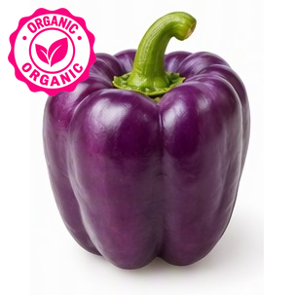  PLU: 93124  Organic Pepper Purple Bell  Category: Organic Pepper  Image Source: AI Generated  Verification Status: 🤖 AI GENERATED REFERENCE IMAGE | 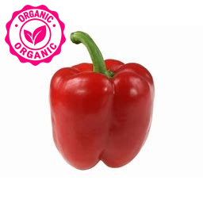  PLU: 94088  Organic Pepper Red  Category: Organic Pepper  Image Source: Code Booklet  Verification Status: ✅ VERIFIED PHOTO | 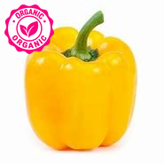  PLU: 94689  Organic Pepper Yellow  Category: Organic Pepper  Image Source: Code Booklet  Verification Status: ✅ VERIFIED PHOTO | 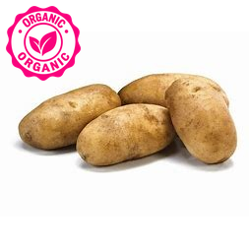  PLU: 94072  Organic Potato Baking  Category: Organic Potato  Image Source: Code Booklet  Verification Status: ✅ VERIFIED PHOTO
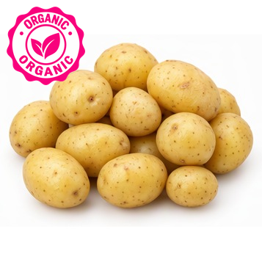  ⚠ DUPLICATE PLU  PLU: 94823  Organic Potato Nugget  Category: Organic Potato  Image Source: AI Generated  Verification Status: 🤖 AI GENERATED REFERENCE IMAGE  Review note: small yellow potatoes; Nugget plausible | 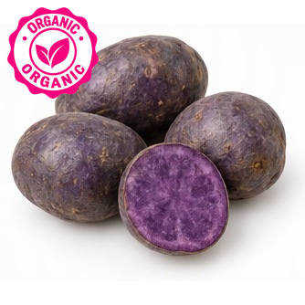  PLU: 93128  Organic Potato Purple  Category: Organic Potato  Image Source: AI Generated  Verification Status: 🤖 AI GENERATED REFERENCE IMAGE | 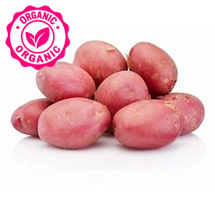  PLU: 94723  Organic Potato Red  Category: Organic Potato  Image Source: Code Booklet  Verification Status: ✅ VERIFIED PHOTO | 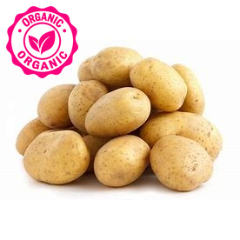  ⚠ DUPLICATE PLU  PLU: 94823  Organic Potato White  Category: Organic Potato  Image Source: Code Booklet  Verification Status: ✅ VERIFIED PHOTO
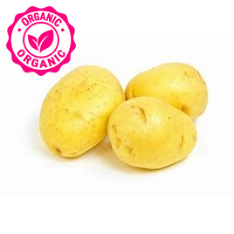  PLU: 94829  Organic Potato Yellow  Category: Organic Potato  Image Source: Code Booklet  Verification Status: ✅ VERIFIED PHOTO | PLU: 94073  Organic Potatoes Red  Category: Organic Potato  Image Source: Code Booklet  Verification Status: ✅ VERIFIED PHOTO | 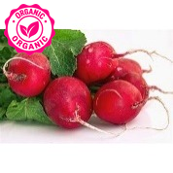  PLU: 94089  Organic Radish Bunch  Category: Organic Root Vegetable  Image Source: Code Booklet  Verification Status: ✅ VERIFIED PHOTO | 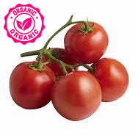  ⚠ DUPLICATE PLU  PLU: 94664  Organic Red Cluster Tomatoes  Category: Organic Tomato  Image Source: Code Booklet  Verification Status: ✅ VERIFIED PHOTO
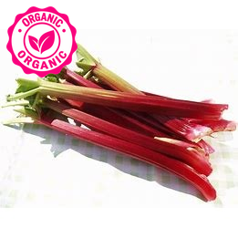  PLU: 94745  Organic Rhubarb  Category: Organic Specialty Vegetable  Image Source: Code Booklet  Verification Status: ✅ VERIFIED PHOTO | 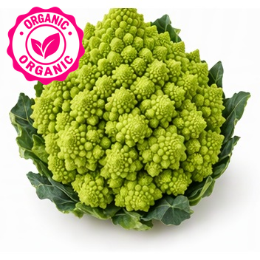  PLU: 93320  Organic Romanesco  Category: Organic Brassica  Image Source: AI Generated  Verification Status: 🤖 AI GENERATED REFERENCE IMAGE | 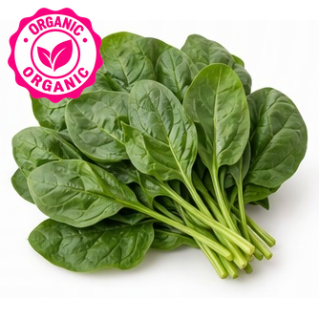  PLU: 94090  Organic Spinach  Category: Organic Leafy Green  Image Source: AI Generated  Verification Status: 🤖 AI GENERATED REFERENCE IMAGE | 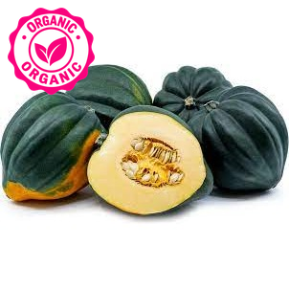  PLU: 94750  Organic Squash Acorn  Category: Organic Squash  Image Source: Code Booklet  Verification Status: ✅ VERIFIED PHOTO
PLU: 94758  Organic Squash Buttercup  Category: Organic Squash  Image Source: AI Generated  Verification Status: ❌ IMAGE REJECTED – REPLACEMENT NEEDED  Review note: shows butter lettuce; product is Buttercup squash | PLU: 94759  Organic Squash Butternut  Category: Organic Squash  Image Source: AI Generated  Verification Status: ❌ IMAGE REJECTED – REPLACEMENT NEEDED  Review note: shows butter lettuce; product is Butternut squash | 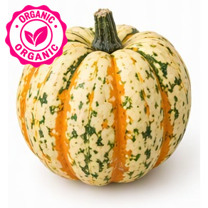  PLU: 93142  Organic Squash Carnivale  Category: Organic Squash  Image Source: AI Generated  Verification Status: 🤖 AI GENERATED REFERENCE IMAGE | 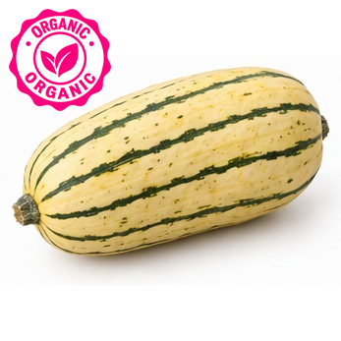  PLU: 94763  Organic Squash Delicata  Category: Organic Squash  Image Source: AI Generated  Verification Status: 🤖 AI GENERATED REFERENCE IMAGE
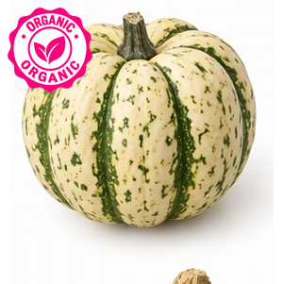  PLU: 94764  Organic Squash Dumpling Sweet  Category: Organic Squash  Image Source: AI Generated  Verification Status: 🤖 AI GENERATED REFERENCE IMAGE | 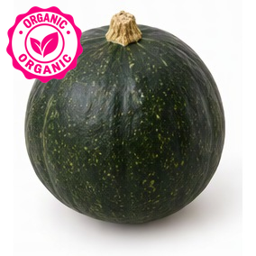  PLU: 93418  Organic Squash Eightball  Category: Organic Squash  Image Source: AI Generated  Verification Status: 🤖 AI GENERATED REFERENCE IMAGE | 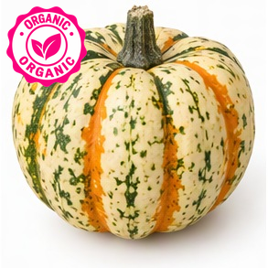  PLU: 94785  Organic Squash Festival  Category: Organic Squash  Image Source: AI Generated  Verification Status: 🤖 AI GENERATED REFERENCE IMAGE | 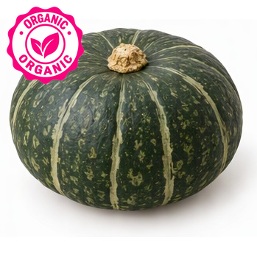  ⚠ DUPLICATE PLU  PLU: 94769  Organic Squash Kabocha  Category: Organic Squash  Image Source: AI Generated  Verification Status: 🤖 AI GENERATED REFERENCE IMAGE
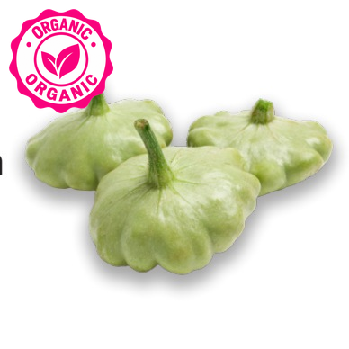  PLU: 94773  Organic Squash Patty Pan  Category: Organic Squash  Image Source: Produce Guide  Verification Status: ✅ VERIFIED PHOTO | PLU: 94774  Organic Squash Red Kurri  Category: Organic Squash  Image Source: AI Generated  Verification Status: 🤖 AI GENERATED REFERENCE IMAGE  Review note: dark green kabocha shown; Red Kuri is orange | 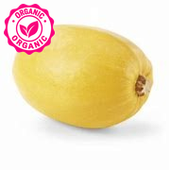  PLU: 94776  Organic Squash Spaghetti  Category: Organic Squash  Image Source: Code Booklet  Verification Status: ✅ VERIFIED PHOTO | 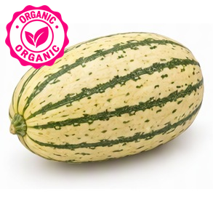  ⚠ DUPLICATE PLU  PLU: 94769  Organic Squash Stripetti  Category: Organic Squash  Image Source: AI Generated  Verification Status: 🤖 AI GENERATED REFERENCE IMAGE
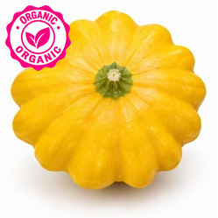  PLU: 94777  Organic Squash Sunburst  Category: Organic Squash  Image Source: AI Generated  Verification Status: 🤖 AI GENERATED REFERENCE IMAGE | 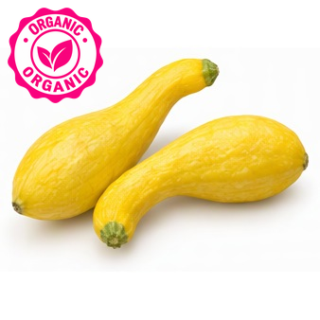  PLU: 94782  Organic Squash Yellow  Category: Organic Squash  Image Source: AI Generated  Verification Status: 🤖 AI GENERATED REFERENCE IMAGE | 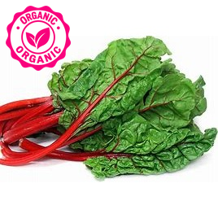  PLU: 94587  Organic Swiss Chard Red  Category: Organic Leafy Green  Image Source: Code Booklet  Verification Status: ✅ VERIFIED PHOTO | 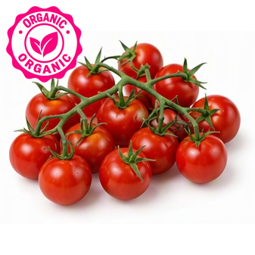  PLU: 94993  Organic Tomato Cherry  Category: Organic Tomato  Image Source: AI Generated  Verification Status: 🤖 AI GENERATED REFERENCE IMAGE
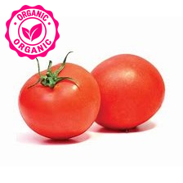  PLU: 94860  Organic Tomato Field  Category: Organic Tomato  Image Source: Code Booklet  Verification Status: ✅ VERIFIED PHOTO | 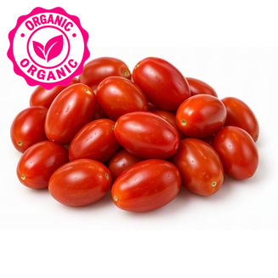  PLU: 93150  Organic Tomato Grape  Category: Organic Tomato  Image Source: AI Generated  Verification Status: 🤖 AI GENERATED REFERENCE IMAGE | 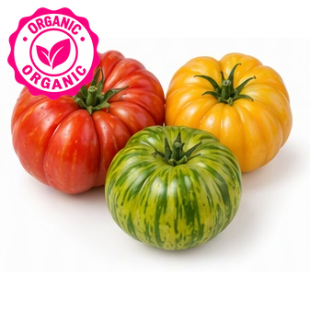  PLU: 93423  Organic Tomato Heirloom  Category: Organic Tomato  Image Source: AI Generated  Verification Status: 🤖 AI GENERATED REFERENCE IMAGE | ⚠ DUPLICATE PLU  PLU: 94664  Organic Tomato On the Vine  Category: Organic Tomato  Image Source: Code Booklet  Verification Status: ✅ VERIFIED PHOTO
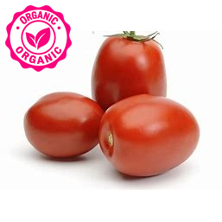  PLU: 94087  Organic Tomato Plum Roma  Category: Organic Tomato  Image Source: Code Booklet  Verification Status: ✅ VERIFIED PHOTO | PLU: 94063  Organic Tomato Red  Category: Organic Tomato  Image Source: Code Booklet  Verification Status: ✅ VERIFIED PHOTO | PLU: 94064  Organic Tomato Red Large  Category: Organic Tomato  Image Source: Code Booklet  Verification Status: ✅ VERIFIED PHOTO | PLU: 94798  Organic Tomatoes  Category: Organic Tomato  Image Source: Code Booklet  Verification Status: ✅ VERIFIED PHOTO
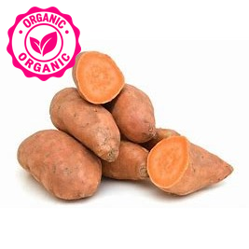  PLU: 94816  Organic Yam  Category: Organic Potato  Image Source: Code Booklet  Verification Status: ⚠ APPROXIMATE PHOTO MATCH  Review note: orange sweet potatoes shown for yam | PLU: 94074  Organic Yams Red Garnet  Category: Organic Potato  Image Source: Code Booklet  Verification Status: ✅ VERIFIED PHOTO | 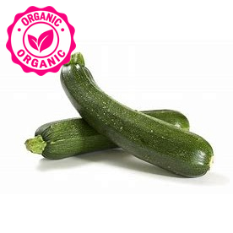  PLU: 94067  Organic Zucchini  Category: Organic Squash  Image Source: Code Booklet  Verification Status: ✅ VERIFIED PHOTO | 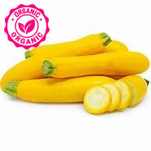  PLU: 94086  Organic Zucchini Yellow  Category: Organic Squash  Image Source: Code Booklet  Verification Status: ✅ VERIFIED PHOTO

