PLU: 4101  Apples Breburn Small  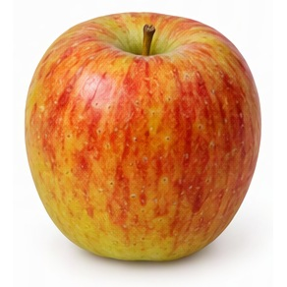 | PLU: 3616  Apples Envy  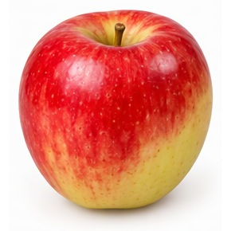
PLU: 4129  Apples Fuji Small  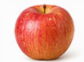 | PLU: 94131  Organic Apples Fuji  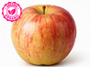
PLU: 4135  Apples Gala Large  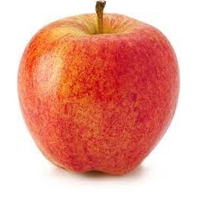 | PLU: 94135  Organic Apples Gala  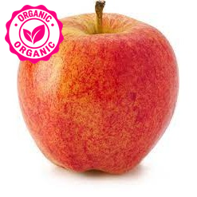

PLU: 94174  Organic Apples Gala | PLU: 4020  Apples Gold Delicious Large  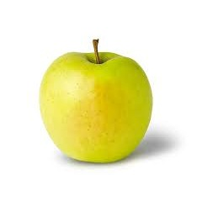
PLU: 4017  Apples Granny Smith  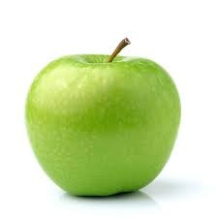 | PLU: 94017  Organic Apples Granny Smith  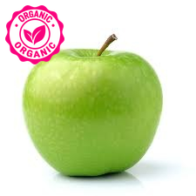
PLU: 94139  Organic Apples Granny Smith | PLU: 3283  Apples Honey Crisp  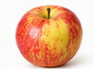

PLU: 3293  Apples Jazz Small  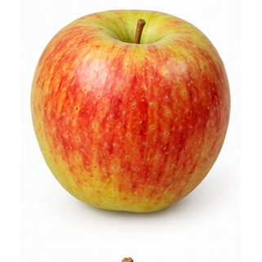 | PLU: 4153  Apples MacIntosh Large  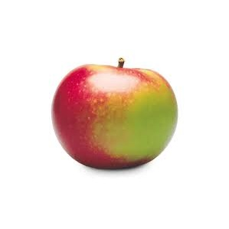
PLU: 94154  Organic Apples MacIntosh  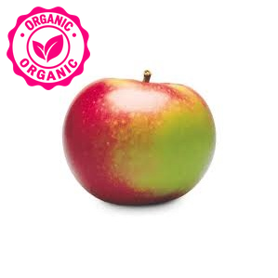 | PLU: 4152  Apples McIntosh Small  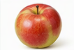
PLU: 94153  Organic McIntosh Apples | PLU: 4130  Apples Pink Lady  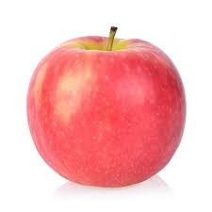

PLU: 94128  Organic Apples Pink Lady  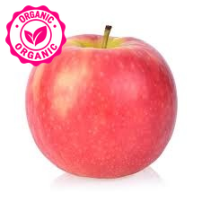 | PLU: 4016  Apples Red Delicious Lrg  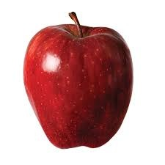
PLU: 94016  Organic Apples Red Delicious  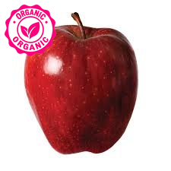 | PLU: 4059  Red Prince Apples
PLU: 4174  Apples Royal Gala Large  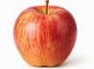 | PLU: 4173  Apples Royal Gala Small  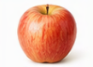

PLU: 94173  Organic Royal Gala Apples | PLU: 4180  Apples Spartan Large  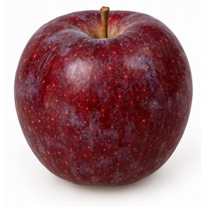
PLU: 94178  Organic Apples Spartan  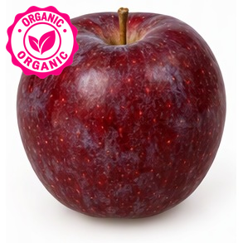 | PLU: 3438  Apples Ambrosia  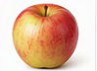
PLU: 93438  Organic Apples Ambrosia  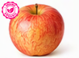 | PLU: 3529  Apple Dazzle  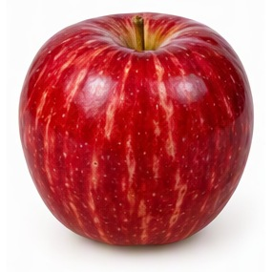

PLU: 3445  Apples Pazza  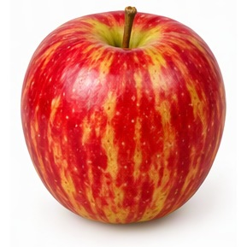 | PLU: 94099  Organic Apples Akane  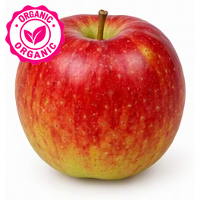
PLU: 94103  Organic Apples Braeburn  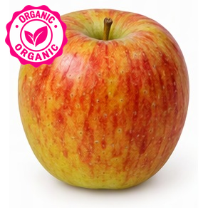 | PLU: 93066  Organic Apples Cameo  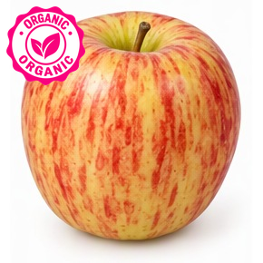
PLU: 94127  Organic Apples Empire  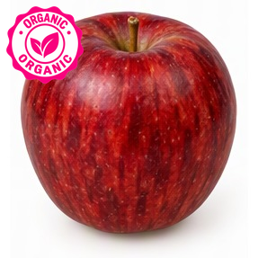 | PLU: 94020  Organic Apples Golden Delicious  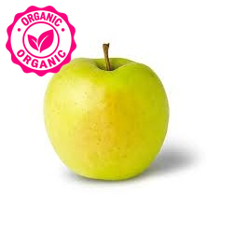

PLU: 94097  Organic Apples Golden Delicious | PLU: 94147  Organic Apples Jona Gold  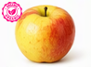
PLU: 93072  Organic Apples Lady | PLU: 94204  Organic Apples Orin  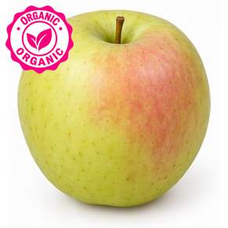
PLU: 94215  Organic Apples Pinata  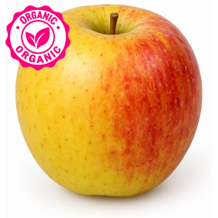 | PLU: 94205  Organic Apples Su Mac  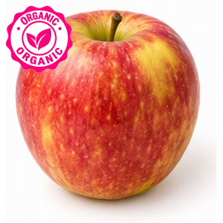

PLU: 94212  Organic Apples Sunrise  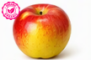 | PLU: 4241  Boysenberries  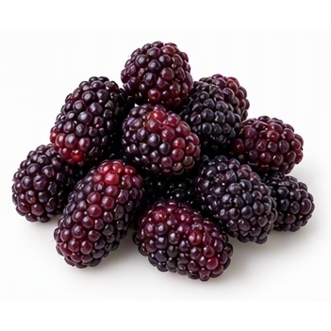
PLU: 4054  Raspberries Half Pint  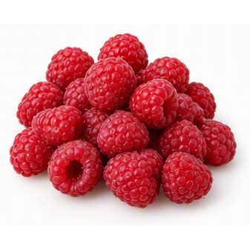 | PLU: 4243  Berries - GooseBerries  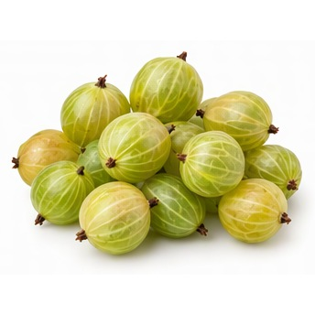
PLU: 82202  Berries - Logan Berries  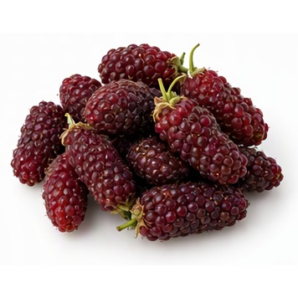 | PLU: 4239  Blackberries Pint  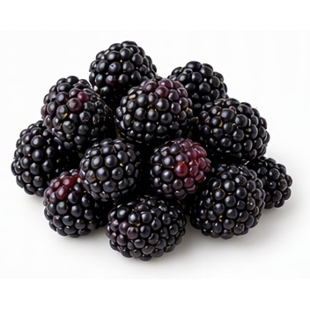

PLU: 19221  Blueberries Bulk  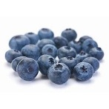 | PLU: 4240  Blueberries Pint
PLU: 94249  Organic Blueberries Pint  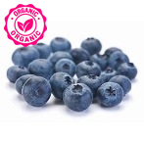 | PLU: 4252  Raspberries 1 Pound
PLU: 4988  Raspberries Flat | PLU: 4253  Strawberries by the Flat  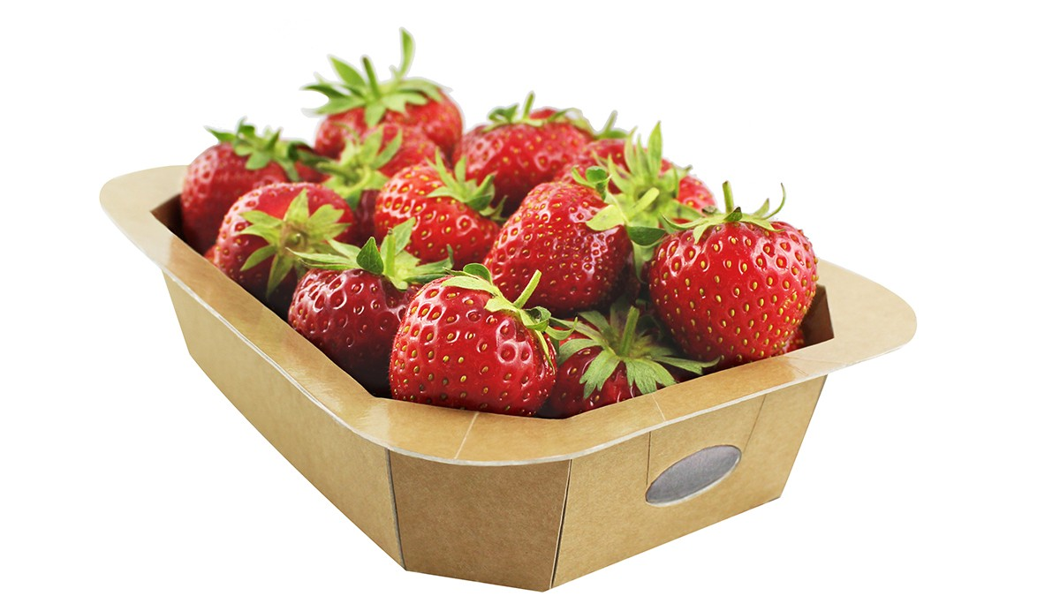

PLU: 3305  Currents - Black  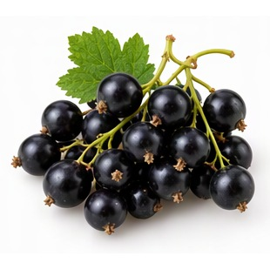 | PLU: 3088  Currents - Red  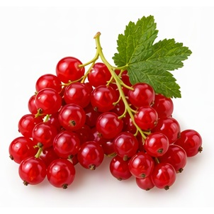
PLU: 4028  Strawberries Pint  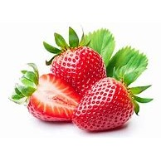 | PLU: 4248  Strawberries Quart
PLU: 4246  Strawberry Pint | PLU: 94252  Organic Strawberry Pint  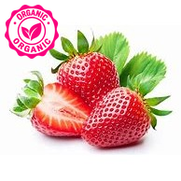

PLU: 3181  Strawberries BC 1 Pound | PLU: 3244  Strawberries 4 Pounds
PLU: 4476  Berries Saskatoon 2 Quart  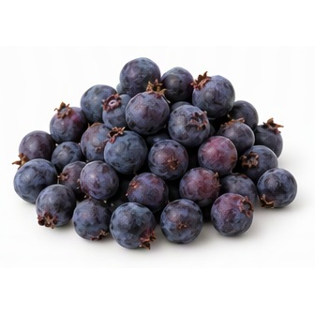 | PLU: 52744  Berries Tay Berries  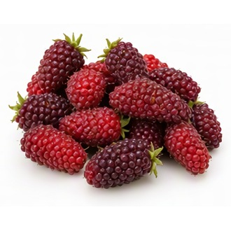
PLU: 4462  Blackberries 1 Pound | PLU: 4450  Clementine

PLU: 4453  Tangerines Honey  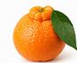 | PLU: 3110  Cara Cara Orange
PLU: 93110  Organic Oranges Cara Cara  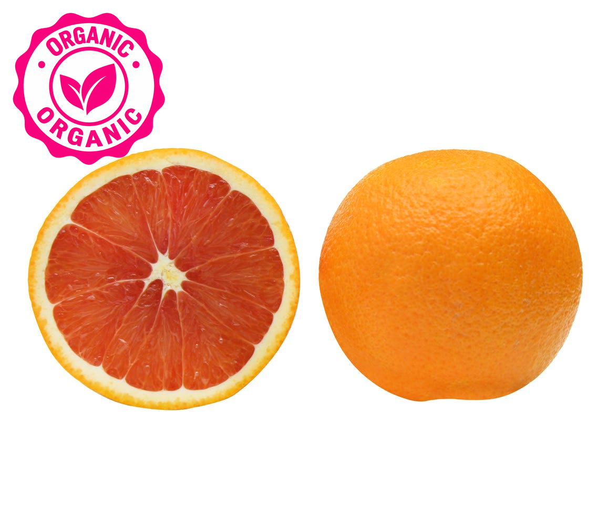 | PLU: 3129  Pomelo
PLU: 4286  Grapefruit Deep Red  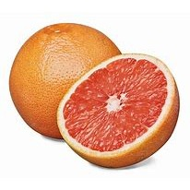 | PLU: 4027  Grapefruit Red Sm

PLU: 4280  Grapefruit Small | PLU: 94027  Organic Grapefruit  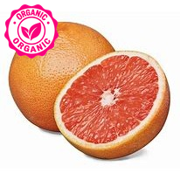
PLU: 4293  Grapefruit White Large  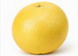 | PLU: 4279  Grapefurit Pummelo  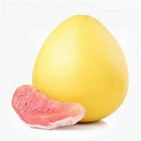
PLU: 4053  Lemons  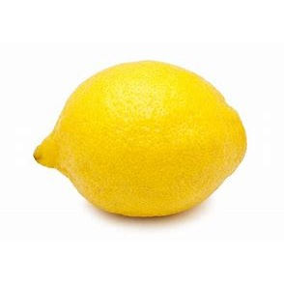 | PLU: 94053  Organic Lemons  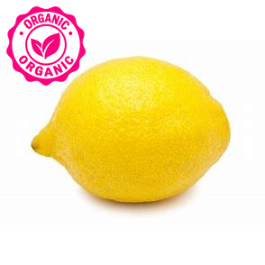

PLU: 4048  Limes  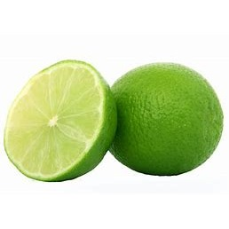 | PLU: 94048  Organic Limes  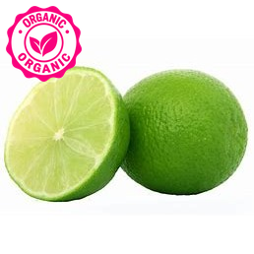
PLU: 4055  Murcott Tangerines  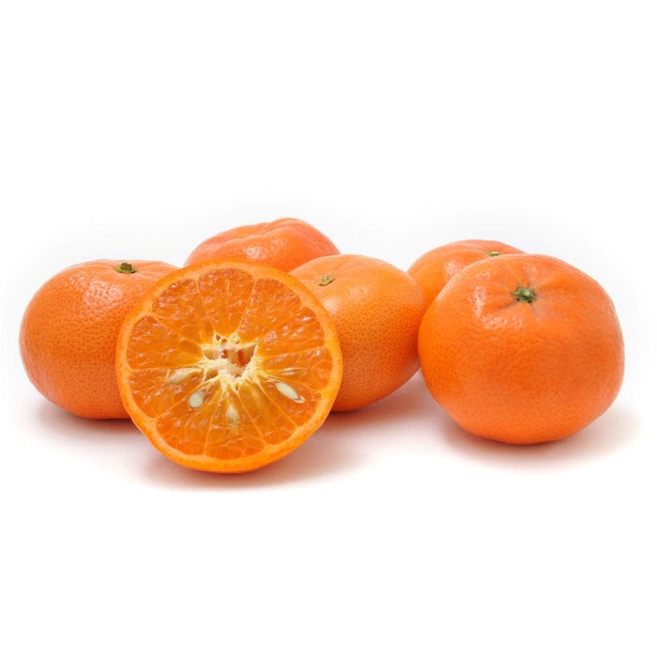 | PLU: 4449  Tangerine Sunburst  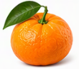
PLU: 4454  Tangerine Murcott  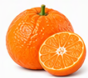 | PLU: 4452  Tangerine Fairchild  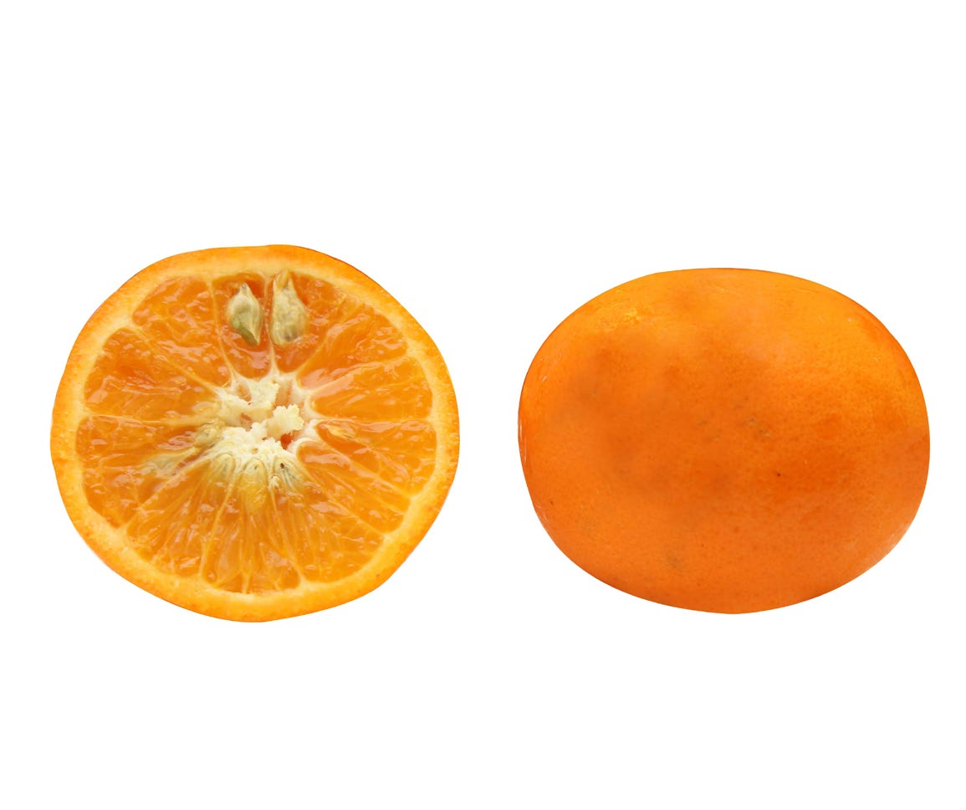

PLU: 4456  Tangelos  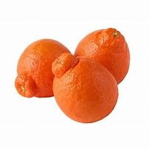 | PLU: 4288  Grapefruit Red Large
PLU: 94047  Organic Red Grapefruit  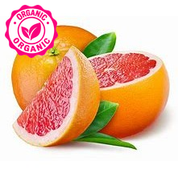 | PLU: 3029  Oranges Mandarin Chinese  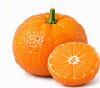
PLU: 3153  Oranges Large  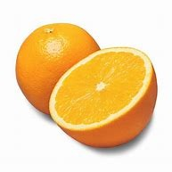 | PLU: 4477  Oranges Madarin Japanese  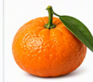

PLU: 4455  Mandarins  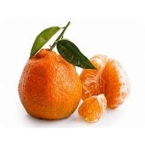 | PLU: 4381  Oranges Blood  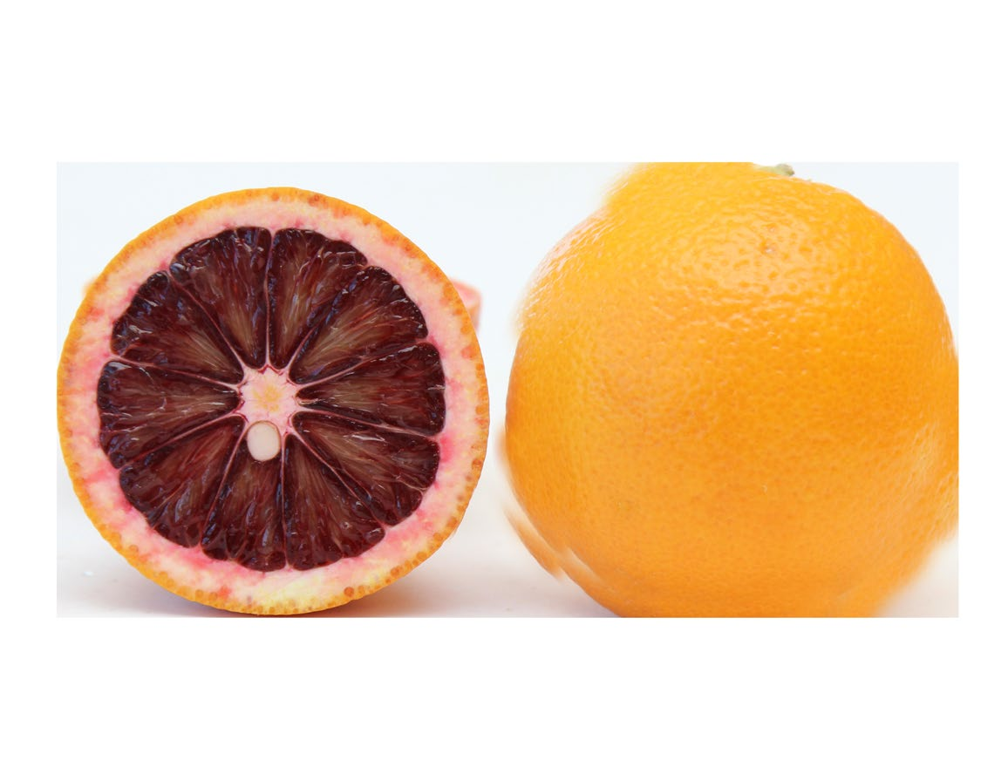
PLU: 94381  Organic Oranges Blood  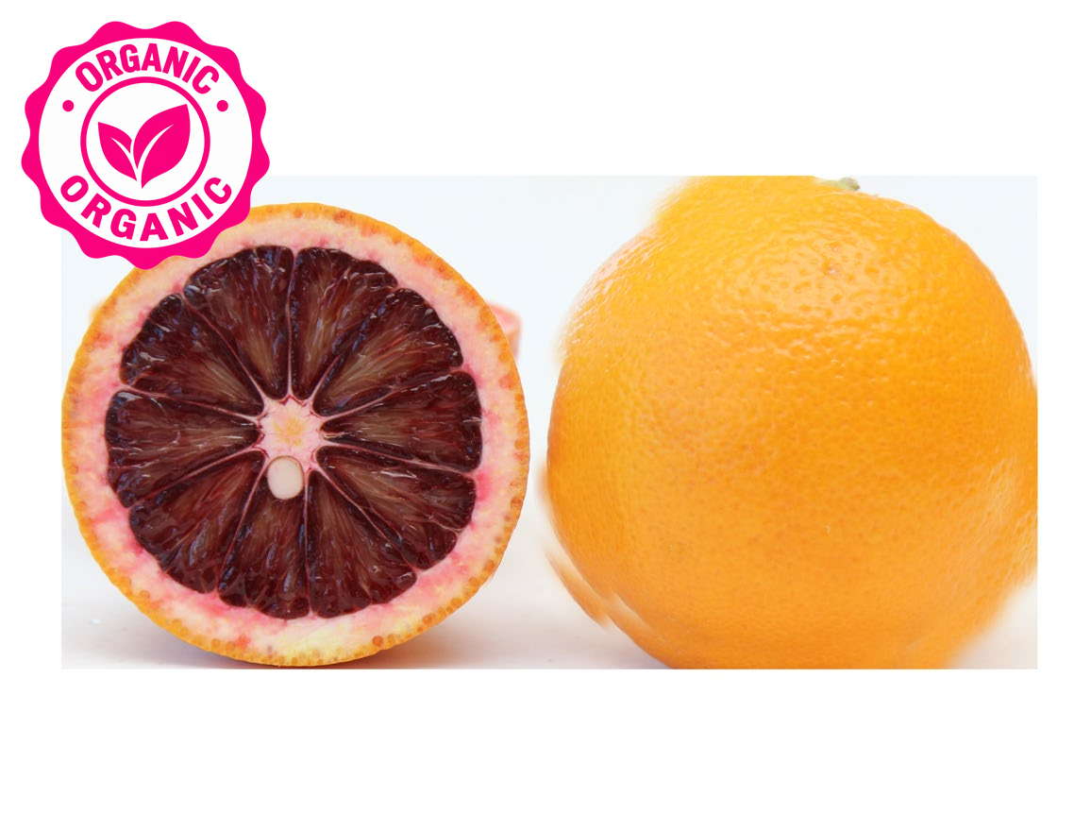 | PLU: 4458  Tangerine Seedless  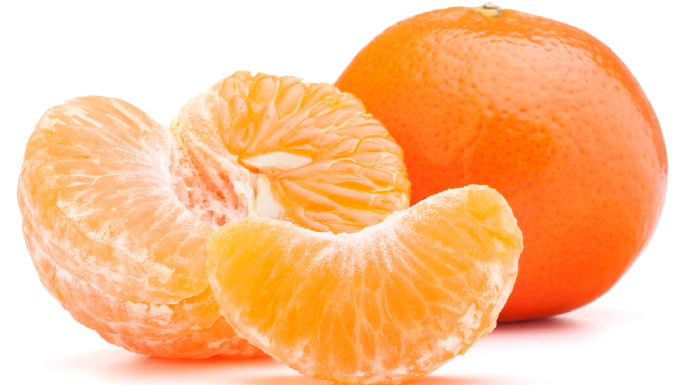
PLU: 4012  Oranges Navel | PLU: 94012  Organic Oranges Navel Large  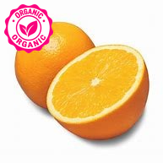

PLU: 93107  Organic Oranges Navel Medium | PLU: 94457  Organic Oranges TDE Tangerine  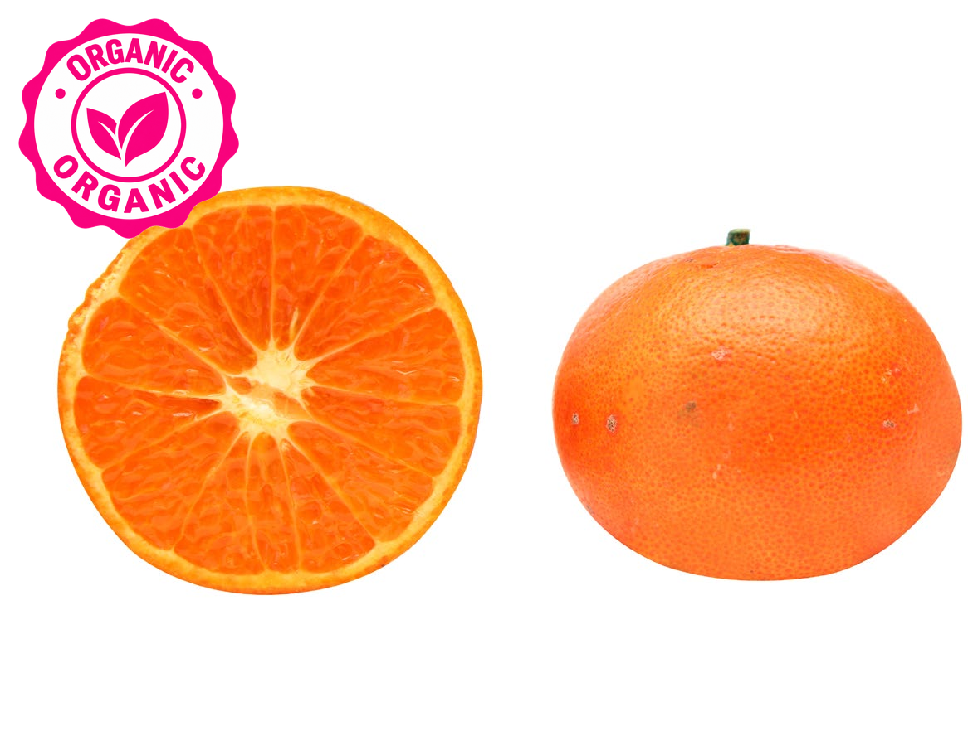
PLU: 94461  Organic Shaddock (Pomelo) | PLU: 93129  Organic Grapefuit Pommelo  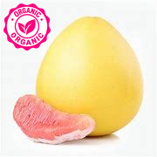
PLU: 94303  Organic KumQuat  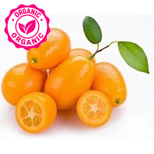 | PLU: 94304  Organic Lemons Meyer-Buckbrand  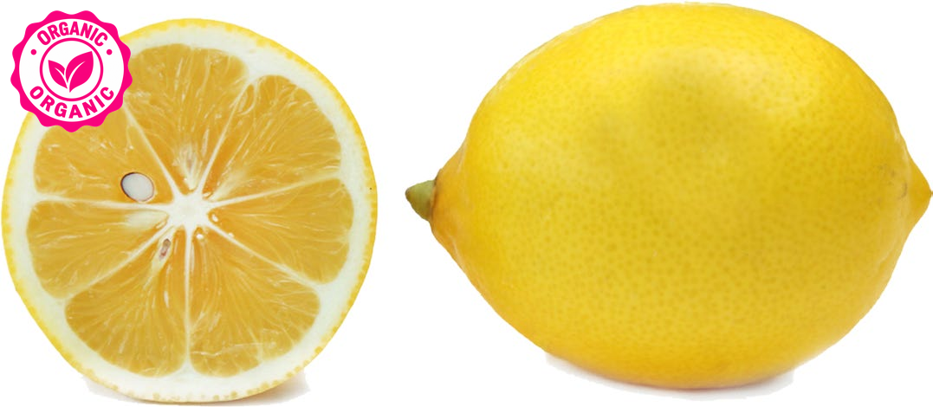

PLU: 94328  Organic Limequats  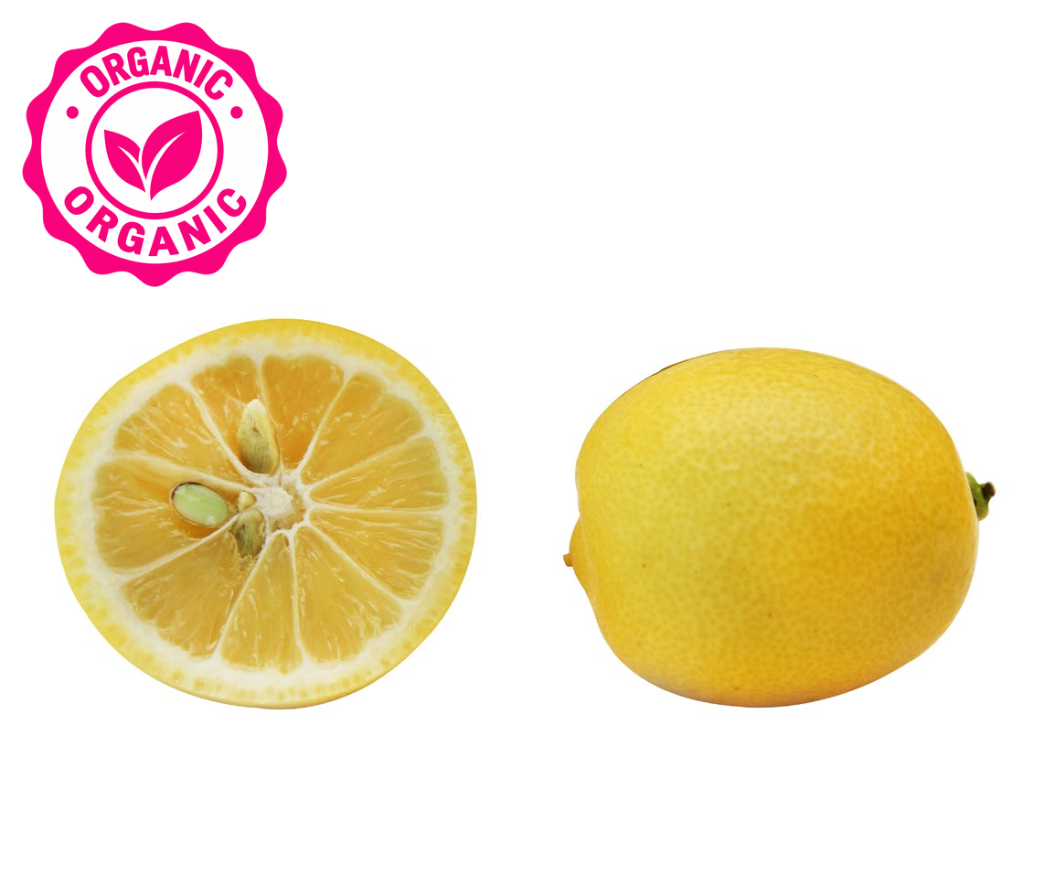 | PLU: 94024  Organic Limes Finger  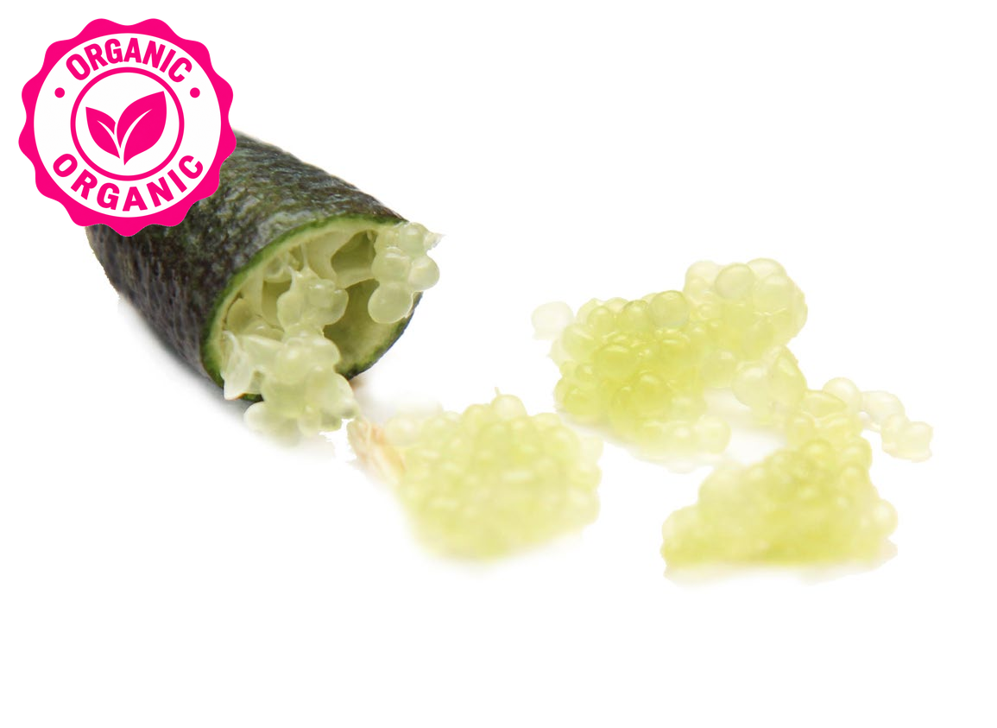
PLU: 94306  Organic Limes Sweet  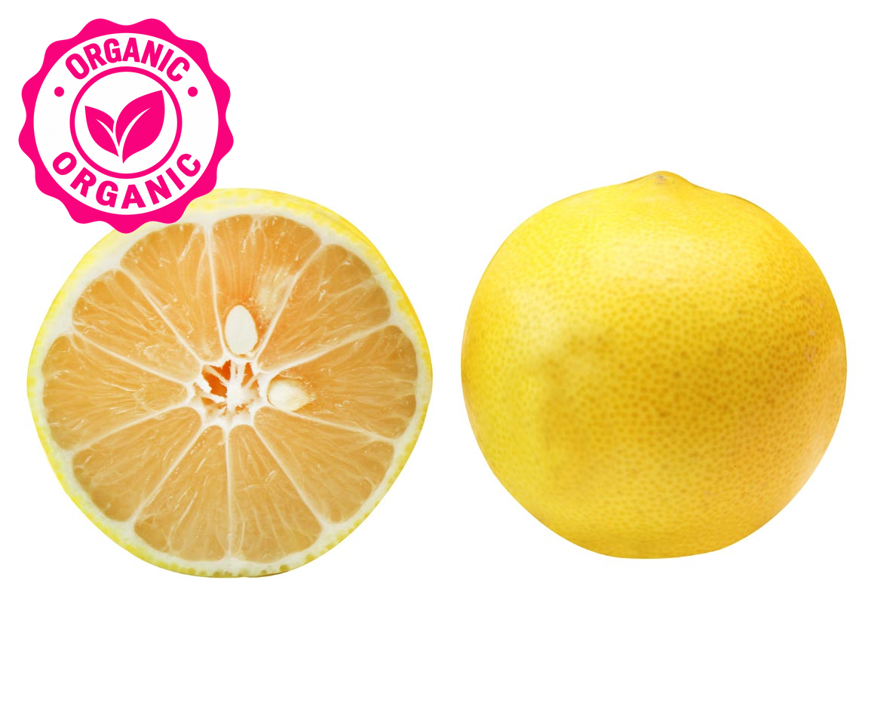 | PLU: 93029  Organic Oranges Mandarin  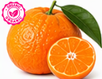
PLU: 94453  Organic Oranges Murcott  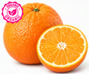 | PLU: 93109  Organic Oranges Seville  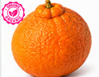

PLU: 94456  Organic Oranges Tangelos  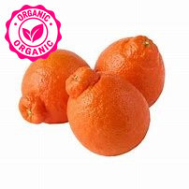 | PLU: 94458  Organic Oranges Tangerine  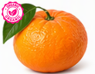
PLU: 93227  Organic Oranges Torange  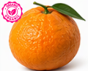 | PLU: 94388  Organic Oranges Valencia  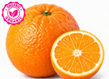
PLU: 93108  Organic Oranges Valencia  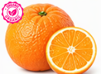 | PLU: 94281  Organic Pink Grapefruit

PLU: 2159  Buddha's Hand Organic  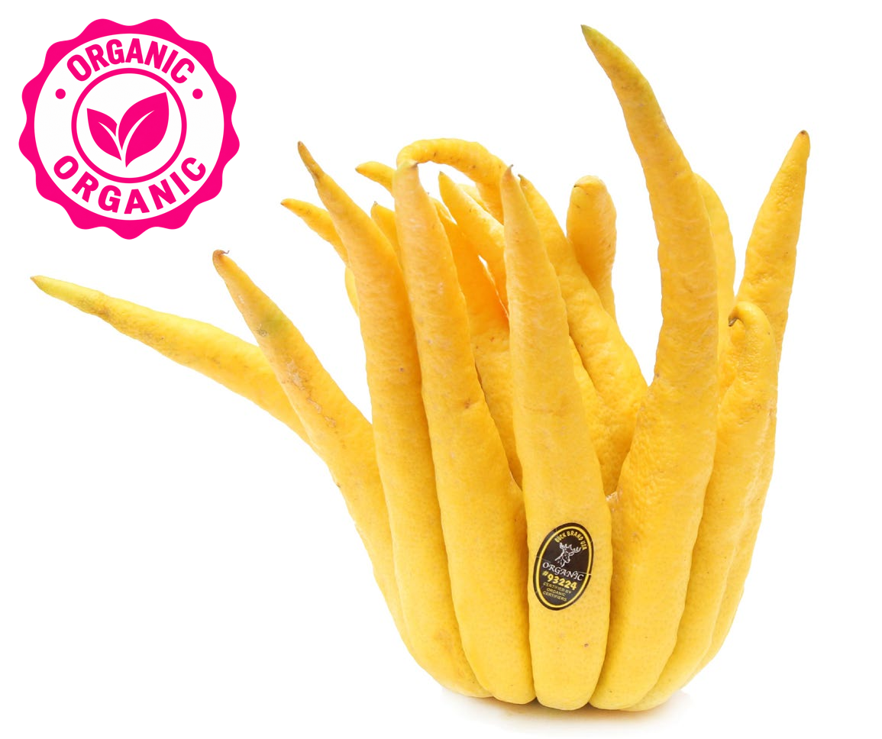 | PLU: 94391  Organic Oranges Mango  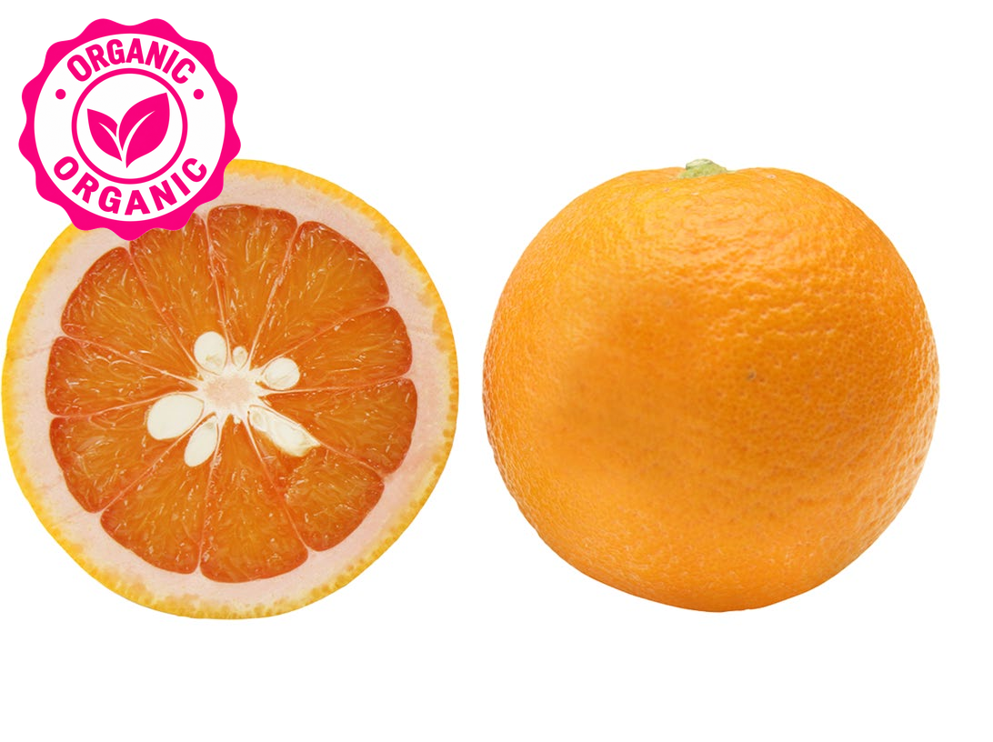
PLU: 4635  Grapes Red Seedless  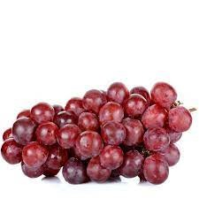 | PLU: 94023  Organic Red Seedless Grapes
PLU: 4056  Grapes Black Seedless  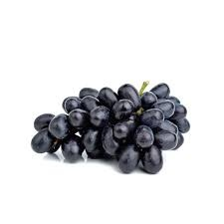 | PLU: 4498  Grapes Green  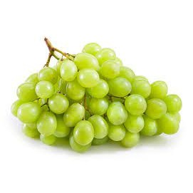

PLU: 4497  Grapes Sugraone  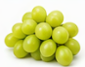 | PLU: 4274  Grapes White Seeded  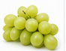
PLU: 4022  Grapes Green Seedless | PLU: 94022  Organic Green Seedless Grapes
PLU: 4023  Grapes Red Seedless (Red Flame)  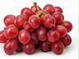 | PLU: 94497  Organic Grapes Green Sdls  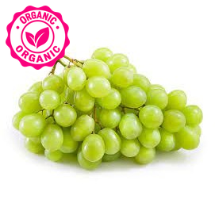

PLU: 4336  Santa Claus Melon | PLU: 3101  Melon Santa Claus  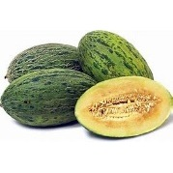
PLU: 4332  Melon Muskmelon  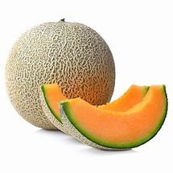 | PLU: 545591  Melon Fancy Cut  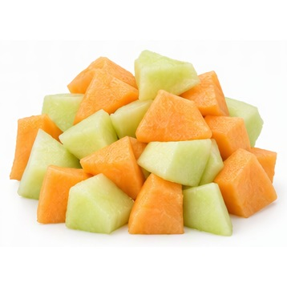
PLU: 4327  Melon Orange  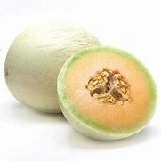 | PLU: 4050  Cantaloupe – Large

PLU: 4319  Melon Cantaloupe Large | PLU: 94050  Organic Melon Cantaloupe  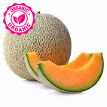
PLU: 4049  Melon Cantaloupe Sm | PLU: 4034  Melon Honeydew Large  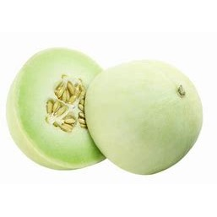
PLU: 4329  Melon Honeydew Small | PLU: 94329  Organic Honeydew Melon

PLU: 4375  Melon Cantaloupe Tuscan  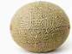 | PLU: 3307  Melon Golden Kiss  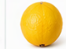
PLU: 4345  Melon Honey Kiss  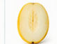 | PLU: 3421  Melon Watermelon Mini  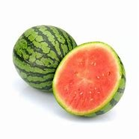
PLU: 3191  Melon Watermelon Mini Cut  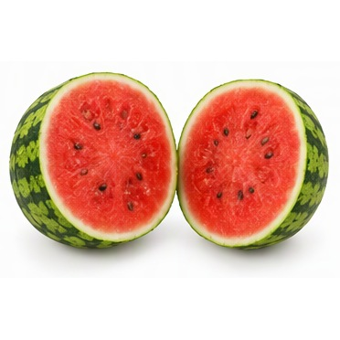 | PLU: 4321  Melon Mini  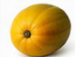

PLU: 4032  Watermelon  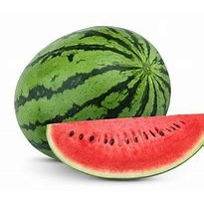 | PLU: 94342  Organic Watermelon
PLU: 3033  Melon Charantais  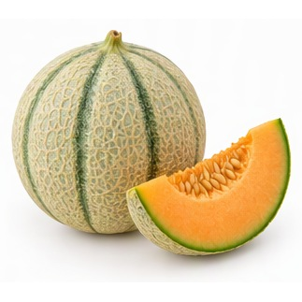 | PLU: 3623  Hami Melon  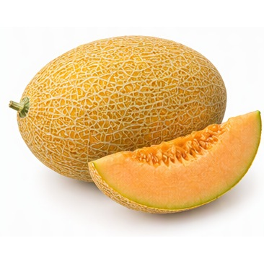
PLU: 3626  Melon Hami | PLU: 4325  Melon Lemon Drop  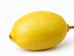

PLU: 4317  Melon Canary  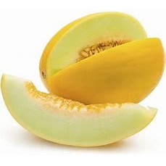 | PLU: 94317  Organic Canary Melon
PLU: 4346  Melon Picasso/Dino  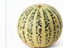 | PLU: 94034  Organic Honeydew  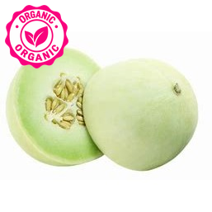
PLU: 94326  Organic Melon Galia  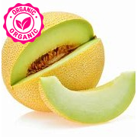 | PLU: 94332  Organic Melon Musk  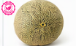

PLU: 94340  Organic Melon Watermelon  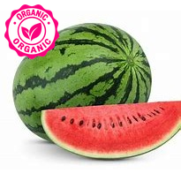 | PLU: 94032  Organic Melon Watermelon
PLU: 4425  Shinko (Shingo) Asian Pear | PLU: 3012  Pear Abate  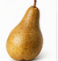
PLU: 4406  Pear Asian White  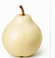 | PLU: 4407  Pear Asian Yellow  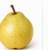

PLU: 4409  Pear Bartlett Green  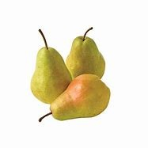 | PLU: 94409  Organic Pears Bartlett Green  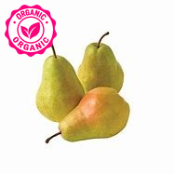
PLU: 4410  Pear Bartlett Red  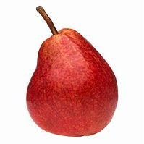 | PLU: 94410  Organic Pears Bartlett Red  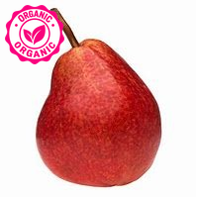
PLU: 4413  Pear Bosc Large  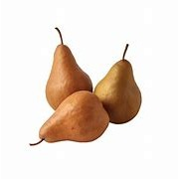 | PLU: 94413  Organic Pears Bosc  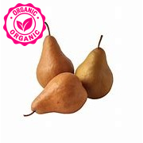

PLU: 4414  Pear Comice  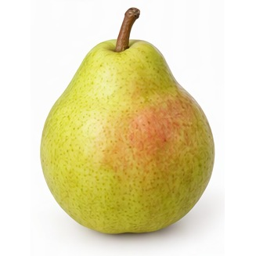 | PLU: 3016  Pear Concorde  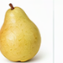
PLU: 3017  Pear Conference  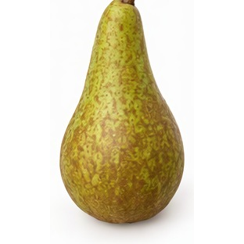 | PLU: 4416  Pear D'Anjou Lrg  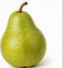
PLU: 94025  Organic D'Anjou Pears  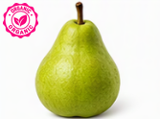 | PLU: 94416  Organic Pear D'Anjou  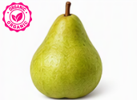

PLU: 4417  Pear D'Anjou Red  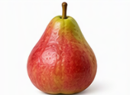 | PLU: 4415  Pear Red  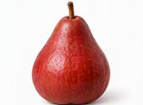
PLU: 3118  Pear Red Crimson  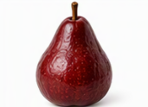 | PLU: 3024  Pear Rocha  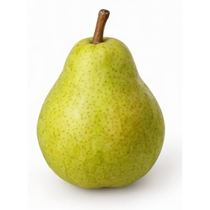
PLU: 4422  Pear Seckel  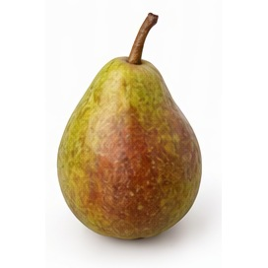 | PLU: 4553  Pear Taylors Gold  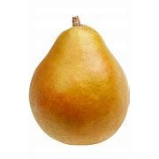

PLU: 82200  Pears Conference BC | PLU: 4005  Pears Honey Belle  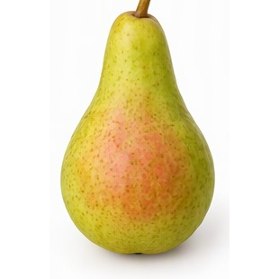
PLU: 4424  Pears Honey Belle Sweet Green | PLU: 4418  Pear Forelle  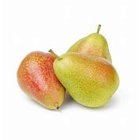
PLU: 93016  Organic Pear Concord  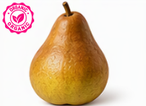 | PLU: 94116  Organic Pears Bartlett

PLU: 4030  Kiwi  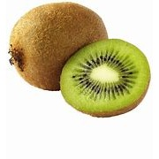 | PLU: 94030  Organic Kiwi  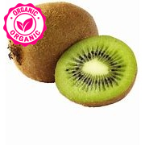
PLU: 3279  Kiwi Golden  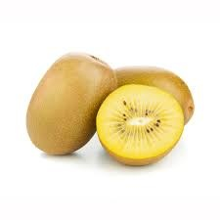 | PLU: 42621  Dates  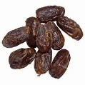
PLU: 3047  Dates Medjool  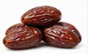 | PLU: 4265  Feijoa  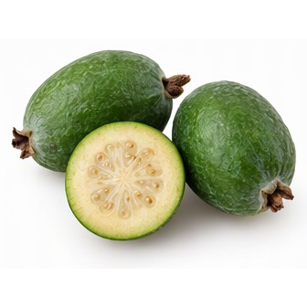

PLU: 4266  Figs Black  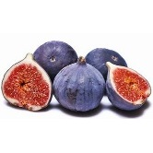 | PLU: 4267  Figs Brown  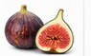
PLU: 4427  Persimmons Hachiya  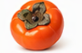 | PLU: 4446  Pomegramate Large  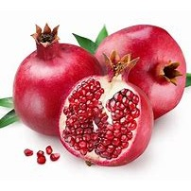
PLU: 4429  Persimmon Large  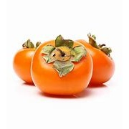 | PLU: 4428  Persimmon Fuyu

PLU: 93127  Organic Pomegrante  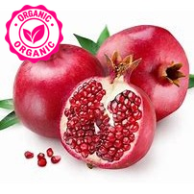 | PLU: 4439  Plum Tree Ripened  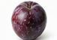
PLU: 4218  Apricots  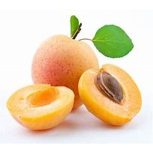 | PLU: 4045  Cherries  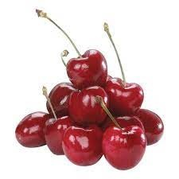
PLU: 94045  Organic Cherries  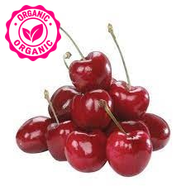 | PLU: 4258  Cherries Rainier  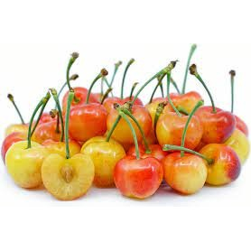

PLU: 4401  Peaches White Lrg  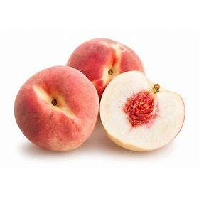 | PLU: 94401  Organic Peaches White  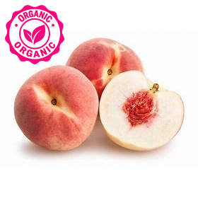
PLU: 4040  Plum Black Large  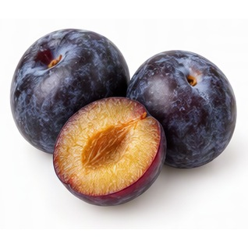 | PLU: 4039  Plum Black Small
PLU: 94040  Organic Black Plums | PLU: 94039  Organic Plums Black Small  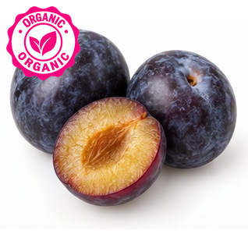

PLU: 4436  Italian Prune Plum | PLU: 3126  Plum Pluot  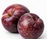
PLU: 4475  Plum Quart  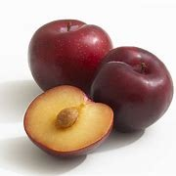 | PLU: 4042  Plum Red Large
PLU: 94042  Organic Plum Red  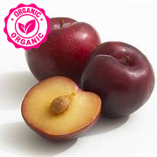 | PLU: 94041  Organic Plums Red Small

PLU: 4865  Prunes  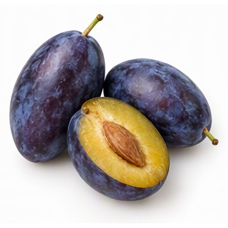 | PLU: 3611  Plum Pluots  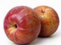
PLU: 3200  Peaches Case  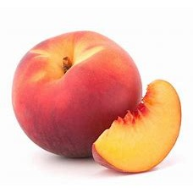 | PLU: 4378  Nectarine  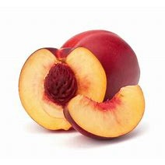
PLU: 94378  Organic Nectarines  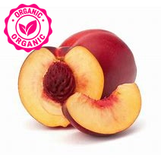 | PLU: 94036  Organic Nectarines Large

PLU: 94035  Organic Nectarines Small | PLU: 4044  Peaches Tree Ripe
PLU: 93035  Organic Nectarines White  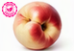 | PLU: 94044  Organic Peaches Tree Ripened  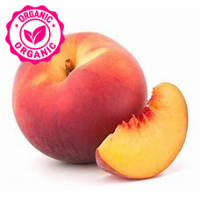
PLU: 94038  Organic Peaches Yellow Lrg | PLU: 3041  Ramboutan  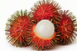

PLU: 3038  Orange Granadilla  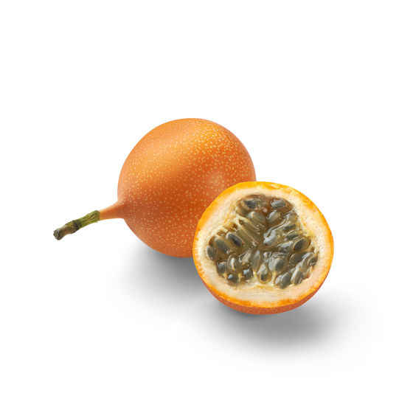 | PLU: 4234  Banana Baby  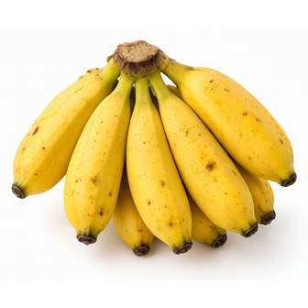
PLU: 4235  Bananas Plantains  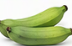 | PLU: 4260  Coconut  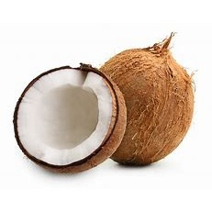
PLU: 4299  Guava  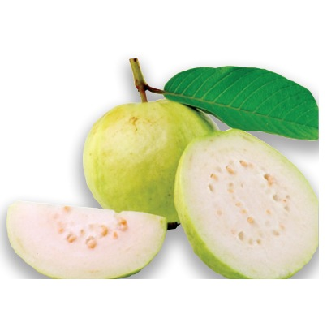 | PLU: 4959  Mango Red  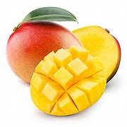

PLU: 4051  Mango Red Small | PLU: 4394  Papaya Large  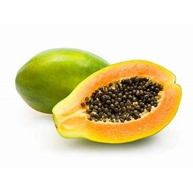
PLU: 4052  Papaya Small | PLU: 4395  Papaya Large Cooking  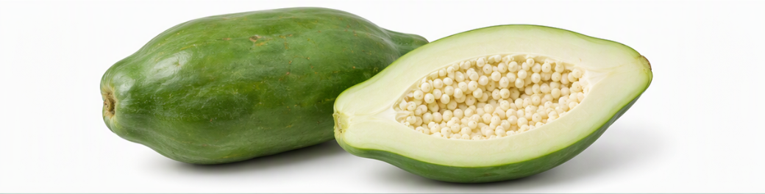
PLU: 3112  Papaya Meridol | PLU: 3111  Papaya Red Flesh  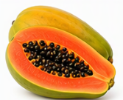

PLU: 4397  Passion Fruit  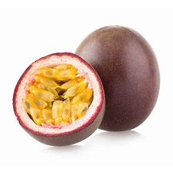 | PLU: 4432  Pineapple Golden  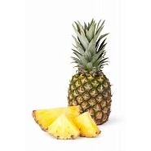
PLU: 4256  StarFruit  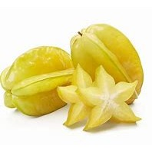 | PLU: 4029  Pineapple Small
PLU: 4430  Pineapple Large  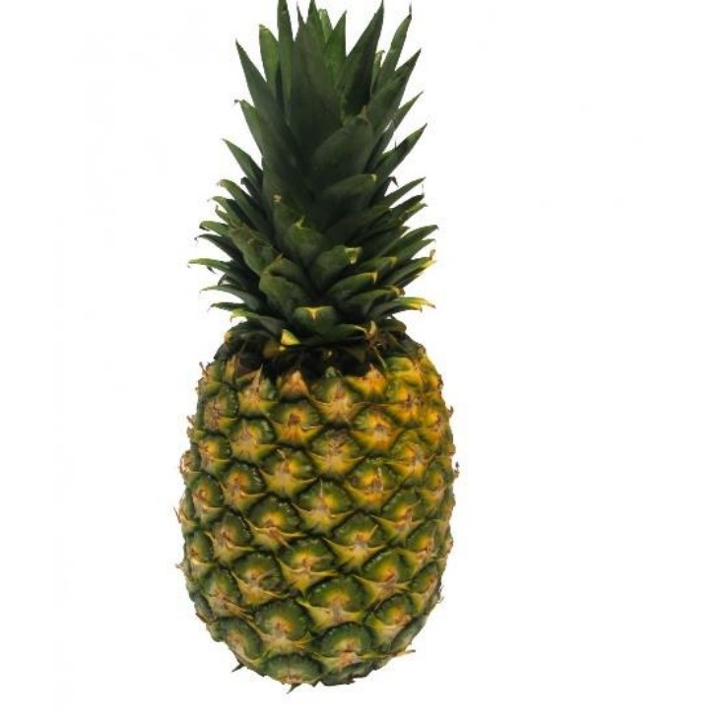 | PLU: 4433  Pineapple

PLU: 94433  Organic Pineapple  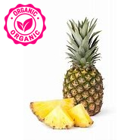 | PLU: 94430  Organic Pineapple
PLU: 81853  Pineapple Half  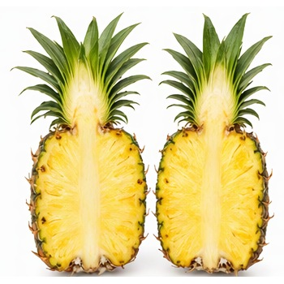 | PLU: 73091  Pineapple Golden Costa Rica Cut
PLU: 23406  Pineapple Golden Costa Rica  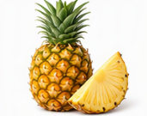 | PLU: 8107  Pineapple Cored  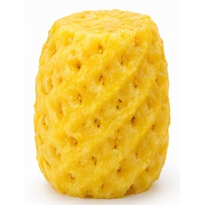

PLU: 3379  Pineapple Baby | PLU: 82191  Papaya Caribbean Cut
PLU: 4961  Mango Ataulfo Mexico  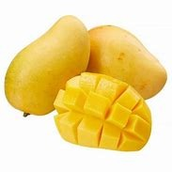 | PLU: 4315  Mango Case
PLU: 4313  Mango Julie  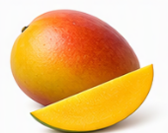 | PLU: 4467  Mangos Australia

PLU: 4011  Bananas  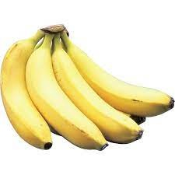 | PLU: 94011  Organic Bananas  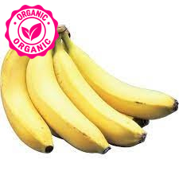
PLU: 4225  Avocado Large Hass  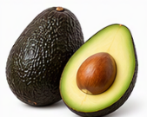 | PLU: 94225  Organic Avocado Large Hass  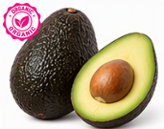
PLU: 6097  Mango | PLU: 94584  Organic Mango  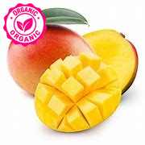

PLU: 94959  Organic Mangoes | PLU: 94311  Organic Mangoes
PLU: 4309  Lychees  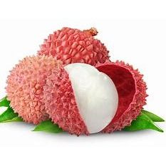 | PLU: 3040  Dragon Fruit - Pitahaya  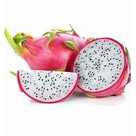
PLU: 94228
Organic Avocado Sharwil


